Chapter 7: Cross-Industry Convergence Patterns

Introduction
Having explored infrastructure optimization in e-commerce, financial services, and healthcare, a striking pattern emerges: despite their different requirements, these industries are converging toward remarkably similar architectural solutions. The techniques that enable sub-millisecond trading are being adapted for real-time fraud detection in retail. Healthcare’s compliance frameworks are informing financial services’ approach to data governance. E-commerce’s auto-scaling strategies are becoming standard across all sectors.
This chapter synthesizes the lessons learned across industries to identify universal patterns, transferable techniques, and the emerging convergence toward intelligent, self-optimizing infrastructure.

7.1 The Convergence Thesis

7.1.1 Why Industries Are Converging
Three forces are driving infrastructure convergence across industries:
Force | Description | Impact
Cloud commoditization | Same underlying infrastructure | Shared architectural patterns
Open source dominance | Common tooling (Kubernetes, Kafka, etc.) | Standardized operations
Talent mobility | Engineers move between industries | Cross-pollination of ideas

7.1.2 Convergence Evidence
Latency Requirements Convergence:
Industry | 2015 Requirement | 2024 Requirement | Trend
Trading | < 1ms | < 100μs | 10x faster
E-commerce | < 3s | < 200ms | 15x faster
Healthcare | < 10s | < 2s | 5x faster
Banking | < 5s | < 500ms | 10x faster
Architecture Pattern Adoption:
Pattern Adoption Timeline:
Event Sourcing: Trading (2010) → Banking (2015) → Healthcare (2020) → Retail (2022)
CQRS: Trading (2012) → E-commerce (2016) → Healthcare (2021)
Microservices: Netflix (2012) → All industries (2018+)
Service Mesh: Google (2016) → Finance (2019) → Healthcare (2022)
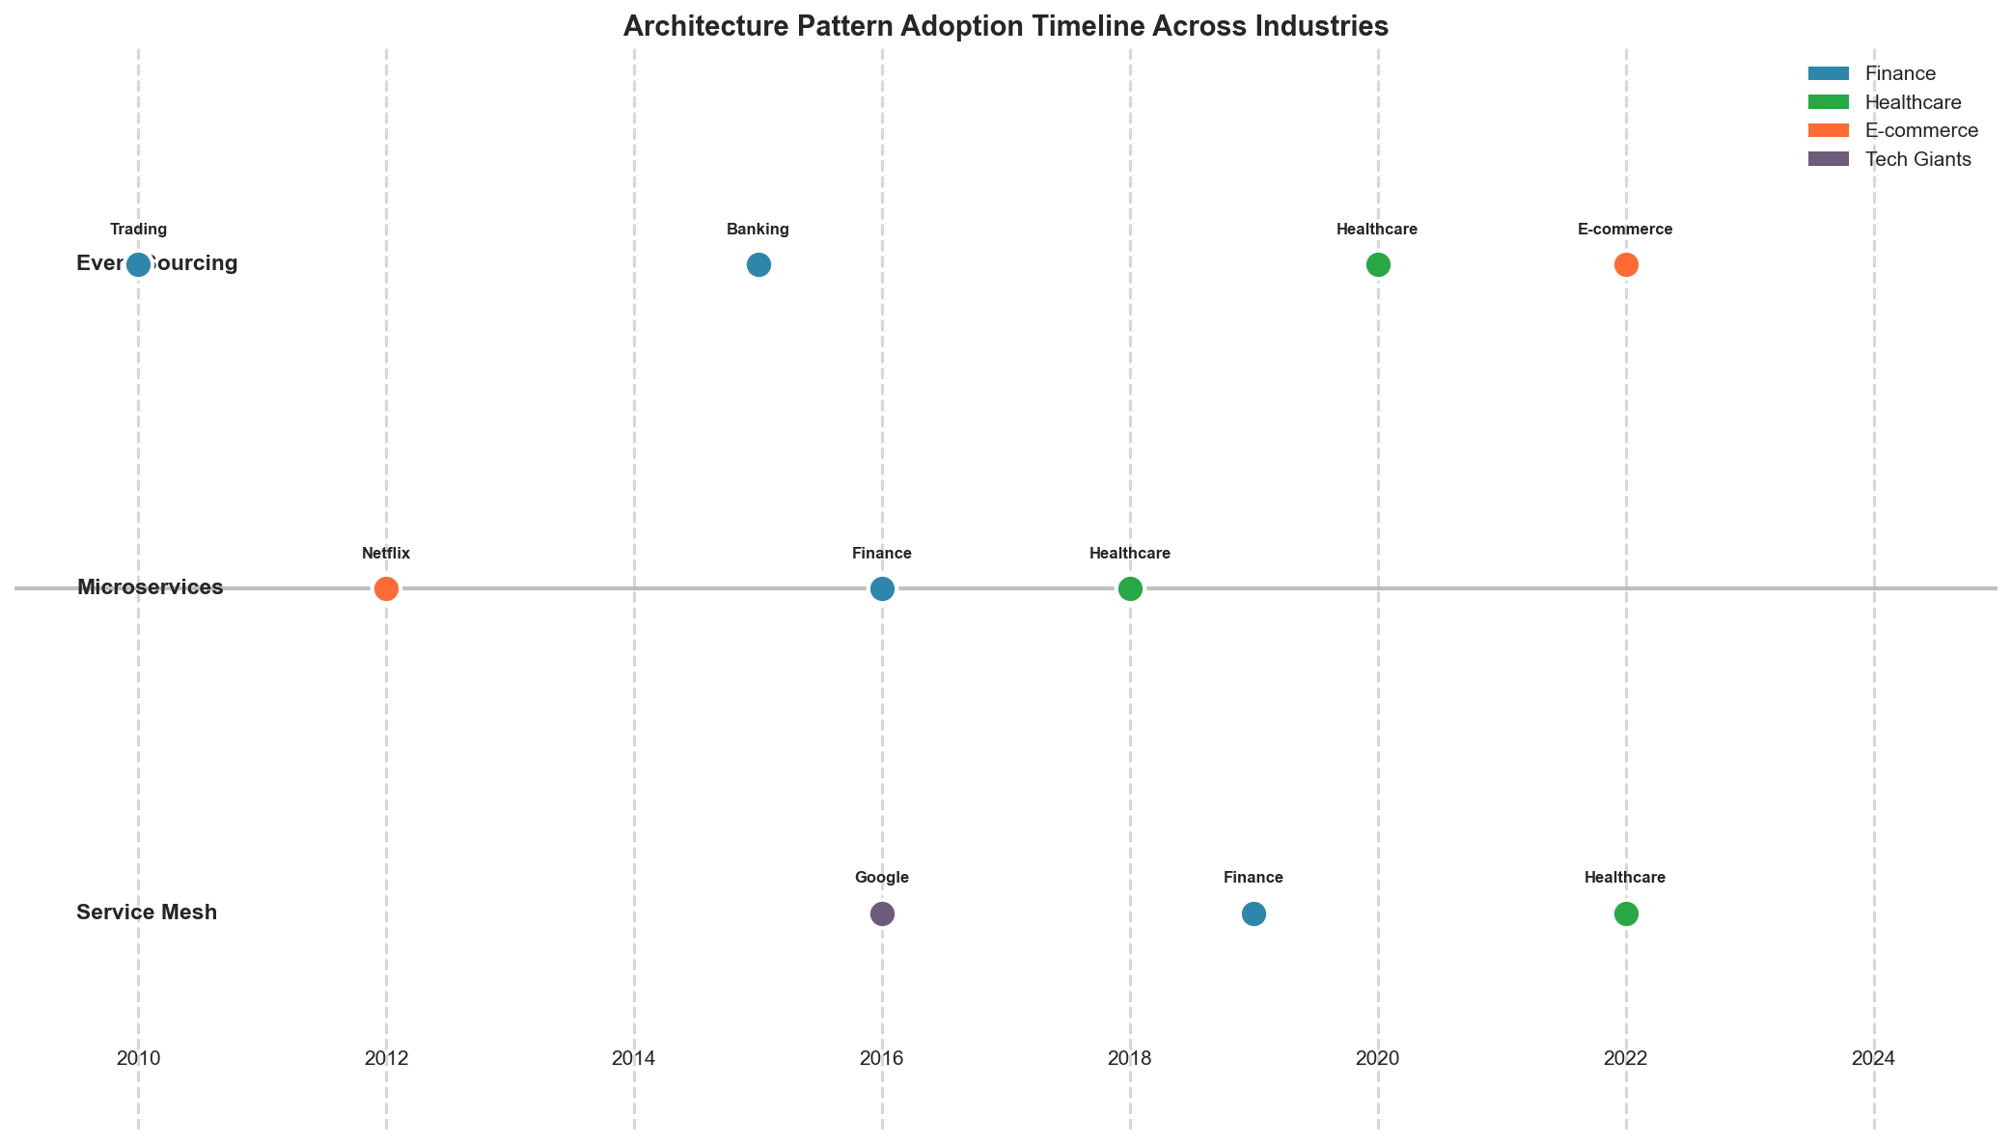
Figure 7.1: Cross-Industry Pattern Convergence
Figure 7.1: Timeline of Architecture Pattern Adoption Across Industries

7.2 Universal Optimization Patterns

7.2.1 Pattern 1: Tiered Architecture
Every industry has adopted tiered architectures, though with different names:
Tier | E-Commerce | Financial Services | Healthcare
Hot | Product cache | Pre-trade risk cache | Active patient records
Warm | Session data | Position data | Recent encounters
Cold | Order history | Trade archive | Historical records
Archive | Analytics | Regulatory archive | Long-term retention
Universal Tiered Storage Implementation:
class UniversalTieredStorage:
"""
Industry-agnostic tiered storage pattern.
Applicable to: E-commerce, Finance, Healthcare, Media
"""
def __init__(self, config: TierConfig):
self.tiers = {
"hot": HotTier(config.hot), # SSD, in-memory
"warm": WarmTier(config.warm), # SSD/HDD hybrid
"cold": ColdTier(config.cold), # Object storage
"archive": ArchiveTier(config.archive) # Glacier/tape
}
self.policy_engine = TieringPolicyEngine()
self.access_tracker = AccessPatternTracker()
async def store(self, key: str, data: bytes, metadata: dict) -> str:
"""Store data in appropriate tier based on metadata."""
# Determine initial tier
tier = self.policy_engine.determine_initial_tier(metadata)
# Store with tracking
await self.tiers[tier].put(key, data)
self.access_tracker.record_write(key, tier)
return tier
async def retrieve(self, key: str) -> tuple[bytes, str]:
"""Retrieve data, promoting to hotter tier if accessed frequently."""
# Find which tier has the data
current_tier = await self._locate(key)
# Retrieve
data = await self.tiers[current_tier].get(key)
# Record access for tiering decisions
self.access_tracker.record_read(key)
# Check if promotion needed
if self._should_promote(key, current_tier):
await self._promote(key, data, current_tier)
return data, current_tier
def _should_promote(self, key: str, current_tier: str) -> bool:
"""Determine if data should be promoted to hotter tier."""
access_pattern = self.access_tracker.get_pattern(key)
return self.policy_engine.should_promote(access_pattern, current_tier)

7.2.2 Pattern 2: Circuit Breaker with Fallback
Originally from electrical engineering, adopted by Netflix, now universal:
class UniversalCircuitBreaker:
"""
Circuit breaker pattern applicable across all industries.
Key insight: The pattern is identical; only thresholds and
fallback strategies differ by industry.
"""
def __init__(
self,
failure_threshold: int = 5,
recovery_timeout: int = 30,
half_open_requests: int = 3
):
self.failure_threshold = failure_threshold
self.recovery_timeout = recovery_timeout
self.half_open_requests = half_open_requests
self.state = CircuitState.CLOSED
self.failure_count = 0
self.last_failure_time = None
self.success_count = 0
async def call(
self,
operation: Callable,
fallback: Callable,
*args,
**kwargs
):
"""Execute operation with circuit breaker protection."""
if self.state == CircuitState.OPEN:
if self._should_attempt_reset():
self.state = CircuitState.HALF_OPEN
else:
return await fallback(*args, **kwargs)
try:
result = await operation(*args, **kwargs)
self._record_success()
return result
except Exception as e:
self._record_failure()
if self.state == CircuitState.OPEN:
return await fallback(*args, **kwargs)
raise
def _record_failure(self):
"""Record failure and potentially open circuit."""
self.failure_count += 1
self.last_failure_time = time.time()
if self.failure_count >= self.failure_threshold:
self.state = CircuitState.OPEN
def _record_success(self):
"""Record success and potentially close circuit."""
if self.state == CircuitState.HALF_OPEN:
self.success_count += 1
if self.success_count >= self.half_open_requests:
self.state = CircuitState.CLOSED
self.failure_count = 0
self.success_count = 0
# Industry-specific configurations
CIRCUIT_BREAKER_CONFIGS = {
"trading": {
"failure_threshold": 2, # Very aggressive
"recovery_timeout": 5, # Quick recovery attempts
"half_open_requests": 1
},
"ecommerce": {
"failure_threshold": 5,
"recovery_timeout": 30,
"half_open_requests": 3
},
"healthcare": {
"failure_threshold": 3,
"recovery_timeout": 60, # More conservative
"half_open_requests": 5 # More validation before closing
}
}

7.2.3 Pattern 3: Event-Driven Architecture
Event sourcing and CQRS have become universal patterns:
class UniversalEventStore:
"""
Event store pattern used across industries.
Trading: Order events, market data events
E-commerce: Cart events, order events, inventory events
Healthcare: Clinical events, audit events
"""
def __init__(self, storage_backend, schema_registry):
self.storage = storage_backend
self.schemas = schema_registry
self.projections = {}
async def append(
self,
stream_id: str,
event_type: str,
event_data: dict,
metadata: dict = None
) -> str:
"""Append event to stream."""
# Validate against schema
schema = self.schemas.get_schema(event_type)
if not schema.validate(event_data):
raise SchemaValidationError(event_type, event_data)
# Create event envelope
event = {
"event_id": str(uuid.uuid4()),
"stream_id": stream_id,
"event_type": event_type,
"event_data": event_data,
"metadata": metadata or {},
"timestamp": datetime.utcnow().isoformat(),
"version": await self._get_next_version(stream_id)
}
# Append to storage
await self.storage.append(stream_id, event)
# Update projections
await self._update_projections(event)
return event["event_id"]
async def get_stream(
self,
stream_id: str,
from_version: int = 0,
to_version: int = None
) -> list:
"""Get events from stream."""
return await self.storage.get_range(
stream_id, from_version, to_version
)
def register_projection(self, name: str, projection: Projection):
"""Register a projection (read model builder)."""
self.projections[name] = projection
async def _update_projections(self, event: dict):
"""Update all registered projections with new event."""
for projection in self.projections.values():
if projection.handles(event["event_type"]):
await projection.apply(event)
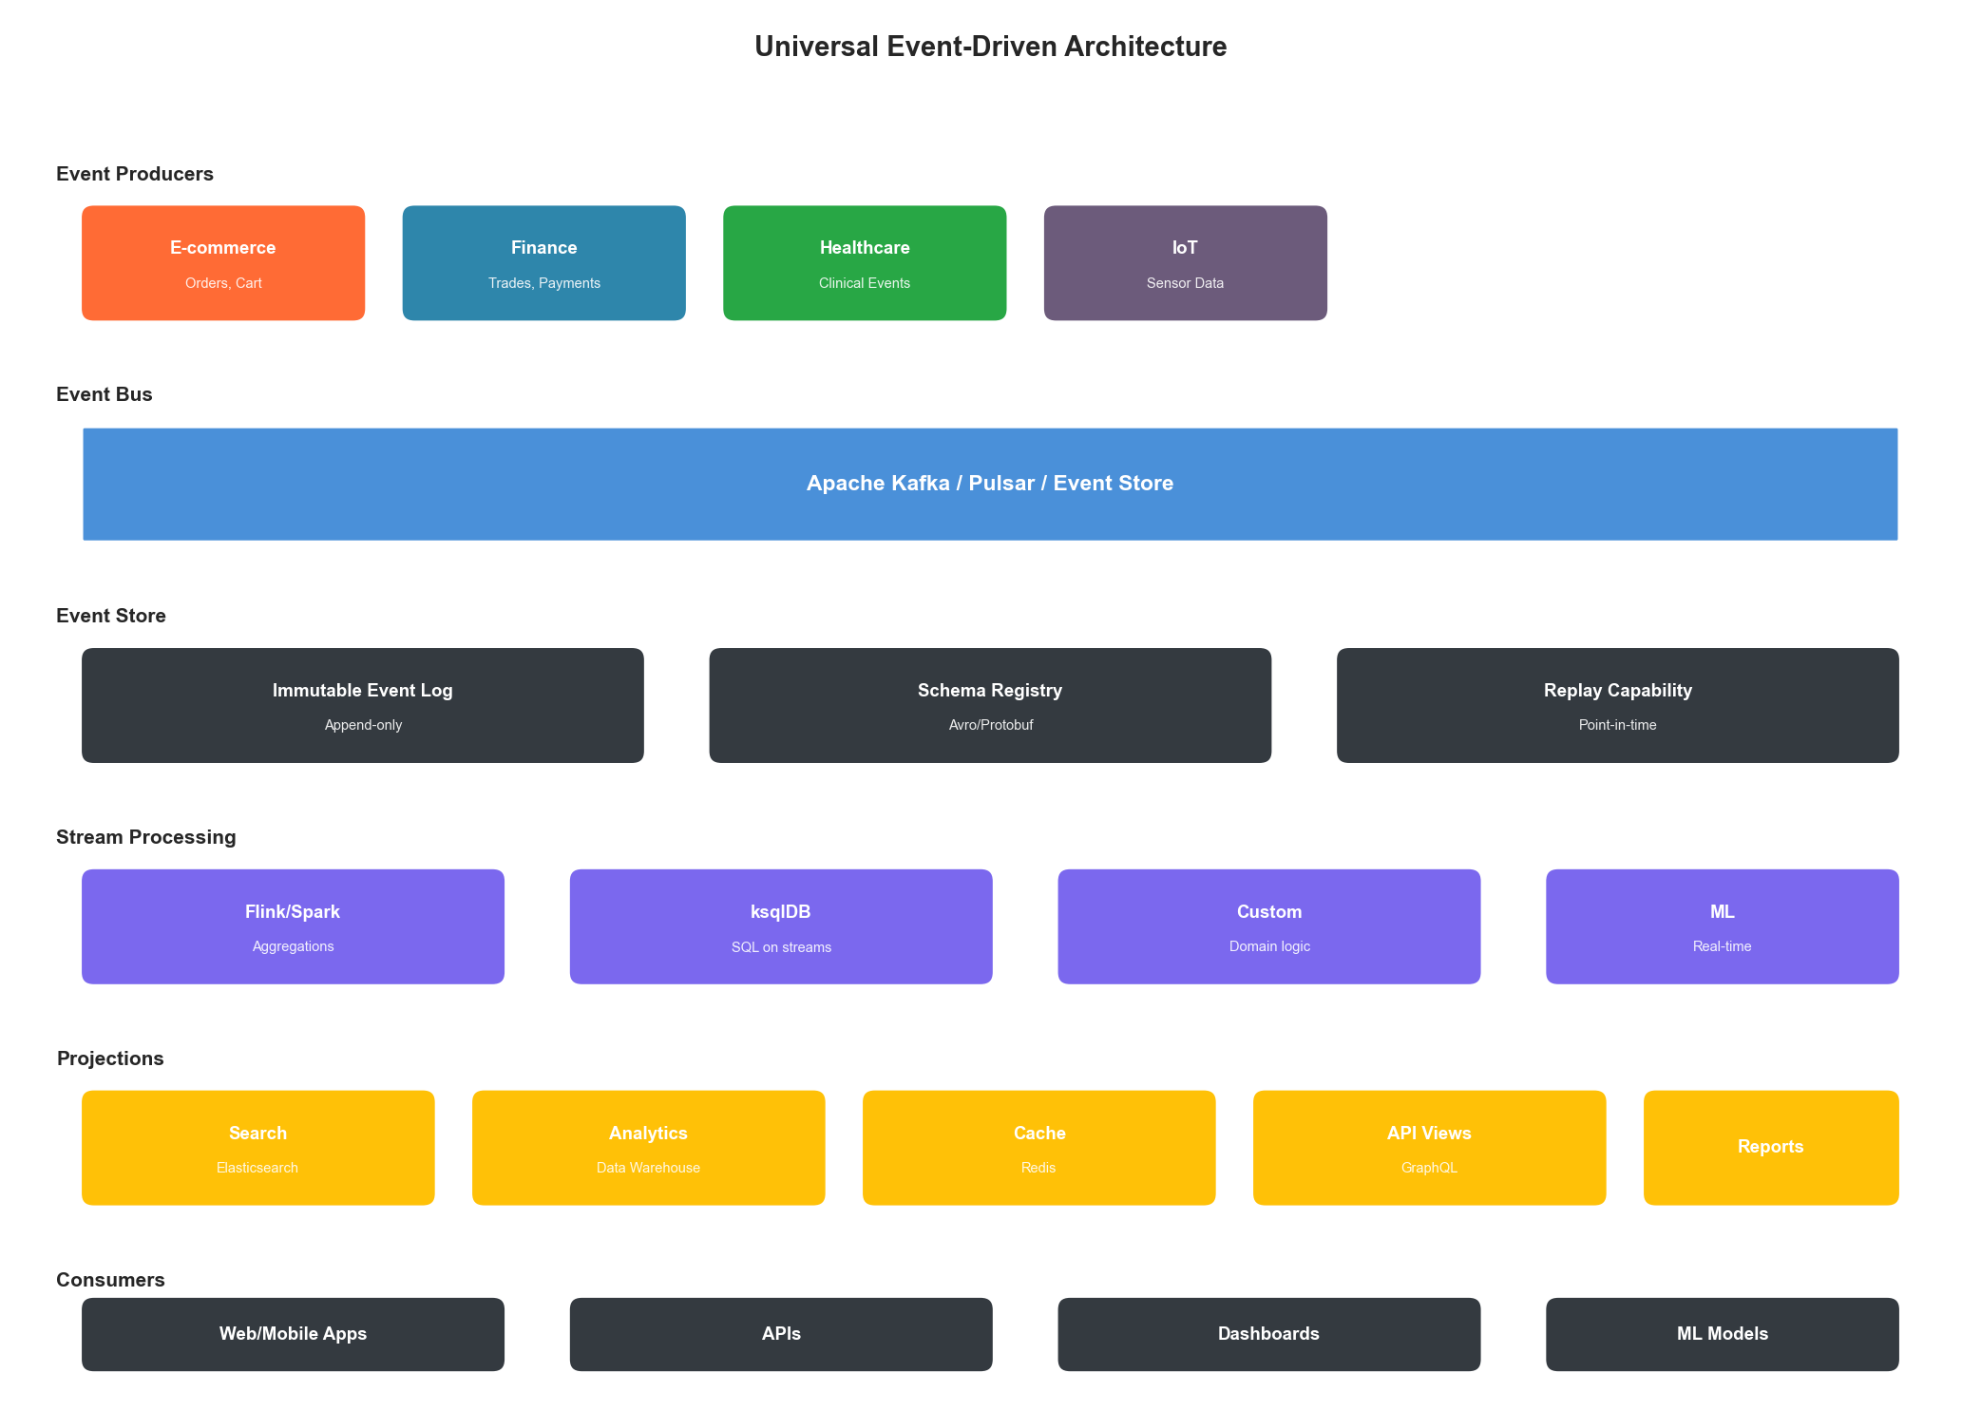
Figure 7.2: Universal Event-Driven Architecture
Figure 7.2: Event-Driven Architecture Pattern Across Industries

7.2.4 Pattern 4: Predictive Scaling
All industries are moving toward ML-driven predictive scaling:
class UniversalPredictiveScaler:
"""
Predictive auto-scaling applicable across industries.
Key insight: The ML models differ by domain (seasonality patterns),
but the scaling infrastructure is identical.
"""
def __init__(
self,
forecaster: DemandForecaster,
orchestrator: ContainerOrchestrator,
config: ScalingConfig
):
self.forecaster = forecaster
self.orchestrator = orchestrator
self.config = config
async def scale_ahead(self, service: str, horizon_minutes: int = 15):
"""Scale based on predicted demand."""
# Get current metrics
current_metrics = await self._get_current_metrics(service)
# Predict future demand
predictions = await self.forecaster.predict(
service=service,
current_metrics=current_metrics,
horizon_minutes=horizon_minutes
)
# Calculate required capacity
required_instances = self._calculate_capacity(
predictions["peak_demand"],
predictions["confidence"],
service
)
# Get current capacity
current_instances = await self.orchestrator.get_instance_count(service)
# Scale if needed (with buffer for prediction uncertainty)
if required_instances > current_instances:
buffer = int(required_instances * (1 - predictions["confidence"]) * 0.5)
target = required_instances + buffer
await self.orchestrator.scale(service, target)
return {
"action": "scale_up",
"from": current_instances,
"to": target,
"predicted_demand": predictions["peak_demand"],
"confidence": predictions["confidence"]
}
return {"action": "no_change", "current": current_instances}
# Industry-specific forecasters
class EcommerceForecaster(DemandForecaster):
"""Handles flash sales, seasonal peaks, marketing events."""
def __init__(self):
self.seasonality_model = SeasonalARIMA()
self.event_calendar = MarketingEventCalendar()
async def predict(self, service, current_metrics, horizon_minutes):
# Factor in known events (flash sales, promotions)
scheduled_events = self.event_calendar.get_upcoming(horizon_minutes)
base_prediction = self.seasonality_model.forecast(
current_metrics, horizon_minutes
)
# Apply event multipliers
for event in scheduled_events:
base_prediction *= event.expected_traffic_multiplier
return {
"peak_demand": base_prediction,
"confidence": 0.85 if not scheduled_events else 0.70
}
class HealthcareForecaster(DemandForecaster):
"""Handles clinic schedules, seasonal illness patterns."""
def __init__(self):
self.schedule_model = ClinicScheduleModel()
self.illness_model = SeasonalIllnessModel()
async def predict(self, service, current_metrics, horizon_minutes):
# Healthcare has more predictable patterns (scheduled appointments)
scheduled_load = self.schedule_model.get_scheduled_load(horizon_minutes)
# Plus walk-ins and emergency adjustments
emergency_adjustment = self.illness_model.get_current_adjustment()
return {
"peak_demand": scheduled_load * emergency_adjustment,
"confidence": 0.90 # Healthcare is more predictable
}

7.3 Transferable Techniques

7.3.1 From Trading to E-Commerce: Low-Latency Patterns
Techniques originally developed for high-frequency trading are now appearing in e-commerce:
Trading Technique | E-Commerce Application
Pre-computed order books | Pre-computed product rankings
Co-location | Edge computing for personalization
Lock-free data structures | High-throughput cart operations
FPGA acceleration | Real-time recommendation serving
Kernel bypass networking | High-volume API gateways
class TradingInspiredProductRanker:
"""
Apply trading system techniques to product ranking.
Borrowed from trading:
- Pre-computation of likely queries
- Lock-free updates
- Tiered caching with speculation
"""
def __init__(self, product_catalog, user_model):
self.catalog = product_catalog
self.user_model = user_model
# Pre-computed rankings (like pre-computed order books)
self.precomputed_rankings = LockFreeCache()
# Speculative computation queue
self.speculation_queue = SPSCQueue(1000)
async def get_ranking(
self,
user_id: str,
category: str,
context: dict
) -> list:
"""Get product ranking with trading-inspired optimizations."""
# Try pre-computed first (< 1ms)
cache_key = self._compute_cache_key(user_id, category, context)
precomputed = self.precomputed_rankings.get(cache_key)
if precomputed and not precomputed.is_stale():
# Trigger background refresh (speculative)
self.speculation_queue.enqueue((cache_key, user_id, category, context))
return precomputed.rankings
# Compute fresh ranking
rankings = await self._compute_ranking(user_id, category, context)
# Cache with lock-free update
self.precomputed_rankings.put(
cache_key,
RankingResult(rankings, ttl=300)
)
# Speculatively compute related rankings
self._speculate_related(user_id, category)
return rankings
def _speculate_related(self, user_id: str, category: str):
"""Speculatively compute rankings user might request next."""
# Based on user browsing patterns, pre-compute likely next queries
likely_next = self.user_model.predict_next_categories(user_id, category)
for next_category in likely_next[:3]:
self.speculation_queue.enqueue(
(None, user_id, next_category, {})
)

7.3.2 From Healthcare to Finance: Compliance Patterns
Healthcare’s mature compliance frameworks inform financial services:
Healthcare Pattern | Financial Application
HIPAA audit trails | SOX compliance logging
Break-the-glass access | Emergency trading authorization
Consent management | Data sharing agreements
De-identification | PII tokenization
class HealthcareInspiredAuditFramework:
"""
Apply healthcare compliance patterns to financial services.
Borrowed from healthcare:
- Comprehensive access logging
- Break-the-glass with justification
- Tamper-evident audit trails
"""
def __init__(self, audit_store, alert_engine):
self.audit = audit_store
self.alerts = alert_engine
self.hash_chain = None
async def log_data_access(
self,
user_id: str,
data_type: str,
data_id: str,
access_type: str,
justification: str = None
) -> str:
"""Log data access with healthcare-grade audit trail."""
# Determine if this is normal access or break-the-glass
is_authorized = await self._check_authorization(user_id, data_type, data_id)
access_record = {
"audit_id": str(uuid.uuid4()),
"timestamp": datetime.utcnow().isoformat(),
"user_id": user_id,
"data_type": data_type,
"data_id_hash": self._hash_id(data_id), # Don't log actual IDs
"access_type": access_type,
"authorized": is_authorized,
"justification": justification,
"source_ip": self._get_source_ip(),
"session_id": self._get_session_id()
}
# Add to hash chain (tamper-evident)
access_record["previous_hash"] = self.hash_chain
access_record["record_hash"] = self._compute_hash(access_record)
self.hash_chain = access_record["record_hash"]
# Store
await self.audit.append(access_record)
# Alert on unauthorized access (break-the-glass)
if not is_authorized:
await self.alerts.send_alert({
"type": "unauthorized_access",
"severity": "high",
"audit_id": access_record["audit_id"],
"user_id": user_id,
"requires_review": True
})
return access_record["audit_id"]

7.3.3 From E-Commerce to Healthcare: Personalization Patterns
E-commerce personalization techniques are transforming healthcare:
E-Commerce Pattern | Healthcare Application
Recommendation engines | Clinical decision support
A/B testing | Treatment optimization
User segmentation | Patient risk stratification
Conversion funnels | Care pathway optimization
class EcommerceInspiredClinicalSupport:
"""
Apply e-commerce personalization to clinical decision support.
Borrowed from e-commerce:
- Collaborative filtering for treatment suggestions
- Real-time personalization
- Outcome tracking and optimization
"""
def __init__(self, treatment_model, outcome_tracker):
self.model = treatment_model
self.outcomes = outcome_tracker
async def suggest_treatments(
self,
patient_context: dict,
condition: str,
current_treatments: list
) -> list:
"""
Suggest treatments using collaborative filtering.
Like product recommendations, but for treatments:
"Patients similar to you who had this condition
responded well to these treatments"
"""
# Find similar patients (collaborative filtering)
similar_patients = await self.model.find_similar_patients(
patient_context, condition
)
# Get treatments that worked for similar patients
effective_treatments = await self.model.get_effective_treatments(
similar_patients, condition
)
# Filter out contraindicated treatments
safe_treatments = self._filter_contraindicated(
effective_treatments,
patient_context,
current_treatments
)
# Rank by expected efficacy (like product ranking)
ranked_treatments = self._rank_by_efficacy(
safe_treatments,
patient_context
)
return [
{
"treatment": t.name,
"expected_efficacy": t.efficacy_score,
"similar_patient_outcomes": t.outcome_summary,
"evidence_level": t.evidence_level,
"contraindication_check": "passed"
}
for t in ranked_treatments[:5]
]

7.4 The Universal Infrastructure Stack

7.4.1 Converged Technology Stack
Despite different requirements, industries are converging on similar technology choices:
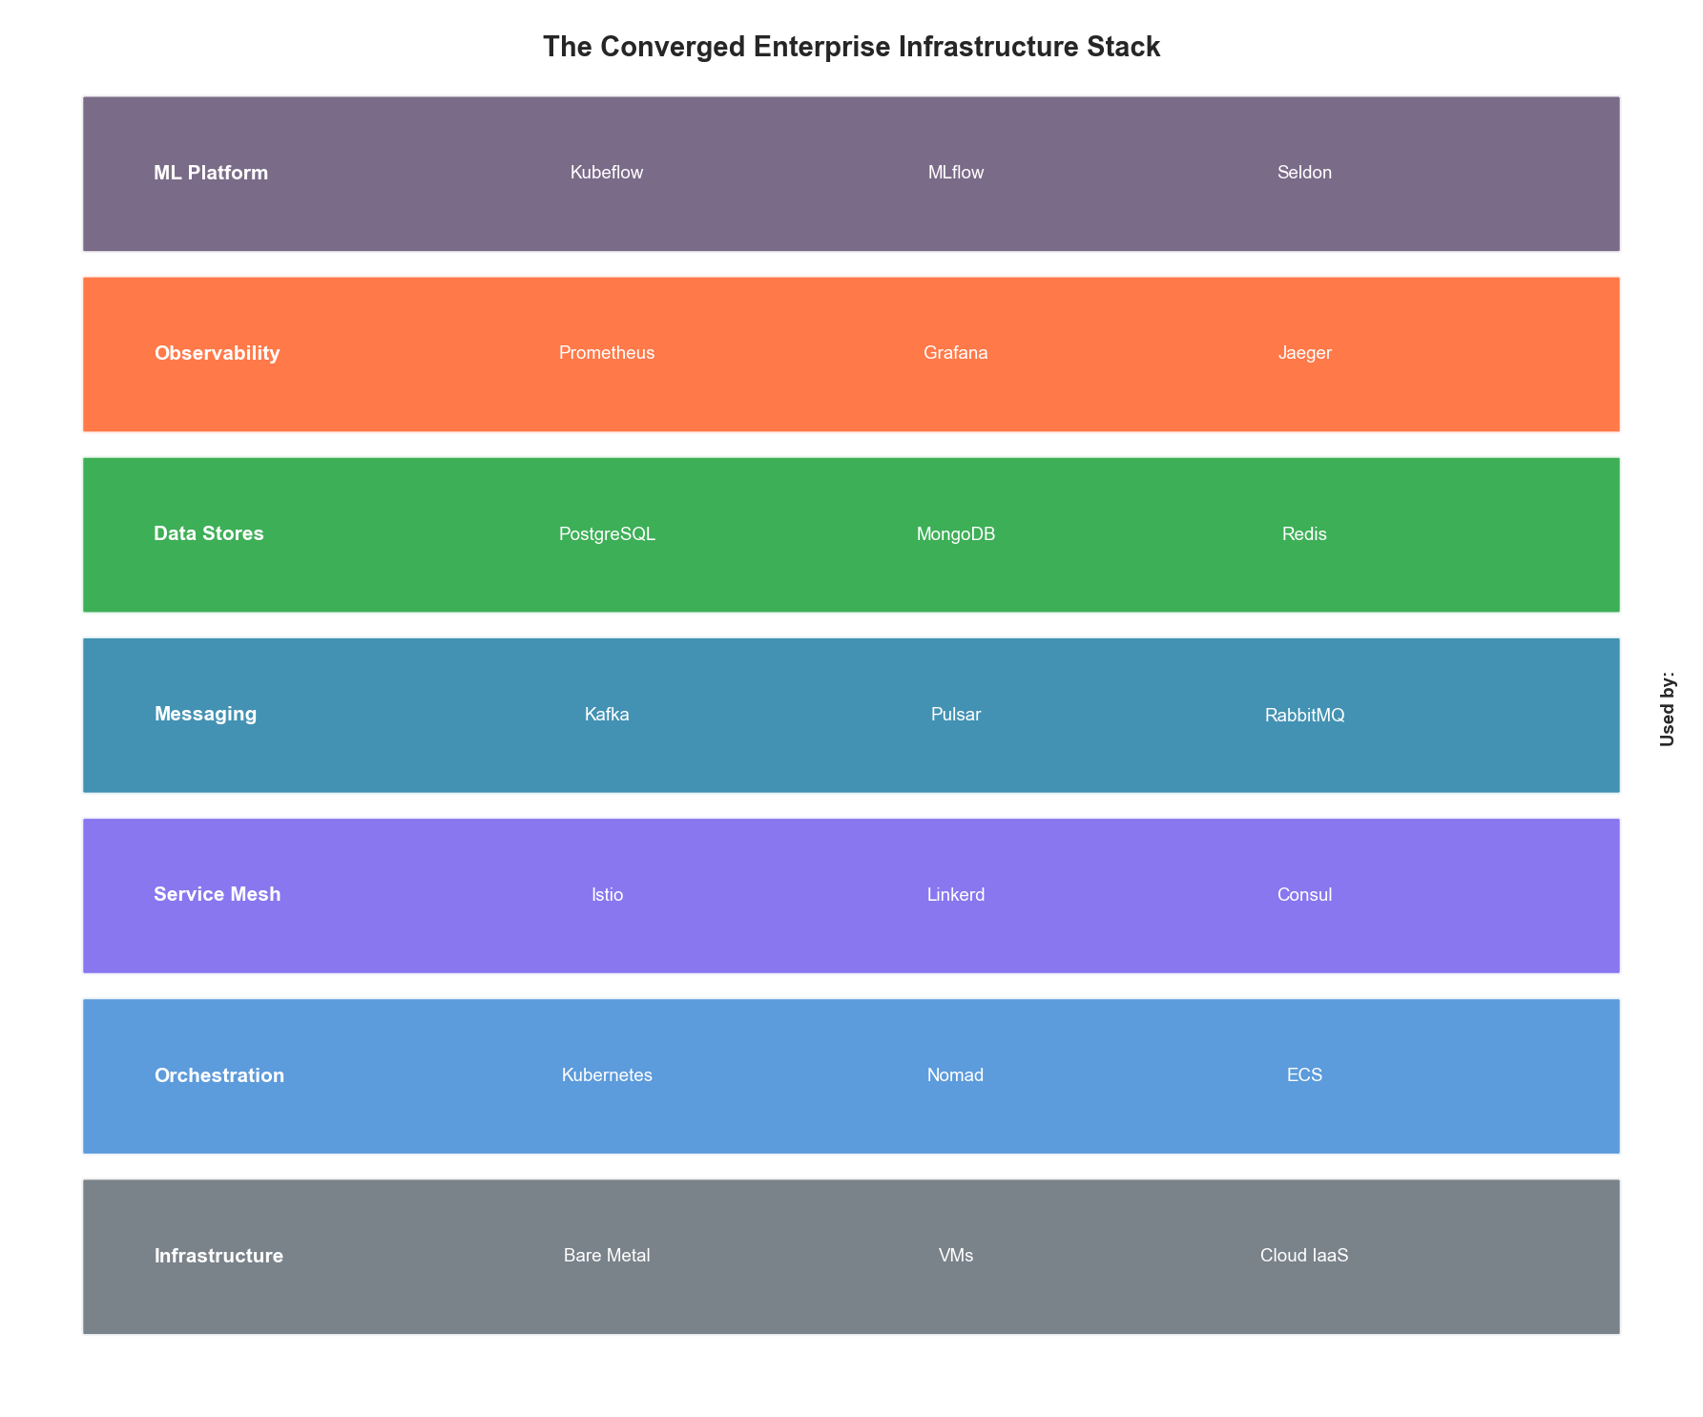
Figure 7.3: Universal Infrastructure Stack
Figure 7.3: The Converged Enterprise Infrastructure Stack
Layer | Common Choices | Industry Variations
Orchestration | Kubernetes | Trading: bare metal + K8s hybrid
Service Mesh | Istio, Linkerd | Finance: enhanced mTLS
Messaging | Kafka, Pulsar | Trading: custom low-latency
Databases | PostgreSQL, MongoDB | Finance: Oracle still common
Caching | Redis, Memcached | Trading: custom in-memory
Observability | Prometheus, Grafana, Jaeger | Healthcare: enhanced audit
ML Platform | Kubeflow, MLflow | All converging

7.4.2 Universal Observability
All industries have converged on the three pillars of observability:
class UniversalObservabilityStack:
"""
Observability implementation applicable across all industries.
"""
def __init__(self, config: ObservabilityConfig):
# Metrics (Prometheus-compatible)
self.metrics = MetricsCollector(config.metrics)
# Logging (structured, centralized)
self.logger = StructuredLogger(config.logging)
# Tracing (OpenTelemetry)
self.tracer = DistributedTracer(config.tracing)
# Industry-specific enrichment
self.enrichers = self._load_enrichers(config.industry)
def instrument_operation(
self,
operation_name: str,
operation_type: str
):
"""Decorator for comprehensive operation instrumentation."""
def decorator(func):
@functools.wraps(func)
async def wrapper(*args, **kwargs):
# Start trace span
with self.tracer.start_span(operation_name) as span:
start_time = time.time()
try:
# Execute operation
result = await func(*args, **kwargs)
# Record success metrics
duration = time.time() - start_time
self.metrics.histogram(
f"{operation_type}.duration",
duration,
tags={"operation": operation_name, "status": "success"}
)
return result
except Exception as e:
# Record failure
duration = time.time() - start_time
self.metrics.histogram(
f"{operation_type}.duration",
duration,
tags={"operation": operation_name, "status": "error"}
)
self.metrics.counter(
f"{operation_type}.errors",
tags={"operation": operation_name, "error_type": type(e).__name__}
)
# Log error with context
self.logger.error(
"Operation failed",
operation=operation_name,
error=str(e),
trace_id=span.trace_id
)
raise
return wrapper
return decorator

7.5 Cross-Industry PROSE Analysis

7.5.1 Comparative PROSE Weights
Dimension | E-Commerce | Finance | Healthcare | Universal
Performance | 30% | 25% | 20% | 25%
Resource Opt | 20% | 15% | 15% | 17%
Operational | 20% | 30% | 35% | 28%
Scalability | 20% | 15% | 15% | 17%
Economic | 10% | 15% | 15% | 13%

7.5.2 Universal Optimization Priorities
Based on cross-industry analysis, the universal optimization priority order is:
- Operational Excellence (28%) - Reliability and compliance are universal
- Performance (25%) - Speed matters everywhere
- Resource Optimization (17%) - Efficiency for sustainability
- Scalability (17%) - Handle growth gracefully
- Economic Impact (13%) - Cost follows quality
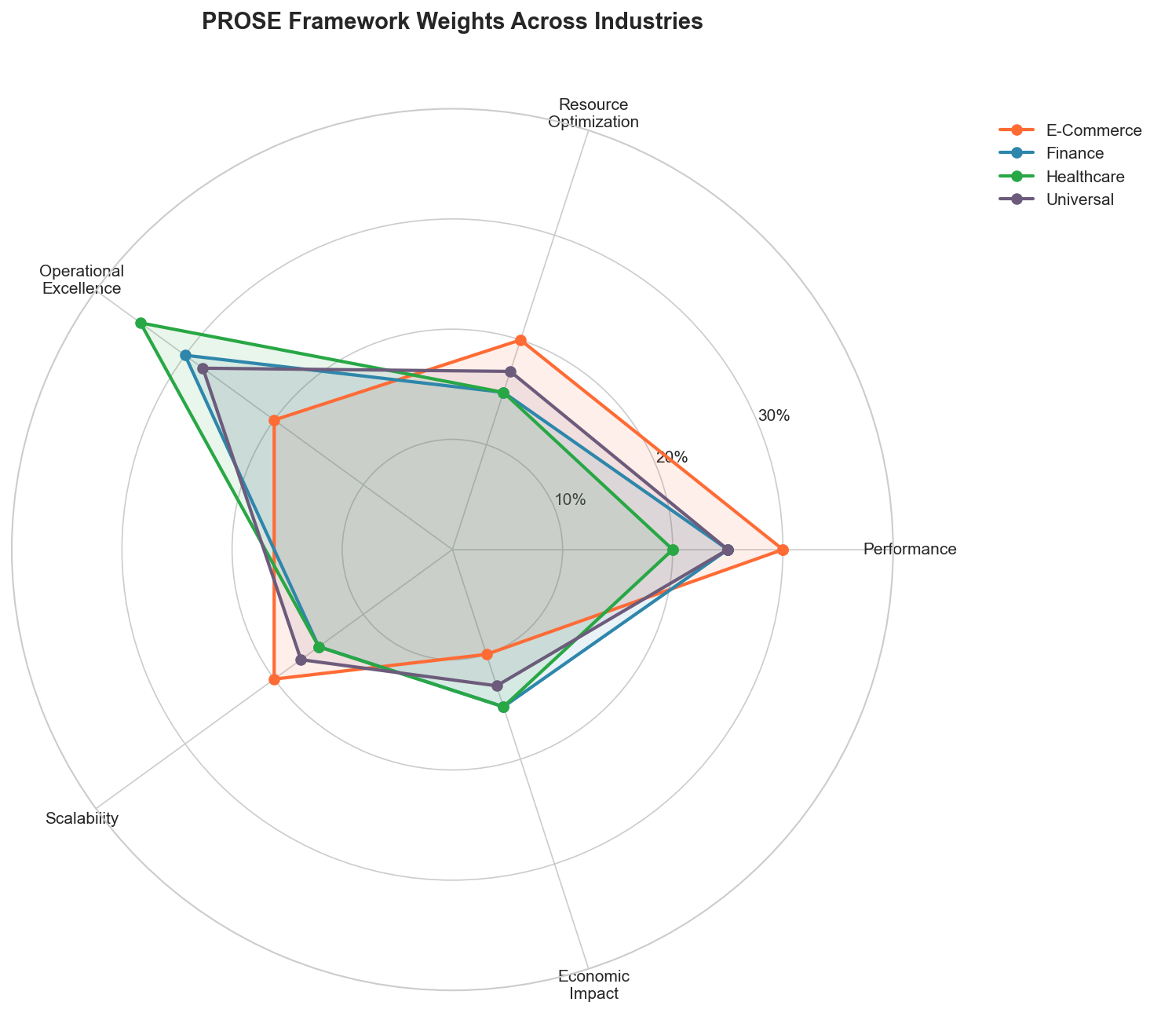
Figure 7.4: Cross-Industry PROSE Comparison
Figure 7.4: PROSE Framework Weights Across Industries

7.6 Emerging Convergence Trends

7.6.1 AI-Native Infrastructure
All industries are moving toward AI-native infrastructure:
Capability | Current State | Future State
Scaling | Rule-based auto-scaling | ML-predicted scaling
Incident Response | Alert → Human → Action | Anomaly → Auto-remediate
Capacity Planning | Spreadsheet-based | Continuous ML optimization
Security | Signature-based | Behavioral AI detection

7.6.2 Edge-Cloud Continuum
The boundary between edge and cloud is dissolving:
2020: Edge OR Cloud
2024: Edge AND Cloud
2028: Edge-Cloud Continuum (seamless)

7.6.3 Sustainability-Driven Optimization
Carbon-aware computing is becoming a universal requirement:
class CarbonAwareScheduler:
"""
Schedule workloads based on carbon intensity.
Applicable across all industries.
"""
def __init__(self, carbon_api, workload_classifier):
self.carbon = carbon_api
self.classifier = workload_classifier
async def schedule_workload(
self,
workload: Workload,
deadline: datetime
) -> ScheduleDecision:
"""Schedule workload to minimize carbon footprint."""
# Classify workload flexibility
flexibility = self.classifier.classify(workload)
if flexibility == WorkloadFlexibility.REAL_TIME:
# Must run now regardless of carbon
return ScheduleDecision(run_now=True, reason="real_time")
# Get carbon intensity forecast
carbon_forecast = await self.carbon.get_forecast(
until=deadline
)
# Find optimal window
optimal_window = self._find_low_carbon_window(
carbon_forecast,
workload.estimated_duration,
deadline
)
return ScheduleDecision(
run_at=optimal_window.start,
expected_carbon=optimal_window.carbon_intensity,
carbon_saved=self._calculate_savings(carbon_forecast, optimal_window)
)

Key Takeaways
- Industries are converging - Despite different requirements, architecture patterns are becoming universal thanks to cloud commoditization and talent mobility
- Patterns are transferable - Trading’s low-latency techniques work for e-commerce; healthcare’s compliance frameworks apply to finance
- The stack is standardizing - Kubernetes, Kafka, Prometheus, and similar tools are becoming universal across industries
- PROSE weights differ, principles don’t - Industries weight dimensions differently, but all five dimensions matter everywhere
- AI-native is the future - All industries are moving toward self-optimizing, ML-driven infrastructure
- Sustainability is universal - Carbon-aware computing is becoming a cross-industry requirement

References
- Newman, S. “Building Microservices.” O’Reilly Media (2021)
- Kleppmann, M. “Designing Data-Intensive Applications.” O’Reilly Media (2017)
- Burns, B. “Designing Distributed Systems.” O’Reilly Media (2018)
- Fowler, M. “Patterns of Enterprise Application Architecture.” Addison-Wesley (2002)
- Richardson, C. “Microservices Patterns.” Manning (2018)

Next Chapter: Intelligent Infrastructure Architecture

