Table of Contents

Chapter 3: Comparative Framework for Evaluating Infrastructure Optimization

Introduction
With the foundations of AI-driven infrastructure established in Chapter 2, organizations face a critical question: how do we evaluate and compare different optimization approaches? This chapter introduces a systematic framework for assessing infrastructure optimization strategies, enabling data-driven decisions about which techniques to adopt.
The framework presented here will be applied throughout the industry-specific chapters that follow, providing a consistent lens for evaluation across e-commerce, financial services, and healthcare domains.

3.1 The Evaluation Challenge

3.1.1 Why Traditional Metrics Fall Short
Most organizations evaluate infrastructure performance using metrics that were designed for static, predictable workloads:
Traditional Metric | Limitation
Average CPU utilization | Masks burst patterns and tail behavior
Uptime percentage | Doesn’t capture degraded performance states
Mean response time | Hides P99 latency that affects user experience
Cost per server | Ignores efficiency and actual utilization
These metrics create blind spots. A system can report 99.9% uptime while delivering unacceptable performance during critical business periods.

3.1.2 The Multi-Dimensional Nature of Modern Infrastructure
Modern infrastructure optimization must balance competing objectives:
- Performance: Response time, throughput, consistency
- Cost: Infrastructure spend, operational overhead, opportunity cost
- Reliability: Availability, fault tolerance, recovery time
- Scalability: Elasticity, resource efficiency, growth capacity
- Operability: Complexity, observability, maintenance burden
No single metric captures this complexity. Effective evaluation requires a framework that addresses all dimensions while acknowledging trade-offs.
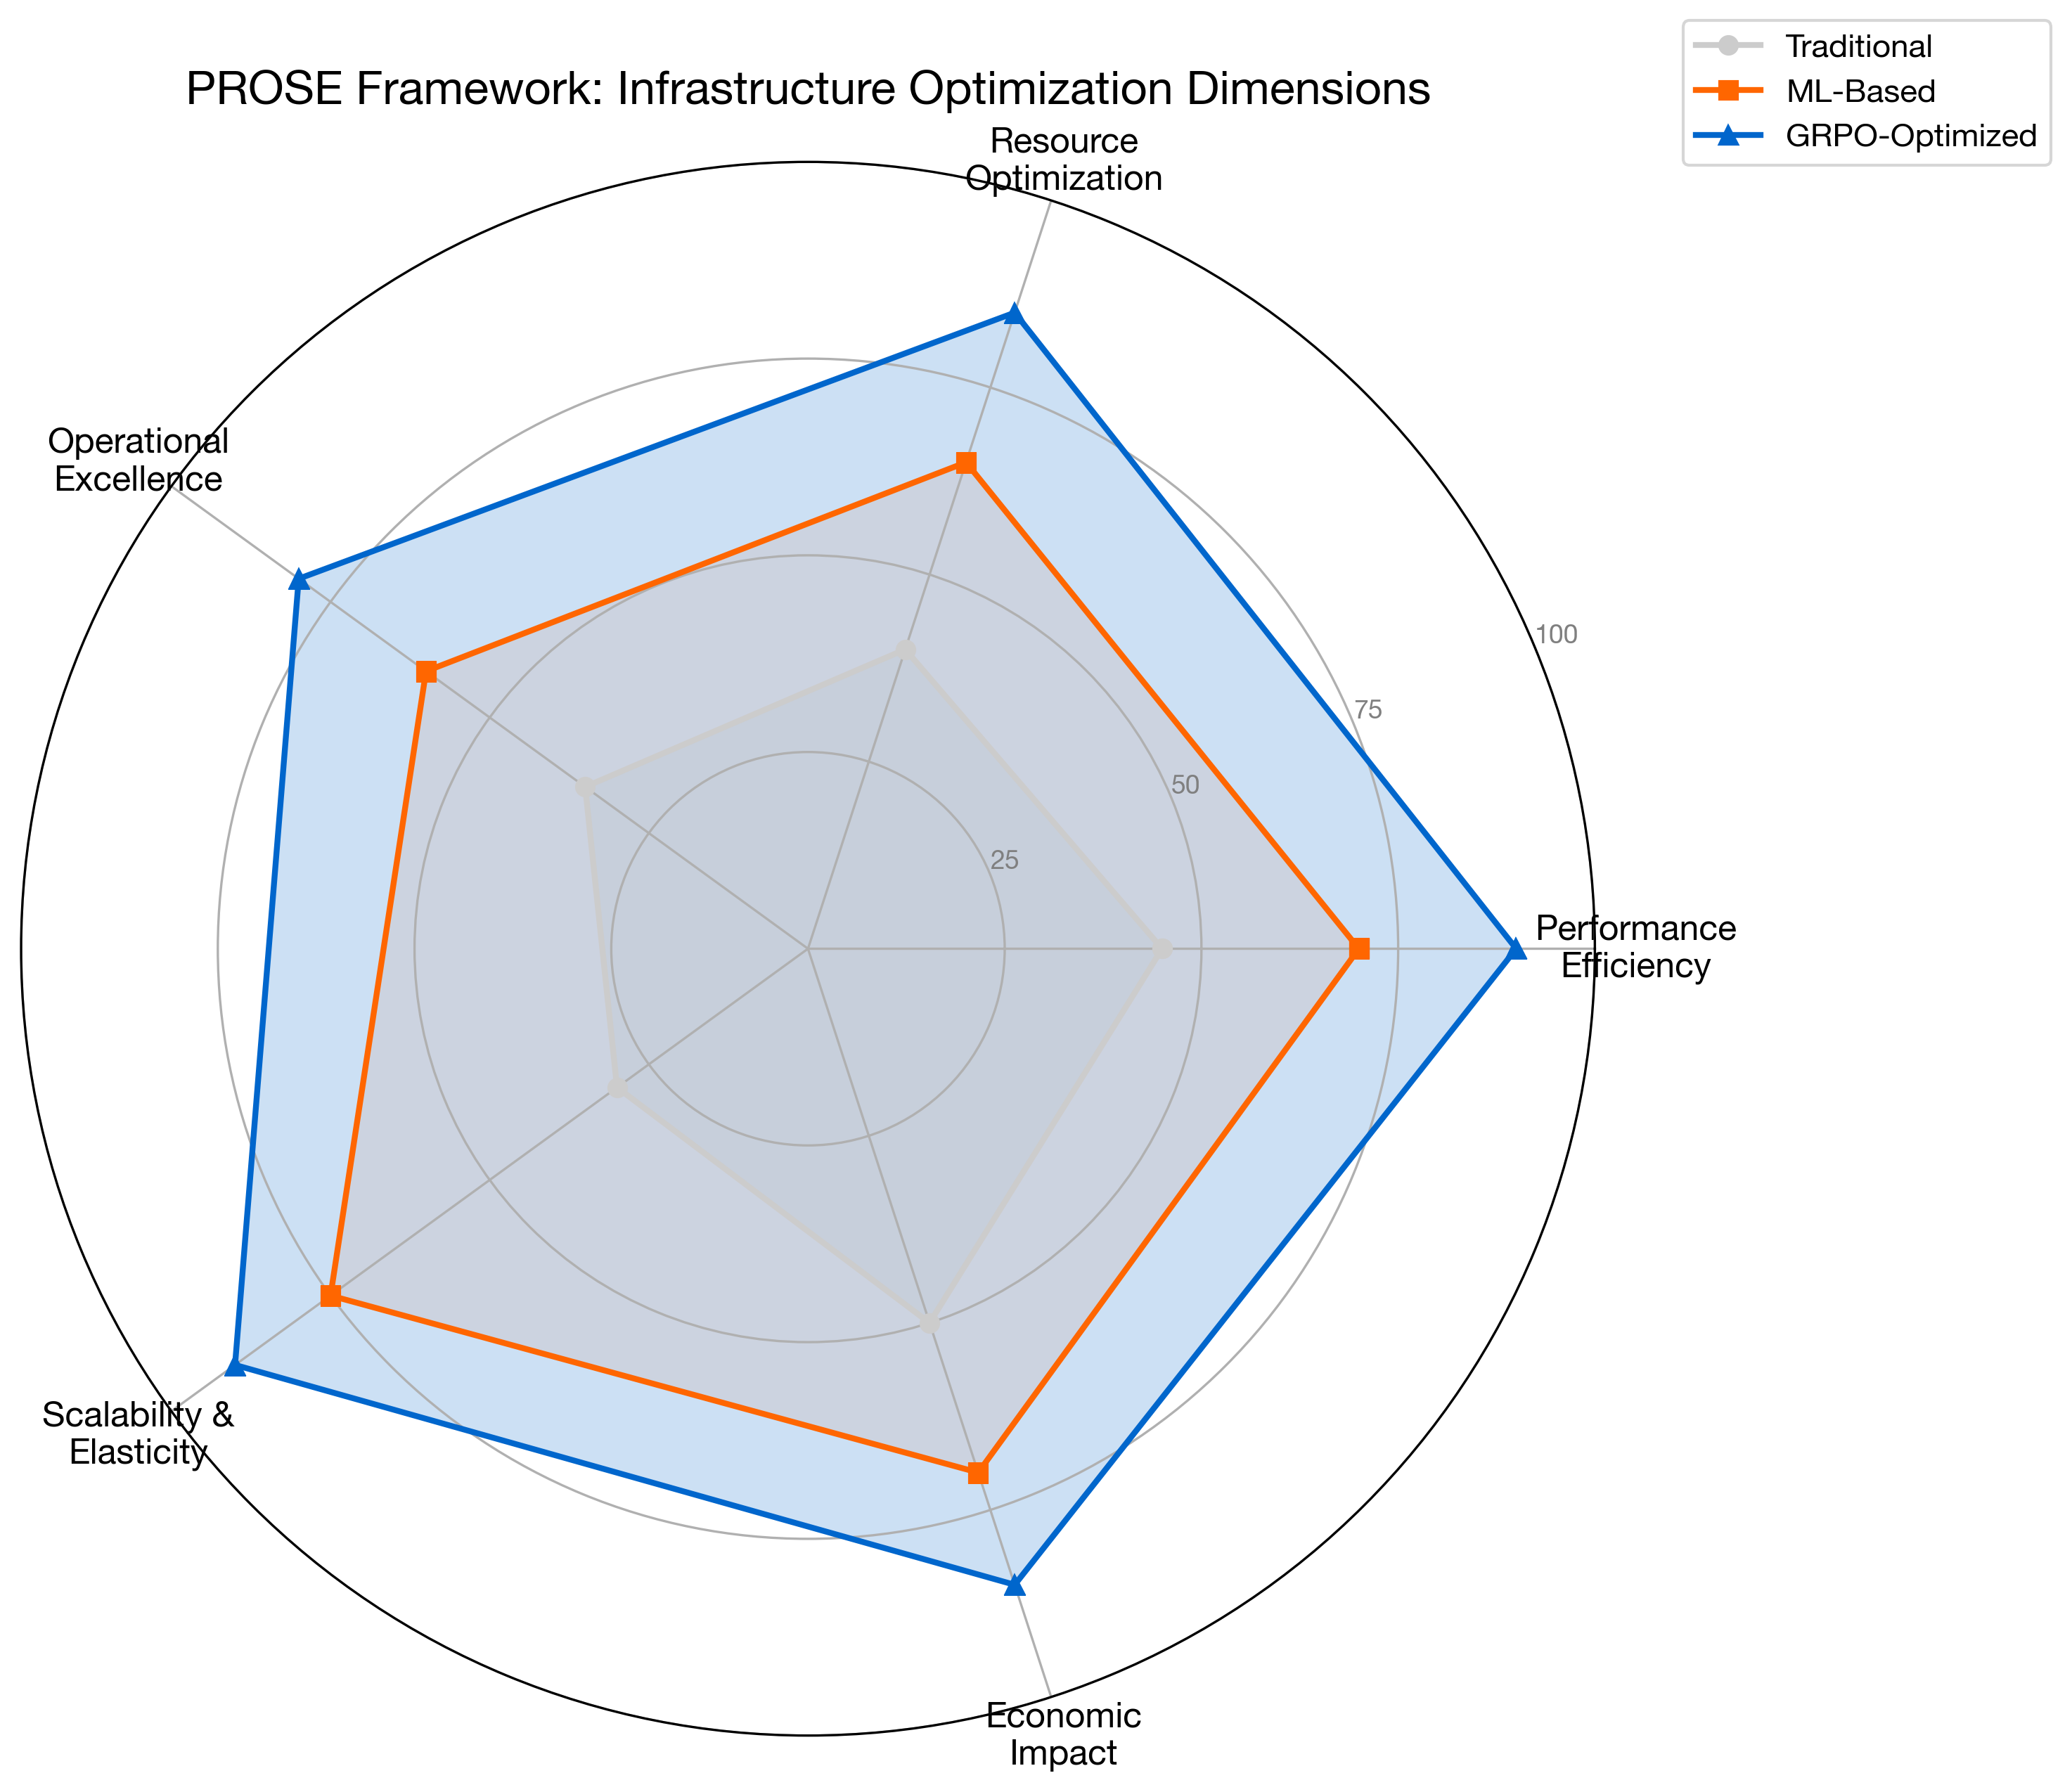
Figure 3.1: Infrastructure Optimization Dimensions
Figure 3.1: The Five Dimensions of Infrastructure Optimization

3.2 The PROSE Framework
We propose the PROSE Framework for comprehensive infrastructure evaluation:
- Performance Efficiency
- Resource Optimization
- Operational Excellence
- Scalability & Elasticity
- Economic Impact

3.2.1 Performance Efficiency
Performance efficiency measures how well the system delivers value to end users.
Key Metrics:
Metric | Definition | Target Range
P50 Latency | Median response time | < 100ms for interactive
P99 Latency | 99th percentile response time | < 500ms for interactive
Throughput | Requests processed per second | Workload-dependent
Error Rate | Failed requests / total requests | < 0.1%
Latency Consistency | Std dev of response times | Low variance preferred
Measurement Approach:
def calculate_performance_score(metrics):
"""
Calculate composite performance efficiency score.
Args:
metrics: Dict containing latency, throughput, error_rate
Returns:
Score between 0-100
"""
latency_score = max(0, 100 - (metrics['p99_latency_ms'] / 10))
throughput_score = min(100, (metrics['throughput'] / metrics['target_throughput']) * 100)
error_score = max(0, 100 - (metrics['error_rate'] * 1000))
# Weighted composite
return (latency_score * 0.4 + throughput_score * 0.35 + error_score * 0.25)

3.2.2 Resource Optimization
Resource optimization assesses how efficiently infrastructure resources are utilized.
Key Metrics:
Metric | Definition | Optimal Range
CPU Utilization Efficiency | Useful work / total CPU time | 60-80%
Memory Utilization | Active memory / allocated memory | 70-85%
Network Efficiency | Payload bytes / total bytes | > 90%
Storage IOPS Efficiency | Useful IOPS / provisioned IOPS | > 70%
Container Density | Workloads per node | Maximize within limits
The Utilization-Performance Curve:
Resources exhibit non-linear behavior as utilization increases. The relationship between utilization and performance follows a characteristic curve:
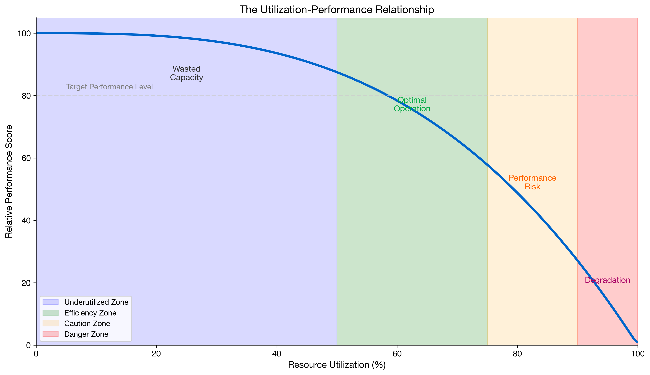
Figure 3.2: Utilization-Performance Curve
Figure 3.2: The Utilization-Performance Relationship
Optimal operation occurs in the “efficiency zone” where utilization is high enough to avoid waste but low enough to maintain performance headroom.

3.2.3 Operational Excellence
Operational excellence evaluates the human and process factors in infrastructure management.
Key Metrics:
Metric | Definition | Target
Mean Time to Detect (MTTD) | Time from incident start to detection | < 5 minutes
Mean Time to Resolve (MTTR) | Time from detection to resolution | < 30 minutes
Change Failure Rate | Failed changes / total changes | < 5%
Deployment Frequency | Successful deployments per week | High (continuous)
Automation Coverage | Automated tasks / total tasks | > 80%
Operational Maturity Model:
Level | Characteristics | Automation | Response
1 - Reactive | Manual monitoring, ticket-driven | < 20% | Hours
2 - Proactive | Threshold alerts, runbooks | 40-60% | Minutes
3 - Predictive | ML-based alerting, auto-remediation | 60-80% | Seconds
4 - Autonomous | Self-healing, continuous optimization | > 90% | Preemptive

3.2.4 Scalability & Elasticity
Scalability measures the system’s ability to handle growth; elasticity measures its ability to adapt to demand changes.
Key Metrics:
Metric | Definition | Target
Scale-up Time | Time to provision additional capacity | < 2 minutes
Scale-down Time | Time to release unused capacity | < 5 minutes
Scaling Accuracy | Actual demand met / predicted demand | > 95%
Burst Handling | Performance during 10x traffic spike | < 20% degradation
Cost Elasticity | Cost change / demand change ratio | Near 1.0
Elasticity Scoring:
def calculate_elasticity_score(scaling_events):
"""
Calculate elasticity score based on scaling behavior.
Args:
scaling_events: List of (demand_change, capacity_change, time_lag) tuples
Returns:
Elasticity score between 0-100
"""
scores = []
for demand_delta, capacity_delta, lag_seconds in scaling_events:
# Ideal: capacity matches demand with zero lag
accuracy = min(capacity_delta / demand_delta, 1.0) if demand_delta > 0 else 1.0
speed = max(0, 1 - (lag_seconds / 300)) # 5-minute baseline
scores.append(accuracy * 0.6 + speed * 0.4)
return sum(scores) / len(scores) * 100

3.2.5 Economic Impact
Economic impact quantifies the financial implications of infrastructure decisions.
Key Metrics:
Metric | Definition | Calculation
Cost per Transaction | Infrastructure cost / transactions | Direct division
Revenue per Infrastructure Dollar | Revenue / infrastructure cost | Higher is better
Waste Ratio | Idle resources / total resources | Lower is better
Optimization ROI | (Savings - Implementation Cost) / Implementation Cost | > 200% target
Total Cost of Ownership | Direct + indirect + opportunity costs | Comprehensive view
TCO Calculation Model:
TCO = Direct Costs + Operational Costs + Opportunity Costs
Where:
Direct Costs = Compute + Storage + Network + Licensing
Operational Costs = Personnel + Tools + Training + Incidents
Opportunity Costs = Downtime Revenue Loss + Performance Impact + Technical Debt

3.3 Benchmarking Methodologies

3.3.1 Controlled Benchmarks
Controlled benchmarks provide repeatable measurements under standardized conditions.
Standard Infrastructure Benchmarks:
Benchmark | Focus Area | Key Output
SPEC CPU | Compute performance | SPECrate, SPECspeed
TPC-C/TPC-E | Database transactions | Transactions per minute
YCSB | NoSQL databases | Operations per second
Fio | Storage I/O | IOPS, bandwidth, latency
wrk/hey | HTTP performance | Requests per second
Benchmark Design Principles:
- Reproducibility: Same inputs produce same outputs
- Isolation: Minimize external interference
- Representativeness: Workload reflects real usage
- Scalability: Can measure across different scales

3.3.2 Production Benchmarks
Production benchmarks measure real-world performance under actual conditions.
Approaches:
Method | Description | Trade-offs
Canary Analysis | Compare new vs. baseline in production | Real data, limited scope
Shadow Traffic | Replay production traffic to test systems | No user impact, resource cost
A/B Testing | Split traffic between configurations | Statistical rigor, complexity
Chaos Engineering | Inject failures to test resilience | Risk requires careful design
Canary Analysis Framework:
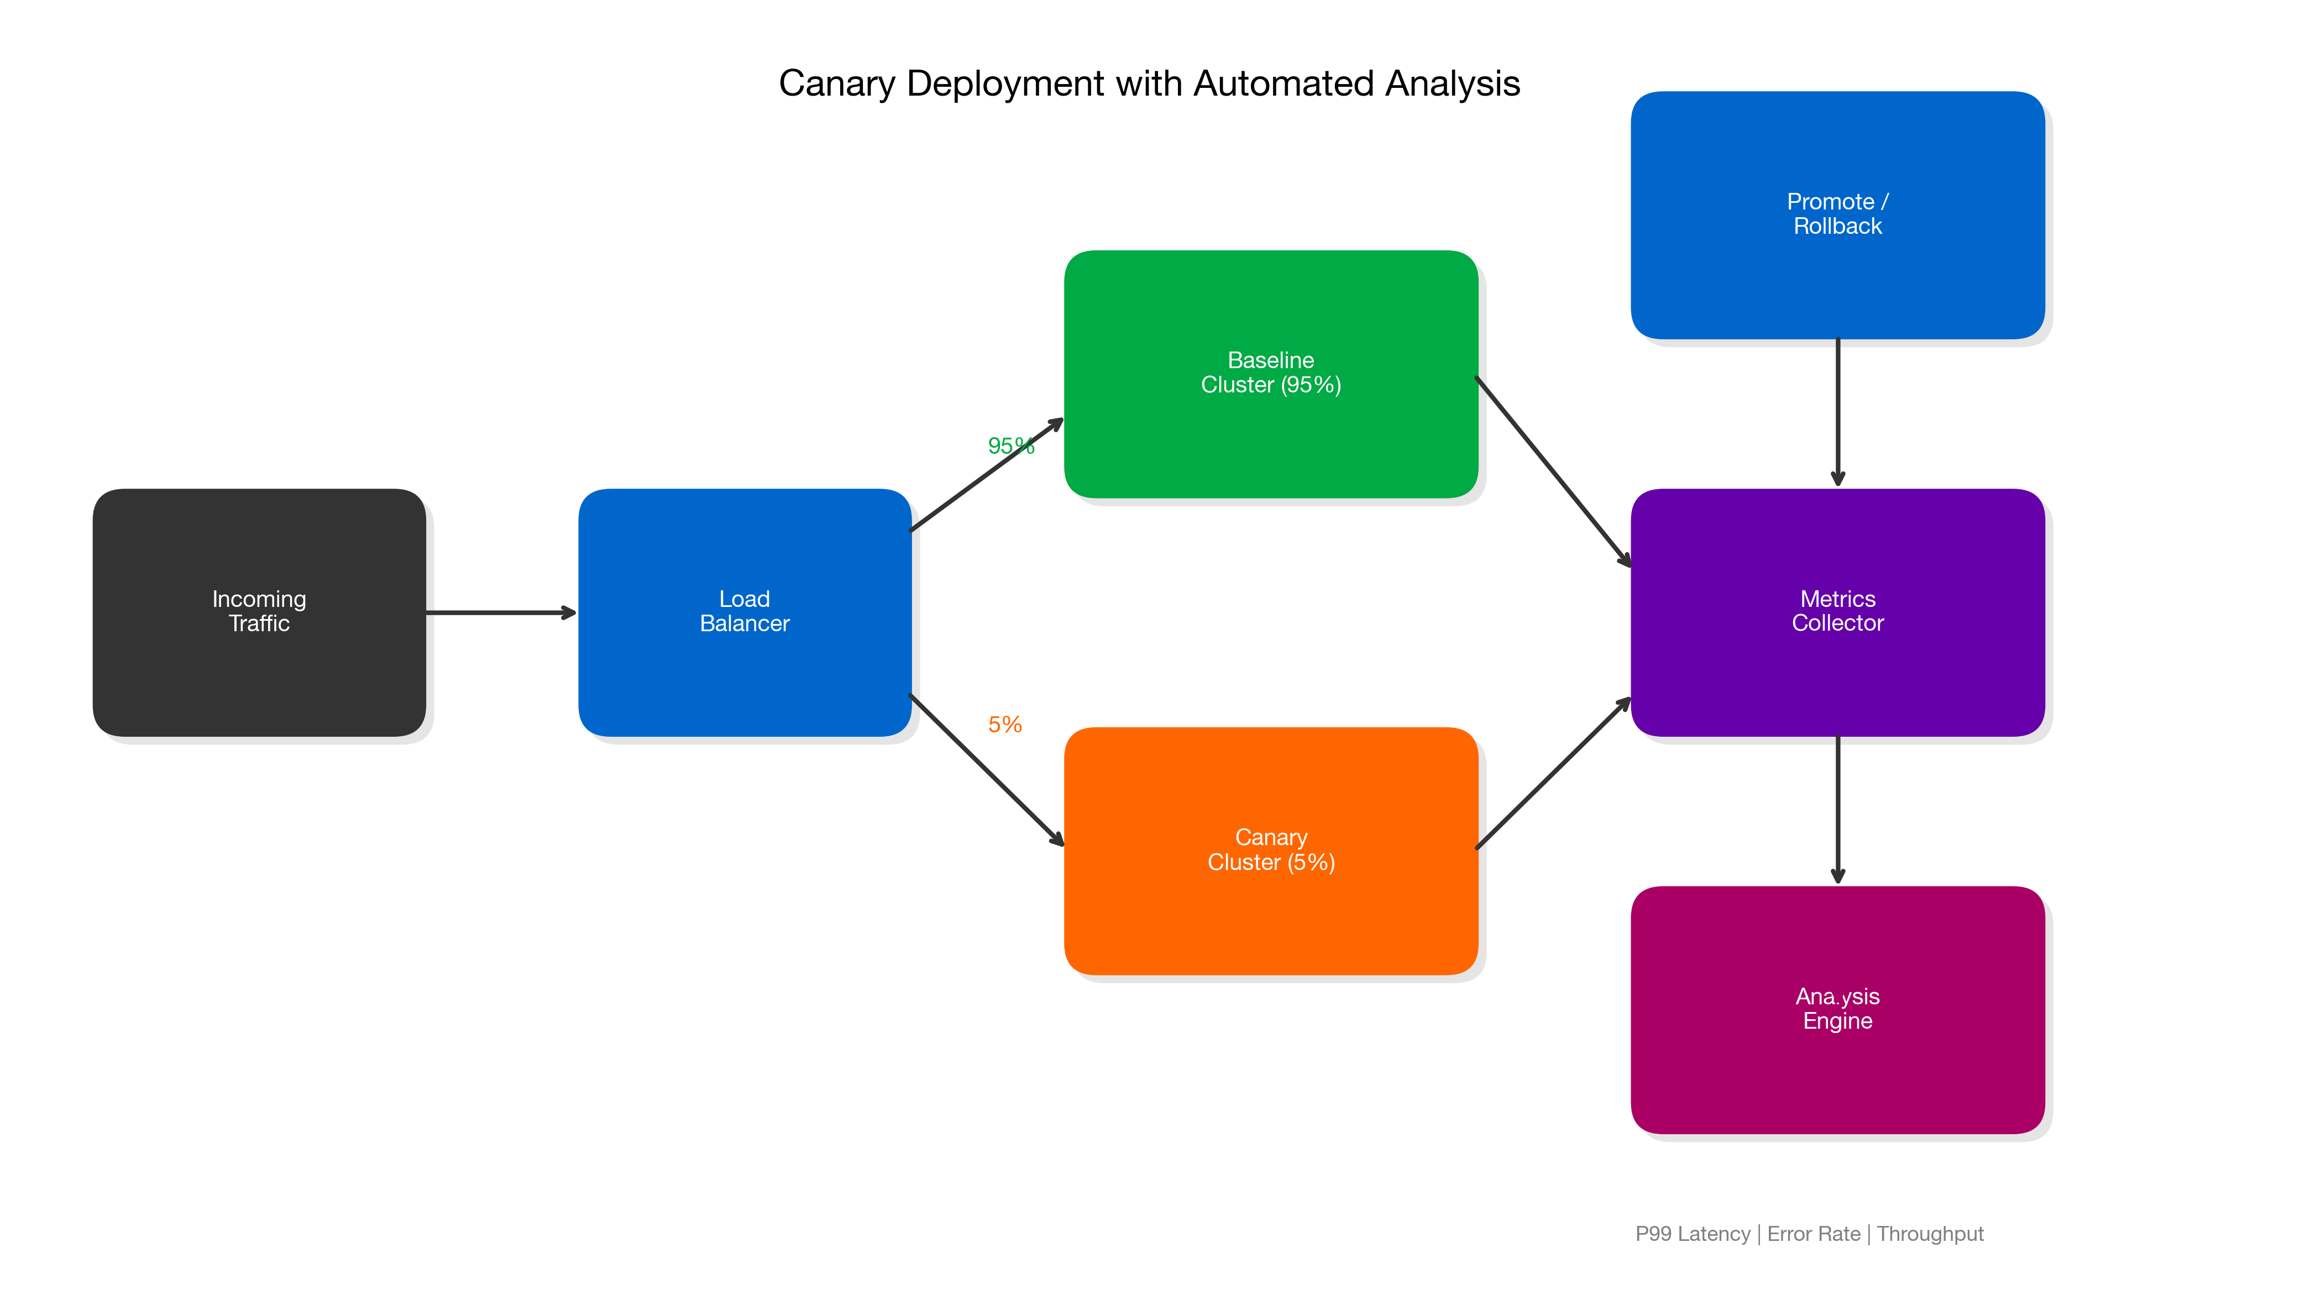
Figure 3.3: Canary Deployment Analysis
Figure 3.3: Canary Deployment with Automated Analysis

3.3.3 Comparative Analysis
When comparing optimization approaches, structure the analysis systematically:
Comparison Matrix Template:
Dimension | Approach A | Approach B | Approach C | Weight
Performance | Score 0-100 | Score 0-100 | Score 0-100 | 25%
Resource Efficiency | Score 0-100 | Score 0-100 | Score 0-100 | 20%
Operational Complexity | Score 0-100 | Score 0-100 | Score 0-100 | 20%
Scalability | Score 0-100 | Score 0-100 | Score 0-100 | 15%
Cost Impact | Score 0-100 | Score 0-100 | Score 0-100 | 20%
Weighted Total |  |  |  | 100%

3.4 Optimization Approach Comparison

3.4.1 Rule-Based vs. ML-Based Optimization
Criterion | Rule-Based | ML-Based
Setup Complexity | Low - define thresholds | High - requires training data
Adaptability | Static - manual updates | Dynamic - learns from data
Explainability | High - clear rules | Variable - depends on model
Edge Cases | Poor - only handles known scenarios | Better - generalizes patterns
Maintenance | High - rules proliferate | Medium - model retraining
Best For | Stable, predictable workloads | Dynamic, evolving workloads

3.4.2 Reactive vs. Predictive Scaling
Criterion | Reactive Scaling | Predictive Scaling
Response Time | Minutes (after threshold breach) | Preemptive (before demand)
Accuracy | High for steady state | Requires pattern learning
Over-provisioning | Common during uncertainty | Optimized based on forecasts
Cold Start Handling | Poor - always behind | Good - anticipates demand
Implementation | Simple threshold rules | ML models + forecasting
Best For | Unpredictable spikes | Patterns with seasonality

3.4.3 Traditional RL vs. GRPO for Infrastructure
Criterion | Traditional RL (PPO/A2C) | GRPO
Sample Efficiency | Lower - needs many episodes | Higher - relative comparisons
Variance | Higher gradient variance | Lower through group normalization
Convergence Speed | Slower | Faster
Exploration | Requires explicit strategy | Built into group sampling
Infrastructure Suitability | Challenging - costly exploration | Better - efficient learning
Best For | Simulated environments | Production optimization
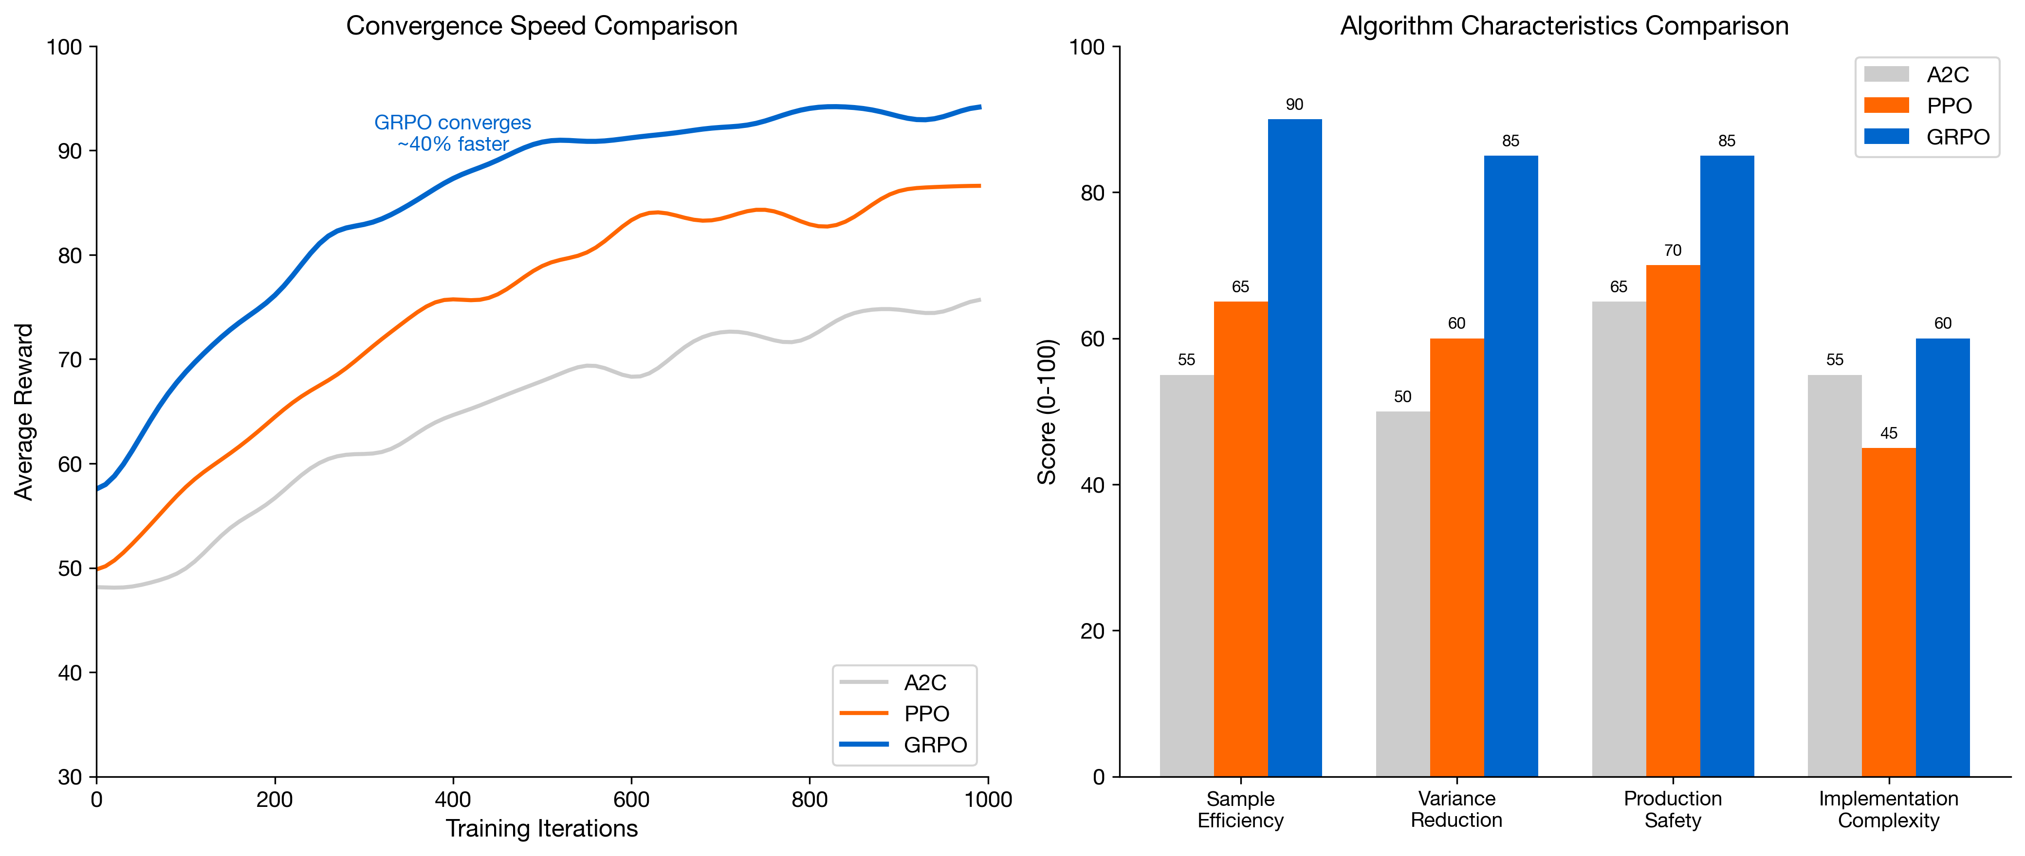
Figure 3.4: RL Algorithm Comparison
Figure 3.4: Reinforcement Learning Approaches for Infrastructure

3.5 Industry-Specific Evaluation Criteria
Different industries weight the PROSE dimensions differently based on their unique requirements:

3.5.1 E-Commerce Weighting
Dimension | Weight | Rationale
Performance | 30% | User experience directly impacts conversion
Resource Optimization | 15% | Important but secondary to availability
Operational Excellence | 20% | Fast recovery during peak seasons
Scalability | 25% | Must handle flash sales, viral events
Economic Impact | 10% | Revenue growth often trumps cost optimization

3.5.2 Financial Services Weighting
Dimension | Weight | Rationale
Performance | 25% | Low latency for trading, transactions
Resource Optimization | 15% | Compliance may require over-provisioning
Operational Excellence | 30% | Regulatory requirements, audit trails
Scalability | 15% | More predictable than e-commerce
Economic Impact | 15% | Cost matters but reliability is paramount

3.5.3 Healthcare Weighting
Dimension | Weight | Rationale
Performance | 20% | Important but not ultra-low latency
Resource Optimization | 15% | Budget constraints in healthcare
Operational Excellence | 35% | Patient safety, data integrity
Scalability | 10% | Generally more predictable demand
Economic Impact | 20% | Cost containment is major industry focus
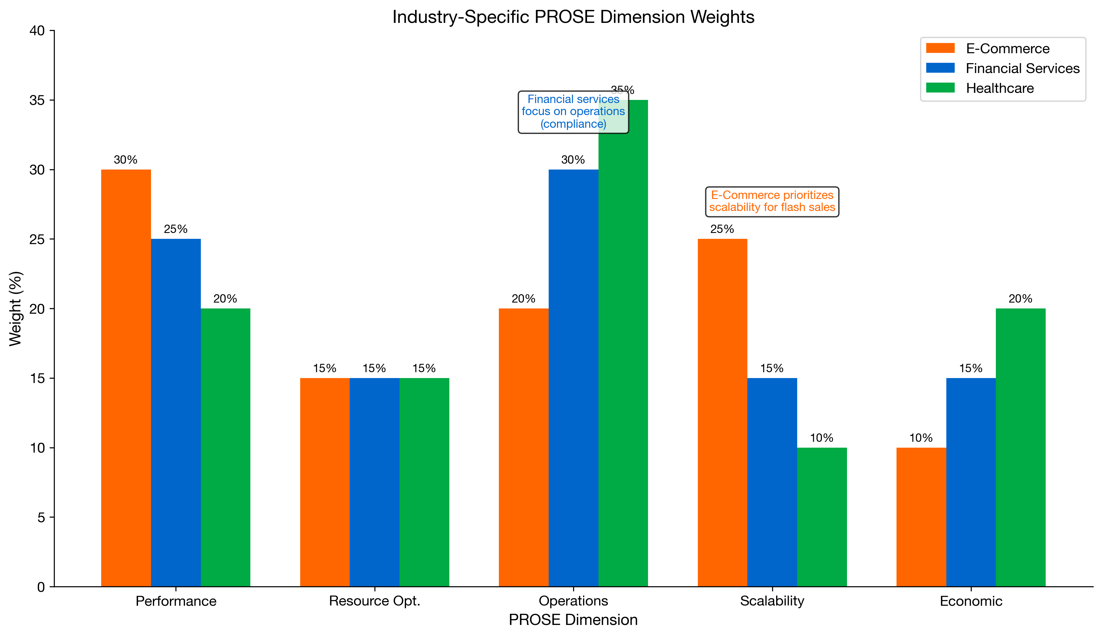
Figure 3.5: Industry Weighting Comparison
Figure 3.5: PROSE Dimension Weights by Industry

3.6 Building Your Evaluation Practice

3.6.1 Establishing Baselines
Before evaluating optimization approaches, establish clear baselines:
- Current State Assessment
  - Document existing metrics across all PROSE dimensions
  - Identify measurement gaps and instrumentation needs
  - Establish data collection pipelines
- Baseline Period Selection
  - Choose representative time periods
  - Include both typical and peak periods
  - Account for seasonality and trends
- Baseline Documentation
  - Record infrastructure configurations
  - Document workload characteristics
  - Capture cost structures

3.6.2 Running Evaluations
Evaluation Checklist:
- Define success criteria before testing
- Ensure statistically significant sample sizes
- Control for external variables
- Document all configuration changes
- Monitor for unintended side effects
- Capture both quantitative and qualitative data
- Include rollback procedures

3.6.3 Interpreting Results
When analyzing evaluation results:
- Statistical Significance: Ensure differences aren’t due to random variation
- Practical Significance: A 5% improvement may not justify implementation complexity
- Trade-off Analysis: Improvements in one dimension may come at cost to others
- Long-term Sustainability: Short-term gains may not persist
- Operational Impact: Consider the burden on teams

3.7 Case Study: Applying the Framework
Consider a hypothetical evaluation of three auto-scaling approaches:
Scenario: E-commerce platform evaluating scaling strategies
Approach | Description
A: Threshold-based | Scale when CPU > 70%
B: Predictive (Prophet) | Forecast-based pre-scaling
C: RL-based (GRPO) | Learned optimal policy
Evaluation Results:
Metric | Approach A | Approach B | Approach C
P99 Latency (ms) | 450 | 280 | 195
Scale-up Time (s) | 180 | 45 | 30
Over-provisioning % | 35% | 18% | 12%
Monthly Cost | $48,000 | $42,000 | $38,500
Implementation Effort | Low | Medium | High
PROSE Score | 62 | 78 | 89
Recommendation: Approach C (GRPO) delivers the best overall performance but requires significant implementation investment. Approach B offers a strong middle ground for organizations not ready for full RL adoption.

Key Takeaways
- Multi-dimensional evaluation is essential - no single metric captures infrastructure optimization effectiveness
- The PROSE Framework provides comprehensive coverage: Performance, Resource optimization, Operational excellence, Scalability, Economic impact
- Benchmarking requires rigor - controlled benchmarks for comparison, production benchmarks for validation
- Industry context matters - weight dimensions according to your specific business requirements
- Baselines are foundational - you cannot measure improvement without a clear starting point
- Trade-offs are inevitable - the goal is informed decision-making, not perfection in every dimension

References
- Ousterhout, J. “Always Measure One Level Deeper.” Communications of the ACM (2018)
- Google Cloud. “The Four Golden Signals.” Site Reliability Engineering (2016)
- Sedgewick, R., Wayne, K. “Algorithms.” Princeton University (2011)
- Dean, J., Barroso, L. “The Tail at Scale.” Communications of the ACM (2013)
- Kim, G., et al. “The DevOps Handbook.” IT Revolution Press (2016)

Next Chapter: E-Commerce Infrastructure Optimization - Applying the Framework

