Chapter 5: Financial Services Infrastructure Optimization

Introduction
Financial services infrastructure operates under constraints that make it fundamentally different from other industries. Where e-commerce optimizes for conversion rates and user experience, financial services must optimize for regulatory compliance, ultra-low latency, absolute reliability, and complete auditability—often simultaneously. A single millisecond of latency in trading systems can cost millions; a single compliance violation can result in billions in fines.
This chapter applies the PROSE Framework to financial services, demonstrating how AI-driven optimization can address the unique challenges of banking, trading, and insurance infrastructure while maintaining the rigorous standards required by regulators.

5.1 The Financial Services Infrastructure Landscape

5.1.1 Unique Constraints
Financial services infrastructure operates under constraints that distinguish it from all other industries:
Constraint | Requirement | Impact
Regulatory compliance | SOX, PCI-DSS, GDPR, MiFID II | Every change requires audit trail
Ultra-low latency | Microsecond-level for trading | Specialized hardware, co-location
Zero data loss | RPO = 0 for transactions | Synchronous replication
High availability | 99.999% uptime (5.26 min/year) | Active-active architectures
Complete auditability | 7+ year retention | Immutable logging
Security | Defense in depth | Multiple security layers
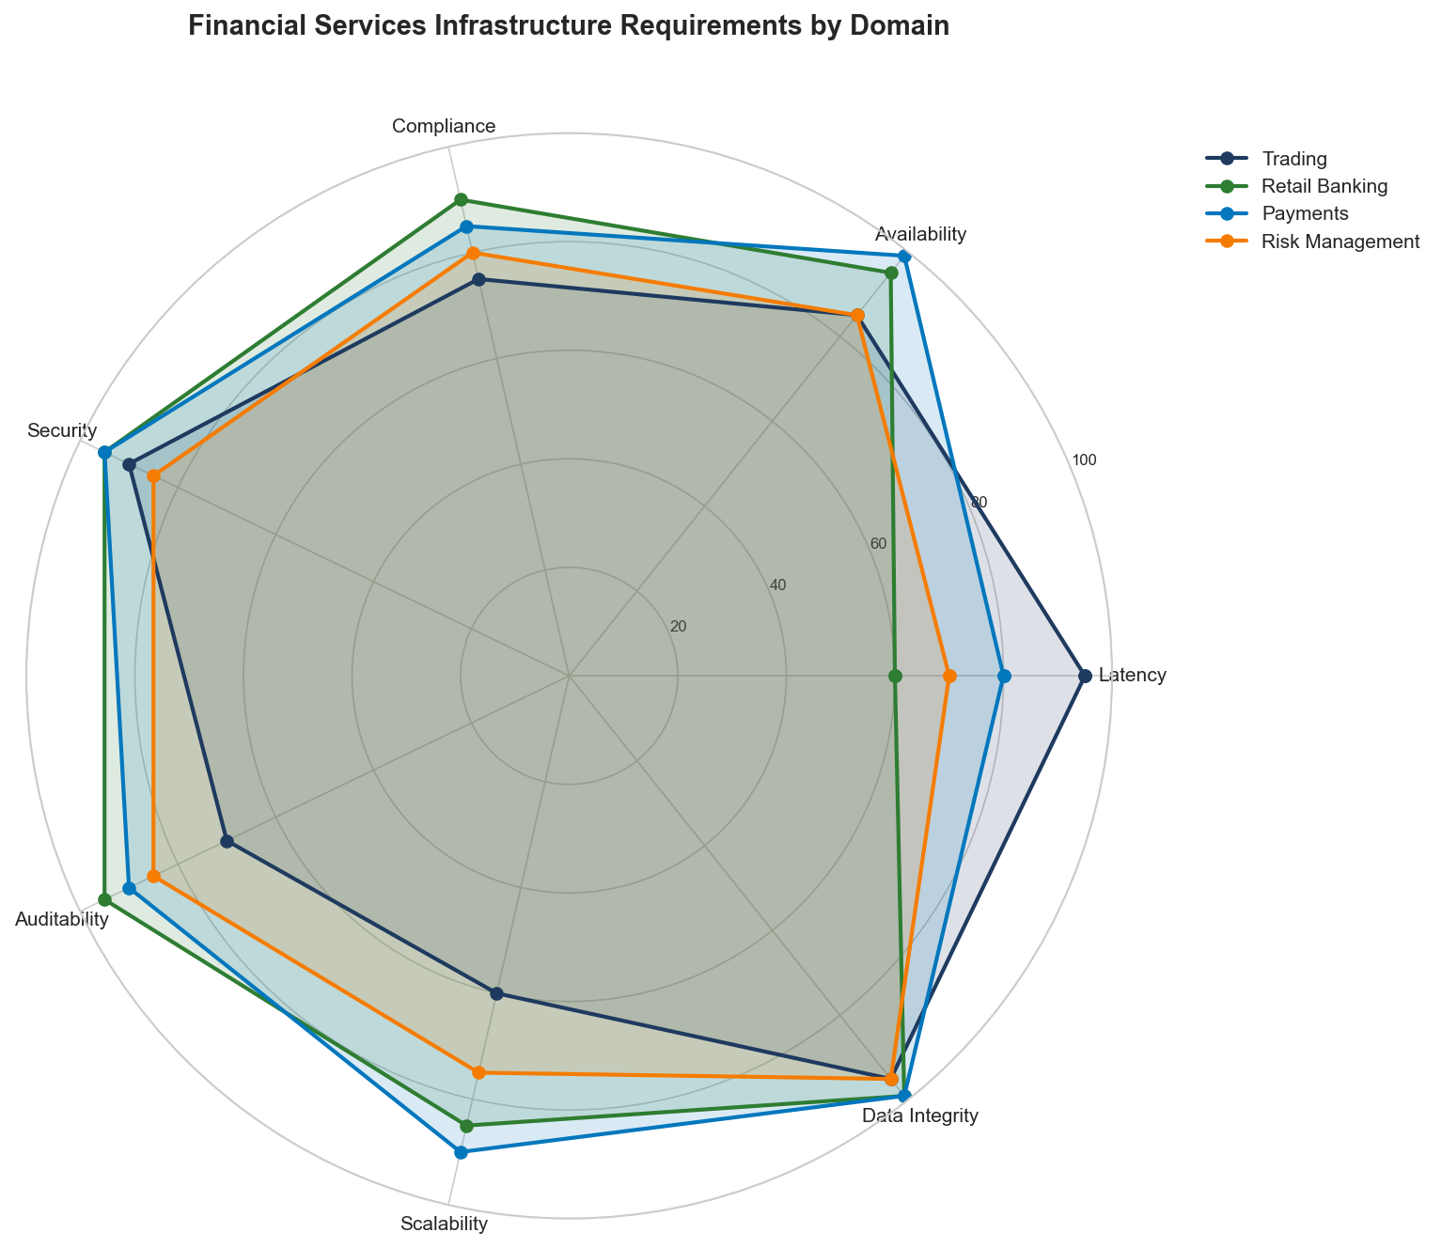
Figure 5.1: Financial Services Infrastructure Requirements
Figure 5.1: Financial Services Infrastructure Requirements by Domain

5.1.2 The Cost of Failure
Infrastructure failures in financial services have consequences beyond lost revenue:
Failure Type | Direct Cost | Indirect Cost
Trading system outage | $5-10M per hour | Market confidence, regulatory scrutiny
Data breach | $150-400 per record | Brand damage, customer churn
Compliance violation | $10M-$1B in fines | License risk, executive liability
Settlement failure | Transaction value + penalties | Counterparty relationships
Audit finding | Remediation costs | Increased oversight

5.1.3 Infrastructure Domains
Financial services infrastructure spans multiple specialized domains:
Domain | Latency Requirement | Availability | Key Challenge
High-Frequency Trading | < 10 microseconds | 99.99% | Latency consistency
Retail Banking | < 500ms | 99.999% | Scale + compliance
Payment Processing | < 100ms | 99.9999% | Fraud detection speed
Risk Management | < 5 seconds | 99.99% | Computational intensity
Regulatory Reporting | Batch (hours) | 99.9% | Data completeness

5.2 Applying the PROSE Framework to Financial Services

5.2.1 Financial Services PROSE Weighting
As introduced in Chapter 3, financial services weights the PROSE dimensions differently than other industries:
Dimension | Weight | Rationale
Performance | 25% | Critical for trading, important for banking
Resource Optimization | 15% | Compliance may require over-provisioning
Operational Excellence | 30% | Regulatory requirements, audit trails
Scalability | 15% | More predictable than e-commerce
Economic Impact | 15% | Cost matters but reliability is paramount

5.2.2 Performance Efficiency in Financial Services
Performance in financial services means different things across domains:
Trading Systems Performance:
Metric | Target | Measurement Method
Order-to-execution | < 50 microseconds | Hardware timestamping
Market data processing | < 5 microseconds | FPGA-based measurement
Risk calculation | < 1 millisecond | End-to-end tracing
Tick-to-trade | < 100 microseconds | Co-located measurement
Banking Systems Performance:
Metric | Target | Business Impact
Login latency | < 2 seconds | Customer satisfaction
Balance inquiry | < 500ms | Core banking responsiveness
Transfer initiation | < 1 second | Transaction completion
Statement generation | < 5 seconds | Self-service adoption
class FinancialPerformanceMonitor:
"""
Performance monitoring for financial systems with regulatory awareness.
"""
def __init__(self, metrics_client, audit_logger):
self.metrics = metrics_client
self.audit = audit_logger
self.sla_thresholds = {
"trading": {"p99_latency_us": 100, "availability": 0.9999},
"banking": {"p99_latency_ms": 500, "availability": 0.99999},
"payments": {"p99_latency_ms": 100, "availability": 0.999999}
}
def measure_transaction(
self,
transaction_type: str,
domain: str,
start_time_ns: int
) -> dict:
"""
Measure transaction performance with audit trail.
"""
end_time_ns = time.time_ns()
latency_us = (end_time_ns - start_time_ns) / 1000
# Record metric
self.metrics.histogram(
f"{domain}.transaction.latency",
latency_us,
tags={"type": transaction_type}
)
# Check SLA
threshold = self.sla_thresholds.get(domain, {})
sla_breach = False
if domain == "trading":
sla_breach = latency_us > threshold.get("p99_latency_us", float("inf"))
else:
sla_breach = latency_us / 1000 > threshold.get("p99_latency_ms", float("inf"))
# Audit log for compliance
self.audit.log({
"event": "transaction_measured",
"transaction_type": transaction_type,
"domain": domain,
"latency_us": latency_us,
"sla_breach": sla_breach,
"timestamp": datetime.utcnow().isoformat()
})
return {
"latency_us": latency_us,
"sla_breach": sla_breach,
"threshold": threshold
}

5.2.3 Operational Excellence for Compliance
Operational excellence in financial services centers on compliance and auditability:
Change Management Framework:
Change Type | Approval Required | Testing Required | Rollback Plan
Emergency fix | 1 approver + post-review | Smoke tests | Automated
Standard change | 2 approvers | Full regression | Documented
Major change | CAB + compliance | Full + penetration | Rehearsed
Infrastructure | CAB + security + compliance | Full + DR test | Blue-green
Audit Trail Requirements:
class ComplianceAuditLogger:
"""
Immutable audit logging for financial compliance.
"""
def __init__(self, storage_backend, encryption_key):
self.storage = storage_backend
self.encryption = encryption_key
self.hash_chain = None
def log(self, event: dict) -> str:
"""
Log event with cryptographic integrity.
Returns audit ID for reference.
"""
# Add metadata
event["_audit_id"] = str(uuid.uuid4())
event["_timestamp"] = datetime.utcnow().isoformat()
event["_source_ip"] = self._get_source_ip()
event["_user_id"] = self._get_current_user()
# Create hash chain for tamper detection
event_json = json.dumps(event, sort_keys=True)
event_hash = hashlib.sha256(event_json.encode()).hexdigest()
if self.hash_chain:
event["_previous_hash"] = self.hash_chain
event["_event_hash"] = event_hash
self.hash_chain = event_hash
# Encrypt sensitive fields
encrypted_event = self._encrypt_sensitive_fields(event)
# Write to immutable storage
self.storage.append(encrypted_event)
return event["_audit_id"]
def verify_integrity(self, start_audit_id: str, end_audit_id: str) -> bool:
"""
Verify hash chain integrity for audit period.
"""
events = self.storage.range(start_audit_id, end_audit_id)
previous_hash = None
for event in events:
if previous_hash and event.get("_previous_hash") != previous_hash:
return False
# Verify event hash
event_copy = {k: v for k, v in event.items() if not k.startswith("_")}
computed_hash = hashlib.sha256(
json.dumps(event_copy, sort_keys=True).encode()
).hexdigest()
if computed_hash != event["_event_hash"]:
return False
previous_hash = event["_event_hash"]
return True
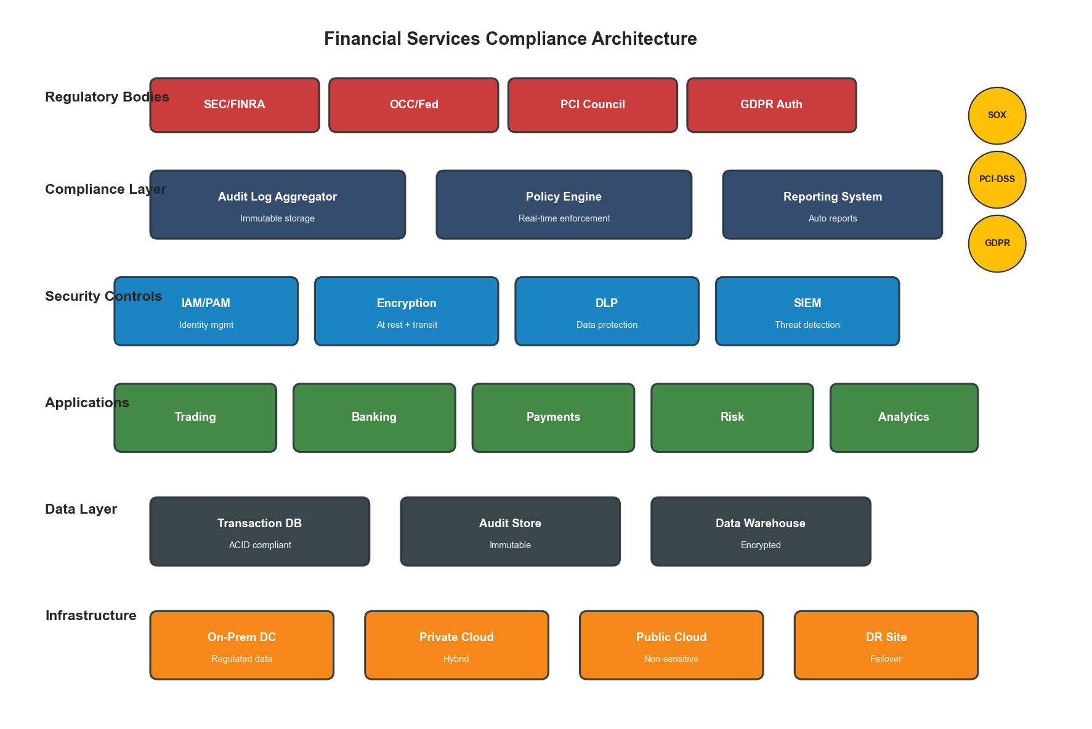
Figure 5.2: Compliance Architecture
Figure 5.2: Financial Services Compliance Architecture

5.2.4 Scalability with Compliance
Scaling financial systems requires maintaining compliance at every scale:
Scaling Constraints:
Constraint | Impact on Scaling | Mitigation
Data sovereignty | Cannot replicate across borders | Regional deployments
Audit requirements | Every instance must log | Centralized audit aggregation
Encryption in transit | Performance overhead | Hardware acceleration
Key management | Keys cannot be shared | Per-region key hierarchies
Change control | Cannot auto-scale freely | Pre-approved capacity pools
class CompliantAutoScaler:
"""
Auto-scaling with compliance guardrails.
"""
def __init__(self, orchestrator, compliance_checker, audit_logger):
self.orchestrator = orchestrator
self.compliance = compliance_checker
self.audit = audit_logger
self.approved_capacity_pool = {}
async def scale(
self,
service: str,
target_instances: int,
reason: str
) -> dict:
"""
Scale with compliance verification.
"""
current = await self.orchestrator.get_instance_count(service)
# Pre-flight compliance check
compliance_result = await self.compliance.check_scaling(
service=service,
current=current,
target=target_instances
)
if not compliance_result["approved"]:
self.audit.log({
"event": "scaling_blocked",
"service": service,
"reason": compliance_result["reason"],
"current": current,
"requested": target_instances
})
return {"success": False, "reason": compliance_result["reason"]}
# Check pre-approved capacity
available_capacity = self.approved_capacity_pool.get(service, 0)
if target_instances > current + available_capacity:
# Request emergency capacity approval
approval = await self._request_emergency_approval(
service, target_instances - current - available_capacity
)
if not approval["granted"]:
return {"success": False, "reason": "capacity_not_approved"}
# Execute scaling
result = await self.orchestrator.scale(service, target_instances)
# Audit the scaling action
self.audit.log({
"event": "scaling_executed",
"service": service,
"previous": current,
"target": target_instances,
"reason": reason,
"compliance_check_id": compliance_result["check_id"]
})
return {"success": True, "new_count": target_instances}

5.2.5 Economic Impact in Regulated Environments
Cost optimization in financial services must account for compliance overhead:
Total Cost Model:
Financial TCO = Infrastructure + Compliance + Risk
Where:
Infrastructure = Compute + Storage + Network + Licensing
Compliance = Audit systems + Security tools + Compliance staff + Certification
Risk = (Probability of breach × Cost) + (Probability of outage × Cost)
Cost Component | Typical % of IT Budget | Optimization Potential
Infrastructure | 40-50% | 20-30% through optimization
Compliance tooling | 15-20% | 10-15% through automation
Security | 10-15% | Limited (cannot reduce)
Staff (compliance) | 15-20% | 30-40% through automation
Audit/certification | 5-10% | 20-30% through continuous compliance

5.3 Low-Latency Trading Infrastructure

5.3.1 The Latency Arms Race
Modern trading systems measure latency in microseconds and nanoseconds:
Component | Typical Latency | Optimized Latency
Network (co-located) | 50-100 microseconds | 5-10 microseconds
Application logic | 100-500 microseconds | 10-50 microseconds
Market data parsing | 10-50 microseconds | 1-5 microseconds
Order validation | 20-100 microseconds | 5-20 microseconds
Risk check | 50-200 microseconds | 10-50 microseconds
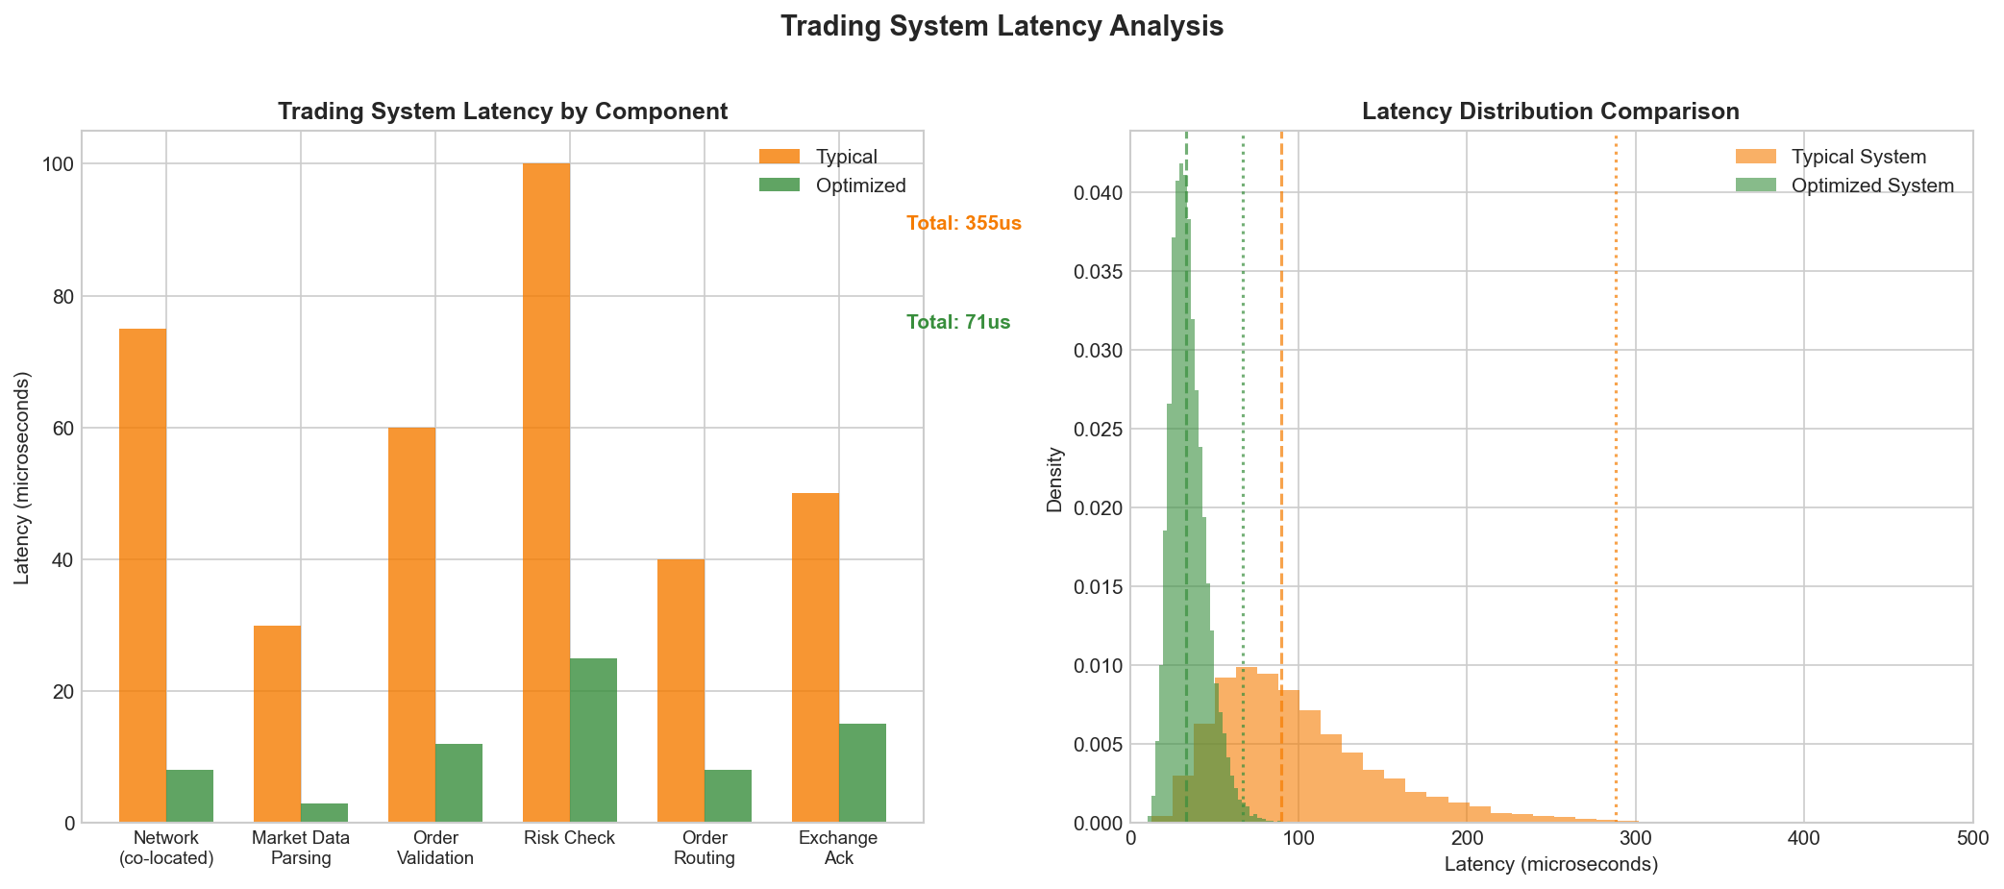
Figure 5.3: Trading System Latency Breakdown
Figure 5.3: Trading System Latency Components

5.3.2 Hardware-Software Co-Design
Ultra-low latency requires thinking about hardware and software together:
Hardware Optimizations:
Technique | Latency Reduction | Implementation
FPGA-based processing | 10-100x | Market data, order routing
Kernel bypass (DPDK) | 5-10x | Network stack
CPU pinning | 2-5x | Eliminate context switches
NUMA awareness | 2-3x | Memory locality
SR-IOV | 3-5x | Direct NIC access
Software Architecture for Low Latency:
class LowLatencyOrderRouter:
"""
Order routing optimized for microsecond latency.
Design principles:
- Lock-free data structures
- Pre-allocated memory pools
- Zero-copy message passing
- Busy-polling (no blocking)
"""
def __init__(self, config):
# Pre-allocate order pool to avoid allocation latency
self.order_pool = self._preallocate_orders(config.pool_size)
self.order_pool_index = 0
# Lock-free queue for incoming orders
self.incoming_queue = SPSCQueue(config.queue_size)
# Pre-computed routing tables
self.routing_table = self._build_routing_table(config.venues)
# Pin to specific CPU core
self._pin_to_core(config.cpu_core)
def route_order(self, order_data: bytes) -> int:
"""
Route order with minimal latency.
Returns order ID.
"""
# Get pre-allocated order (no malloc)
order = self.order_pool[self.order_pool_index]
self.order_pool_index = (self.order_pool_index + 1) % len(self.order_pool)
# Parse directly into pre-allocated structure (zero-copy)
order.parse_from_bytes(order_data)
# Lookup routing (pre-computed, O(1))
venue = self.routing_table[order.symbol_id]
# Send via kernel bypass
venue.send_order_dpdk(order)
return order.order_id
def _pin_to_core(self, core_id: int):
"""Pin this thread to a specific CPU core."""
os.sched_setaffinity(0, {core_id})
# Set real-time scheduling priority
param = os.sched_param(os.sched_get_priority_max(os.SCHED_FIFO))
os.sched_setscheduler(0, os.SCHED_FIFO, param)

5.3.3 Market Data Infrastructure
Processing market data at scale requires specialized infrastructure:
Data Type | Volume | Processing Requirement
Level 1 quotes | 1-5M messages/sec | Real-time display
Level 2 depth | 10-50M messages/sec | Order book reconstruction
Trade prints | 500K-2M messages/sec | Trade analytics
Options chains | 100M+ symbols | Greeks calculation
class MarketDataProcessor:
"""
High-performance market data processing.
"""
def __init__(self, config):
self.parser = FPGAMarketDataParser(config.fpga_device)
self.book_builder = LockFreeOrderBook()
self.subscribers = SubscriberRegistry()
def process_feed(self, raw_data: memoryview):
"""
Process market data with FPGA acceleration.
Uses memory-mapped I/O for zero-copy processing.
"""
# FPGA parses and normalizes in hardware
parsed_messages = self.parser.parse_batch(raw_data)
for msg in parsed_messages:
if msg.type == MessageType.QUOTE:
self._handle_quote(msg)
elif msg.type == MessageType.TRADE:
self._handle_trade(msg)
elif msg.type == MessageType.DEPTH:
self._handle_depth_update(msg)
def _handle_depth_update(self, msg):
"""Update order book and notify subscribers."""
# Lock-free update
self.book_builder.apply_update(
msg.symbol,
msg.side,
msg.price,
msg.quantity
)
# Fan-out to subscribers (also lock-free)
self.subscribers.notify(msg.symbol, self.book_builder.get_book(msg.symbol))

5.4 Banking Infrastructure Optimization

5.4.1 Core Banking Architecture
Modern core banking systems must balance legacy integration with modern performance:
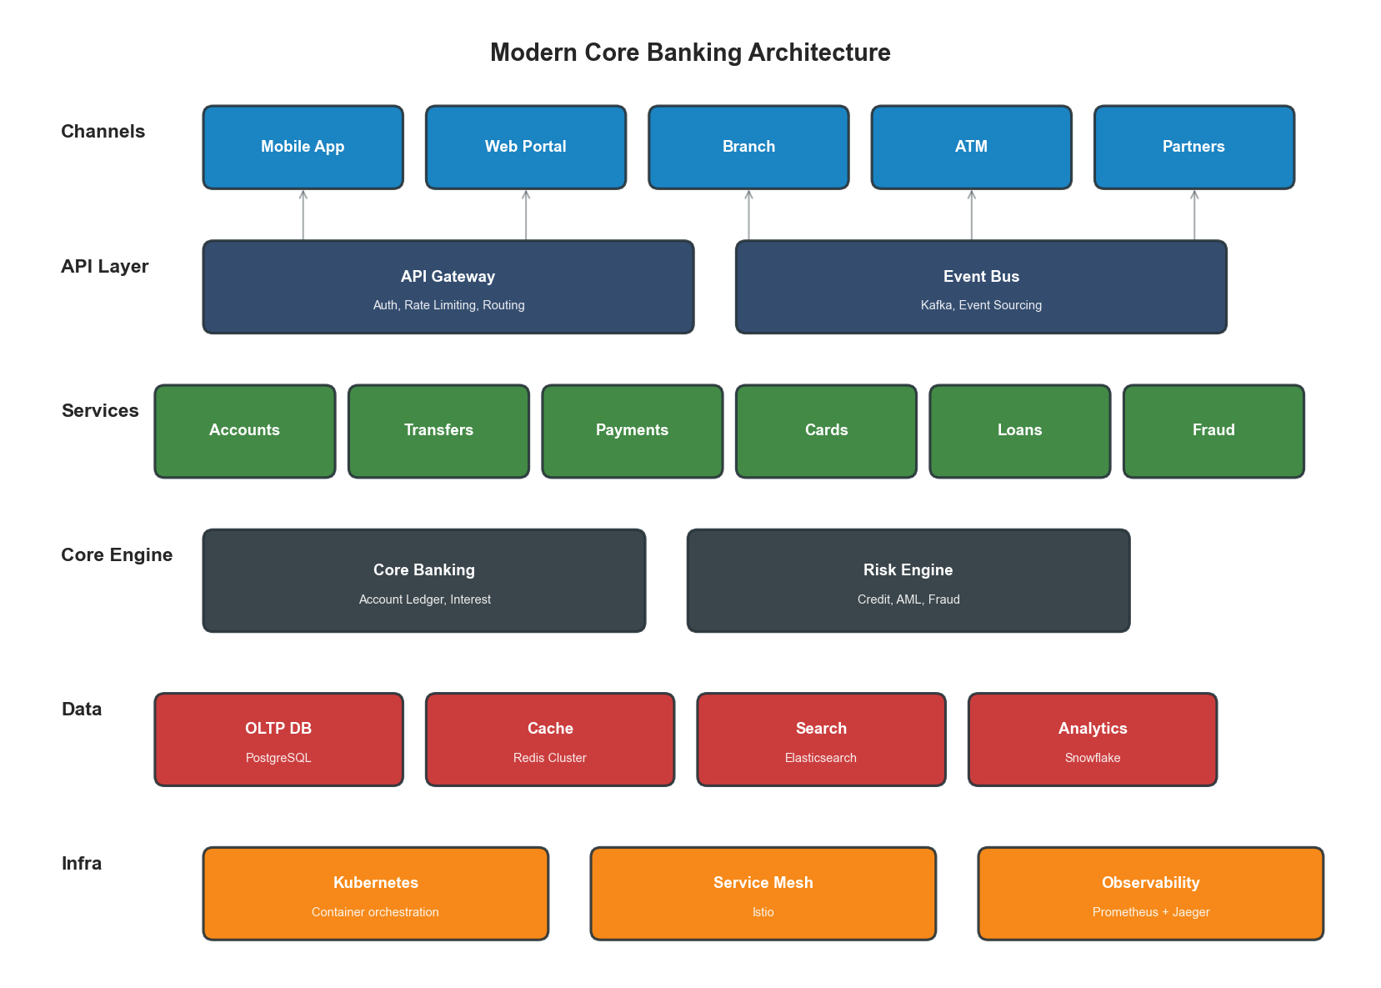
Figure 5.4: Core Banking Architecture
Figure 5.4: Modern Core Banking Architecture Layers
Architecture Layers:
Layer | Function | Technology Options
Channel | Customer touchpoints | Mobile, web, branch, ATM
API Gateway | Security, routing | Kong, Apigee, custom
Microservices | Business logic | Java, Go, .NET
Core Banking | Account management | Temenos, Finacle, custom
Data Layer | Persistence | Oracle, PostgreSQL, distributed

5.4.2 Transaction Processing
Financial transaction processing requires ACID guarantees with high throughput:
class TransactionProcessor:
"""
ACID-compliant transaction processing.
"""
def __init__(self, db_pool, audit_logger, fraud_detector):
self.db = db_pool
self.audit = audit_logger
self.fraud = fraud_detector
async def process_transfer(
self,
from_account: str,
to_account: str,
amount: Decimal,
currency: str,
idempotency_key: str
) -> dict:
"""
Process fund transfer with full compliance.
"""
# Check idempotency (prevent duplicate processing)
existing = await self._check_idempotency(idempotency_key)
if existing:
return existing
# Pre-transaction fraud check
fraud_result = await self.fraud.check_transaction({
"from": from_account,
"to": to_account,
"amount": float(amount),
"currency": currency
})
if fraud_result["blocked"]:
self.audit.log({
"event": "transaction_blocked",
"reason": "fraud_detection",
"details": fraud_result
})
return {"success": False, "reason": "transaction_blocked"}
# Execute with distributed transaction
async with self.db.transaction() as txn:
try:
# Debit source account
debit_result = await txn.execute("""
UPDATE accounts
SET balance = balance - $1,
last_transaction = NOW()
WHERE account_id = $2
AND balance >= $1
AND status = 'active'
RETURNING balance
""", amount, from_account)
if not debit_result:
raise InsufficientFundsError()
# Credit destination account
await txn.execute("""
UPDATE accounts
SET balance = balance + $1,
last_transaction = NOW()
WHERE account_id = $2
AND status = 'active'
""", amount, to_account)
# Record transaction
txn_id = await txn.execute("""
INSERT INTO transactions
(from_account, to_account, amount, currency, status, idempotency_key)
VALUES ($1, $2, $3, $4, 'completed', $5)
RETURNING transaction_id
""", from_account, to_account, amount, currency, idempotency_key)
# Commit
await txn.commit()
# Audit log (after commit for consistency)
self.audit.log({
"event": "transfer_completed",
"transaction_id": txn_id,
"from": from_account,
"to": to_account,
"amount": str(amount),
"currency": currency
})
return {"success": True, "transaction_id": txn_id}
except Exception as e:
await txn.rollback()
self.audit.log({
"event": "transfer_failed",
"error": str(e),
"from": from_account,
"to": to_account
})
raise

5.4.3 High Availability Patterns
Banking systems require extreme availability:
Pattern | RTO | RPO | Use Case
Active-Active | 0 | 0 | Payment processing
Active-Passive (sync) | < 1 min | 0 | Core banking
Active-Passive (async) | < 5 min | < 1 min | Batch systems
Multi-region active | 0 | < 1 sec | Global banking
Active-Active Implementation:
class ActiveActiveRouter:
"""
Route requests across active-active data centers.
"""
def __init__(self, dc_configs: list):
self.datacenters = [DataCenter(cfg) for cfg in dc_configs]
self.consistency_checker = ConsistencyChecker()
async def route_request(self, request: Request) -> Response:
"""
Route with conflict detection and resolution.
"""
# Determine primary DC based on account affinity
primary_dc = self._get_affinity_dc(request.account_id)
secondary_dc = self._get_secondary_dc(primary_dc)
try:
# Execute on primary
response = await primary_dc.execute(request)
# Async replicate to secondary
asyncio.create_task(
self._replicate_to_secondary(secondary_dc, request, response)
)
return response
except DataCenterUnavailable:
# Failover to secondary
self.audit.log({
"event": "dc_failover",
"primary": primary_dc.name,
"secondary": secondary_dc.name
})
response = await secondary_dc.execute(request)
# Mark for reconciliation when primary recovers
await self._mark_for_reconciliation(primary_dc, request)
return response

5.5 Real-Time Risk Management

5.5.1 Risk Calculation Infrastructure
Real-time risk management requires massive computational power:
Risk Type | Calculation Complexity | Latency Requirement
Pre-trade risk | O(1) lookups | < 1 millisecond
Position risk | O(n) portfolio | < 100 milliseconds
VaR (Value at Risk) | O(n*m) simulations | < 5 seconds
Stress testing | O(nms) scenarios | Minutes to hours
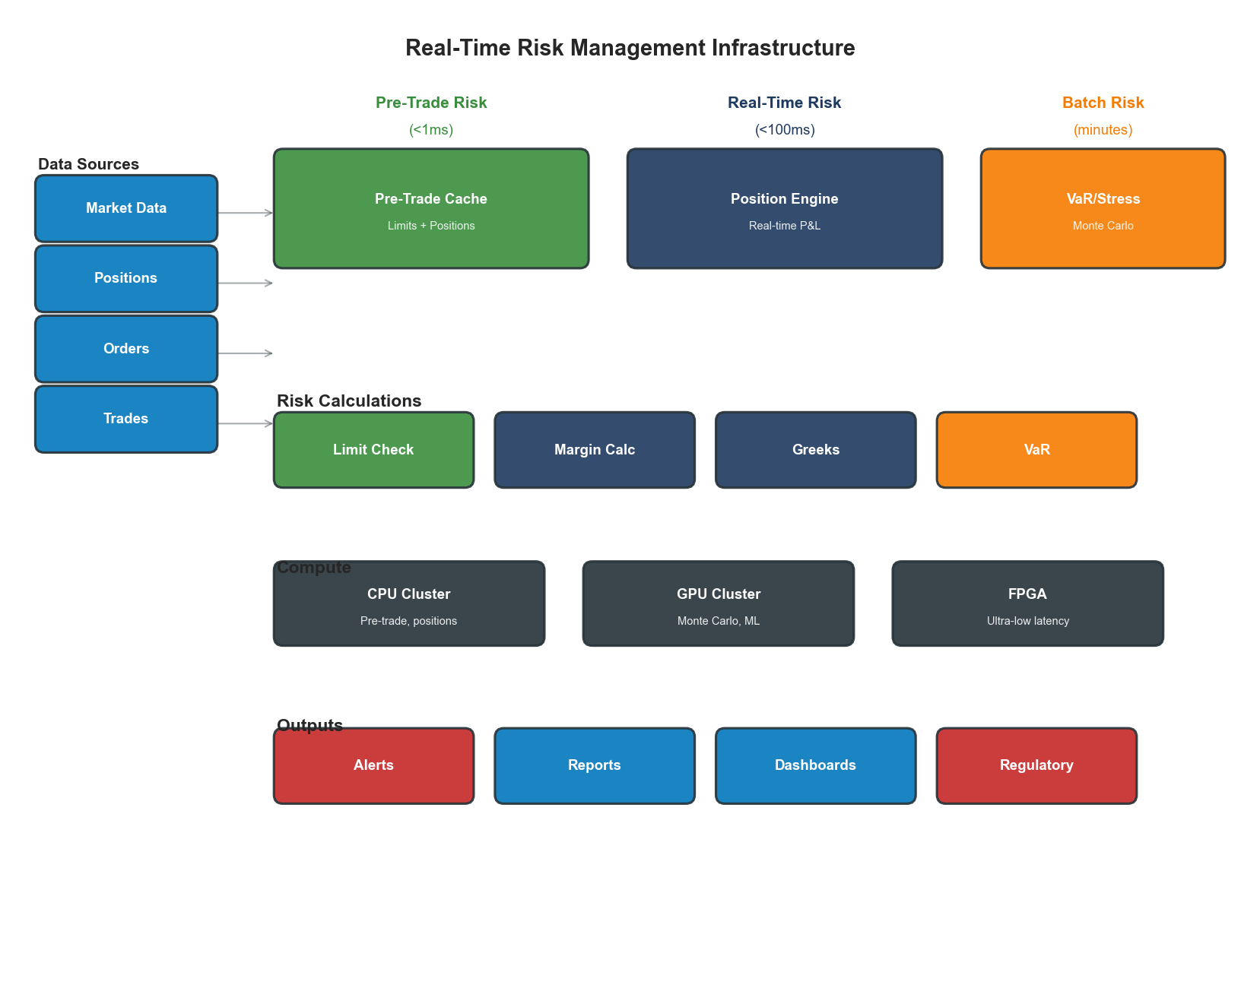
Figure 5.5: Risk Management Architecture
Figure 5.5: Real-Time Risk Management Infrastructure
class RealTimeRiskEngine:
"""
Real-time risk calculation with tiered architecture.
"""
def __init__(self, config):
self.pre_trade_cache = PreTradeRiskCache()
self.position_service = PositionService()
self.var_calculator = VaRCalculator(config.gpu_cluster)
async def check_pre_trade_risk(
self,
order: Order
) -> RiskCheckResult:
"""
Pre-trade risk check in < 1ms.
Uses pre-computed limits and cached positions.
"""
# Get cached limits (O(1) lookup)
limits = self.pre_trade_cache.get_limits(order.trader_id, order.symbol)
# Get current position (O(1) lookup)
position = self.pre_trade_cache.get_position(order.trader_id, order.symbol)
# Calculate exposure
new_exposure = position.quantity + order.quantity
new_notional = new_exposure * order.price
# Check limits
checks = [
("position_limit", abs(new_exposure) <= limits.max_position),
("notional_limit", abs(new_notional) <= limits.max_notional),
("order_size", order.quantity <= limits.max_order_size),
("loss_limit", position.unrealized_pnl > limits.max_loss)
]
failed_checks = [name for name, passed in checks if not passed]
return RiskCheckResult(
approved=len(failed_checks) == 0,
failed_checks=failed_checks,
latency_us=self._get_elapsed_us()
)
async def calculate_portfolio_var(
self,
portfolio_id: str,
confidence: float = 0.99,
horizon_days: int = 1
) -> VaRResult:
"""
Calculate VaR using GPU-accelerated Monte Carlo.
"""
# Get portfolio positions
positions = await self.position_service.get_portfolio(portfolio_id)
# Get market data and correlations
market_data = await self._get_market_data(positions)
correlation_matrix = await self._get_correlations(positions)
# GPU-accelerated Monte Carlo simulation
simulations = await self.var_calculator.run_monte_carlo(
positions=positions,
market_data=market_data,
correlations=correlation_matrix,
num_simulations=100000,
horizon_days=horizon_days
)
# Calculate VaR from simulation results
var = np.percentile(simulations, (1 - confidence) * 100)
return VaRResult(
var=var,
confidence=confidence,
horizon_days=horizon_days,
num_simulations=100000
)

5.6 Case Study: Digital Bank Infrastructure Modernization

5.6.1 Scenario
A traditional bank launching a digital-first subsidiary with requirements:
- Target scale: 5M customers in 3 years
- Transaction volume: 100M transactions/month
- Availability: 99.99% for customer-facing systems
- Compliance: Full regulatory compliance from day one
- Cost: 50% lower cost-to-serve than parent bank

5.6.2 Architecture Decisions
Component | Decision | Rationale
Cloud strategy | Hybrid (regulated workloads on-prem) | Compliance + flexibility
Core banking | Cloud-native (Thought Machine) | API-first, scalable
Data platform | Snowflake + Kafka | Real-time + analytics
Security | Zero-trust architecture | Modern threat landscape
Observability | OpenTelemetry + Datadog | Full-stack visibility

5.6.3 Results
Metric | Traditional Bank | Digital Bank | Improvement
Account opening time | 5-7 days | 5 minutes | 99.9%
Transaction latency (P99) | 3 seconds | 200ms | 93%
Cost per transaction | $0.50 | $0.08 | 84%
Deployment frequency | Monthly | Daily | 30x
Availability | 99.9% | 99.99% | 10x fewer outages
Compliance findings | 15/year | 2/year | 87%
PROSE Score Comparison:
Dimension | Traditional | Digital | Weighted Impact
Performance | 55 | 88 | +8.25
Resource Optimization | 40 | 82 | +6.30
Operational Excellence | 50 | 90 | +12.00
Scalability | 45 | 85 | +6.00
Economic Impact | 35 | 88 | +7.95
Weighted Total | 46 | 87 | +40.5

Key Takeaways
- Compliance is non-negotiable - Every optimization must maintain full regulatory compliance with complete audit trails
- Latency requirements vary by domain - Trading needs microseconds; banking needs sub-second; batch can tolerate minutes
- Zero data loss is achievable - Synchronous replication and proper transaction design enable RPO=0
- Automation enables compliance - Continuous compliance checking reduces audit findings and manual overhead
- Hardware-software co-design - Ultra-low latency requires thinking about FPGA, kernel bypass, and CPU affinity
- Active-active is complex but necessary - Multi-region active deployments require careful conflict resolution

References
- Harris, L. “Trading and Exchanges: Market Microstructure for Practitioners.” Oxford University Press (2002)
- Basel Committee. “Principles for Effective Risk Data Aggregation.” BIS (2013)
- PCI Security Standards Council. “PCI DSS Requirements and Security Assessment Procedures.” (2022)
- AWS. “Financial Services Industry Lens - AWS Well-Architected Framework.” (2023)
- Aldridge, I. “High-Frequency Trading: A Practical Guide.” Wiley (2013)

Next Chapter: Healthcare Infrastructure Optimization

