🏠
HouseHunt
House Rent Management System
Full Stack Development (MERN Stack) — Internship Project Documentation

Developed By | Jampapuram Sai Kiran Reddy
College | Mohan Babu University, Tirupati
Roll Number | 23102A040254
Branch | B.Tech – Computer Science and Engineering
Internship Track | Full Stack Developer (MERN Stack)
Organized By | SmartBridge
Documentation Date | 07 July 2026

Certificate
This is a placeholder page reserved for the official internship completion certificate issued by SmartBridge upon successful evaluation of the HouseHunt – House Rent Management System project.
Once issued, the certificate image/PDF can be inserted on this page.

Candidate: Jampapuram Sai Kiran Reddy
College: Mohan Babu University, Tirupati
Roll No.: 23102A040254
Branch: B.Tech – Computer Science and Engineering
Organized By: SmartBridge

Acknowledgement
I would like to express my sincere gratitude to SmartBridge for providing the guidance, resources, and structured internship framework that made the completion of this project, HouseHunt – House Rent Management System, possible.
I am thankful to my mentors and faculty at Mohan Babu University, Tirupati for their continuous support and encouragement throughout the development of this MERN stack application. This project has significantly strengthened my practical understanding of full-stack web development, from database design to deployment.
— Jampapuram Sai Kiran Reddy

Abstract
Renting or selling residential property in India is still largely dependent on brokers, word-of-mouth, and scattered classifieds — a process that is slow, opaque, and often costly. HouseHunt is a full-stack MERN web application designed to modernize this experience by giving tenants, buyers, and property owners a single, verified, role-based platform to list, discover, and manage rental and sale properties.
The system is built on MongoDB, Express.js, React.js, and Node.js, and implements secure JWT-based authentication, role-based authorization (User/Admin), property CRUD operations, search & filtering, a booking/enquiry workflow, admin-side listing approval, and a fully responsive interface. This documentation describes the system's architecture, database design, APIs, module-by-module implementation, testing strategy, and deployment process, organized epic-wise in the same way a professional software team would structure its project documentation.

Table of Contents
1. Project Overview
2. Problem Statement
3. Existing System
4. Proposed System
5. Objectives
6. Scope
7. Software Requirements
8. Hardware Requirements
9. Technology Stack
10. Architecture Diagram
11. Workflow Diagram
12. System Modules
13. Database Design
14. API Documentation
15. Folder Structure
16. Installation Guide
17. Deployment Guide
18. Testing
19. Results / Screenshots
20. Known Issues
21. Future Enhancements
22. Conclusion
23. References
24. Epic-Wise Documentation Index

1. Project Overview
HouseHunt is a role-based rental/sale property management platform where:
- Users (tenants/owners) can register, browse properties, search & filter listings, save favorites, message owners, and book/enquire about a property.
- Owners can list, edit, and manage their own properties from a dedicated dashboard.
- Admins review and approve every new listing before it goes live, keeping the platform free of spam and duplicate posts.

Key Features
- Secure Authentication (JWT + bcrypt)
- Role-Based Authorization (User / Admin)
- Property Listings with search & filtering
- Booking / Enquiry System
- Admin Approval Workflow
- Responsive, modern UI
- Full CRUD Operations
- MongoDB Database with Mongoose ODM

2. Problem Statement
Home seekers and property owners lack a single, trustworthy, verified digital platform to list, discover, and transact residential rental/sale properties — resulting in fragmented listings, brokerage overheads, and a lack of direct, secure communication between the two parties.

3. Existing System
- Relies on local brokers and word-of-mouth referrals.
- Listings scattered across classifieds and social media groups.
- No verification step — duplicate and fake listings are common.
- No direct, in-platform communication channel between owner and tenant.
- Booking and negotiation happen manually, offline.

4. Proposed System
- Centralized online platform with zero brokerage.
- Single searchable, filterable listing database.
- Admin-approval workflow before any listing goes live.
- In-app chat/messaging between owner and seeker.
- Digital booking & request management from a personal dashboard.

5. Objectives
- Build a secure, role-based full-stack rental platform using the MERN stack.
- Provide an intuitive UI for browsing, searching, and filtering properties.
- Implement an admin approval workflow to maintain listing quality.
- Enable direct owner–tenant communication and a booking/enquiry system.

6. Scope

In Scope
- Authentication & authorization, property CRUD, search/filter, booking requests, admin approval, user dashboard, messaging, wishlist, responsive UI.

Out of Scope (Current Phase)
- Online payments, legal/e-signature integration, government ID verification API.

7. Software Requirements
Component | Requirement
Runtime | Node.js v18+
Database | MongoDB 6+ / MongoDB Atlas
Package Manager | npm v9+
Version Control | Git
IDE | VS Code
Browser | Any modern browser (Chrome, Edge, Firefox)

8. Hardware Requirements
Component | Minimum
Processor | Dual-core 2 GHz+
RAM | 4 GB (8 GB recommended)
Storage | 1 GB free space
Internet | Required for MongoDB Atlas, deployment

9. Technology Stack
Layer | Technology
Frontend | React.js, React Router, Bootstrap / custom CSS
Backend | Node.js, Express.js
Database | MongoDB with Mongoose ODM
Authentication | JWT + bcryptjs
HTTP Client | Axios
Version Control | Git & GitHub
Deployment | Render/Railway (backend), Vercel/Netlify (frontend), MongoDB Atlas (DB)

10. Architecture Diagram
HouseHunt follows a 3-tier MERN architecture: React client communicates over HTTPS with a stateless JWT-authenticated Express REST API, which in turn persists data through Mongoose to MongoDB.
React Client (SPA) ──HTTPS + JWT─▶ Express REST API (Node.js) ──Mongoose─▶ MongoDB

11. Workflow Diagram
Typical seeker journey:
Register/Login → Browse/Search Properties → View Property Detail → Submit Booking Request → Owner Confirms/Rejects → Chat & Coordinate → Deal Closed
Typical owner journey:
Register/Login → Add Property → Pending Approval → Admin Approves → Listing Live → Receive Booking Requests → Confirm/Reject

12. System Modules
Module | Description
Authentication | Register, login, JWT issuance, protected routes
Property Management | Add, edit, delete, browse, search/filter listings
Booking Management | Create, confirm, reject booking/enquiry requests
Admin Dashboard | Approve/reject listings, manage users
User Dashboard | Overview, profile, listings, bookings, wishlist, chat, alerts
Messaging | In-app chat between owner and seeker

13. Database Design
Three core collections — users, properties, bookings — modeled with Mongoose and referenced (ObjectId) relationships.

User → Property → Booking Relationship
User (1) ──owns─▶ (M) Property (1) ──receives─▶ (M) Booking ──made by─▶ (1) User

users
Field | Type
name | String, required
email | String, required, unique
password | String, hashed, required
role | enum: user | admin
phone | String
address | String
bio | String

properties
Field | Type
title | String, required
type | enum: Apartment | Villa | PG | Commercial
listingType | enum: rent | sale
price | Number, required
city | String, required
bedrooms / bathrooms / areaSqft | Number
images | [{ url, publicId }]
owner | ObjectId ref User
approvalStatus | enum: Pending Approval | Approved | Rejected
rentalStatus | enum: Available | Rented | Sold

bookings
Field | Type
property | ObjectId ref Property
tenant | ObjectId ref User
status | enum: Pending | Confirmed | Rejected | Cancelled
moveInDate | Date
message | String

14. API Documentation

Auth — /api/auth
Method | Endpoint | Access | Description
POST | /register | Public | Register a new user
POST | /login | Public | Login, returns a JWT
GET | /me | Private | Get logged-in user profile
PUT | /me | Private | Update profile

Properties — /api/properties
Method | Endpoint | Access | Description
GET | / | Public | List approved, available properties
GET | /:id | Public | Get one property
POST | / | Owner | Create a listing
PUT | /:id | Owner | Update own listing
DELETE | /:id | Owner/Admin | Delete a listing
GET | /search | Public | Filter by city, type, price, bedrooms

Bookings — /api/bookings
Method | Endpoint | Access | Description
POST | /:propertyId | Private | Create a booking/enquiry
GET | /my | Private | Get own bookings
GET | /requests | Owner | Get requests on owned properties
PUT | /:id/status | Owner | Confirm/reject a booking

Admin — /api/admin
Method | Endpoint | Access | Description
GET | /properties/pending | Admin | Pending-approval queue
PUT | /properties/:id/approve | Admin | Approve a listing
PUT | /properties/:id/reject | Admin | Reject a listing
GET | /users | Admin | List users

15. Folder Structure

Server
server/config, controllers, middleware, models, routes, server.js, package.json

Client
client/src/components, pages, dashboard pages, context, services, App.jsx
Full tree diagrams are provided in docs/epic-02-environment-setup and docs/epic-04-backend-development of the GitHub documentation package.

16. Installation Guide
- Install Node.js v18+, MongoDB (or Atlas account), Git, and VS Code.
- Clone the repo and run npm install inside both /server and /client.
- Create .env files for server (PORT, MONGO_URI, JWT_SECRET, JWT_EXPIRES_IN, CLIENT_URL) and client (REACT_APP_API_BASE_URL).
- Start backend: npm start (in /server). Start frontend: npm start (in /client).

17. Deployment Guide
Component | Platform
Backend | Render / Railway
Frontend | Vercel / Netlify
Database | MongoDB Atlas
Set environment variables via the hosting provider's dashboard, never commit secrets to Git, and enforce HTTPS on both frontend and backend.

18. Testing
Testing combined Jest + Supertest (backend), Postman (manual API testing), React Testing Library (frontend), and manual end-to-end browser walkthroughs.
Test Case | Expected Output | Status
Register with existing email | 400 - Email already registered | Pass
Login with wrong password | 401 - Invalid credentials | Pass
Create property without title | 400 - Validation error | Pass
Unauthenticated property creation | 401 - Not authorized | Pass
Non-owner edits another's listing | 403 - Forbidden | Pass
Search filters narrow results | Only matching properties returned | Pass
Non-admin hits admin route | 403 - Forbidden | Pass
Mobile responsiveness | Layout reflows correctly | Pass

19. Results / Screenshots

Home Page
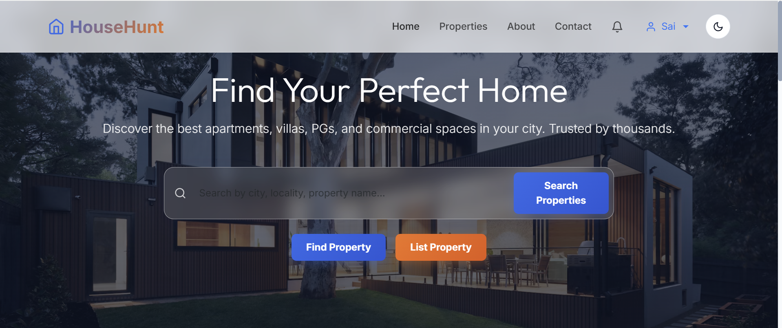
Home page hero — search bar and primary CTAs.

Platform trust stats.
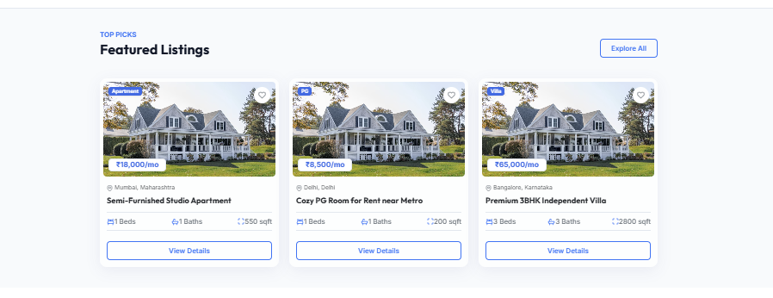
Featured Listings grid.

Popular Cities section.
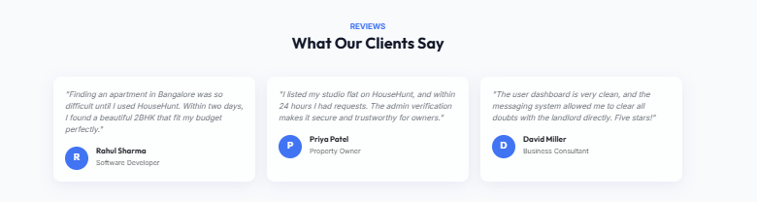
Client testimonials.
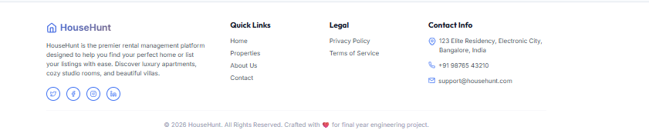
Site footer.

About Page
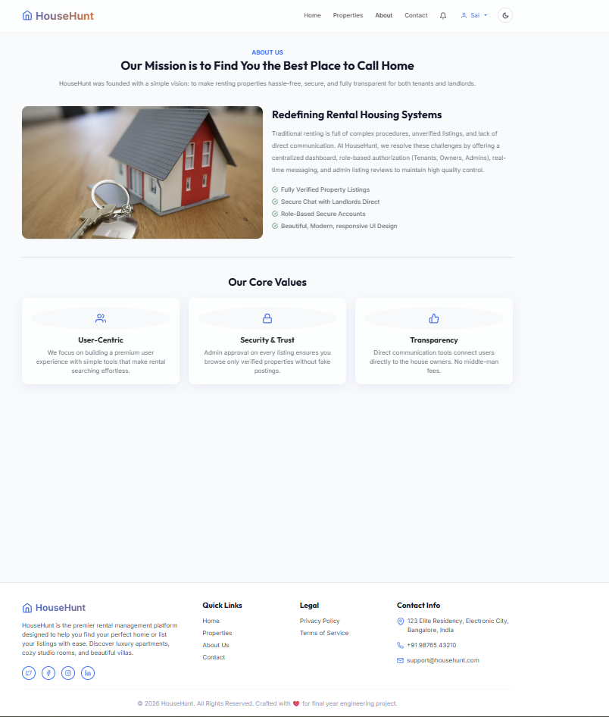
About page — mission and core values.

Contact Page
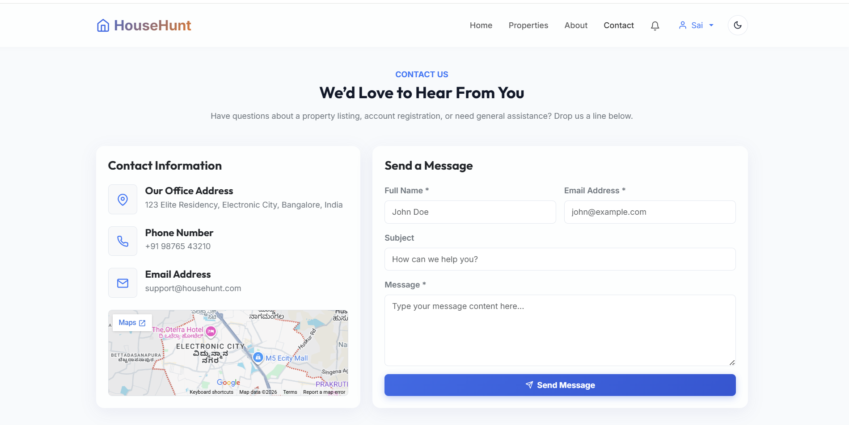
Contact page with form and embedded map.

User Dashboard
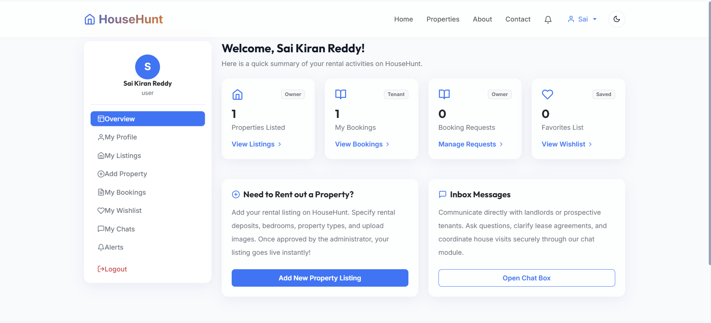
Dashboard Overview with role-based stat cards.

Profile Settings
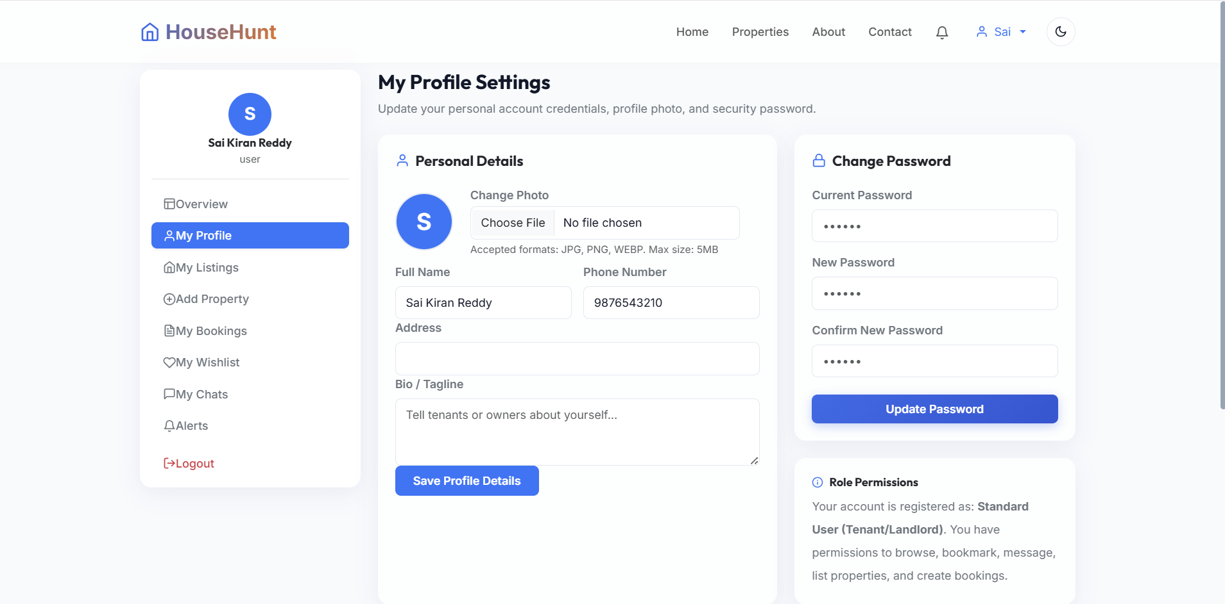
My Profile Settings — personal details & password change.

My Listings
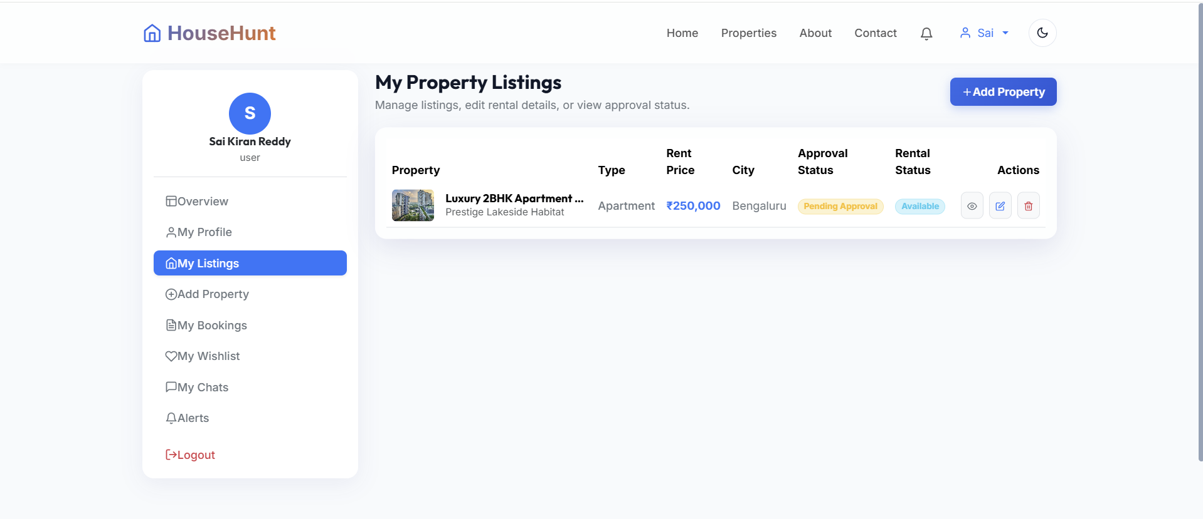
My Property Listings with approval & rental status.

20. Known Issues
- No real-time push notifications yet (bell icon is currently static).
- No payment/booking-deposit flow (out of current scope).
- Admin Dashboard UI screenshots pending capture.

21. Future Enhancements
- Payment gateway integration for booking deposits.
- Real-time notifications (Socket.IO / web push).
- Owner analytics (views, enquiries per listing).
- Featured/boosted listings (monetization).
- AI-assisted property description generation.
- Native mobile app (React Native) reusing the existing REST API.
- Multi-language support.

22. Conclusion
HouseHunt addresses a genuine, relatable problem — the friction and lack of trust in traditional property renting — with a full-stack solution that is functional, secure, and extensible. The admin-approval workflow and role-based access control give it a level of trust and quality control that distinguishes it from a simple listings board, while the modular MERN architecture leaves clear room for future enhancement.

23. References
- MongoDB Documentation — mongodb.com/docs
- Express.js Documentation — expressjs.com
- React Documentation — react.dev
- Node.js Documentation — nodejs.org/docs
- JWT.io Introduction — jwt.io/introduction
- SmartBridge Internship Program Guidelines

24. Epic-Wise Documentation Index
Epic | Title
1 | Project Planning
2 | Environment Setup
3 | Database Design
4 | Backend Development
5 | Frontend Development
6 | Authentication & Security
7 | Property Management
8 | Booking Management
9 | Admin Dashboard
10 | Testing & Validation
11 | Monitoring & Optimization
12 | Deployment
13 | Project Conclusion
Full epic-wise Markdown documentation with source-level detail is included in the accompanying GitHub-ready folder package (HouseHunt-Documentation/docs/).

