AWS IAM User Creation - Step-by-Step Documentation

Step 1: Go to AWS Console
- Open a web browser and navigate to the AWS Management Console homepage.
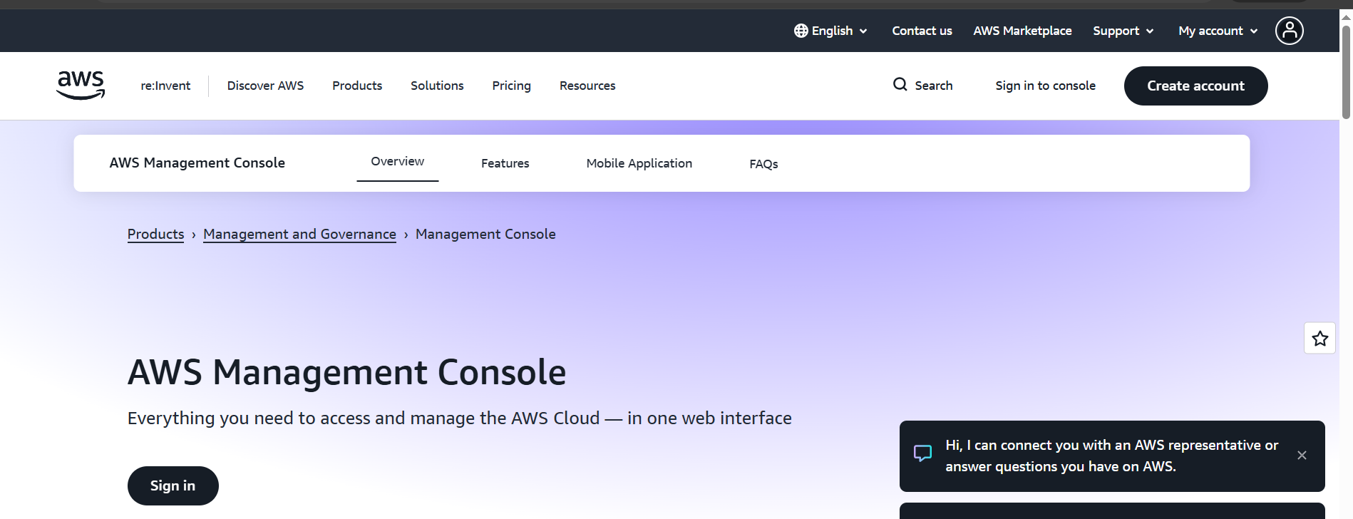

Step 2: Sign in to AWS Console
- Enter your AWS account credentials (email/username and password) to sign in.
- If applicable, complete Multi-Factor Authentication (MFA).
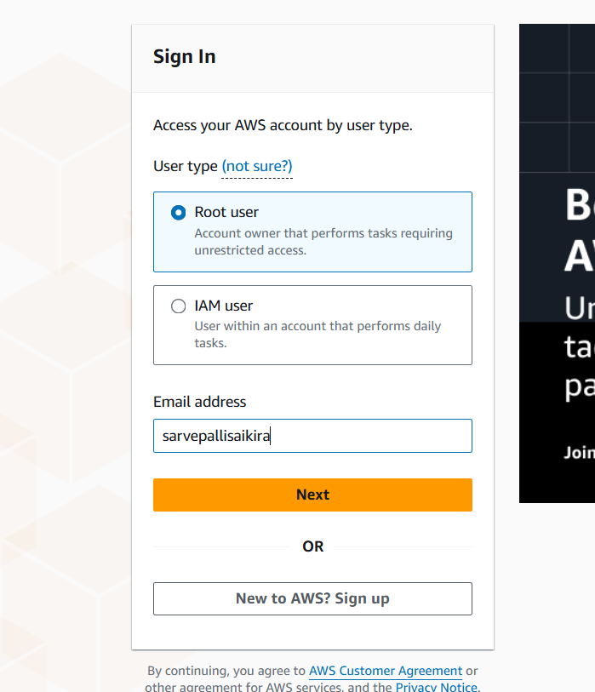
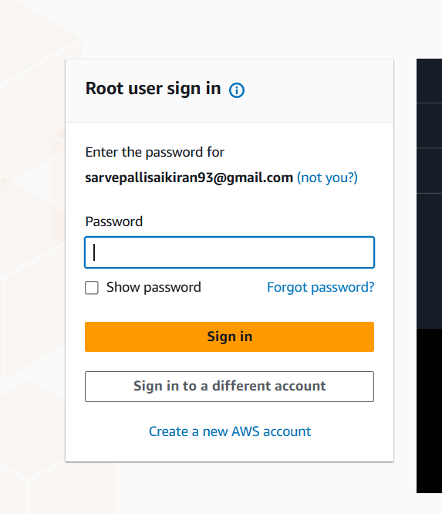

Step 3: Navigate to IAM
- Once signed in, locate the search bar at the top of the console.
- Type 'IAM' and select the IAM service from the dropdown.

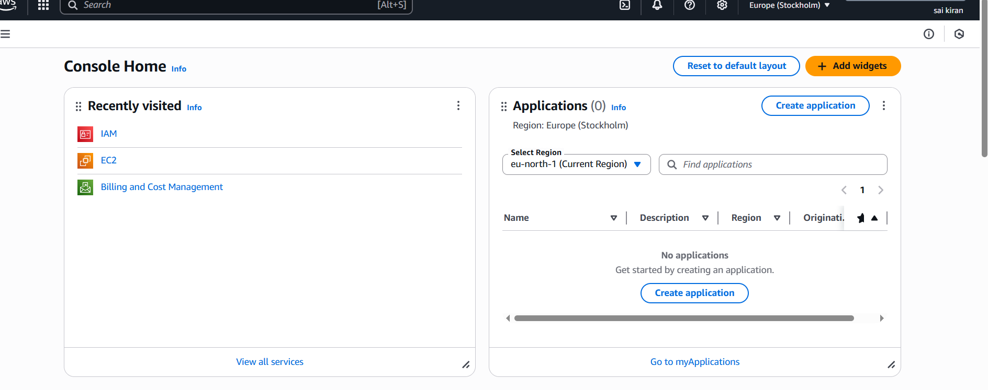

Step 4: Go to Users
- Inside the IAM dashboard, look at the left-hand navigation pane.
- Click on 'Users' to view the existing users list.
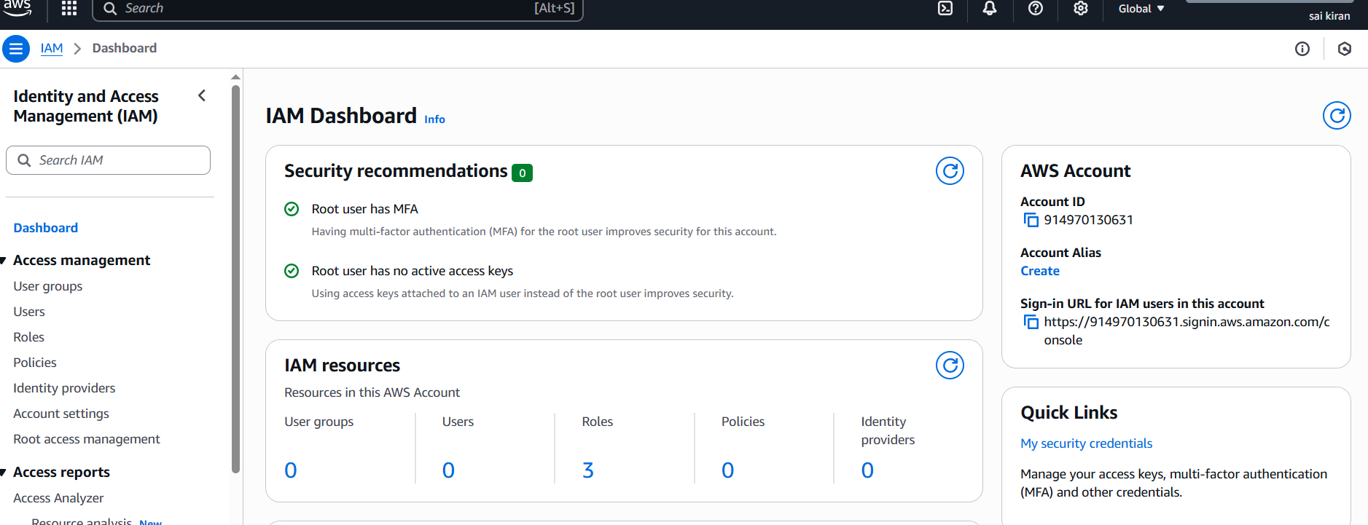

Step 5: Select 'Create user'
- Click the 'Create user' button to begin the setup process.

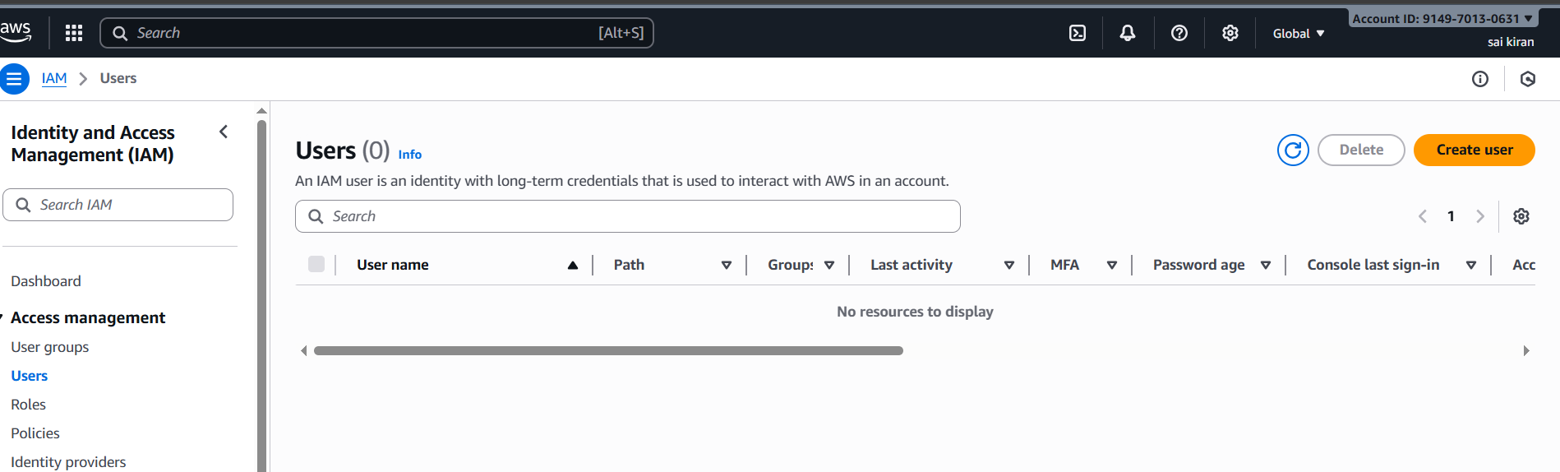

Step 6: Provide Username
- Enter a unique username for the new IAM user.
- This name will identify the user in the AWS account.
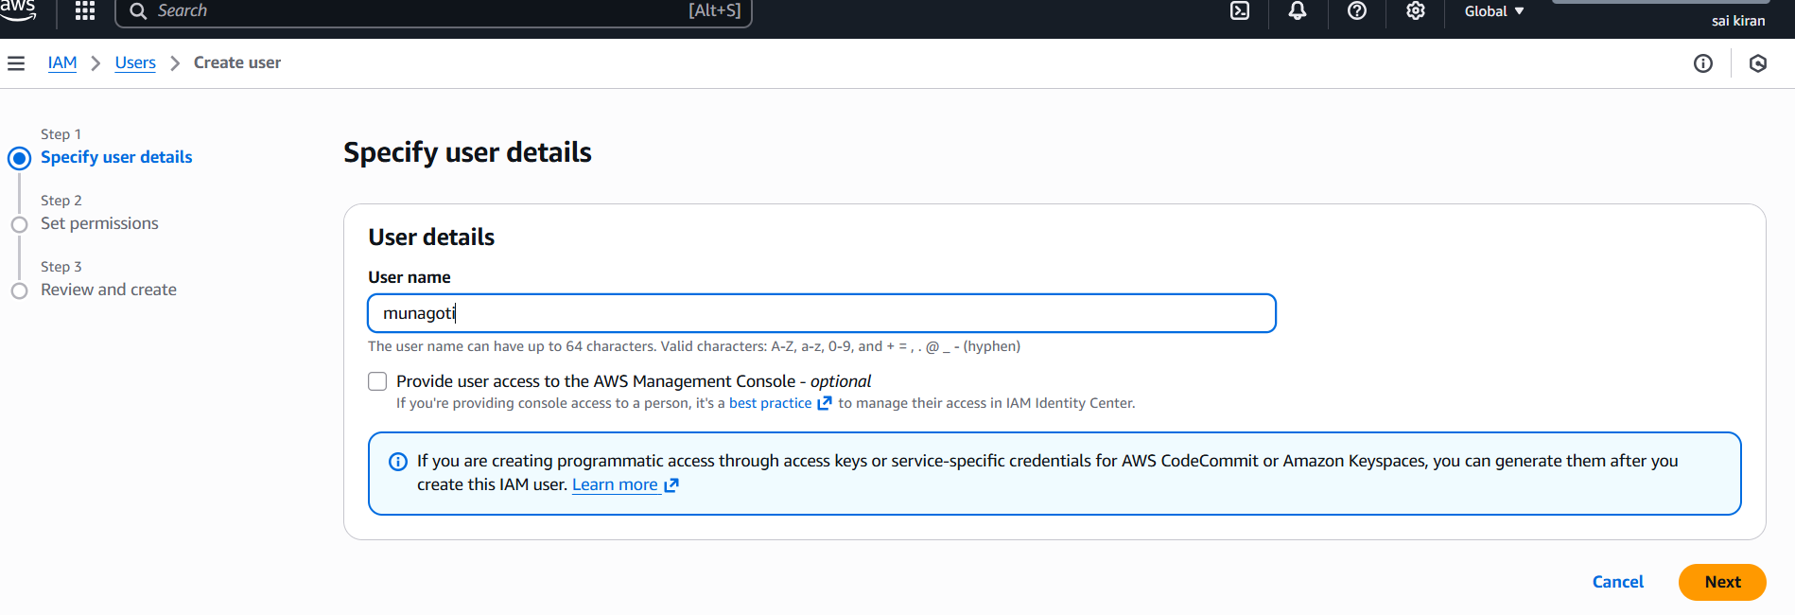

Step 7: Provide Console Access
- Enable AWS Management Console access for the user.
- Choose whether to auto-generate a password or create a custom one.
- Ensure you store the credentials securely.
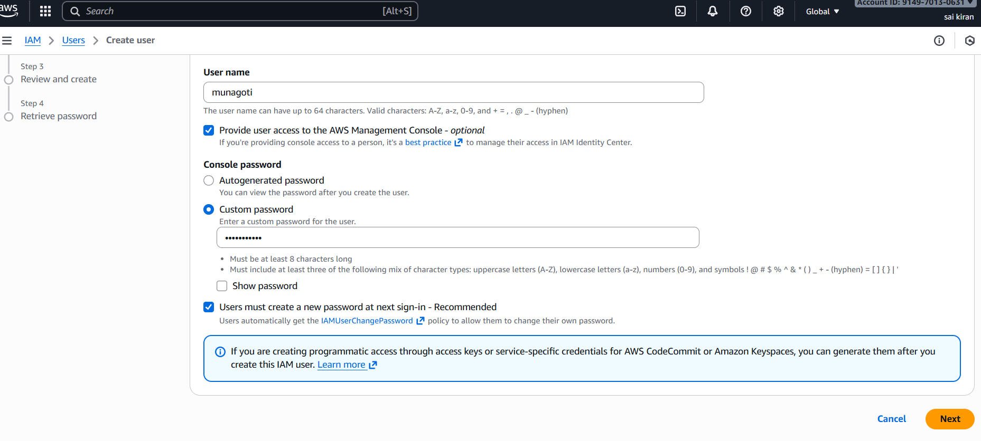

Step 8: Provide Access Roles to IAM user
- Give Permission Policies to IAM user
- Attach policies directly – Not recommended unless needed

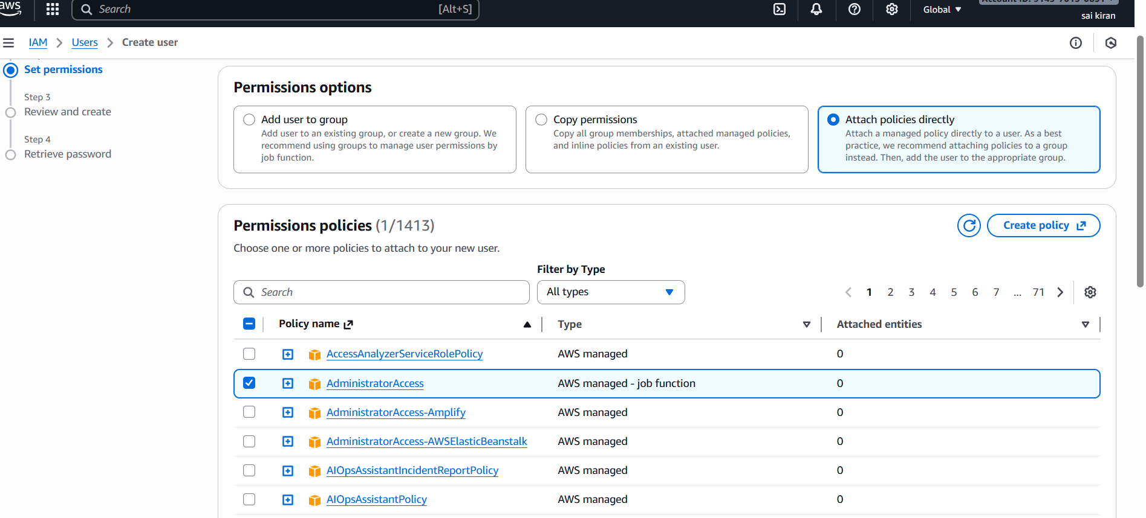

Step 9: Provide Console Access Review and Create User
- Review user Details and Permission Summary
- And Create user

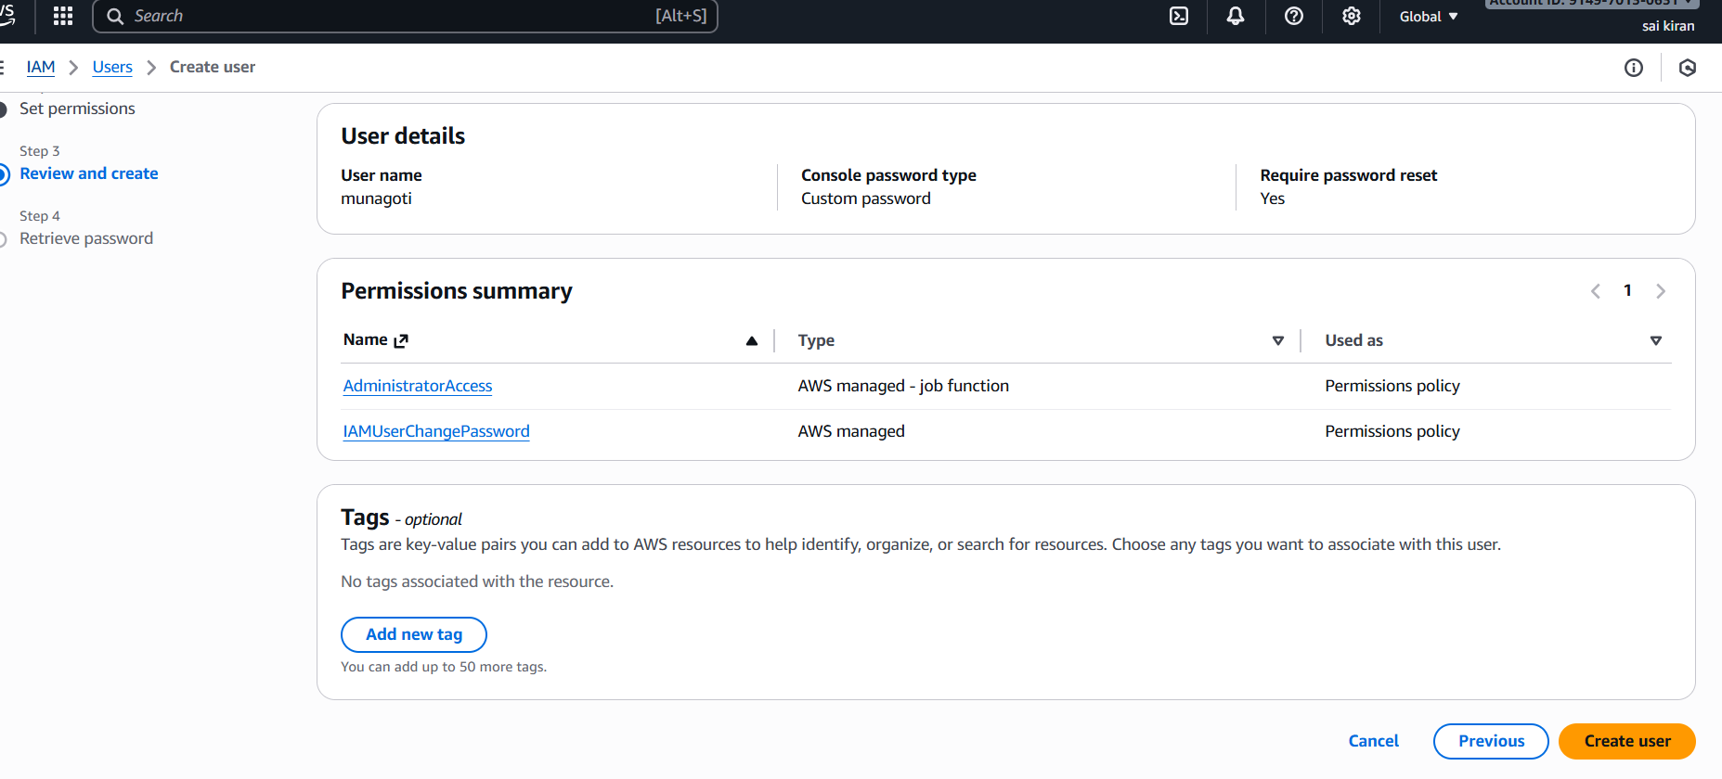

Step 10: IAM user Account Created Successfully

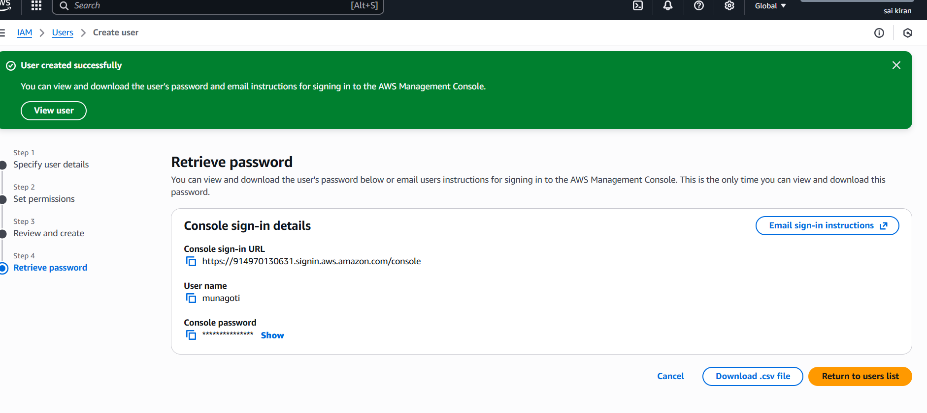

Step 11: Provide Login Instructions to IAM User
- Give the user:
- Login URL (IAM login link)
- Username
- Password (temporary)
- Reset your Password
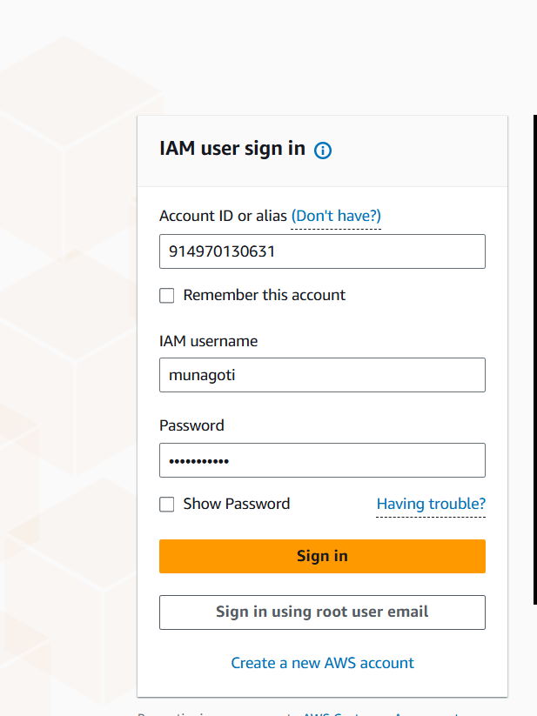

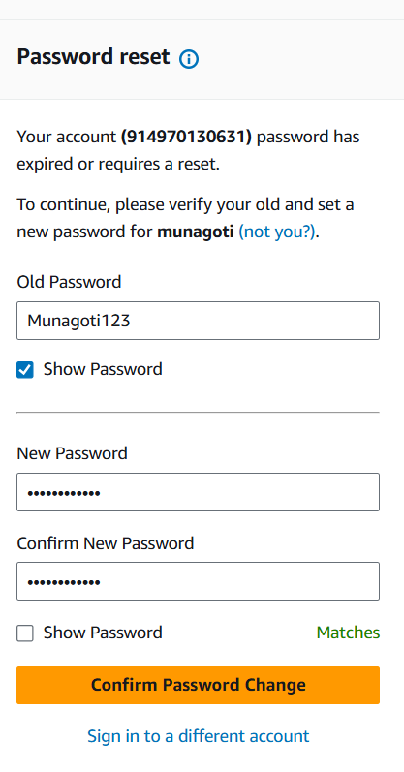

Step 12: IAM user login Successfully
- You have successfully created a new IAM user and assigned appropriate permissions. This helps maintain secure access control in your AWS environment

