A Complete Guide to AWS EC2 Instance Types and Their Use Cases
Amazon Web Services (AWS) offers a wide range of Elastic Compute Cloud (EC2) instance types to suit nearly every possible workload—from small web servers to massive machine learning clusters. Understanding the differences between these instance families is essential for optimizing performance, reducing cost, and building scalable cloud applications.
This blog provides a comprehensive breakdown of all major AWS EC2 instance families, what they are designed for, and real-world use cases.
What Are AWS EC2 Instance Types?
In AWS, an instance type defines the CPU, memory, storage, and networking capacity of a virtual machine. These types are grouped into instance families, each optimized for a specific class of workloads:
- General Purpose
- Compute Optimized
- Memory Optimized
- Storage Optimized
- Accelerated Computing
- High Memory
- Bare Metal

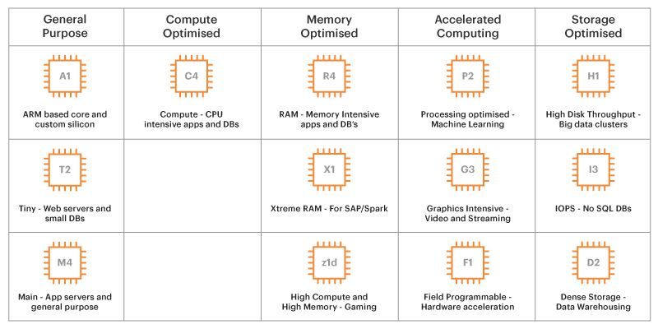
1. General Purpose Instances
Balanced compute, memory, and network resources—best for most applications.
Families:
- T Series (t2, t3, t3a, t4g), Burstable performance

- Use cases
- Micro services
- Web servers
- Dev/test environments

- M Series (m5, m6i, m7g) , Balanced CPU/memory
- Use Cases
  - Application servers,
  - Small DBs,
  - Enterprise apps.

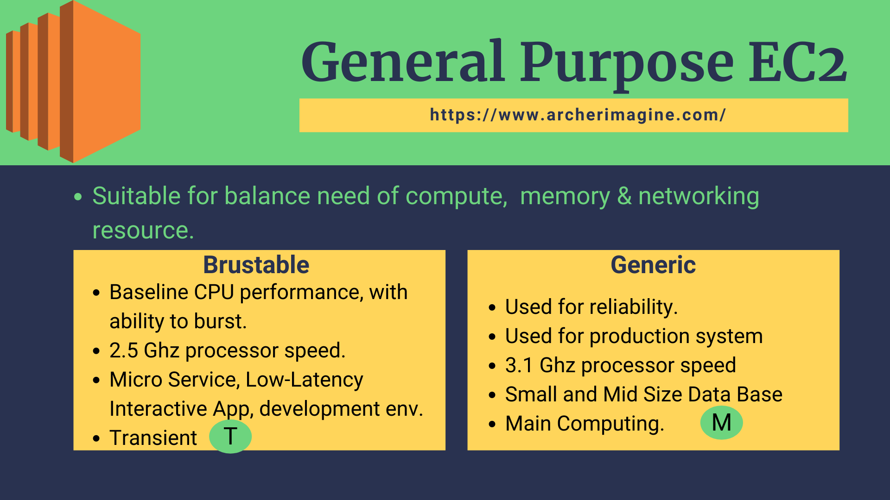

2. Compute Optimized Instances
Designed for compute-intensive applications requiring high-performance processors.
Families:
- C Series (c5, c6i, c7g, c7i)
Use Cases:
- High‑performance computing
- Gaming servers
- Batch processing
- Scientific modeling
- ML inference
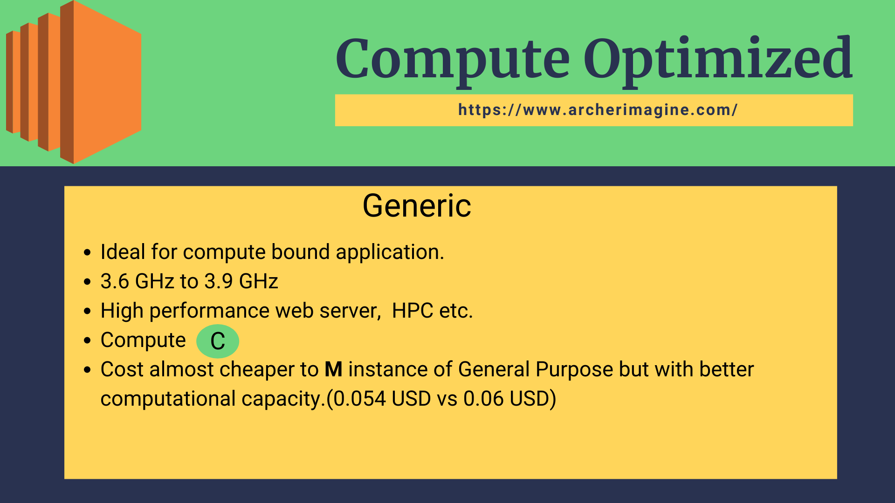

3. Memory Optimized Instances
Built for workloads requiring large memory and high throughput.
Families:
- R Series (r5, r6g, r7i): High memory ratio.
- Use cases:
    - Redis,
    - Big data analytics,
    - Databases.

- X Series (x2gd, x2idn, x2iezn): Extreme memory

Use cases:
- SAP HANA,
- In‑memory databases

- Z Series (z1d): High-frequency CPUs.
- Use cases:
- Financial trading,
- EDA,
- CPU-bound DBs
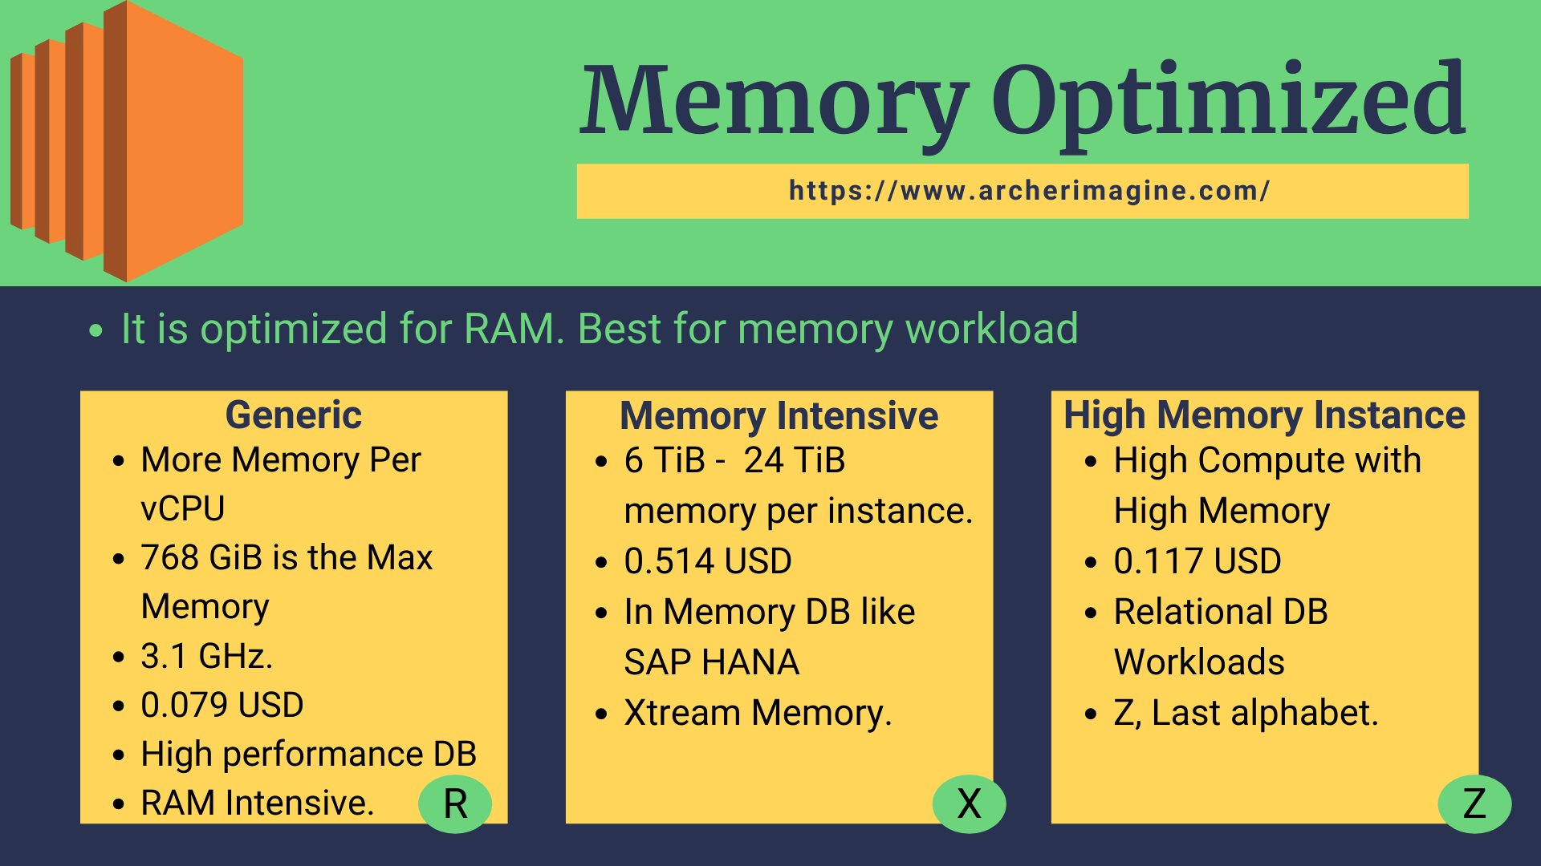
4. Storage Optimized Instances
Engineered for applications needing high IOPS and fast local storage.
Families:
- I Series (NVMe) (i3, i3en, i4i): NVMe SSDs.
- Use cases:
    - NOSQL databases,
    - Elasticsearch,
    - OLTP.
- D Series (d2, d3, d3en): Dense HDD.
Use cases:
- Hadoop
- Data warehousing.

- H Series(h1): High disk throughput.
Use cases:
- Map Reduce,
- Data mining.
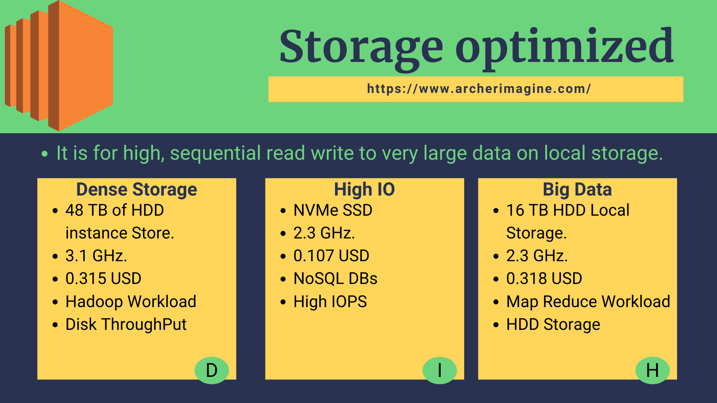

5. Accelerated Computing Instances
Powered by GPUs, FPGAs, or AWS accelerators.
Families:
- P Series : GPU for deep learning training.
- G Series : GPU for inference and graphics.
- Inf Series: AWS Inferentia for high-throughput ML inference.
- Trn Series: AWS Trainium for ML training
- F Series: FPGA instances.
Use Cases:
  - ML training
  - ML inference
  - Graphics rendering
  - Computational simulations


6. High Memory Instances (U Series)
Designed for extremely large in‑memory workloads.
U-Series (up to 24 TB)
Use Cases:
- SAP HANA scale‑up
- Massive caching layers
- Enterprise analytics
7. Bare Metal Instances
Provides direct access to underlying hardware.
Use Cases:
- Custom hypervisors
- HPC clusters
- Performance-critical apps.
- Low‑level hardware access
- Licensing‑restricted workloads

8. Networking Optimized Instances

- HPC-Series: Large-scale simulations
Use Cases:
- Genomics,
- CFD ,Computational Fluid Dynamics
Instance Types
Instance Family | Optimized For | Example Use Cases
T | Burstable General | Low traffic web apps, dev/test
M | Balanced | App servers, small DBs
C | Compute | HPC, gaming, analytics
R | Memory | Redis, big data
X | Extreme Memory | SAP HANA
Z | High-frequency CPU | Financial apps
I | NVMe storage | NoSQL, OLTP
D | Dense HDD | Hadoop, logs
H | Big data storage | Data lakes
P | GPUs | Deep learning training
G | GPUs | Graphics, ML inference
Inf | Inferentia | High-speed ML inference
Trn | Trainium | ML training
F | FPGA | Hardware acceleration
U | Huge RAM | Enterprise DBs
Bare Metal | Hardware access | Custom hypervisors
HPC | High network | Scientific workloads

Conclusion
AWS offers a diverse ecosystem of EC2 instance families designed to meet a wide variety of performance requirements. By aligning your workload's compute, memory, storage, and networking needs with the right instance family, you can optimize cost, maximize performance, and ensure efficient scaling.

