Sai Kiran Putta
Hari Krishna Rangineeni

PART – I : Titanic DataSet Exploration in PySpark
PART – II : Text Classification using PySpark

PART – I :
- Titanic Dataset after loading into Pyspark has a schema like follows with top 5 rows as below:
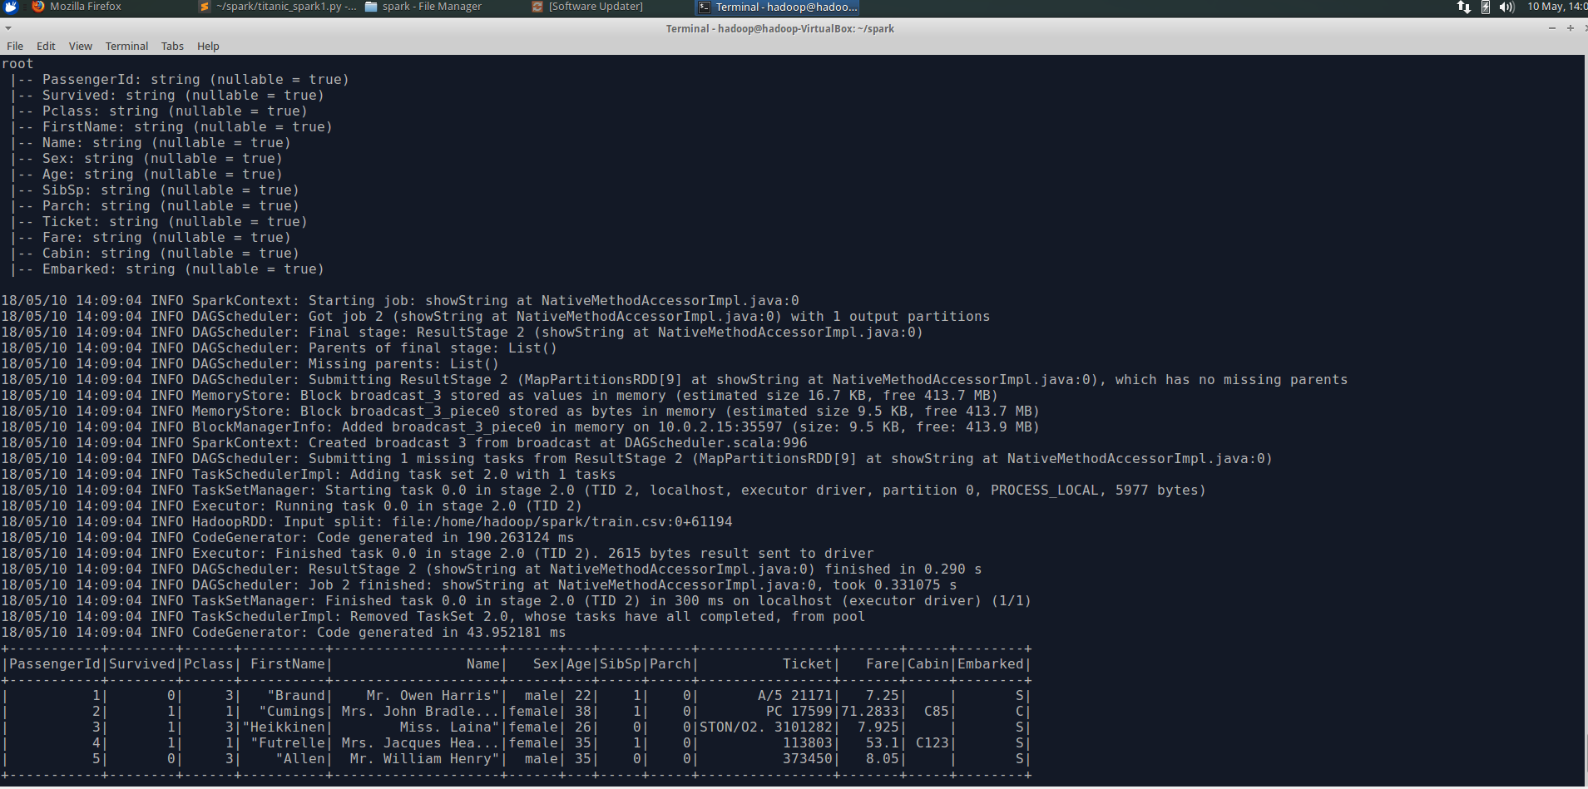

- We can observe that all the numeric features too are in String Format. After changing the datatype of features and checking the schema gives the following.
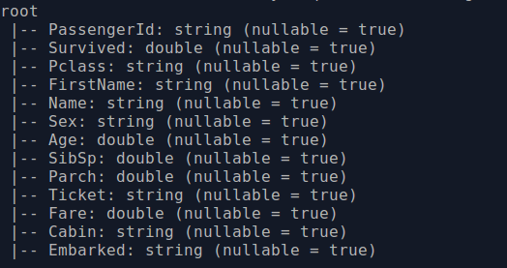

- Following are total number of observations in the dataset and columns in the dataset as follow.

- Features, Age and Fare have few observations missing. Imputing those features with the mean of respective columns. Following are the means.
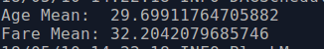

- The statistics of each feature is as follows.
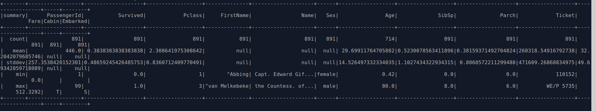
- Grouping the dataset by Fare, following are top 20 counts.
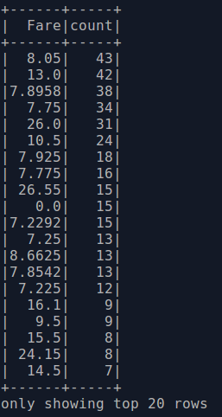

PART – II:

Building Features
Build Machine Learning Models
Data Collection
Data Cleaning
Machine Learning Model Evaluation

Data Collection :

Using the API, NYTimesArticle different posts on Business, Technology, Sports and Politics are collected. The data collection code can be found in the ipynb notebook attached as part of submission.

In total we collected around 4MB of data for all the different classes.

Data Cleaning:
Make text to lower case
Remove numbers from text
Remove stop words from text
Remove punctuation from text

Building Features:

We experimented with different way we can build features. Such as,
- Term Frequency
- TF – IDF
- Term Frequency with N-grams
- TF – IDF with N-grams

Out of all the combinations we observed that Term Frequency was giving best results while doing validation later on while building Machine Learning models.

Building Machine Learning Models:

We tried three different Machine Learning models as follows,
- Logistic Regression
- Naive Bayes
- Random Forest

While the best results were obtained using Term Frequency, the second best were obtained while using TF-IDF. The results are as below.
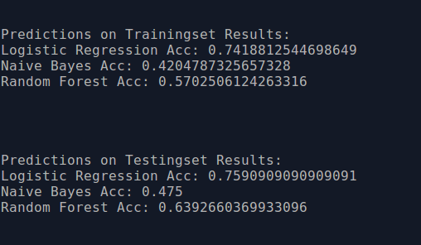

The best results were obtained while using Term Frequency. The results are like below.

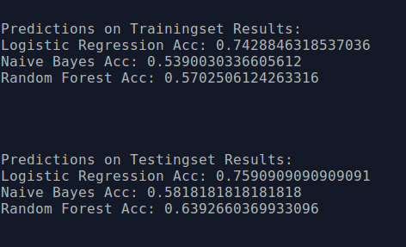

Taking new data and running the classifiers gave following results.

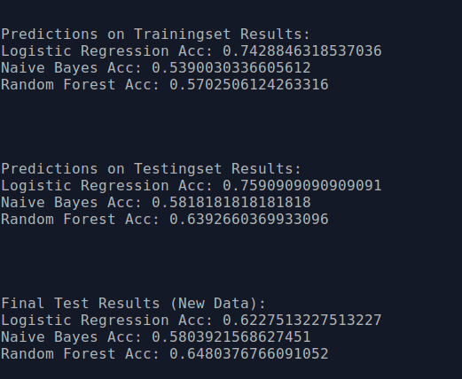

Inference : Getting similar results for the final testing set same as testing and training set implies that the models have been performing consistently.

Final Inference: Looking at all the figures the order of precedence of best classifier for this dataset is as follows,
- Logistic Regression
- Random Forest
- Naive Bayes

