**Exam – 01**

**50 points**

1. **Instructions to create the project.**
2. Create a project in XCode with the name “**LastName_****SurgeryCostApp**”.
3. While creating the app make sure to follow minimum deployment and project format as shown below:



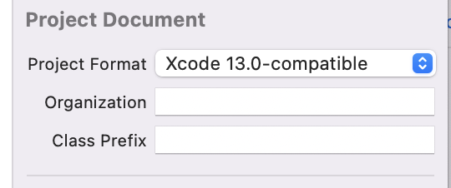

1. **Instructions to create the Surgery Cost App.**
2. The UI of the app is shown in **Fig 01**. Design an app that takes the Patient Name, the Surgery type, and Cost as inputs and calculates the total cost for the surgery.
3. Your app should consist of the following UI components and you may use your own colors of choice.
   1. A header Label that shows “Surgery Cost”.
   2. Three text fields for
      1. Patient name
      2. Surgery name (Ex: Heart, Brain, Knee replacement)
      3. Cost
   3. A button to calculate the total cost of surgery.
   4. An image to display.
   5. A label to display the total amount.

**Fig 01: App Design**

1. Your application should calculate the total amount for the surgeries as given in Table 01 using
2. Your app should work for all the below test cases displayed in the table.

|  |  |  |  |
| --- | --- | --- | --- |
| **Surgery Type** | **Surgery Cost ($)** | **Tax%** | **Health Insurance ($)** |
| Heart | 3000.5 | 11.75 | 500 |
| Brain | 5500.8 | 13.5 | 750 |
| Knee replacement | 1500.75 | 6.25 | 350 |

**Table 01**

1. Below are the validations you should perform:

* If any of the fields are empty, you should populate the default image and display an error message as “Enter all the details”.

**Fig 02: Display default image for empty fields**

1. Refer below images for sample outputs.

**Note: Patient Name should be displayed in one line and Total Cost in another line (Use only one label).**

**Total Cost should be rounded to two decimal points.**

**Fig 03: View of Heart Surgery Fig 04: View of Knee replacement Surgery**

**Fig 05: View of Heart Surgery**

1. **Submission Instructions:**
2. Save your XCode project of SurgeryCostApp
3. Name it with your LastName_Exam01. Compress the folder and submit it to this exam.