TASKS
Tasks are the database objects which can execute SQL, stored procedures and can be scheduled accordingly as per the timings.
Here is generalized syntax for creating tasks
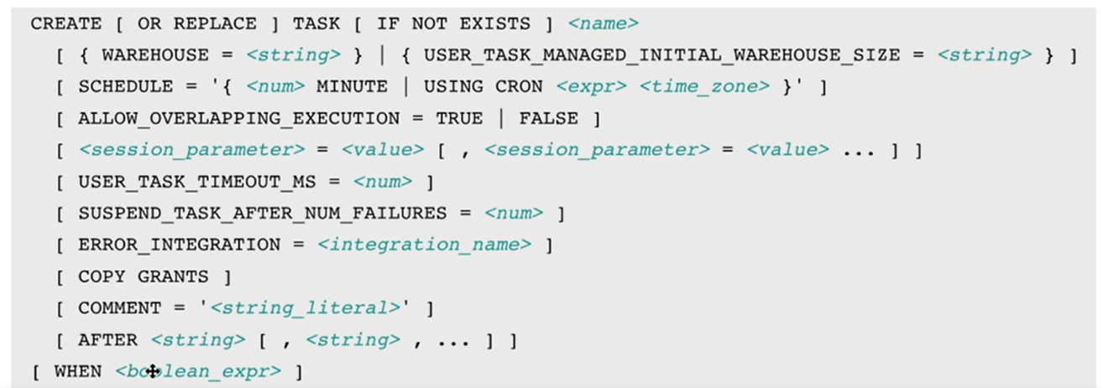
In this document, let’s use warehouse and schedule parameters while creating tasks & remaining parameters will be discussed in upcoming
Let’s see its use and functioning practically
Create a table
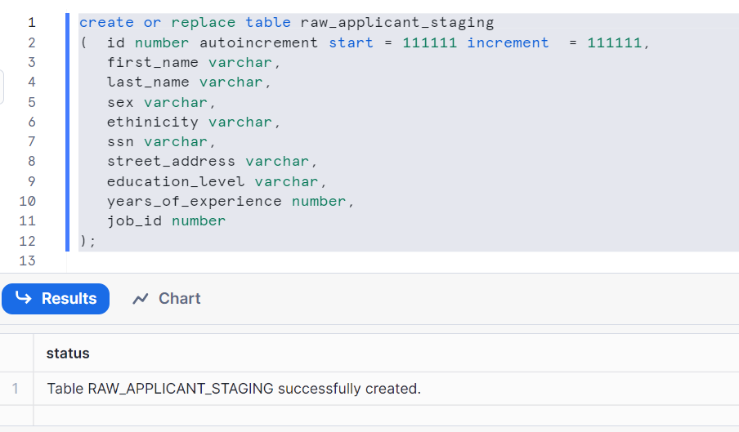

Case1: CREATING A TASK WITHOUT SCHEDULE WITH WAREHOUSE (called as USER MANAGED TASK)
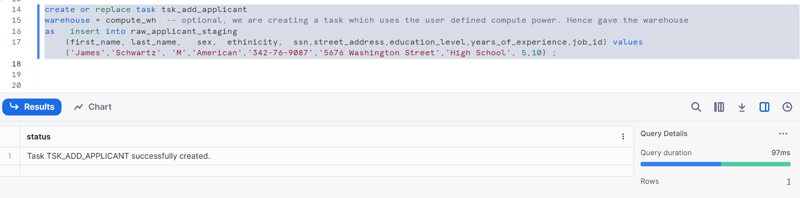
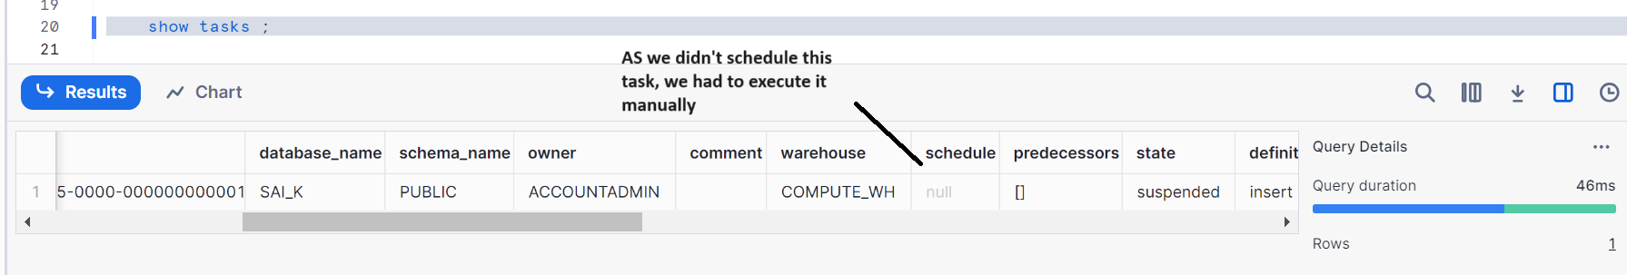
Firstly we don’t have data in our table, let’s check
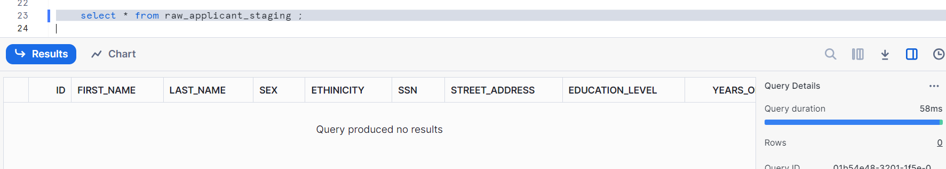
Let’s execute the task manually
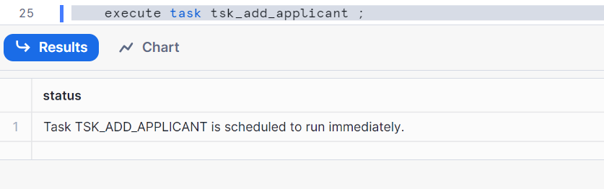

Now, let’s check the data in our table
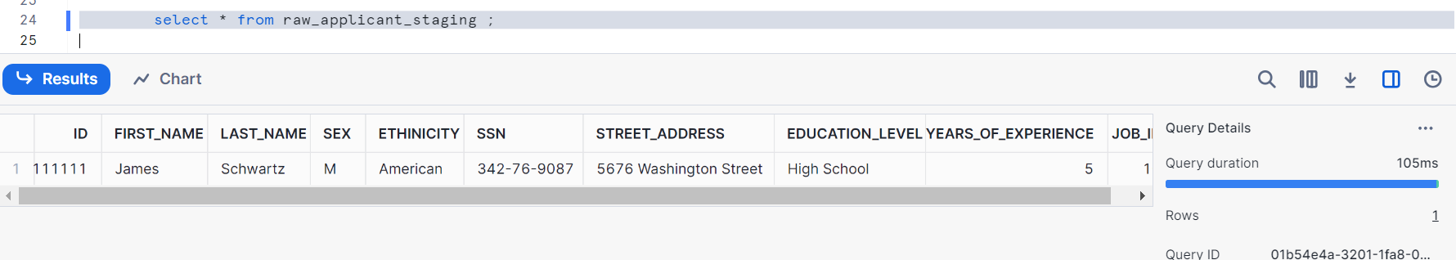

Case2: CREATING SCHEDULED TASK WITHOUT WAREHOUSE (called SERVERLESS TASK)
First clean the data
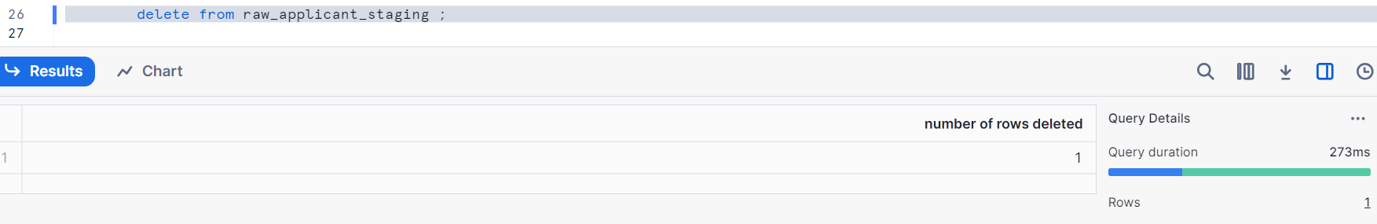
Check it, as we see no data in the table
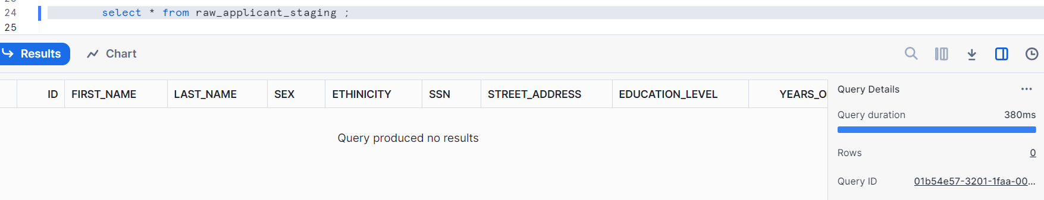
Create a task
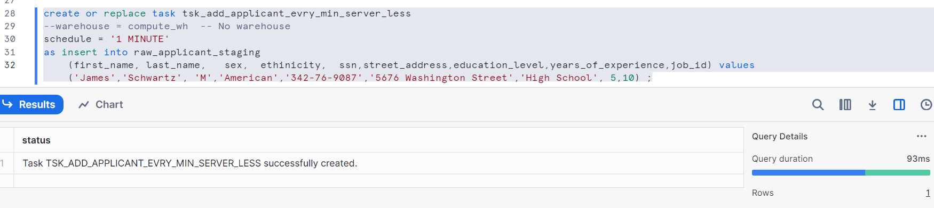
We had scheduled the task for every one minute (implies every one minute, the task runs)
Here as warehouse is not mentioned, snowflake uses by default its own compute power
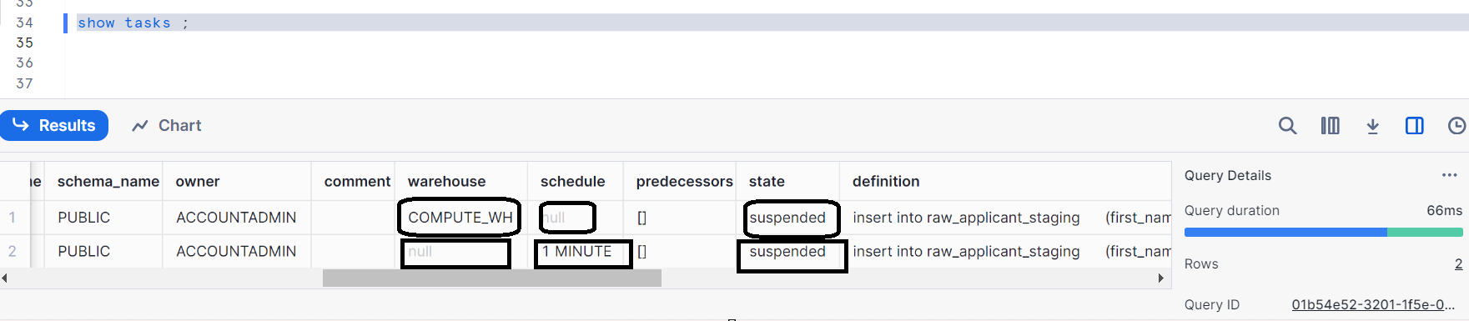
As you all know, suspended state is nothing but it stopped resuming
Now let’s resume the task
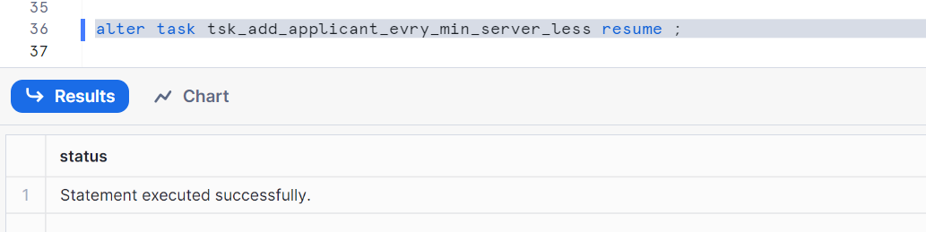

Wait for 1 minute and check the data
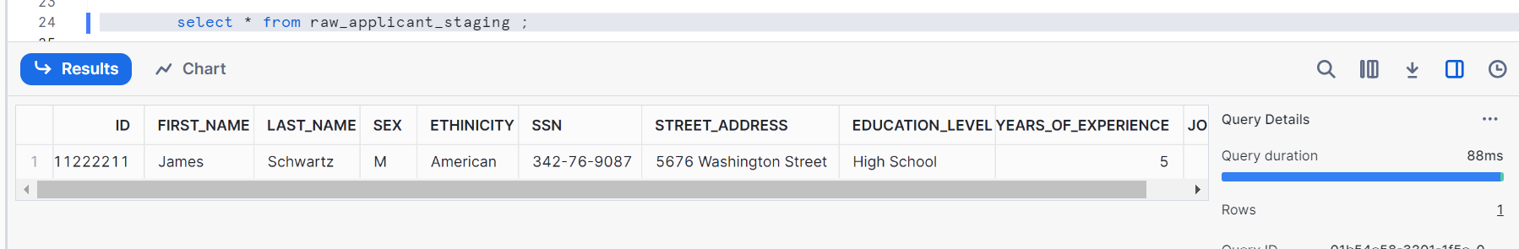
Now stop it, I mean suspend or else it goes on running continuously every 1 minute. Suspend once we see the data
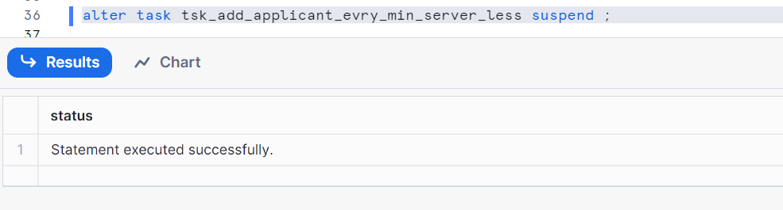

Case3: CREATE SCHEDULED TASK WITH WAREHOUSE
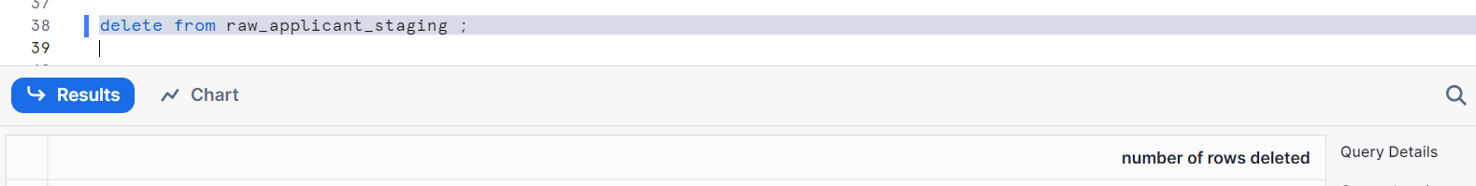
Check the data
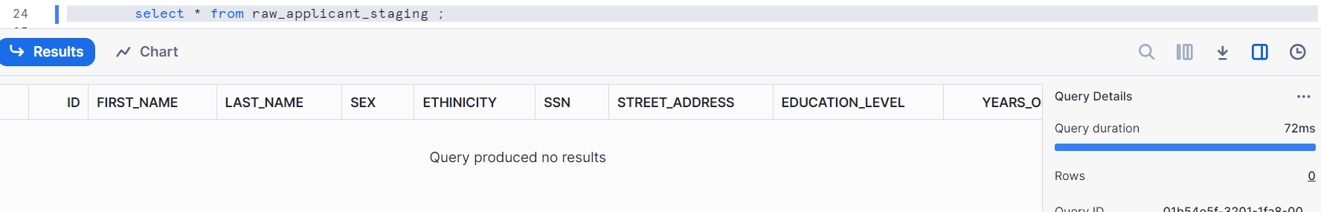
Create a task with schedule and warehouse
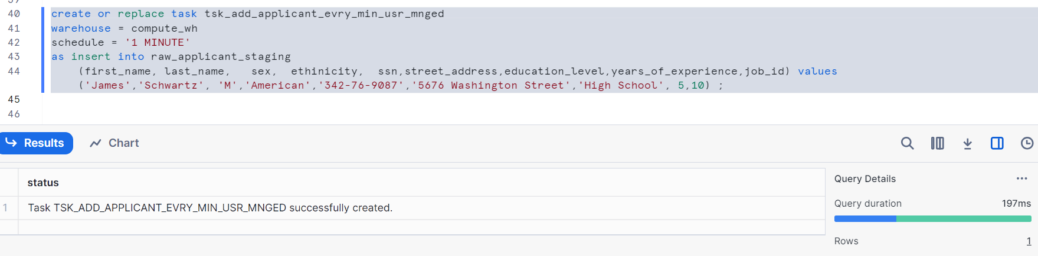
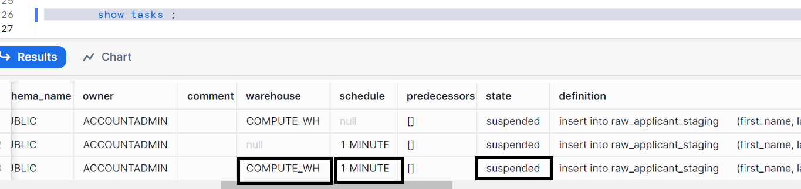
Let’s resume the task
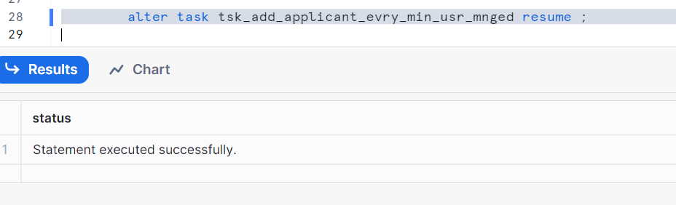
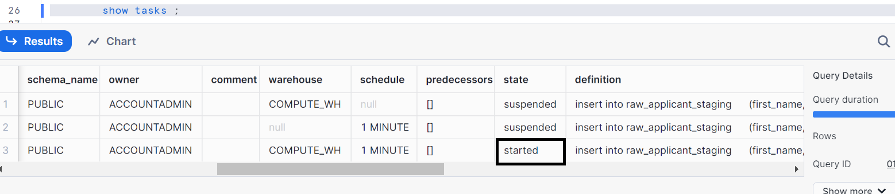

Let’s wait for 1 minute and check the data
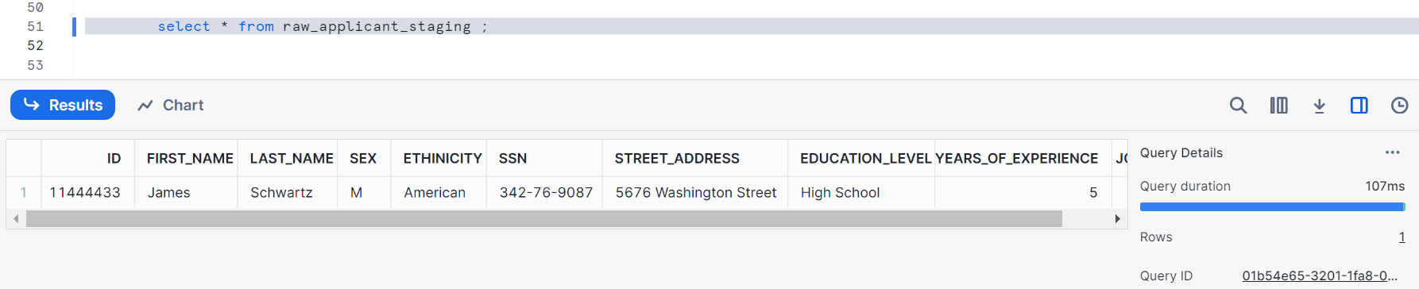
Wait for one more minute and check the data
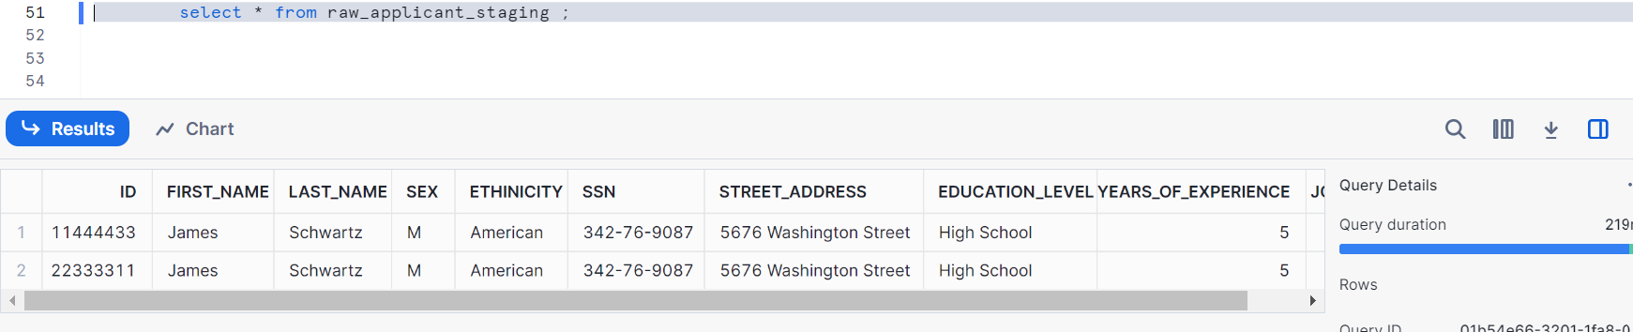
We see 2 records and it goes on
Let’s suspend the task
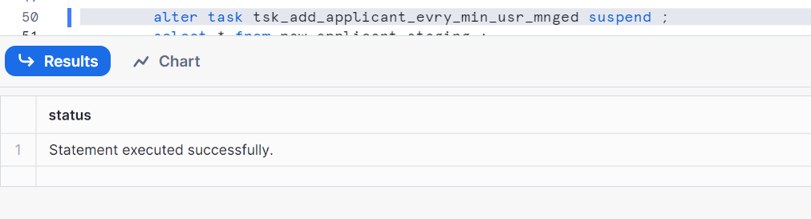

Let’s clean up
Drop table if exists RAW_APPLICANT_STAGING;
Drop task if exists TSK_ADD_APPLICANT;
Drop task if exists TSK_ADD_APPLICANT_EVRY_MIN;
Drop task if exists TSK_ADD_APPLICANT_EVRY_MIN_SERVER_LESS;
Drop task if exists TSK_ADD_APPLICANT_EVRY_MIN_USR_MNGED;

