TASKS
CREATING TASK TO CALL STORED PROCEDURE
Let's create table
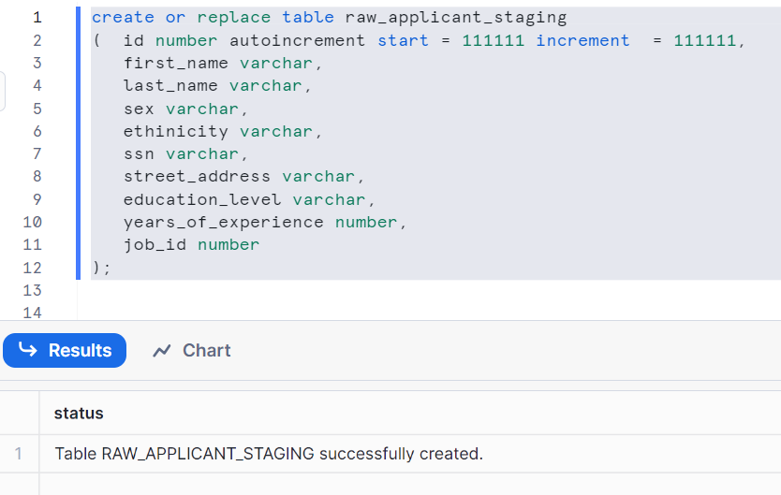
Check the data
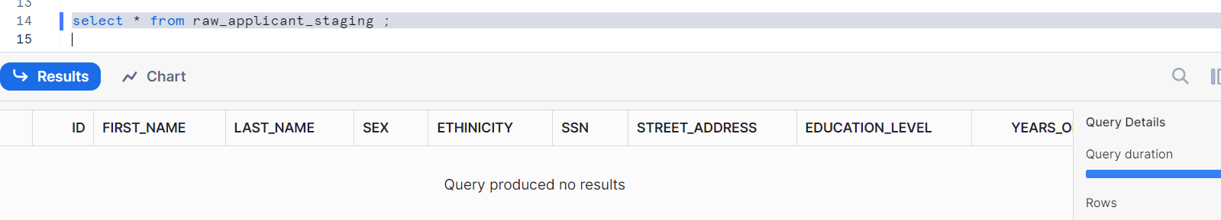
Create a procedure using Snowflake Scripting code
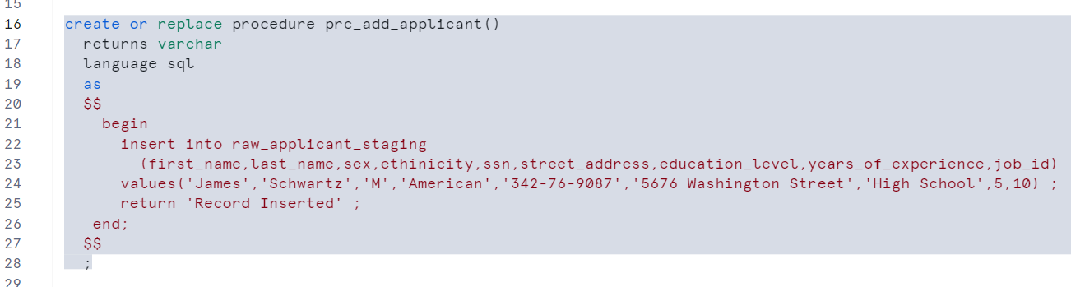
Let’s call the procedure
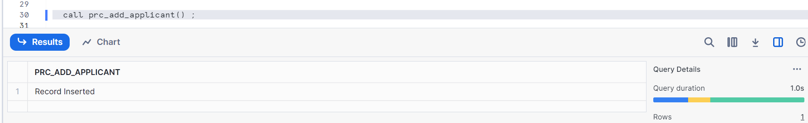
Check the data now
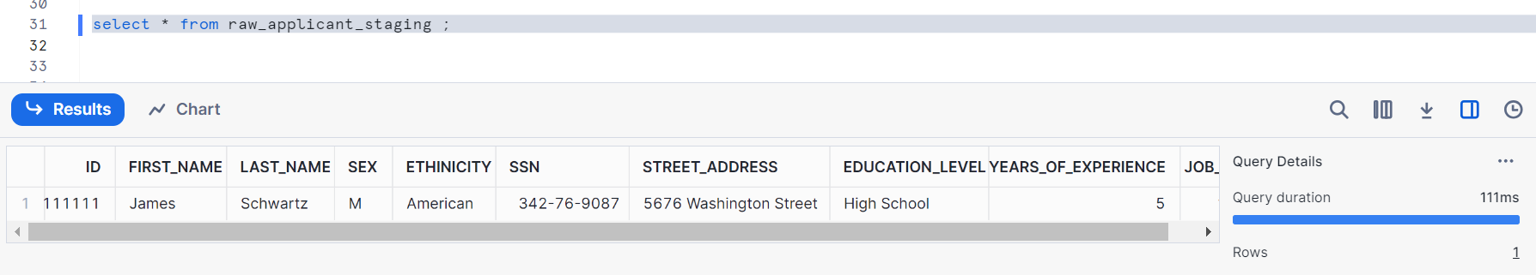

We got our data
Now let’s delete the data and let us insert data using task
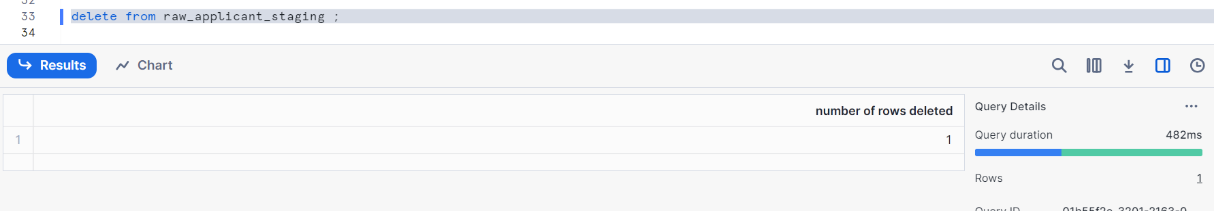
Create task to call a procedure
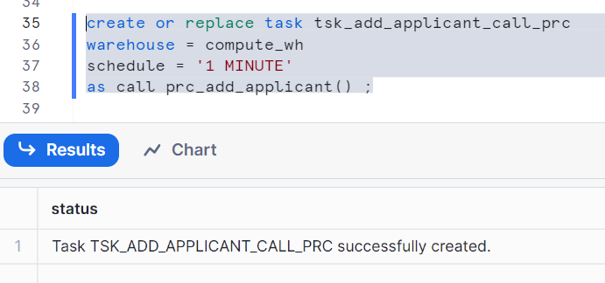
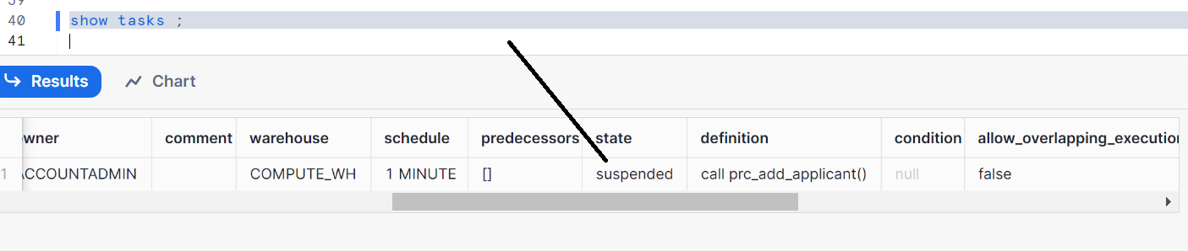
Resume the task now
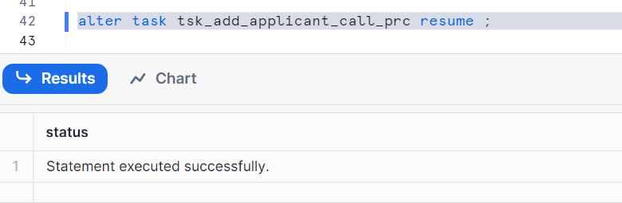
Wait for a minute and check the data
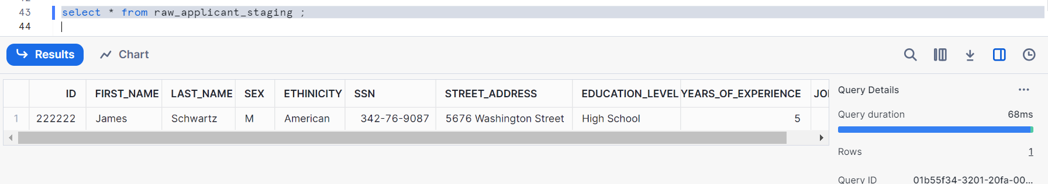
We got our data, now let’s suspend the task
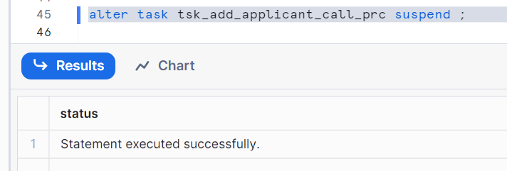
Note: we had seen how this works in my previous post (snowflake_39), please check

Clean up the task
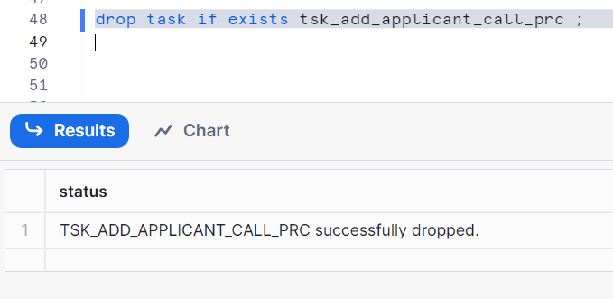

CREATE TASK BASED ON CONDITION (USING WHEN)
Let’s delete the data first
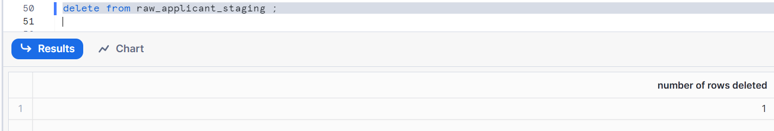
Getdate gives today's date and time
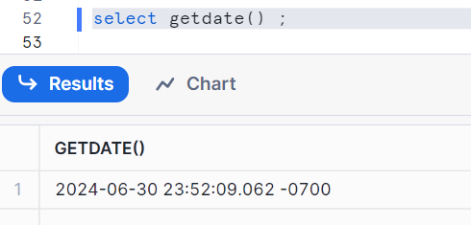
Let’s get yesterday’s date using datedd
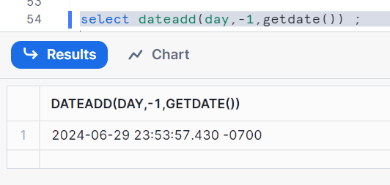
Let’s get tomorrow’s date
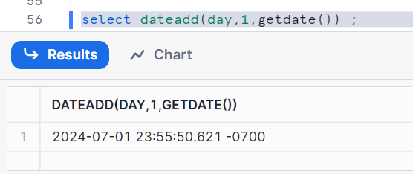
Let’s create a task using when
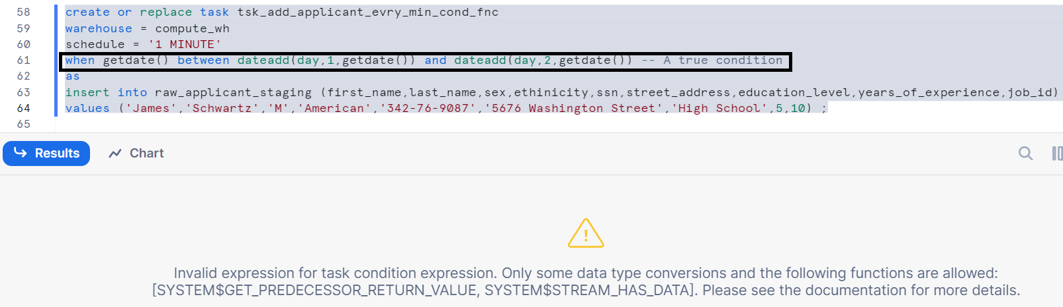
We are getting error here i.e.
Invalid expression for task condition expression. Expecting one of the following: [SYSTEM$STREAM_HAS_DATA]
So, It cannot accept any other function while using ‘when’ condition other than SYSTEM$STREAM_HAS_DATA
We will see later, how to use SYSTEM$STREAM_HAS_DATA

Creating task using conditions false and true and not using any function
Using false condition:
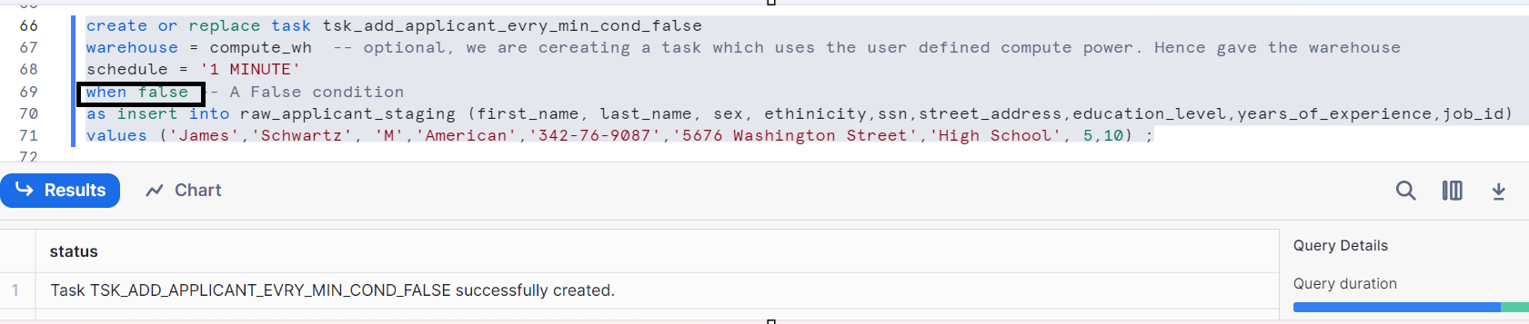

Using true condition:
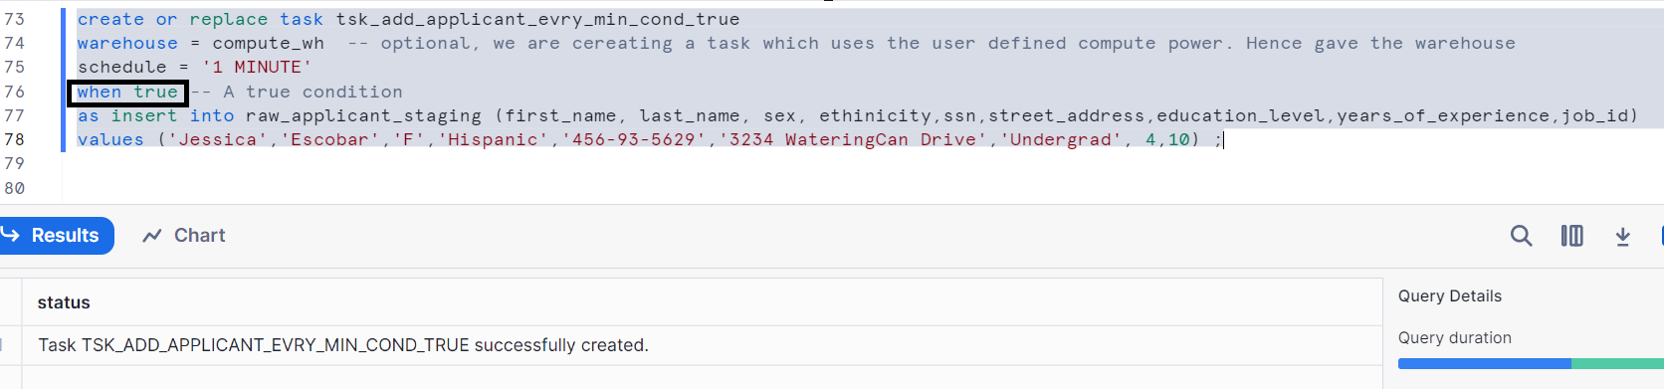
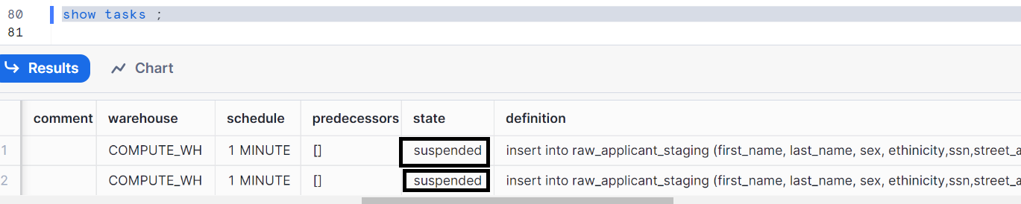
Let’s resume two tasks & wait for 1 min and check the data
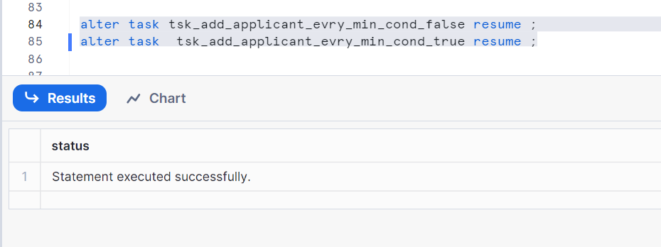
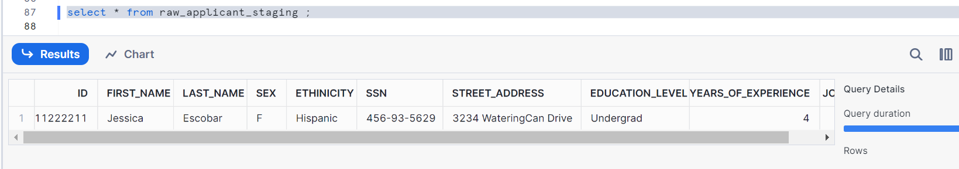
We got records only for true condition i.e. Jessica record is inserted but we don’t see James record.
In order to understand why James record did not get inserted, we need to understand some of the troubleshooting ways
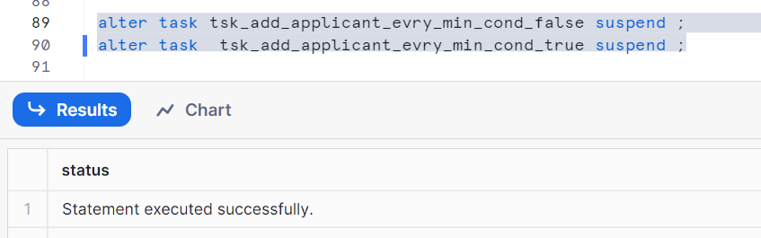
Troubleshooting tasks:
Now we know that Jessica is inserted but James is not getting inserted.
We check by troubleshooting the tasks
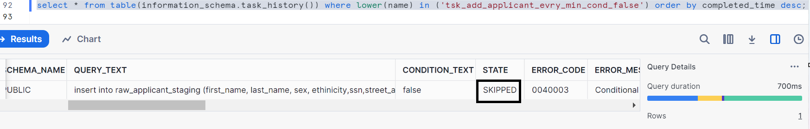
Get tasks in last one hour
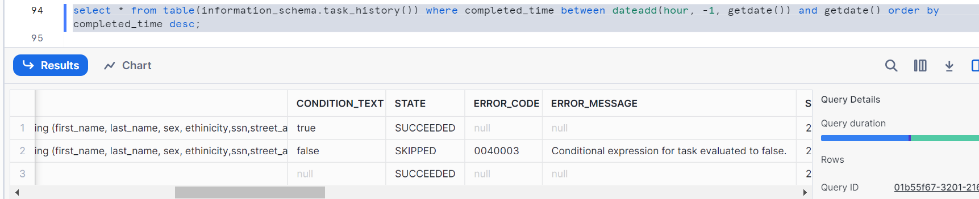
Can add the conditions of query one and two to get the specific task details via time
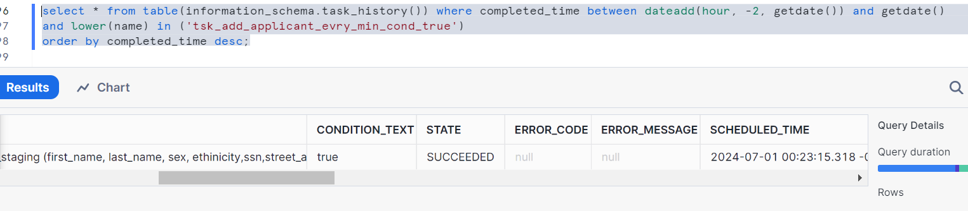
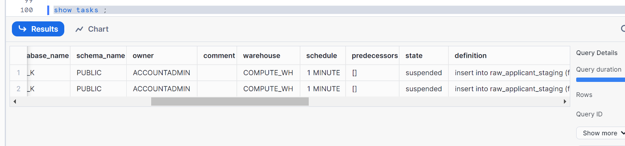

Let’s clean up
