TASKS
Scheduling tasks using CRONS
As we had discussed how to create task with schedule parameter with minutes involved in it, let’s focus on scheduling using CRON as shown below
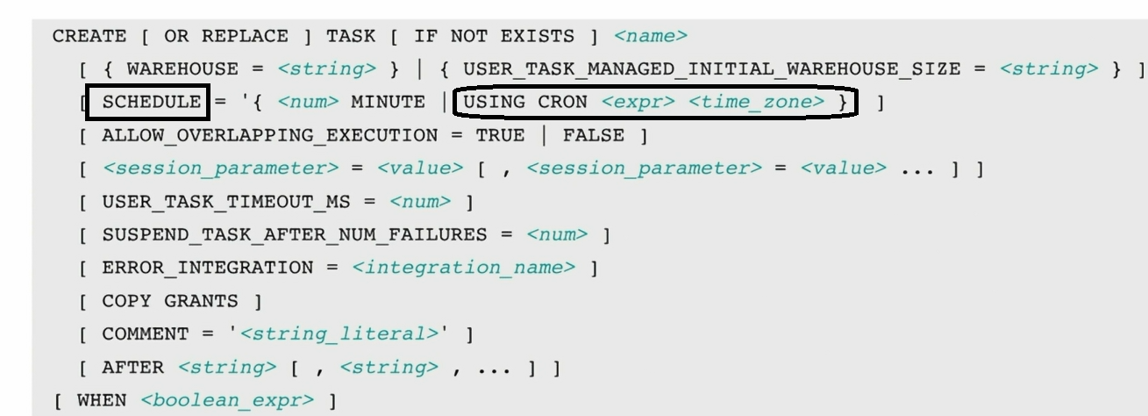
First let’s see our timezone
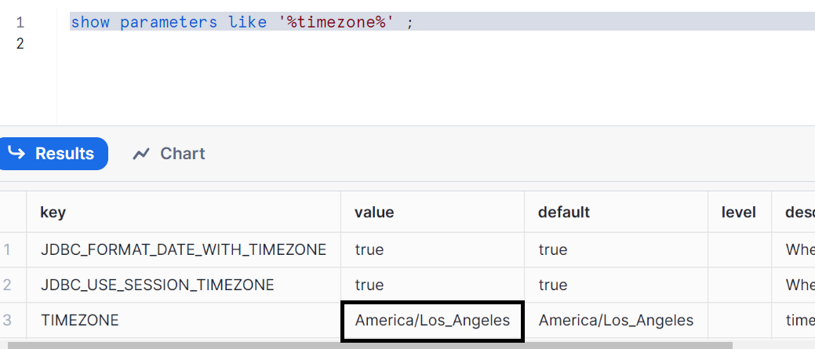

Let’s clean up the data in our table
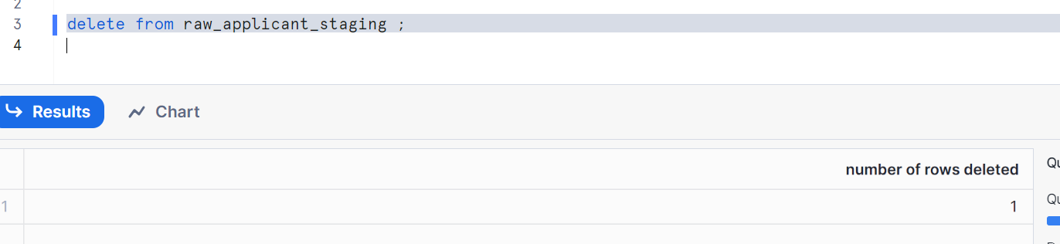
Now, to make you understand better let’s indicate with numbers and define it
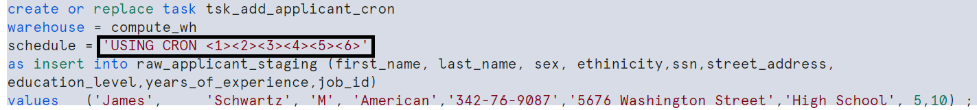
<1> - (0-59) minute you can give at which minute you want to execute your task
<2> - (0-23) hour you can give at which hour you want to execute your task
<3> - (1-31, L) day of month you can give at which day of month you want to execute your task, if it is a last day of month you can give directly ‘L’ without mentioning last day
<4> - (1-12, JAN, FEB, MAR...DEC) month you can give at which month you want to execute your task
<5> - (0-6, SUN, MON, TUE...SAT, L) day of week you can give at which day of week you want to execute your task
<6> - (America/Los_Angeles, America/New_York, 'America/Chicago') timezone you can give your time zone
EmptyValue is * this implies if I want to leave any, I simply give a star at that place

Let’s see with practical examples
Case1: Runs at 4.50 AM every day as per LA time zone
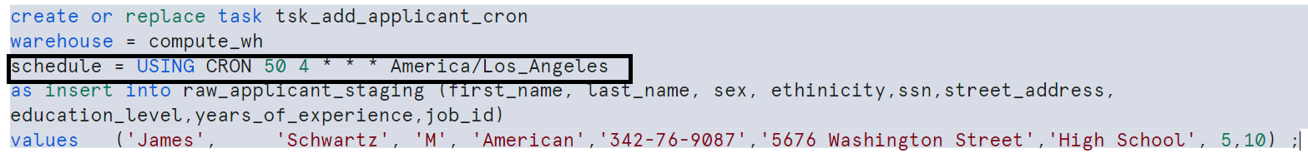

Case2: Runs at 4.50 AM on 2nd day of each month as per LA time zone
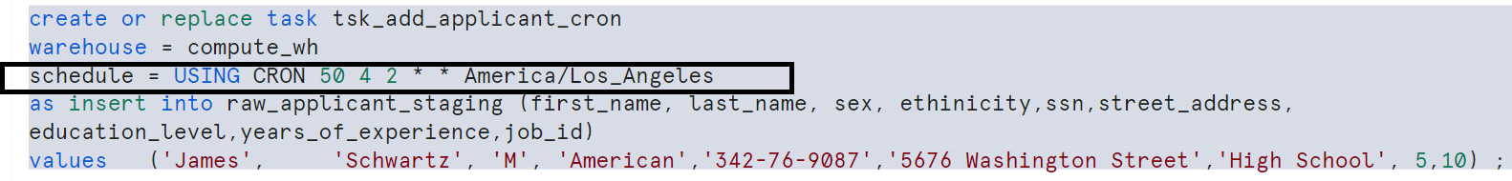
Case3: Runs at 4.50 AM on 2nd day of Oct as per LA time zone
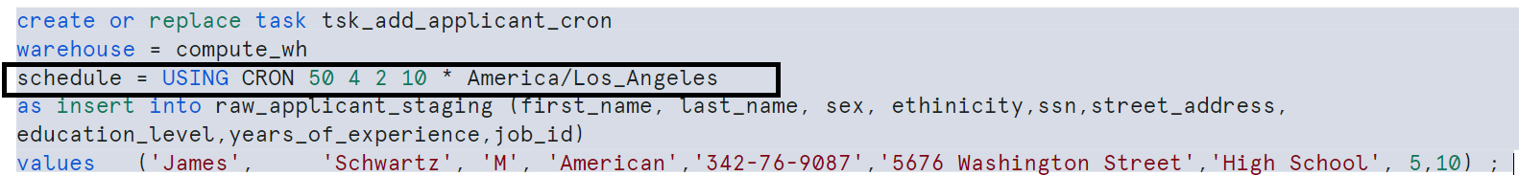
Case4: Runs at 4.50 AM in Oct every Monday as per LA time zone
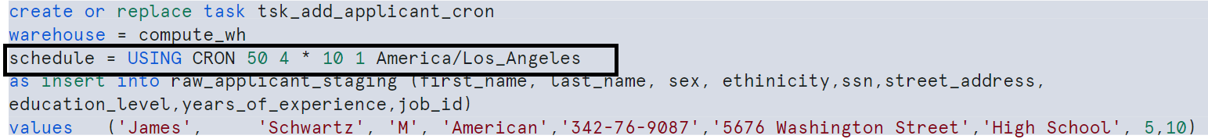
Case5: Runs every hour from 4:00 AM to 8:00 PM on last day of each month
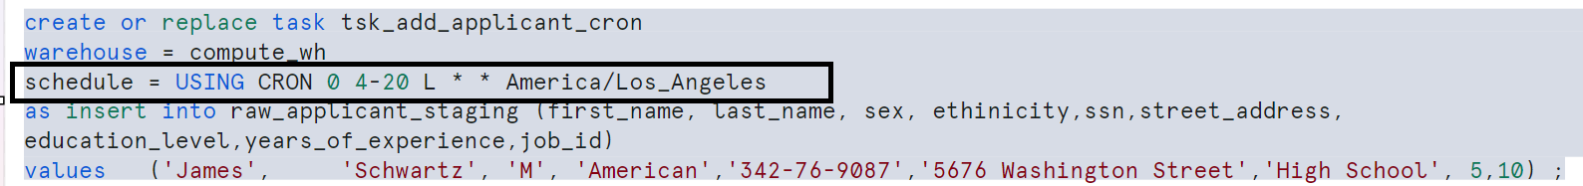
Note: 20 implies 8:00 pm
Case6: Runs every hour from 4:00 AM to 8:00 PM on last day of each week i.e. SAT
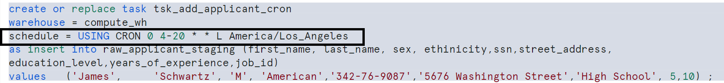

Note: please observe carefully of the above written schedules

Dag (Directed Acyclic graph) or Tree of TASK:
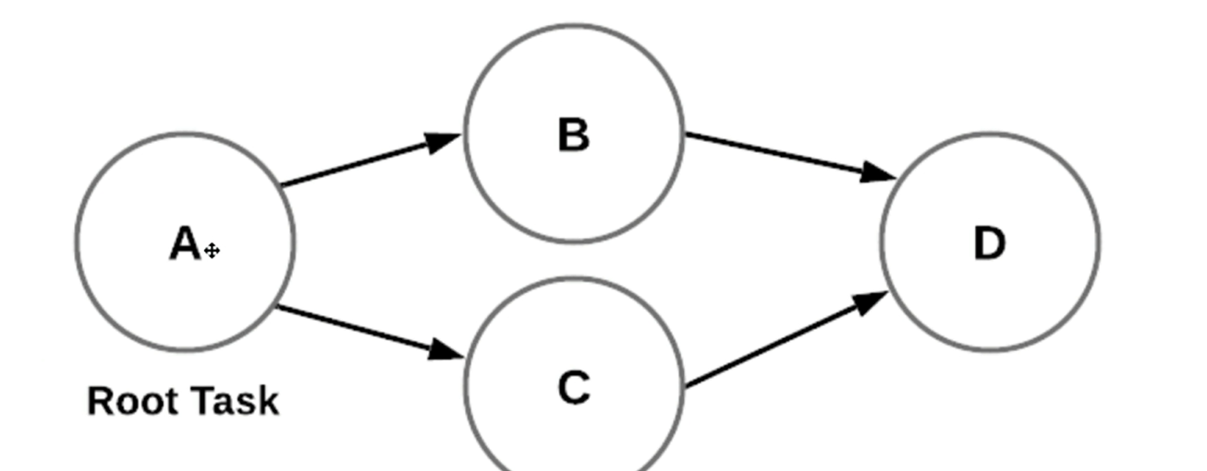
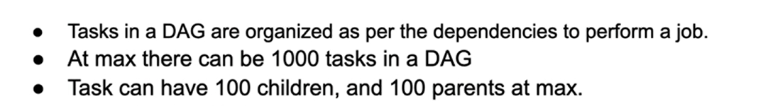
Let’s see it practically
Create a table
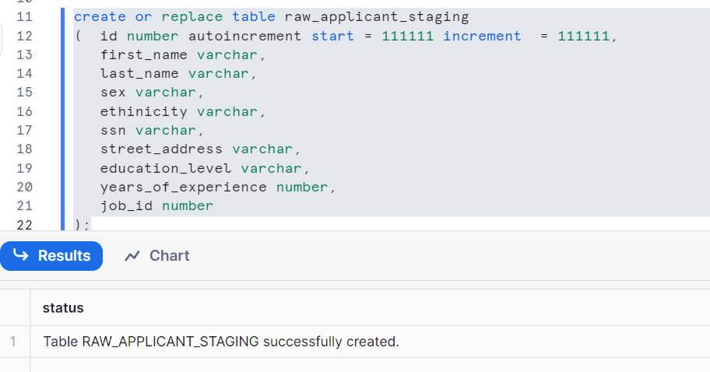

Create another table
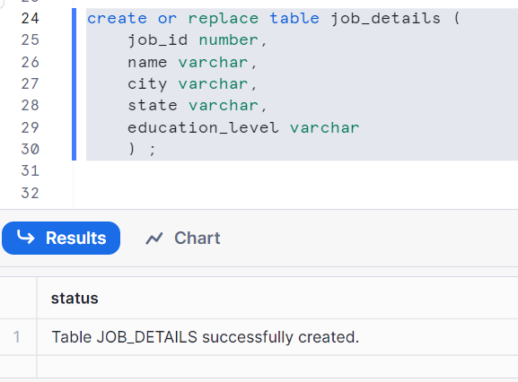
Let’s insert some data in job_details table
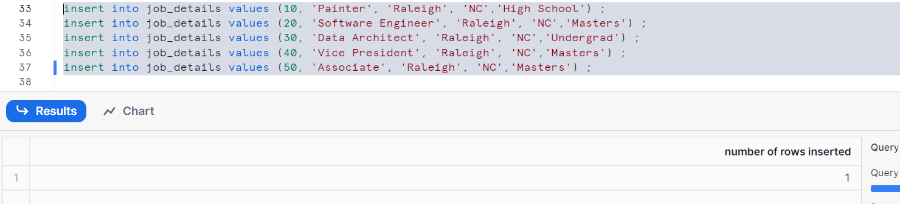
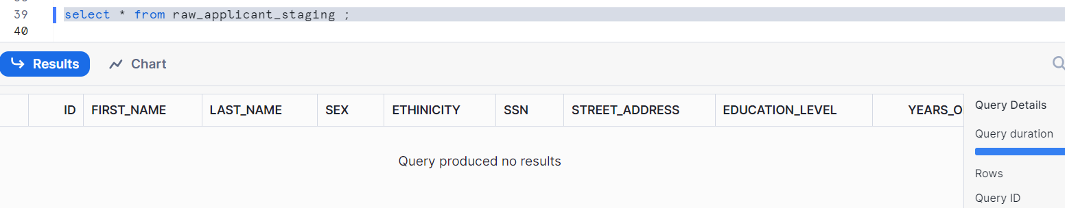
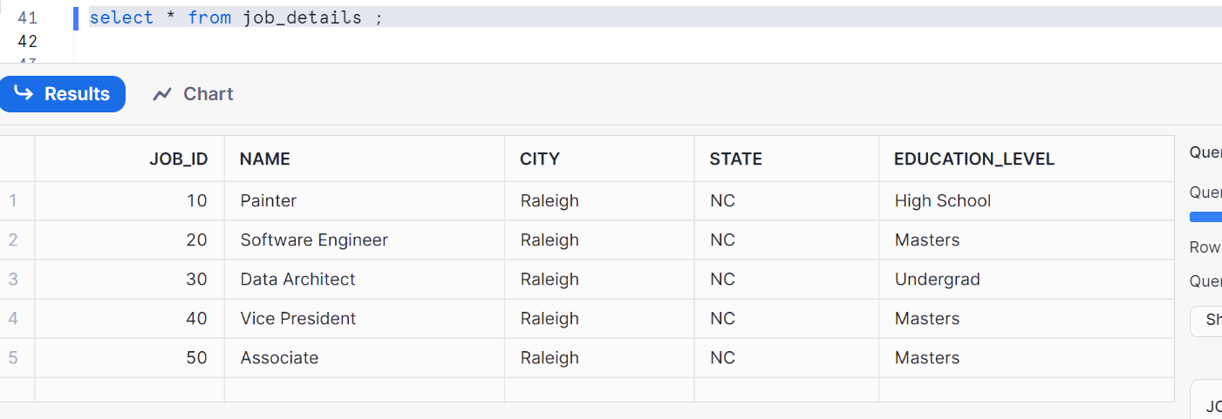
Let’s create a target table
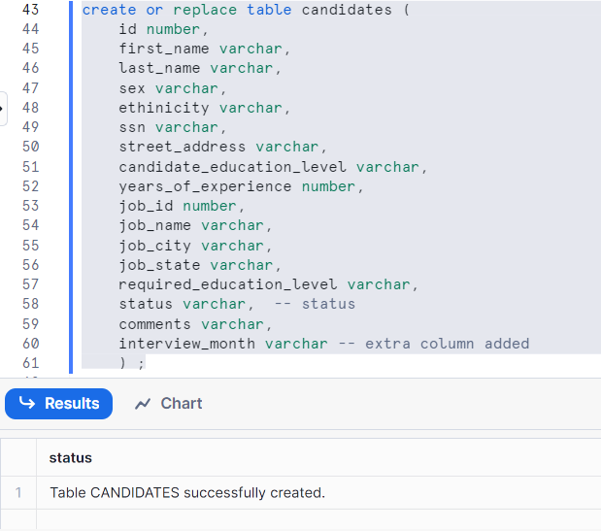
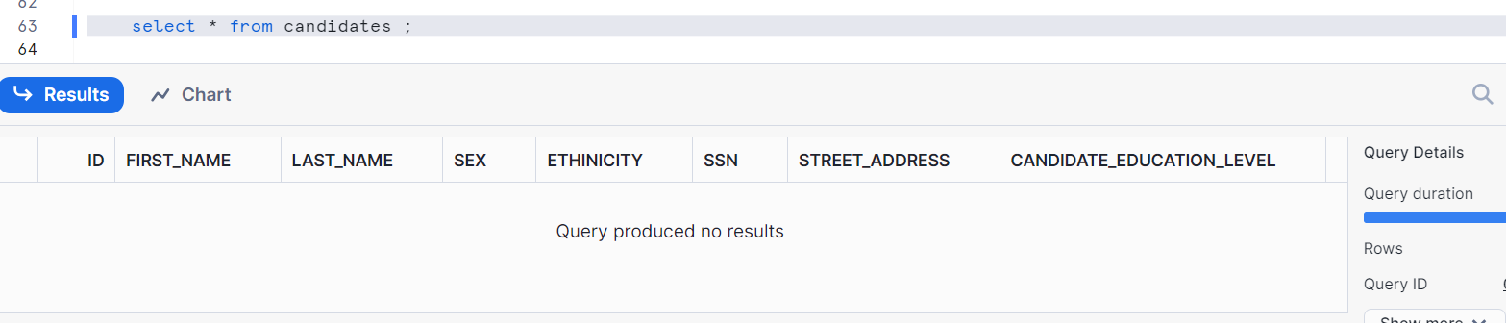
Overall view of creating Dag/tree for the above
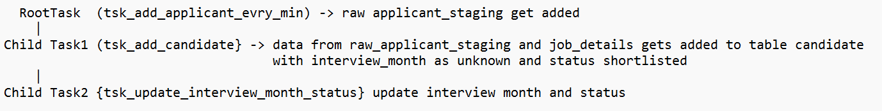

Let’s create root task i.e.
1 record will be inserted in the staging table when u resume task after 1 min
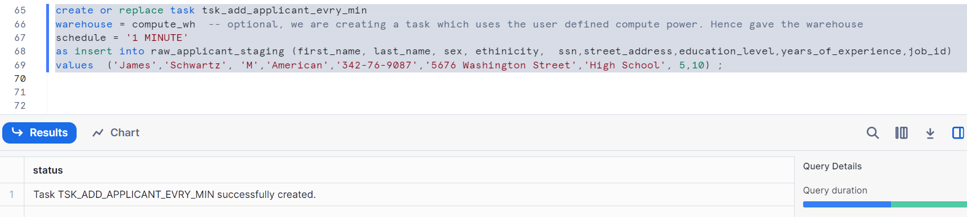
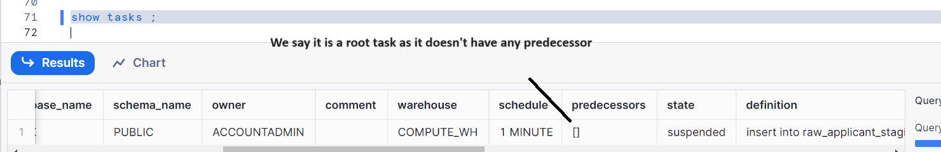

Let’s create a child task 1
This child task 1 is to create a task, run it after root task & merge by joining with staging table and job_details into target table
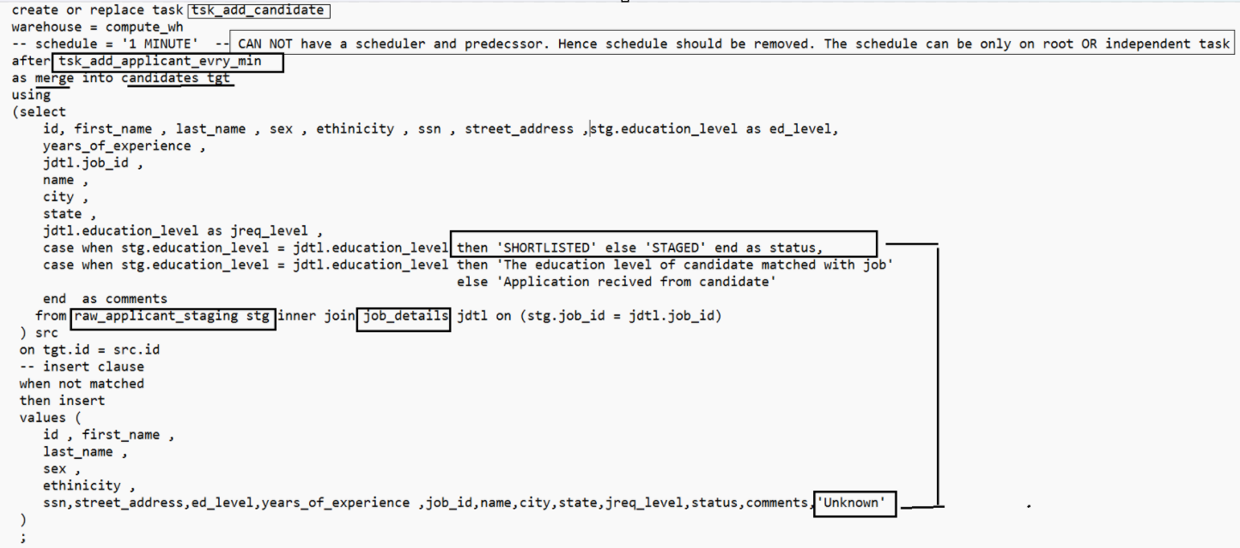
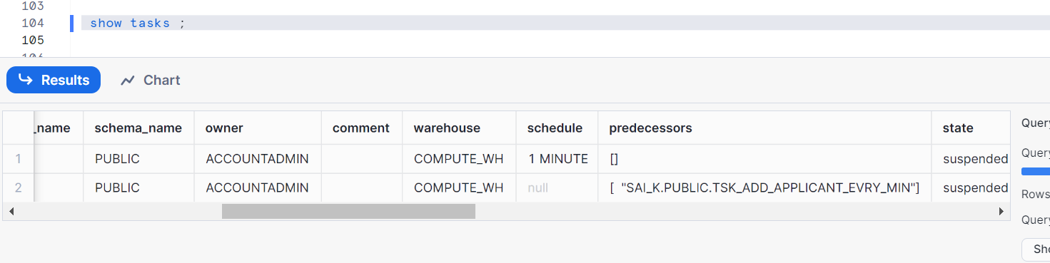
Now, let’s resume this child task 1
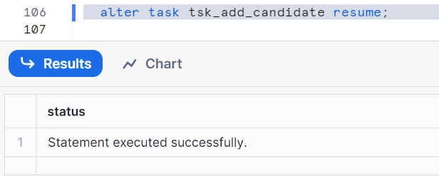

Let’s create child task 2, before that we will see some functions
Getting the month by adding a number in current date. The below query gives August
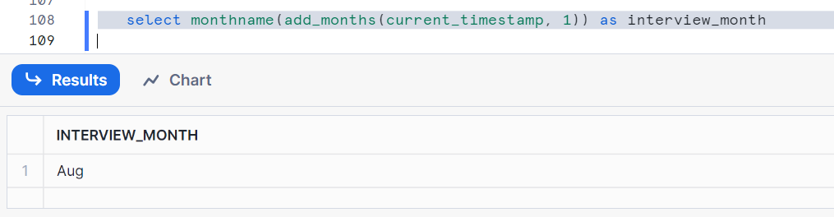
Get a random number from below between 0 and 11
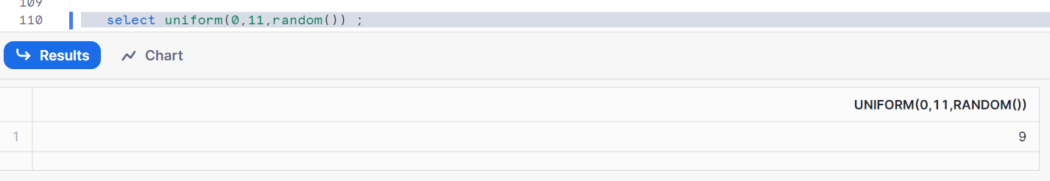

Get a random month as per the below syntax
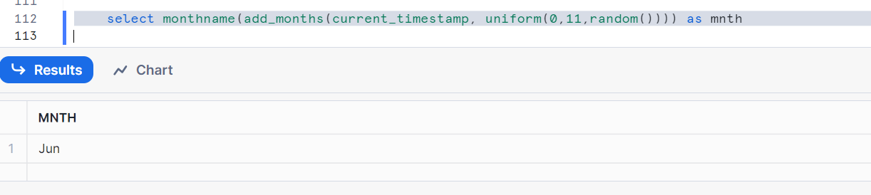

Let’s create child task 2, where we are updating target table after child task 1 is done
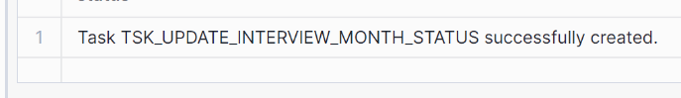
Let’s resume our child task2
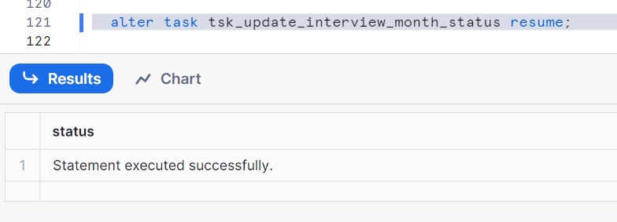
First let us check the data before running resuming the root task
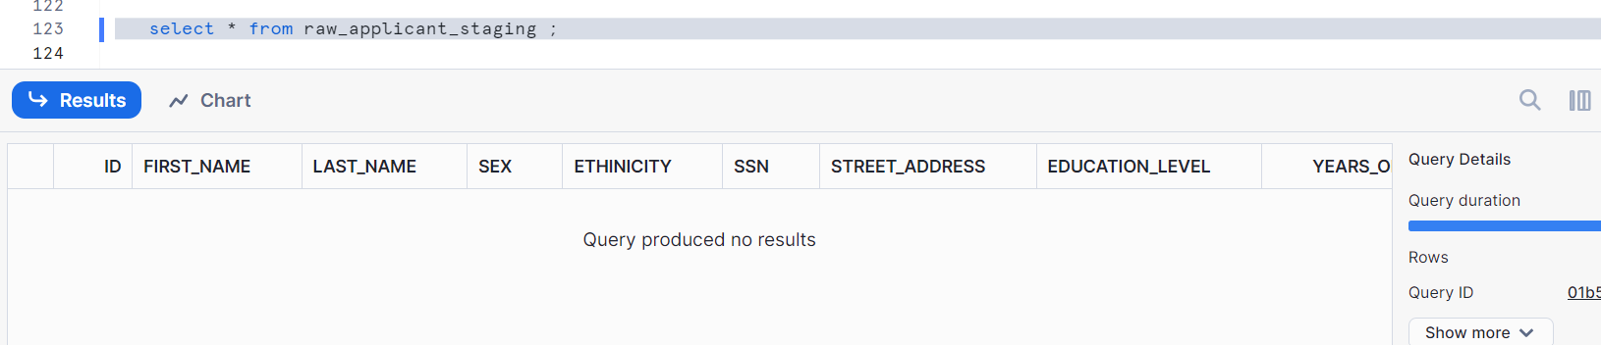
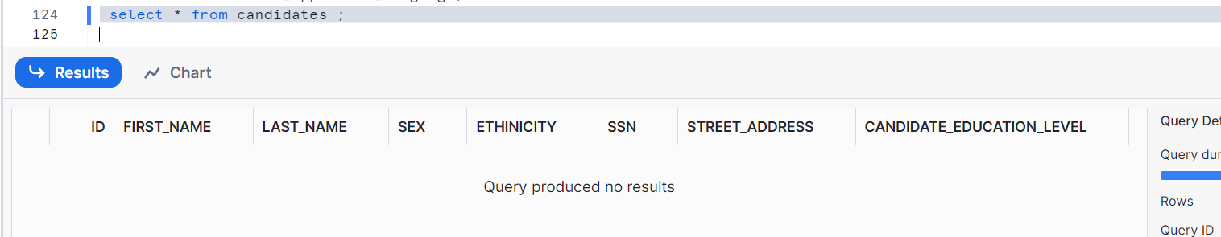
Let’s resume the root task
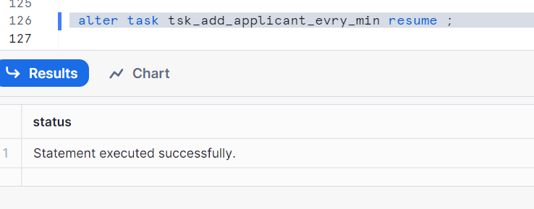
Let’s wait for 1 min and check the data
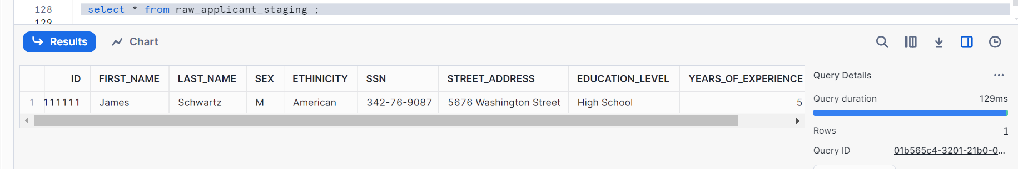
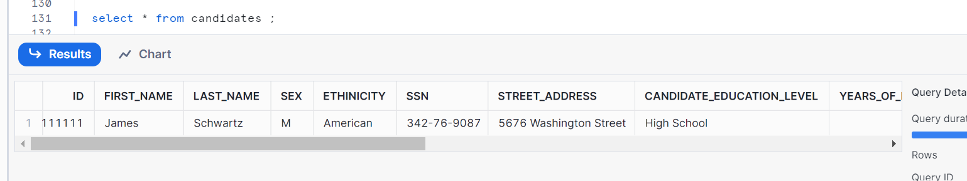
We noticed, that when u run the root task then child tasks related to it gets executed one by one in an order i.e. while creating, we had used the keyword ‘after’

Task history
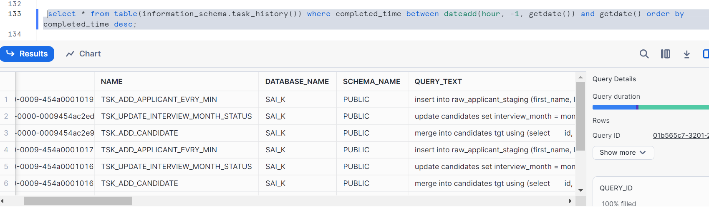
Now, let’s stop this root task else it goes on running every 1 min
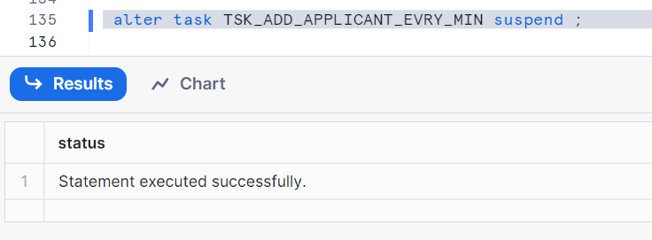

Thanks

