TASKS
WITH STREAMS
Let’s do it hands on
Create a table
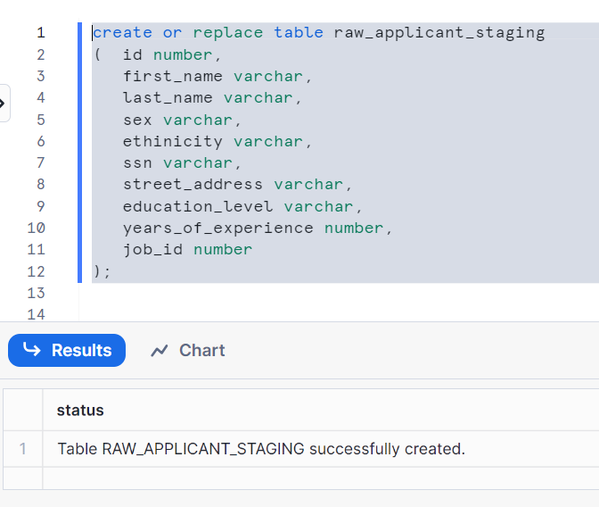
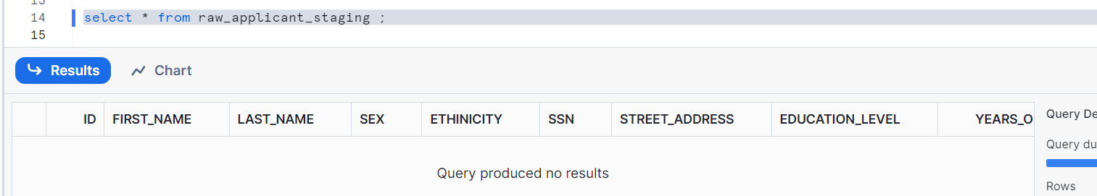Let’s create another table job_details
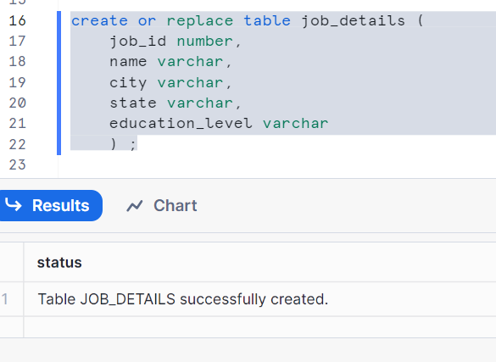
Let’s insert some records in it
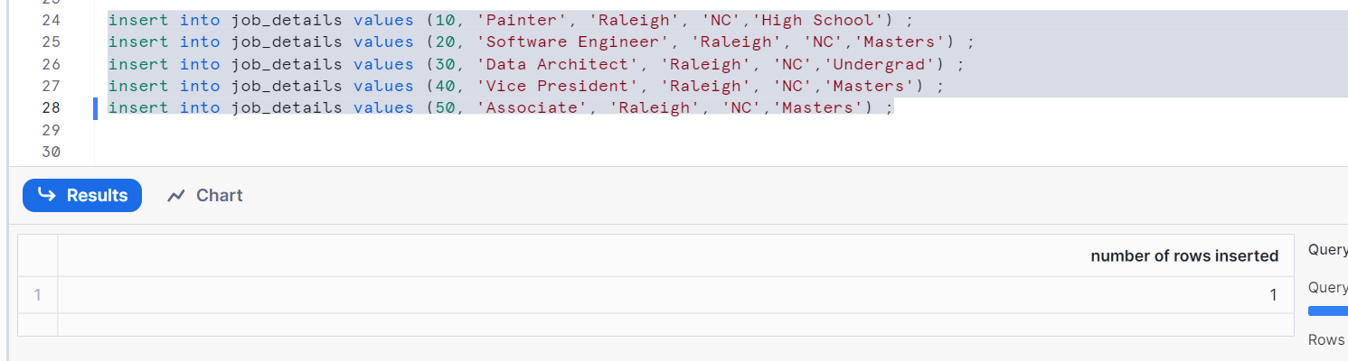
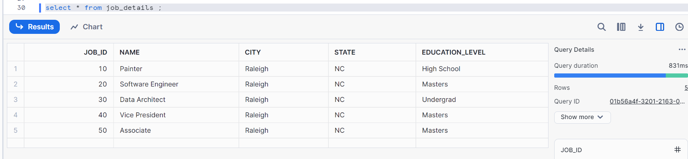
Let’s create target i.e. candidate table
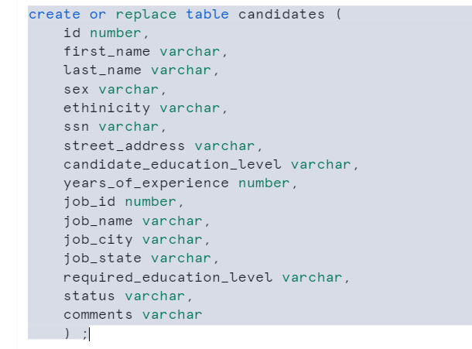
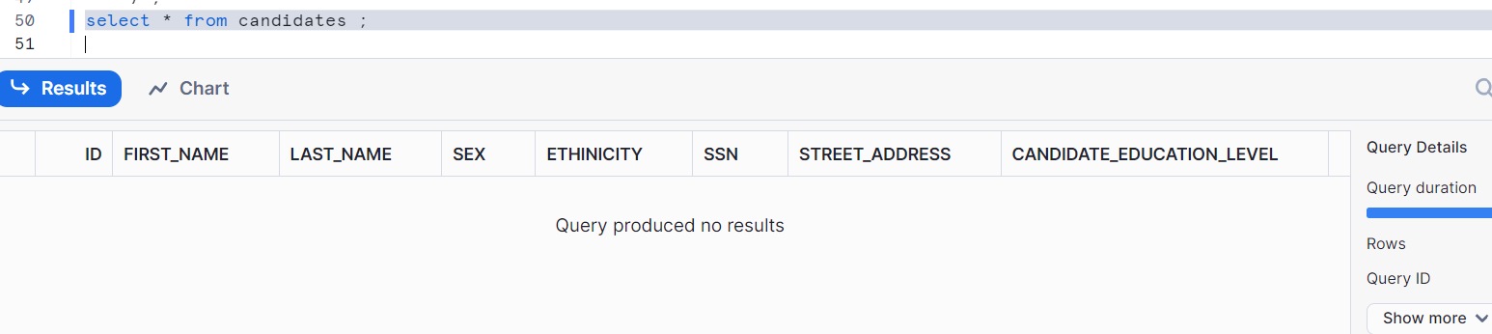
Create a default stream on raw_applicant_staging
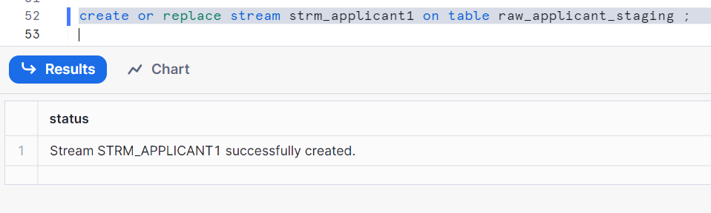
Creating task using stream (note: we used ‘when’ clause application i.e. applicable only for streams). Please check the post snowflake_40 and snowflake_41
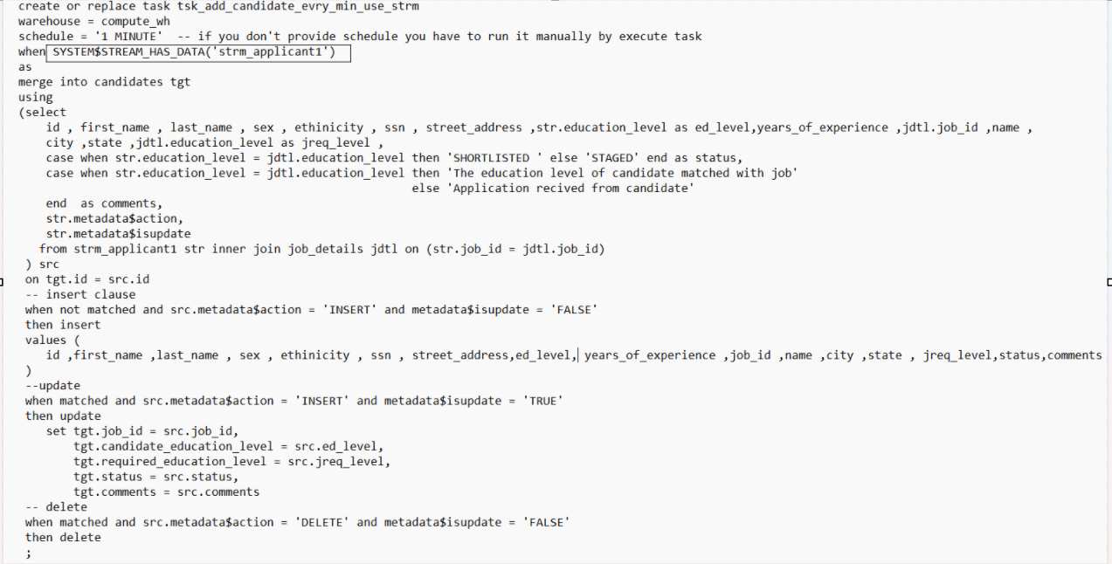
Resume the task
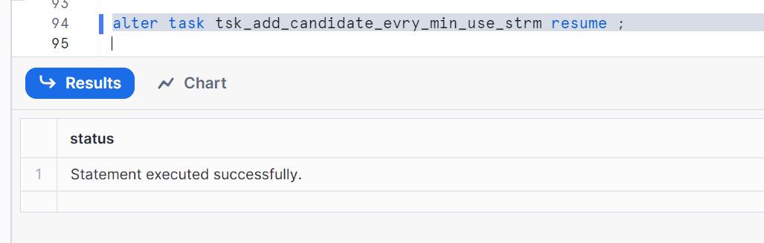
Let’s insert some data in raw_applicant_staging table
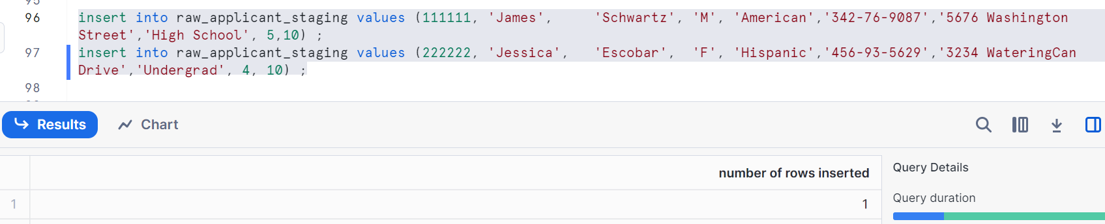
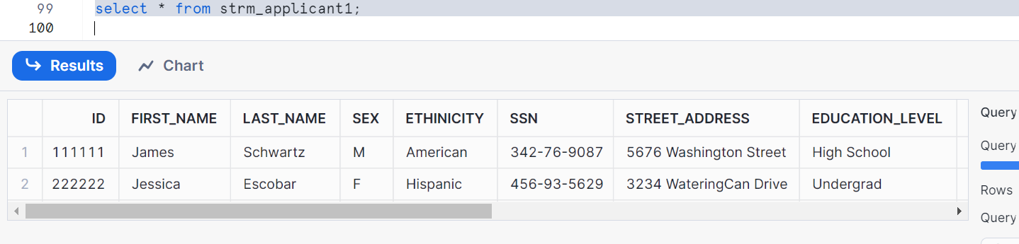
Wait a minute and check the target
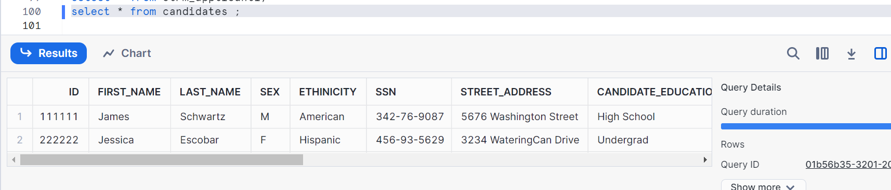
Insert three more rows
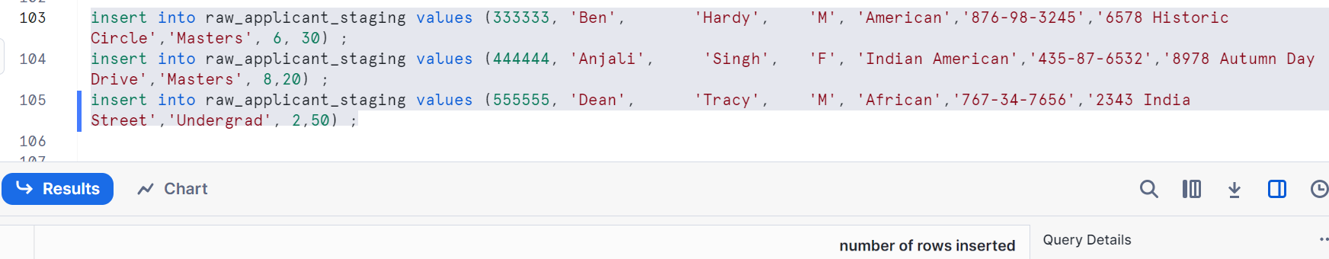
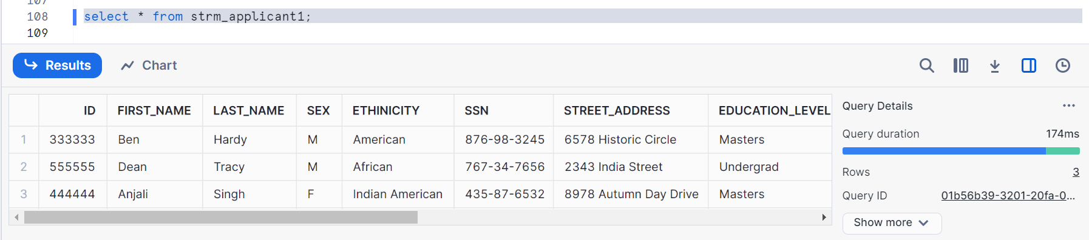

Wait a minute & check
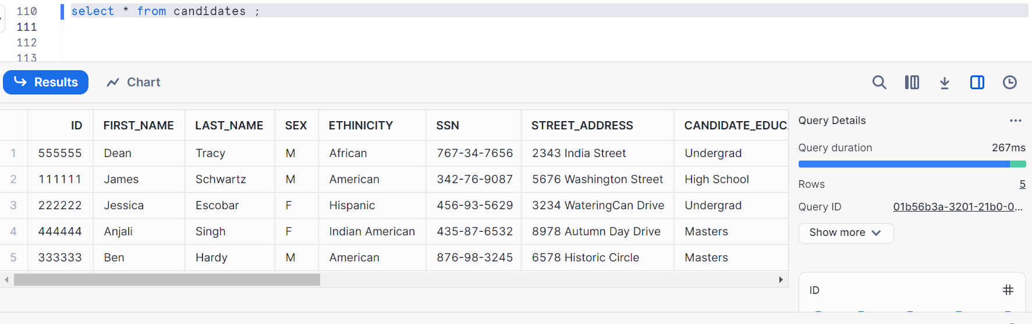
Check stream, it consumes data
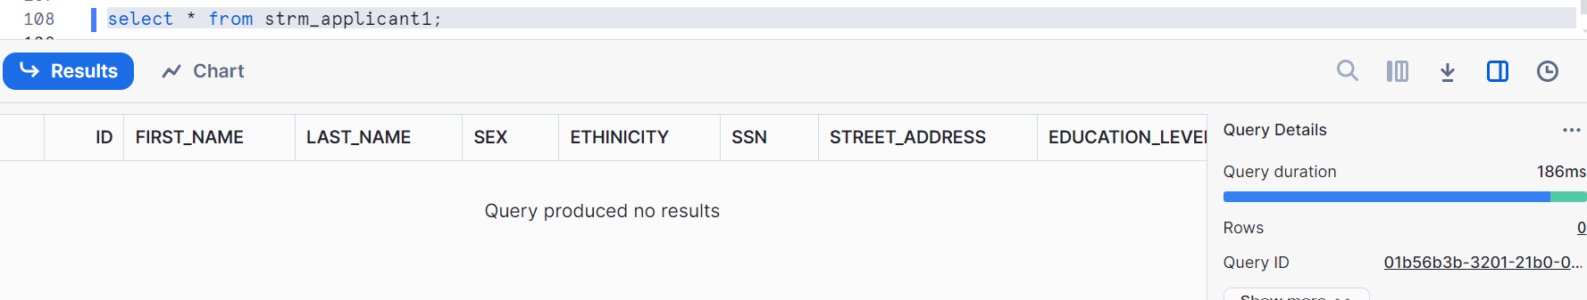
Now, update the data in staging
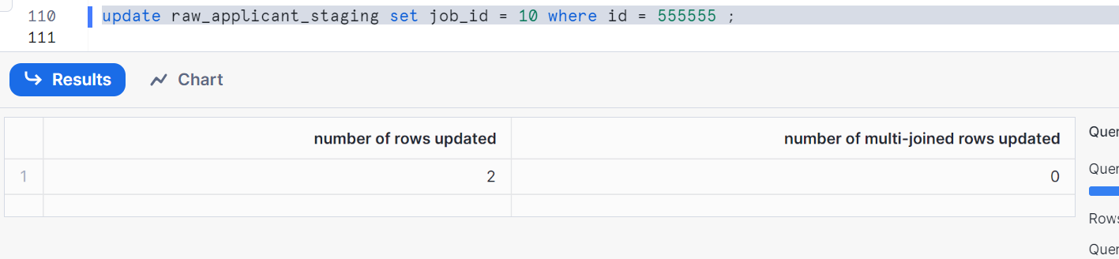
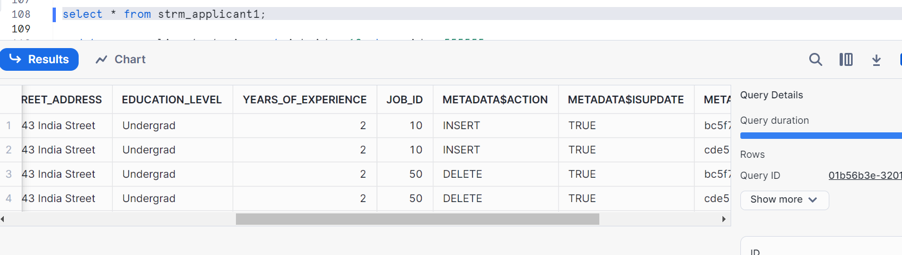
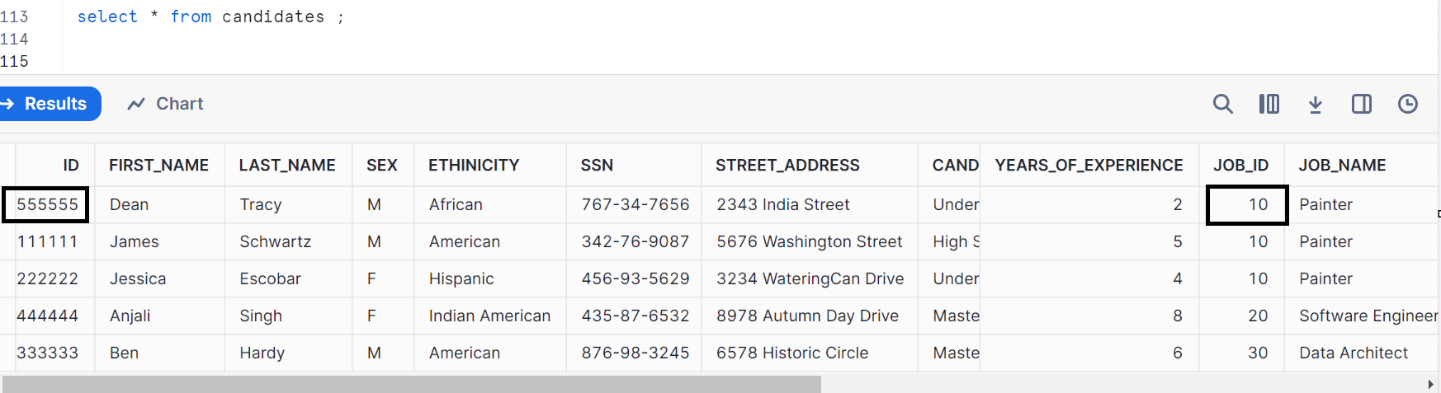
It got updated in the target
Pull the records which are inserted
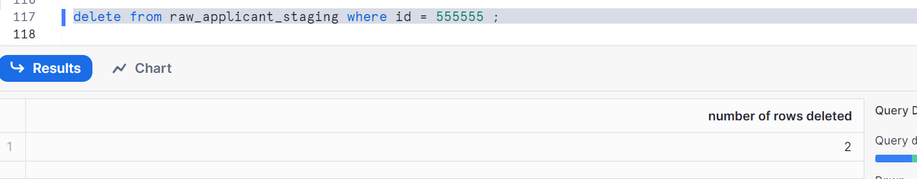
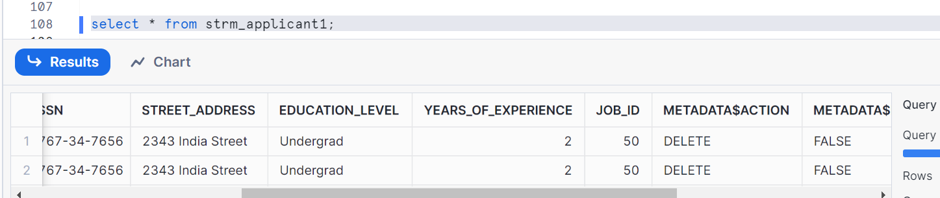
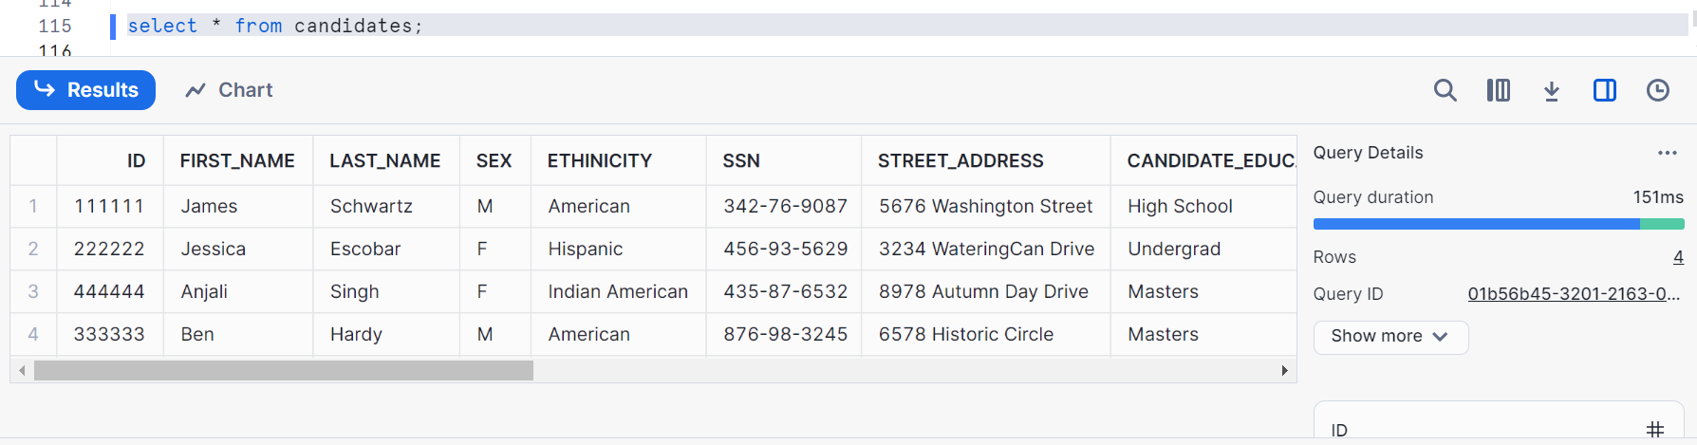
Hence, there is no id 55555 as it got reflected in target as shown in above image

You can check your task history as shown
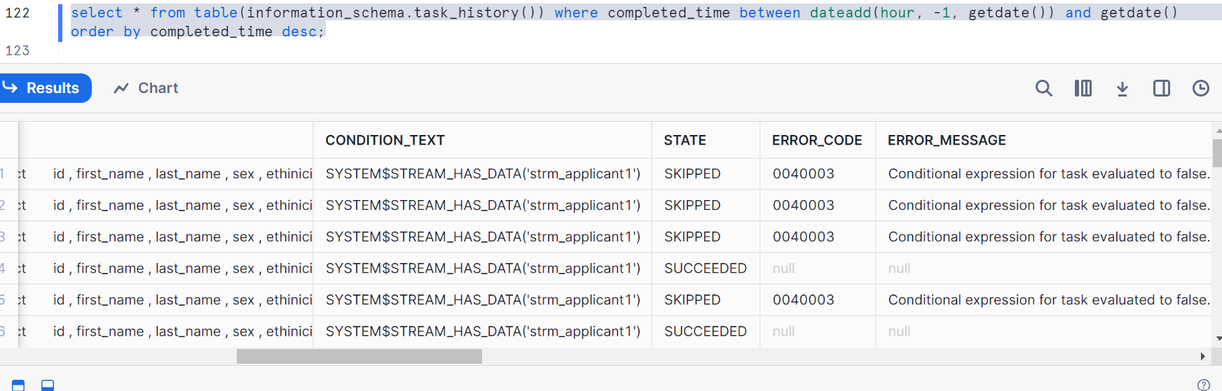
Clean up:
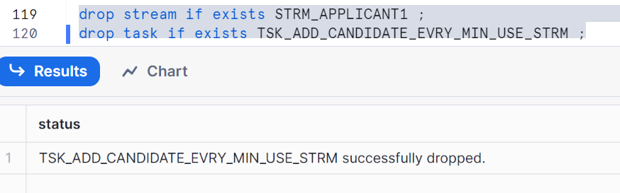
User managed tasks and warehouse considerations
Considerations while estimating a warehouse size when creating a user managed task:
