SNOWFLAKE
Introduction:
The Snowflake tool, or Snowflake Data Cloud, is a cloud-based data platform designed to simplify the storage, integration, and analysis of data. It serves as a comprehensive solution for data warehousing, data lakes, data engineering, data science, data application development, and data sharing.
Core Features of Snowflake:
- Cloud-Based
- Storage and Compute Separation
- Multi-Cloud Support (AWS – 2014, Azure – 2018, Google Cloud Platform – 2020)
- Data Sharing
Problems in traditional architectures:
Shared Disc Architecture:
Different compute nodes are connected to shared disc as shown below
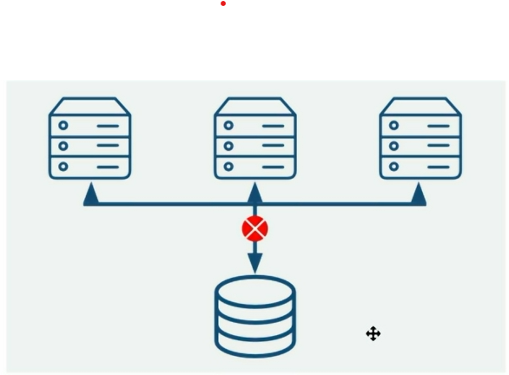
When load increases, multiple nodes are added and shared disc becomes a limitation
To solve this problem, non-shared disc architecture is introduced
Non-Shared Disc Architecture:
Here, each node has its own disc and they are connected with each other
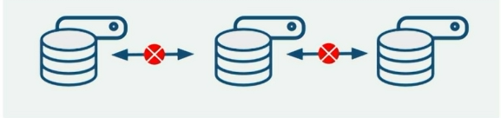
When work load increases, each node has its own disc and process faster
But the challenge is maintain consistency in the data that has to be shuffled across the nodes

Hence, SNOWFLAKE solves the challenges in the both the architectures and that’s the reason it is called as “hybrid shared & non shared disc architecture” model

Snowflake Architecture:
- Database Storage: Data is optimized, compressed, columnar format which snowflake manages and data is stored in cloud platforms (AWS S3 buckets) which is not directly visible or accessible to users instead u can get by SQL in snowflake
- Query Processing Layer:
- Muscle of the system
- Query execution using virtual warehouse
- Massively parallel processing compute cluster (has various number of compute nodes)
- Service Layer: Brain of the system (lot of management is done here)

