SNOWFLAKE
Virtual warehouse:
- A virtual warehouse in Snowflake is a powerful concept that represents the computational resource used for executing queries and performing data manipulations.
- A virtual warehouse in Snowflake is entirely software-defined, making it highly scalable and flexible.

Virtual warehouse Sizes
Virtual warehouse belongs to query processing layer as per snowflake architecture (from post1 of snowflake)
Virtual warehouse (VWH) in Snowflake is MPP (massively parallelly processing) cluster
Each VWH you create has its own cluster size (the more the size, the more the cost) and each cluster has its compute nodes as per the following
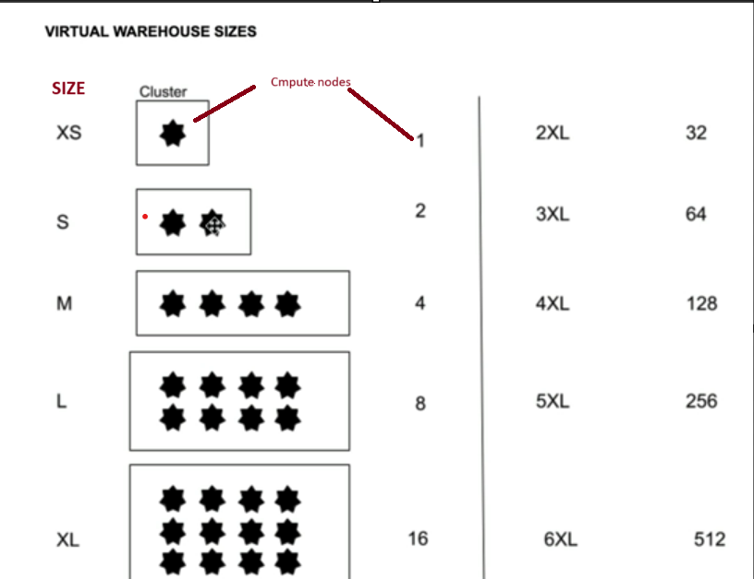
So, let me assume I had created a virtual ware house in snowflake of size Large (which has 4 compute nodes), now as we have a single cluster which has same compute power to execute the queries for different users at different times
But what if all the users came at same time to EXECUTE???
As the concurrency increases as we have limited computer power of Large size VWH, users had to wait in que
So in order to avoid this and get the output faster for all the users at same time, SNOWFLAKE introduces a concept of MULTI-CLUSTERING
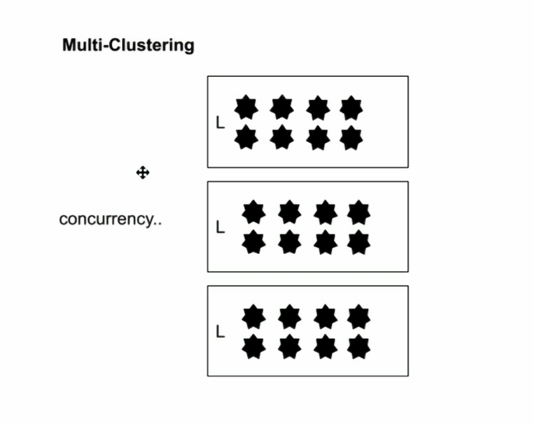
Here as the concurrency of users increases, VWH creates its own clusters automatically as per what we give while creating VWH (took 3 clusters max as e.g.) .Hence as the number of clusters are increased, the compute power is increased and hence users at same time gets their output without waiting in que

CREATING YOUR OWN VIRTUAL WAREHOUSE
Go to Admin on click on warehouses:
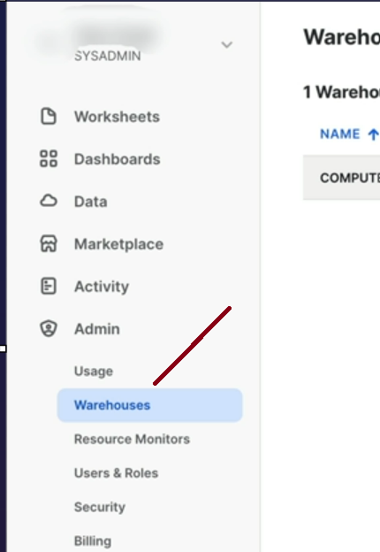
CLICK ON THE + TO CREATE
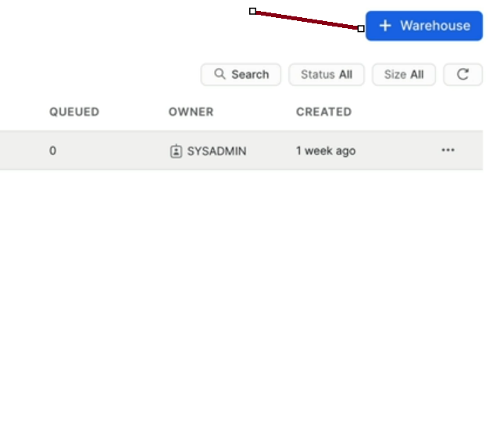
Choosed X-small size for cost saving
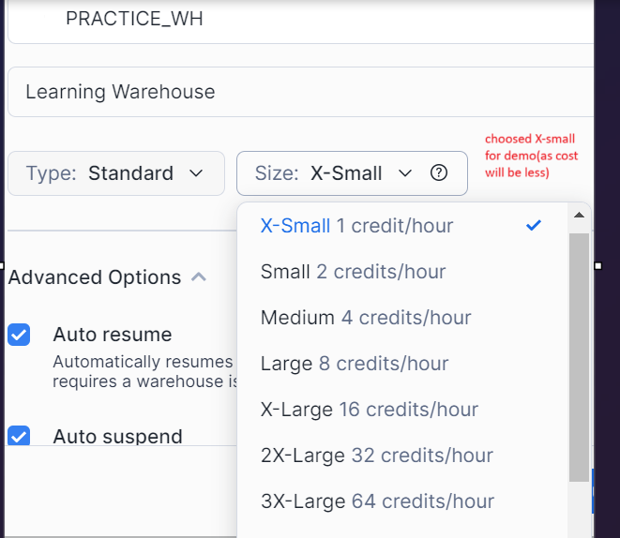
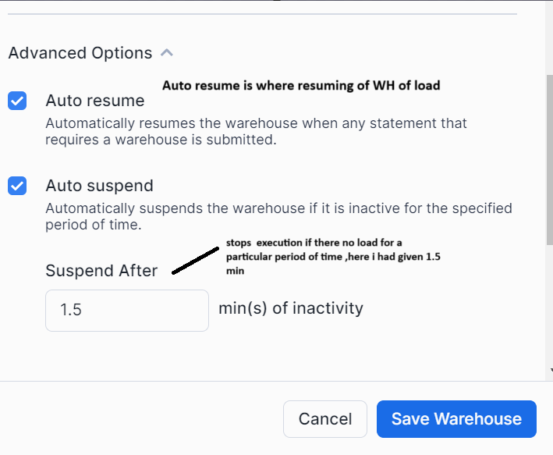
As every second is important to save the cost, hence these options play a crucial role
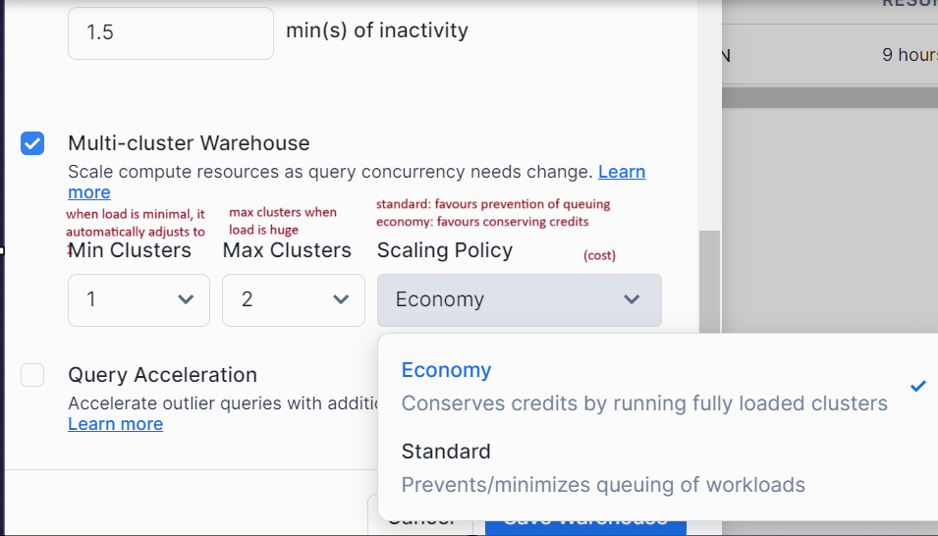

Click on save warehouse
Now once u created click on 3 dots as shown
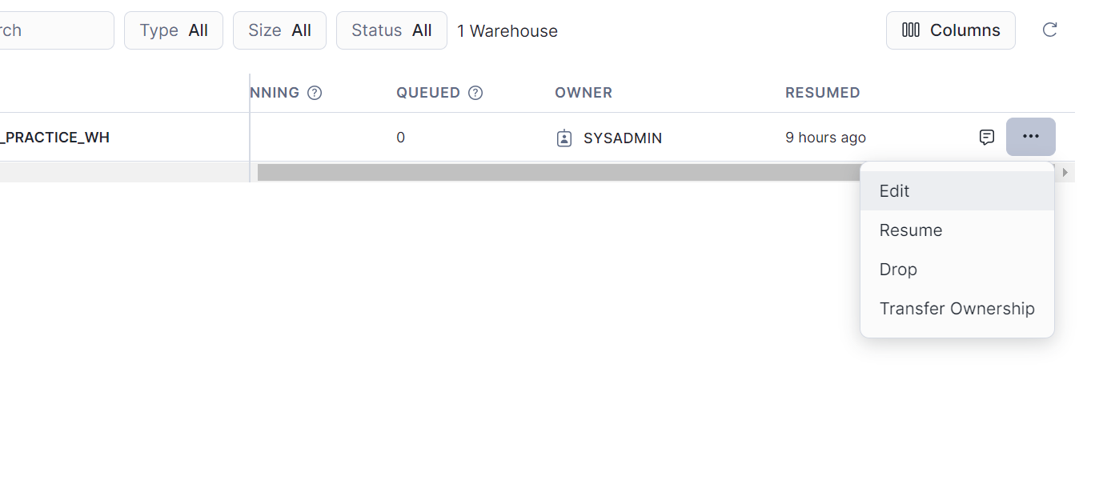
1. Edit is to change what u want to change
2. Resume: while resuming, u have an option to increase size
3. Drop: u can delete your WH
4.transfer ownership: you change as per your requirement

