SNOWFLAKE
As per the previous post i.e. snowflake_2, what is scaling policy actually mean while creating VWH????
Scaling Policy represents a Virtual warehouse (VWH) to decide when to start additional clusters to be started as per the load
Two types of scaling policy:
- Standard
- Economy
Standard:
Favors prevention of queuing (prevents waiting of users)
Economy:
Favors conserving credits (cost saving and most companies prefer this)

Now let’s see how this scaling policy works when Warehouse starts and ends in both standard and Economy scaling policies
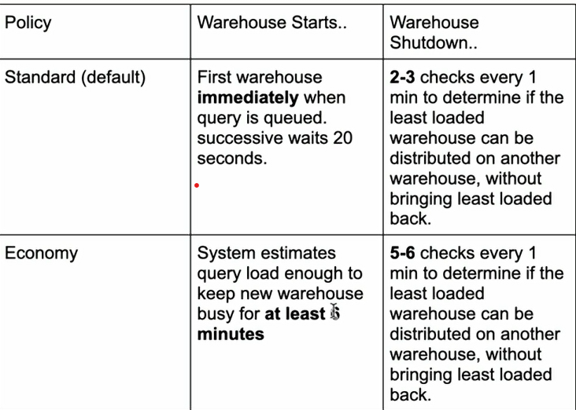
Creating a new database
Click on databases under Data tab, click on + symbol and create your own database by giving a name
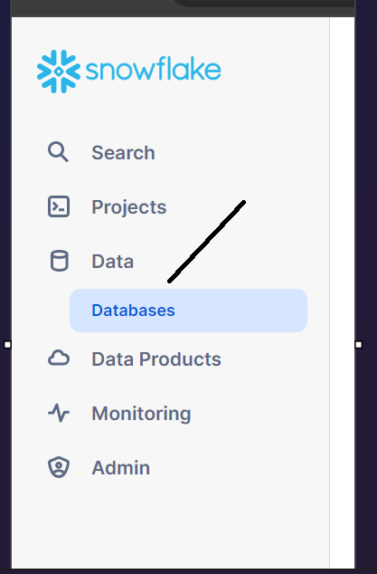
When you create your DB, we got by default two schemas
1. Information schema
2. Public schema
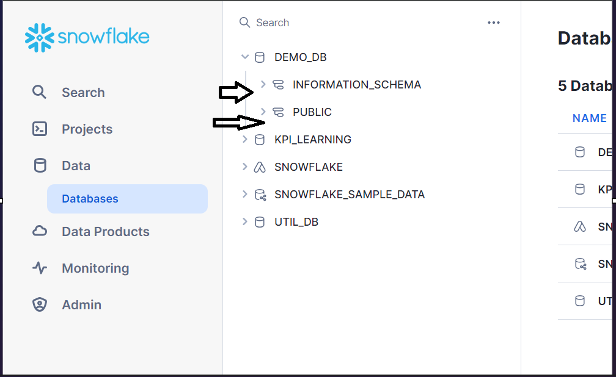

Create a table in the database u created
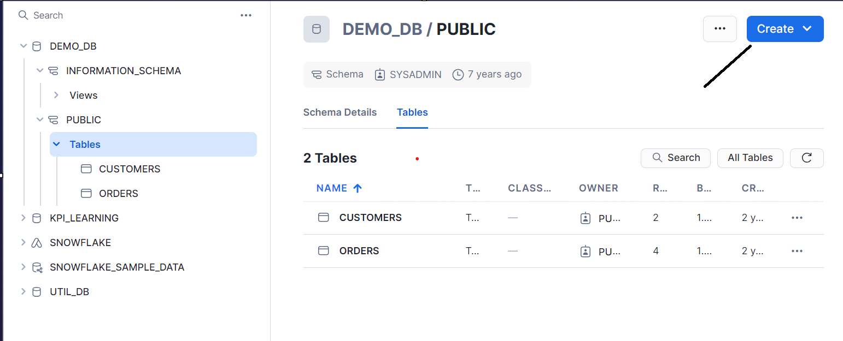
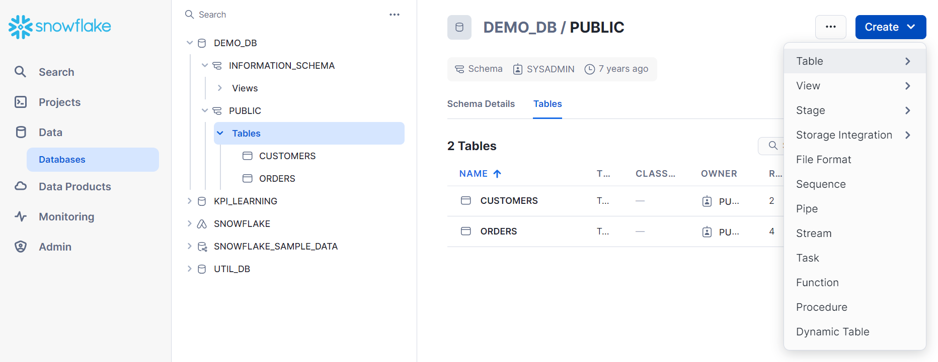
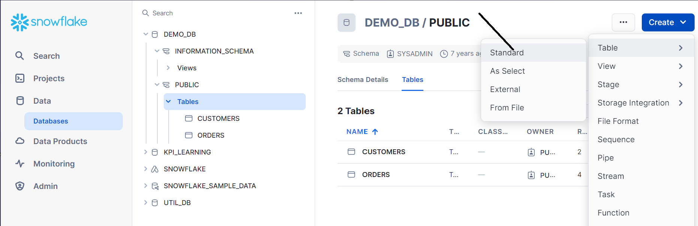
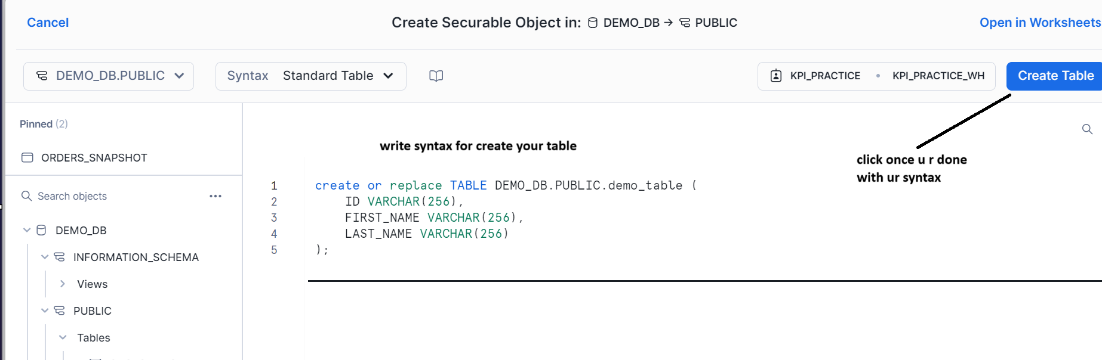

U can also insert values into your table and make your table ready with values in your database

Load csv file from S3 bucket
Go to your worksheets, click on new worksheet and u can see all the DB’s on left
Click on which DB u want to select and schema as shown
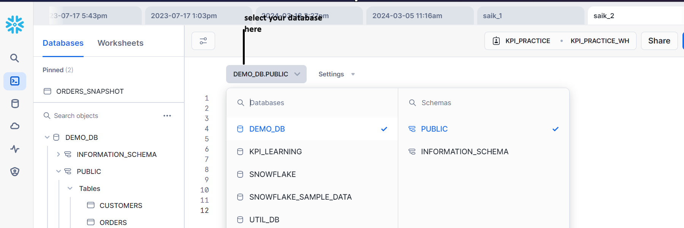
Create a table, I created contacts as example
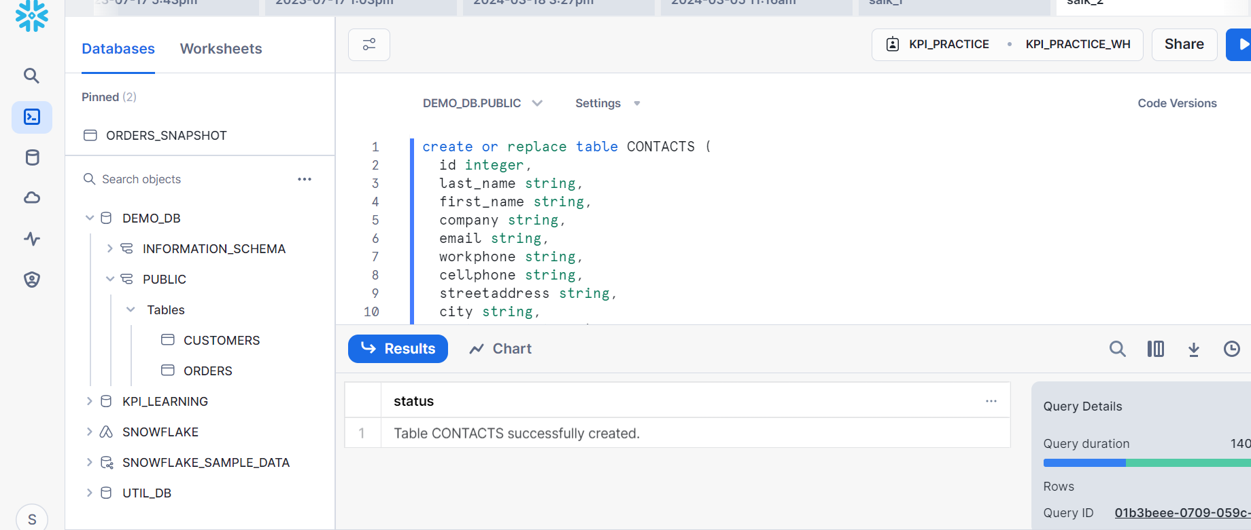
Copying the data from s3 bucket with the syntax as shown
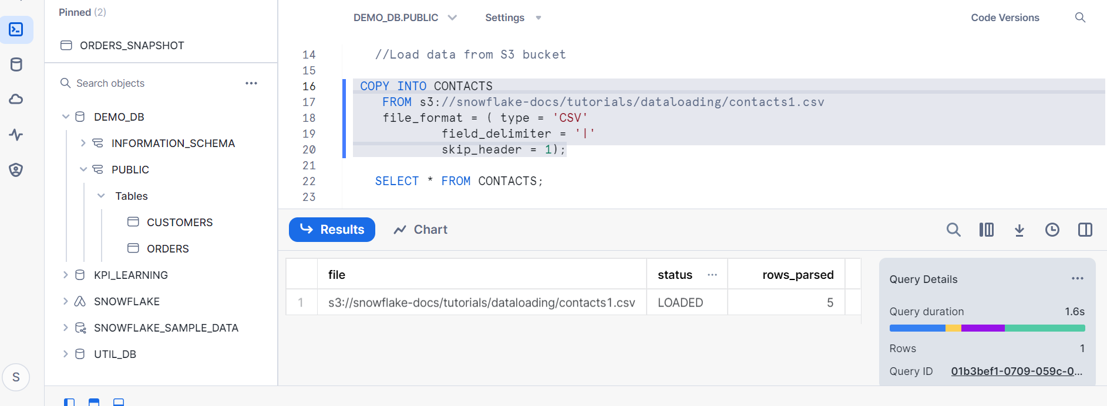
Now the data is available in contacts table
