SNOWPIPE
Snowpipe is the capability in snowflake, which is provided to load the data continuously

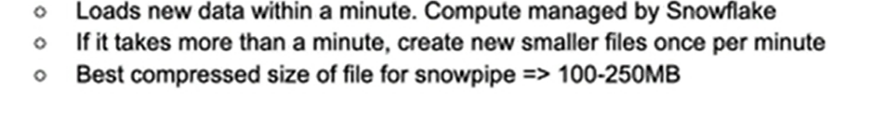
Flowchart
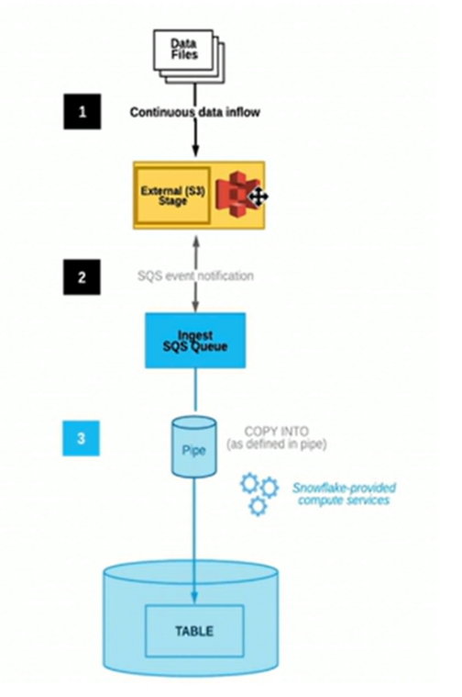

Steps to load data via SNOWPIPE:
1. Use existing S3 bucket
2. Create the integration object
3. Create file format
4. Create external stage
5. Create the table to load the data via pipe
6. Create and test the copy command
7. Create pipe
8. Create S3 notification
9. Place the files in S3 bucket and validate the load

Let’s do some hands on
First, let’s go to our S3 bucket and create a folder ‘snowpipe’ and upload a file in it as shown
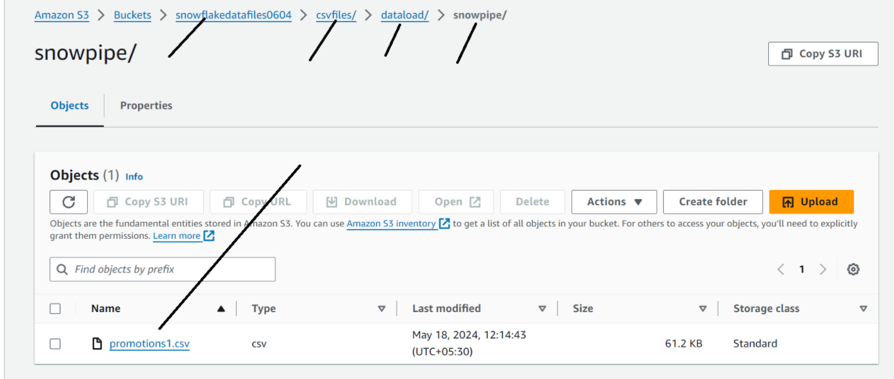

Let’s create an integration object in snowflake (refer snowflake_23 post)
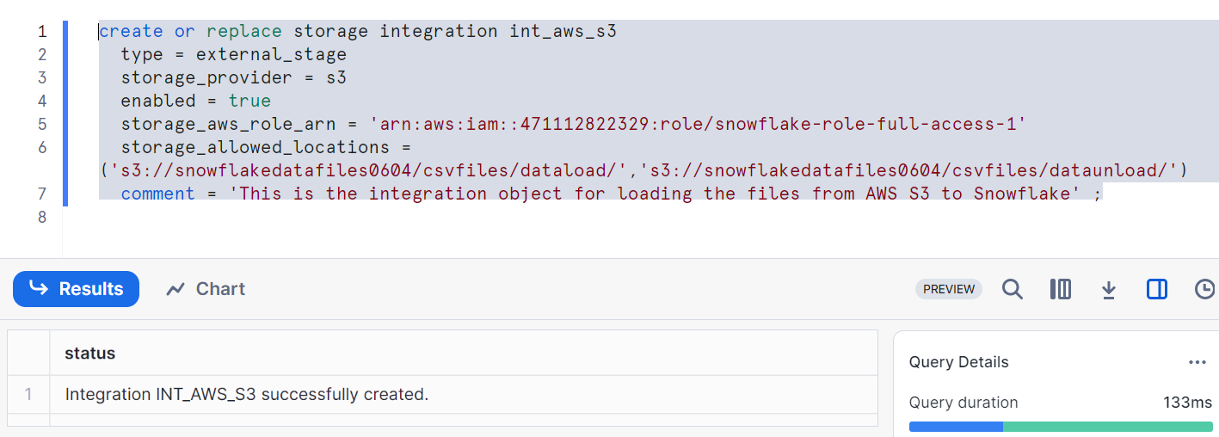
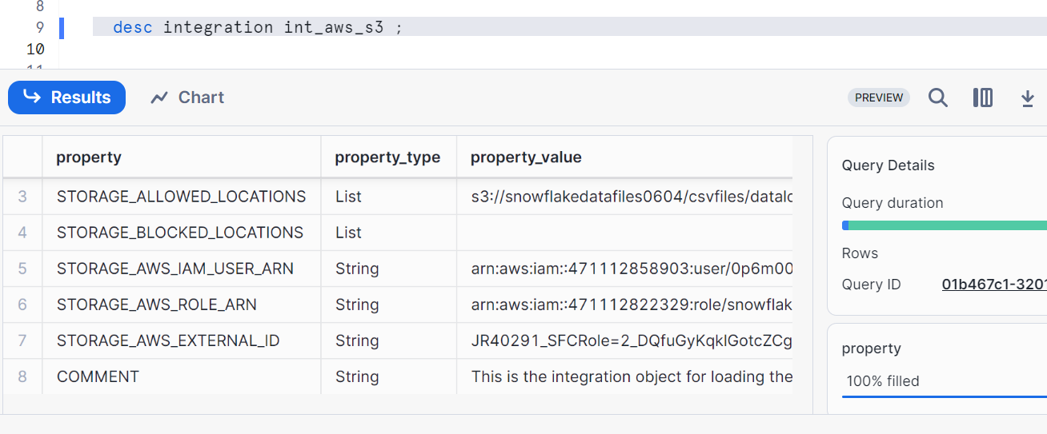
Copy ARN and External ID in IAM Role at AWS (refer snowflake_23 post)
I.e. copy STORAGE_AWS_IAM_USER_ARN & STORAGE_AWS_EXTERNAL_ID in edit trust policy as shown
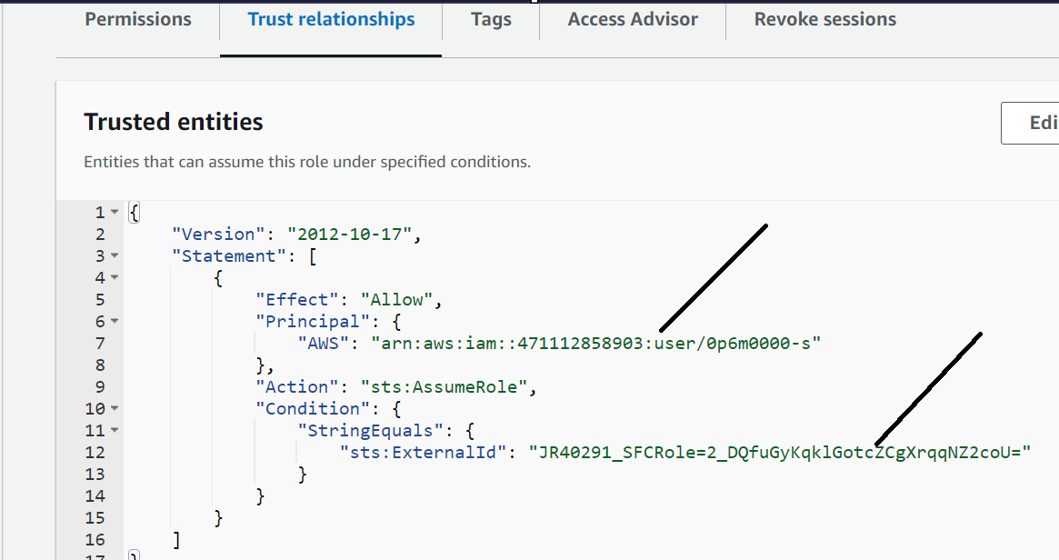
Creating file format
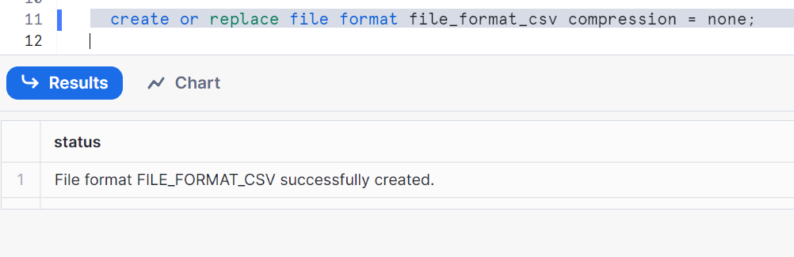
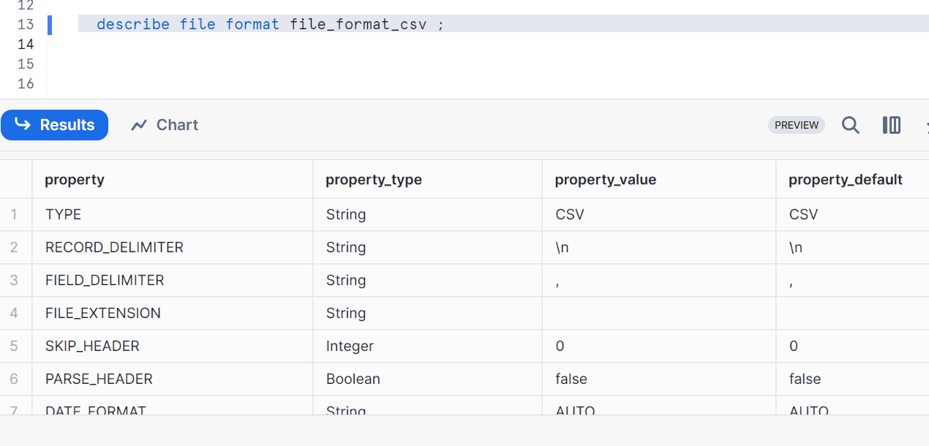
Creating external stage for loading data
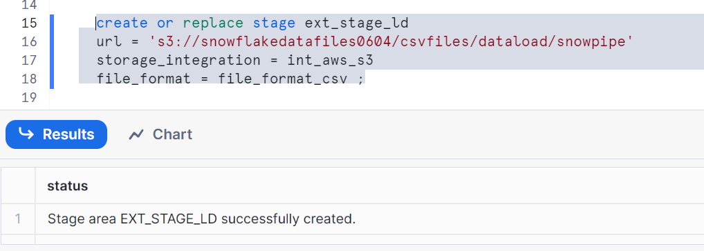

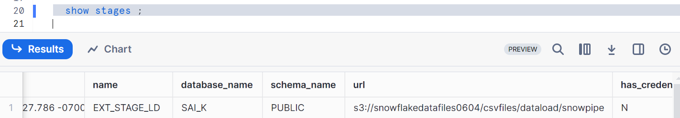
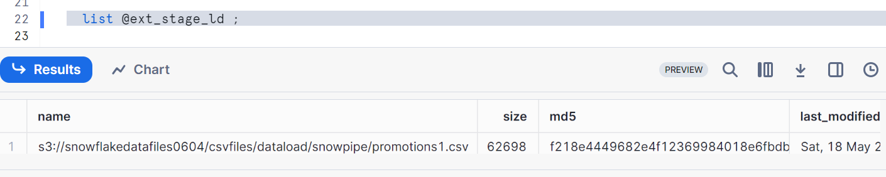
Create the table to load
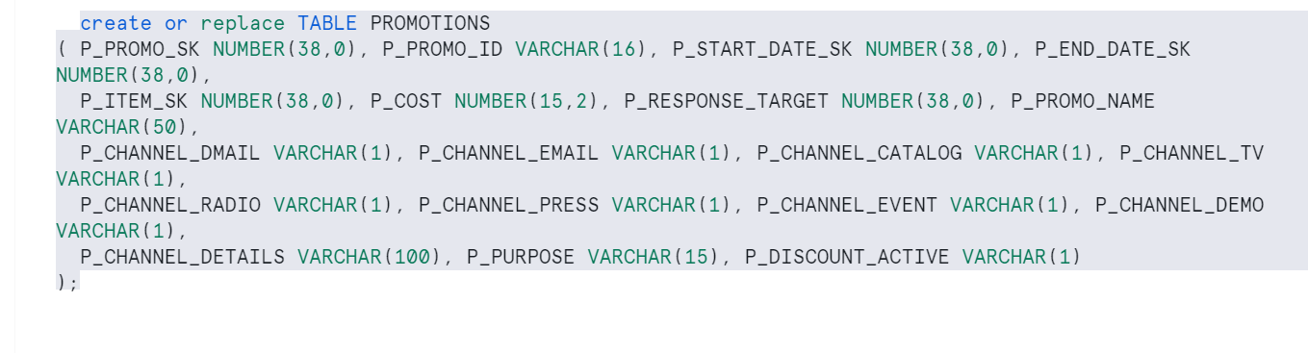
Copy from external stage
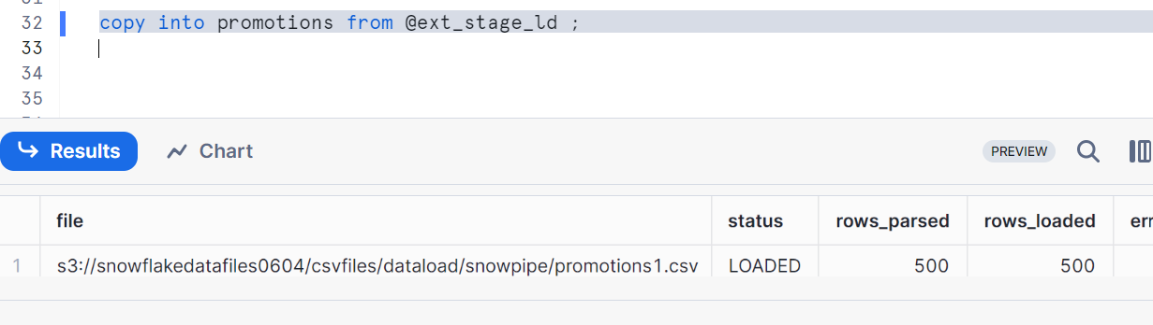
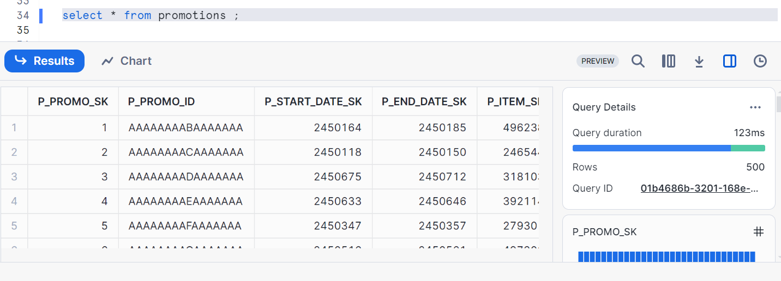
Now, let’s create a PIPE
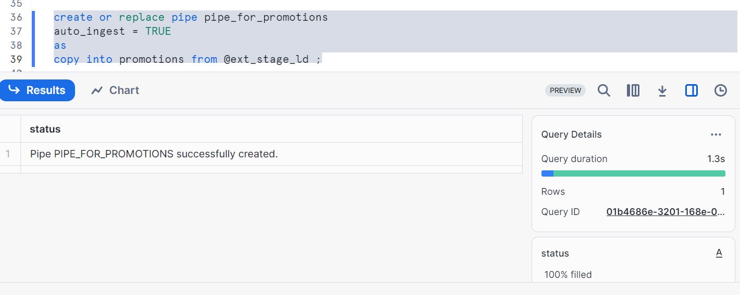
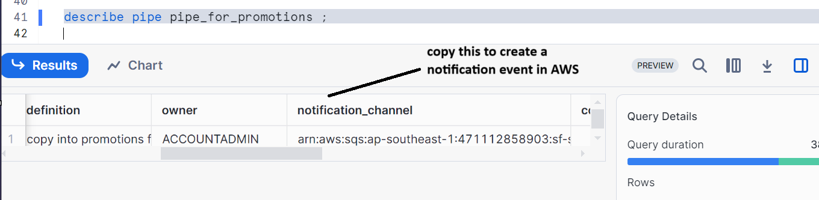
Go to your S3 bucket and click on properties
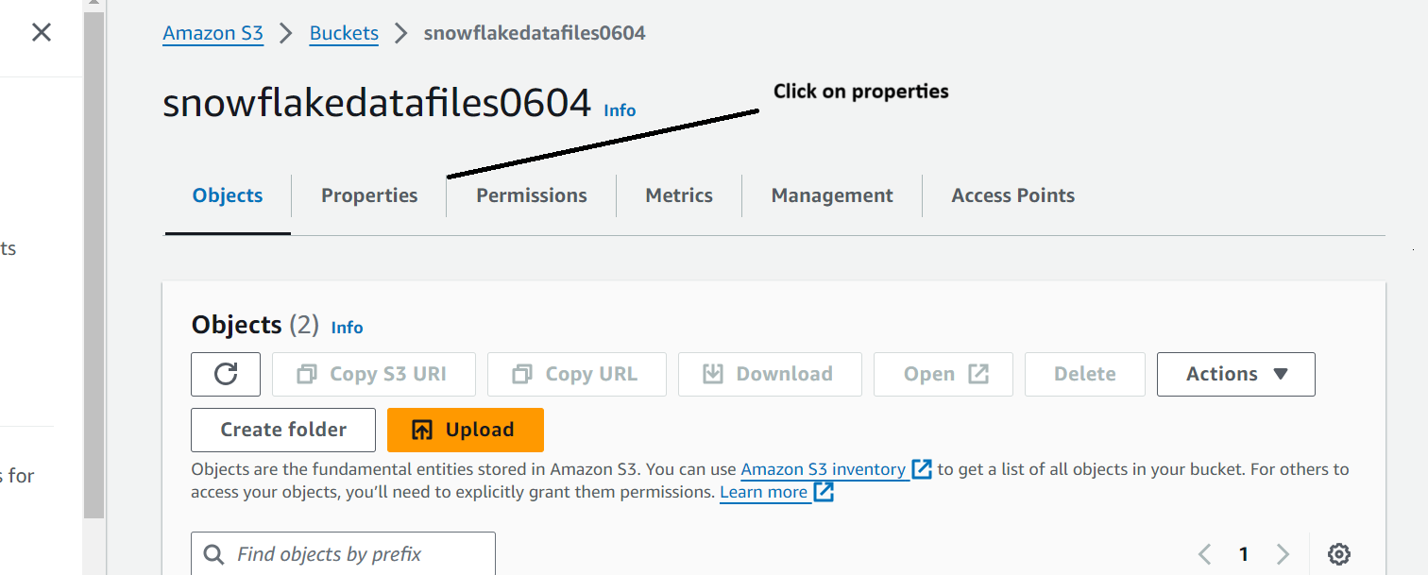

Scroll down & go to event notification and click on create event notification
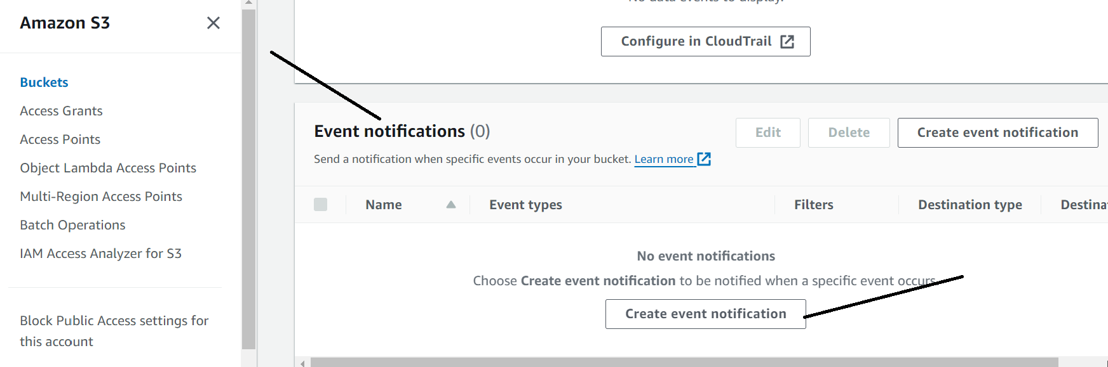
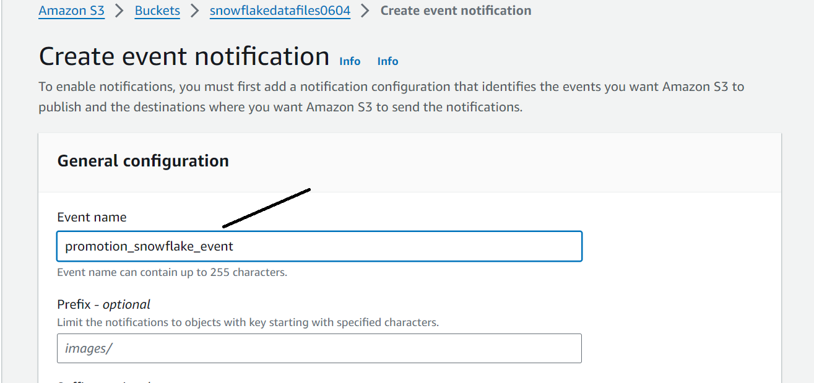
Scroll down
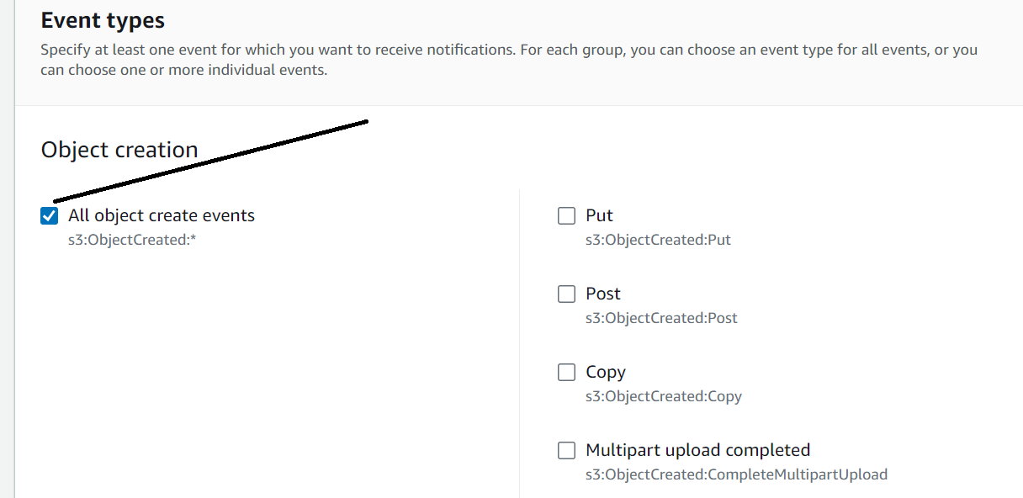
Scroll down
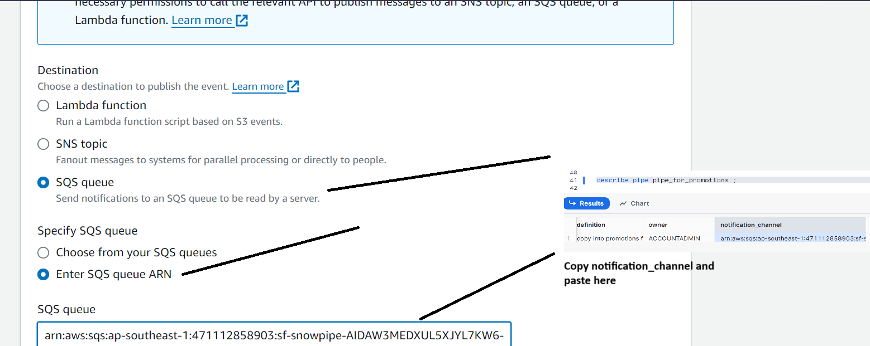
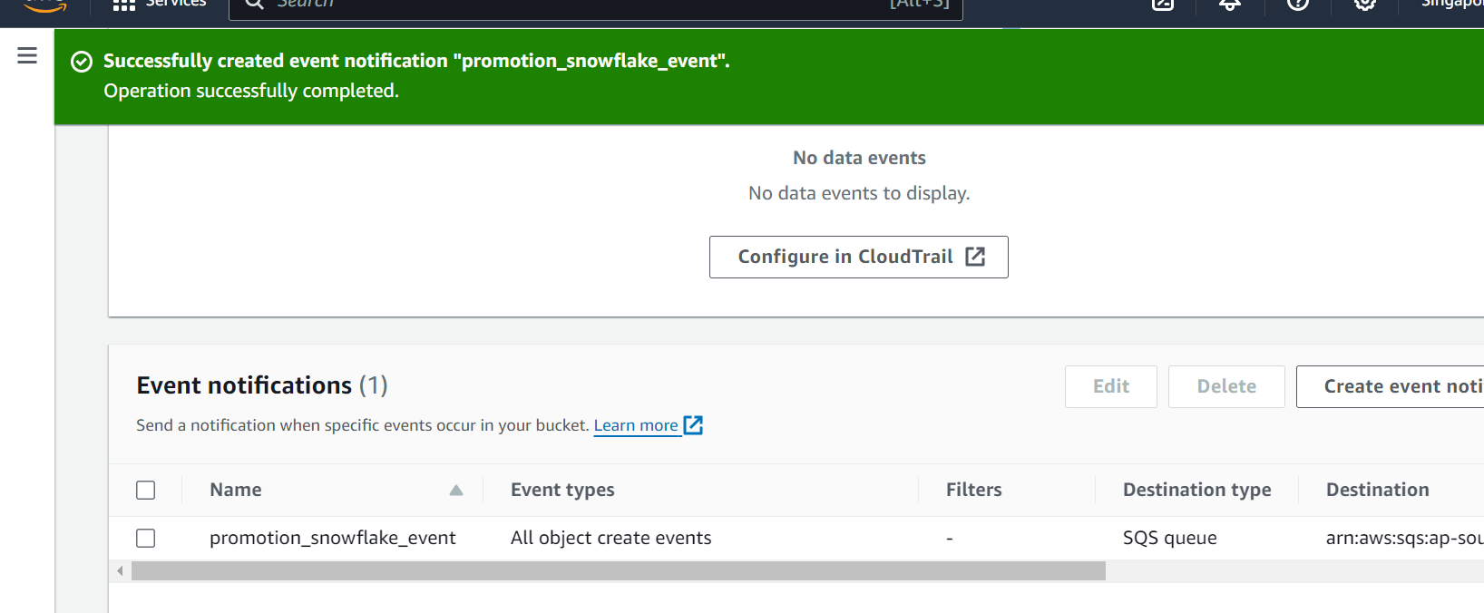
Let’s check the data in snowflake
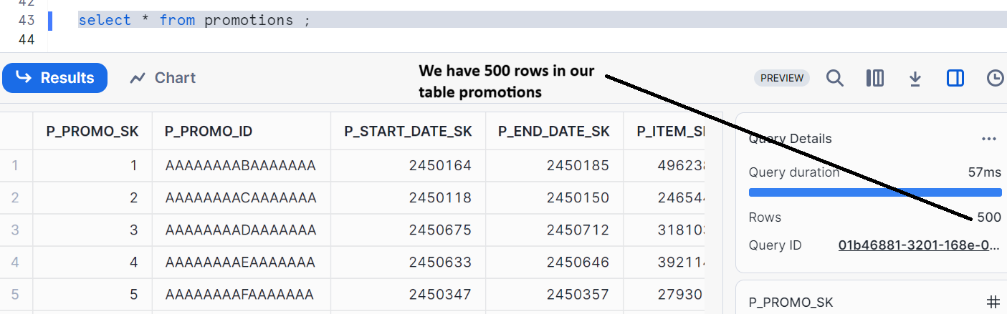

Now, Keep Adding files to snowpipe folder in S3
