SNOWPIPE
With the continuation of previous post on snow pipe (snowflake_25), I had uploaded some other files in my S3 bucket and let me check in my snowflake if it populates
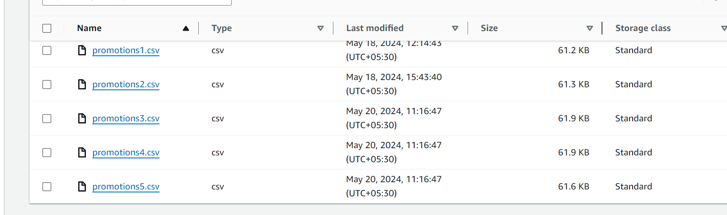
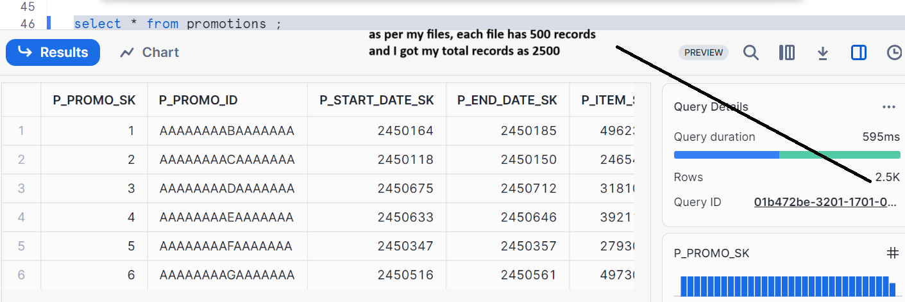
Now let’s add a file which has some errors
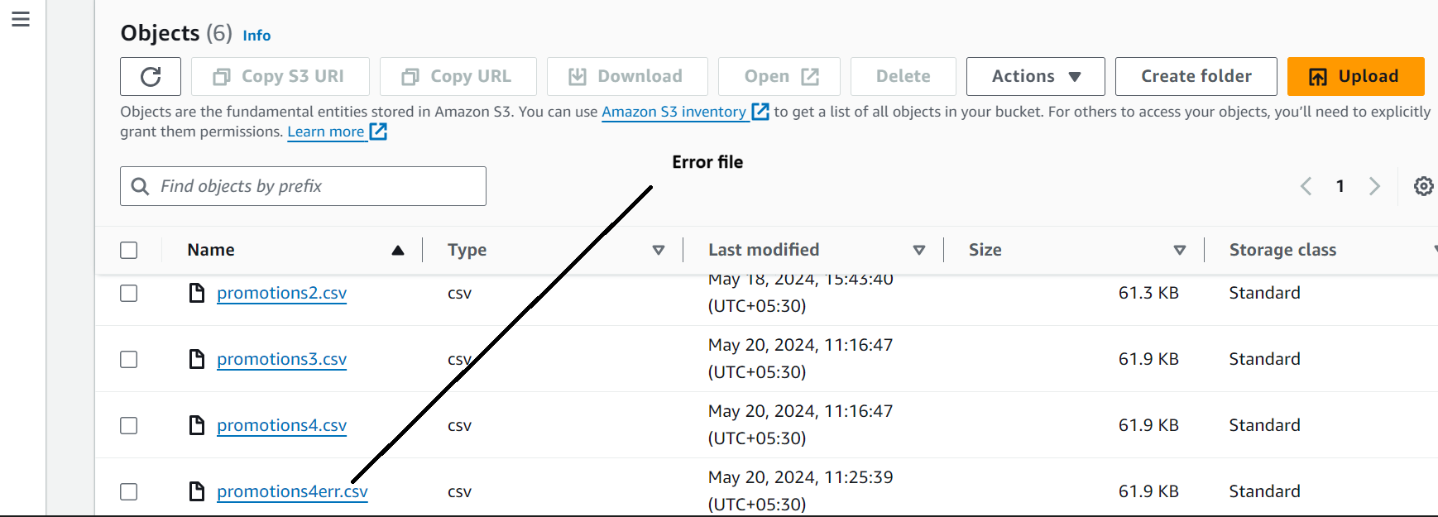

Let’s check in snowflake
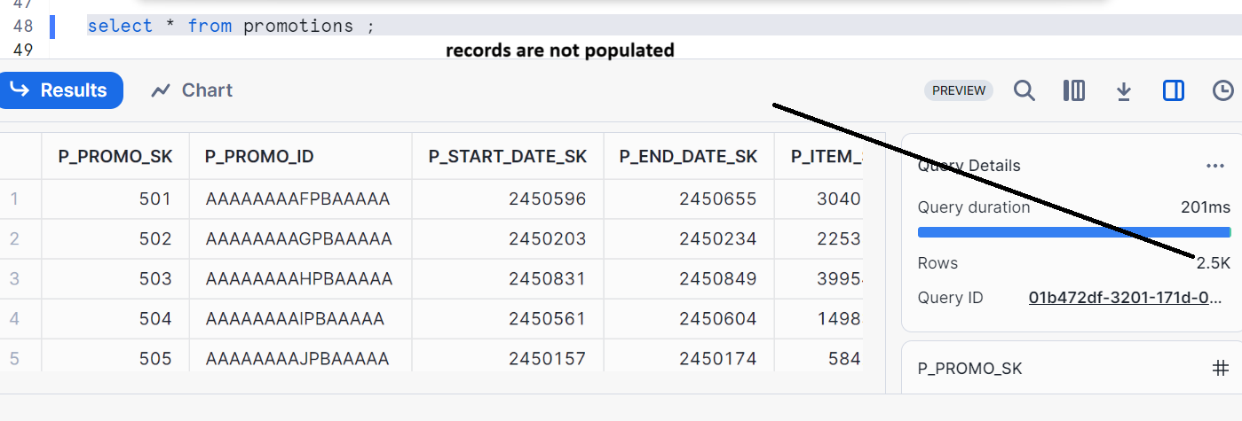
Let’s check if what it is trying to do in last 2 hrs.
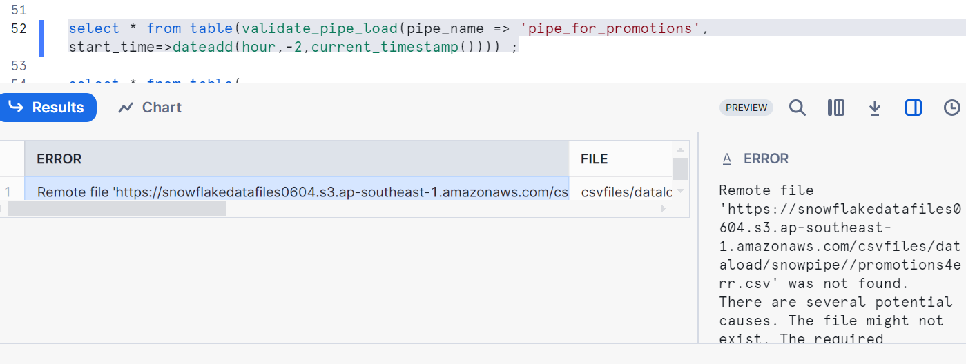
Checking Error in History
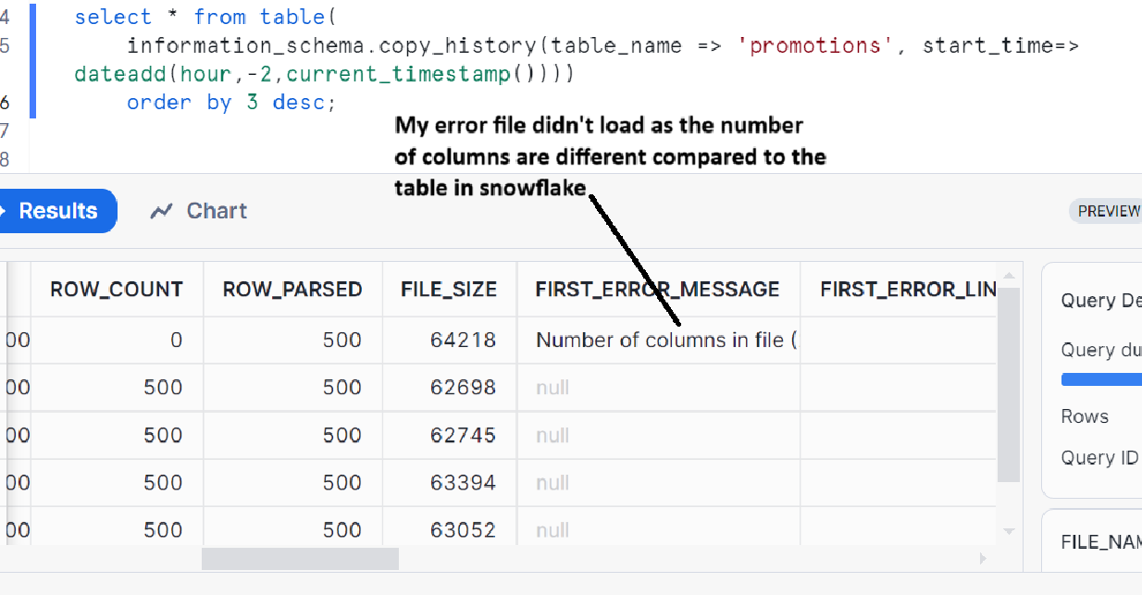
Trouble shooting the PIPE:
You can simply edit manually the error file, remove the extra columns in your file. Then add this new file into your S3 by removing the old one
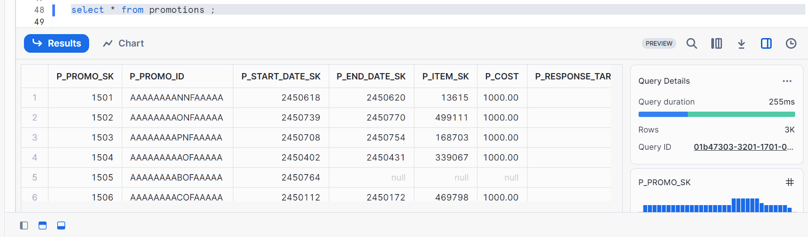
Some syntaxes on pipes:
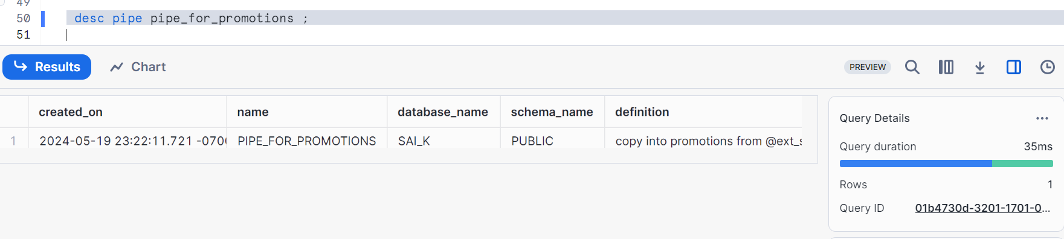
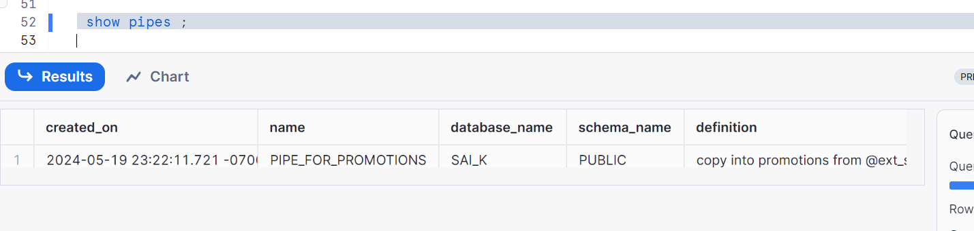
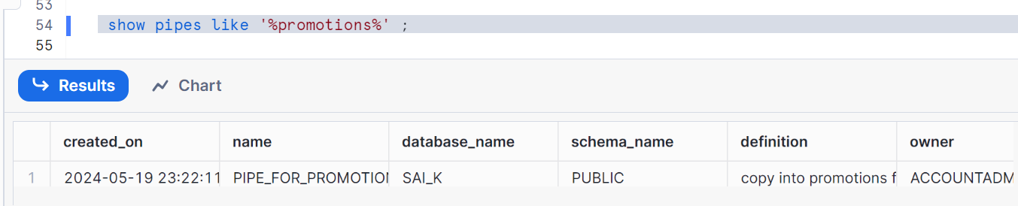
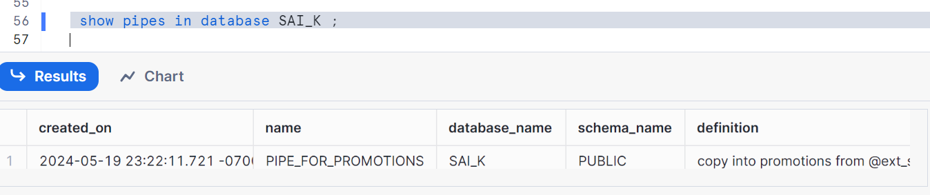
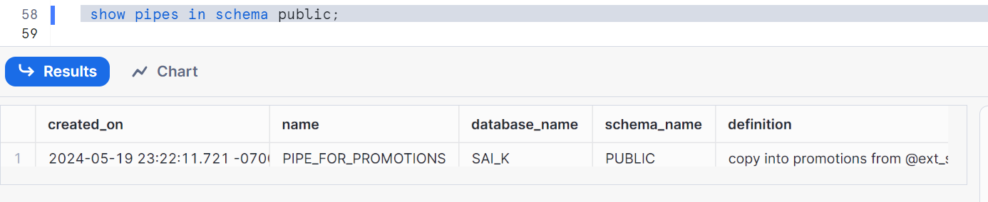
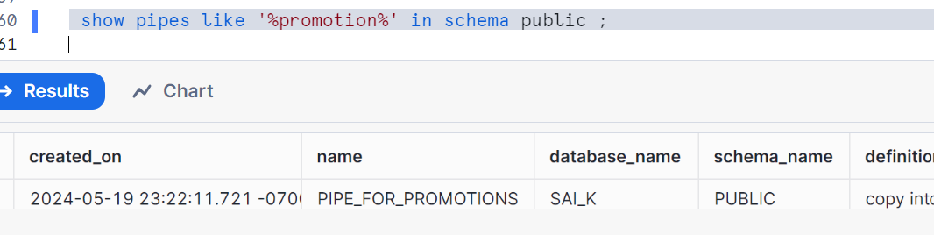
PIPES do not support PURGE COPY Option, We need use remove to delete the staged files
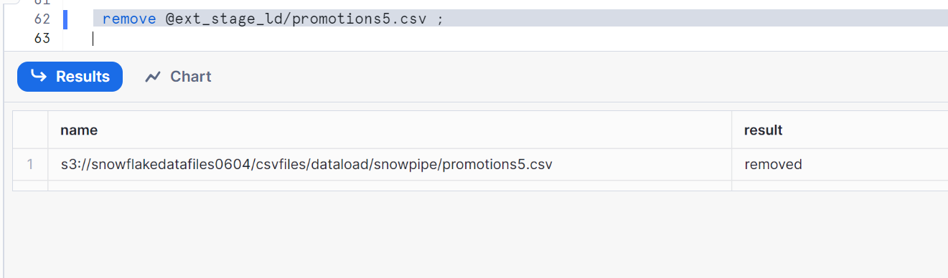
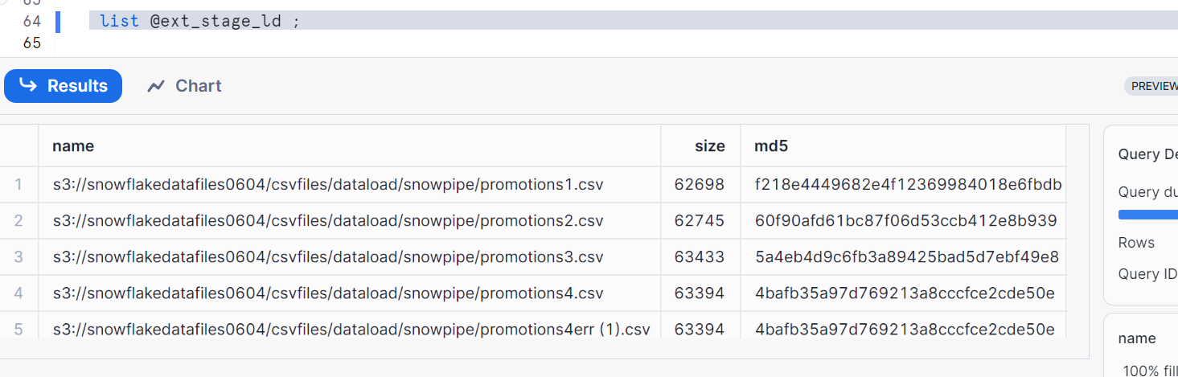
You can delete with the help of command
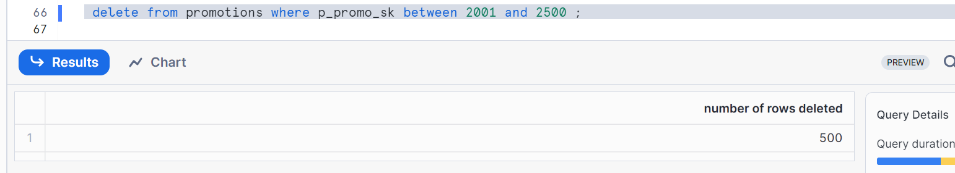
Altering the PIPES
My stage (@ext_stage_ld) is pointing to my snowpipe folder in AWS
Let’s change the URL of the stage
So, create a new folder in S3
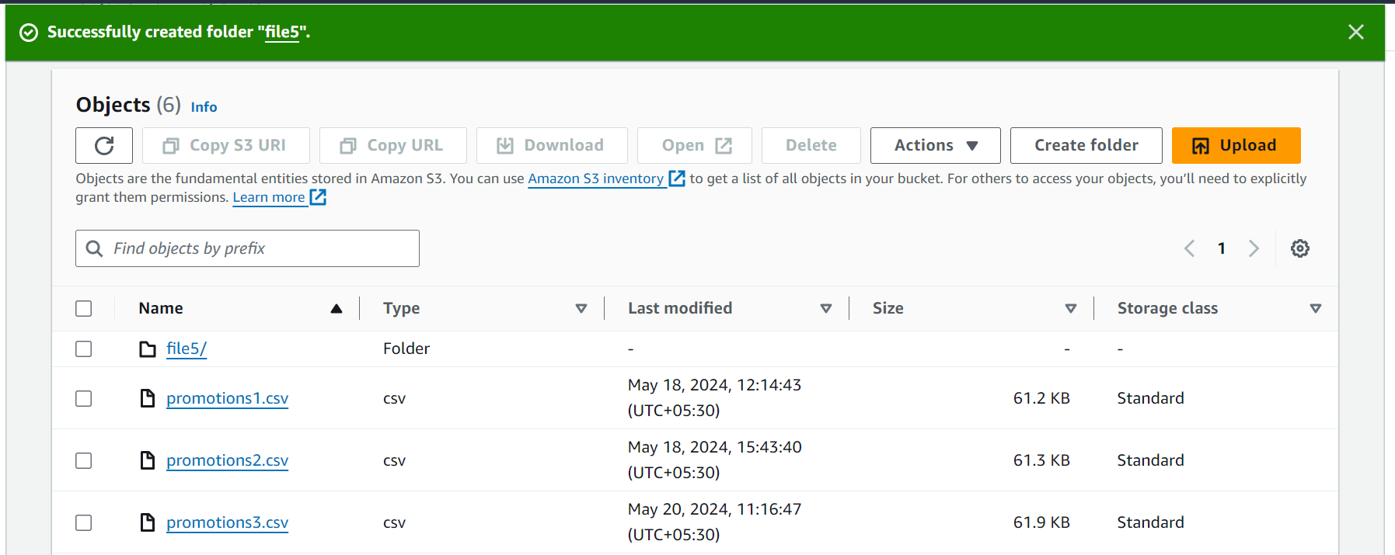

Now, let’s pause the pipe
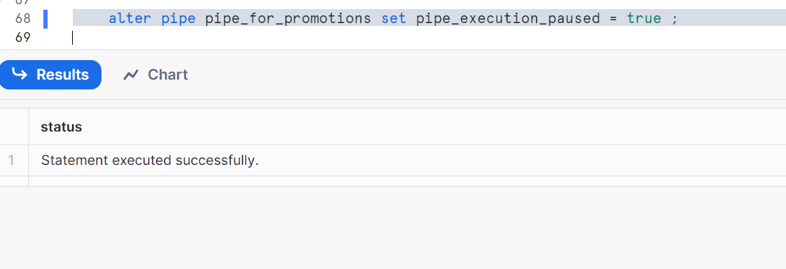
Status of PIPE
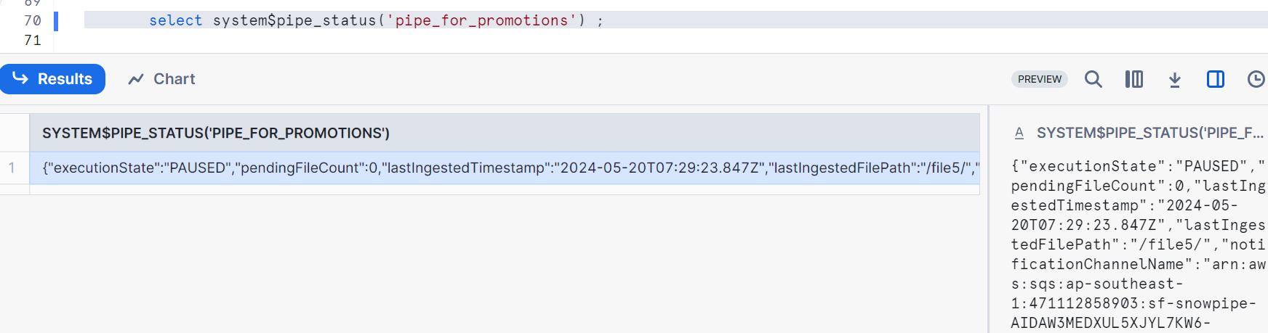
Pointing my stage to my file location
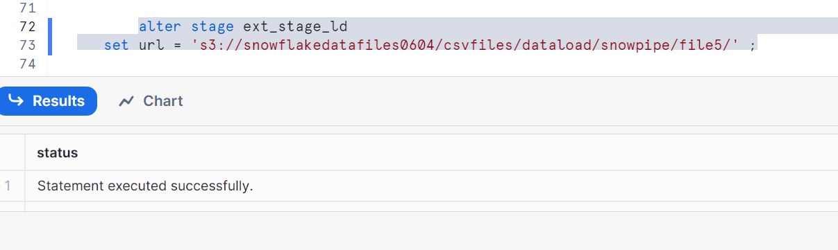
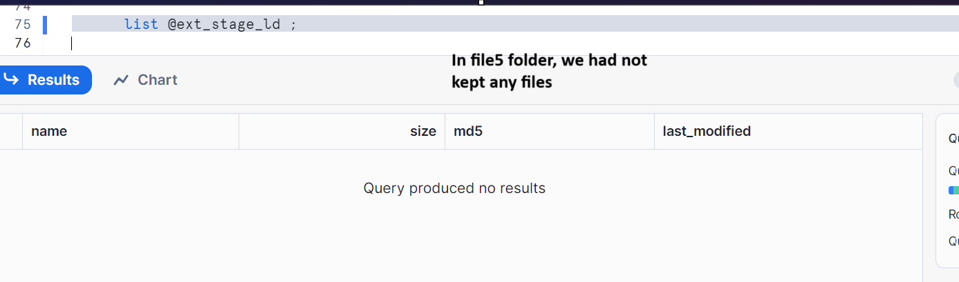
Let’s make the pipe to running state
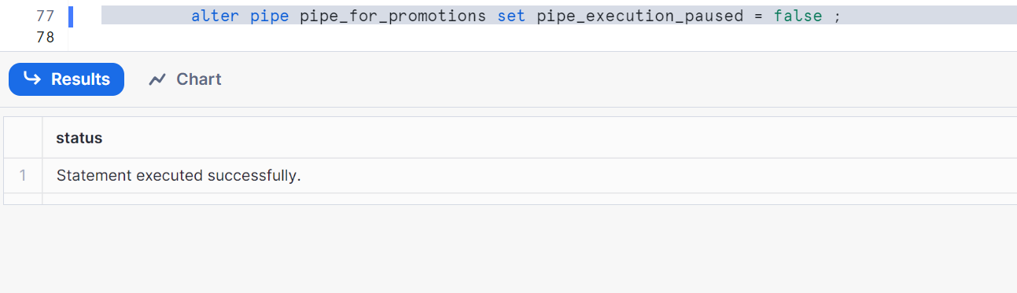
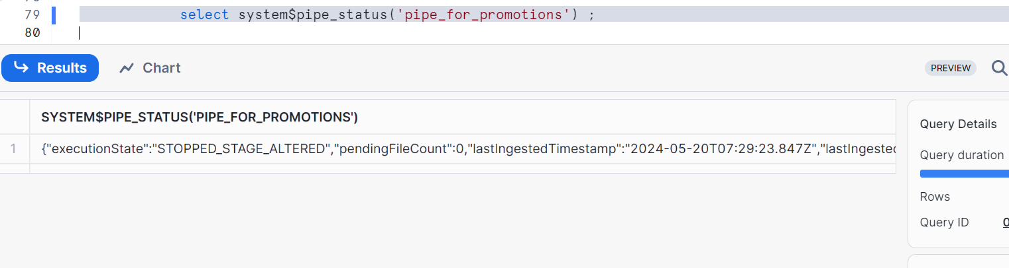
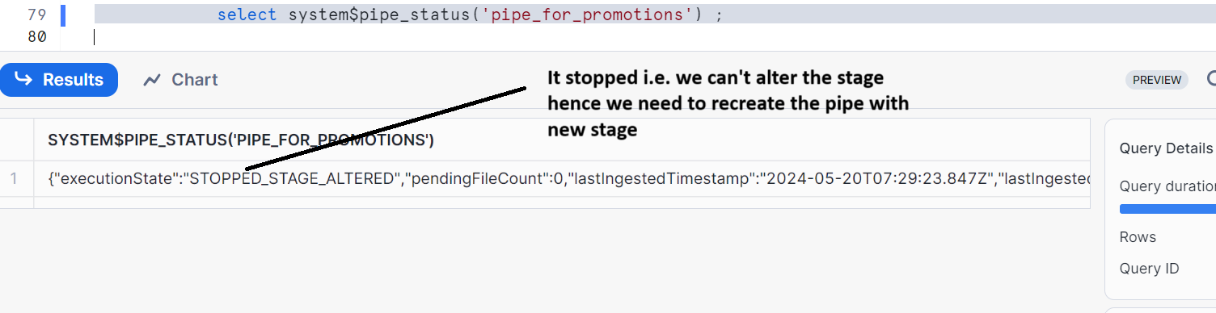
Hence to recreate, first pause the pipe
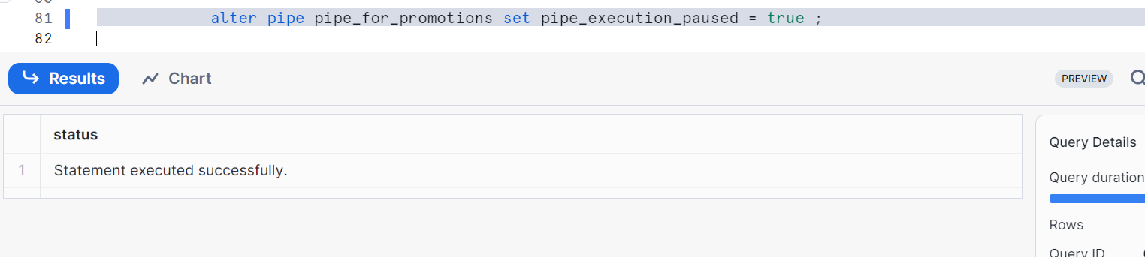
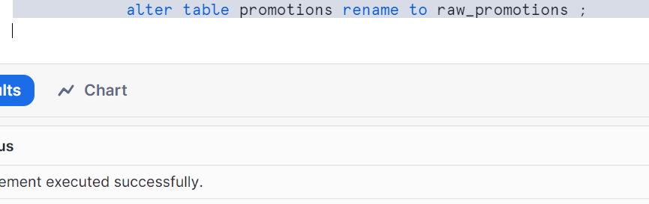
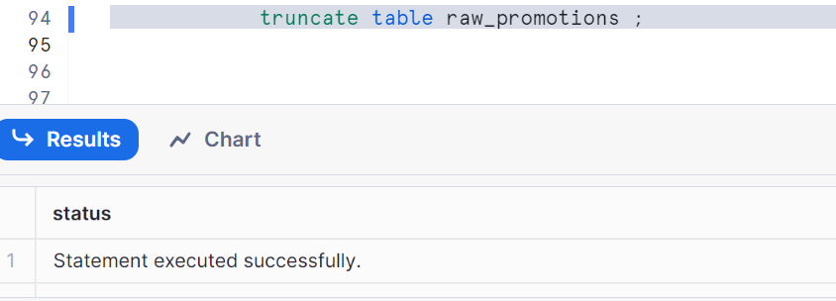
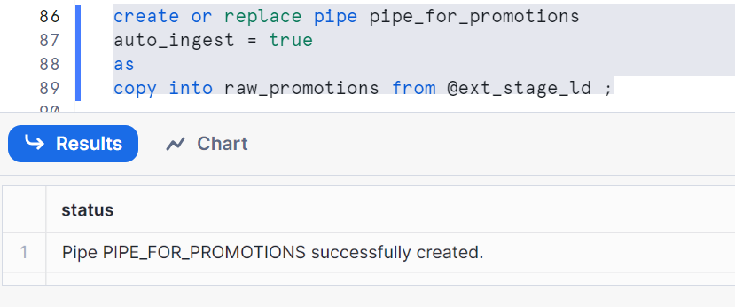

Let’s upload a file in S3
