STREAMS
Here is the representation of continuous data pipeline, streams come in the position of 2 as shown below

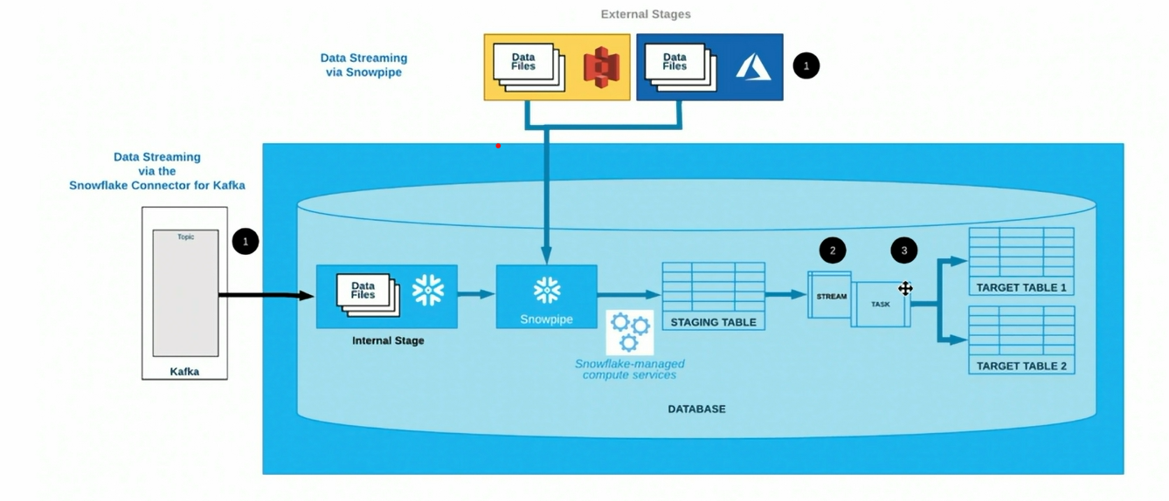
Let’s perform what streams actually does by creating staging and target tables as per the above image
Let’s create a staging table
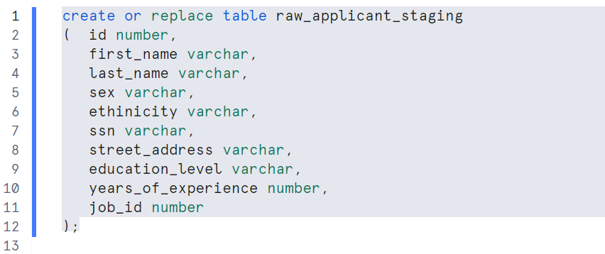

Creating job_details table
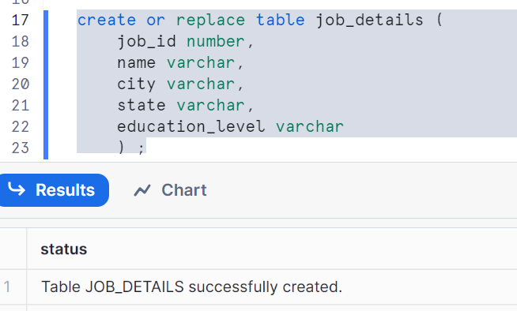
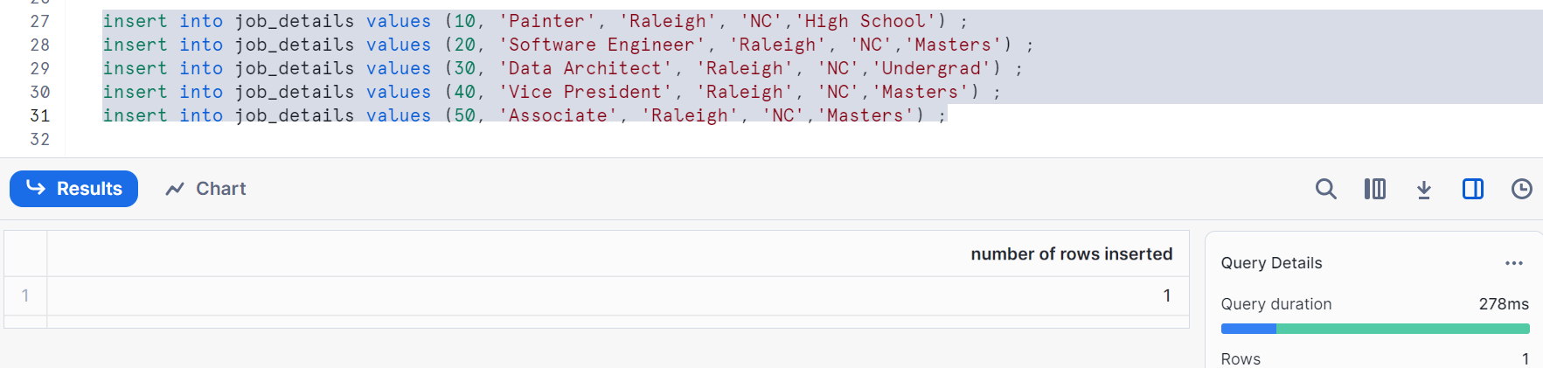
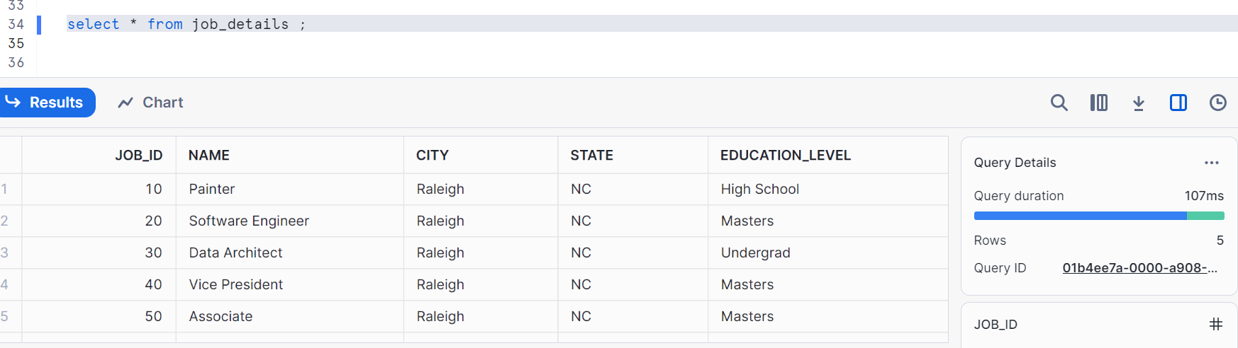
Creating a target table
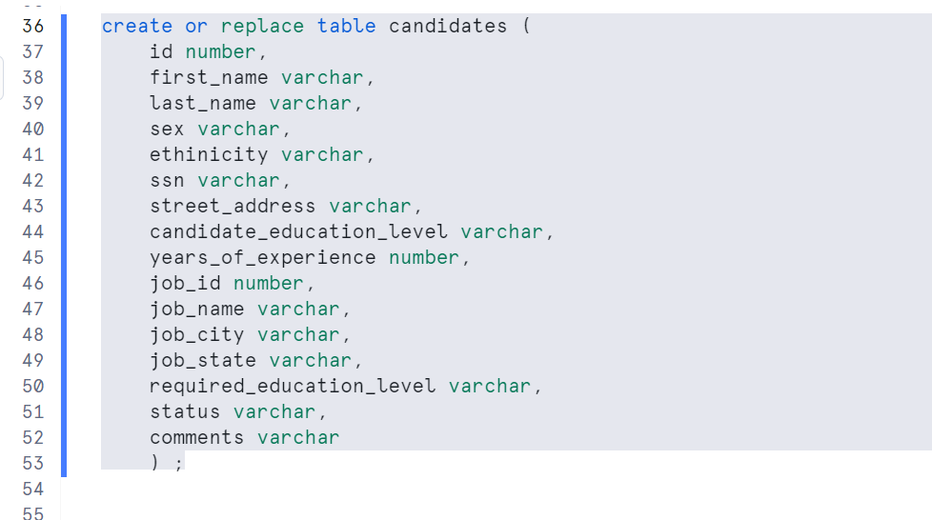
Inserting one record in our target table
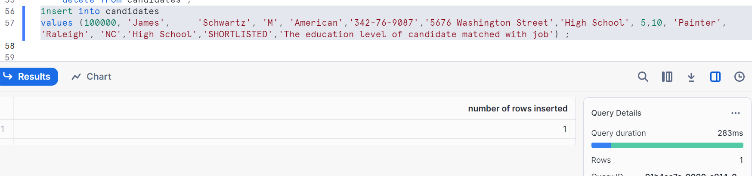
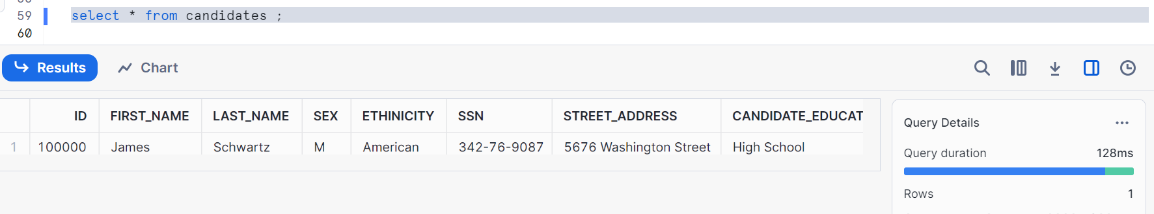
Now, let’s create a stream as shown which is connected to staging table
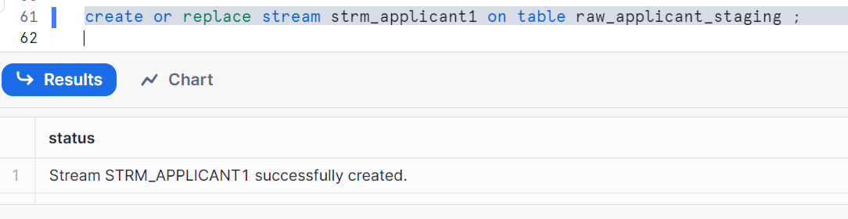
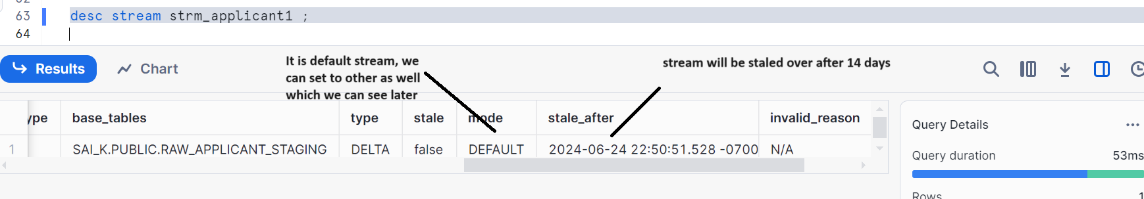
For now, just understand stale means ‘not new’
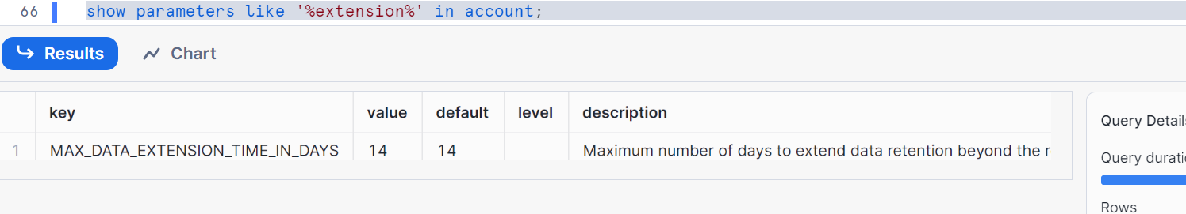
Let’s insert some data in raw-applicant_staging table
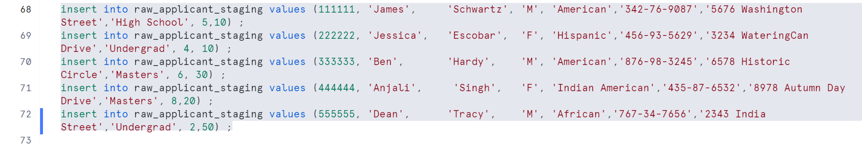
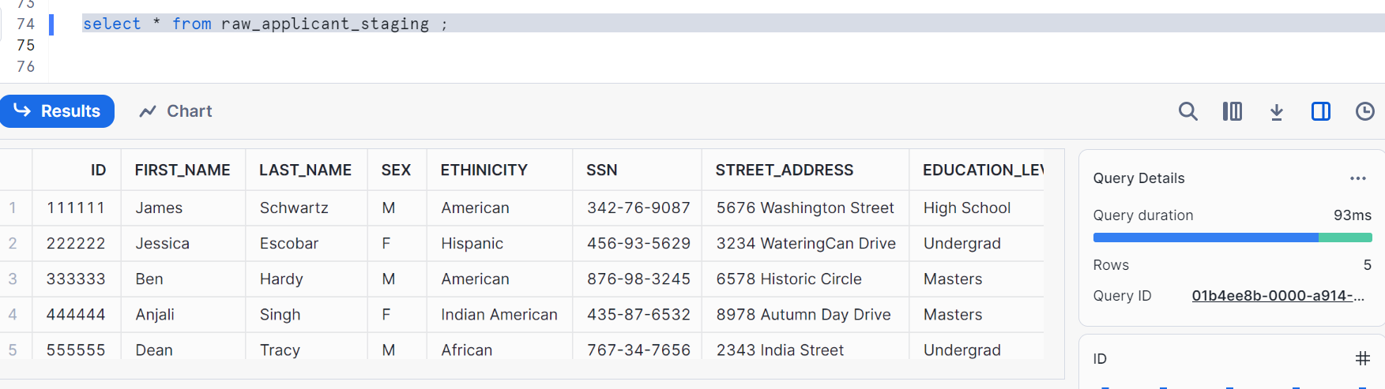
Check stream and Observe extra columns
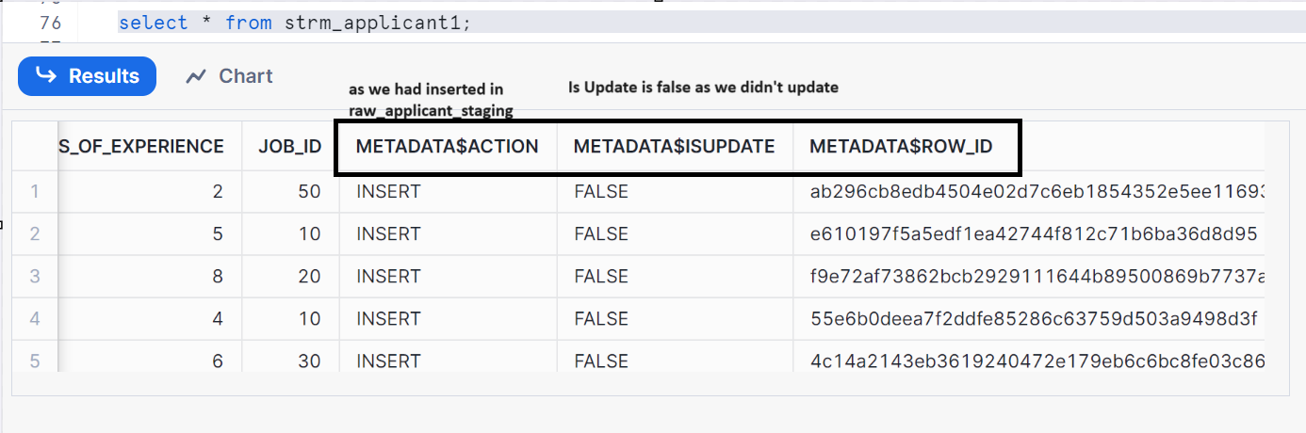
Update the data in staging
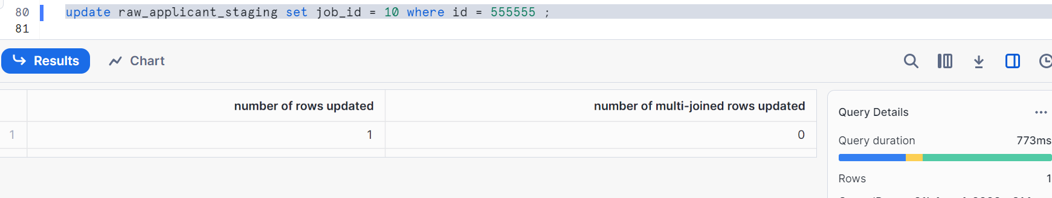

Check stream
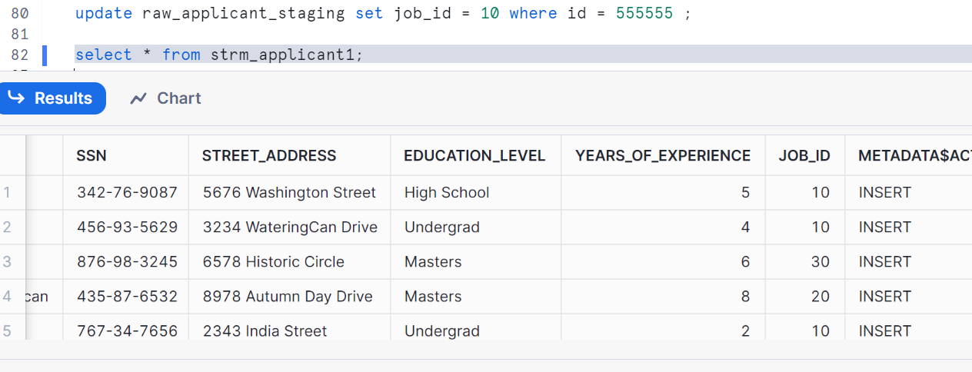
So stream is immediately reflecting what changes are done in staging, this is called net effect or default stream. It doesn’t show you intermediate states, it shows net effect of multiple insert, updates and deletes
Let’s delete and check
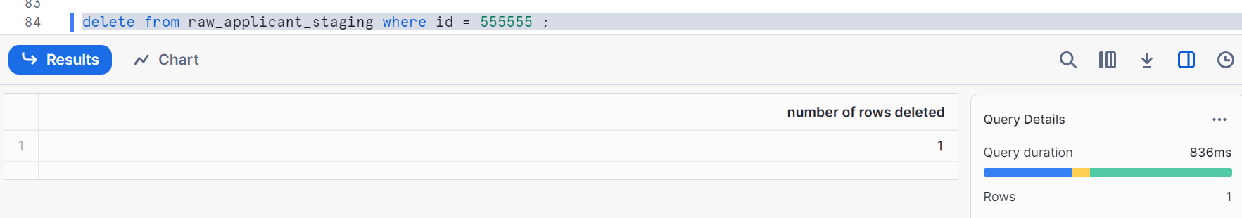
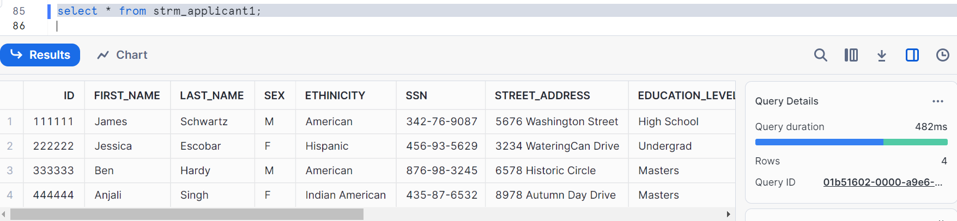
So, even if I delete it, it will not show you any history that it has 5 rows/records initially
So stream is immediately reflecting what changes are done in staging

Streams:
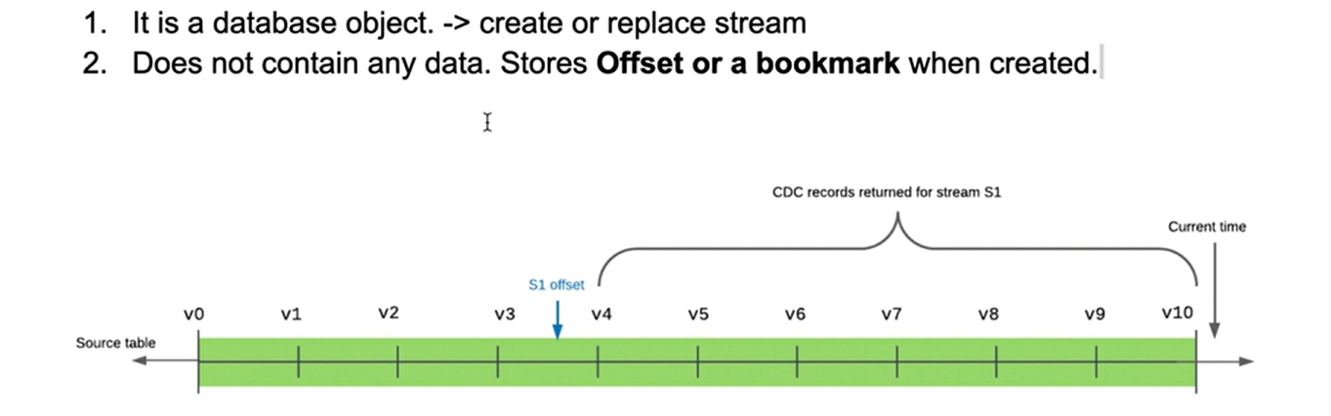

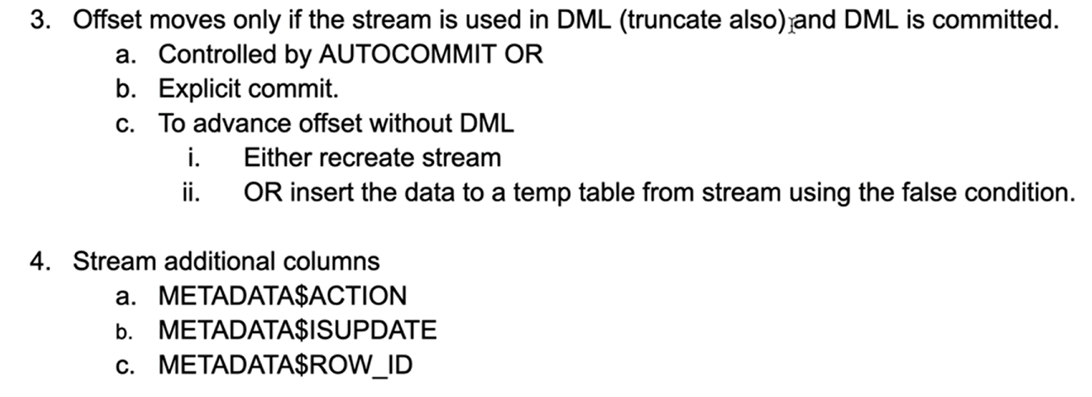

Let’s see consumption of streams, how offset actually moves & how can stream is used to load the data into the target
Let’s delete the data from staging and see consumption of stream
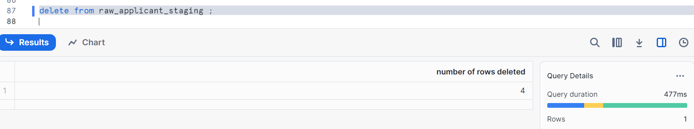
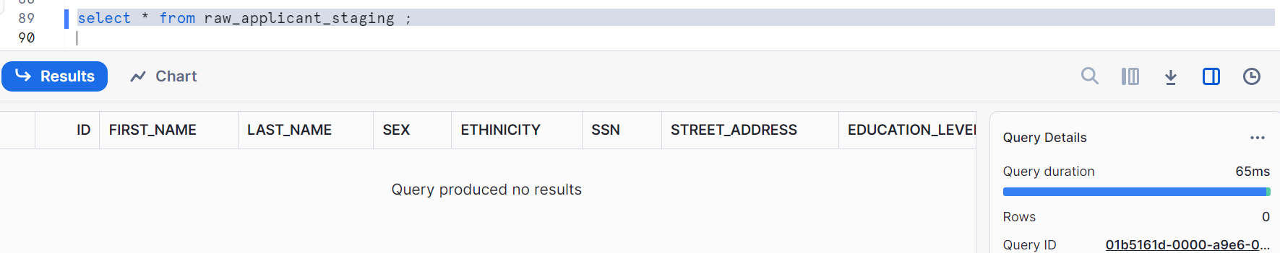
No records in stream
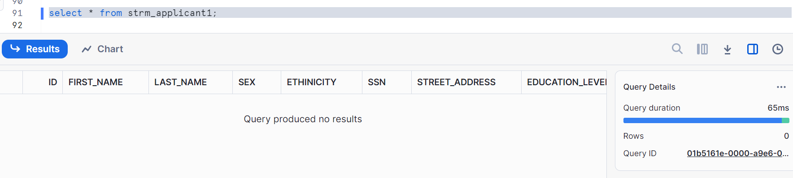
Let’s insert some records
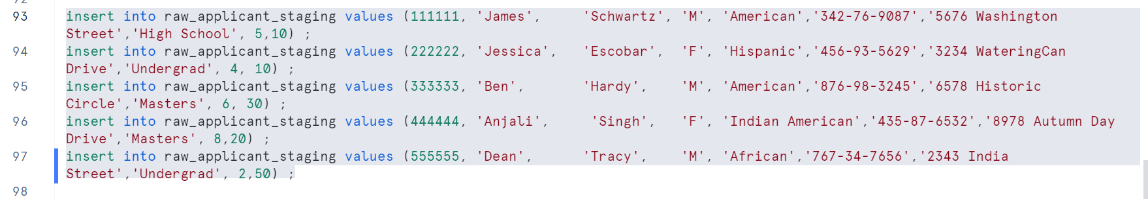
Let’s check the stream
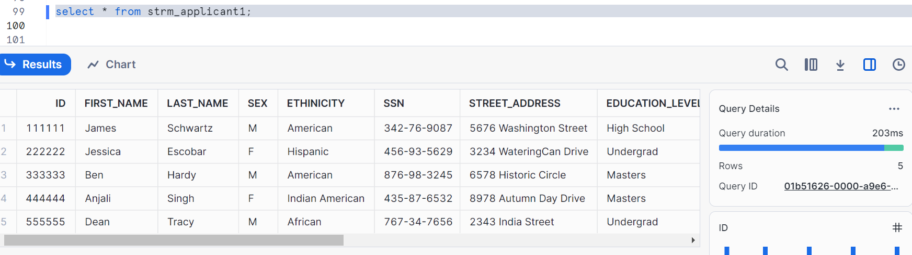
Our target table has one record as shown
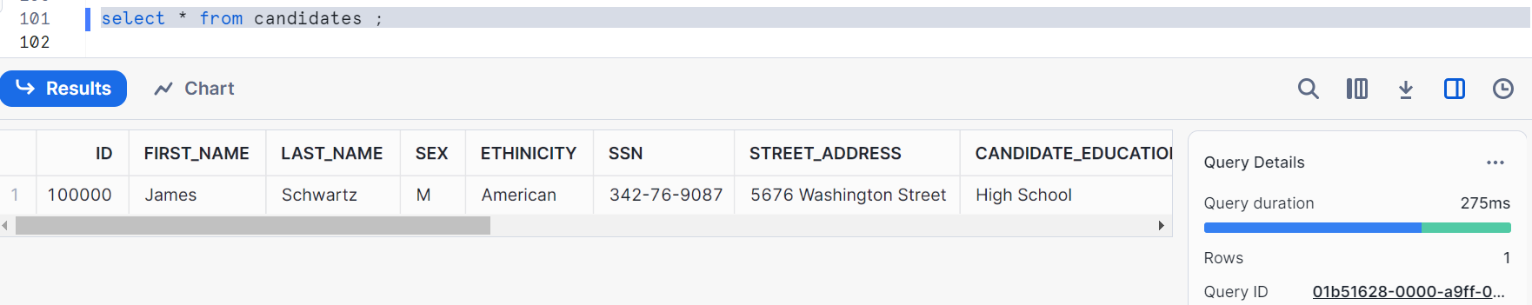
Let’s check our job_details table as well
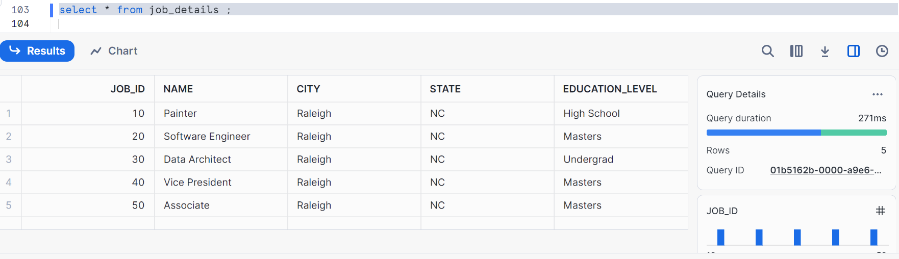
Now, let us merge the data into target table
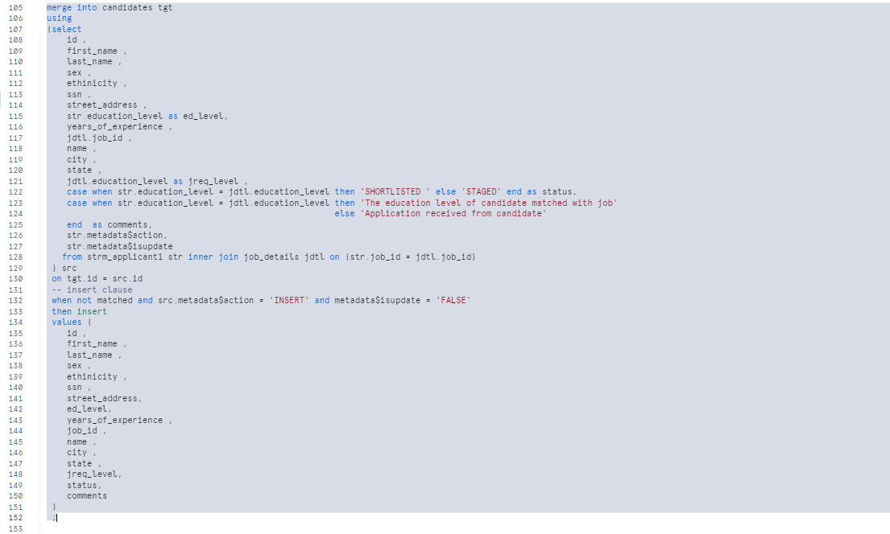
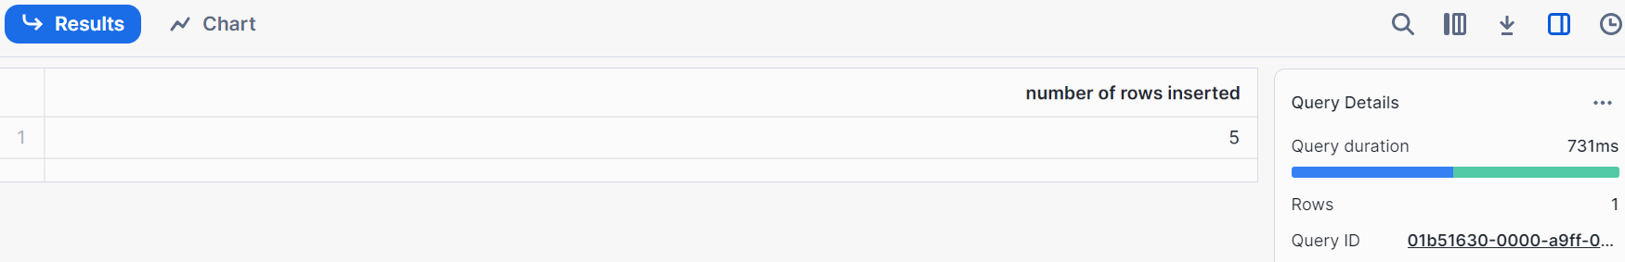

Hence our target table got all the 5 records, initially it is 1 record so total 6 records
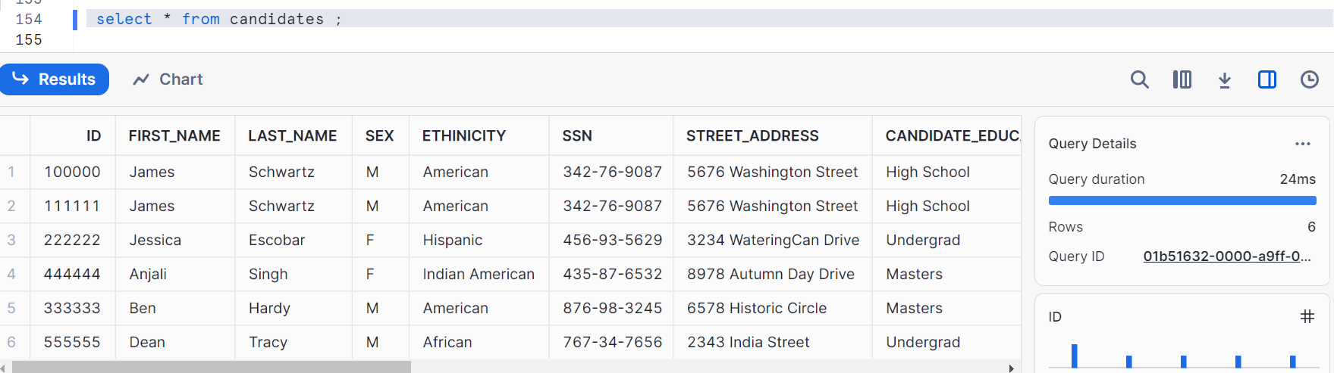
Check if stream is consumed, offset is moved
