STREAMS
Here is the second part on streams, please go through first part on streams for your reference (snowflake_34)
Types of streams:
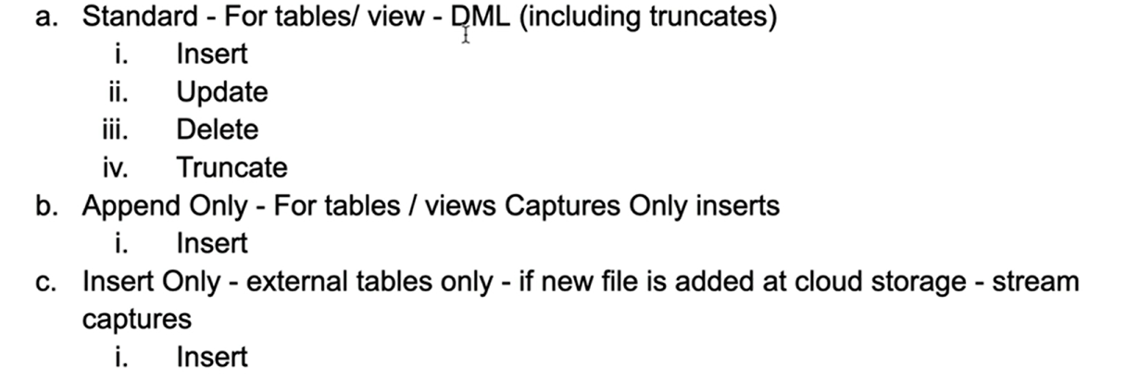
As we had seen how to create standard streams i.e. default streams in our earlier post,
Let’s create append only streams
Create staging table
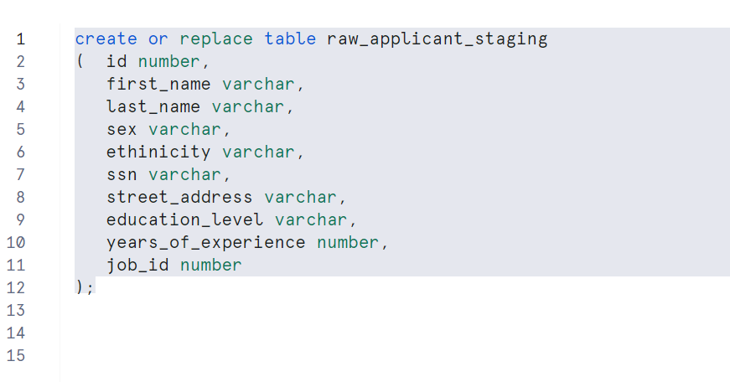
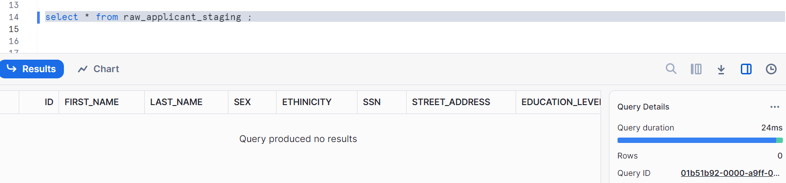
Create a default stream
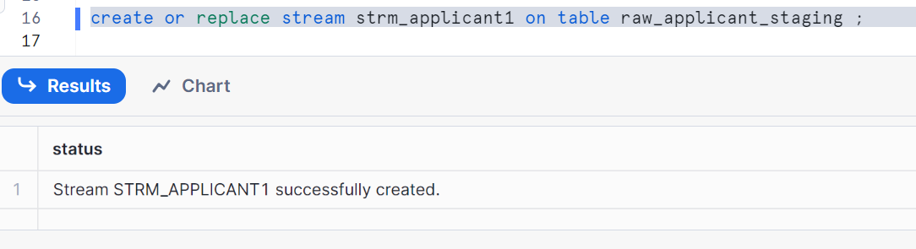
Creating append only stream (below is the syntax to create)
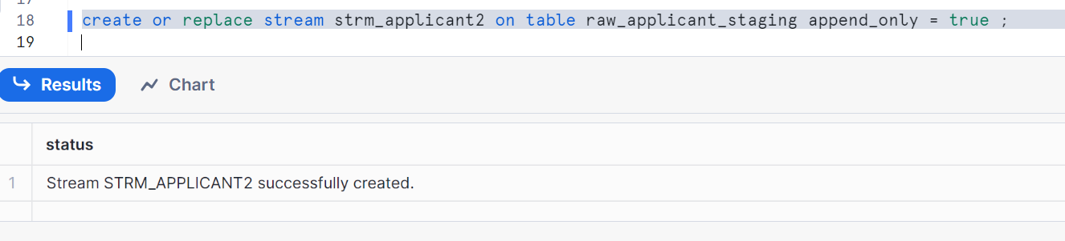
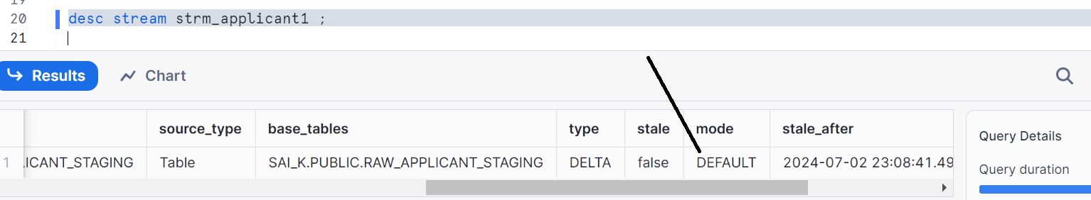
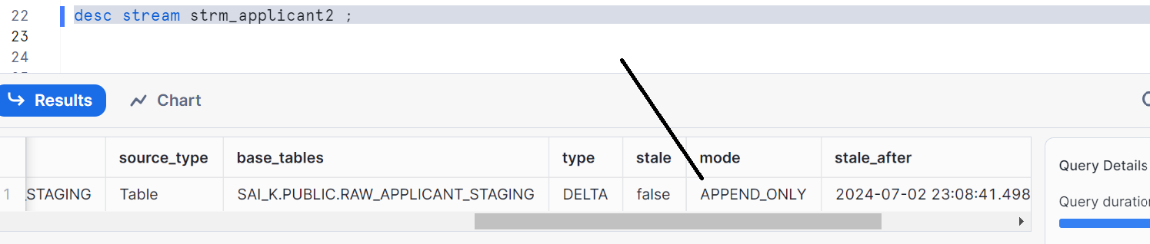

Let’s insert some data in raw-applicant_staging table
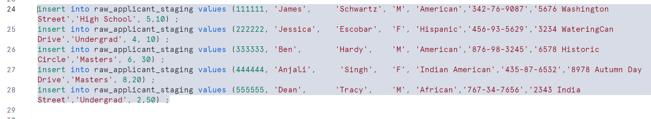
Checking data in streams
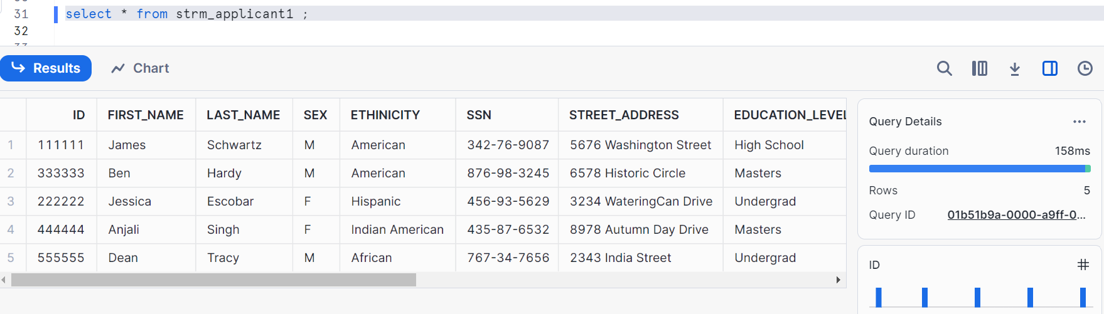
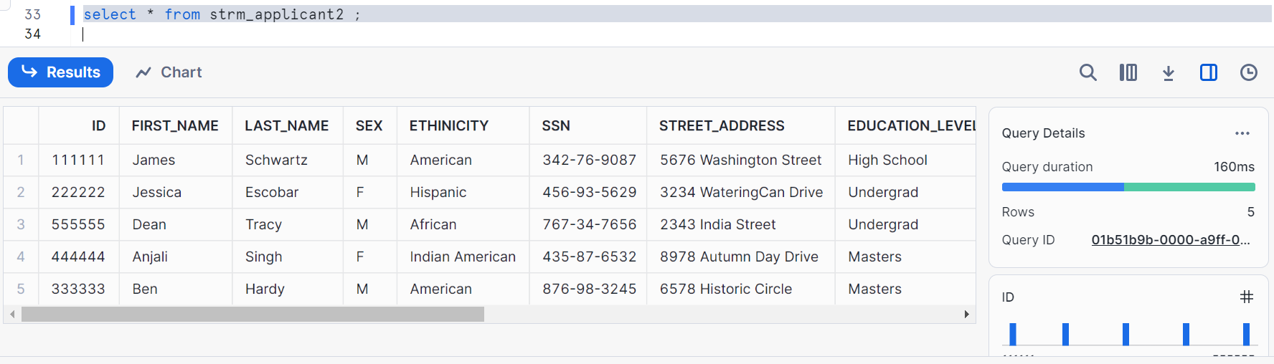
Insert operation reflects in append only stream
Now, let’s delete the data in staging table
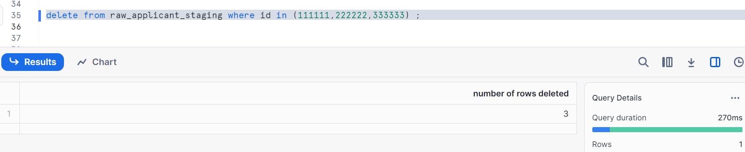

Now check the default stream, shows 2 rows
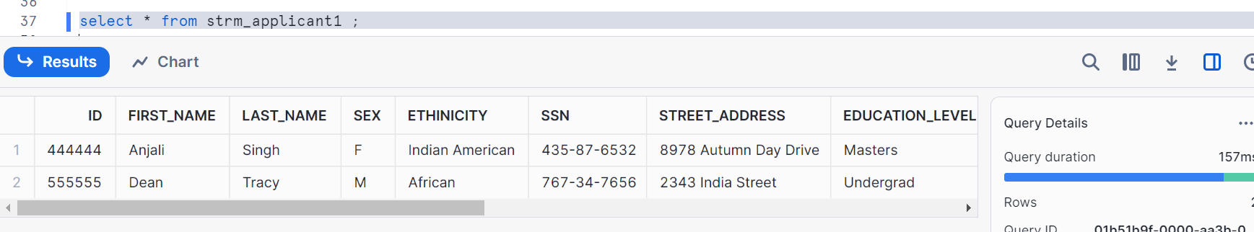
Check append only stream, it doesn’t reflect as it is delete operation. Append only stream gets reflected only if you do insert operations in your staging table
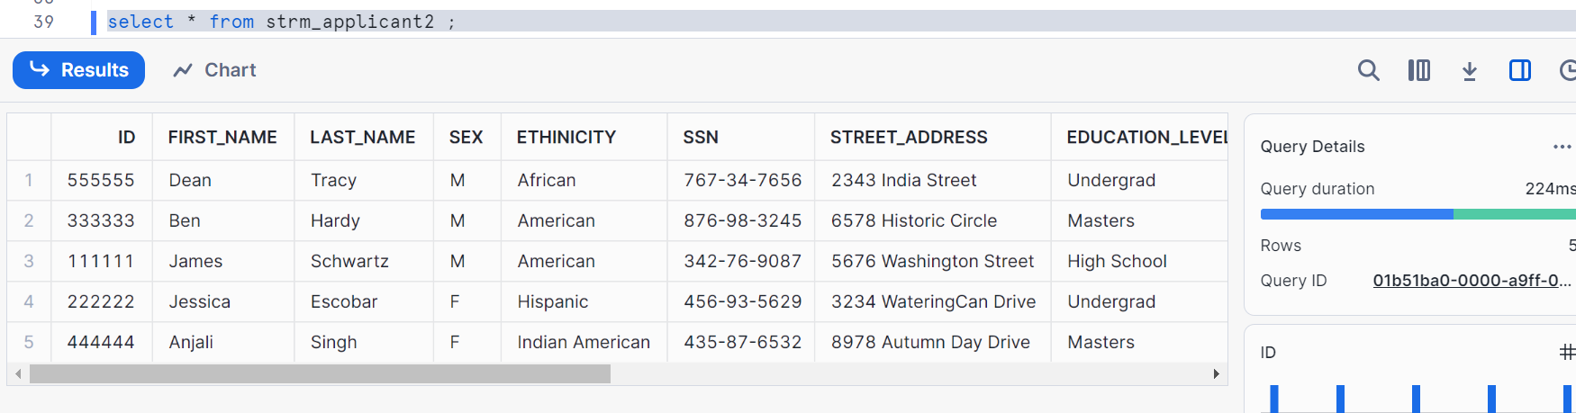
Now, let’s update the data and check both the streams
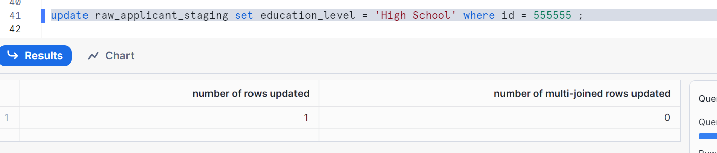
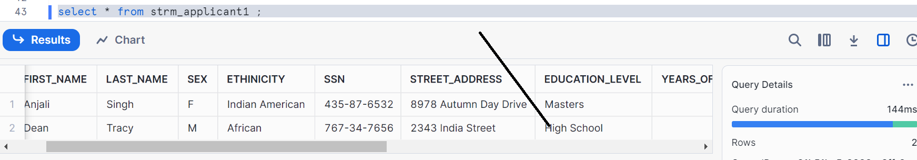
Shows 2 rows, and id 555555 updated the education level to High School
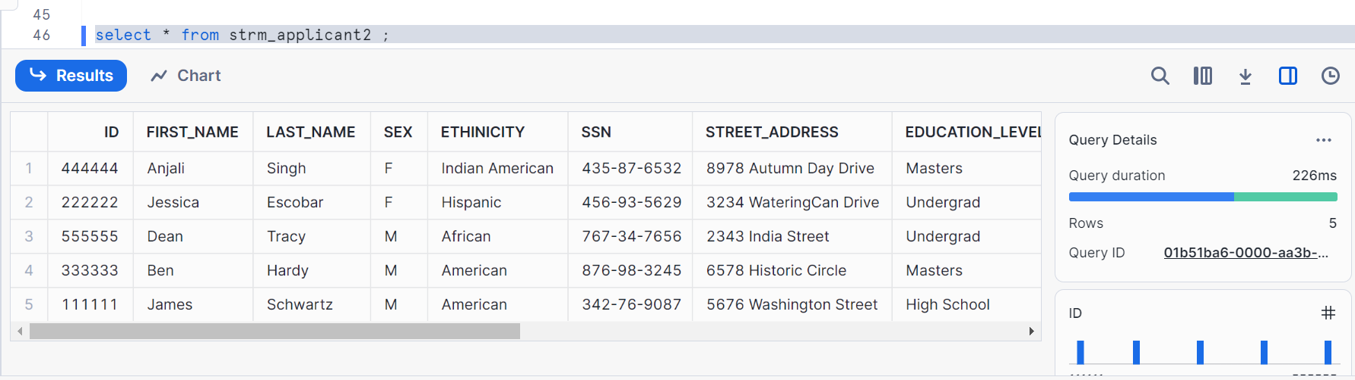
Shows 5 rows - does not capture the delete, no impact of update

Now, truncate the data and check the streams
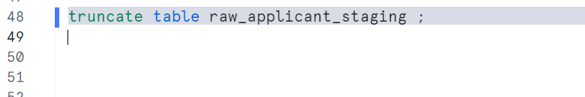
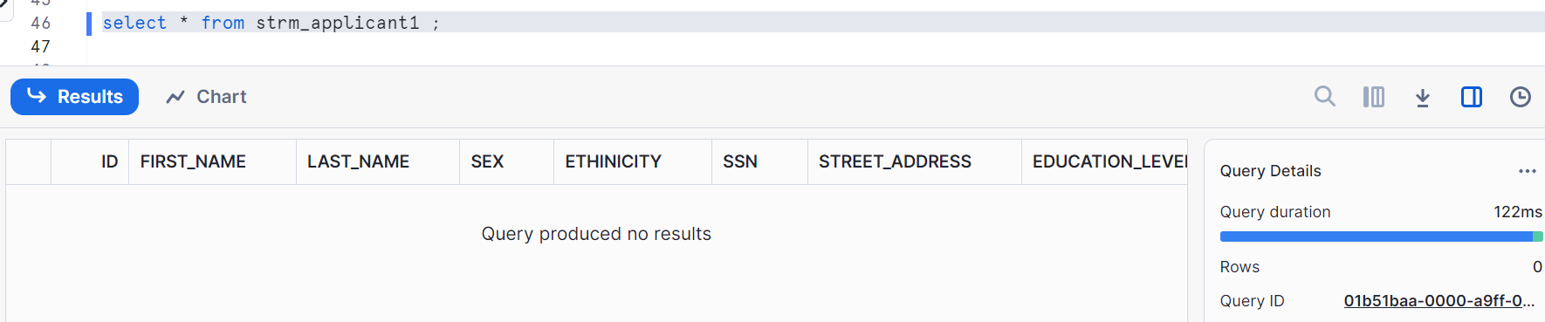
No rows in default stream, reflects the truncate
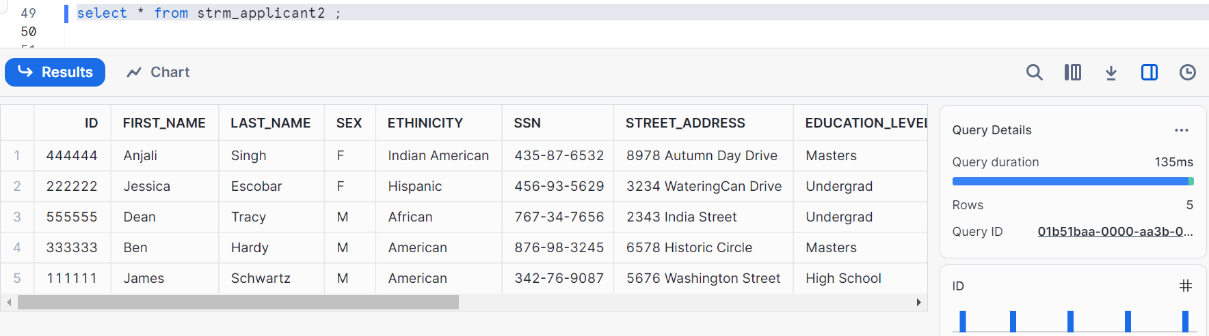
Shows 5 rows in append only stream - No effect of truncate

Let’s see the net effect of insert and delete
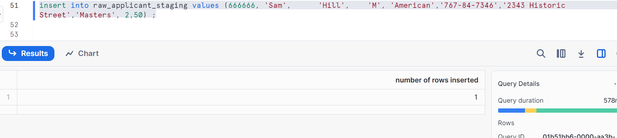
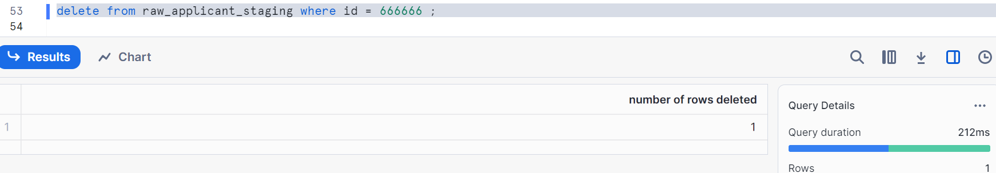
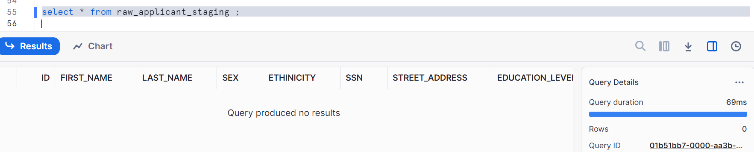
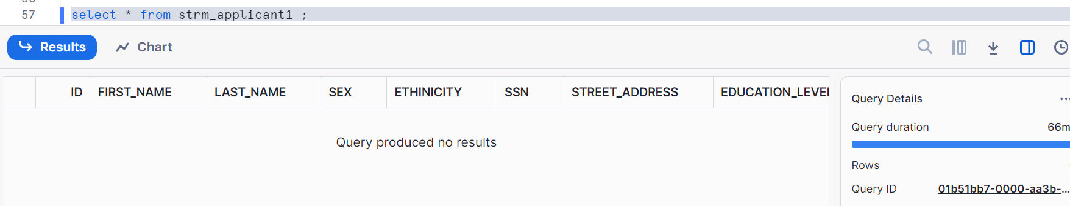
Insert and then delete is not reflected in the default stream. Since default stream provides the row level data
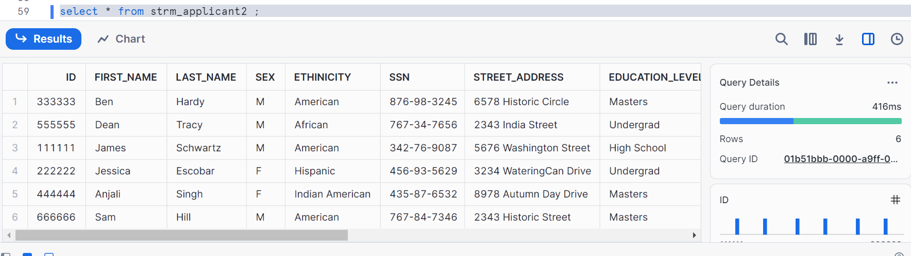
The new row inserted is reflected.
Advancing offset in a stream using a false condition
Method1: using a temporary table for insert with false condition
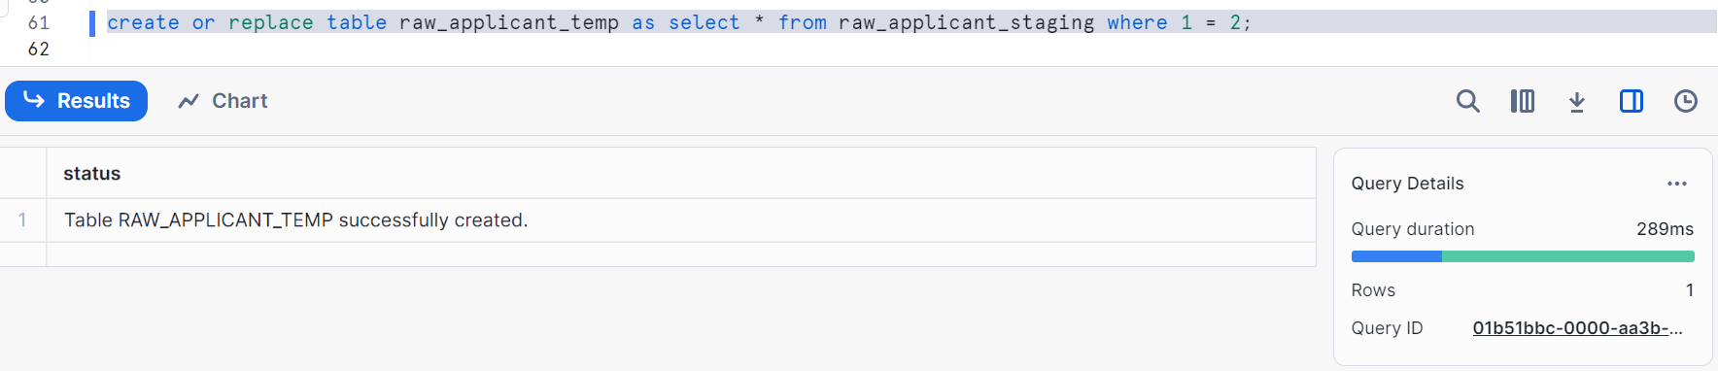
Consume stream using false condition
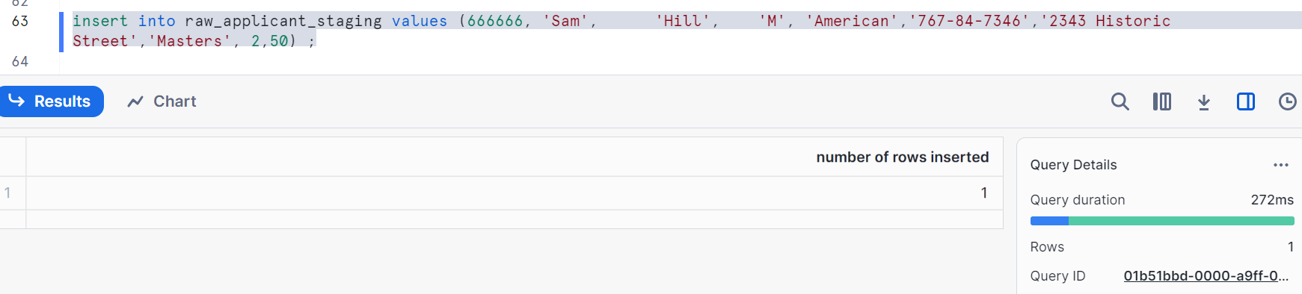
Now, I don’t want to store in my stream i.e. I want to empty my stream
Insert into temporary table
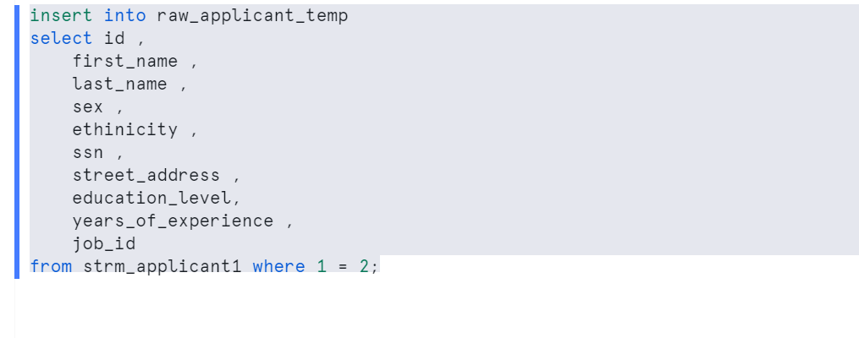
Stream will get consumed by giving false condition and we don’t store that data in our stream we inserted
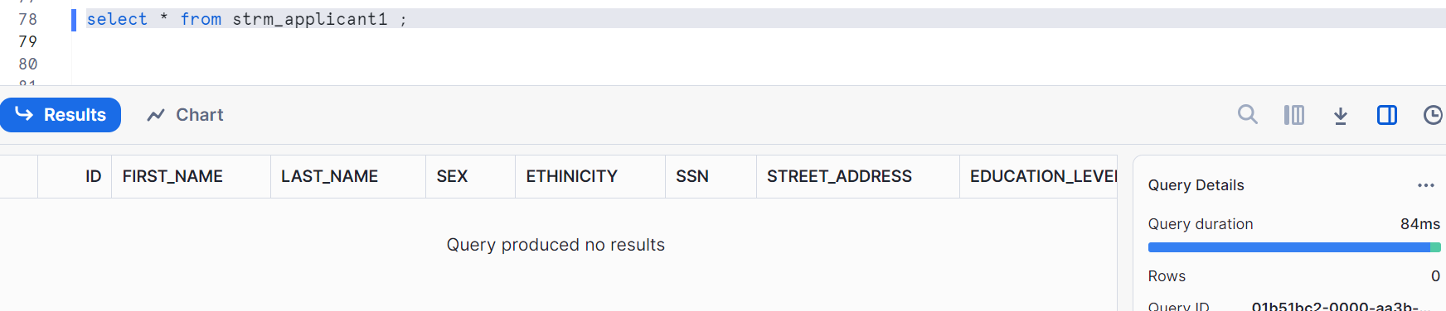
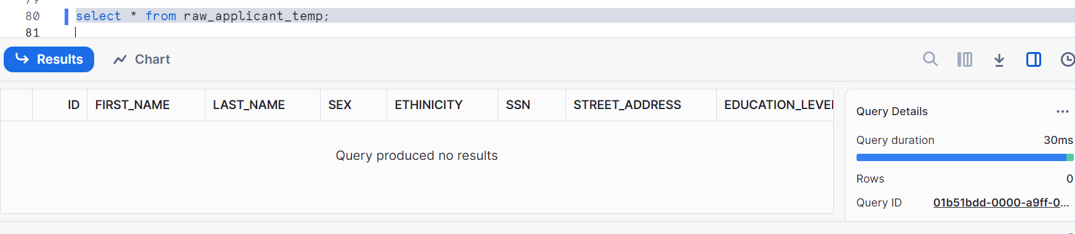
Another method is using a stream on create table temp
