STREAMS
Multiple consumers with streams
So far, we have seen that you create a stream and then when you consume it so the data is forever gone from the stream.
But there can be scenarios where you have multiple users in the environment and then want to consume the data
So, if there is only one stream and the user consume it, then it is not available for the second user. What is the solution??
The solution is like if you have multiple users or consumers in your system, you need to create separate stream for each user
Let’s see in practical
Creating a table
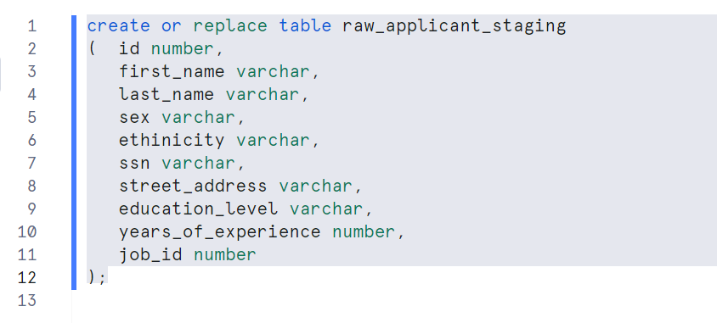
Now, let’s consider we have two customers Adam and smith who has different requirements to load data to their respective target tables

Adam is a consumer and has target table to load i.e. applicant_adam
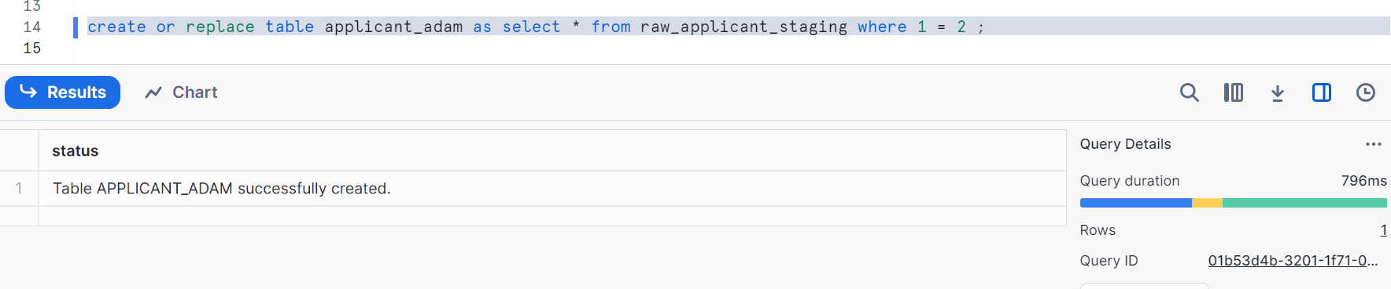
Smith is also a consumer and has a target table to load i.e. applicant_smith
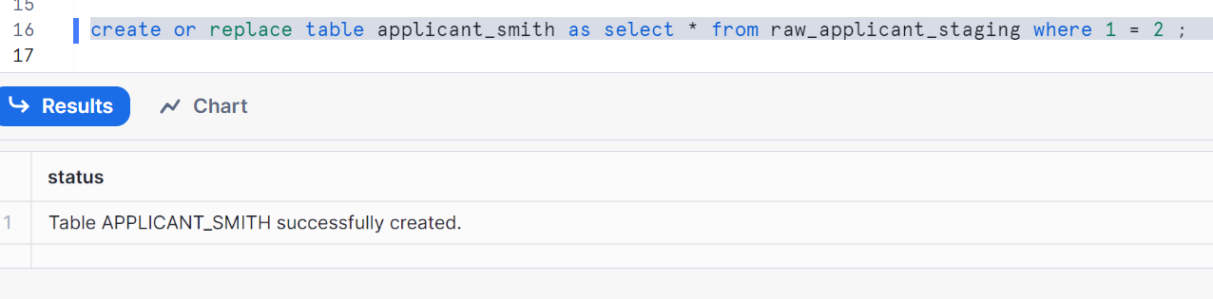
Let’s check the raw_applicant_staging table
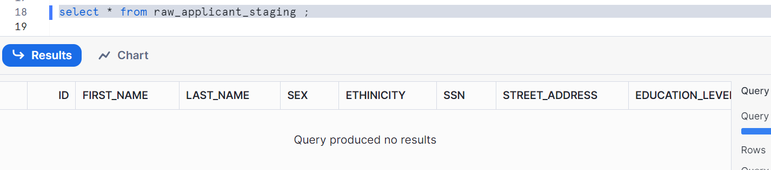
Let’s create a default stream for Adam
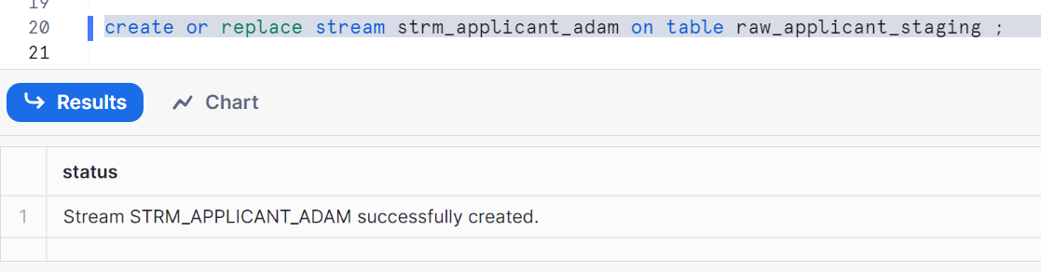
Create a default stream for Smith
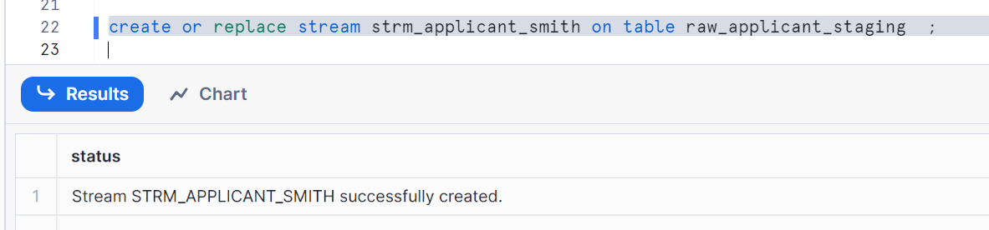
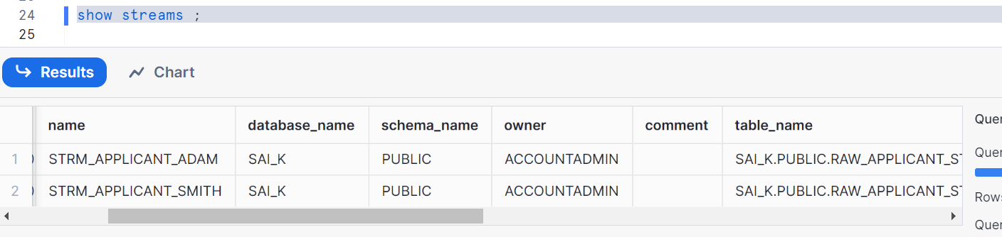
Check the data in streams for Adam and Smith
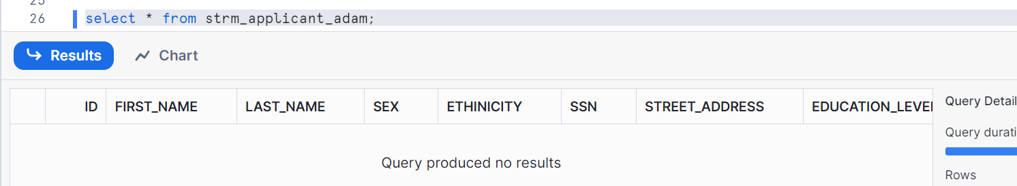
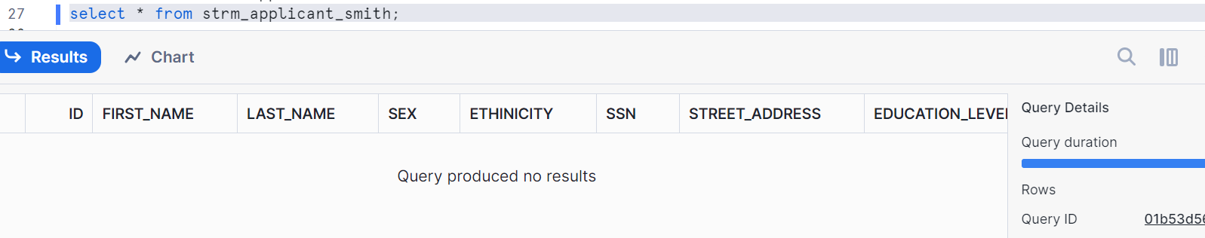
Let’s insert two records in staging table
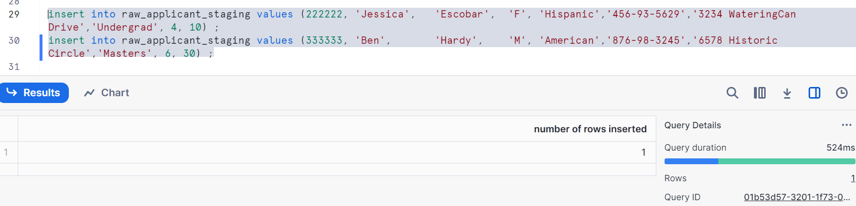
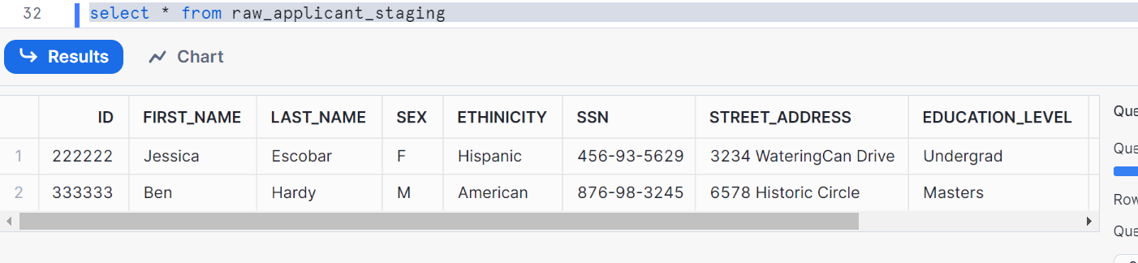

Now Adam wants to consume this data from its stream and insert into its target table
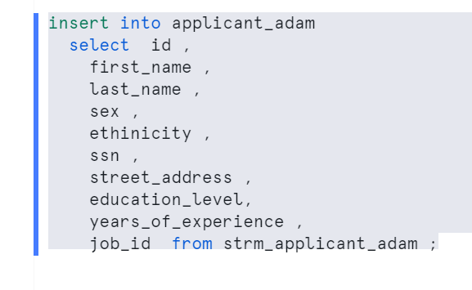
Adam stream is consumed as shown
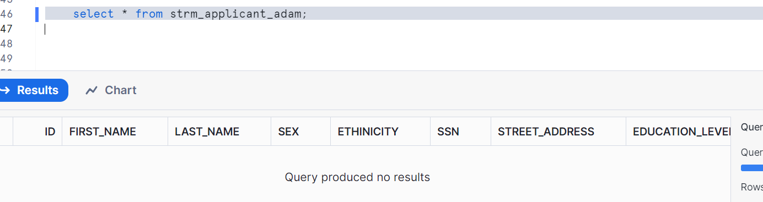
But smith stream is not consumed yet
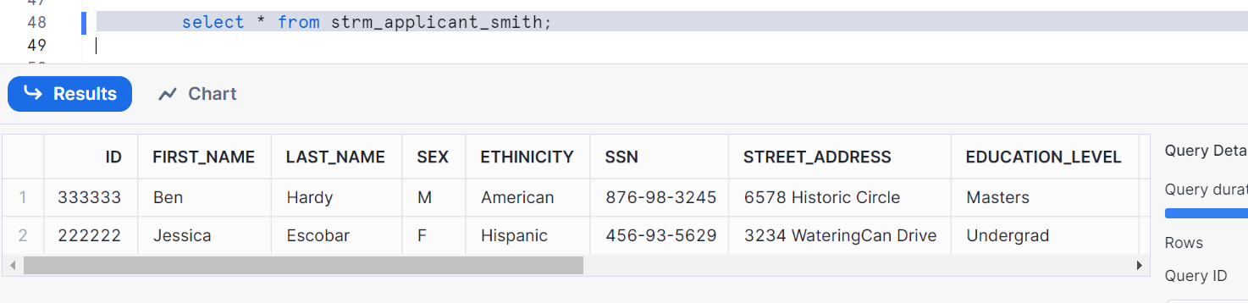
Let’s insert two more rows in staging table
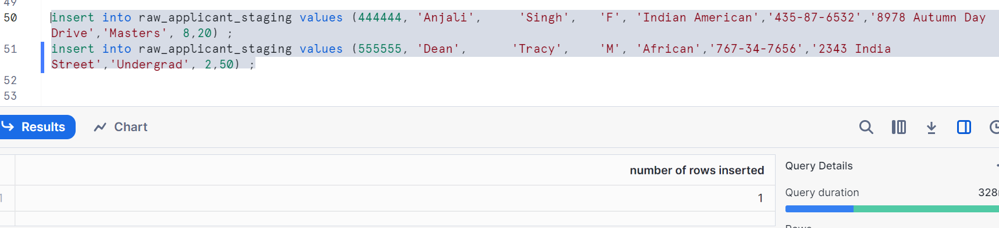
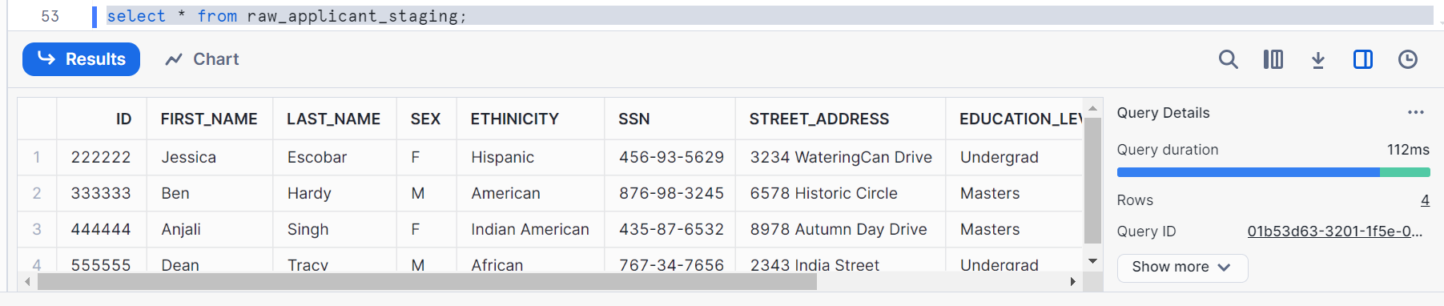
So, Adam had consumed its stream but smith didn’t, hence when I inserted the two rows as per the above, Adam stream should have two rows (since earlier two rows are consumed) and Smith stream should have 4 rows
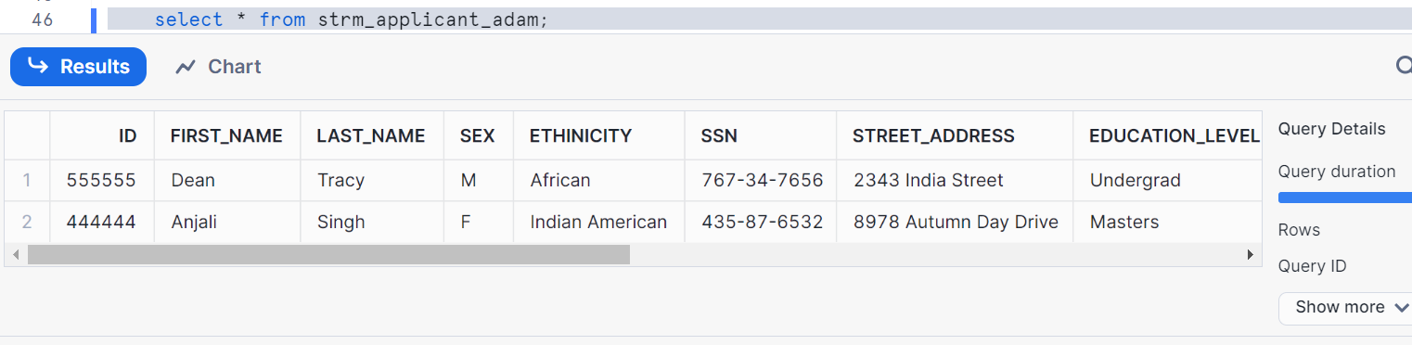
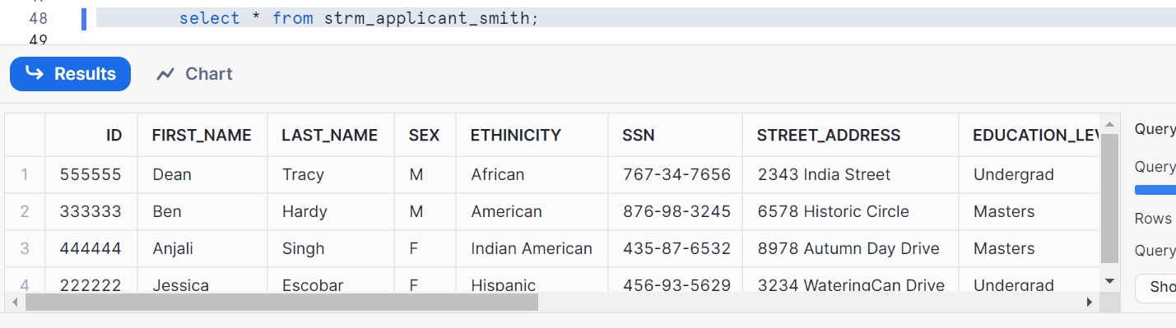
Now Smith wants to consume this data from its stream and insert into its target table
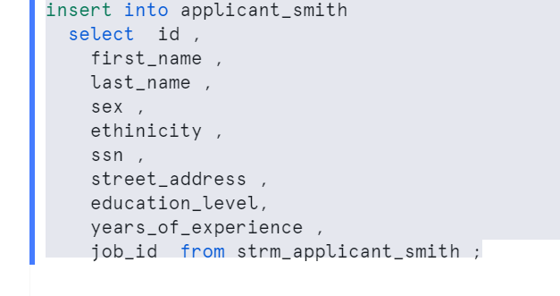
Therefore, Smith consumed all 4 records and Adam had consumed only 2 records in its own streams
Let’s check the target tables
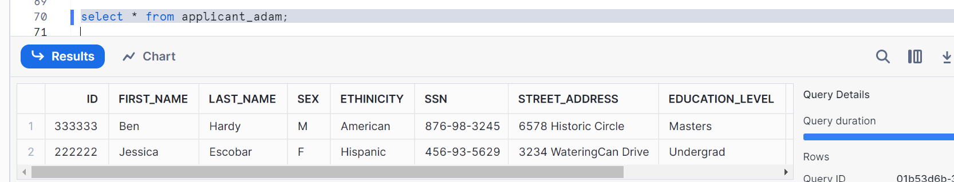
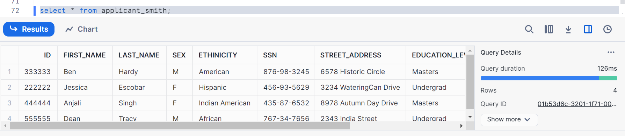
Now, let’s say Adam want to consume the remaining records in its stream
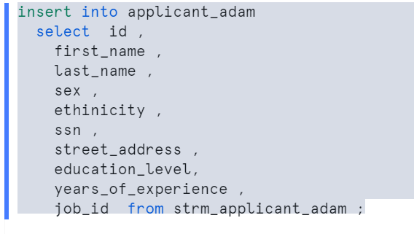
Now, we can see all records in our Adam target table
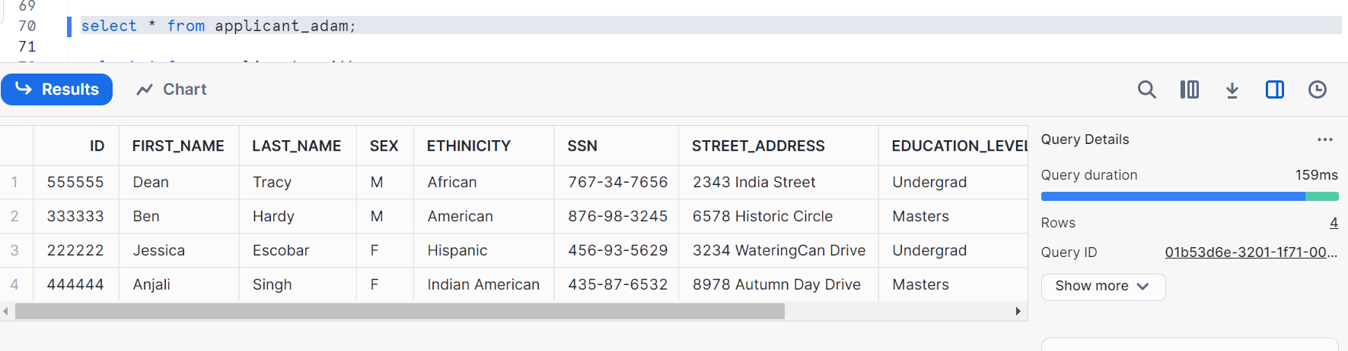
Finally, check the streams. It has to be empty as entire data is consumed
