STREAMS
About “CHANGES” clause
CHANGES clause is used where data persists even after consumption
Let’s apply it on tables and views
Create a table
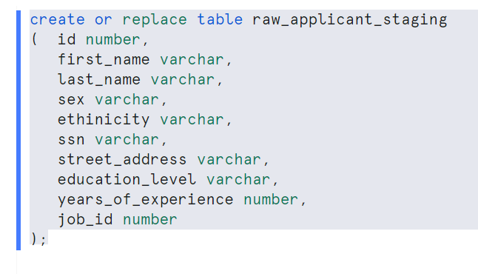
Insert some rows
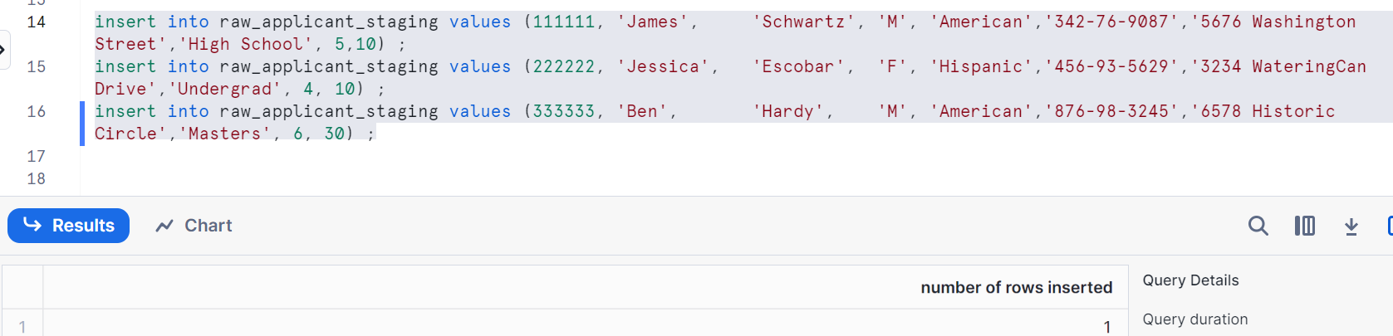
Creating a view by using the above table for male
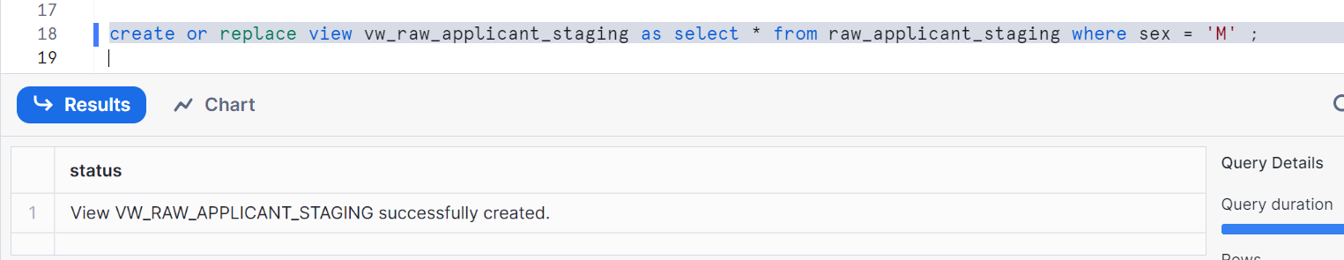

Change clause for table
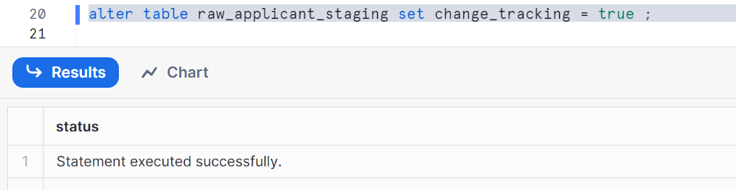
Change clause for view
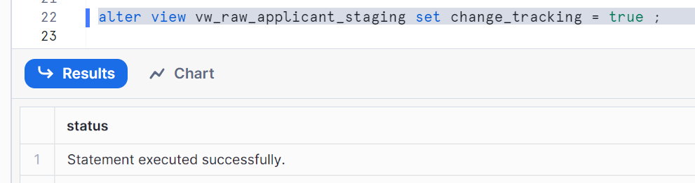
‘change_tracking’ can be given at the time of table creation as well, since we created table we used it in alter statement

Let’s use my current timestamp as offset, store it to see the changes before and after
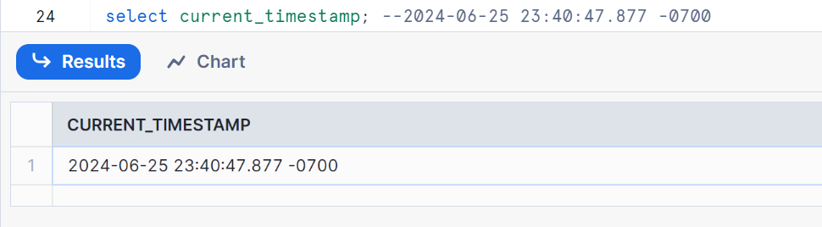

Checking existing data
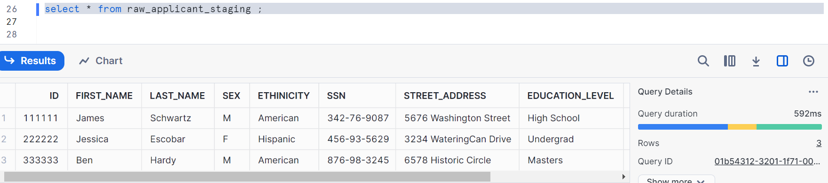
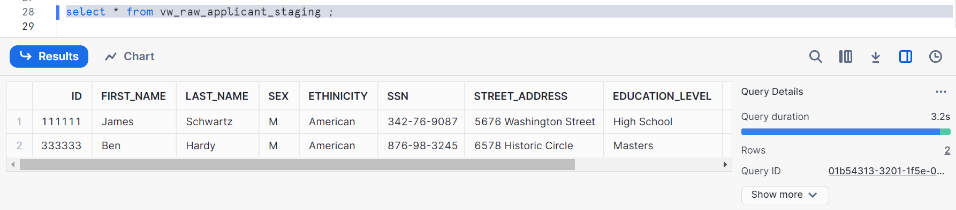
Now, inserting the data post our offset
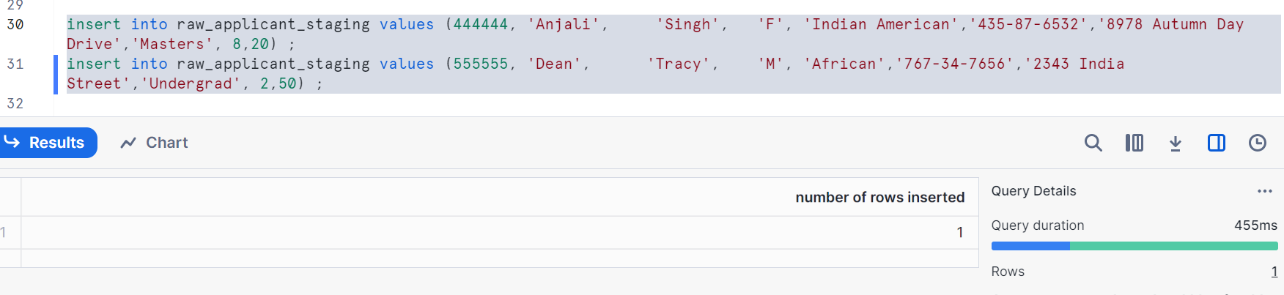
Now, using changes clause as below
Note: I had given my offset and it will show me what the changes are done after this particular time shown. Before offset it is 3 records but after offset it is 2 records as we had inserted.
Information=>default: You can pass like whether you want default or you want append only data on table, just like streams
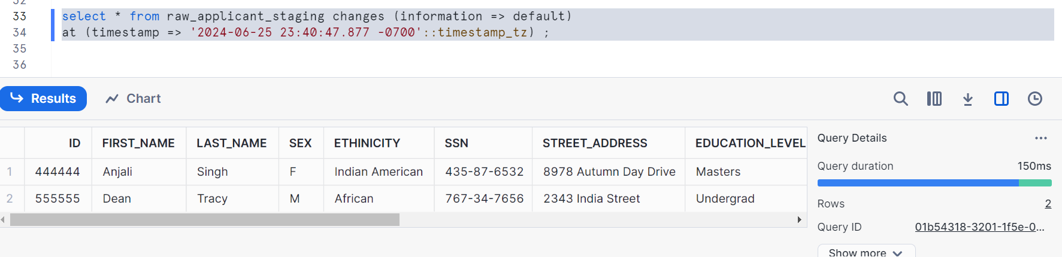

Applied same on view, we know view is to get only male candidates
As we had inserted rows 1 male & 1 female after offset, we had to get 1 record of male
Here is the output
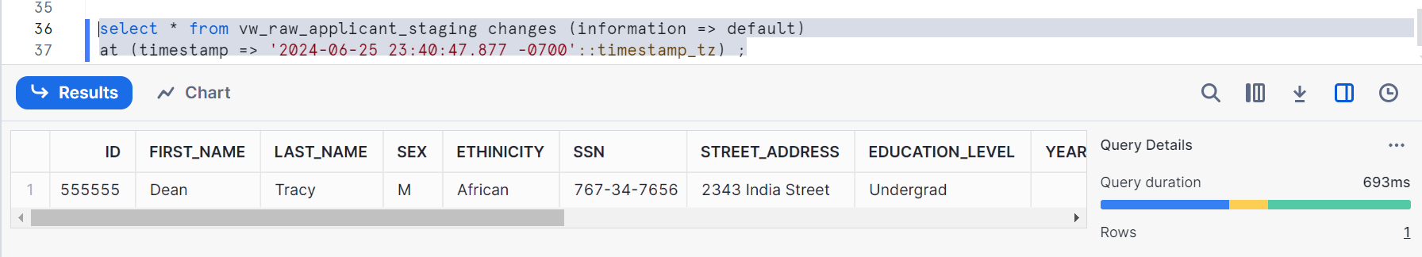
Let’s use, information=>append_only
Here, in case of insert the behavior will not be different because append_only captures the insert and we are testing the inserts here.
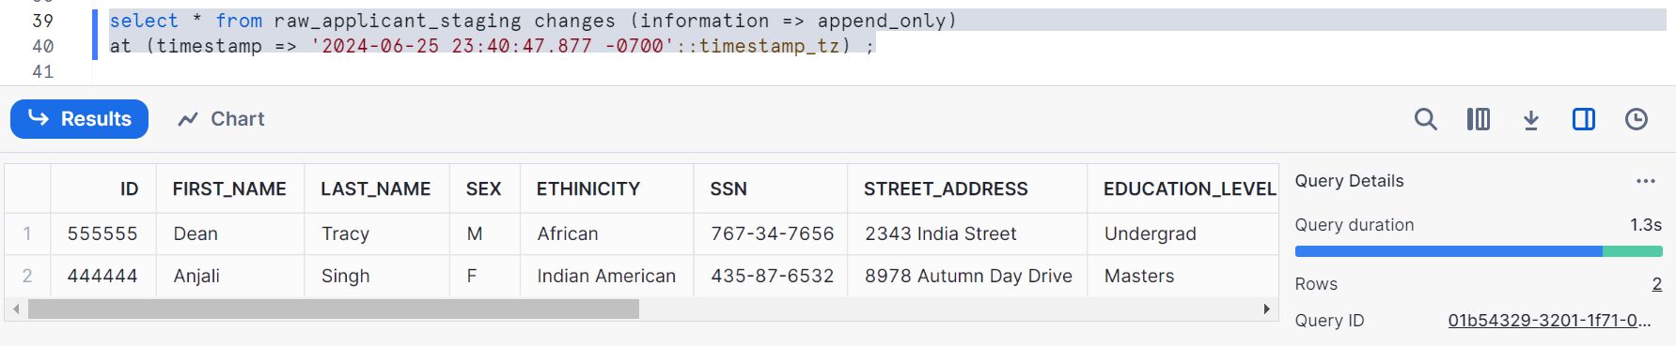
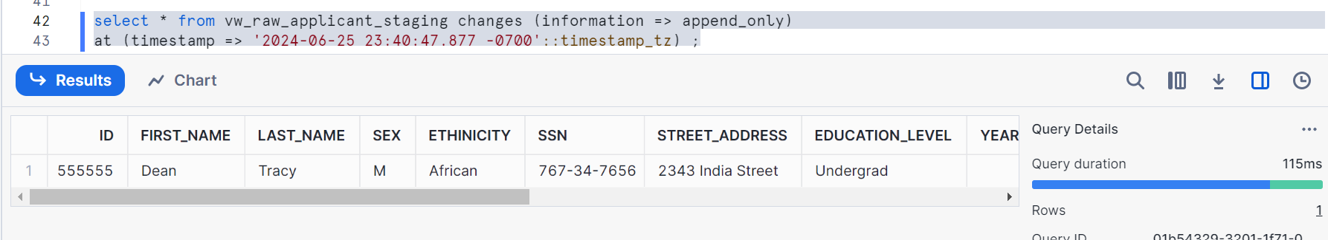

Let’s do delete operations and check
Taking an offset
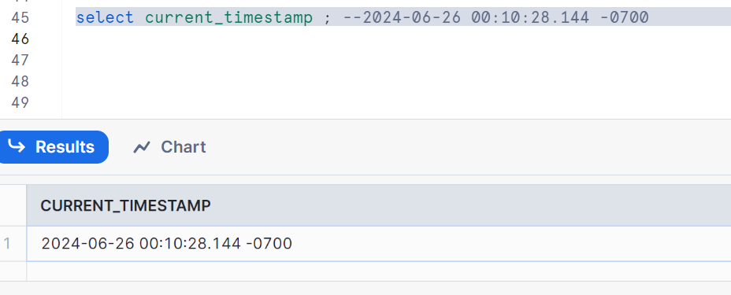
We have total 5 records
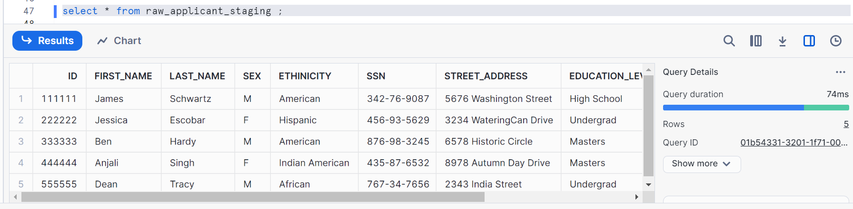
Now, let’s delete 1 male & 1 female after offset
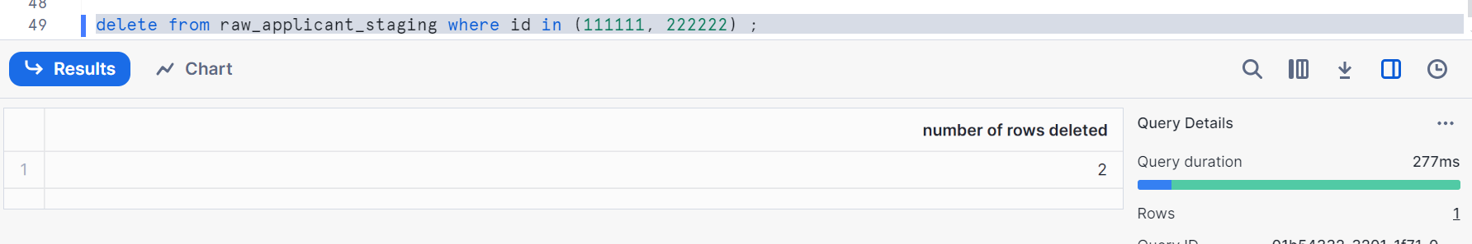
Let’s check
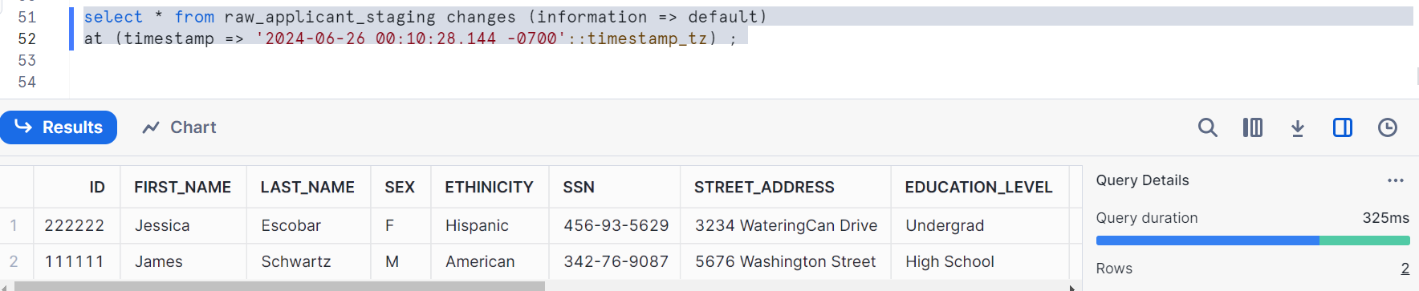

As you know, view is for males and we got only 1 male record as we deleted 1 male & 1 female
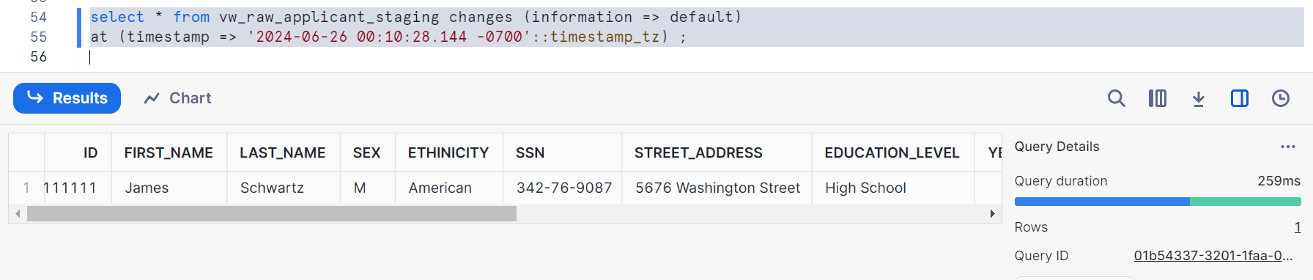
Let’s check with append_only
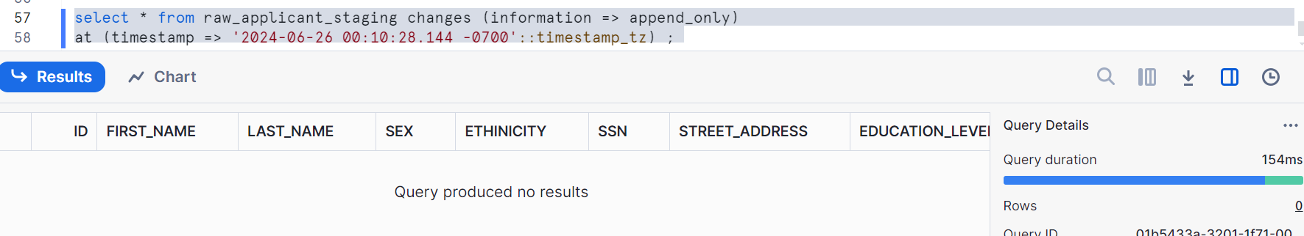
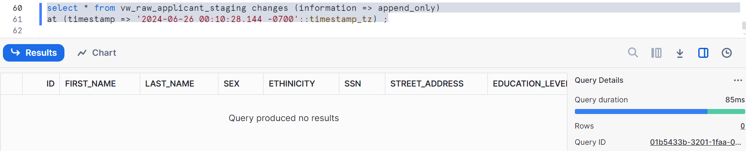
Append_only captures only the data which is inserted. Hence we got 0 records in above

Let’s check with UPDATE operation
Taking an offset
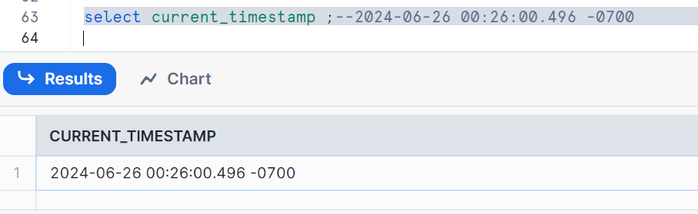

Our current table & view have 3 & 2 records as shown currently
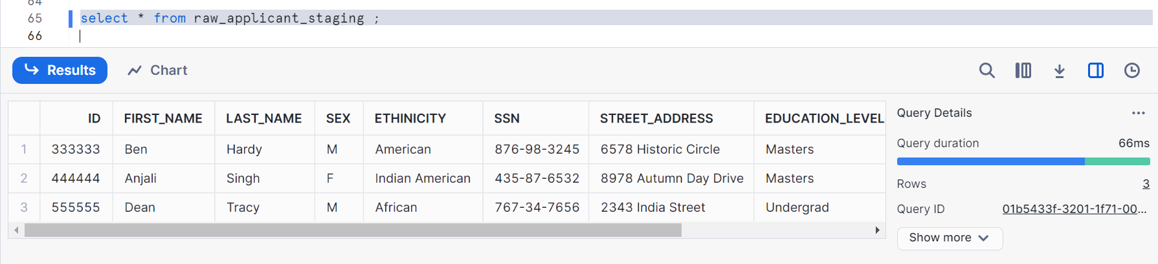
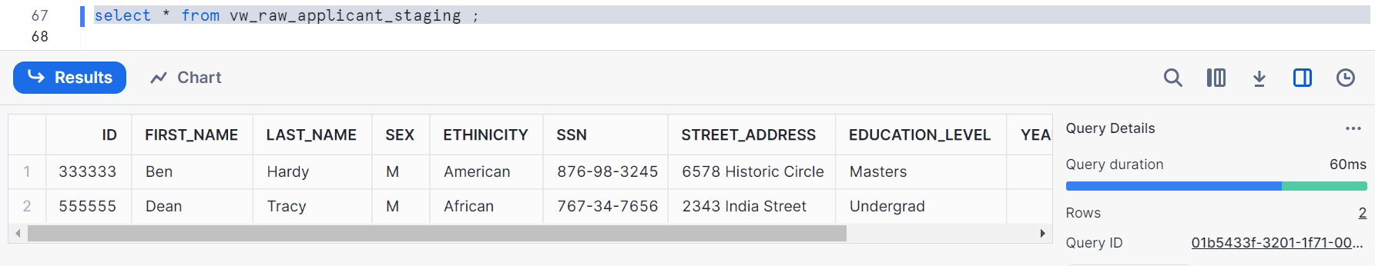
Updating the records after offset above
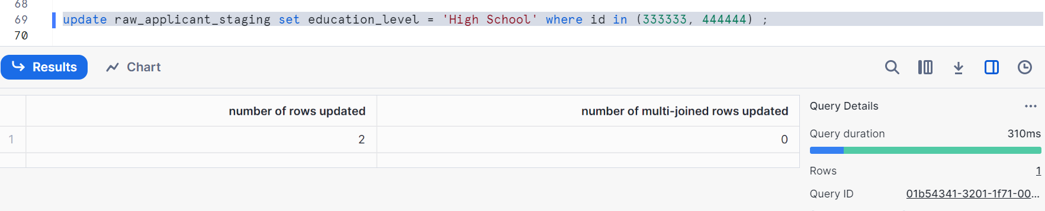
Let’s run the change clause query
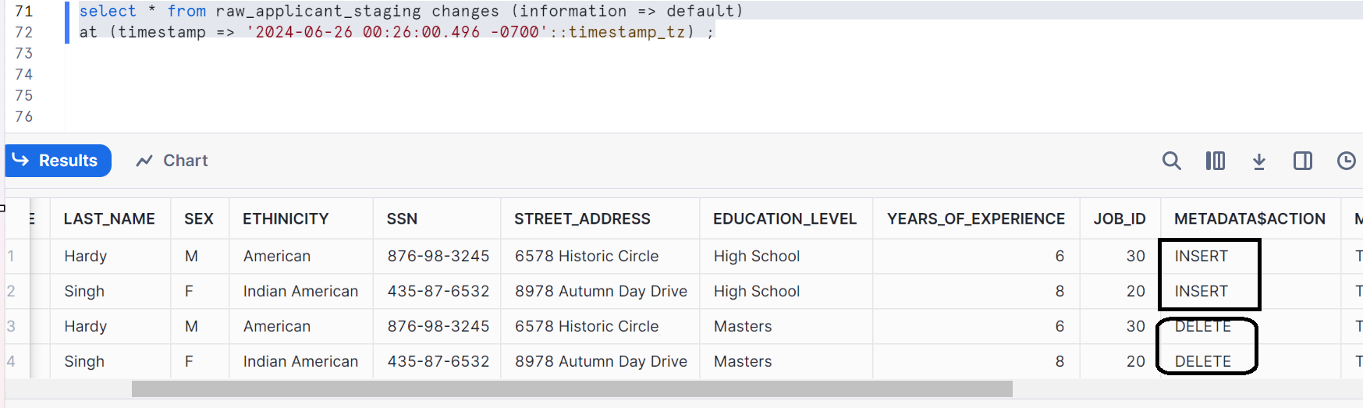
We are getting 4 records reason being, we updated 2 records meaning deleting them from table and inserting them with updated/new values

Similarly for view
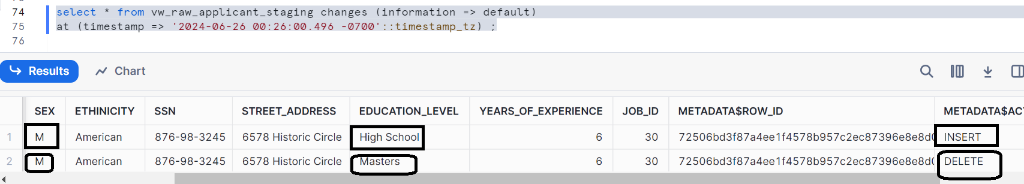
Using append_only, since we know that append_only doesn’t capture the update operations
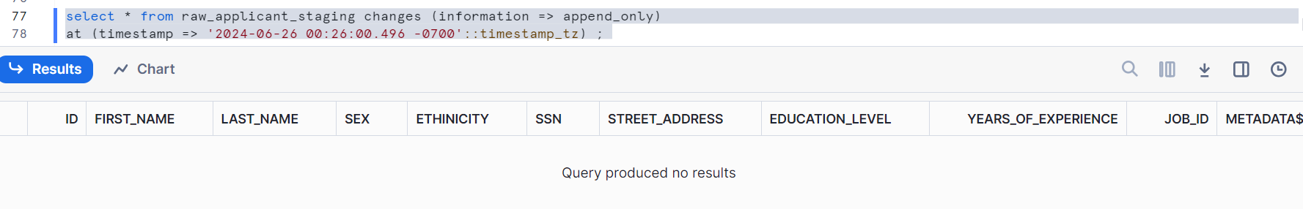
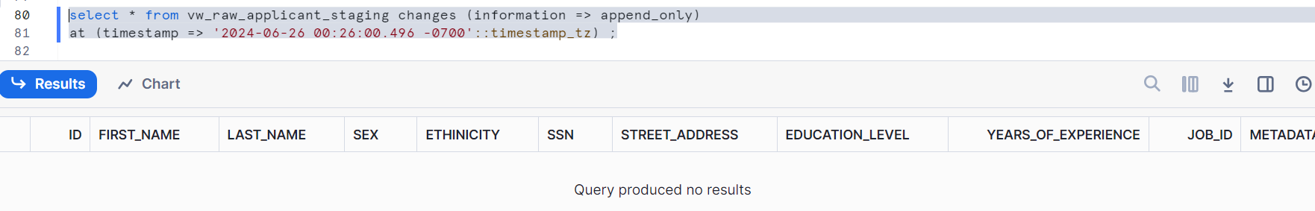
We have seen that we can capture data using changes clause on a table and the view
We have to also confirm that if you are consuming the data using the changes clause that it is not going away, it is still persisting
Let’s check
Consuming the change clause doesn’t advance the offset
Create a temp table
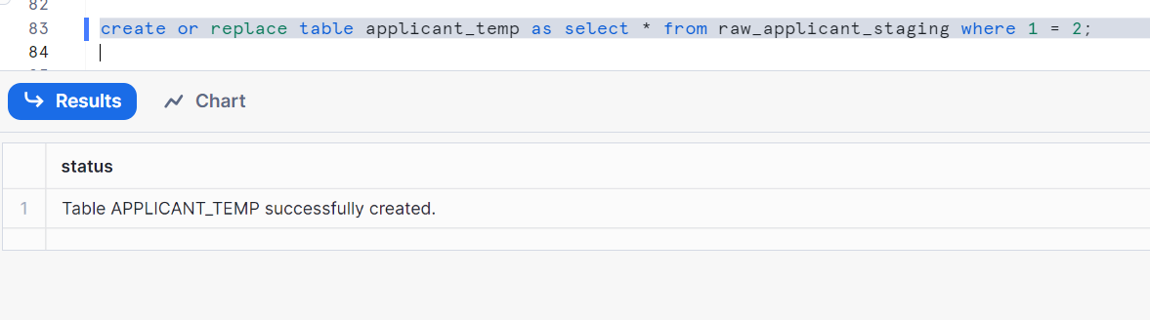

Consuming by inserting in temp table
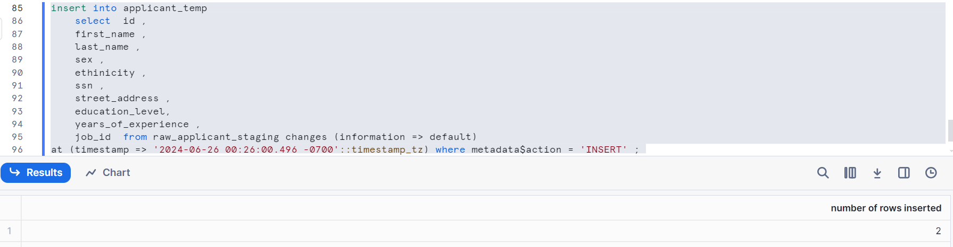
Data is consumed and let’s check
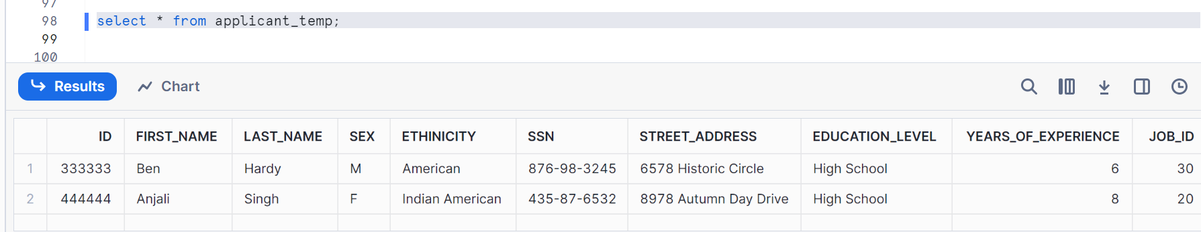
If you still check with changes clause, we can still see the data
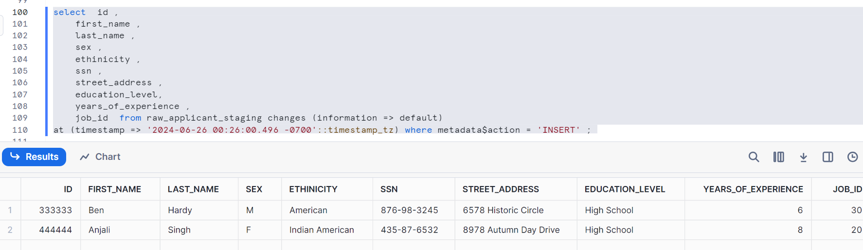
So, data is actually getting persisted even after I have consumed
The change track is not consumer OR the offset is not moved by the consumption

Can be used in create table as well, Let us check
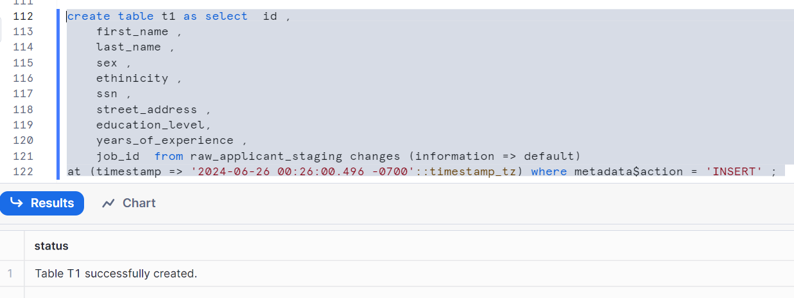
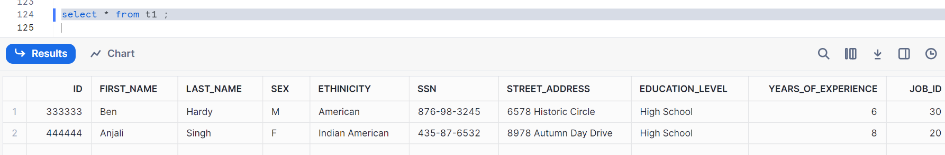
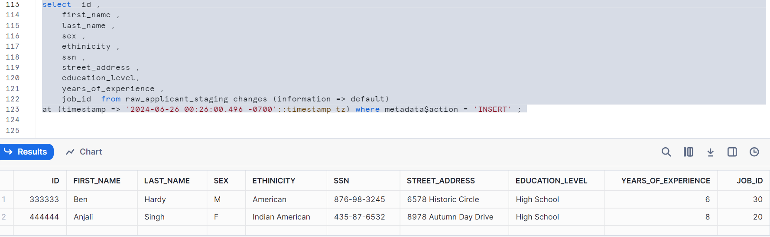
The data is still persisting even after consumption
Please note that if you have a scenario where you have multiple consumers, it is also a good idea to use the change clause then to create the multiple streams or specific streams for each user. But be careful that you are leveraging the offset which is called timestamp

