STREAMS
Streams stale_after and extension in days
To understand it better let’s recall again some parameters,
DATA_RETENTION_TIME_IN_DAYS:
Specifies how many days snowflake preserves the historical data so that time travel can be done. When this period ends, this data is no longer available and moves to fail safe. This can be changed any time for a table, schema or database.
MIN_DATA_RETENTION_TIME_IN_DAYS:
A minimum value of data retention can also be set to make sure that data retention doesn’t go below this value even if the data retention is marked as very less
MAX_DATA_EXTENSION_TIME_IN_DAYS:
This is the maximum number of days for which the retention period can be extended on the tables to make sure that the stream doesn’t become stale and can be set at account, database, schema and table

Stream becomes stale when its offset is out of data retention period
For tables having retention less than 14 days, unconsumed streams are extended to not go stale for the extension time. Hence Cost is affected.
Formula for stale_after is given by
stale_after = current_time + max (extension, retention), retention = (max (min_retention, retention))
Let’s understand it practically
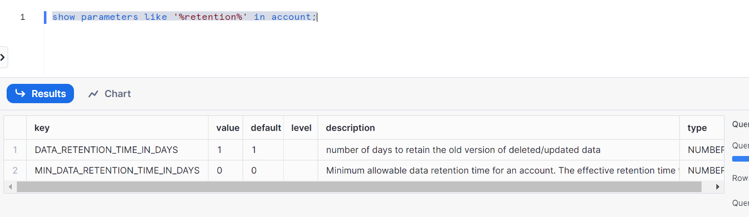
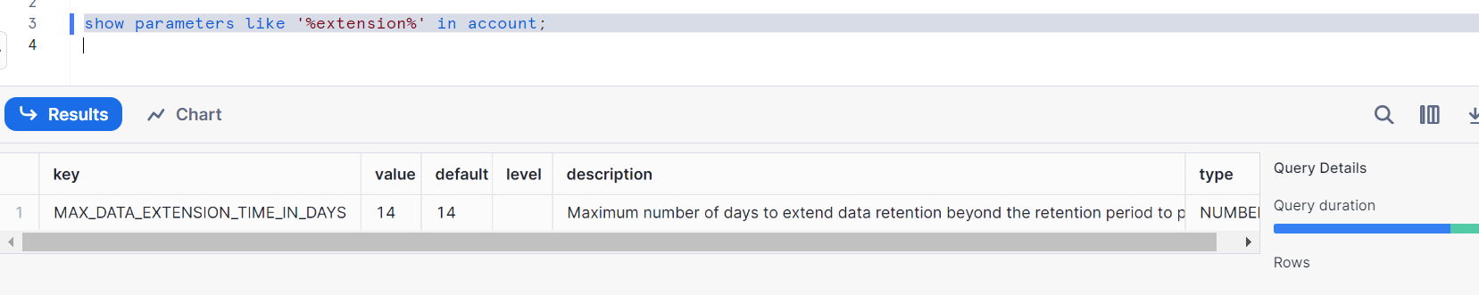
Let’s create a table
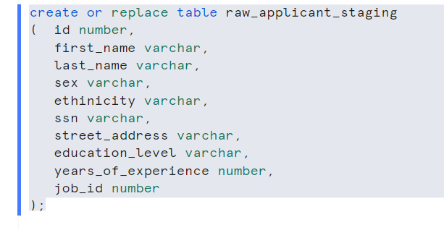
Insert some records
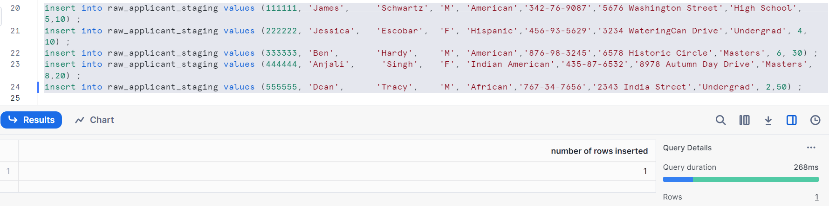
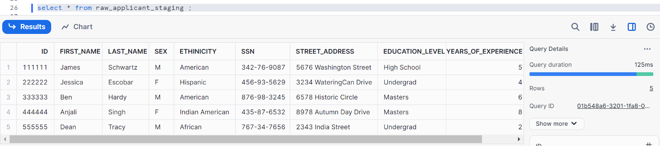

Create a default stream
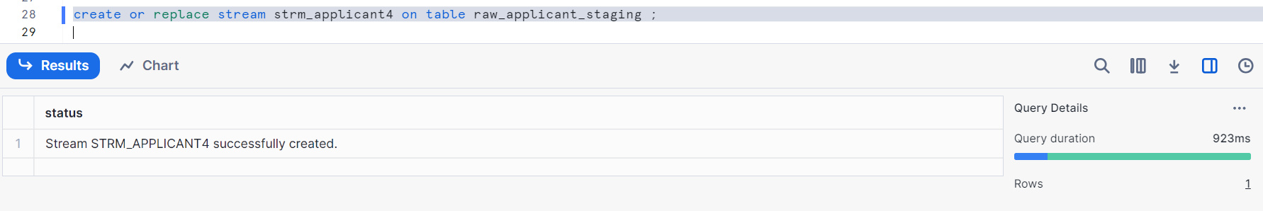
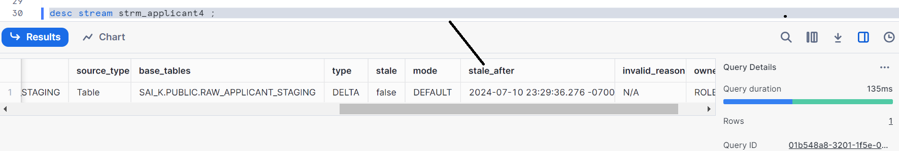
stale_after => Post 14 days
Reason as follows:
stale_after = current_time + max (extension, retention), retention = (max (min_retention, retention))
= current_time + max (14, 1) retention= max (0, 1) = 1 Please see the above images for numbers that I had put in
=current_time + 14 days
Implies stale_after is post 14 days from current time

Let’s change the values and see its effect on stale_after
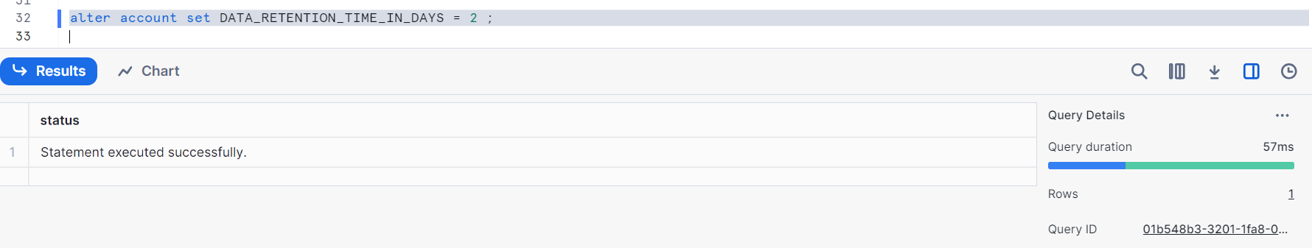
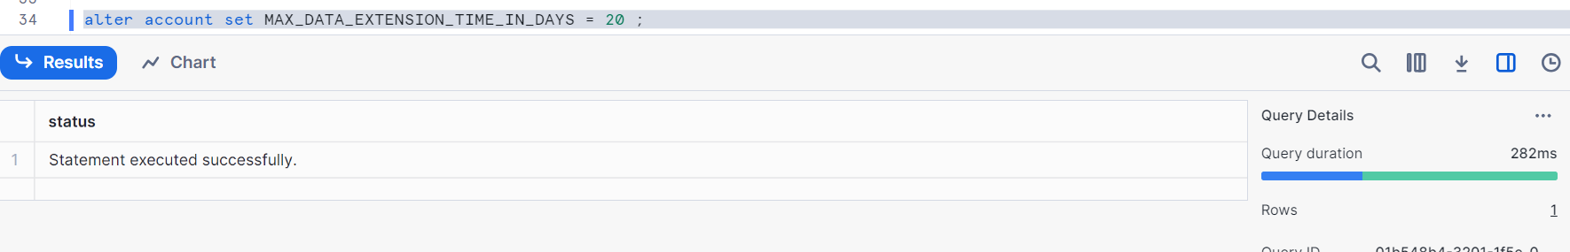
Once we had changed the values at the account level as above, they are actually inherited down i.e. from account to database to schema, here are the following images shown below
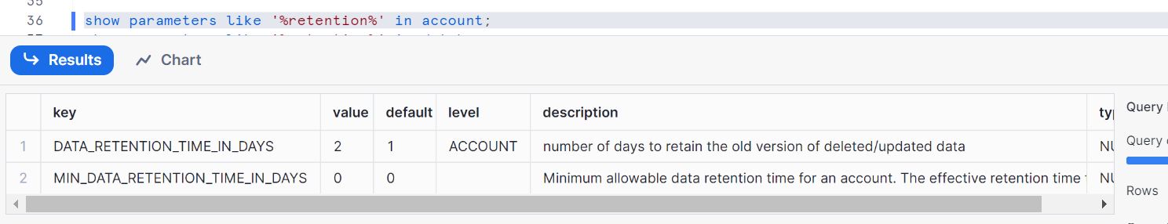
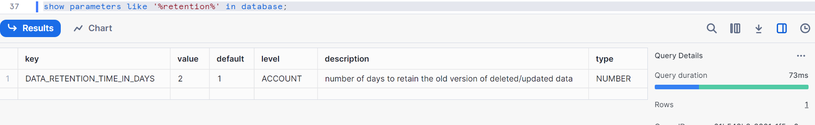
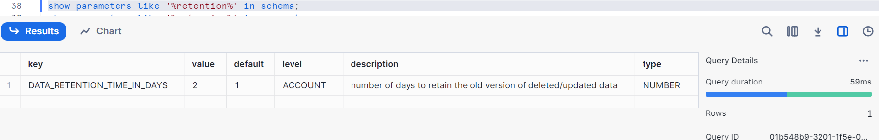
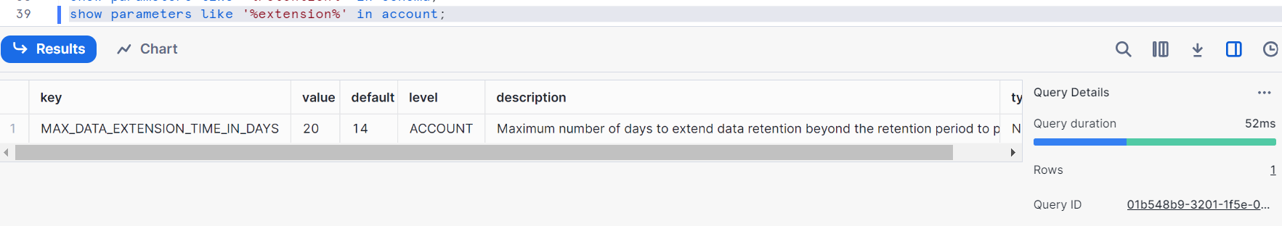
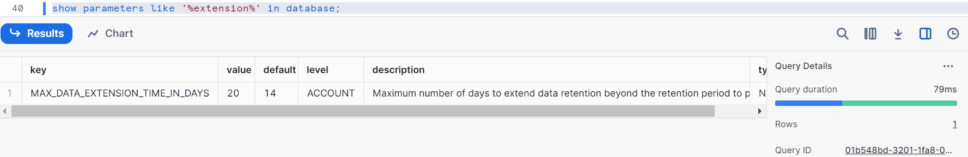
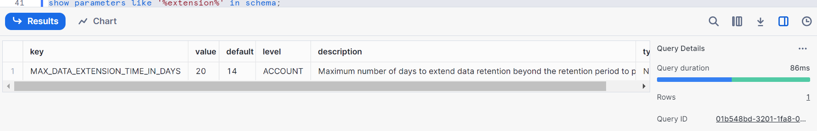
Check stale_after i.e. shows stale_after is post 20 days from current date
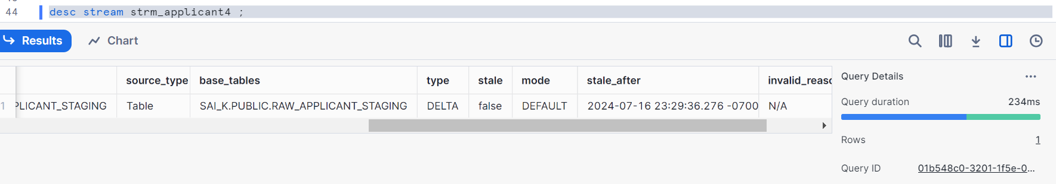
stale_after = current_time + max (extension, retention)
Stale_after= current_time + max (20, 1) retention= max (0, 2) = 2
= current_time + max (20, 1)
= current_time + 20 days

Now let’s change the maximum extension value to some value along with others and check
Firstly changing retention time value
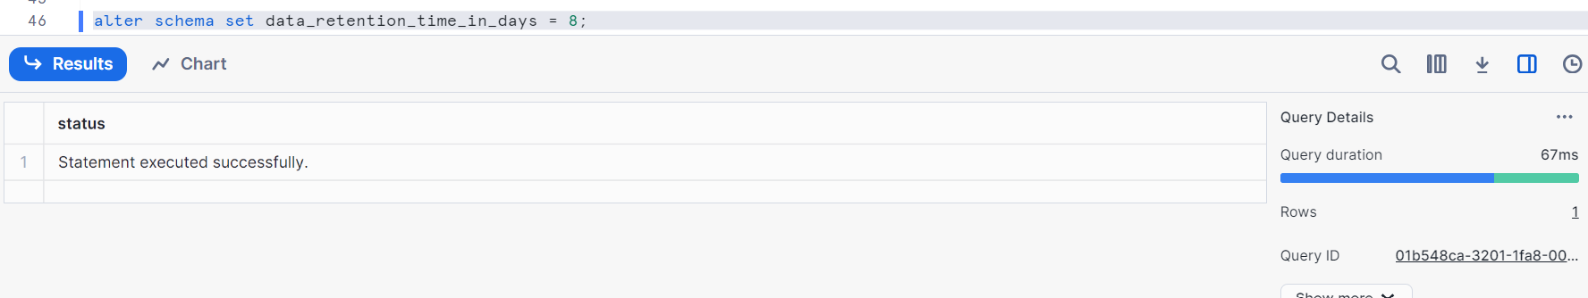Note: I am changing data retention at schema level, then it gets fixed whatever the value you had set up and when you try to change at account level then down level i.e. schema level value doesn’t change
I had changed at schema level initially and now changing account level to verify
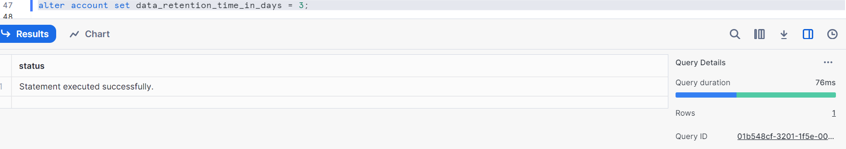
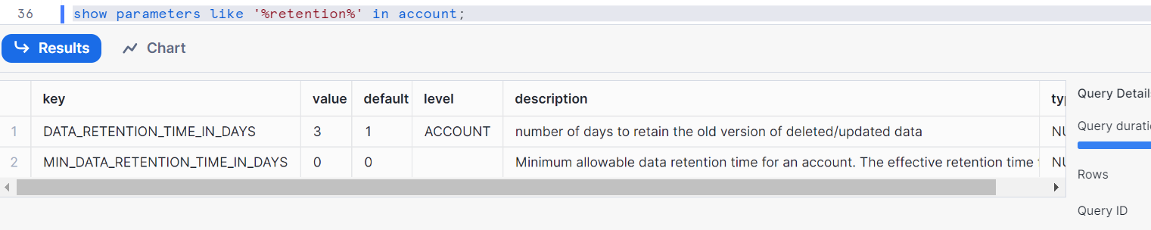
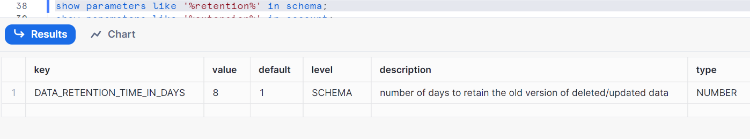
Therefore, the value didn’t change in schema level even if I change at account level
Let’s change other parameters as well
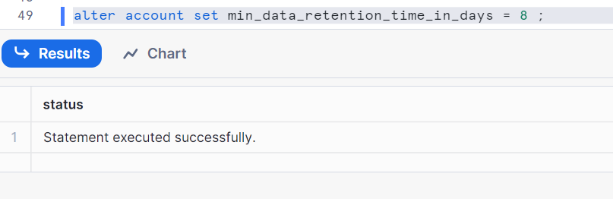
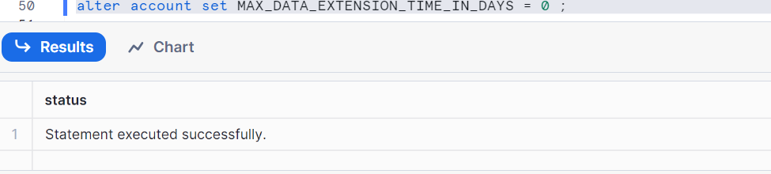
Let’s check stale_after
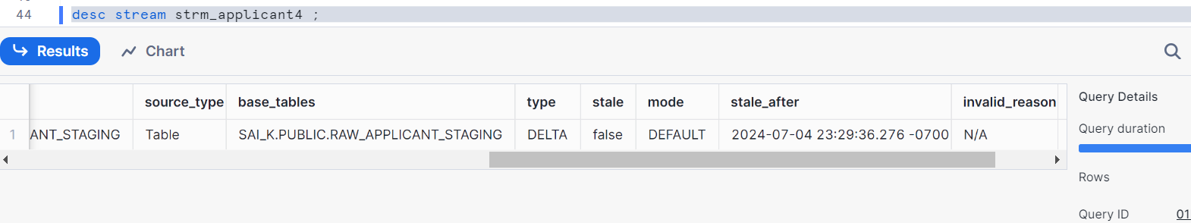
stale_after = current_time + max (extension, retention)
= current_time + max (0, 8) retention= max (8, 3) = 8
== current_time + 8 days

Recreate, Rename and Clone effect on stream
Considerations of streams:
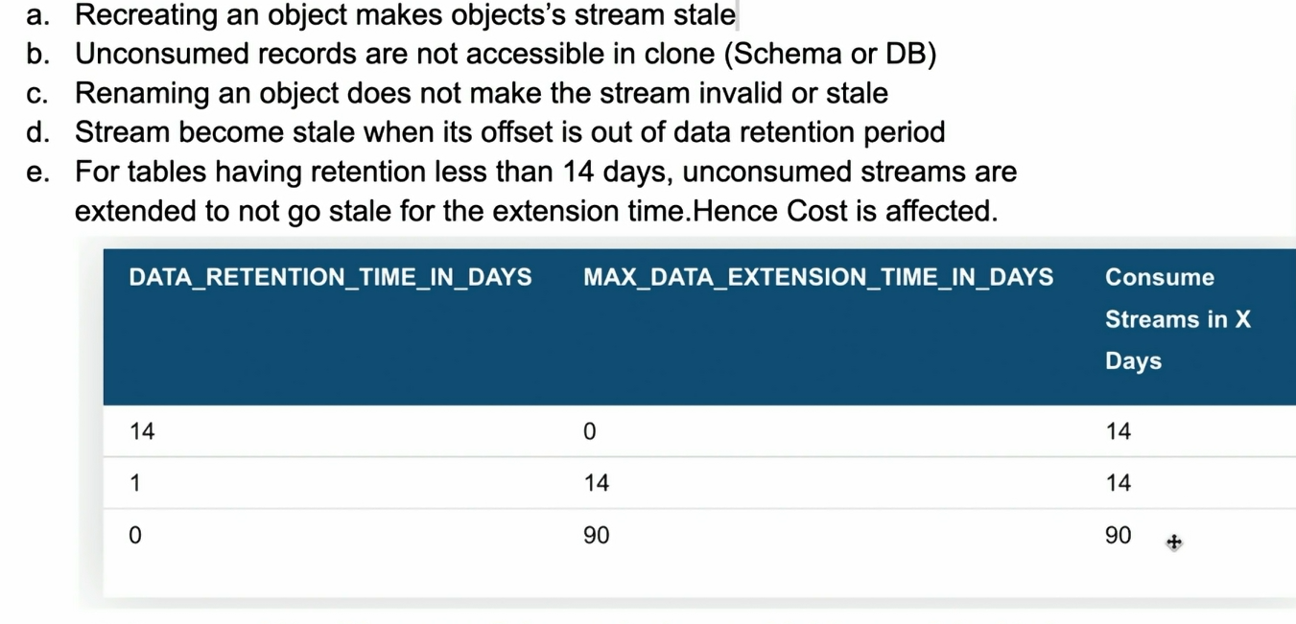
Let’s recreate the table and check stream stale
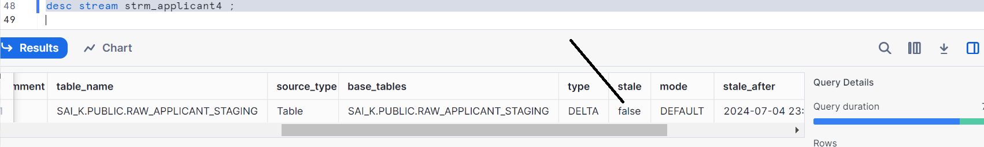
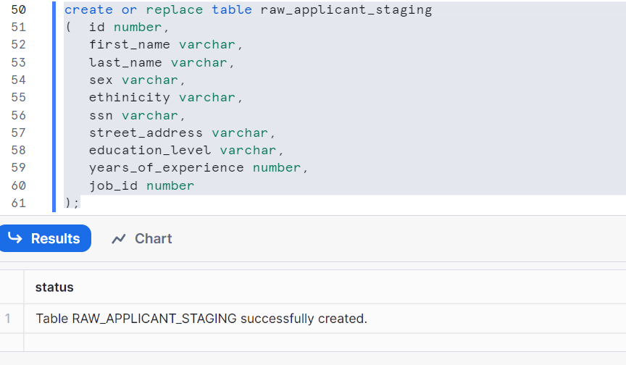

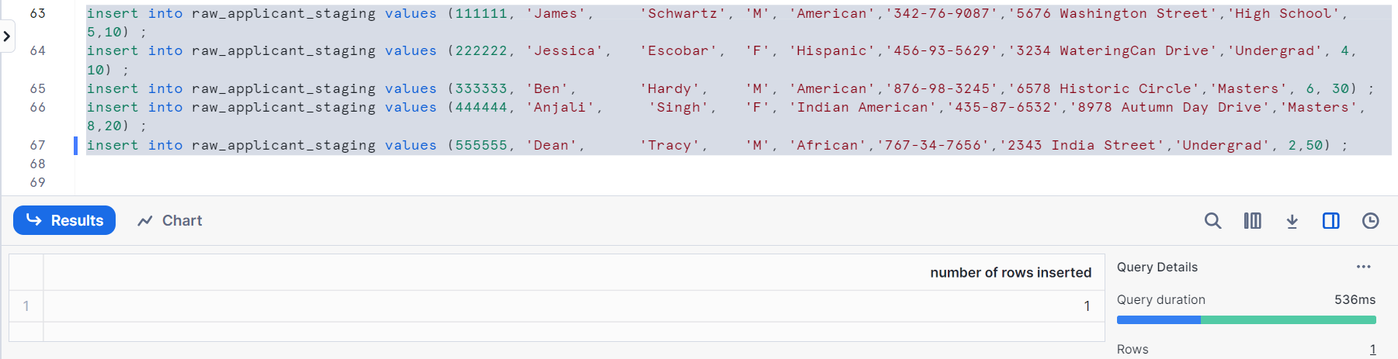
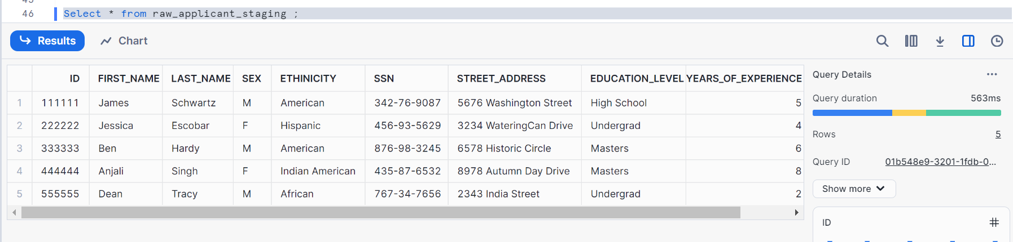
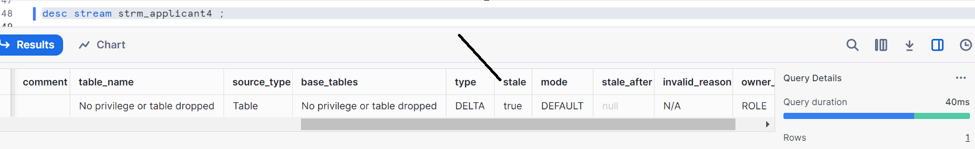
stale_after => NULL, stale = True

Renaming the object will not make the stream invalid, let’s check
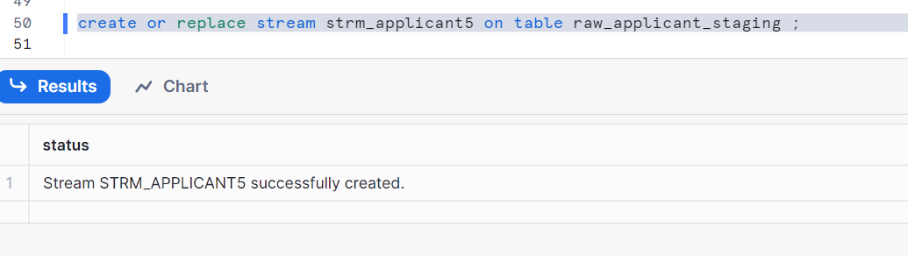
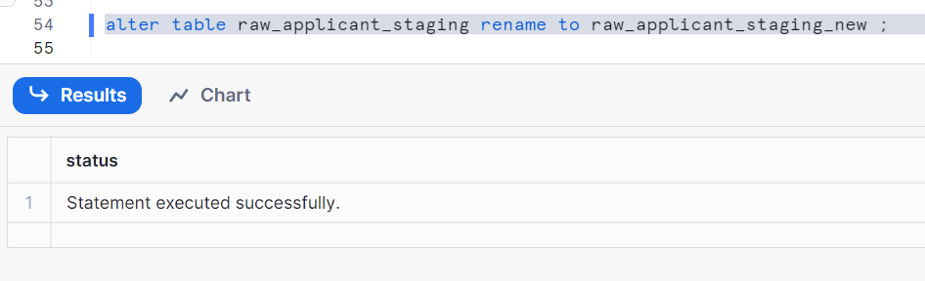
Select the data from new stream
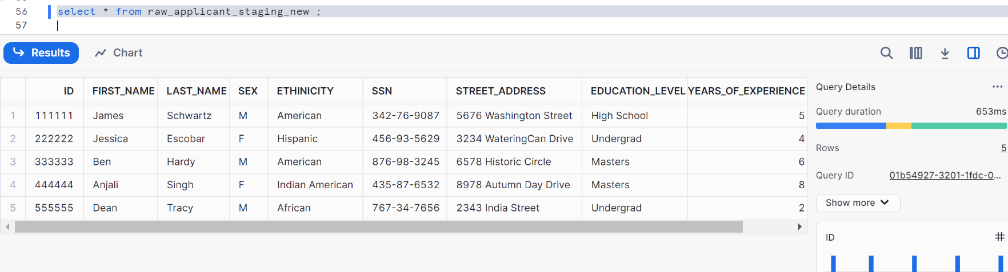
Make sure old table doesn’t exists
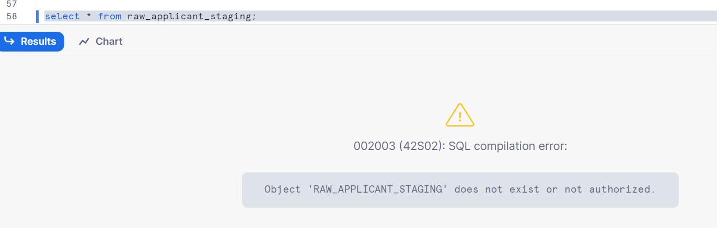
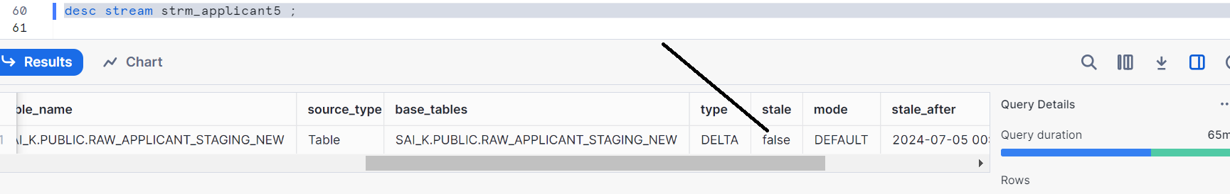
Hence, the stream in not staled
Conclusion: When you are recreating the underlying table, it makes this stream as stale. But when renaming it, it doesn’t as it remains as it is.
Let’s see how a stream works if it is cloned
Let’s create a table
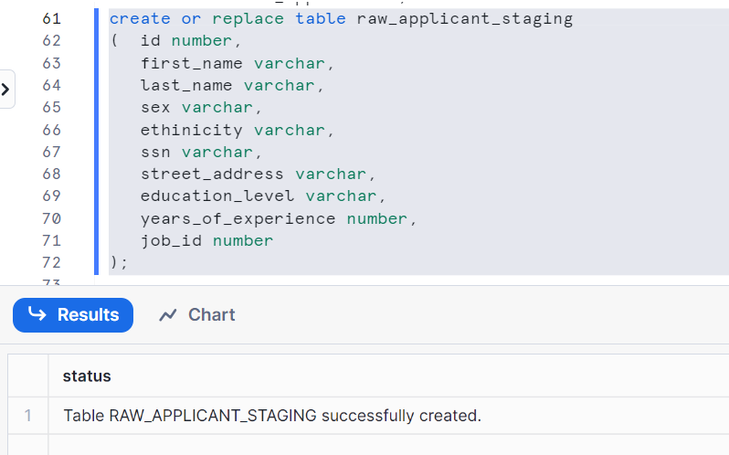
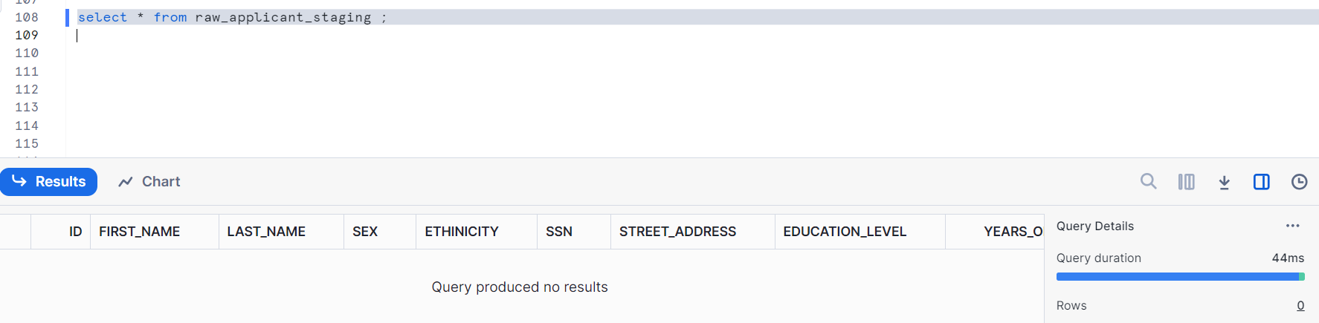
Let’s create a stream
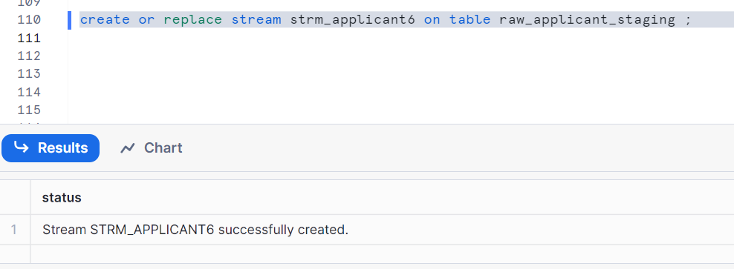
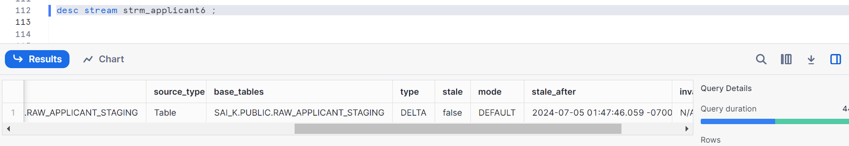
Insert some data
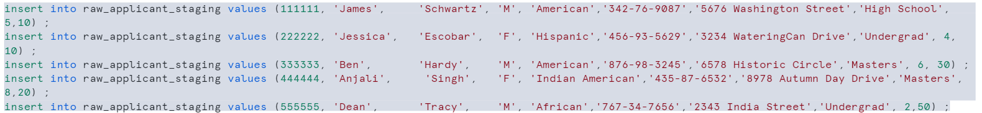
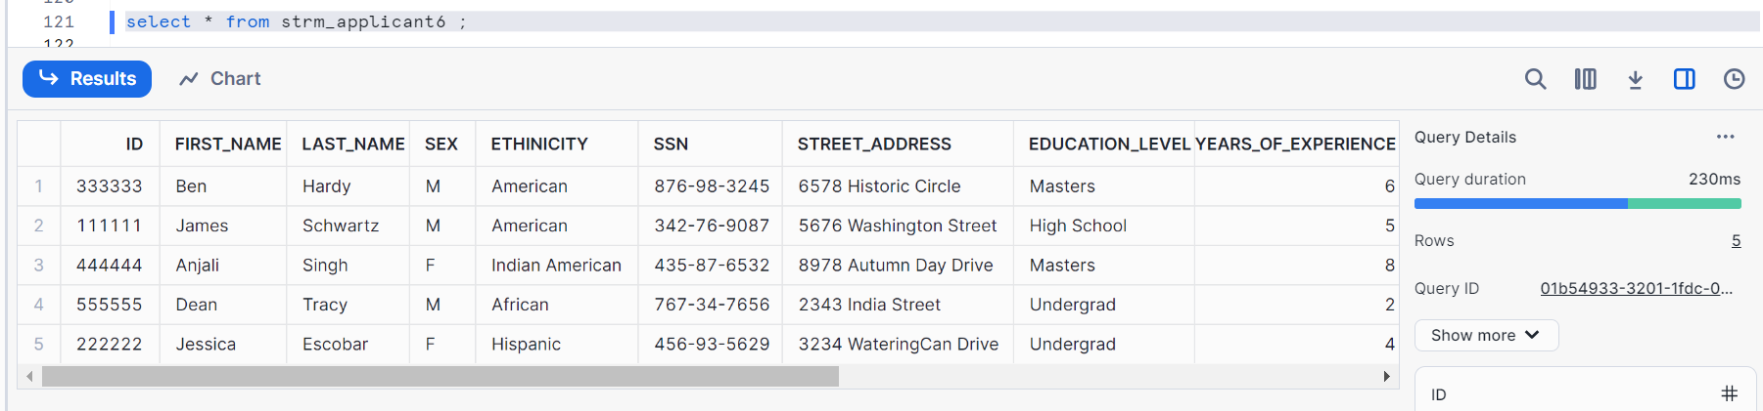
Create clone schema public (note: you can clone any schema as per your wish in the DB)
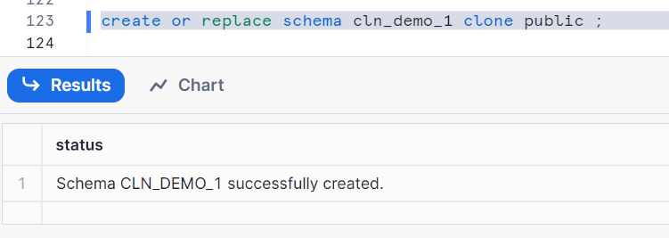
Now let’s use this new schema cln_demo_1
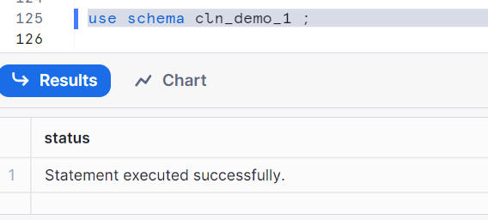
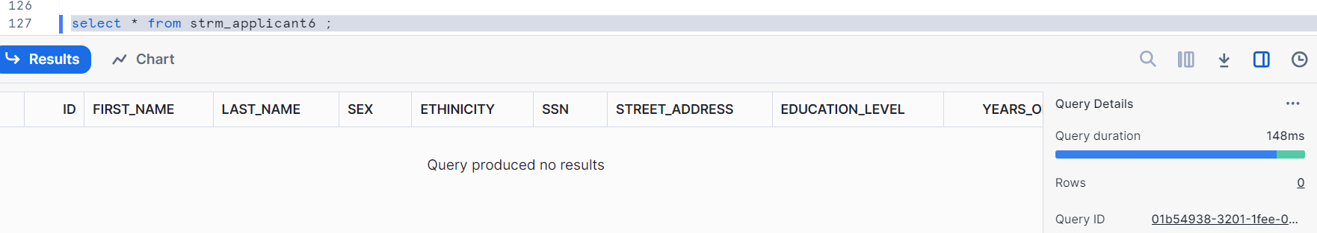
Therefore, this stream was unconsumed in our main schema which is public schema. Hence, in the clone you will not see any data

Now, let’s go back to our main schema i.e. public
