**Importing ACADGILD vm using oracle vm:**

**1. Imported ACADGILD vm:**

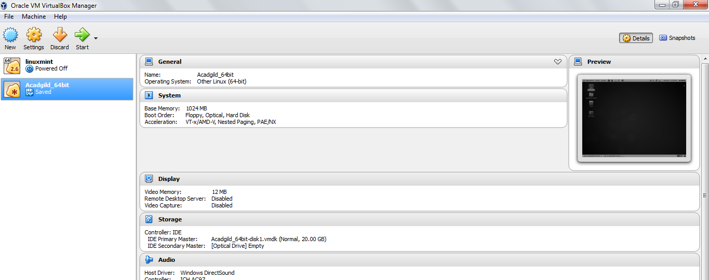

**2. Starting all daemons:**

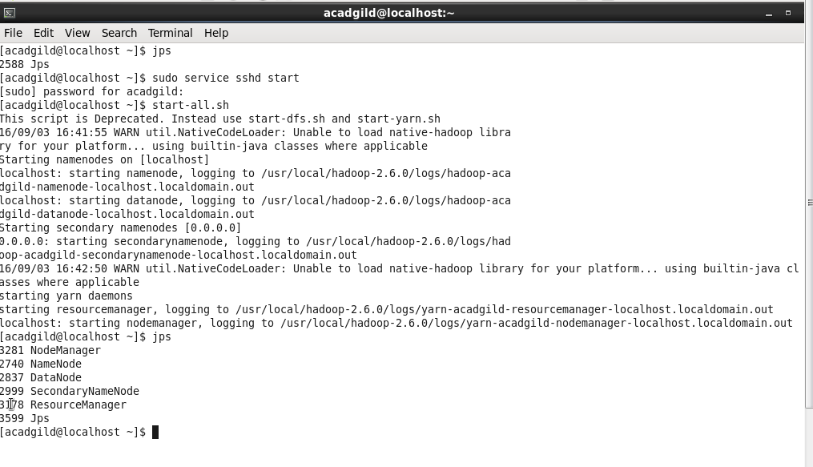

**3. Starting history Server:**

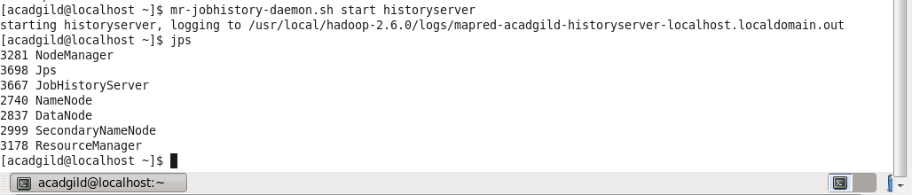

**4. Starting pig in hdfs mode:**

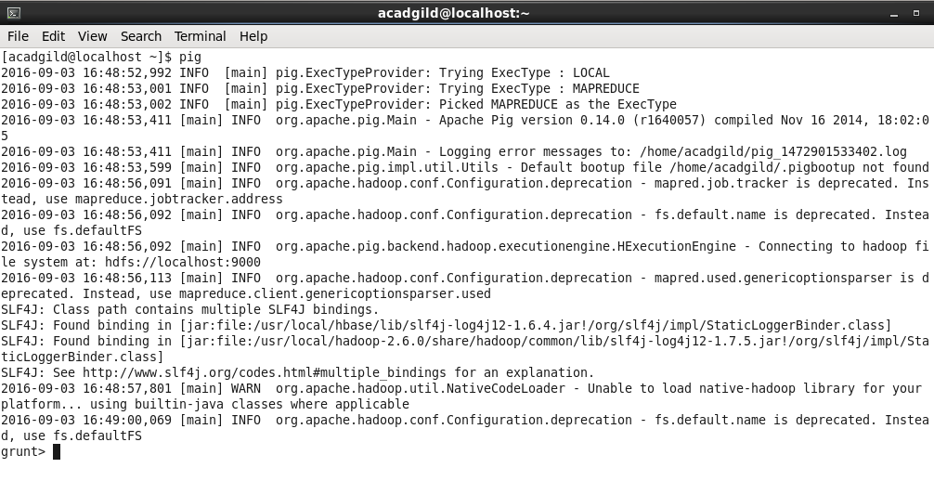

**5. Starting hive:**

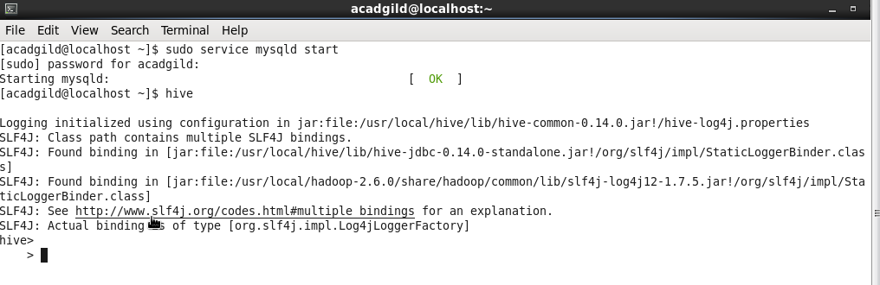

**6. Starting hbase:**

