**Assignment 2.1:**

**Task1(To create hadoop folder ):**

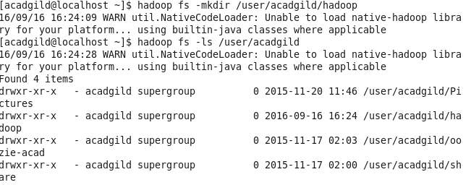

**Task2: To put a file in Hadoop directory:**

