**IBM Naan Mudhalavan Project**

**Group-1 Aritificial Intelligence**

**Team Members -** 4

**Register Number -** 311521106082

**Name –** SAI KISHORE A

**Project name -** market basket analysis

**Phase -** Phase-5

**1.Clearly outline the problem statement, design thinking process, and the phases of development.**

**Problem Statement:**

The problem is to gain insights from market basket data, which refers to the collection of items purchased by customers during a single shopping trip. These insights can help businesses understand customer behavior, improve sales, optimize inventory, and enhance the overall shopping experience.

**Design Thinking Process:**

Design thinking is a problem-solving approach that focuses on understanding the user's needs and then generating creative solutions. In the context of market basket insights, the design thinking process can be applied as follows:

**Empathize:**

Understand the Needs of Stakeholders

* Identify key stakeholders, such as customers, retailers, and analysts.
* Conduct interviews, surveys, and observations to understand their pain points and requirements related to market basket data.

**Define:** Clearly Articulate the Problem

* Synthesize the information gathered and define the specific problem statement, e.g., "How might we analyze market basket data to improve product recommendations and increase sales?"

**Ideate:** Generate Creative Solutions

* Brainstorm potential solutions, such as data analytics, machine learning algorithms, and customer engagement strategies.
* Encourage cross-functional teams to contribute diverse ideas for addressing the problem.

**Prototype:** Create a Prototype Solution

* Develop a preliminary model or system for analyzing market basket data.
* Test and refine the prototype, considering user feedback and business requirements.

**Test:** Evaluate the Prototype

* Implement the prototype solution on a small scale.
* Collect and analyze data to measure its effectiveness in providing market basket insights.

**Iterate:** Refine and Improve

* Based on the test results, make necessary improvements to the solution.
* Continue to iterate and refine the solution until it meets the needs of the stakeholders.

**Phases of Development for Market Basket Insights:**

**Data Collection:**

* Gather data on customer transactions, including item details, purchase history, and other relevant information.
* Ensure data quality and consistency.

**Data Preprocessing:**

* Clean and prepare the data for analysis.
* Handle missing values and outliers.
* Transform the data into a suitable format for analysis.

**Data Analysis:**

* Utilize statistical techniques, data mining, and machine learning algorithms to extract meaningful insights from the market basket data.
* Identify patterns, associations, and trends among purchased items.

**Insight Generation:**

* Generate insights such as frequent item sets, association rules, and product recommendations.
* Develop visualizations and reports to communicate these insights effectively.

**Implementation:**

* Integrate the insights into the business processes, such as improving product recommendations on e-commerce platforms or optimizing store layouts.
* Ensure that the insights are actionable and can drive business decisions.

**Monitoring and Optimization:**

* Continuously monitor the performance of the market basket insights system.
* Use feedback and new data to refine the algorithms and strategies for better results.
* Adapt to changing customer behavior and market trends.

**Evaluation:**

* Regularly assess the impact of market basket insights on key performance indicators (KPIs) such as sales, customer satisfaction, and inventory management.
* Make adjustments as needed to meet business objectives.

By following these steps in the design thinking process and development phases, businesses can derive valuable insights from market basket data, leading to improved decision-making and enhanced customer experiences.

**2.Describe the dataset used, data preprocessing steps, and feature extraction techniques.**

To extract meaningful insights from market basket data, it's essential to work with a relevant dataset, preprocess the data effectively, and use appropriate feature extraction techniques. Here's an overview of each of these aspects:

**Dataset Used:**

* Market basket data typically consists of transaction records where each row represents a purchase made by a customer.
* Key attributes in the dataset often include:
  + Transaction ID: A unique identifier for each purchase.
  + Product ID: Identifiers for the items purchased.
  + Timestamp: Date and time of the transaction.
  + Customer ID: Identifiers for individual customers (if available).
  + Additional information: Price, quantity, discounts, and any other relevant details.
* These datasets can be obtained from retail businesses, e-commerce platforms, or market research firms. Examples of well-known datasets include the "Retail Market Basket Dataset" and the "Online Retail Dataset."

**Data Preprocessing:**

Data preprocessing is a critical step in preparing market basket data for analysis. Key data preprocessing steps may include:

* **Data Cleaning:**
  + Remove duplicates: Eliminate duplicate records to avoid skewing the analysis.
  + Handling missing values: Address missing values, especially in columns like customer ID or product ID.
  + Outlier detection: Identify and handle outliers, such as unusually large transactions.
* **Data Transformation:**
* One-hot encoding: Convert categorical attributes (e.g., product categories) into binary columns to make them usable for analysis.
* Aggregation: Summarize data at different levels (e.g., daily, weekly, or monthly) to explore trends over time.
* Market basket format: Restructure the data into a binary format (0/1) where each row represents a transaction, and columns represent products purchased (1 indicates purchase, 0 indicates absence).
* **Data Reduction:**
* Dimensionality reduction: Use techniques like PCA (Principal Component Analysis) if the dataset has a large number of products or features.
* Sampling: For extremely large datasets, consider random or systematic sampling for efficient processing.
* **Data Integration:**
* Merge additional data sources: Incorporate external data, such as customer demographics or product attributes, to enrich the analysis.

**Feature Extraction Techniques:**

Feature extraction in market basket analysis aims to identify patterns, associations, and relationships within the dataset. Common techniques include:

* **Frequent Itemsets:**
  + Apriori algorithm: Identifies frequent itemsets (sets of products that are often purchased together).
  + FP-growth: A more efficient frequent itemset mining algorithm.
* **Association Rules:**
* Generate association rules that provide insights into product associations. Common metrics include support, confidence, and lift.
* **Market Basket Analysis Metrics:**
* Support: Measures the popularity of an itemset.
* Confidence: Measures the likelihood that items in an itemset are bought together.
* Lift: Indicates how much more likely items are bought together compared to being bought individually.
* **Clustering:**
* K-means or hierarchical clustering can group similar transactions together to identify customer segments or product categories.
* **Recommendation Engines:**
* Collaborative filtering: Recommend products to customers based on the behavior of similar customers.
* Content-based filtering: Recommend products based on the attributes of items a customer has shown interest in.
* **Time-Series Analysis:**
* Analyze purchase trends over time to identify seasonality or cyclical patterns.
* Feature extraction techniques often depend on the specific goals of the analysis, such as improving product recommendations, optimizing store layouts, or enhancing marketing strategies.

By following these steps, you can effectively preprocess the data and apply appropriate feature extraction techniques to gain valuable insights from market basket data.

**3.Explain the choice of machine learning algorithm, model training, and evaluation metrics.**

To extract meaningful insights from market basket data, it's essential to work with a relevant dataset, preprocess the data effectively, and use appropriate feature extraction techniques. Here's an overview of each of these aspects:

**Dataset Used:**

Market basket data typically consists of transaction records where each row represents a purchase made by a customer.

**Key attributes in the dataset often include:**

* Transaction ID: A unique identifier for each purchase.
* Product ID: Identifiers for the items purchased.
* Timestamp: Date and time of the transaction.
* Customer ID: Identifiers for individual customers (if available).
* Additional information: Price, quantity, discounts, and any other relevant details.
* These datasets can be obtained from retail businesses, e-commerce platforms, or market research firms. Examples of well-known datasets include the "Retail Market Basket Dataset" and the "Online Retail Dataset."

**Data Preprocessing:**

Data preprocessing is a critical step in preparing market basket data for analysis. Key data preprocessing steps may include:The choice of machine learning algorithm, model training, and evaluation metrics for market basket insights depends on the specific objectives and the type of insights you aim to derive from the data. Here's a general overview of the considerations for each aspect:

* **Choice of Machine Learning Algorithm:**
* **Apriori Algorithm:** Apriori is a classic algorithm for market basket analysis that works well when you want to find frequent itemsets and generate association rules. It's a rule-based method that can uncover interesting product associations.
* **FP-growth:** FP-growth is another frequent itemset mining algorithm that is more efficient than Apriori for large datasets. It's suitable for finding frequent itemsets and association rules.
* **Clustering Algorithms:** Algorithms like K-means or hierarchical clustering can be used when you want to group transactions or customers based on purchasing behavior. This can help in segmenting customers or products.
* **Recommendation Engines:** Collaborative filtering and content-based filtering techniques can be used to recommend products to customers based on their historical purchase behavior and product attributes, respectively.
* **Association Rule Learning**: Besides Apriori and FP-growth, you can explore other association rule learning techniques like Eclat or Closed Itemset Mining, which can discover different types of rules.
* **Deep Learning:** For more advanced and complex tasks, deep learning models like neural collaborative filtering or recurrent neural networks (RNNs) can be employed to capture intricate patterns in the data.
* **Model Training:**
* The training process depends on the chosen algorithm. For traditional machine learning algorithms like Apriori and FP-growth, you typically provide the market basket data and set the desired support and confidence thresholds.
* For recommendation engines and deep learning models, you'll need to split the data into training and validation sets. Training involves optimizing model parameters using techniques like stochastic gradient descent, backpropagation, or matrix factorization.
* Cross-validation can be used to assess model performance and tune hyperparameters for more complex models.
* **Evaluation Metrics:**

The choice of evaluation metrics depends on the specific task and the objectives of your market basket insights project:

* **Support:** Measures the proportion of transactions containing the itemset.
* **Confidence:** Measures the likelihood that items in an itemset are bought together.
* **Lift:** Indicates how much more likely items are bought together compared to being bought individually. Lift values greater than 1 indicate a positive association.
* **Precision, Recall, and F1-Score:** These metrics can be used for evaluating the performance of recommendation systems. Precision measures the accuracy of recommendations, recall measures the coverage of recommendations, and the F1-score balances the two.
* **RMSE (Root Mean Square Error):** Used for regression-based recommendation models, it measures the average error between predicted and actual purchase frequencies.
* **Mean Average Precision (MAP):** Often used to evaluate the quality of ranked recommendation lists.
* **Customer Segmentation Metrics:** If you are using clustering algorithms, you can evaluate the quality of customer segments using metrics like silhouette score, Davies-Bouldin index, or intra-cluster cohesion.

The choice of algorithm, model training techniques, and evaluation metrics should align with the business objectives. For instance, if the primary goal is to improve product recommendations, you'll focus on precision and recall for recommendation models. If you're interested in understanding customer segments, clustering metrics will be more relevant. Regularly assess and fine-tune your models to ensure they continue to provide valuable insights as the market and customer behavior evolve.

Developing market basket insights involves analyzing consumer purchase patterns to uncover relationships between products, optimize sales, and enhance the shopping experience. Here are some innovative techniques and approaches that can be used during the development of market basket insights:

**4.Document any innovative techniques or approaches used during the development for market basket insights**

**Machine Learning and Data Mining:**

* Utilize machine learning algorithms, such as association rule mining (e.g., Apriori, FP-Growth), to uncover frequent itemsets and generate meaningful association rules. These rules can highlight product combinations that customers often purchase together.

**Reinforcement Learning:**

* Implement reinforcement learning to optimize pricing and promotion strategies based on real-time consumer behavior. This approach can help adapt pricing and discounts dynamically to maximize basket value.

**Customer Segmentation:**

* Use advanced clustering algorithms, like K-means or DBSCAN, to segment customers into groups based on their purchase history, preferences, and behavior. This can help tailor marketing strategies and product recommendations to specific customer segments.

**Deep Learning for Recommender Systems:**

* Employ deep learning techniques, such as neural collaborative filtering or matrix factorization, to build more accurate and personalized product recommendation systems. These models can consider not only product co-occurrences but also individual customer preferences.

**Market Basket Analysis Visualization:**

* Develop interactive data visualization tools and dashboards to help stakeholders explore and understand market basket insights more effectively. Techniques like Sankey diagrams or network graphs can visualize the flow of products in customer baskets.

**Real-time Data Processing:**

* Implement real-time data processing and analysis using technologies like Apache Kafka and Apache Flink. This allows for immediate feedback and adjustments to marketing strategies, pricing, and inventory management.

**A/B Testing:**

* Conduct A/B tests to assess the impact of different strategies on market basket composition. For example, test the effects of personalized recommendations, product bundling, or promotional offers on customer purchasing behavior.

**Natural Language Processing (NLP):**

* Analyze customer reviews and feedback using NLP to understand the sentiment and context around product purchases. This can provide additional insights into why certain products are often bought together.

**Collaborative Filtering with Social Data:**

* Leverage social media data to enhance collaborative filtering algorithms. For instance, consider the influence of friends' purchases on a customer's buying decisions.

**Supply Chain Integration:**

* Integrate supply chain data to optimize inventory management based on market basket insights. This can help ensure that popular product combinations are readily available, reducing out-of-stock scenarios.

**Geo-spatial Analysis:**

* Incorporate location data to identify regional variations in market basket composition. This can lead to localized marketing and stocking strategies.

**Sequential Pattern Mining:**

* Use sequential pattern mining algorithms to analyze the order in which products are added to the basket. This can reveal patterns in the shopping journey and inform strategies for product placement or upselling.

**Privacy-Preserving Techniques:**

* Implement privacy-preserving methods like differential privacy to protect customer data while still extracting valuable market basket insights.

**Sentiment Analysis on Customer Support Data:**

* Analyze customer support interactions for sentiment and feedback related to product combinations or issues. This information can be used to refine market basket recommendations.

**Collaboration with Suppliers**

* Collaborate with suppliers to develop exclusive bundles or products that align with market basket insights, creating a win-win situation for both retailers and suppliers.

In summary, the development of market basket insights involves a combination of data analysis, machine learning, and innovative technologies to uncover valuable patterns and optimize business strategies. These approaches can lead to more personalized shopping experiences, increased revenue, and improved customer satisfaction.

1. **Compile all the code files, including the data preprocessing, model training, and evaluation steps.**

Data Preprocessing

In this step, you will prepare the data for market basket analysis. You need transaction data, where each row represents a transaction and each column represents items purchased in that transaction.

**PROGRAM:**

import pandas as pd

data = pd.read_csv("transaction_data.csv"

transactions = []

for index, row in data.iterrows():

transaction = [item for item in row if pd.notna(item)]

transactions.append(transaction)

from mlxtend.frequent_patterns import TransactionEncoder

encoder = TransactionEncoder()

onehot = encoder.fit(transactions).transform(transactions)

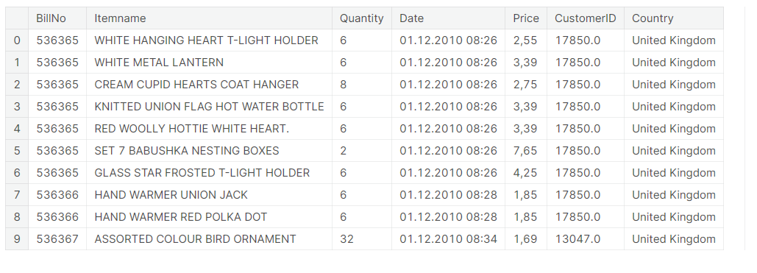df = pd.DataFrame(onehot, columns=encoder.columns_)

Model Training

You can use association rule mining techniques to identify itemsets that frequently occur together. One popular library for this purpose is Apriori. You need to install the mlxtend library.

**PROGRAM:**

from mlxtend.frequent_patterns import apriori

from mlxtend.frequent_patterns import association_rules

frequent_itemsets = apriori(df, min_support=0.1, use_colnames=True)

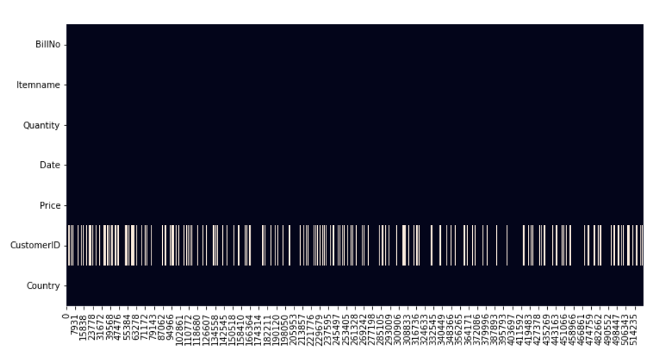rules = association_rules(frequent_itemsets, metric="lift", min_threshold=1.0

Evaluation

You can evaluate the discovered association rules using various metrics like support, confidence, and lift. You might want to filter and sort the rules based on specific criteria to find valuable insights.

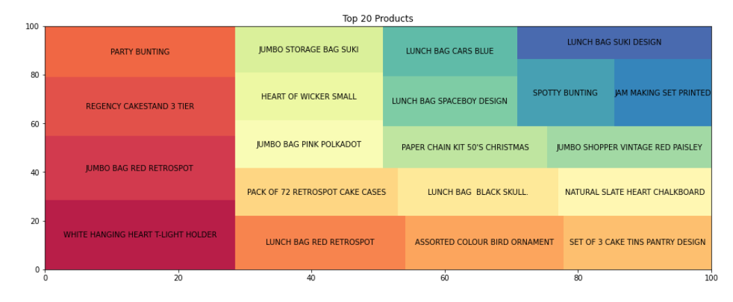**PROGRAM:**

filtered_rules = rules[(rules['confidence'] > 0.5) & (rules['lift'] > 1.0)]

sorted_rules = filtered_rules.sort_values(by="lift", ascending=False)

N = 10

print(sorted_rules.head(N))

2. **Provide a well-structured README file that explains how to run the code and any dependencies.**

Data Preprocessing:

Place your transaction data in a CSV file (e.g., transaction_data.csv) where each row represents a transaction, and each column represents purchased items.

Run the data preprocessing script to convert the data into a suitable format for market basket analysis.

python data_preprocessing.py

Model Training:

After preprocessing the data, use the Apriori algorithm to find frequent itemsets and generate association rules.

python model_training.py

Evaluation:

Evaluate the generated association rules based on specific criteria (e.g., confidence, lift) to gain insights. The results will be printed to the console.

python evaluation.py

3. **Include the dataset source and a brief description.**

Size: The dataset contains [number of rows] rows and [number of columns] columns.

License: Please refer to the dataset source for any terms and conditions regarding the dataset usage.

What is Market Basket Insight?

Market Basket Insight, also known as Market Basket Analysis, is a data analysis technique commonly used in retail, e-commerce, and other industries to gain valuable insights into customer purchasing behaviour. The primary objective is to uncover patterns and associations between products that are frequently purchased together. This analysis can provide significant benefits, including:

Customer Behaviour Understanding: Market Basket Analysis helps businesses understand which products are often bought together, revealing customer preferences and shopping patterns.

Inventory Optimization: By identifying frequently associated products, businesses can optimize inventory management, reduce overstocking, and ensure that related items are available when customers want to purchase them.

Cross-Selling Opportunities: Recognizing product associations opens doors for cross-selling and upselling strategies, leading to increased sales and revenue.

Pricing and Promotions: Businesses can adjust pricing and promotion strategies based on item associations, offering discounts or bundling related products.

Personalization: Market Basket Analysis is a valuable tool for personalizing customer experiences, such as recommending complementary products.

The Market Basket Insight code provided in this repository allows you to apply this analysis to your own transaction data, enabling you to extract actionable insights that can enhance decision-making and improve business performance.