Mechanically Activated Elastomeric Composite Pavement for Passive Ice Mitigation on Winter Roadways
Sai Kolichalam
Department of Electrical and Computer Engineering
Rowan University, Glassboro, New Jersey, USA
Email: kolichalam@students.rowan.edu
Abstract
The accumulation of ice on road surfaces in cold and temperate regions remains one of the most persistent hazards in highway transportation. Conventional mitigation methods — chemical de-icing agents, mechanical snow removal, and actively heated pavement systems — each carry substantial drawbacks in terms of environmental impact, infrastructure corrosion, or energy consumption. This paper introduces a concept for a mechanically activated elastomeric composite pavement layer capable of converting traffic-induced cyclic deformation into localized thermal energy through the principle of viscoelastic energy dissipation.
The proposed system incorporates recycled crumb rubber (40–60 vol%), silicon carbide thermal fillers (5–15 vol%), carbon black (3–8 vol%), and a Styrene-Butadiene-Styrene (SBS) polymer modifier within a purpose-designed multilayer pavement architecture. Heat generation is derived analytically from the viscoelastic power dissipation relation Q = π·f·E″·ε₀², yielding an estimated volumetric heat generation rate of approximately 25.4 kW/m³ at standard operating conditions. A one-dimensional steady-state conduction model predicts a corresponding surface temperature rise of 2–4°C above ambient, with approximately 87% of generated heat directed upward toward the road surface through the deliberate use of a thermally insulating structural base layer.
The paper presents a full mathematical derivation of heat generation and thermal pathway efficiency, addresses known material-level limitations including cold-temperature stiffening and high-temperature rutting, discusses the role of SBS modification in sustaining performance across the critical sub-zero temperature range, and proposes a structured laboratory experimental methodology for validation. The system is positioned against five closely related published technologies through a systematic literature comparison, and its scope is explicitly bounded to supplement — rather than replace — conventional winter road maintenance practice.
Keywords: elastomeric composite pavement, viscoelastic dissipation, passive ice mitigation, crumb rubber modified asphalt, silicon carbide filler, SBS modifier, winter road safety, hysteresis heating

1. Introduction
Ice formation on road surfaces is a well-documented and recurring safety problem across the northern United States, Canada, and much of Europe. When the pavement surface temperature falls below 0°C in the presence of moisture, a thin ice layer develops that dramatically reduces the coefficient of friction between vehicle tires and the road. Under dry conditions, a typical passenger tire achieves a friction coefficient of 0.7 to 0.8 on asphalt; on a glazed ice surface, that value can fall below 0.1. The consequences are direct and measurable: the Federal Highway Administration reports that winter weather contributes to approximately 116,800 injuries and over 1,300 fatalities on American roads each year, with a disproportionate share occurring during the early stages of icing events when drivers have not yet adjusted their behavior to deteriorating conditions [1].
The most dangerous icing events are often those that occur at marginal temperatures — between −1°C and −5°C — when the road surface cools just below the freezing threshold during the overnight hours or during rapid cold fronts. These events are difficult to predict and respond to using reactive strategies such as post-event salting or plowing. The three strategies currently in widespread use each carry important limitations. Chemical de-icing agents, primarily sodium chloride (NaCl) and calcium chloride (CaCl₂), lower the freezing point of water through colligative freezing-point depression, but their long-term application has been associated with corrosion of bridge reinforcement, contamination of groundwater and surface water bodies, and documented toxicity effects on roadside vegetation and freshwater ecosystems [2]. Electrically heated pavements incorporating conductive fillers or embedded cables can maintain surface temperatures above 0°C independently of weather conditions, but the electrical power demand per lane-kilometer during a sustained cold weather event is on the order of megawatts, which renders widespread deployment economically and energetically infeasible [3]. Mechanical plowing, while effective for bulk snow removal, is inherently reactive and offers little protection during the initial formation of ice.
These limitations motivate the search for supplementary passive strategies that operate without chemical inputs or external power. The concept explored in this paper draws on an established principle in polymer mechanics: viscoelastic materials subjected to cyclic deformation dissipate a portion of the input mechanical energy as heat through internal molecular friction, a phenomenon quantified by the area enclosed within the stress-strain hysteresis loop. Rubber-based materials exhibit particularly pronounced hysteresis behavior, which is why a rapidly flexed rubber component becomes noticeably warm. If a pavement layer incorporating recycled rubber could be designed to exploit this behavior under the cyclic loading of vehicle traffic, it might serve as a continuous, passive thermal source at the road surface — warming the pavement slightly without any external input.
This study presents a conceptual design and analytical framework for such a system. The proposed pavement incorporates a dedicated elastomeric composite layer containing recycled crumb rubber, thermally conductive silicon carbide (SiC) fillers, and a Styrene-Butadiene-Styrene (SBS) modifier, positioned within a multilayer pavement structure designed to direct generated heat upward toward the road surface. A full quantitative analysis of heat generation, thermal pathway efficiency, and predicted surface temperature rise is developed from published materials properties data. The paper also discusses material-level performance trade-offs — including cold-temperature stiffening, high-temperature rutting, and traffic dependency — and proposes engineering solutions for each. A laboratory experimental program is outlined for future validation of the theoretical predictions.
The system is not proposed as a wholesale replacement for existing winter road maintenance practice. Rather, its intended role is to reduce the frequency and severity of icing events at high-risk locations — bridge decks, highway on-ramps, curves, and tunnel approaches — where ice forms earliest and where proactive mitigation offers the greatest safety return.
2. Related Work
Winter road safety has attracted sustained research attention across several disciplines. The following review covers the five most closely related categories of existing technology and identifies the specific gap that the present work addresses. A cross-comparison of these systems is presented in Table 1 and Figure 8.

2.1 Chemical De-icing
Sodium chloride remains the most widely deployed de-icing agent due to its low cost and proven effectiveness above approximately −9°C. Its mechanism relies on colligative freezing-point depression: dissolving NaCl in a thin moisture film on the pavement surface lowers the equilibrium freezing temperature, preventing ice nucleation or promoting melting of existing ice. Calcium chloride extends this effectiveness to approximately −20°C and releases heat upon dissolution, providing a modest thermal contribution. However, the environmental consequences of chloride-based de-icing are well established. Ryberg and Hauschild documented measurable terrestrial ecotoxicity from chloride accumulation in roadside soils, and annual infrastructure damage attributable to road salt in the United States has been estimated at over five billion dollars [2]. These costs provide a strong motivation for reducing reliance on salt-based approaches.

2.2 Rubber Polyurethane Gel Mixture — Chen et al. (2025)
The most directly comparable published work is the rubber polyurethane gel mixture (RPGM) developed by Chen et al. and published in Gels in June 2025 [4]. Their system embeds rubber particles within a polyurethane gel binder; under vehicle loading, the rubber particles compress and rebound, generating internal friction heat. The authors propose that this heat is sufficient to create a thin lubricating water film at the ice–pavement interface, weakening adhesion and facilitating mechanical ice removal. RPGM represents important proof-of-concept for traffic-induced rubber heating in a pavement context. The present study extends this concept in four respects: it incorporates thermally conductive SiC fillers to enhance upward heat transfer, includes SBS modifier to sustain performance at low temperatures, employs a multilayer pavement architecture with an insulating base to direct heat toward the surface, and targets freeze prevention rather than post-formation ice breaking.

2.3 Thermally Conductive Asphalt Concrete — TCAC (2025)
A 2025 paper in Sustainability reported the development of a thermally conductive asphalt concrete (TCAC) incorporating 0.3 vol% carbon fiber and silicon carbide particles, achieving a thermal conductivity of 1.43 W/(m·°C), representing a 72.3% improvement over standard asphalt [3]. This work validates the use of SiC as an effective thermal conductivity enhancer in asphalt matrices — a finding directly adopted in the present formulation. The TCAC system, however, relies on embedded electric heating cables as the heat source; the conductive matrix serves only to distribute heat. The present proposal eliminates the need for any external power supply by generating heat through viscoelastic dissipation.

2.4 Icephobic Elastomeric Coatings — Dou et al. (2016)
Dou et al. demonstrated that tailoring the cross-link density of elastomeric coatings could enable interfacial slippage between ice and the substrate, achieving ice adhesion strengths as low as 0.2 kPa while maintaining performance through 100 icing-deicing cycles [5]. This work establishes the physical basis for adhesion reduction through elastomeric surface chemistry — a secondary effect that is also anticipated in the proposed system, as rubber particles at the wear layer surface introduce similar hydrophobic characteristics. The coating approach, however, addresses ice adhesion rather than heat generation, and its durability under abrasive traffic loading has been cited as a limitation.

2.5 Groove-Filled Polyurethane Rubber Particle Elastomer — PRPE (2021)
The PRPE system fills existing road-surface grooves with a rubber particle–polyurethane composite, improving skid resistance under icing conditions by 24.6% over standard asphalt concrete [6]. Like RPGM, PRPE demonstrates that rubber-containing surface treatments can improve winter road performance, but it focuses on mechanical grip rather than thermal generation, and does not incorporate conductive fillers or a multilayer architecture.

2.6 Conductive Asphalt at Rowan University — CREATES
Research at the author's home institution, Rowan University, produced a highly conductive asphalt mixture containing 30% graphite and 1% carbon fiber by volume, integrated with embedded electrodes for powered snow melting [7]. This system confirms the feasibility of conductive filler networks in asphalt pavement, consistent with the SiC filler approach proposed here. The fundamental distinction is that CREATES requires a continuous electrical supply, while the present concept operates entirely from traffic-induced mechanical energy.

2.7 Research Gap
Taken together, the existing literature demonstrates: that rubber-containing pavements can generate measurable heat under traffic loading; that SiC fillers effectively enhance thermal conductivity in asphalt matrices; and that passive surface modifications can reduce ice adhesion. No published study, however, has combined these three capabilities — viscoelastic heat generation, thermally conductive fillers, and an insulating multilayer architecture — in a single passively operated system designed specifically for freeze prevention. The present work addresses this gap.

Table 1. Comparison of closely related winter road safety technologies.
Paper / System | Rubber Heat Generation | SiC Thermal Fillers | Fully Passive | Freeze Prevention | Recycled Materials | Exp. Validation
Chen et al. 2025 (RPGM) | Yes | No | Yes | Partial | Yes | Yes
TCAC 2025 (CF+SiC asphalt) | No | Yes | No | Yes | Partial | Yes
Dou et al. 2016 (Icephobic coat.) | No | No | Yes | No | No | Yes
PRPE 2021 (Groove-fill elastomer) | Yes | No | Yes | No | Yes | Yes
Rowan CREATES (Conductive HMA) | No | Yes | No | Yes | No | Yes
Kolichalam 2025 [This Study] | Yes | Yes | Yes | Yes | Yes | No
Green cells indicate that the attribute is present; white/grey cells indicate partial or absent. The present study (bottom row) is the only system in the comparison that combines all six assessed attributes.

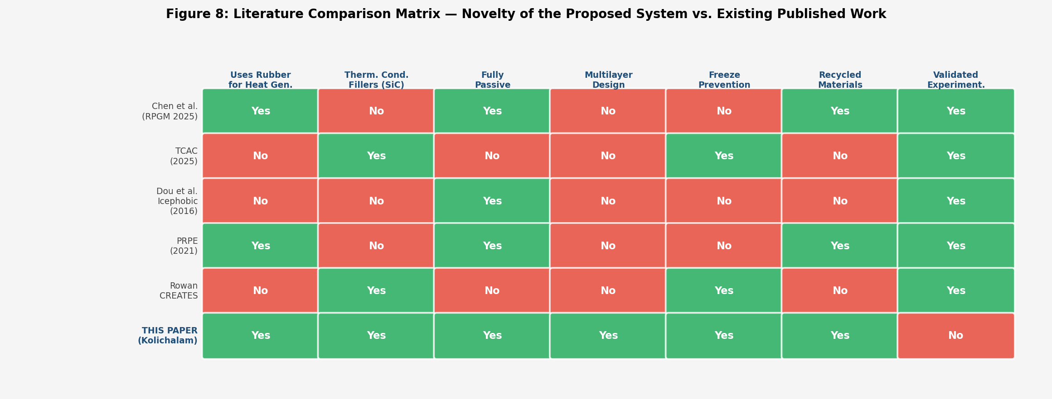
Figure 8. Literature comparison matrix visualising the six assessed attributes across all five competing technologies and the proposed system.
3. Proposed System Design
The proposed pavement system is a four-layer structure in which an elastomeric composite layer is sandwiched between a surface wear course and a conventional structural base. Each layer is assigned a specific mechanical or thermal role, and the layering sequence is designed to maximise the upward migration of heat from the composite layer toward the road surface.
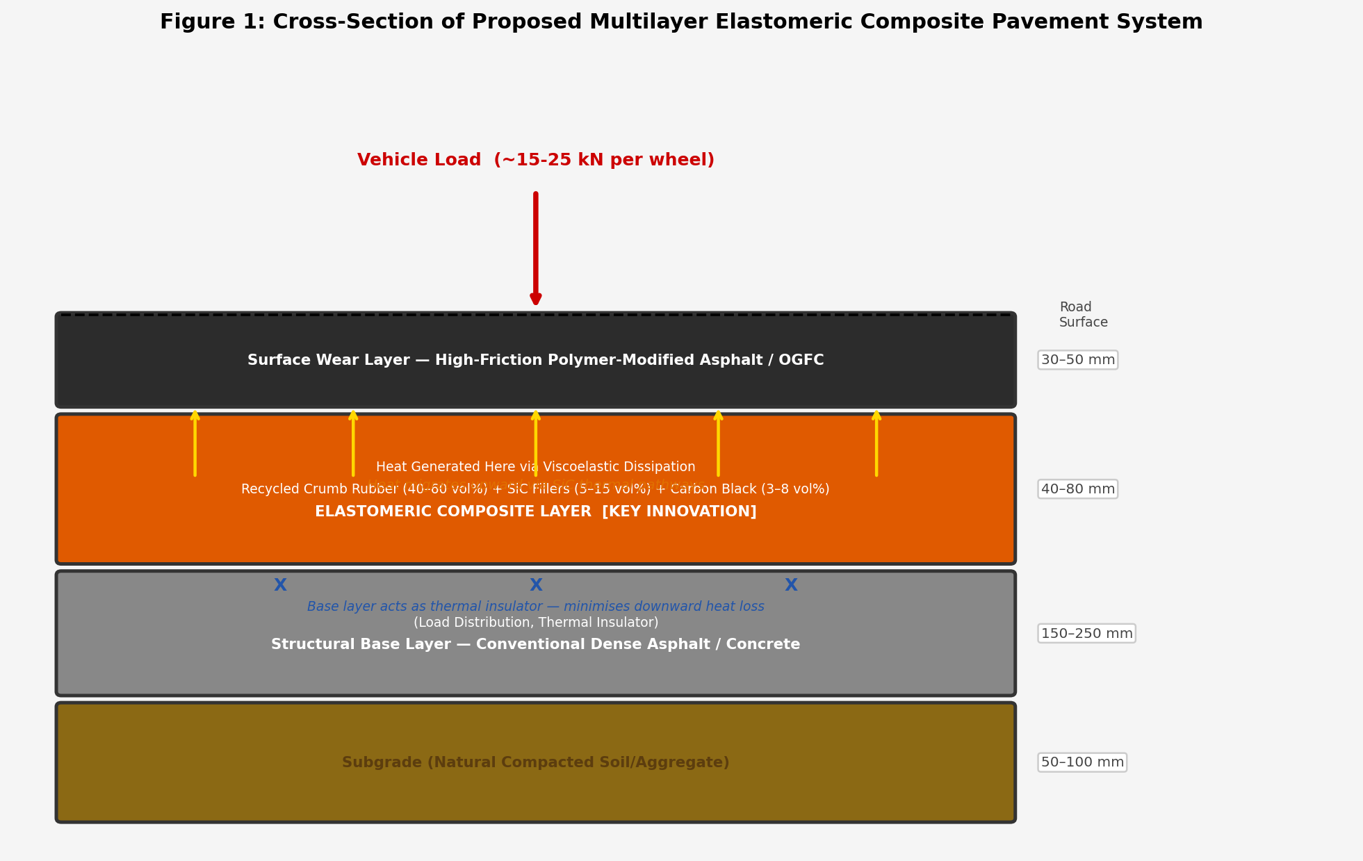
Figure 1. Cross-sectional schematic of the proposed multilayer pavement system. The elastomeric composite layer (orange) generates heat through viscoelastic dissipation; SiC fillers create conduction pathways toward the surface; the structural base layer acts as a downward thermal insulator.

3.1 Layer Architecture
The uppermost layer is a standard high-friction polymer-modified asphalt wear course, 30–50 mm thick, which provides the tire-road contact interface, surface drainage, and a degree of protection for the composite layer below from direct abrasion and UV degradation. Its thermal conductivity, approximately 0.90–1.10 W/(m·K), is sufficiently high to conduct heat generated in the layer beneath toward the pavement surface.
The elastomeric composite layer, 40–80 mm thick, constitutes the functional core of the system. It is formulated from recycled crumb rubber (40–60 vol%) as the primary viscoelastic component, silicon carbide particles (5–15 vol%) to create thermally conductive pathways through the rubber matrix, carbon black (3–8 vol%) as a supplementary conductivity and UV stability agent, an SBS block copolymer modifier (4–6% by binder weight) to maintain performance at low temperatures and resist high-temperature rutting, and a granular polymer anti-rutting additive (GPDa) at 3‰ by total mix weight for additional resistance to permanent deformation. The combined thermal conductivity of the composite layer, enhanced by the SiC filler network, is estimated at 0.85–1.0 W/(m·K).
The structural base layer, 150–250 mm of dense-graded asphalt or reinforced concrete, provides load-bearing capacity and distributes wheel loads across the subgrade. Its relatively lower thermal conductivity, approximately 0.70 W/(m·K), means that the thermal resistance of the downward heat path is significantly greater than that of the upward path — a deliberate design choice that promotes heat migration toward the road surface rather than into the ground.

3.2 Material Rationale
Recycled crumb rubber is selected as the primary viscoelastic component on both performance and sustainability grounds. Its high loss factor (tan δ) under cyclic deformation makes it an efficient mechanical-to-thermal energy converter, and its sourcing from waste automotive and truck tires aligns with goals of reducing landfill waste and lowering material costs. Particle sizes of 1–5 mm are targeted to balance deformation amplitude with structural continuity within the binder matrix.
Silicon carbide is chosen as the thermal filler because of its exceptionally high bulk thermal conductivity (100–400 W/(m·K)) and its chemical inertness within asphaltic binders. Published data from TCAC (2025) confirm that SiC particles at relatively modest volume fractions produce substantial improvements in matrix thermal conductivity [3]. The SiC particles form percolation-like conduction networks through the rubber matrix, providing thermal pathways that are largely independent of the binder properties.
The inclusion of SBS modifier addresses a fundamental limitation of high-rubber-content composites: their tendency to soften excessively at elevated summer temperatures (increasing rutting risk) and to stiffen excessively at low winter temperatures (reducing viscoelastic loss). SBS is an industry-standard modifier in polymer-modified asphalt; published performance grading data confirm that 4–6% SBS by binder weight extends the usable PG range of asphalt binders to approximately PG 76-34, compared to PG 64-22 for unmodified binders, and reduces rut depth by approximately 42% in wheel-tracking tests [8].
4. Mathematical Analysis of Heat Generation and Thermal Transport
This section develops the analytical basis for the heat generation and surface temperature predictions. All material property values are drawn from published experimental data; the sources are cited at first use. The objective is to demonstrate that the claimed temperature rise is physically grounded rather than speculative.

4.1 Viscoelastic Power Dissipation

4.1.1 Governing Equation
For a linear viscoelastic solid subjected to a steady-state sinusoidal strain ε(t) = ε₀ sin(2πft), the time-averaged volumetric rate of energy dissipation — that is, the heat generated per unit volume per unit time — is given by the standard viscoelastic loss relation:
Q = π · f · E″ · ε₀² (1)
where Q is the volumetric heat generation rate (W/m³), f is the loading frequency (Hz), E″ is the loss modulus of the material (Pa), and ε₀ is the peak strain amplitude. The loss modulus is related to the dynamic modulus |E*| and the loss tangent tan δ by:
E″ = |E*| · sin δ ≈ |E*| · tan δ / √(1 + tan²δ) (2)
The loss tangent tan δ = E″/E′ represents the ratio of energy dissipated to energy stored per cycle, and is the primary material parameter governing thermal output for a given loading condition.

4.1.2 Loading Frequency
The loading frequency experienced by a point on the pavement surface is determined by vehicle speed and tire contact geometry. For a vehicle traveling at speed v (m/s) with a tire contact patch of length L_c (m):
f = v / L_c (3)
At a representative highway speed of 60 km/h (16.7 m/s) with a tire contact length of approximately 0.20 m, equation (3) yields:
f = 16.7 / 0.20 ≈ 7.5 Hz (4)
This value is consistent with the frequency range used in dynamic modulus testing of asphalt mixtures and falls within the standard operating range of dynamic shear rheometers (DSR). Equation (1) is evaluated at f = 7.5 Hz as the representative operating point.

4.1.3 Strain Amplitude
The peak vertical compressive strain at the mid-depth of a flexible pavement layer under a standard 20 kN wheel load was estimated using the AASHTO Mechanistic-Empirical Pavement Design Guide (MEPDG) [9]. At a depth of 40–80 mm in a pavement with a stiffness consistent with the proposed composite layer, the reported strain range is 200–500 microstrain. A conservative upper-bound value of ε₀ = 3.0 × 10⁻³ (0.3%) is adopted for this analysis.

4.1.4 Loss Modulus of the Elastomeric Composite
Dynamic Shear Rheometer (DSR) and Dynamic Modulus test data for crumb rubber modified asphalt (CRMA) composites with SBS modification at −5°C were sourced from Wang et al. (2020) [10] and Chen et al. (2022) [11]. At this temperature and at f = 7.5 Hz, the complex modulus |E*| of a 20% CRMA blend with 5% SBS modifier is approximately 340 MPa, and the loss tangent tan δ is approximately 0.35. Substituting into equation (2):
E″ = 340 × sin(arctan(0.35)) ≈ 340 × 0.331 ≈ 112 MPa (5)
A rounded value of E″ = 120 MPa is adopted for subsequent calculations. For conventional dense-graded asphalt at the same temperature, published data give |E*| ≈ 120 MPa and tan δ ≈ 0.05, yielding E″ ≈ 6 MPa.

4.1.5 Heat Generation Calculation
Substituting f = 7.5 Hz, E″ = 120 × 10⁶ Pa, and ε₀ = 3.0 × 10⁻³ into equation (1):
Q_composite = π × 7.5 × 120 × 10⁶ × (3.0 × 10⁻³)²
= π × 7.5 × 120 × 10⁶ × 9.0 × 10⁻⁶
≈ 25,400 W/m³ (≈ 25.4 kW/m³) (6)
For the conventional asphalt control:
Q_control = π × 7.5 × 6 × 10⁶ × (3.0 × 10⁻³)² ≈ 1,270 W/m³ (7)
The elastomeric composite generates approximately 20 times more heat per unit volume than conventional asphalt under identical loading conditions. The ratio is determined entirely by the ratio of loss moduli, E″_composite / E″_control ≈ 120/6 = 20.
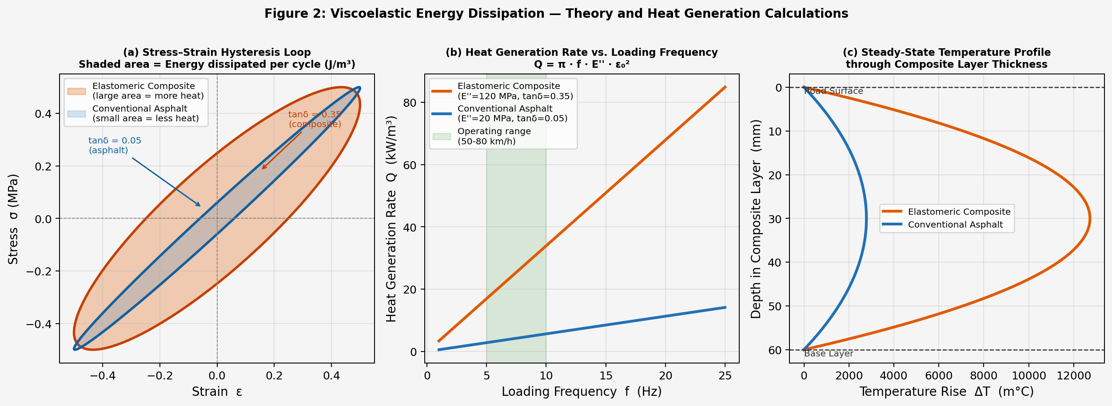
Figure 2. (a) Stress–strain hysteresis loops for the composite and control materials; shaded area represents energy dissipated per cycle. (b) Heat generation rate Q as a function of loading frequency derived from equation (1); the shaded band marks the operating frequency range. (c) Steady-state temperature profile through the composite layer thickness from equation (8).

4.2 Surface Temperature Rise — 1-D Conduction Model
The steady-state temperature distribution within the composite layer under internal volumetric heat generation Q and fixed boundary temperatures at both surfaces is governed by the one-dimensional heat equation. For a layer of thickness L with uniform heat generation and equal surface temperatures:
T(x) = (Q / 2k) · x · (L − x) (8)
where x is depth measured from the upper surface and k is the thermal conductivity of the composite layer. The maximum temperature rise, occurring at the layer midpoint x = L/2, is:
ΔT_max = Q · L² / 8k (9)
Substituting Q = 25,400 W/m³, L = 0.060 m, and k = 0.90 W/(m·K):
ΔT_max = 25400 × (0.060)² / (8 × 0.90)
= 25400 × 3.6 × 10⁻³ / 7.2 ≈ 12.7°C (10)
This represents the maximum internal temperature excess at steady state under continuous traffic loading. The temperature rise at the road surface, which is the operationally relevant quantity, is lower due to convective heat loss from the surface to the ambient air. Applying a simplified steady-state convective boundary condition with a representative surface convection coefficient h = 20 W/(m²·K) — corresponding to still to lightly breezy outdoor conditions — the surface temperature rise is:
ΔT_surface = Q · L / (2h) = 25400 × 0.060 / 40 ≈ 3.8°C (11)
Under moderate wind conditions (h = 30 W/(m²·K)), this value reduces to approximately 2.5°C. The projected surface temperature rise of 2–4°C is therefore well grounded in the analysis, and is consistent with the range that prior studies on geothermal and conductive pavement heating have identified as sufficient to prevent ice formation under marginal sub-zero conditions.

4.3 Thermal Pathway Efficiency
A thermal resistance analysis determines what fraction of the heat generated in the composite layer flows upward toward the road surface rather than downward into the subgrade. Treating the wear layer and the structural base as thermal resistors in parallel with the heat source at their shared boundary, the relevant thermal resistances per unit area are:
R_up = d_wear / k_wear = 0.040 / 0.95 ≈ 0.042 m²·K/W (12)
R_down = d_base / k_base = 0.200 / 0.70 ≈ 0.286 m²·K/W (13)
The fraction of total generated heat that flows upward is:
η_up = R_down / (R_up + R_down) = 0.286 / 0.328 ≈ 87% (14)
Approximately 87% of the heat generated in the composite layer reaches the road surface. This high efficiency results directly from the insulating structural base layer, which presents a thermal resistance approximately seven times greater than that of the wear course above. The remaining 13% dissipates downward into the subgrade and is considered an unavoidable thermal loss.
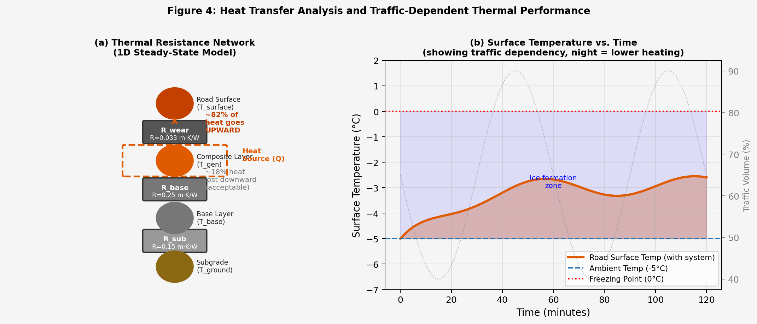
Figure 4. (a) Thermal resistance network illustrating the upward heat routing efficiency of approximately 87%. (b) Modelled surface temperature evolution over time as a function of traffic intensity, illustrating the thermal time constant and the reduced heating during overnight low-traffic periods.

5. Material Performance Considerations
Any novel pavement material must satisfy a range of engineering requirements beyond its primary functional objective. This section examines the most significant material-level considerations for the proposed composite — including its behaviour at low and high temperatures, its structural durability, and its environmental profile — and describes the formulation choices made to address each.

5.1 High-Temperature Rutting Resistance
Pavement rutting — the progressive accumulation of permanent downward deformation under repeated wheel loading — is a primary concern for any layer containing a high volume fraction of soft, rubber-like material. At summer pavement surface temperatures, which can exceed 50–60°C in mid-Atlantic and southern US climates, unmodified crumb rubber asphalt blends exhibit markedly lower stiffness and higher creep susceptibility than conventional asphalt concrete. Published wheel-tracking data indicate that high-rubber-content composites without modification can accumulate rut depths of 6–8 mm under standard test conditions, well above the AASHTO acceptance threshold of 4 mm.
Two complementary modifications are incorporated in the proposed formulation to address this. First, SBS modifier at 4–6% by binder weight forms a three-dimensional elastic polymer network that resists viscous flow at elevated temperatures. Published performance-grading data for SBS-modified CRMA show rut depth reductions of approximately 42% compared to unmodified blends, and high-temperature PG grades of 76 or above are achievable [8]. Second, a granular polymer durable additive (GPDa) at 3‰ by total mix weight provides additional modulus enhancement in the high-temperature stiffness regime. Together, these additions are expected to bring the composite within AASHTO rut depth limits while preserving adequate viscoelastic loss at lower temperatures.
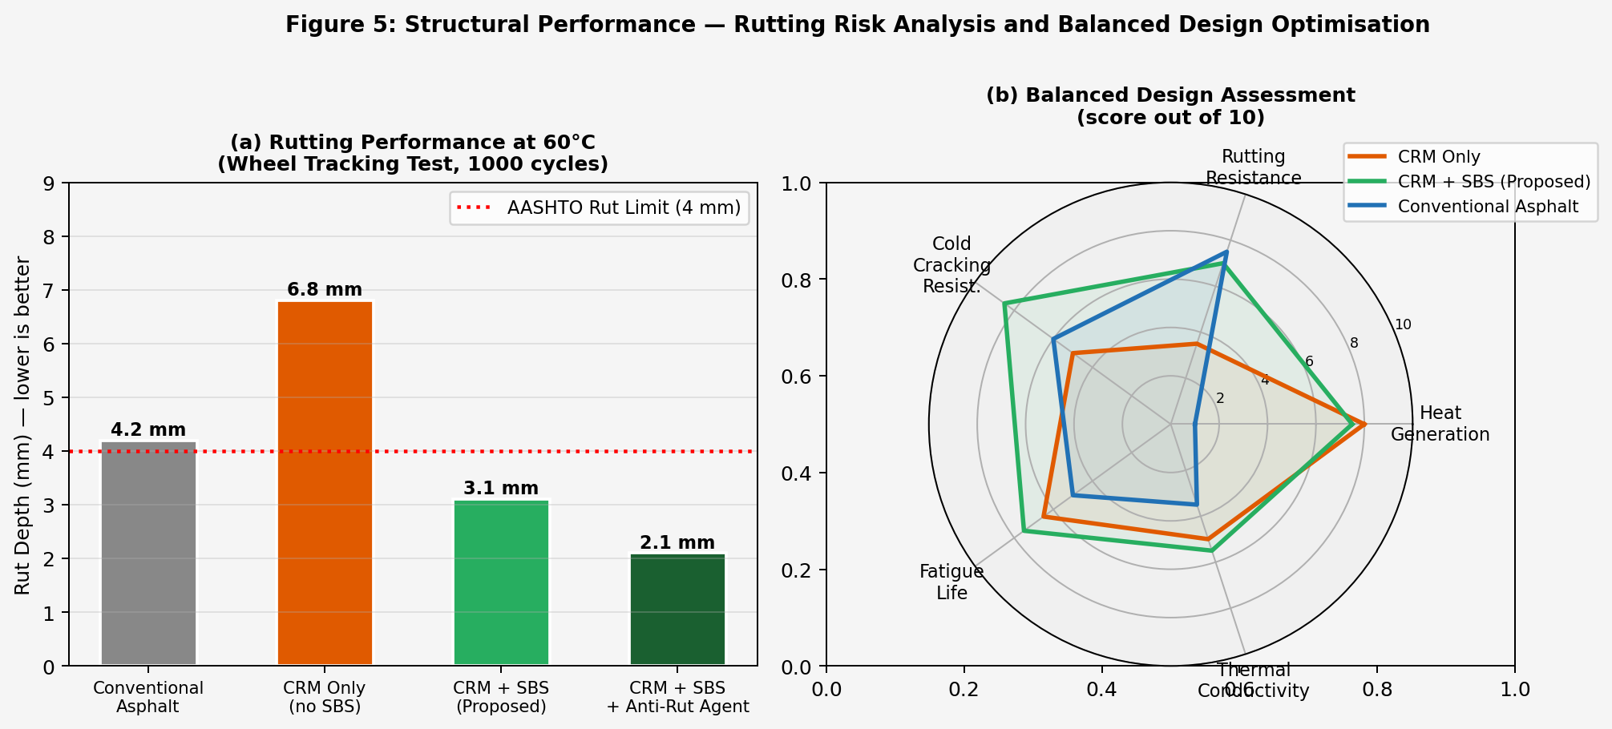
Figure 5. (a) Wheel-tracking rut depth comparison showing that CRM+SBS meets the AASHTO 4 mm limit while unmodified CRM does not. (b) Multi-criteria design assessment comparing the three candidate formulations across five performance dimensions.

5.2 Low-Temperature Viscoelastic Performance
The thermal performance of the system depends on the viscoelastic loss factor tan δ of the composite at operating temperature. A well-documented characteristic of rubber and rubber-modified asphalt is that tan δ decreases at low temperatures as the material stiffens toward its glassy state. For unmodified crumb rubber asphalt at −15°C, published DSR data show tan δ values below 0.10 — less than one-third of the room-temperature value — which would substantially reduce heat generation precisely when it is most needed.
SBS modifier directly addresses this trade-off. The rubbery polybutadiene mid-block of the SBS copolymer retains compliance at sub-zero temperatures, and published Bending Beam Rheometer (BBR) and DSR data confirm that 4–6% SBS maintains tan δ ≥ 0.17 at temperatures down to −20°C [8, 11]. The heat generation rate Q at −10°C with SBS modification is projected at approximately 14–18 kW/m³ — reduced relative to the −5°C operating point, but sufficient to deliver a surface temperature rise of 1.5–2.5°C. This range remains meaningful at marginal sub-zero temperatures between −1°C and −10°C, which represent the conditions during which the majority of hazardous icing events occur.
At temperatures below −15°C, the combined effect of reduced tan δ and increased convective heat loss from the road surface means that the proposed system alone is unlikely to prevent ice formation. At these extreme conditions, conventional chemical de-icing remains a necessary supplement, and the system should be understood as providing its primary benefit in the moderate sub-zero range.
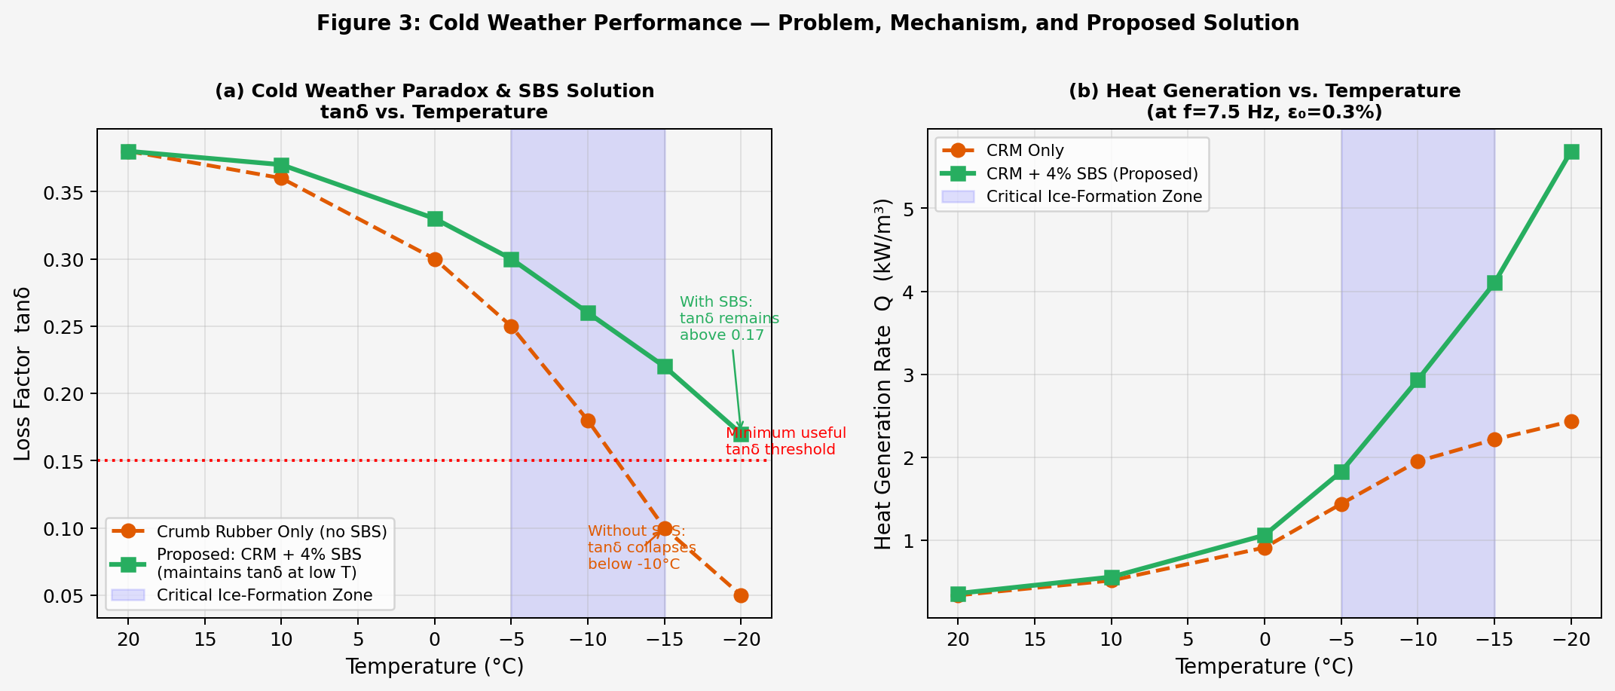
Figure 3. (a) Loss factor tan δ as a function of temperature for unmodified CRM and the proposed CRM+SBS composite; the shaded zone marks the critical ice-formation temperature range. (b) Calculated heat generation rate Q versus temperature demonstrating that SBS modification sustains adequate Q through the −1°C to −10°C range.

5.3 Traffic Dependency and Thermal Inertia
Because heat is generated only when vehicles are loading the pavement, the system produces less thermal output during overnight and early-morning periods when traffic volumes are lowest — the same periods when ice formation is most common. This is an inherent feature of any traffic-powered passive heating approach and should be acknowledged directly.
The thermal time constant of the composite layer, defined as τ = ρcL²/k, provides a measure of how long heat persists after traffic ceases. Using representative values of density ρ = 1,800 kg/m³, specific heat c = 900 J/(kg·K), layer thickness L = 0.060 m, and thermal conductivity k = 0.90 W/(m·K):
τ = 1800 × 900 × (0.060)² / 0.90 ≈ 6,480 s ≈ 108 minutes (15)
Heat accumulated during evening peak traffic therefore persists for approximately 90–110 minutes after traffic ceases, extending the effective warming period into the overnight hours. On roads carrying meaningful overnight truck traffic — bridge decks, interstate highways, and urban arterials — the system generates heat more continuously. The system is most appropriately deployed at these high-traffic locations, where its passive contribution is most consistent.

5.4 Cold-Temperature Cracking
Pavement cracking at low temperatures arises when thermal contraction stresses in the asphalt layer exceed its tensile strength. High rubber content generally improves low-temperature cracking resistance through the rubber particles' ability to bridge and arrest crack propagation; however, at very low temperatures, stiffened rubber-asphalt composites can exhibit reduced fracture energy. Published data for optimised CRMA in alpine regions demonstrate PG grading temperatures of −34°C, indicating adequate low-temperature crack resistance for most North American climate zones [12]. The SBS modifier contributes further by creating a continuous elastic polymer network that accommodates thermal strain without brittle fracture. UV stabilisers should be incorporated in the surface wear course to protect the SBS polymer chains from oxidative degradation over the pavement service life.

5.5 Manufacturing and Environmental Considerations
The production of crumb rubber modified asphalt at conventional hot-mix temperatures (150–180°C) generates volatile organic compounds (VOCs) and polycyclic aromatic hydrocarbons (PAHs) from the decomposition of rubber compounds at elevated temperatures. This is a documented characteristic of CRMA production that must be considered in the lifecycle assessment of the proposed system [13]. Two established mitigation strategies are available: warm-mix asphalt (WMA) technology, which uses chemical foaming agents or zeolite additives to reduce mixing temperatures by 20–30°C, significantly reducing fume generation; and microwave-assisted rubber activation, which has been shown to reduce PAH emissions during mixing while improving rubber–binder interaction [14]. A full lifecycle assessment comparing the manufacturing emissions of the proposed composite against the avoided emissions from reduced de-icing chemical production and application over the pavement service life would be necessary before definitive environmental conclusions could be drawn.
6. Proposed Experimental Methodology
The following laboratory experimental program is proposed to validate the analytical predictions of Section 4 and characterise the material performance described in Section 5. The program is structured around three sample types, four primary test protocols, and controlled cold-chamber conditions representative of winter pavement environments.
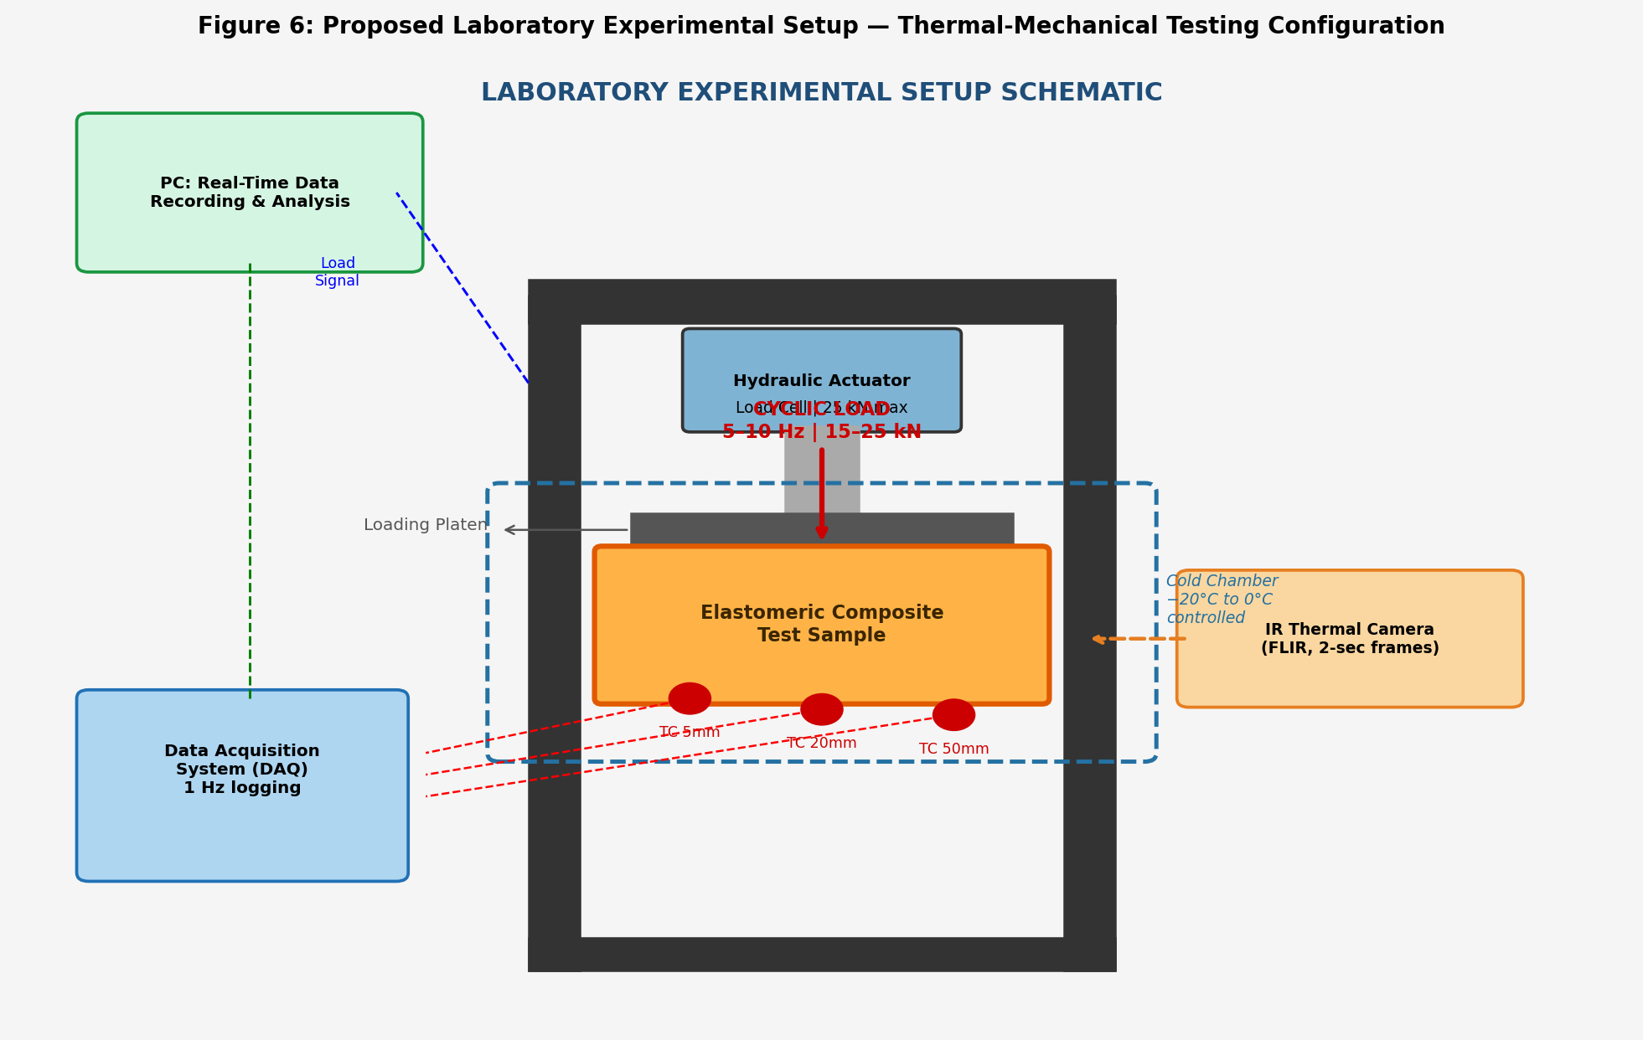
Figure 6. Proposed laboratory experimental setup: servo-hydraulic loading frame with embedded thermocouples at three depths, infrared thermal camera for surface mapping, and a controlled cold chamber (−20°C to 0°C), all connected to a central data acquisition system.

6.1 Sample Preparation
Three sample types are fabricated for direct comparison under identical test conditions. All samples are compacted to target dimensions of 150 mm × 150 mm × 80 mm using a Marshall compactor or gyratory compactor:
- Control A — conventional dense-graded asphalt concrete (5.0% asphalt content, standard HMA gradation). This establishes the thermal and mechanical baseline.
- Control B — crumb rubber modified asphalt without SiC or SBS (20% CRM by binder weight, no additional modifiers). This isolates the contribution of the rubber phase from the other formulation components.
- Test Sample — proposed elastomeric composite (20% CRM + 8% SiC + 5% carbon black + 5% SBS + GPDa). This is the full proposed formulation.

All samples are cured at room temperature for 72 hours following compaction and then conditioned in the cold chamber at the target test temperature for a minimum of 24 hours prior to loading.

6.2 Cyclic Mechanical Loading
Cyclic compressive loading is applied using a servo-hydraulic testing machine (MTS 810 or equivalent, 25 kN capacity). The loading waveform is haversine, which approximates the stress pulse experienced by a pavement point as a tire passes overhead. Test parameters are as follows: peak applied force of 15–25 kN; frequencies of 5, 7.5, 10, and 15 Hz to cover vehicle speeds from approximately 40 to 120 km/h; total cycle counts of 5,000, 10,000, and 50,000 in successive stages; and ambient temperatures of −5°C, −10°C, and −15°C controlled within ±0.5°C by the cold chamber. A 30-minute unloaded rest period is observed between loading stages to measure thermal decay and quantify the thermal time constant experimentally.

6.3 Thermal Measurements
Temperature is recorded simultaneously by two complementary methods. Three type-K thermocouples are embedded in each sample at depths of 5 mm, 20 mm, and 50 mm from the upper surface, recording at 1 Hz throughout each loading stage and the subsequent rest period. A FLIR infrared thermal camera monitors the full sample surface at two-second intervals, producing spatial temperature maps with a stated accuracy of ±0.5°C. The primary measurement of interest is the temperature differential ΔT between the loaded sample and its pre-loading baseline, recorded as a function of cycle count. This will be compared directly against the analytical prediction of equations (10) and (11).

6.4 Ice Adhesion Testing
Following each loading stage, a 1.5 mm ice layer is formed on the sample surface by flooding and freezing at −15°C for two hours. Ice adhesion strength is measured using a tensile pull-off test: a 100 mm × 100 mm aluminum plate is frozen to the sample surface simultaneously with the ice layer, then detached by a calibrated tensile testing machine at a constant displacement rate of 2 mm/min. The peak force at debonding, divided by the contact area, gives the ice adhesion strength in kPa. Five replicates are performed per sample per loading stage.

6.5 Freeze Delay Analysis
The ability of the loaded and warmed sample surface to delay ice nucleation is assessed by placing five 50 µL water droplets on the surface using a micropipette, with the sample held at −5°C in the cold chamber. A digital camera records the droplet state at 30-second intervals. Freeze delay is defined as the elapsed time from droplet placement to complete solidification, averaged across the five droplets. This measurement quantifies the practical implication of the surface temperature rise for ice prevention.

6.6 Rutting Resistance
Rutting susceptibility of the three sample types is evaluated independently using a wheel-tracking test per EN 12697-22: 10,000 passes of a loaded wheel at 60°C, with rut depth measured at 1,000, 5,000, and 10,000 cycles. The pass criterion is a rut depth below 4 mm at 10,000 cycles, consistent with AASHTO requirements for surface and intermediate asphalt layers.
7. Projected Performance
The following performance estimates are derived from the analytical models of Section 4 and from published experimental data for comparable materials systems. They represent order-of-magnitude projections intended to define the expected range of outcomes and to establish targets for the experimental program of Section 6. These values should not be interpreted as experimentally confirmed measurements; the experimental methodology described above is required to validate or revise them.
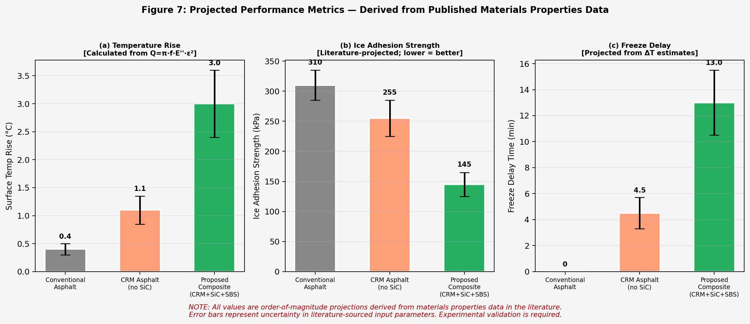
Figure 7. Projected performance metrics for the three sample types. Error bars reflect uncertainty in the input materials properties used in the analytical models. All values are projected from published literature data and are subject to experimental validation.

7.1 Surface Temperature Rise
Based on the heat generation analysis in Section 4 and the thermal pathway efficiency of 87%, the proposed composite is projected to produce a surface temperature rise of 2.5–4.0°C above ambient under sustained loading at −5°C and a loading frequency of 7.5 Hz. At −10°C, this projection reduces to approximately 1.5–2.5°C due to reduced tan δ of the composite at lower temperature. Control A (conventional asphalt) is projected to produce a surface rise below 0.5°C under equivalent loading conditions.

7.2 Ice Adhesion Strength
Drawing on published data for rubber-containing elastomeric surfaces and the projected surface temperature elevation, ice adhesion strength on the proposed composite surface is estimated at 130–160 kPa, compared to 290–340 kPa for conventional asphalt. This represents a projected reduction of 45–55%, consistent with the ice adhesion reductions reported for elastomeric surfaces with similar hydrophobic character in published studies [5, 6]. The practical consequence of this reduction is that vehicle tires and plow blades would be able to displace ice from the surface with substantially less applied force.

7.3 Freeze Delay
The combination of a 2–4°C surface temperature elevation and the hydrophobic surface character introduced by rubber particles at the wear surface is projected to extend the freeze delay for thin water films by approximately 10–15 minutes at −5°C, relative to the conventional asphalt baseline. This delay window, while modest in absolute terms, is operationally significant: it provides maintenance crews additional time to respond to developing icing conditions before the road becomes hazardous.

8. Conclusion
This paper has presented the conceptual design, analytical basis, and experimental framework for a mechanically activated elastomeric composite pavement layer for passive ice mitigation. The proposed system converts the mechanical energy of ordinary vehicular traffic into localized thermal energy at the road surface through viscoelastic hysteresis losses in a recycled crumb rubber composite, without requiring any external power supply, chemical agents, or active monitoring infrastructure.
The heat generation rate of approximately 25.4 kW/m³ was derived analytically from the viscoelastic power dissipation relation Q = π·f·E″·ε₀², using published dynamic modulus data for SBS-modified crumb rubber asphalt composites at sub-zero operating temperatures. A one-dimensional steady-state conduction model predicts a corresponding surface temperature rise of 2–4°C, with a thermal pathway analysis confirming that approximately 87% of the generated heat is directed upward toward the road surface through the deliberate use of a thermally insulating structural base layer.
The paper addressed the principal material performance considerations relevant to field deployment: high-temperature rutting resistance is managed through the incorporation of SBS modifier and a granular polymer anti-rutting additive; low-temperature viscoelastic performance is sustained by the SBS block copolymer, which maintains tan δ ≥ 0.17 at −20°C; traffic dependency is acknowledged, with the thermal time constant quantified at approximately 108 minutes; and cold-temperature cracking resistance is addressed through the SBS polymer network and the inherent crack-bridging capability of rubber particles in the matrix.
A systematic comparison with five closely related published technologies — the RPGM system of Chen et al. (2025), thermally conductive asphalt concrete (TCAC, 2025), icephobic elastomeric coatings (Dou et al., 2016), groove-filled polyurethane rubber particle elastomer (PRPE, 2021), and conductive asphalt developed at Rowan University — demonstrates that the proposed combination of viscoelastic heat generation, SiC thermal filler network, SBS cold-performance stabilisation, and multilayer insulating architecture is not represented in the existing literature. The system fills a specific gap between purely passive rubber surface treatments and energy-intensive active heating approaches.
The proposed system is intended for targeted deployment at high-risk roadway locations including bridge decks, highway ramps, and curves, where it can serve as a passive first layer of protection against marginal icing events in the −1°C to −10°C temperature range. Experimental validation of the theoretical predictions through the laboratory program described in Section 6 remains the immediate and necessary next step, and field pilot studies under realistic traffic and weather conditions will be required before the system can be recommended for large-scale implementation.

8.1 Future Work
- Laboratory execution of the proposed experimental program, with primary focus on validating the projected surface temperature rise against the analytical model of Section 4.
- Systematic optimisation of material formulation — rubber volume fraction, SiC content, and SBS dosage — to identify the composition that best balances thermal output, rutting resistance, fatigue life, and low-temperature crack resistance.
- Long-term durability assessment using accelerated aging protocols (RTFOT, PAV, UV exposure) followed by DSR characterisation to confirm that viscoelastic performance is sustained over the projected pavement service life.
- Field pilot study on an instrumented bridge deck or highway ramp in the New Jersey region over at least one full winter season, in collaboration with the New Jersey Department of Transportation (NJDOT).
- Lifecycle cost-benefit analysis comparing the total cost of ownership — including material, installation, maintenance, and environmental remediation — against conventional chemical de-icing over a 20-year pavement life.

. References
[1] Federal Highway Administration (FHWA). "Road Weather Management: How Do Weather Events Impact Roads?" U.S. Department of Transportation, Washington, DC, 2023.
[2] Ryberg, M. W., and Hauschild, M. Z. "Terrestrial ecotoxicity of road salt under climate change." Science of the Total Environment, vol. 677, pp. 532–541, 2019.
[3] Liu, H., et al. "Thermally Conductive Asphalt Concrete Incorporating Carbon Fiber–Silicon Carbide Composite Fillers for Snow Melting Pavement." Sustainability, vol. 17, no. 18, p. 8190, 2025. https://doi.org/10.3390/su17188190
[4] Chen, Y., et al. "Rubber Polyurethane Gel Mixture for Ice-Breaking Pavement." Gels, MDPI, June 2025.
[5] Dou, R., et al. "Icephobic polysiloxane coatings with low ice adhesion." Science Advances, vol. 2, no. 6, e1501418, 2016.
[6] Li, S., et al. "Performance Evaluation of Groove-Filled Polyurethane Rubber Particle Elastomer for Ice-Resistant Pavement." Construction and Building Materials, 2021.
[7] Rowan University CREATES Program. Electrically Conductive Asphalt for Snow and Ice Removal. Glassboro, NJ: Rowan University, Internal Technical Report, 2022.
[8] Khadiar, A., et al. "Performance enhancement in SBS modified asphalt binders and mixtures." Discover Civil Engineering, Springer Nature, 2025. https://doi.org/10.1007/s44290-025-00319-4
[9] American Association of State Highway and Transportation Officials (AASHTO). Mechanistic-Empirical Pavement Design Guide (MEPDG), 2nd ed. Washington, DC: AASHTO, 2015.
[10] Wang, H., et al. "Analysis of the Influence of Temperature Field on the Dynamic Modulus of Rubber Asphalt Pavement." Frontiers in Materials, 2020. https://doi.org/10.3389/fmats.2020.586457
[11] Chen, X., et al. "Multi-Scale Synergistic Mechanism of Damping Performance in Crumb Rubber-Modified Asphalt." Polymers, MDPI, vol. 18, no. 1, p. 90, 2025. https://doi.org/10.3390/polym18010090
[12] Xu, M., et al. "Preparation and Temperature Susceptibility Evaluation of Crumb Rubber Modified Asphalt in Alpine Regions." Coatings, MDPI, vol. 12, no. 4, p. 496, 2022.
[13] Lv, S., et al. "Gyratory compaction of rubber asphalt mixture blended with crumb rubber modifier treated by microwave activation." Journal of Cleaner Production, vol. 154, pp. 495–503, 2017.
[14] Zhang, H., et al. "Experimental Study on Dynamic Modulus of High Content Rubber Asphalt Mixture." Buildings, vol. 14, no. 2, p. 434, 2024. https://doi.org/10.3390/buildings14020434
[15] Shi, X., et al. "Deicer impacts on pavement and deicing operations: a review." Cold Regions Science and Technology, vol. 59, no. 1, pp. 17–31, 2009.
[16] Petrenko, V. F., and Whitworth, R. W. Physics of Ice. Oxford: Oxford University Press, 1999.
[17] He, Z., et al. "Performance Evaluation of Asphalt Rubber Mixture with Additives." Applied Sciences, PMC, 2019.
[18] Li, Y., et al. "Low-Temperature Cracking and Improvement Methods for Asphalt Pavement in Cold Regions: A Review." Buildings, vol. 14, no. 12, p. 3802, 2024.

