**Group – 11 :**

**Seshaiah Erugu**

**Joshith Gunreddy**

**Rajesh Korlam**

**Test Cases: US Gun Violence Data Exploration**

**Display first 5 records of the data frame**

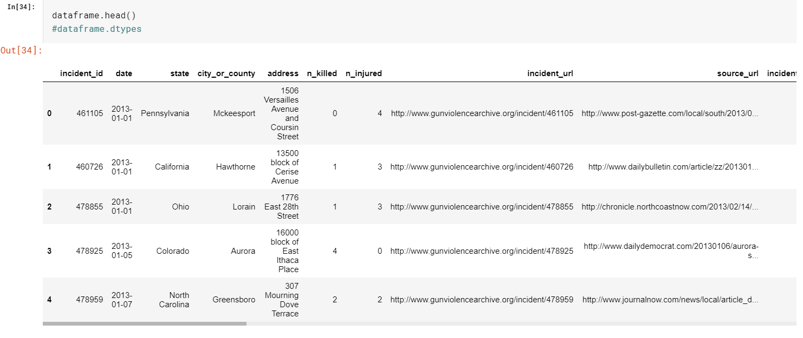

**Finding the total number of Gun incidents happened in US**

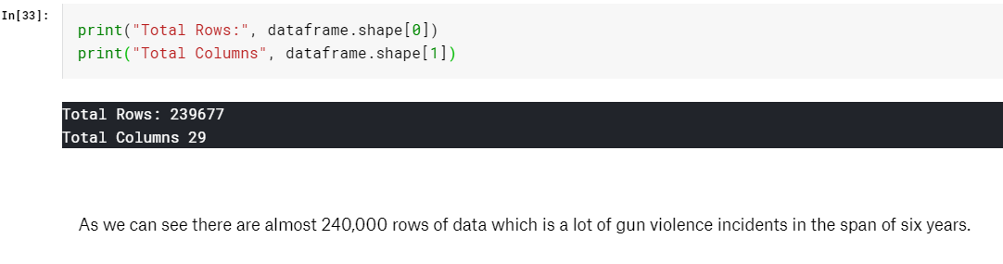

**Description about the dataframe loaded**

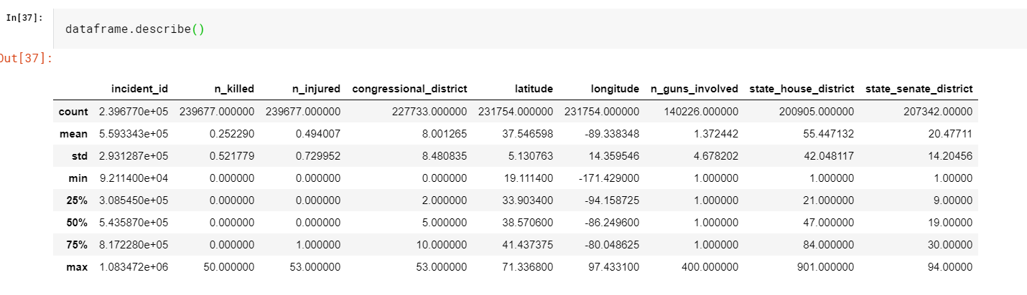

**Year-wise data visualization (Gun incidents happen between 2013 – 2018)**

**Number of Gun Violence by Year**

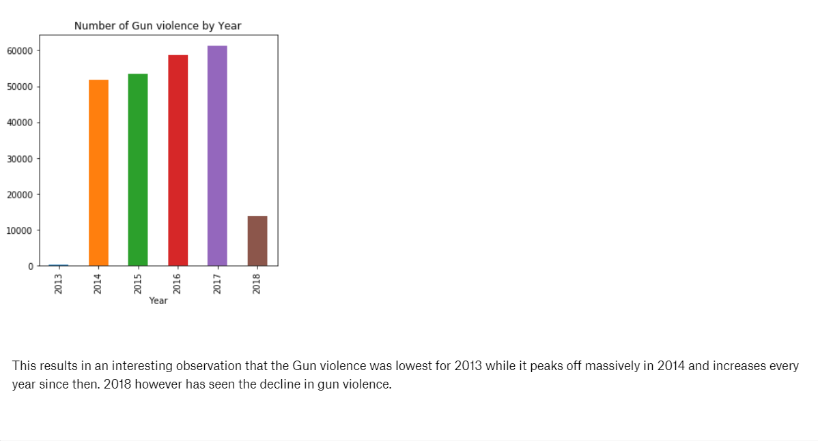

**Number of Gun Violence by Month : Month-wise Data Visualizations**

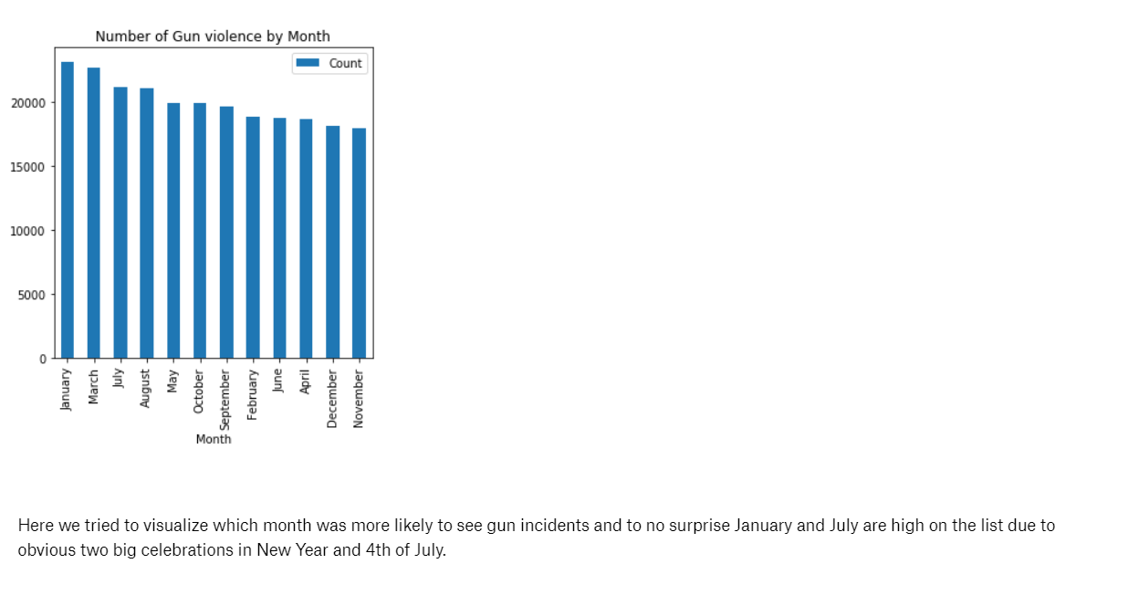

**Number of Gun Violence by Day of Month**

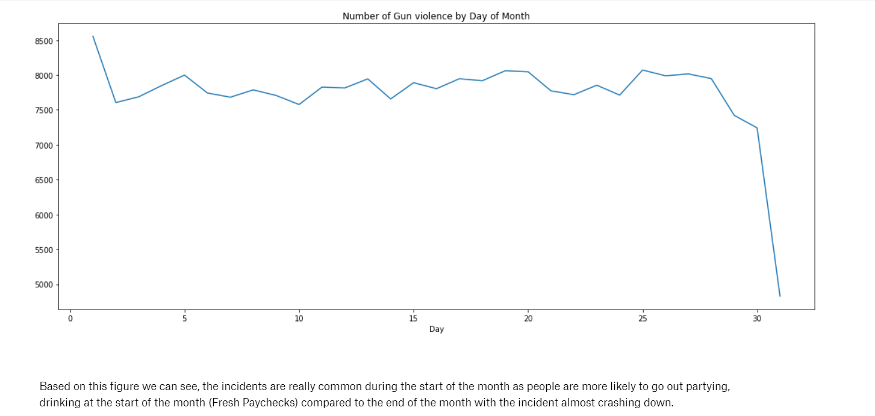

**Number of Deaths in every State**

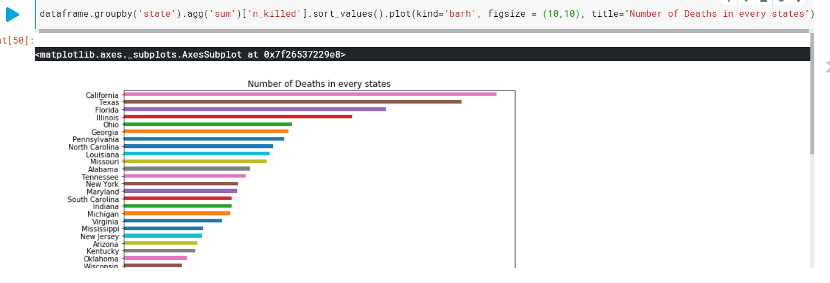

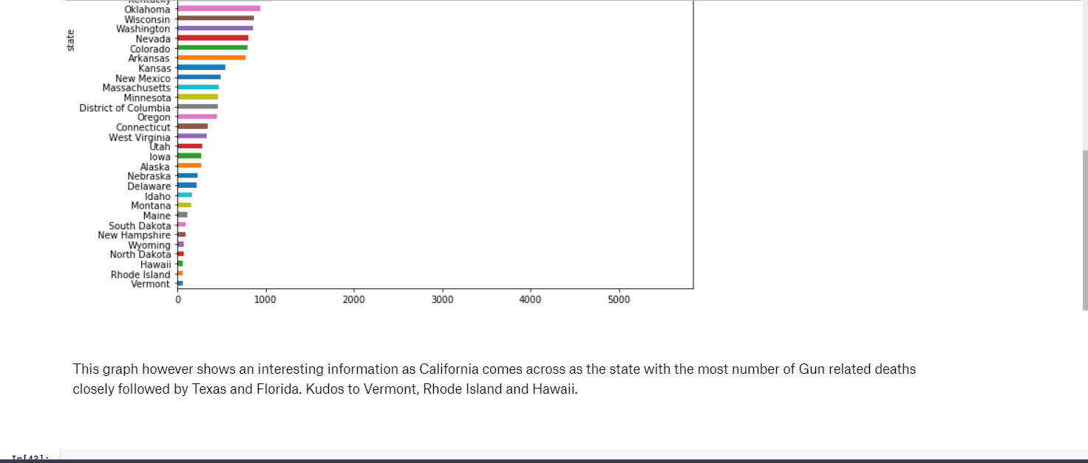

**Gun Casaulities by State**

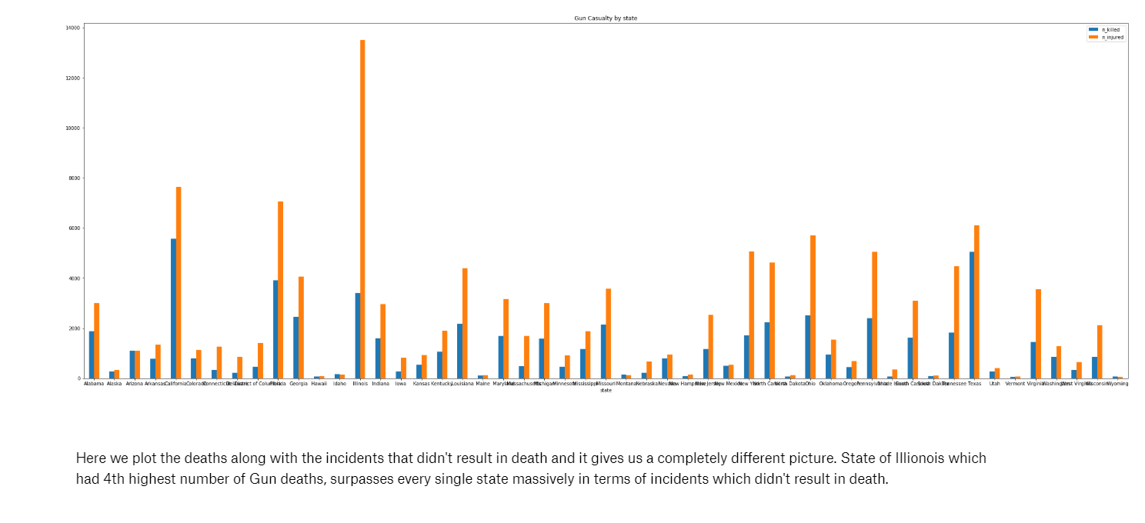

**Number of Casaulties by year**

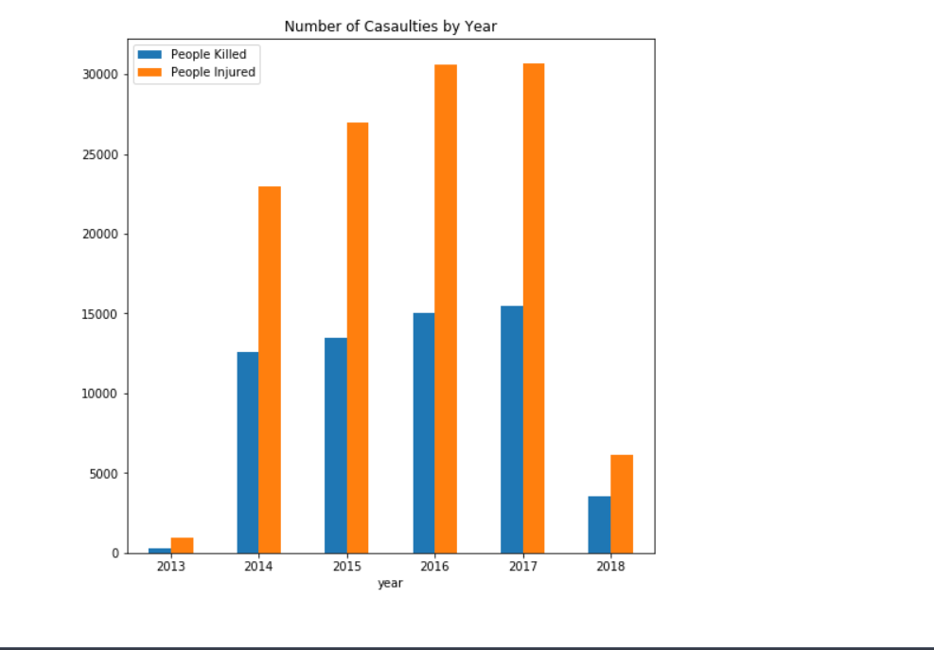

**Number of Casaulities by Month**

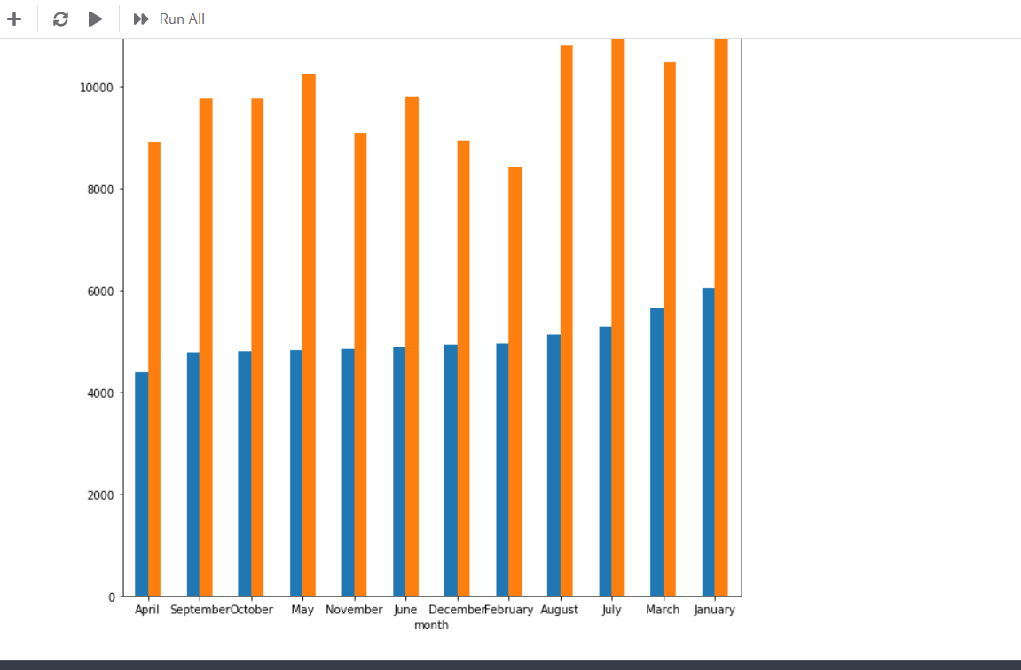

**Number of deaths by day of the month**

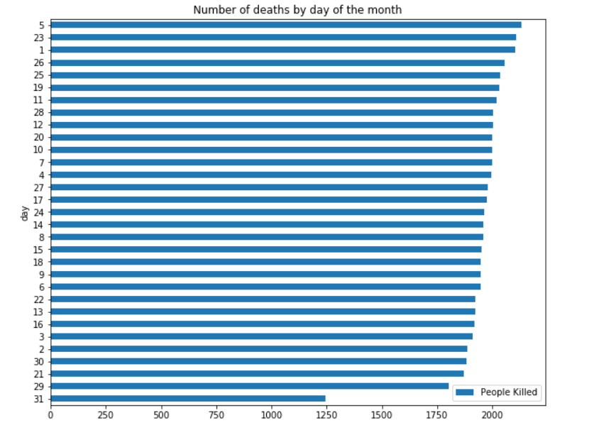



**Top 10 days with maximum number of Gun Violence**

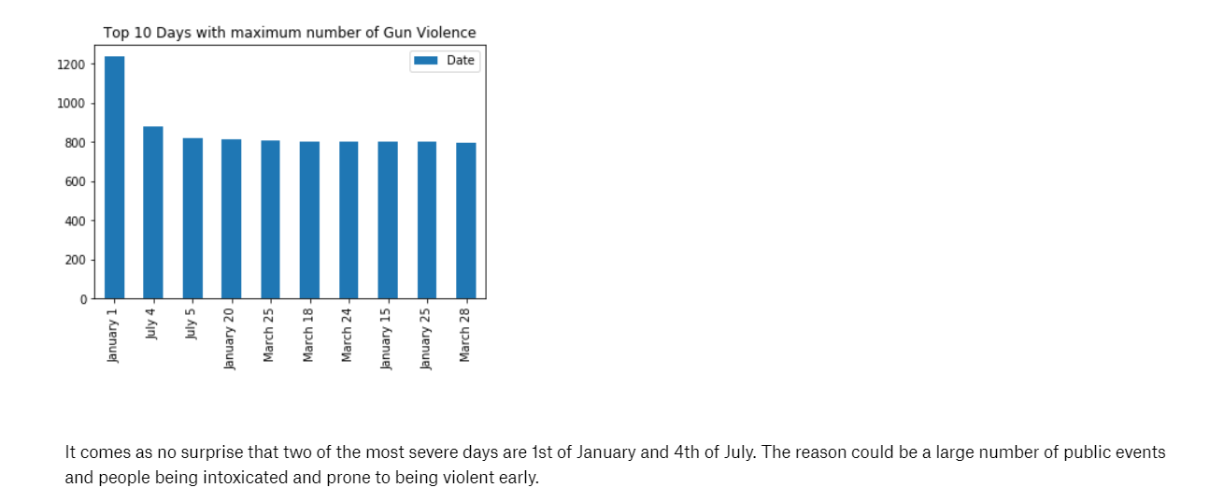

**Incidents by day of the week.**

