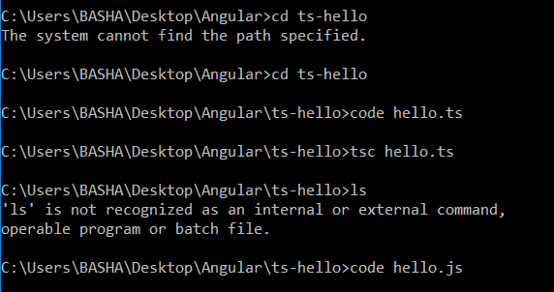

# Hello.ts

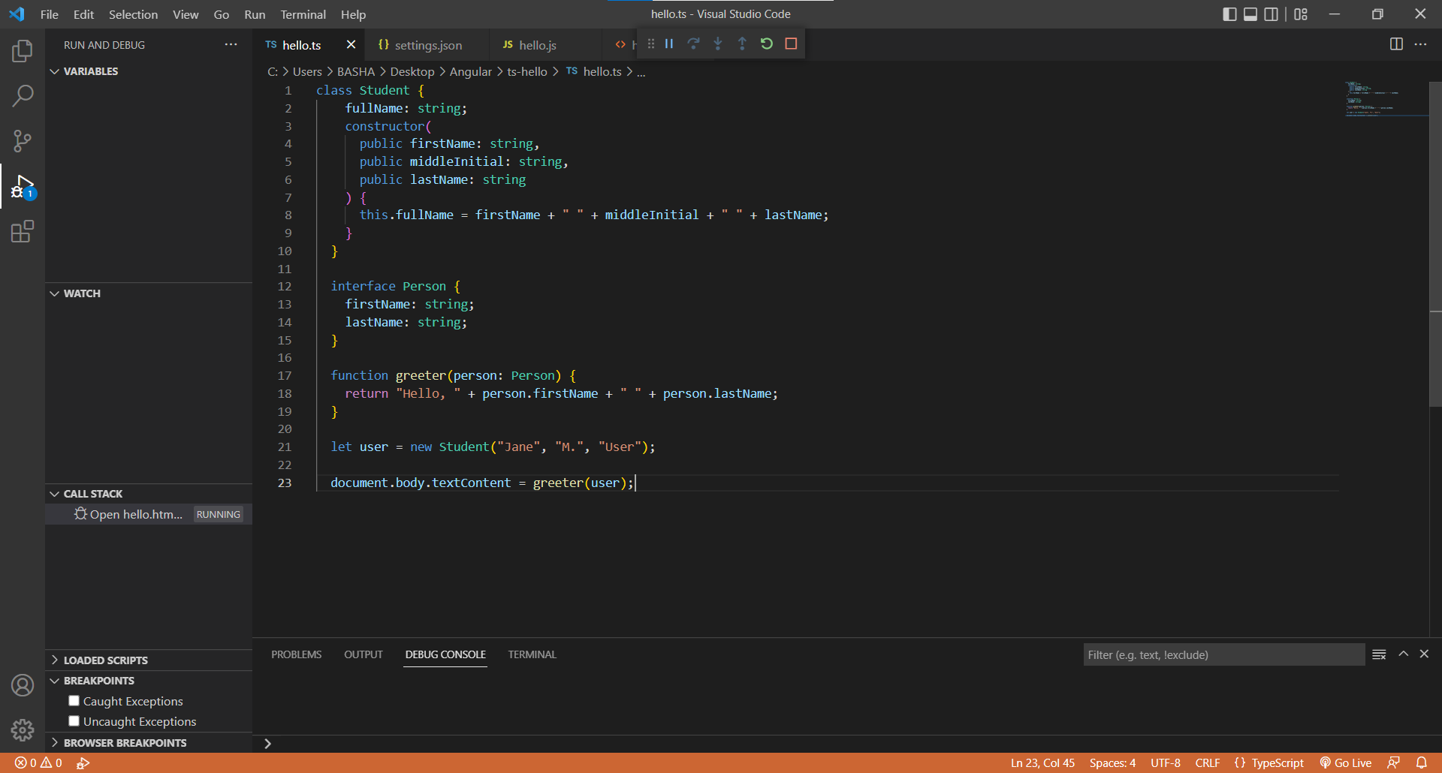

# Hello.js

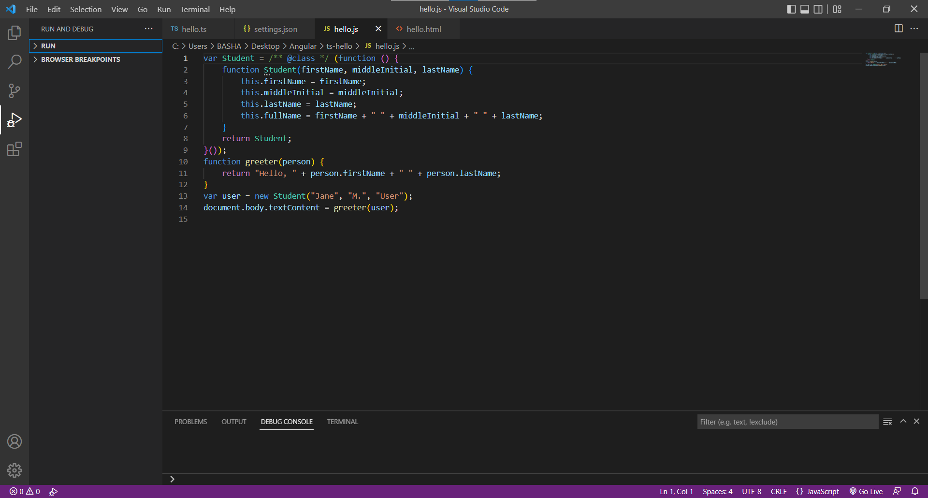

# Output

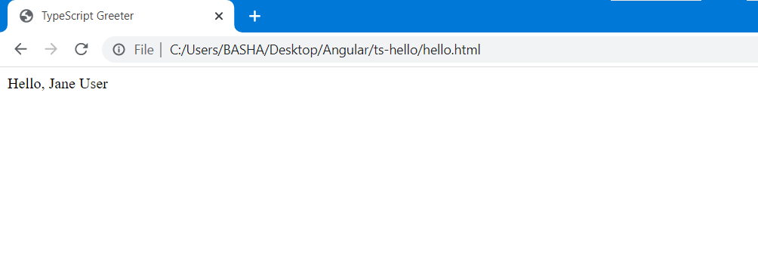

# Department.ts

export interface Department{

   department_id:number,

    department_name:string

}

# Skills.ts

export interface Skills{

    Skill_id:number;

    Skill_name:string;

}

# Employee-test.ts

import { Employee } from "./employee"

var em1:Employee=

{

   id : 1,

   name:'john',

   salary:10000,

   permanent:true,

   dept:{department_id:1,department_name:'mechanical'},

   skill:[{Skill_id:1,Skill_name:'html'},{Skill_id:2,Skill_name:'css'},{Skill_id:3,Skill_name:'java'}]

}

console.log(em1)

# employee.cs

import { Department } from "./department";

import { Skills } from "./skills";

export interface Employee{

    id:number;

    name:string;

    salary:number;

    permanent:boolean;

    dept:Department;

    skill:Skills[];

}

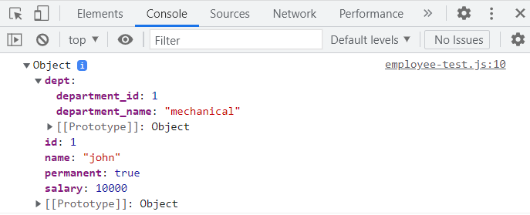

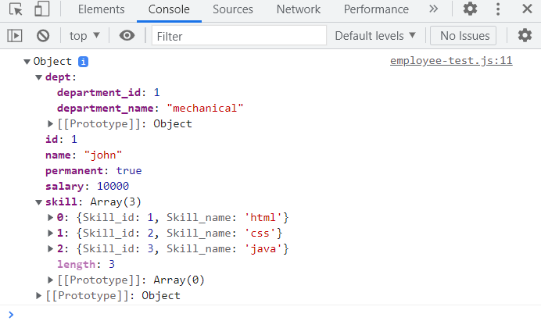

import { Department } from "./department";

import { Employee } from "./employee"

import { Skills } from "./skills";

class EmployeeTest{

    _emp:Employee;

    constructor(id:number,name:string,salary:number,permanent:boolean,department:Department,skills:Skills[]){

        this._emp.id=id;

        this._emp.name=name;

        this._emp.salary=salary;

        this._emp.permanent=permanent;

        this._emp.dept=department;

        this._emp.skill=skills;

    }

     Display():void{

        console.log(this._emp);

       }

}

let obj =new EmployeeTest(1,'john',10000,true,{department_id:1,department_name:'payroll'},[{Skill_id:1,Skill_name:'html'},{Skill_id:2,Skill_name:'css'},{Skill_id:3,Skill_name:'java'}]);

obj.Display();

