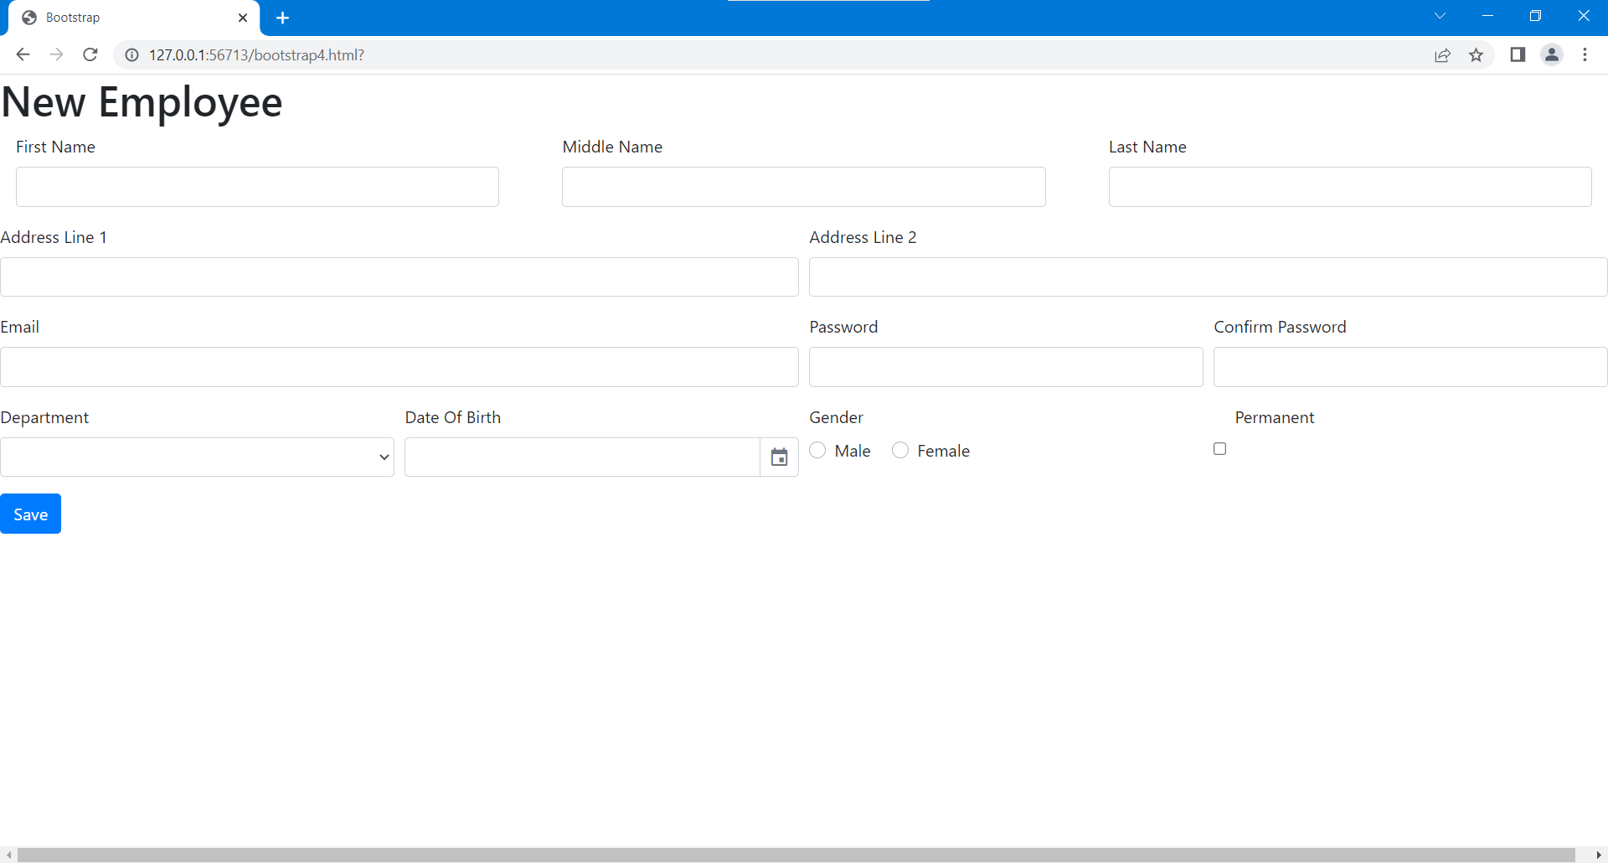

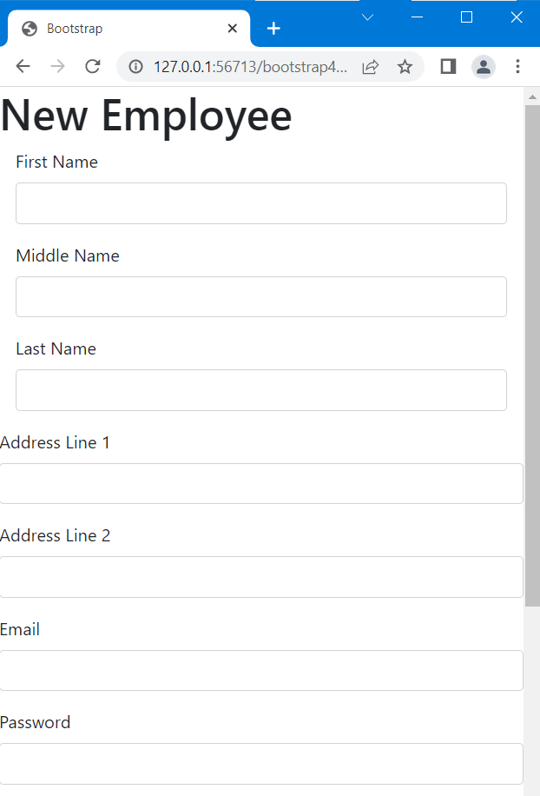

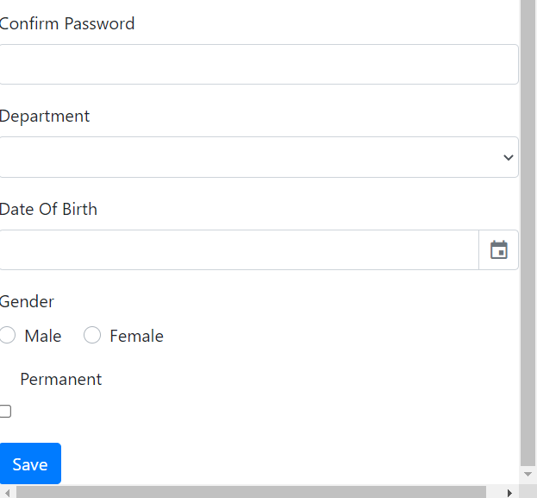

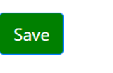

<!DOCTYPE html>

<html lang="en">

<head>

<meta charset="UTf-8">

<meta name="viewport" content="width=device-width,initial-scale=1.0">

<title>Bootstrap</title>

<link href="https://unpkg.com/gijgo@1.9.13/css/gijgo.min.css" rel="stylesheet" type="text/css"/>

<link rel="stylesheet" href="https://cdn.jsdelivr.net/npm/bootstrap@4.3.1/dist/css/bootstrap.min.css" integrity="sha384-ggOyR0iXCbMQv3Xipma34MD+dH/1fQ784/j6cY/iJTQUOhcWr7x9JvoRxT2MZw1T" crossorigin="anonymous">

<style>

.btn btn-primary {

background-color: blue;

}

.bg-green {

background-color: green;

}

</style>

</head>

<body>

<h1>New Employee</h1>

<form>

<div class="row">

<div class="col-md-4 mb-3">

<div class="col">

<label >First Name</label>

<input type="text" class="form-control" placeholder="">

</div>

</div>

<div class="col-md-4 mb-3">

<div class="col">

<label >Middle Name</label>

<input type="text" class="form-control" placeholder="">

</div>

</div>

<div class="col-md-4 mb-3">

<div class="col">

<label >Last Name</label>

<input type="text" class="form-control" placeholder="">

</div>

</div>

</div>

<div class="form-row">

<div class="form-group col-md-6">

<label for="inputAddress">Address Line 1</label>

<input type="text" class="form-control" id="inputAddress" placeholder="">

</div>

<div class="form-group col-md-6">

<label for="inputAddress2">Address Line 2</label>

<input type="text" class="form-control" id="inputAddress2" placeholder="">

</div>

</div>

<div class="form-row">

<div class="form-group col-md-6">

<label for="inputEmail4">Email</label>

<input type="email" class="form-control" id="inputEmail4" placeholder="">

</div>

<div class="form-group col-md-3">

<label for="inputPassword4">Password</label>

<input type="password" class="form-control" id="inputPassword4" placeholder="">

</div>

<div class="form-group col-md-3">

<label for="inputPassword4">Confirm Password</label>

<input type="password" class="form-control" id="inputPassword4" placeholder="">

</div>

</div>

<div class="form-row">

<div class="form-group col-md-3">

<label for="Depatment">Department</label>

<select id="Department" class="form-control">

<option selected></option>

<option>...</option>

</select>

</div>

<div class="form-group col-md-3">

<label for="dateOfBirth">Date Of Birth</label>

<div>

<input type="text" class="form-control" id="dateOfBirth">

</div>

</div>

<div class="form-group col-md-3">

<label >Gender</label><br>

<div class="custom-control custom-radio custom-control-inline">

<input type="radio" id="customRadioInline1" name="customRadioInline1" class="custom-control-input">

<label class="custom-control-label" for="customRadioInline1">Male</label>

</div>

<div class="custom-control custom-radio custom-control-inline">

<input type="radio" id="customRadioInline2" name="customRadioInline1" class="custom-control-input">

<label class="custom-control-label" for="customRadioInline2">Female</label>

</div>

</div>

<div class="form-group col-md-3">

<div class="form-check">

<label>Permanent</label><br>

<input class="form-check-input" type="checkbox" id="gridCheck">

<label class="form-check-label" for="gridCheck">

</label>

</div>

</div>

</div>

<button type="submit" class="btn btn-primary bg-green">Save </button>

</form>

<script src="https://code.jquery.com/jquery-3.3.1.slim.min.js" integrity="sha384-q8i/X+965DzO0rT7abK41JStQIAqVgRVzpbzo5smXKp4YfRvH+8abtTE1Pi6jizo" crossorigin="anonymous"></script>

<script src="https://cdn.jsdelivr.net/npm/popper.js@1.14.7/dist/umd/popper.min.js" integrity="sha384-UO2eT0CpHqdSJQ6hJty5KVphtPhzWj9WO1clHTMGa3JDZwrnQq4sF86dIHNDz0W1" crossorigin="anonymous"></script>

<script src="https://cdn.jsdelivr.net/npm/bootstrap@4.3.1/dist/js/bootstrap.min.js" integrity="sha384-JjSmVgyd0p3pXB1rRibZUAYoIIy6OrQ6VrjIEaFf/nJGzIxFDsf4x0xIM+B07jRM" crossorigin="anonymous"></script>

</body>

<script src="https://unpkg.com/gijgo@1.9.13/js/gijgo.min.js" type="text/javascript"></script>

<script>

$('#dateOfBirth').datepicker({

uiLibrary: 'bootstrap4',

format: 'dd/mm/yyyy' });

</script>

</html>