# Code:

using System;

using System.Collections.Generic;

using System.Linq;

using System.Net;

using System.Net.Http;

using System.Web.Http;

namespace MoviesWebAPI.Controllers

{

public class MoviesController : ApiController

{

public string Get()

{

return "Hello from Web API";

}

}

}

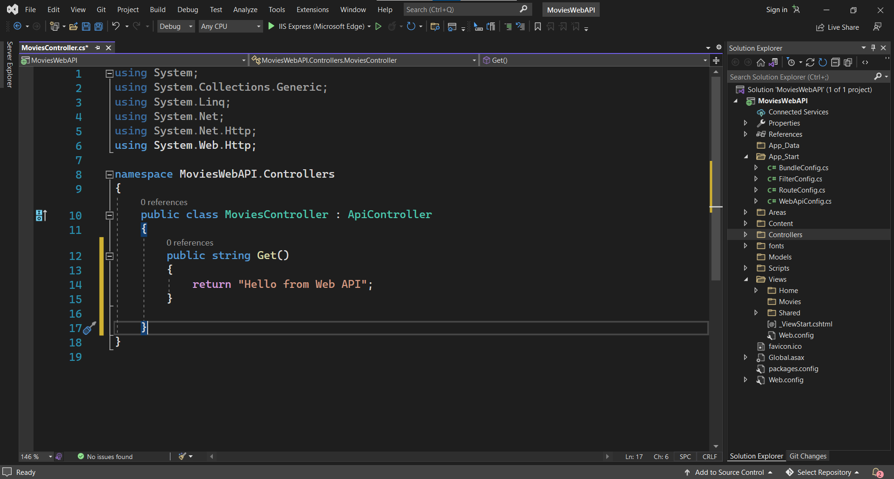

# Output:

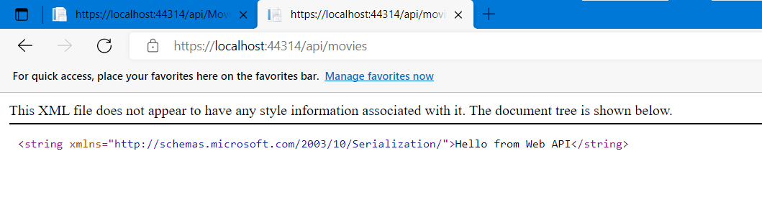

# Code:

using System;

using System.Collections.Generic;

using System.Linq;

using System.Net;

using System.Net.Http;

using System.Web.Http;

namespace MoviesWebAPI.Controllers

{

public class MoviesController : ApiController

{

public List<string> GetMovies()

{

return new List<string> { "Titanic","Mission Impossible","Matrix"};

}

}

}

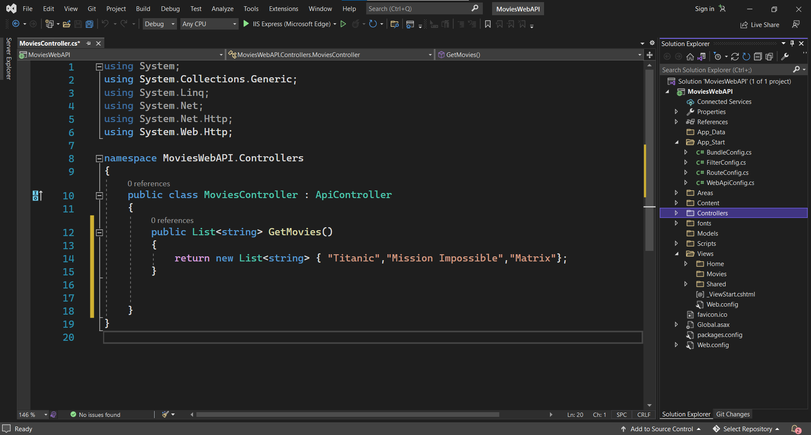

# Output:

