* **Source Code**

namespace MoviesWebAPI.Controllers

{

public class MoviesController : ApiController

{

public string Get()

{

return "Hello from the WEB API";

}

}

}

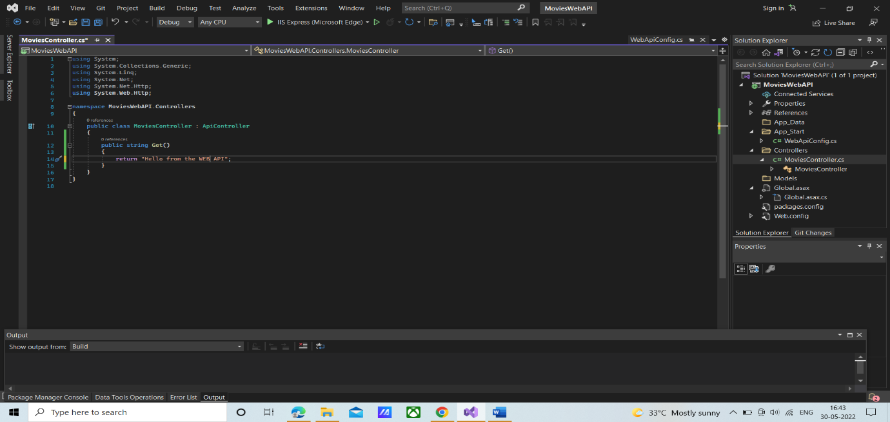

* **OutPut**

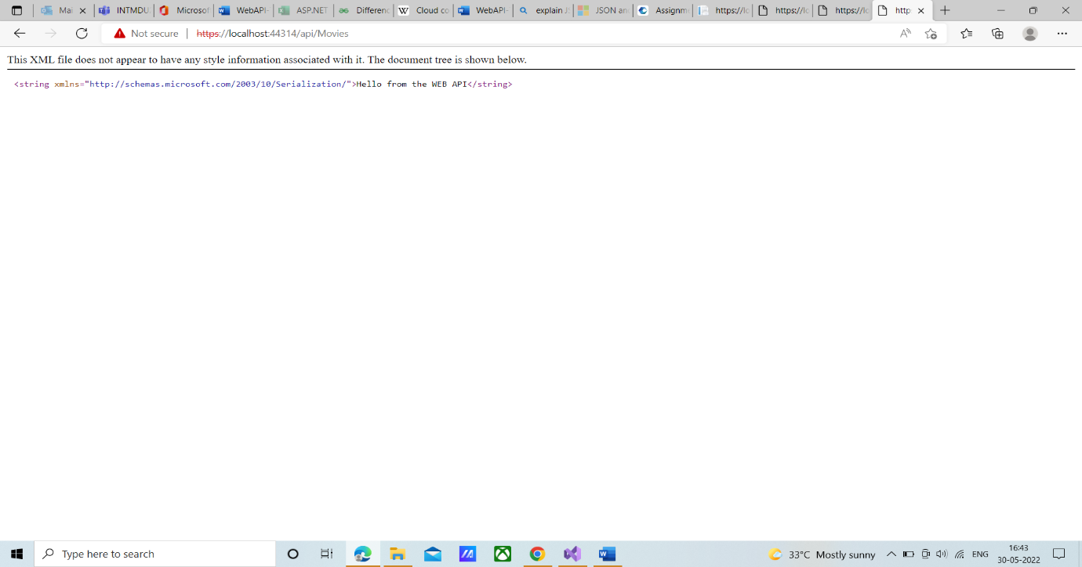

**Source Code**

namespace MoviesWebAPI.Controllers

{

public class MoviesController : ApiController

{

public List<string>GetMovies()

{

return new List<string> { "Titanic", "Mission Impossible", "Matrix"};

}

}

}

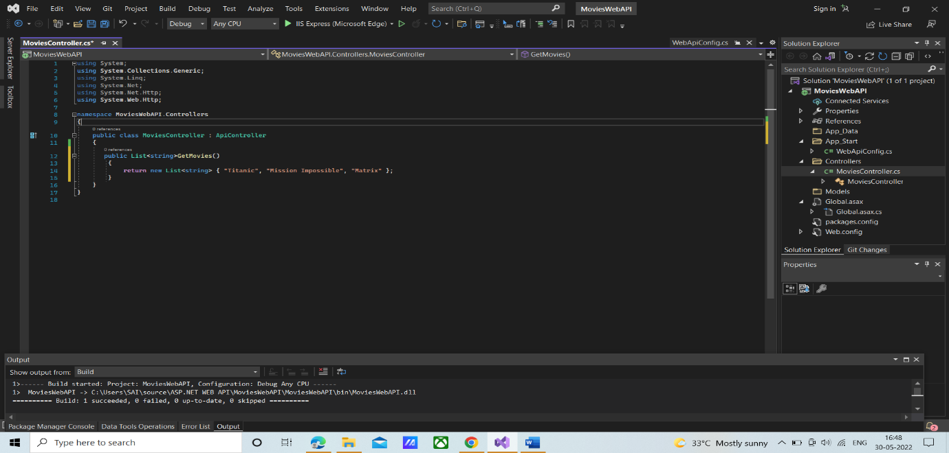

**Output**

