**Brand.cs**

using System;

using System.Collections.Generic;

using System.Linq;

using System.Web;

namespace Web_API.Models

{

public class Brand

{

public string BrandId { get; set; }

public string Name { get; set; }

}

}

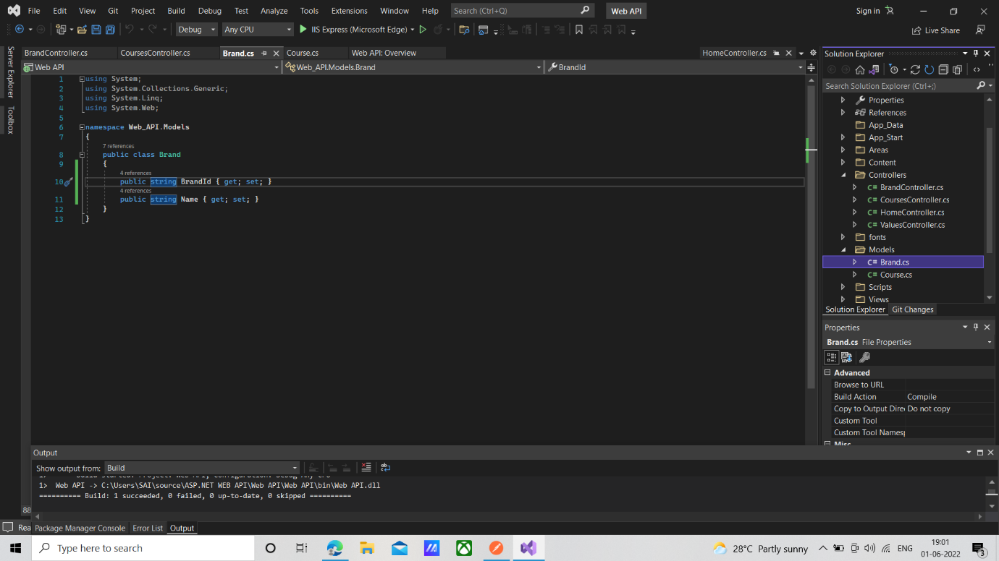

**Course.cs**

using System;

using System.Collections.Generic;

using System.Linq;

using System.Web;

namespace Web_API.Models

{

public class Course

{

public int CourseId { get; set; }

public string CourseName { get; set; }

public string Trainer { get; set; }

public int Fees { get; set; }

public string CourseDescription { get; set; }

}

}

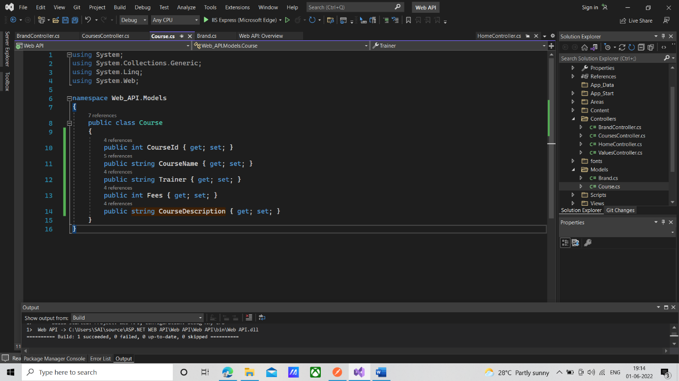

**BrandController**

using System;

using System.Collections.Generic;

using System.Linq;

using System.Net;

using System.Net.Http;

using System.Web.Http;

using Web_API.Models;

namespace Web_API.Controllers

{

public class BrandController : ApiController

{

static List<Brand> brands = new List<Brand>()

{

new Brand(){BrandId="B001",Name="Haro"},

new Brand(){BrandId="B002",Name="Electra"},

new Brand(){BrandId="B003",Name="Heller"},

new Brand(){BrandId="B004",Name="Trek"}

};

public HttpResponseMessage Post([FromUri]Brand brand)

{

brands.Add(brand);

return Request.CreateResponse(HttpStatusCode.Created,brand);

}

}

}

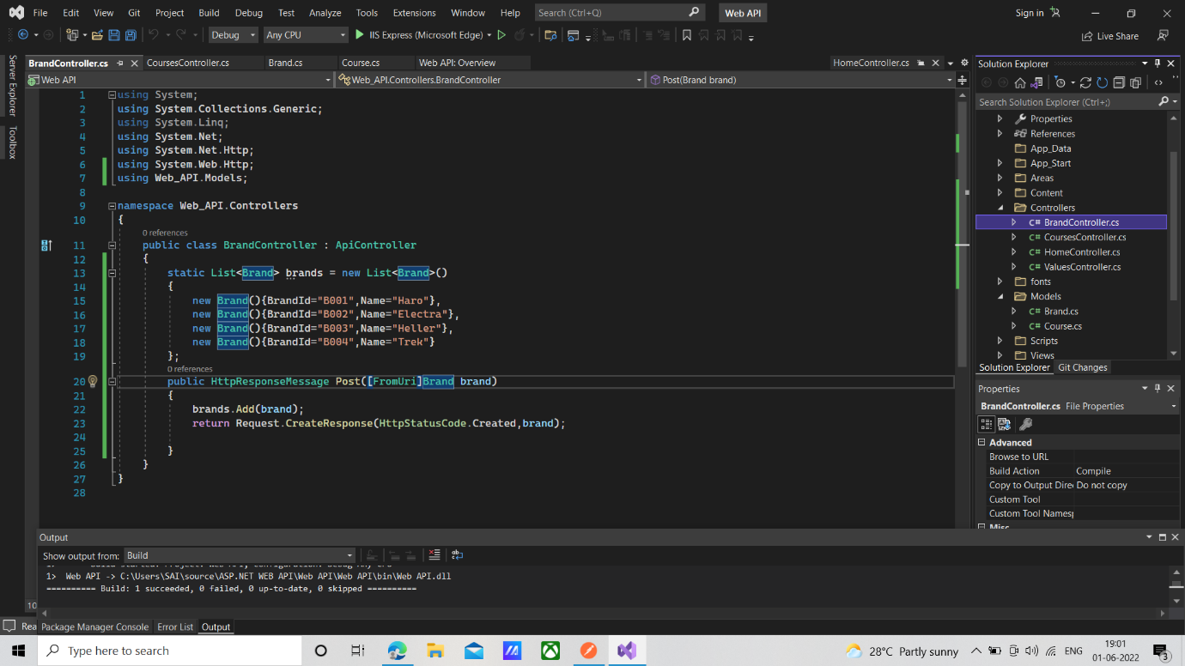

**CoursesController**

using System;

using System.Collections.Generic;

using System.Linq;

using System.Net;

using System.Net.Http;

using System.Web.Http;

using Web_API.Models;

namespace Web_API.Controllers

{

public class CoursesController : ApiController

{

static List<Course> courses = new List<Course>()

{

new Course(){CourseId=1,CourseName="Android",Trainer="Shawn",Fees=12000,CourseDescription="Android is a mobile operating system development"},

new Course(){CourseId=2,CourseName="ASP.Net",Trainer="Kevin",Fees=10000,CourseDescription="ASP.NET is a open source web development framework"},

new Course(){CourseId=3,CourseName="JSP",Trainer="Debaratha",Fees=10000,CourseDescription="Java server pages is a technology used for web page creations"},

new Course(){CourseId=4,CourseName="Xamarin",Trainer="Mark John",Fees=15000,CourseDescription="Xamarin forms are cross platform UI tools"}

};

public HttpResponseMessage Get(string courseName)

{

var details = courses.Where(p => p.CourseName == courseName).FirstOrDefault();

if(details==null)

{

return Request.CreateErrorResponse(HttpStatusCode.NotFound,$"course name {courseName} not found");

}

return Request.CreateResponse(HttpStatusCode.OK, details);

}

public HttpResponseMessage Post([FromBody]Course course)

{

courses.Add(course);

return Request.CreateResponse(HttpStatusCode.Created, course);

}

}

}

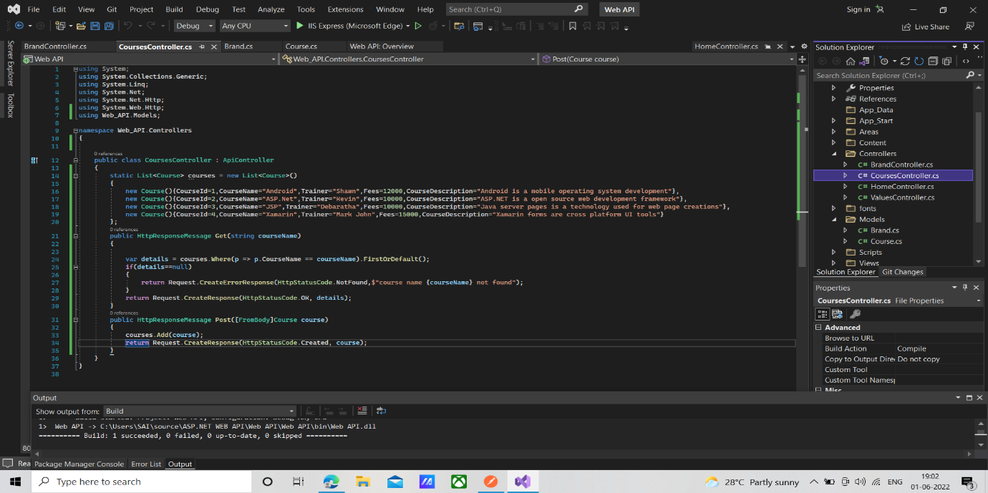

**Web Api Config.**

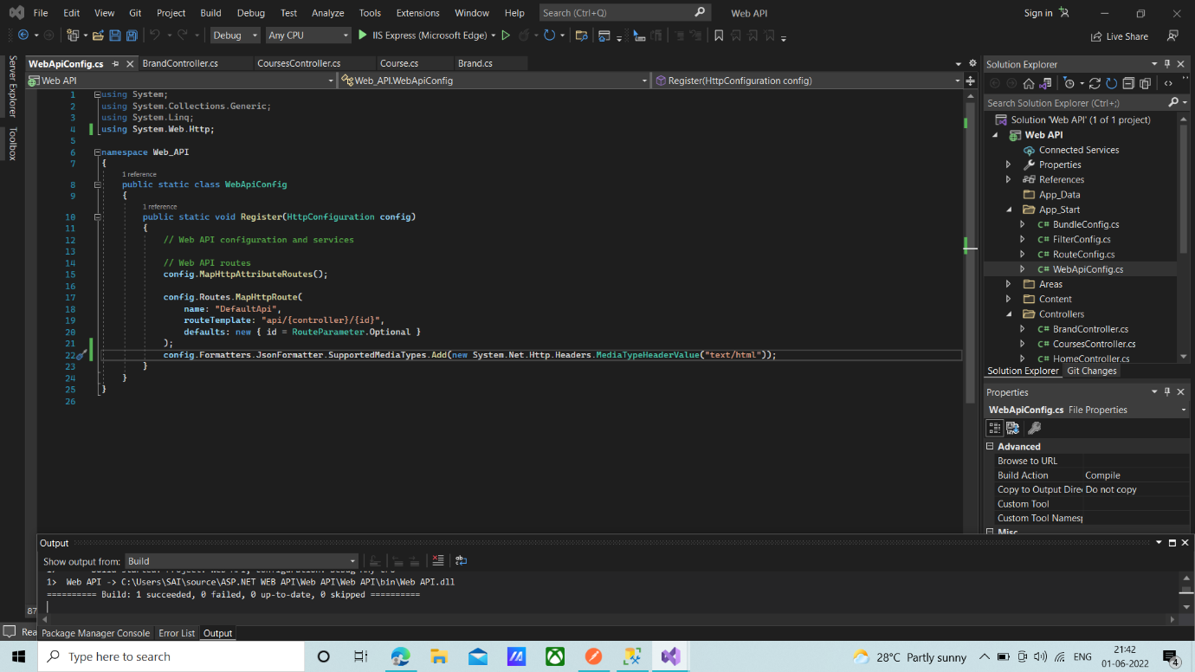

**Result**

Post <https://localhost:44391/api/Courses>

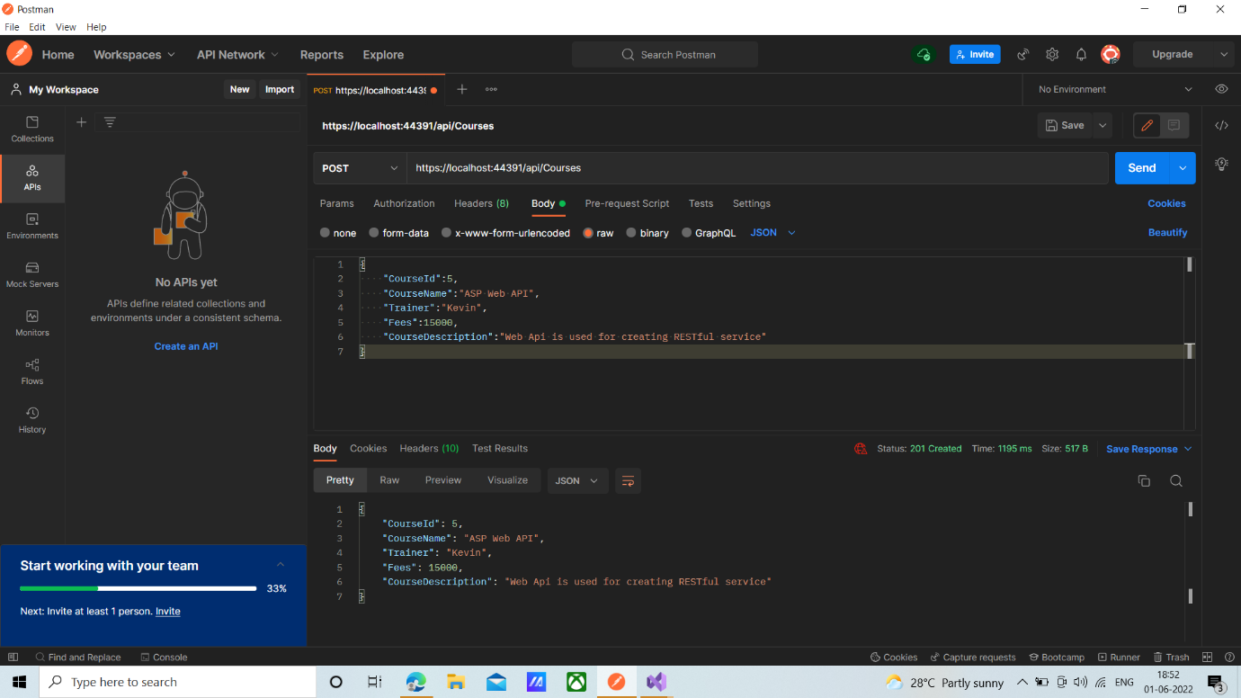

**Get** [**https://localhost:44391/api/Courses?CourseName=ASP20%MVC**](https://localhost:44391/api/Courses?CourseName=ASP20%25MVC)

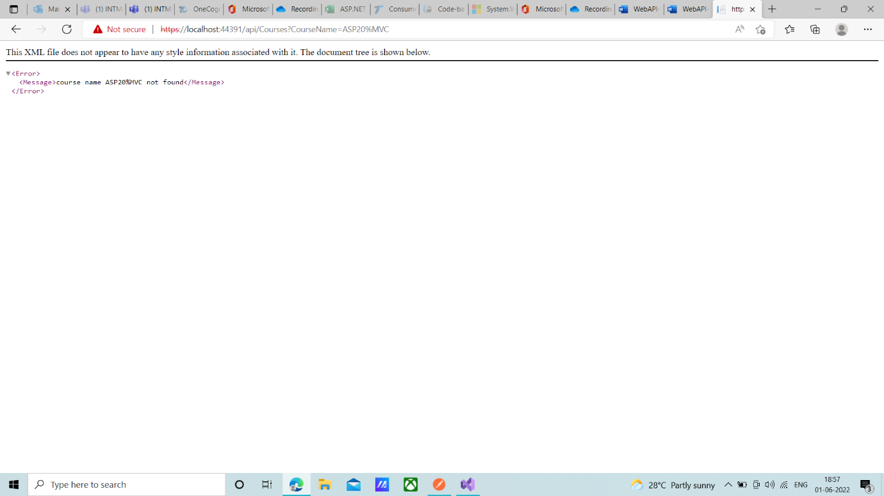

**Get** [**https://localhost:44391/api/Courses?CourseName=ASP.Net**](https://localhost:44391/api/Courses?CourseName=ASP.Net)

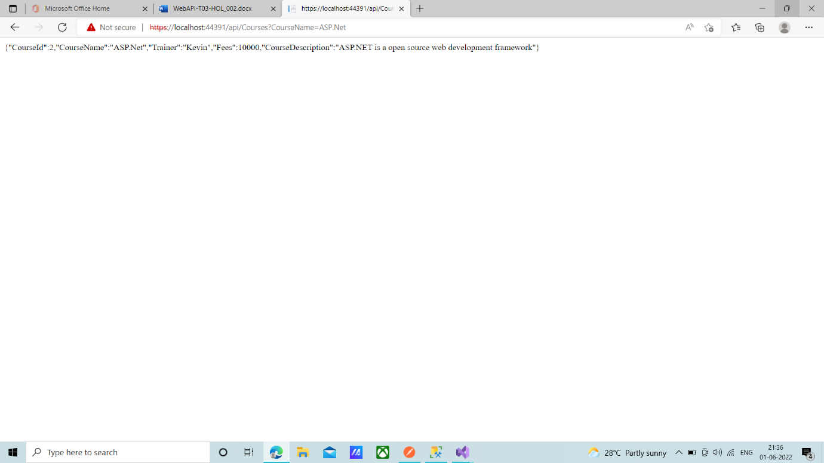

Post <https://localhost:44391/api/Brand?BrandId=B005&Name=Surly>

