**Student.cs**

namespace StudentService.Models

{

using System;

using System.Collections.Generic;

public partial class Student

{

public int ID { get; set; }

public string FirstName { get; set; }

public string LastName { get; set; }

public string Gender { get; set; }

public string Address { get; set; }

}

}

**StudentDBContext**

namespace StudentService.Models

{

using System;

using System.Data.Entity;

using System.Data.Entity.Infrastructure;

public partial class StudentDBContext : DbContext

{

public StudentDBContext()

: base("name=StudentDBContext")

{

}

protected override void OnModelCreating(DbModelBuilder modelBuilder)

{

throw new UnintentionalCodeFirstException();

}

public virtual DbSet<Student> Students { get; set; }

}

}

**StudentController**

using System;

using System.Collections.Generic;

using System.Linq;

using System.Net;

using System.Net.Http;

using System.Web.Http;

using StudentService.Models;

namespace StudentService.Controllers

{

public class StudentsController : ApiController

{

public IEnumerable<Student> Get()

{

using(StudentDBContext dbContext=new StudentDBContext())

{

return dbContext.Students.ToList();

}

}

public Student Get(int id)

{

using(StudentDBContext dbContext=new StudentDBContext())

{

return dbContext.Students.FirstOrDefault(s => s.ID == id);

}

}

}

}

**Result**

**Get** <https://localhost:44332/api/Students>

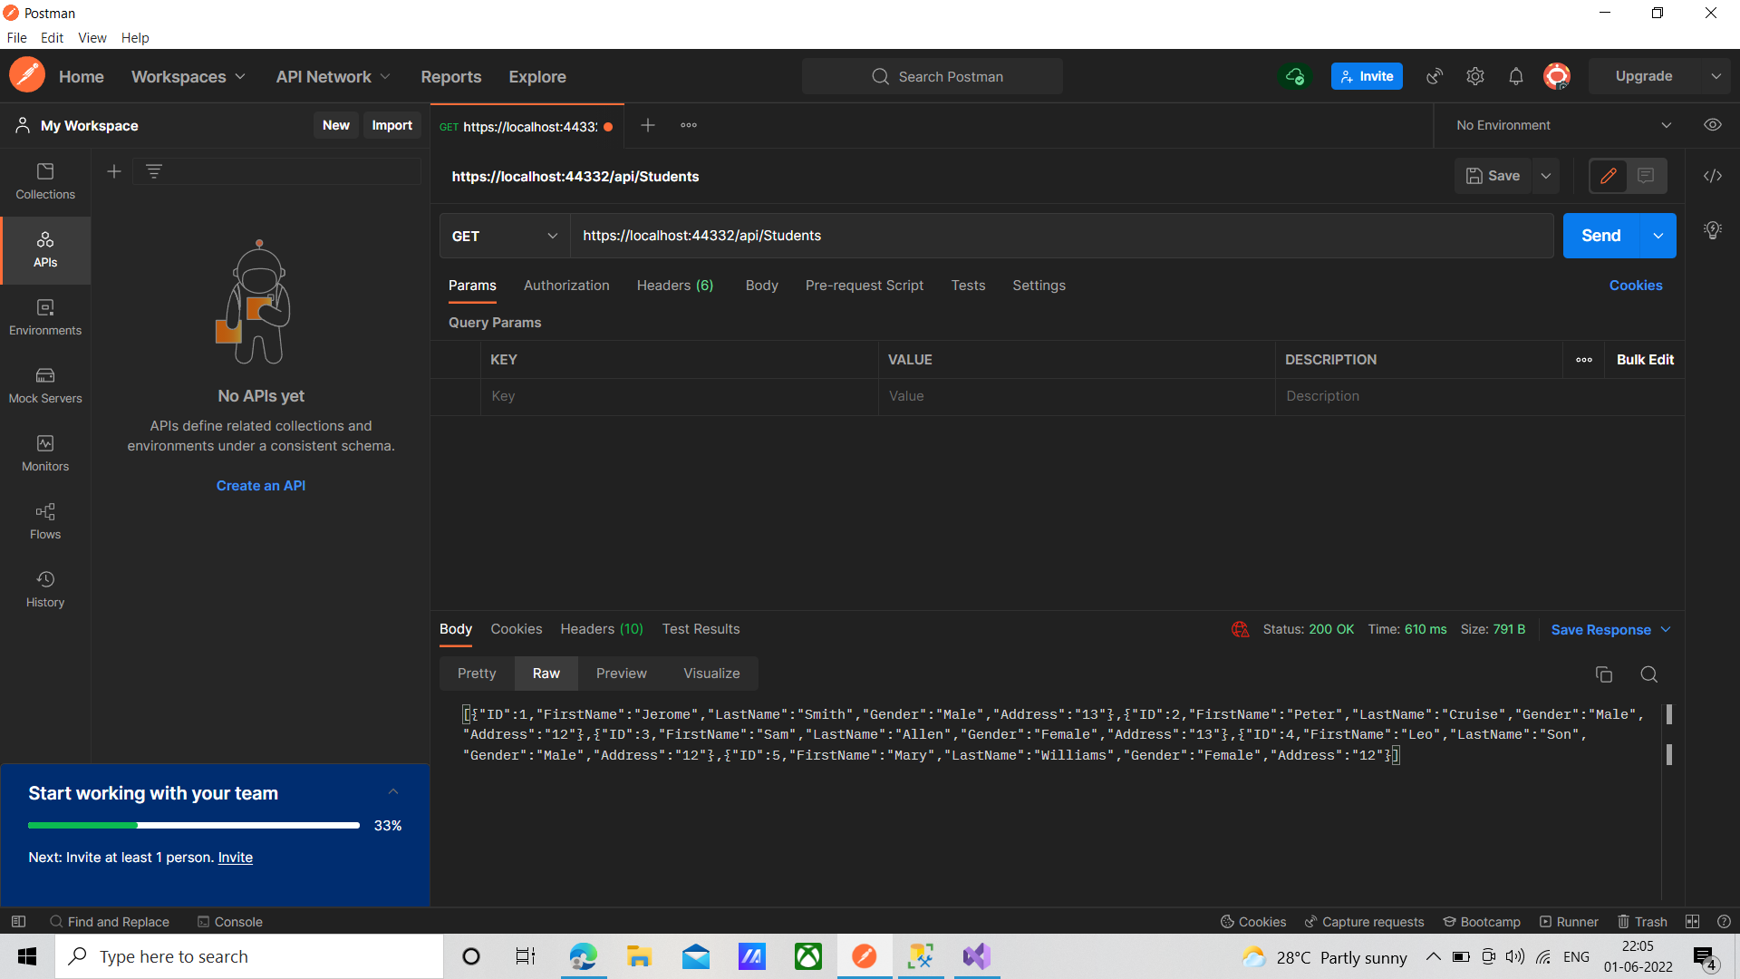

Get <https://localhost:44332/api/Students/1>

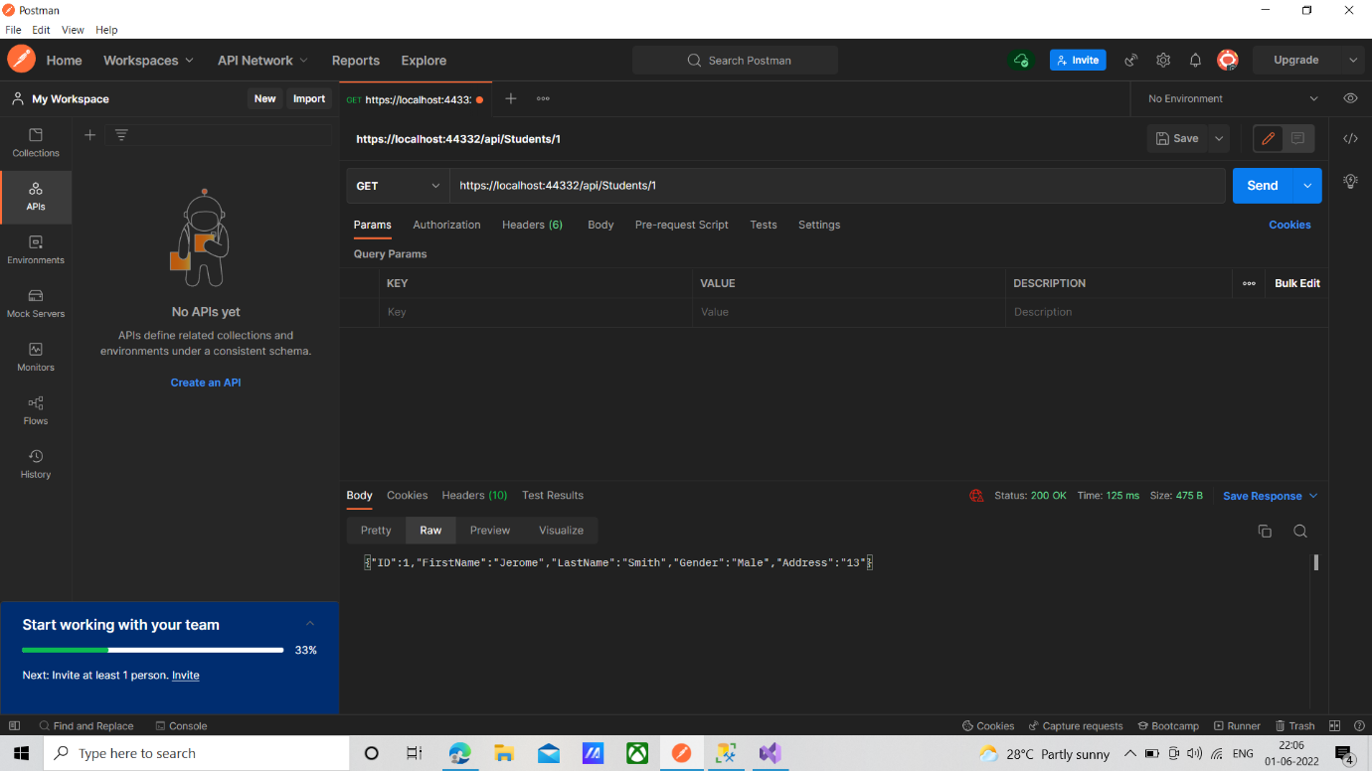

Get <https://localhost:44332/api/Students/10>

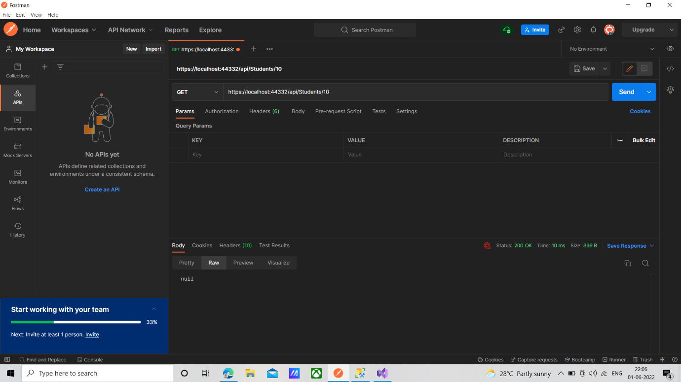

**StudentsController(Modified)**

using System;

using System.Collections.Generic;

using System.Linq;

using System.Net;

using System.Net.Http;

using System.Web.Http;

using StudentService.Models;

namespace StudentService.Controllers

{

public class StudentsController : ApiController

{

public HttpResponseMessage Get()

{

using (StudentDBContext dbContext = new StudentDBContext())

{

return Request.CreateResponse(HttpStatusCode.OK, dbContext.Students.ToList());

}

}

public HttpResponseMessage Get(int id)

{

using (StudentDBContext dbContext = new StudentDBContext())

{

var entity = dbContext.Students.FirstOrDefault(x => x.ID == id);

if(entity!=null)

{

return Request.CreateResponse(HttpStatusCode.OK, entity);

}

return Request.CreateResponse(HttpStatusCode.NotFound, $"Student with Id {id} not found");

}

}

}

}

Get <https://localhost:44332/api/Students/10>

