**DataBaseCreation**

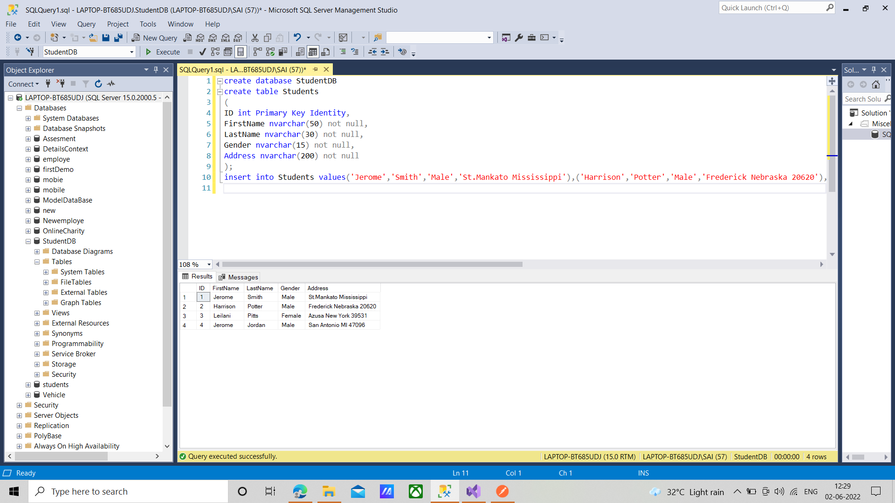

**Student.cs**

namespace StudentService.Models

{

using System;

using System.Collections.Generic;

public partial class Student

{

public int ID { get; set; }

public string FirstName { get; set; }

public string LastName { get; set; }

public string Gender { get; set; }

public string Address { get; set; }

}

}

**StudentDBContext**

namespace StudentService.Models

{

using System;

using System.Data.Entity;

using System.Data.Entity.Infrastructure;

public partial class StudentDBContext : DbContext

{

public StudentDBContext()

: base("name=StudentDBContext")

{

}

protected override void OnModelCreating(DbModelBuilder modelBuilder)

{

throw new UnintentionalCodeFirstException();

}

public virtual DbSet<Student> Students { get; set; }

}

}

**StudentController.cs**

using System;

using System.Collections.Generic;

using System.Linq;

using System.Net;

using System.Net.Http;

using System.Web.Http;

using StudentService.Models;

namespace StudentService.Controllers

{

public class StudentsController : ApiController

{

public void Post([FromBody] Student student)

{

using(StudentDBContext dBContext=new StudentDBContext())

{

dBContext.Students.Add(student);

dBContext.SaveChanges();

}

}

}

}

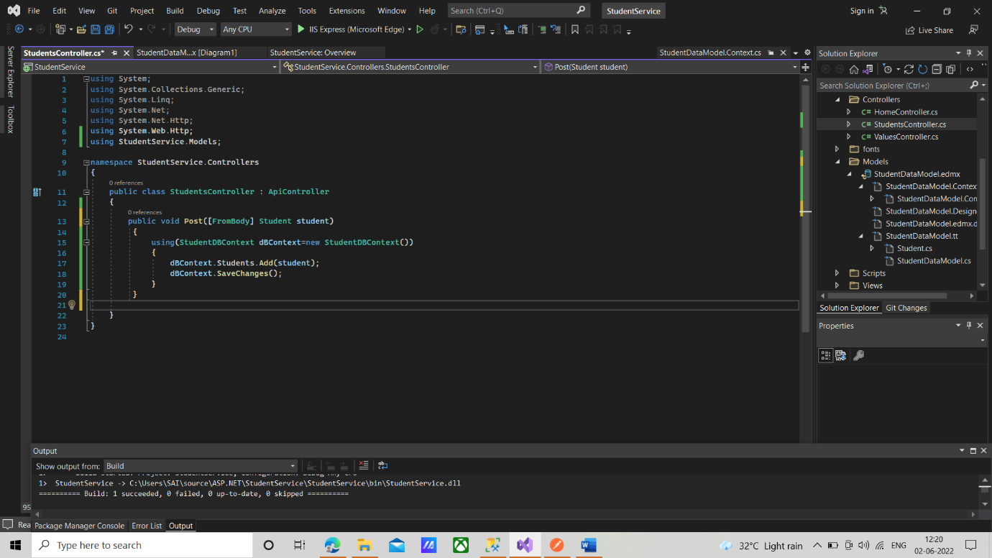

**Result**

Post <https://localhost:44330/api/Students>

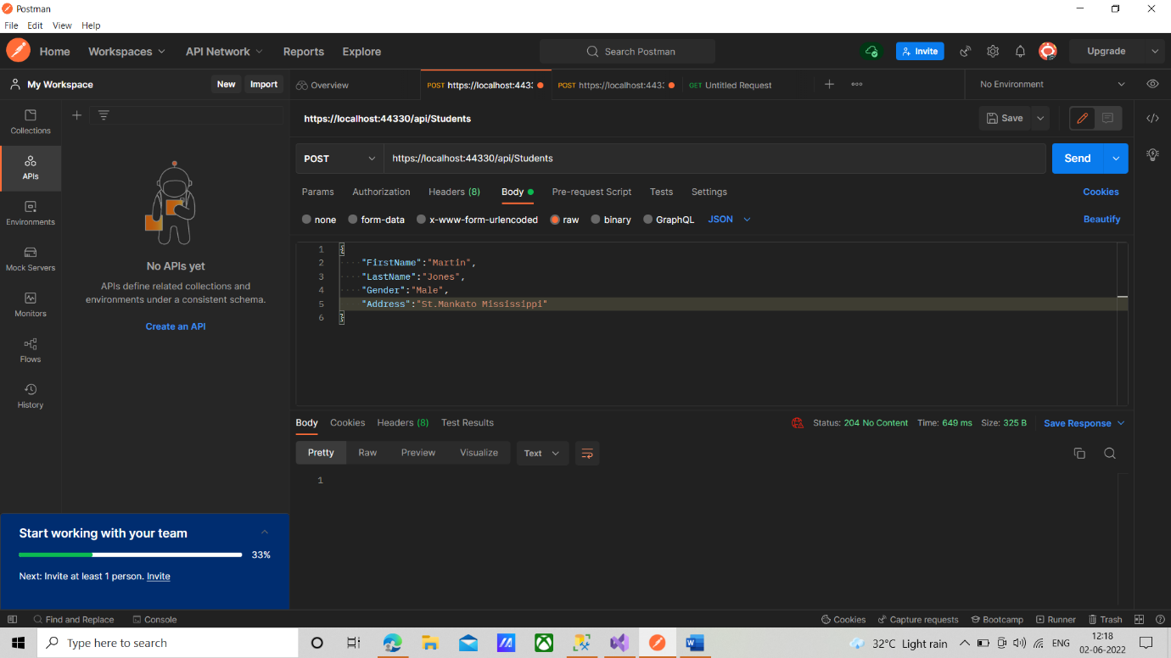

**StudentController.cs(Modified)**

using System;

using System.Collections.Generic;

using System.Linq;

using System.Net;

using System.Net.Http;

using System.Web.Http;

using StudentService.Models;

namespace StudentService.Controllers

{

public class StudentsController : ApiController

{

public HttpResponseMessage Post([FromBody] Student student)

{

try

{

using (StudentDBContext dBContext = new StudentDBContext())

{

dBContext.Students.Add(student);

dBContext.SaveChanges();

var message = Request.CreateResponse(HttpStatusCode.Created, student);

return message;

}

}

catch(Exception ex)

{

return Request.CreateResponse(HttpStatusCode.BadRequest, ex);

}

}

}

}

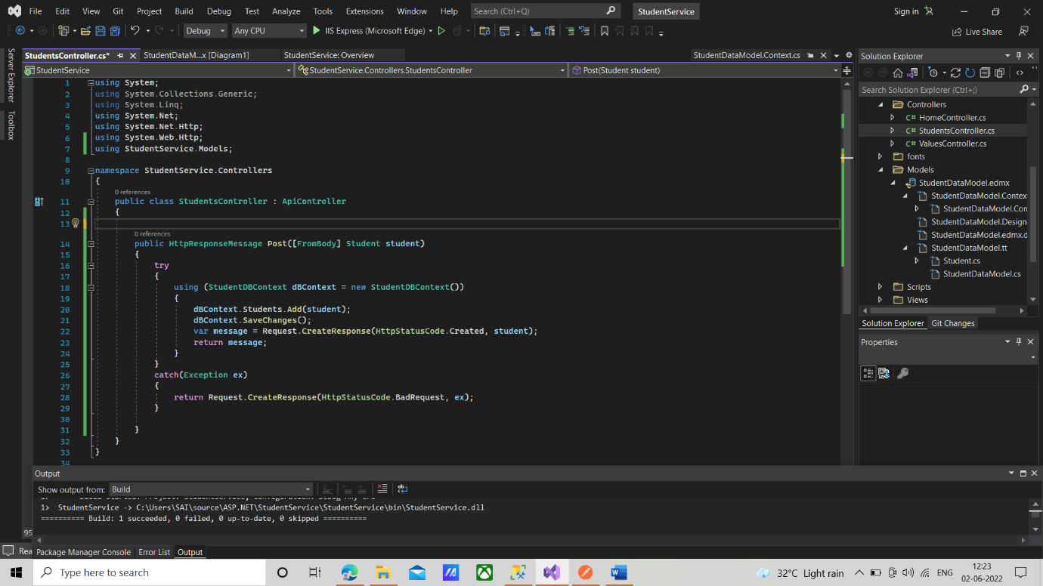

**Result**

Post <https://localhost:44330/api/Students>

