**Database Creation**

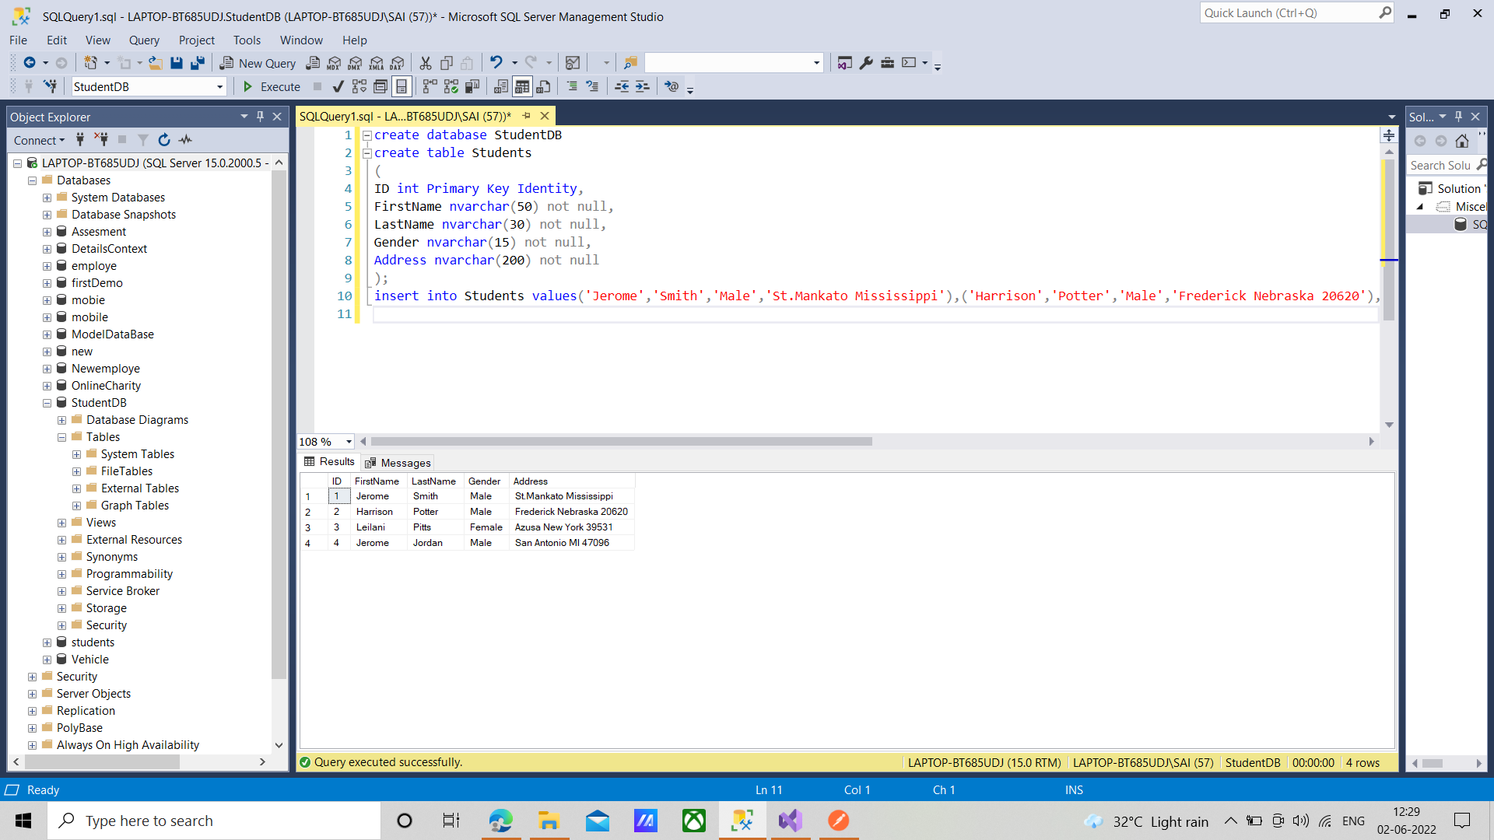

**Student.cs**

namespace StudentService.Models

{

using System;

using System.Collections.Generic;

public partial class Student

{

public int ID { get; set; }

public string FirstName { get; set; }

public string LastName { get; set; }

public string Gender { get; set; }

public string Address { get; set; }

}

}

**studentDbContext**

namespace StudentService.Models

{

using System;

using System.Data.Entity;

using System.Data.Entity.Infrastructure;

public partial class StudentDBContext : DbContext

{

public StudentDBContext()

: base("name=StudentDBContext")

{

}

protected override void OnModelCreating(DbModelBuilder modelBuilder)

{

throw new UnintentionalCodeFirstException();

}

public virtual DbSet<Student> Students { get; set; }

}

}

**StudentsController.cs**

using System;

using System.Collections.Generic;

using System.Linq;

using System.Net;

using System.Net.Http;

using System.Web.Http;

using StudentService.Models;

namespace StudentService.Controllers

{

public class StudentsController : ApiController

{

public void Delete(int id)

{

using (StudentDBContext dBContext = new StudentDBContext())

{

dBContext.Students.Remove(dBContext.Students.FirstOrDefault(s => s.ID == id));

dBContext.SaveChanges();

}

}

}

}

}

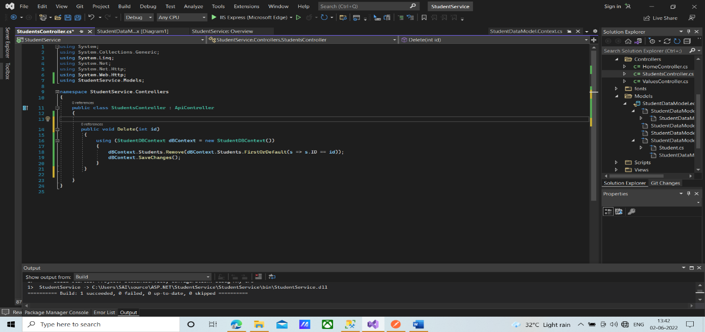

**Result**

Delete <https://localhost:44330/api/Students/6>

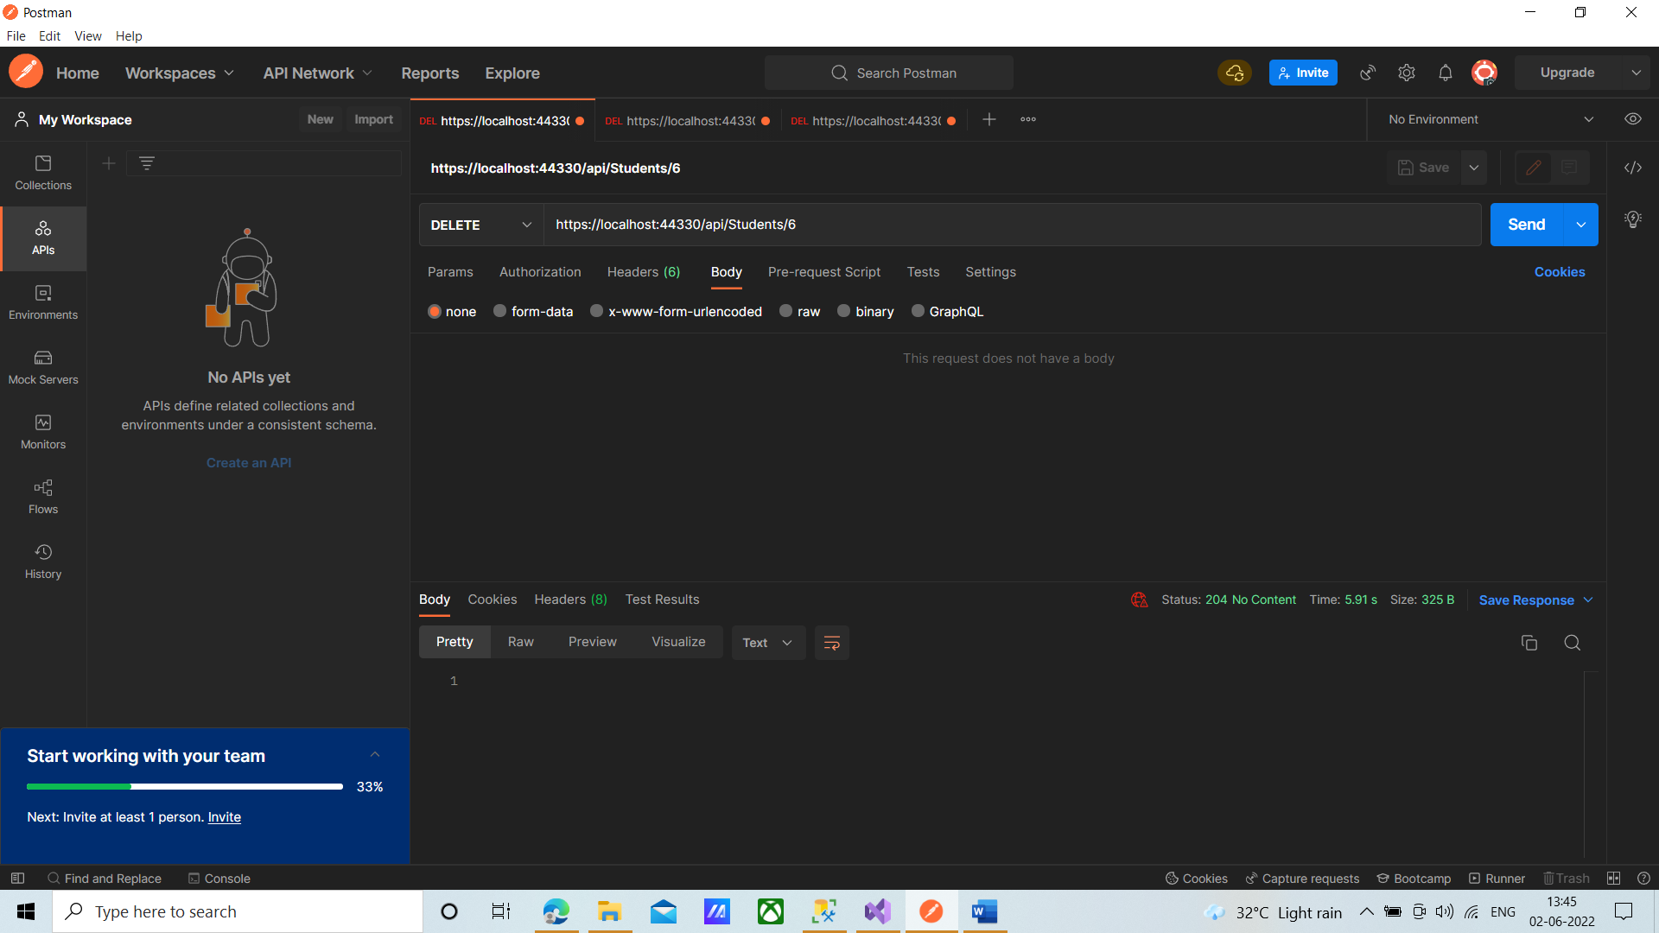

**StudentsController.cs(Modified)**

using System;

using System.Collections.Generic;

using System.Linq;

using System.Net;

using System.Net.Http;

using System.Web.Http;

using StudentService.Models;

namespace StudentService.Controllers

{

public class StudentsController : ApiController

{

public HttpResponseMessage Delete(int id)

{

using (StudentDBContext dBContext = new StudentDBContext())

{

dBContext.Students.Remove(dBContext.Students.FirstOrDefault(s => s.ID == id));

dBContext.SaveChanges();

return Request.CreateResponse(HttpStatusCode.OK);

}

}

}

}

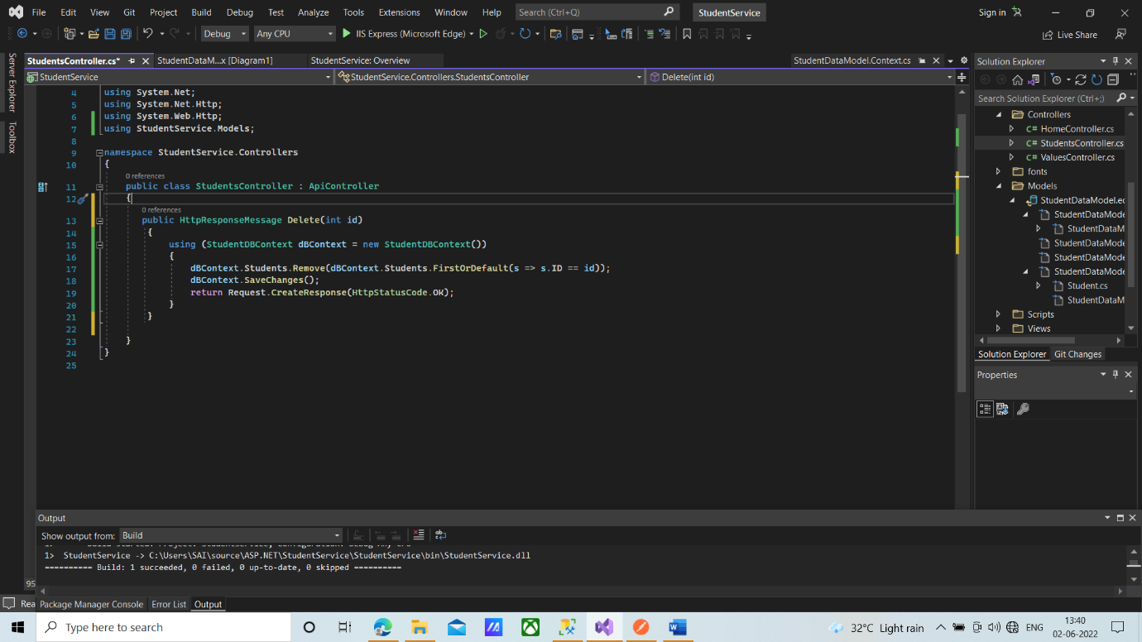

**Result**

Delete <https://localhost:44330/api/Students/4>

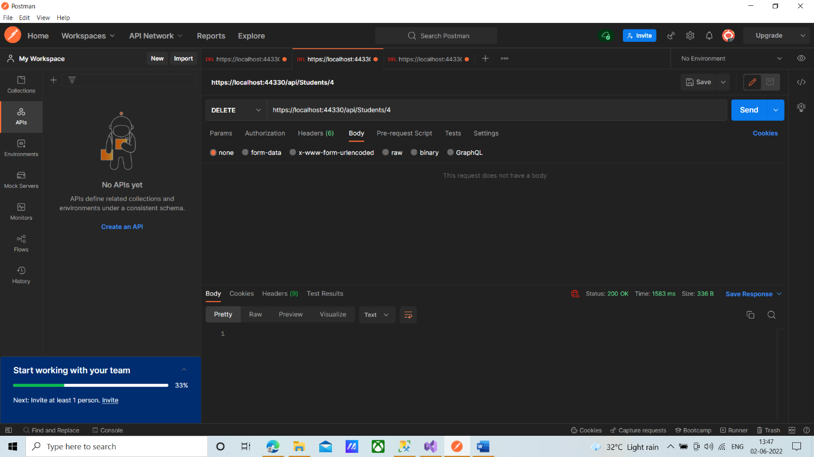

**StudentsController.cs(Modified)**

using System;

using System.Collections.Generic;

using System.Linq;

using System.Net;

using System.Net.Http;

using System.Web.Http;

using StudentService.Models;

namespace StudentService.Controllers

{

public class StudentsController : ApiController

{

public HttpResponseMessage Delete(int id)

{

try

{

using (StudentDBContext dBContext = new StudentDBContext())

{

var entity = dBContext.Students.FirstOrDefault(s => s.ID == id);

if(entity==null)

{

return Request.CreateErrorResponse(HttpStatusCode.NotFound, $"Student with Id={id} not found to delete");

}

else

{

dBContext.Students.Remove(entity);

dBContext.SaveChanges();

return Request.CreateResponse(HttpStatusCode.OK);

}

}

}

catch(Exception ex)

{

return Request.CreateErrorResponse(HttpStatusCode.BadRequest, ex);

}

}

}

}

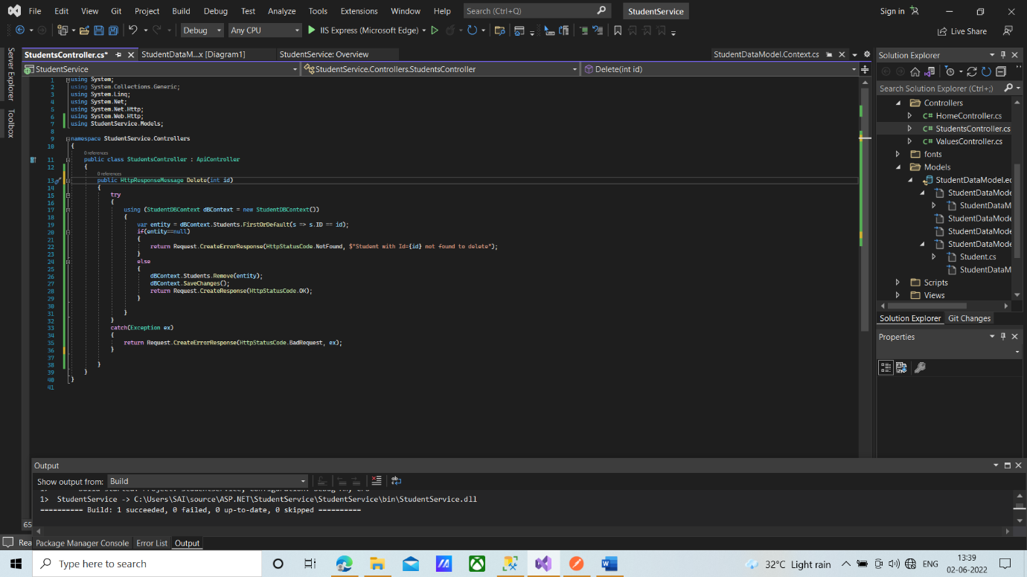

**Result**

Delete <https://localhost:44330/api/Students/89>

