# Book.cs

namespace BookService.Models

{

using System;

using System.Collections.Generic;

public partial class Book

{

public int BookCode { get; set; }

public string Title { get; set; }

public string Publisher { get; set; }

public string Type { get; set; }

public Nullable<decimal> Price { get; set; }

}

}

# BookController.cs

using BookService.Models;

using System;

using System.Collections.Generic;

using System.Linq;

using System.Net;

using System.Net.Http;

using System.Web.Http;

namespace BookService.Controllers

{

public class BooksController : ApiController

{

public IEnumerable<Book> Get()

{

using (BooksDBContext dbContext = new BooksDBContext())

{

return dbContext.Books.ToList();

}

}

public HttpResponseMessage Post([FromBody]Book book)

{

using (BooksDBContext dbContext = new BooksDBContext())

{

dbContext.Books.Add(book);

dbContext.SaveChanges();

return Request.CreateResponse(HttpStatusCode.OK);

}

}

}

}

Get url: /api/Books

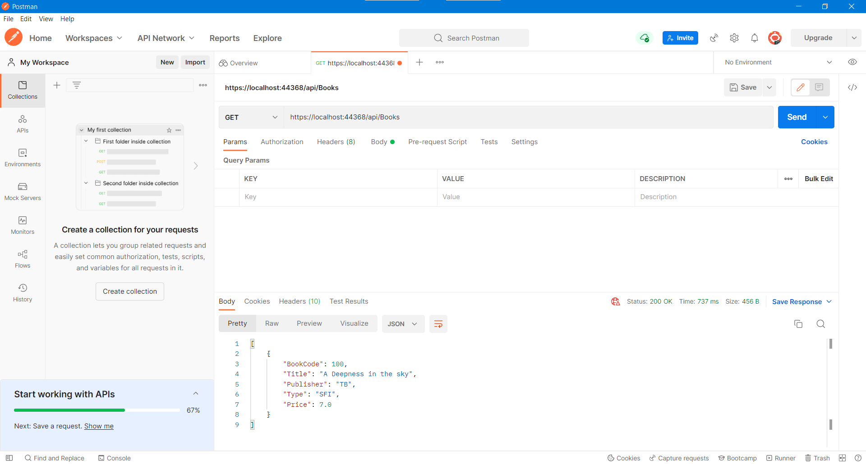

Post url:/api/Books

