1. Display Passenger details who travelled between 1st Dec,2012 to 15th Dec,2012.

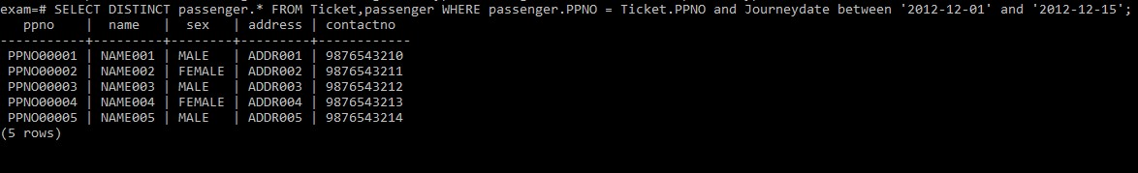

1. Find all the Flight id’s of Fly Safe Airways.

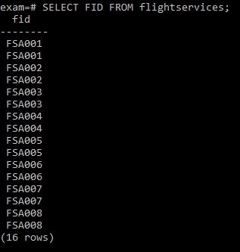

1. Display the Service Names available in Flight id FSA003.



1. Find the flights which offer Wheelchair services.

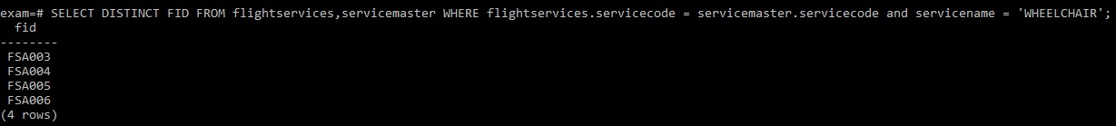

1. Find the availability of the seats of all the flights whose journey date is 15th Dec, 2012, Source city Name is Hyderabad and destination city name is Delhi.
2. Find the Economy that can be generated by flight FSA003 only on tickets service.

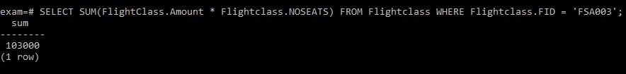

1. Find the Costliest service (Service Name) provided by flight FSA002.



1. Display the total number of seats reserved for the class Economy of all the flights on date 5th Dec,2012.



1. Select Flight names who can generate the highest economy on flight tickets(luggage, service, Meals excluded).
2. Display the flight id’s which provide all the services.