PROJECT DOCUMENTATION
Book a Doctor App
Full Stack Development with MERN

MongoDB · Express.js · React.js · Node.js
Prepared by:
Hema Sri Ala (Team Lead)
Dadi Harika
Venkata Bhavani
Sai Koti Adari
Yeswin Dasyam
July 2026

Table of Contents
Table of Contents 2
1. Introduction 4
1.1 Project Title 4
1.2 Team Members 4
1.3 Document Purpose 4
2. Project Overview 5
2.1 Purpose 5
2.2 Goals 5
2.3 Key Features 5
2.4 Target Users 6
3. Architecture 7
3.1 High-Level Architecture 7
3.2 Frontend Architecture (React) 7
3.3 Backend Architecture (Node.js + Express.js) 7
3.4 Database Design (MongoDB) 8
Entity Relationship Overview 8
3.5 Non-Functional Requirements 8
4. Setup Instructions 9
4.1 Prerequisites 9
4.2 Installation 9
Step 1: Clone the repository 9
Step 2: Install backend dependencies 9
Step 3: Install frontend dependencies 9
Step 4: Configure environment variables 9
Step 5: Seed the database (optional) 9
4.3 Troubleshooting Common Setup Issues 9
5. Folder Structure 11
5.1 Client (React Frontend) 11
5.2 Server (Node.js/Express Backend) 11
6. Running the Application 13
6.1 Start the Backend 13
6.2 Start the Frontend 13
6.3 Verifying the Setup 13
6.4 Deployment 13
7. API Documentation 14
7.1 Authentication Endpoints 14
7.2 Doctor Endpoints 14
7.3 Appointment Endpoints 14
7.4 Document Endpoints 15
7.5 Admin Endpoints 15
7.6 Example Request & Response 15
POST /api/appointments 15
7.7 Error Handling & Status Codes 15
8. Authentication 17
8.1 Overview 17
8.2 Authentication Flow 17
8.3 Authorization (Role-Based Access Control) 17
8.4 Security Measures 18
8.5 Token Refresh & Session Expiry 18
9. User Interface 19
9.1 Key Screens 19
9.2 Screenshot Placeholders 19
10. Testing 23
10.1 Testing Strategy 23
10.2 Tools Used 23
10.3 Sample Test Cases 23
10.4 Code Coverage & Continuous Integration 23
11. Screenshots or Demo 24
12. Known Issues 25
13. Future Enhancements 26
13.1 Roadmap Timeline 26
14. Appendix 27
14.1 Environment Variables Reference 27
14.2 Glossary of Terms 27
14.3 References 28

1. Introduction

1.1 Project Title
Book a Doctor App

1.2 Team Members
Name | Role
Hema Sri Ala | Team Lead
Dadi Harika | Member
Venkata Bhavani | Member
Sai Koti Adari | Member
Yeswin Dasyam | Member

1.3 Document Purpose
This document provides a complete technical and functional overview of the Book a Doctor App. It is intended for developers, reviewers, and evaluators who need to understand the system's architecture, setup process, API surface, and design decisions. It also serves as a maintenance and onboarding reference for future contributors to the project.

2. Project Overview

2.1 Purpose
The Book a Doctor App is a healthcare booking platform built to simplify how patients discover, schedule, and manage appointments with doctors. It removes the friction of phone-based or walk-in scheduling by giving patients an online, self-service way to search for doctors, check availability, and book appointments, while giving doctors and administrators the tools to manage schedules, patient records, and platform operations from a single system.
The platform connects three types of users — patients, doctors, and administrators — through a shared, role-based interface, and digitizes the appointment lifecycle from search to confirmation to follow-up.

2.2 Goals
- Reduce the time and effort patients spend finding and booking a suitable doctor.
- Give doctors a centralized way to manage their availability, appointments, and patient documents.
- Provide administrators with oversight tools to manage users, doctors, and platform content.
- Ensure patient data (identity documents, medical records) is uploaded and stored securely.
- Keep all parties informed through real-time notifications on booking status changes.

2.3 Key Features
- Doctor Browsing: Patients can search and filter doctors by specialization, location, availability, and ratings.
- Appointment Scheduling: Patients can view a doctor's open time slots and book, reschedule, or cancel appointments.
- Secure Document Upload: Patients can upload identity proofs and medical documents required for consultation, stored securely and linked to their profile.
- Role-Based Dashboards: Separate, tailored dashboards for patients, doctors, and administrators.
- Doctor Schedule Management: Doctors can set their working hours, block out unavailable slots, and view upcoming appointments.
- Admin Panel: Administrators can approve/reject doctor registrations, manage users, and monitor platform activity.
- Notifications: Email/in-app notifications for booking confirmation, reminders, cancellations, and schedule changes.
- Authentication & Authorization: Secure login and role-based access control across the three user types.
- Responsive UI: A mobile-friendly interface built with React so patients can book appointments from any device.

2.4 Target Users
User Role | Primary Needs
Patient | Find doctors, book/manage appointments, upload documents, receive reminders
Doctor | Manage availability, view patient appointments and documents, update profile
Admin | Approve doctors, manage users, monitor bookings, maintain platform integrity

3. Architecture
The application follows the MERN stack architecture — a three-tier design consisting of a React front end, an Express/Node.js back end exposing a REST API, and a MongoDB database. The layers communicate over HTTP using JSON, with JWT-based tokens used to authenticate requests after login.

3.1 High-Level Architecture
┌─────────────────────┐ HTTPS/JSON ┌──────────────────────┐
│ React Frontend │ <--------------------> │ Express REST API │
│ (Client - port 3000)│ Axios/Fetch │ (Server - port 5000) │
└─────────────────────┘ └──────────┬───────────┘
│ Mongoose ODM
▼
┌──────────────────────┐
│ MongoDB │
│ (Users, Doctors, │
│ Appointments, Docs) │
└──────────────────────┘

3.2 Frontend Architecture (React)
The client is a single-page application built with React.js. It uses functional components and hooks (useState, useEffect, useContext) for state management, React Router for client-side navigation, and Axios for communicating with the backend REST API.
- Component Structure: UI is broken into reusable components (forms, cards, modals, navigation) and page-level containers (Login, DoctorList, BookAppointment, Dashboard).
- State Management: Global state such as the logged-in user and auth token is handled with React Context; local component state is handled with useState.
- Routing: React Router DOM handles route protection, redirecting unauthenticated users to the login page and routing users to role-specific dashboards.
- Styling: CSS (with component-scoped stylesheets) is used for layout and responsive design.
- API Communication: Axios instances attach the JWT token to the Authorization header for protected requests.

3.3 Backend Architecture (Node.js + Express.js)
The server is built with Node.js and Express.js, structured using the MVC (Model-View-Controller) pattern to separate concerns between routing, business logic, and data access.
- Routes: Define API endpoints and map them to controller functions (e.g., /api/auth, /api/doctors, /api/appointments).
- Controllers: Contain the business logic for each route — validating input, interacting with models, and shaping responses.
- Models: Mongoose schemas defining the shape of documents stored in MongoDB (User, Doctor, Appointment, Document, Notification).
- Middleware: Handles authentication (JWT verification), role-based authorization, request validation, error handling, and file upload processing (Multer).
- Config: Environment-based configuration for database connection strings, JWT secrets, and third-party service keys.

3.4 Database Design (MongoDB)
MongoDB stores data as flexible, JSON-like documents. The schema below reflects the primary collections and their relationships.
Collection | Key Fields | Relationships
Users | name, email, password (hashed), role, phone | Referenced by Appointments, Documents
Doctors | userId, specialization, qualifications, availability, fee, rating | 1:1 with Users; referenced by Appointments
Appointments | patientId, doctorId, date, timeSlot, status, notes | References Users and Doctors
Documents | patientId, fileUrl, fileType, uploadedAt, verified | References Users
Notifications | userId, message, type, read, createdAt | References Users

Entity Relationship Overview
User (role: patient/doctor/admin)
└──1:1──> Doctor Profile (if role = doctor)
└──1:N──> Appointments <──N:1── Doctor Profile
└──1:N──> Documents
└──1:N──> Notifications

3.5 Non-Functional Requirements
- Performance: API responses for standard read operations (doctor search, appointment listing) return within roughly 300ms under normal load; frequently filtered fields (specialization, location, doctorId, patientId) are indexed in MongoDB.
- Scalability: The stateless REST API and JWT-based authentication allow the Node.js server to scale horizontally behind a load balancer; MongoDB can scale further via replica sets or sharding as appointment volume grows.
- Security: All production traffic is served over HTTPS; passwords are hashed with bcrypt; every endpoint validates and sanitizes input to guard against injection and malformed payloads.
- Availability: A lightweight /api/health endpoint reports service status for uptime monitoring, with a target of 99.5% availability outside planned maintenance windows.
- Maintainability: Clear MVC separation, consistent naming conventions, and documented environment configuration keep the codebase approachable for new contributors.
- Usability: Role-based dashboards surface only the actions relevant to each user type, reducing cognitive load for patients, doctors, and admins alike.

4. Setup Instructions

4.1 Prerequisites
- Node.js (v18.x or later)
- npm (v9.x or later) or yarn
- MongoDB (local installation or a MongoDB Atlas cluster)
- Git
- A code editor such as VS Code

4.2 Installation
Follow the steps below to set up the project locally.

Step 1: Clone the repository
git clone https://github.com/<your-org>/book-a-doctor-app.git
cd book-a-doctor-app

Step 2: Install backend dependencies
cd server
npm install

Step 3: Install frontend dependencies
cd ../client
npm install

Step 4: Configure environment variables
Create a .env file inside the server directory with the following variables:
PORT=5000
MONGO_URI=mongodb://localhost:27017/bookadoctor
JWT_SECRET=your_jwt_secret_key
JWT_EXPIRES_IN=7d
CLOUDINARY_URL=your_file_storage_url # if using cloud storage for documents
EMAIL_USER=your_email_service_username
EMAIL_PASS=your_email_service_password
Create a .env file inside the client directory with:
REACT_APP_API_BASE_URL=http://localhost:5000/api

Step 5: Seed the database (optional)
cd server
npm run seed
This populates the database with sample doctors, specializations, and demo accounts for testing.

4.3 Troubleshooting Common Setup Issues
The table below lists issues commonly encountered while setting up the project locally, along with their likely cause and fix.
Issue | Likely Cause | Suggested Fix
MongoNetworkError: failed to connect to server | MongoDB service is not running, or MONGO_URI is incorrect | Start local MongoDB (mongod) or verify the connection string / Atlas IP whitelist
Port 5000 already in use | Another process is bound to the configured port | Change PORT in server/.env, or stop the conflicting process
CORS error in the browser console | Client and server origins do not match | Confirm REACT_APP_API_BASE_URL matches the backend URL and that CORS middleware allows the client origin
401 Unauthorized on every request | Missing or expired JWT token | Log in again to refresh the token; check JWT_EXPIRES_IN
File upload fails silently | Missing uploads directory or Multer misconfiguration | Ensure the uploads folder exists and matches the destination set in uploadMiddleware.js
npm install fails with peer dependency errors | Node.js version mismatch | Use Node.js v18.x or later as listed in Prerequisites

5. Folder Structure

5.1 Client (React Frontend)
client/
├── public/
│ └── index.html
├── src/
│ ├── assets/ # Images, icons, static files
│ ├── components/ # Reusable UI components (Navbar, DoctorCard, Modal...)
│ ├── context/ # AuthContext, NotificationContext
│ ├── pages/ # Route-level pages
│ │ ├── Login.jsx
│ │ ├── Register.jsx
│ │ ├── DoctorList.jsx
│ │ ├── DoctorProfile.jsx
│ │ ├── BookAppointment.jsx
│ │ ├── PatientDashboard.jsx
│ │ ├── DoctorDashboard.jsx
│ │ └── AdminDashboard.jsx
│ ├── services/ # Axios API call modules (authService, doctorService...)
│ ├── routes/ # ProtectedRoute, RoleBasedRoute
│ ├── App.jsx
│ └── index.js
└── package.json

5.2 Server (Node.js/Express Backend)
server/
├── config/
│ └── db.js # MongoDB connection setup
├── controllers/
│ ├── authController.js
│ ├── doctorController.js
│ ├── appointmentController.js
│ ├── documentController.js
│ └── adminController.js
├── middleware/
│ ├── authMiddleware.js # JWT verification
│ ├── roleMiddleware.js # Role-based access control
│ ├── uploadMiddleware.js # Multer config for file uploads
│ └── errorHandler.js
├── models/
│ ├── User.js
│ ├── Doctor.js
│ ├── Appointment.js
│ ├── Document.js
│ └── Notification.js
├── routes/
│ ├── authRoutes.js
│ ├── doctorRoutes.js
│ ├── appointmentRoutes.js
│ ├── documentRoutes.js
│ └── adminRoutes.js
├── utils/
│ ├── generateToken.js
│ └── sendEmail.js
├── server.js
└── package.json

6. Running the Application
Once dependencies are installed and environment variables are configured, start the backend and frontend servers in two separate terminals.

6.1 Start the Backend
cd server
npm start
# Server runs on http://localhost:5000

6.2 Start the Frontend
cd client
npm start
# App runs on http://localhost:3000

6.3 Verifying the Setup
- Open http://localhost:3000 in the browser — the landing page should load.
- Register a new patient account and confirm you're redirected to the patient dashboard.
- Confirm API requests in the browser Network tab return 200 responses from http://localhost:5000/api.

6.4 Deployment
While the steps above cover local development, the application can be deployed to free or low-cost hosting for demos and evaluation.
- Backend: Push the server/ directory to a Node-friendly host (e.g., Render or Railway). Set PORT, MONGO_URI, JWT_SECRET, JWT_EXPIRES_IN, CLOUDINARY_URL, EMAIL_USER, and EMAIL_PASS as environment variables in the hosting dashboard rather than committing a .env file.
- Frontend: Run npm run build in client/ and deploy the resulting static build to Vercel or Netlify. Set REACT_APP_API_BASE_URL to the deployed backend's public URL before building.
- Database: Use a MongoDB Atlas cluster instead of a local instance so both the deployed backend and local development can share (or separately point to) a managed database; whitelist the hosting provider's outbound IPs or allow access from anywhere for demo purposes only.
- Continuous Deployment: On every push to the main branch, run npm test for both client and server before deploying, so regressions are caught prior to release. Render/Vercel/Netlify can each trigger a redeploy automatically on a successful push.

7. API Documentation
All endpoints are prefixed with /api. Protected endpoints require a valid JWT sent in the Authorization header as Bearer <token>.

7.1 Authentication Endpoints
Method & Endpoint | Description | Access
POST /api/auth/register | Register a new patient or doctor account | Public
POST /api/auth/login | Authenticate user and return a JWT | Public
GET /api/auth/me | Get the currently logged-in user's profile | Authenticated
POST /api/auth/logout | Invalidate the current session/token | Authenticated

7.2 Doctor Endpoints
Method & Endpoint | Description | Access
GET /api/doctors | List all doctors (supports filters: specialization, location) | Public
GET /api/doctors/:id | Get details of a specific doctor | Public
PUT /api/doctors/:id | Update doctor profile and availability | Doctor (self)
POST /api/doctors/:id/availability | Set or update weekly availability slots | Doctor (self)

7.3 Appointment Endpoints
Method & Endpoint | Description | Access
POST /api/appointments | Book a new appointment | Patient
GET /api/appointments/me | List appointments for the logged-in user | Patient / Doctor
PUT /api/appointments/:id | Reschedule an appointment | Patient / Doctor
DELETE /api/appointments/:id | Cancel an appointment | Patient / Doctor
GET /api/appointments/:id | Get details of a specific appointment | Patient / Doctor / Admin

7.4 Document Endpoints
Method & Endpoint | Description | Access
POST /api/documents/upload | Upload a patient document (ID proof, reports) | Patient
GET /api/documents/:userId | Retrieve documents for a given patient | Patient / Doctor / Admin
DELETE /api/documents/:id | Delete an uploaded document | Patient (owner)

7.5 Admin Endpoints
Method & Endpoint | Description | Access
GET /api/admin/users | List all registered users | Admin
PUT /api/admin/doctors/:id/approve | Approve a pending doctor registration | Admin
DELETE /api/admin/users/:id | Deactivate or remove a user account | Admin
GET /api/admin/appointments | View all appointments across the platform | Admin

7.6 Example Request & Response

POST /api/appointments
Request body:
{
"doctorId": "64f1a2b3c4d5e6f7a8b9c0d1",
"date": "2026-07-15",
"timeSlot": "10:30 AM",
"reason": "General consultation"
}
Example response (201 Created):
{
"success": true,
"appointment": {
"_id": "64f1a9b3c4d5e6f7a8b9c0e2",
"patientId": "64f1a2b3c4d5e6f7a8b9c0aa",
"doctorId": "64f1a2b3c4d5e6f7a8b9c0d1",
"date": "2026-07-15",
"timeSlot": "10:30 AM",
"status": "confirmed"
}
}

7.7 Error Handling & Status Codes
All error responses share a consistent JSON shape so the frontend can handle them generically:
{
"success": false,
"message": "Human-readable error description",
"errorCode": "SLOT_ALREADY_BOOKED"
}
Common HTTP status codes returned by the API:
Status Code | Meaning
200 OK | Request succeeded (GET/PUT)
201 Created | A new resource (user, appointment, document) was created
400 Bad Request | Validation failed or required fields are missing
401 Unauthorized | Missing, invalid, or expired JWT
403 Forbidden | Authenticated, but the user's role does not permit this action
404 Not Found | The requested resource does not exist
409 Conflict | The requested time slot is already booked
500 Internal Server Error | An unexpected error occurred on the server

8. Authentication

8.1 Overview
The application uses JSON Web Tokens (JWT) for stateless authentication. When a user logs in with valid credentials, the server issues a signed JWT containing the user's ID and role. This token is stored on the client (in memory or local storage) and attached to the Authorization header of subsequent requests.

8.2 Authentication Flow
- 1. User submits email and password to POST /api/auth/login.
- 2. Server verifies the password against the bcrypt-hashed password stored in the database.
- 3. On success, the server signs a JWT with the user's ID and role, and returns it to the client.
- 4. The client stores the token and includes it as Bearer <token> in the Authorization header for all protected requests.
- 5. The authMiddleware verifies the token's signature and expiry on every protected route, attaching the decoded user to the request object.

8.3 Authorization (Role-Based Access Control)
Beyond authentication, a roleMiddleware restricts access to specific endpoints based on the user's role (patient, doctor, admin). For example, only users with the doctor role can update their own availability, and only admin users can approve doctor registrations.
Figure 8.1 — Role-Based Login Screens
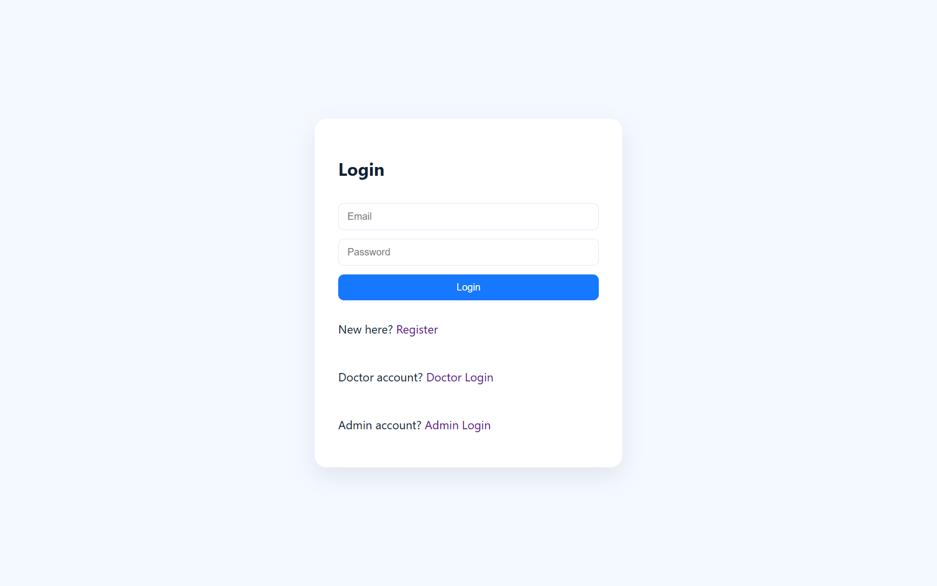
Patient Login
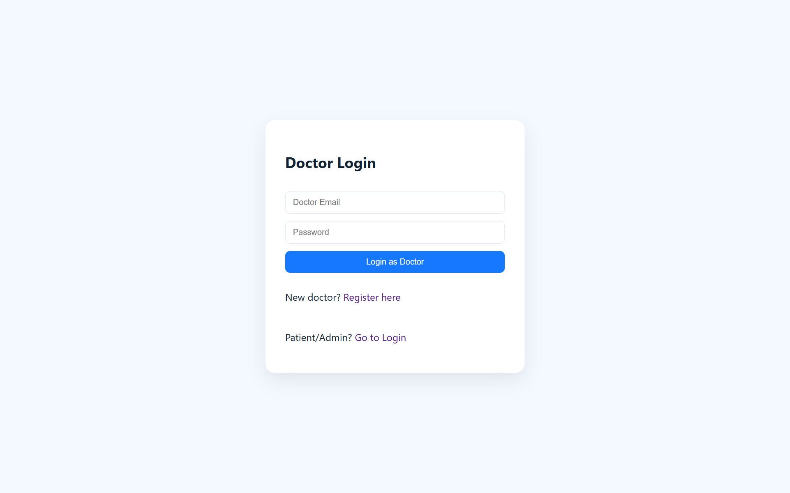
Doctor Login
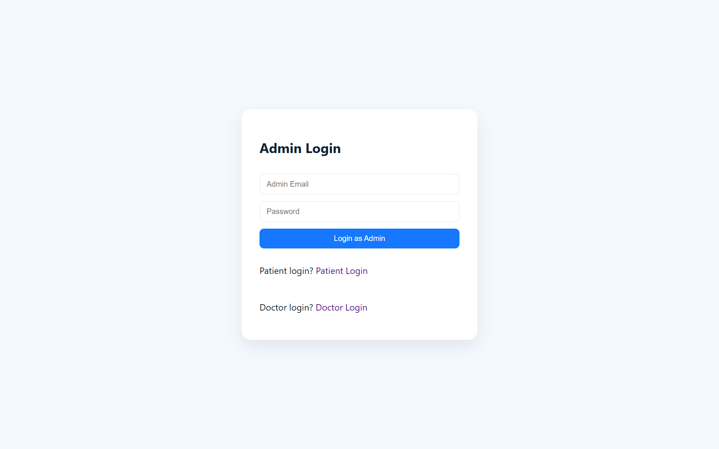
Admin Login

Role | Permissions
Patient | Browse doctors, book/manage own appointments, upload own documents
Doctor | Manage own profile/availability, view own appointments and linked patient documents
Admin | Manage all users, approve doctors, view all appointments and platform data

8.4 Security Measures
- Passwords are hashed using bcrypt before being stored.
- JWTs are signed with a secret key and have a configurable expiry (e.g., 7 days).
- Sensitive routes are protected by middleware chains (authMiddleware → roleMiddleware).
- Uploaded documents are validated for file type and size before storage.
- Environment variables (JWT secret, DB URI) are kept out of version control via .env files.

8.5 Token Refresh & Session Expiry
JWTs are short-lived by design (JWT_EXPIRES_IN, default 7 days) so a compromised token has a limited window of use. When a token expires, protected requests receive a 401 Unauthorized response instead of silently failing.
- Client behavior: On receiving a 401, the client clears the stored token and redirects the user to the appropriate login page (patient, doctor, or admin) based on their last known role.
- Re-authentication: The user simply logs in again to receive a fresh token; no separate refresh-token endpoint is used in the current version, keeping the authentication flow simple for this project's scope.
- Planned improvement: Adding a rotating refresh-token pair (short-lived access token plus a longer-lived refresh token) is listed under Future Enhancements as a way to avoid repeated logins without lengthening the access token's exposure window.

9. User Interface
The UI is designed to be clean, minimal, and role-aware — patients, doctors, and admins each see a dashboard tailored to their needs. Below are the key screens in the application. Replace the placeholders with actual screenshots or GIFs of your running application.

9.1 Key Screens
- Landing / Login Page: Entry point for patients and doctors to sign in or register.
- Doctor Listing Page: Grid/list view of doctors with search and filter options (specialization, availability, rating).
- Doctor Profile Page: Detailed doctor information with an appointment booking calendar.
- Booking Confirmation: Summary screen shown after a successful appointment booking.
- Patient Dashboard: Upcoming/past appointments, document uploads, and notifications.
- Doctor Dashboard: Appointment calendar, availability management, and patient document access.
- Admin Dashboard: User management, doctor approval queue, and platform-wide appointment overview.

9.2 Screenshot Placeholders
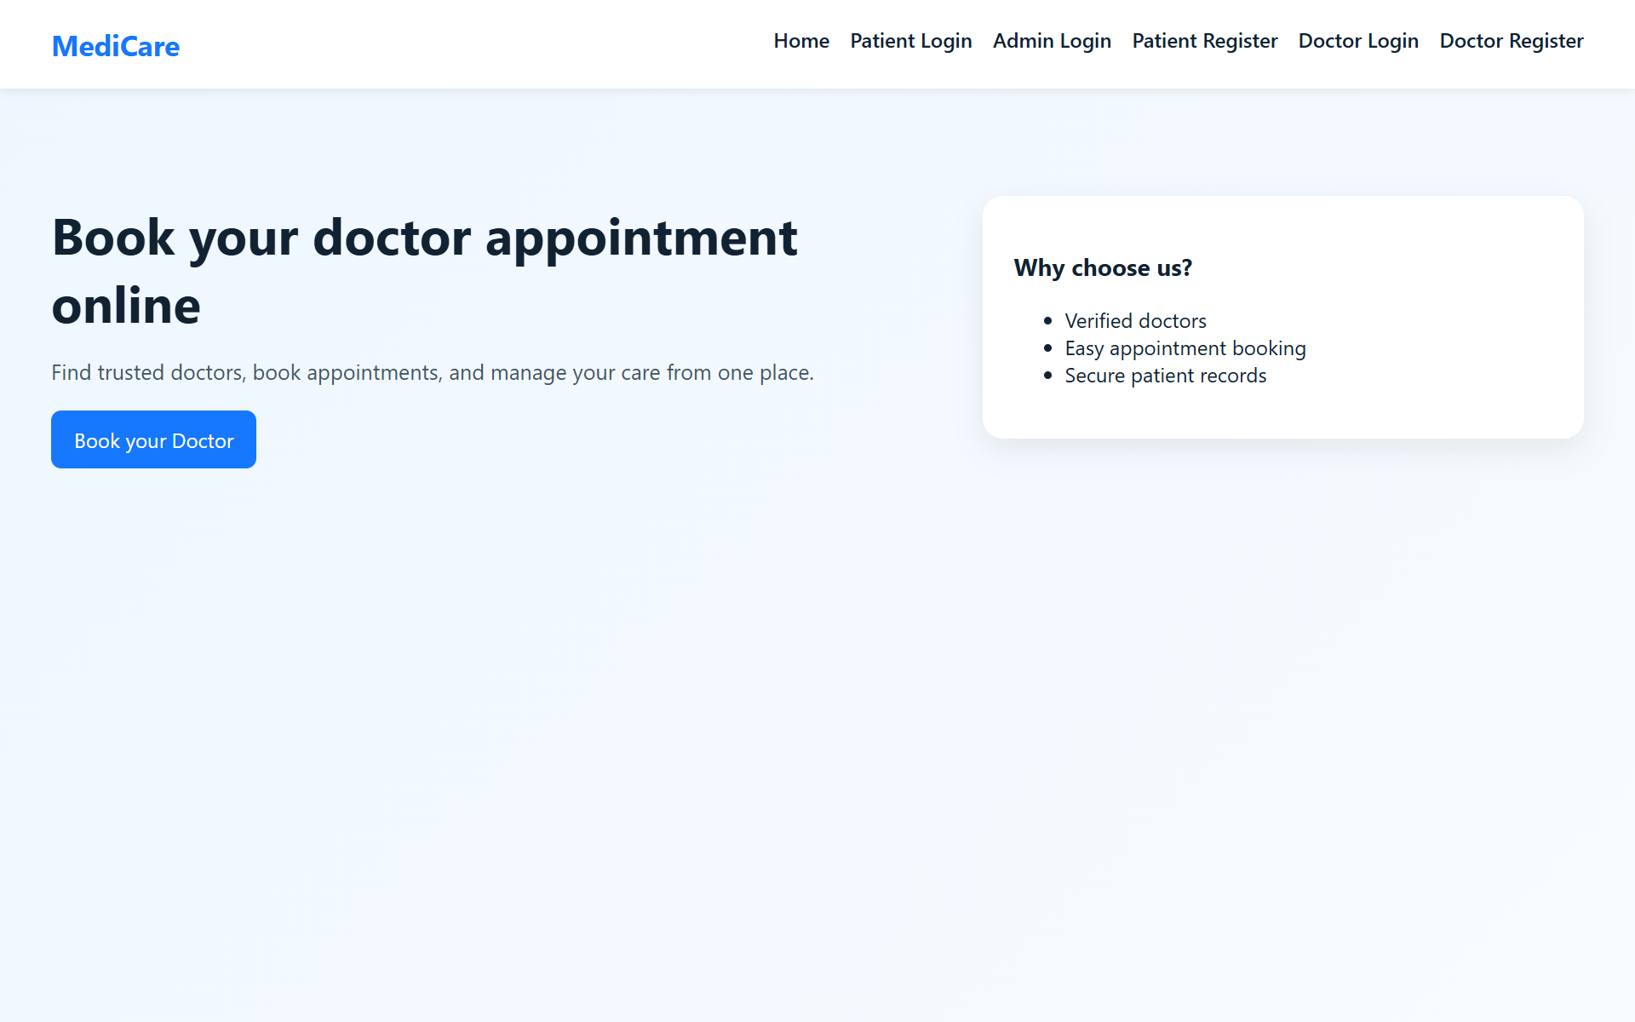
Figure 9.1 — Landing Page: entry point for patients, doctors, and admins to log in or register.
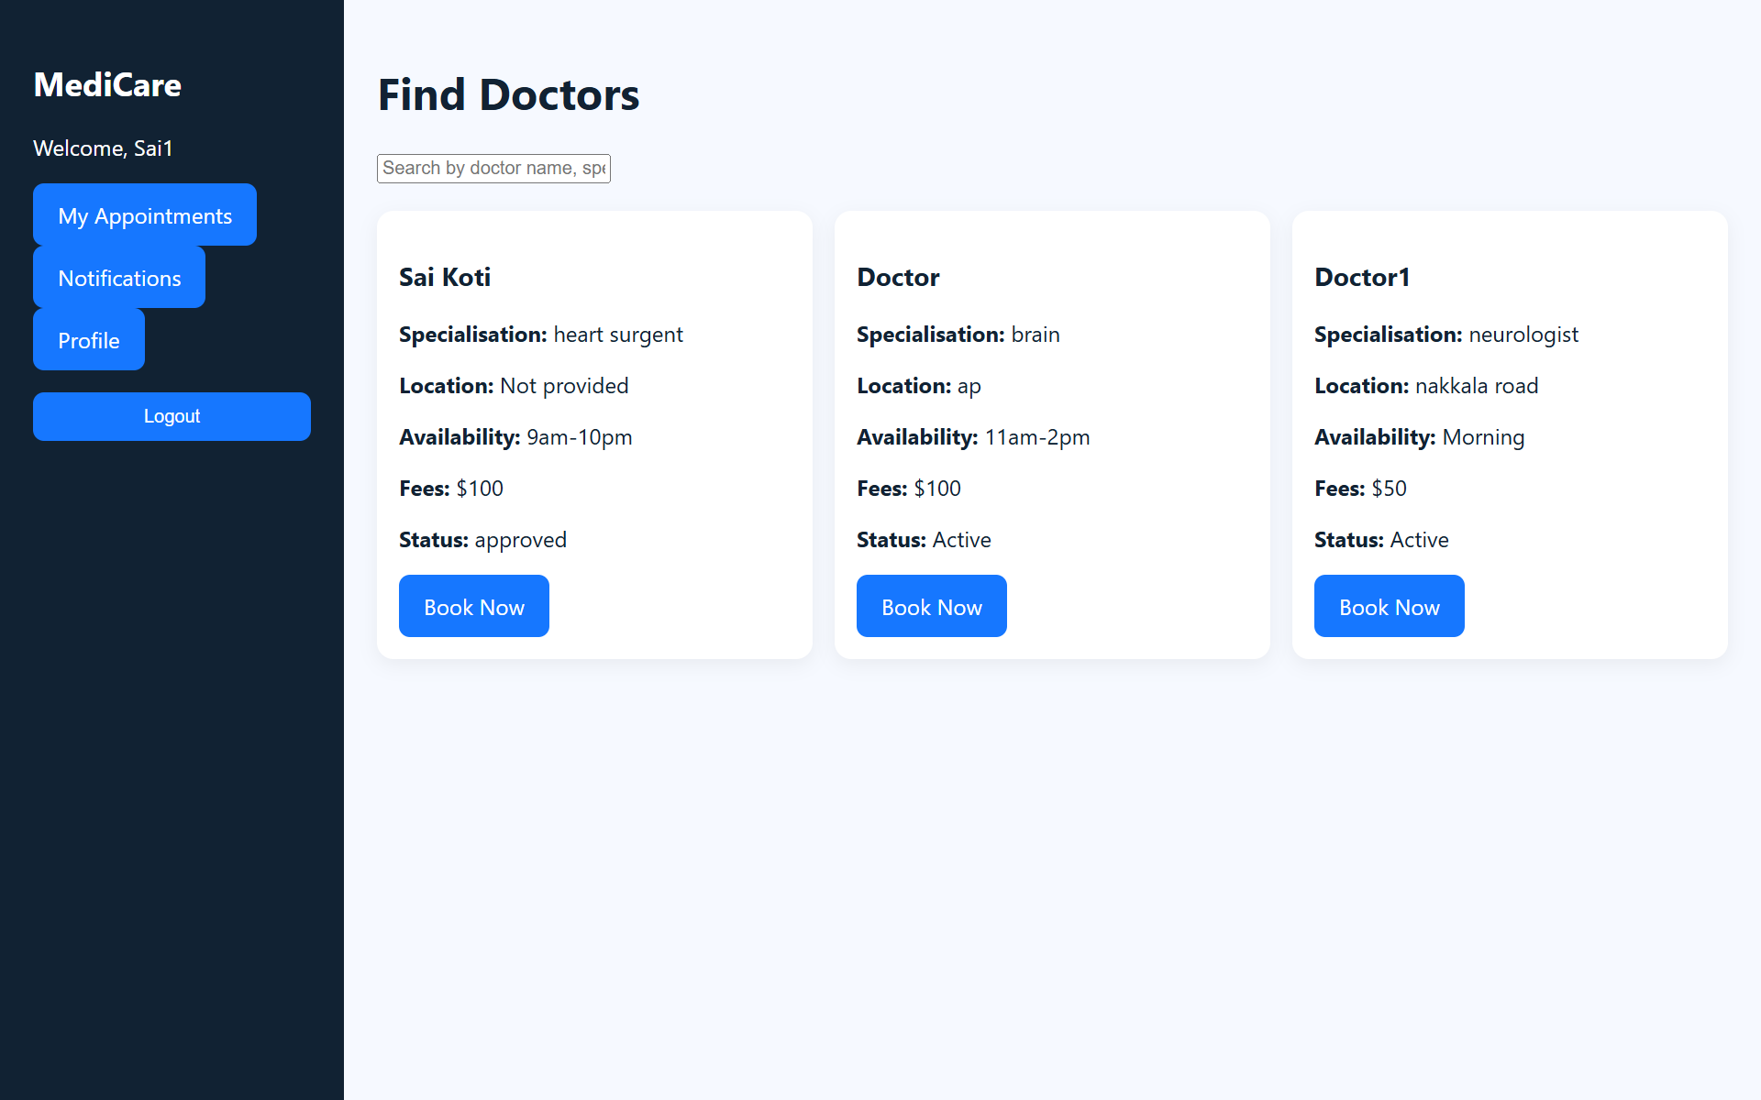
Figure 9.2 — Doctor Listing Page: patients can search and view doctors with specialization, location, availability, fees, and status.
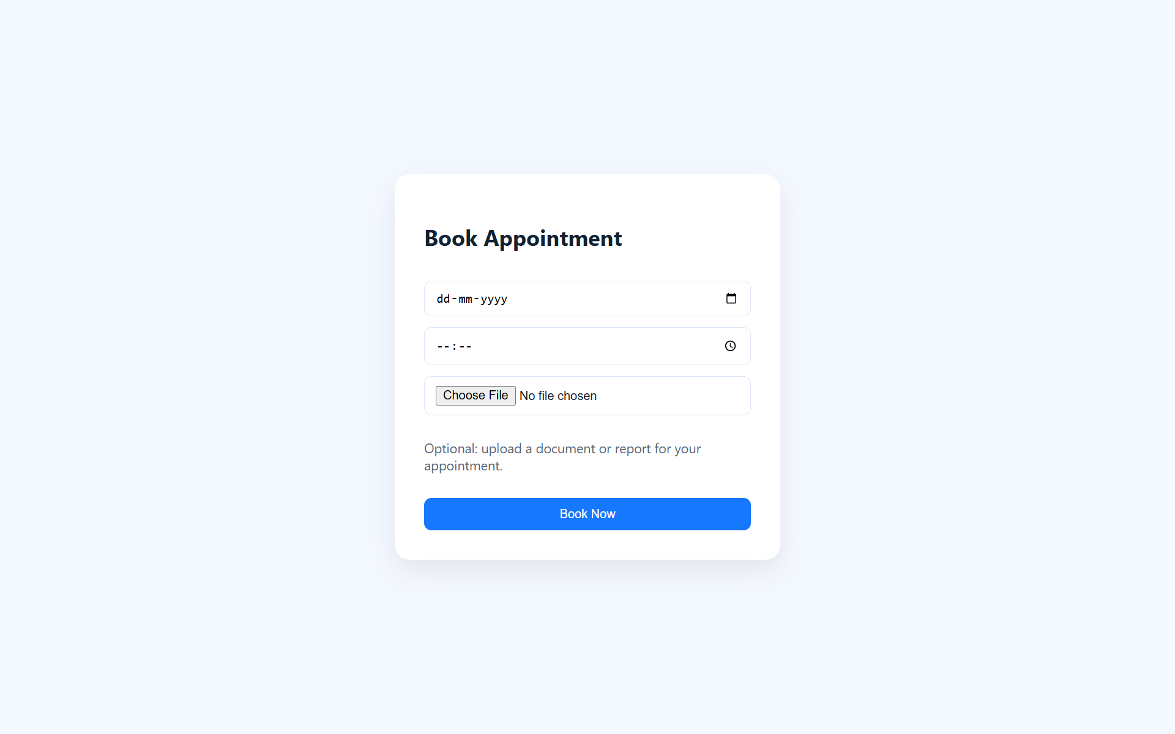
Figure 9.3 — Book Appointment Page: patients select date/time and optionally upload a supporting document.
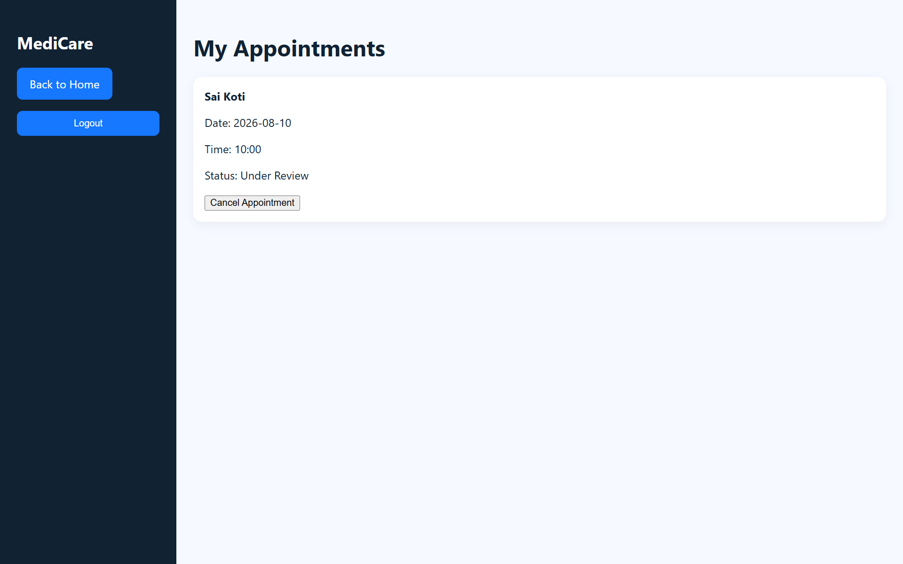
Figure 9.4 — Patient Dashboard (My Appointments): view booked appointments and their current status.
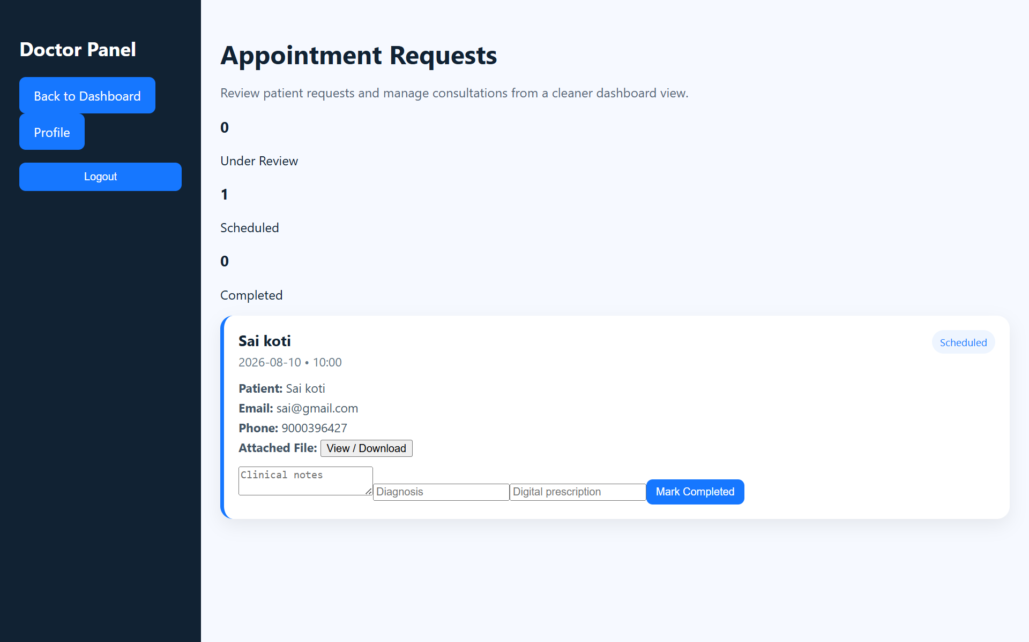
Figure 9.5 — Doctor Dashboard (Appointment Requests): doctors review requests, add clinical notes/diagnosis, and mark consultations complete.
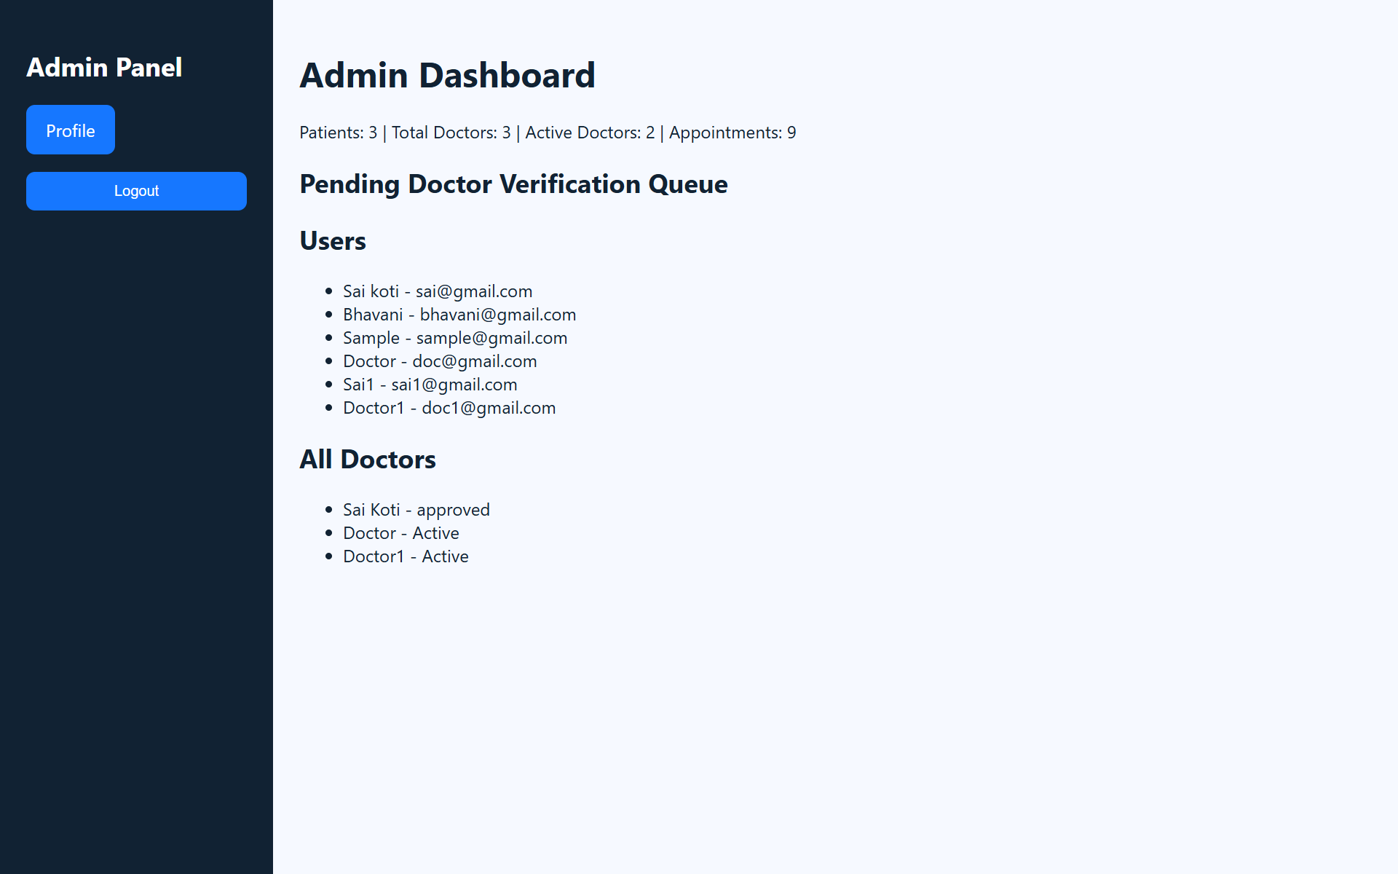
Figure 9.6 — Admin Dashboard: platform-wide overview of patients, doctors, and appointments, plus doctor verification queue.

10. Testing

10.1 Testing Strategy
Testing is carried out at multiple levels to ensure reliability across the frontend, backend, and API layers:
- Unit Testing: Individual functions and components (e.g., form validation, utility functions) are tested in isolation.
- Integration Testing: API endpoints are tested end-to-end, verifying that controllers, models, and middleware work together correctly.
- Manual/UI Testing: Core user flows (registration, booking, cancellation, document upload) are manually tested across browsers and screen sizes.

10.2 Tools Used
Tool | Purpose
Postman | Manual and automated testing of REST API endpoints
Jest | Unit testing for backend controller and utility functions
React Testing Library | Component-level testing for React UI
MongoDB Compass | Verifying data persistence and schema correctness during testing

10.3 Sample Test Cases
Test Case | Expected Result
Register with an already-used email | API returns 400 with a duplicate-email error
Login with incorrect password | API returns 401 Unauthorized
Book an appointment in an already-taken slot | API rejects the booking with a conflict error
Upload a document exceeding the size limit | Upload is rejected with a file-size validation error
Access an admin route as a patient | API returns 403 Forbidden

10.4 Code Coverage & Continuous Integration
Jest is configured to report coverage alongside test results:
npm test -- --coverage
Current coverage focuses on controllers and utility functions; the project targets at least 70% statement coverage on the backend before a feature is considered done. React component tests using React Testing Library cover the core flows: login, doctor search, and booking.
- CI Pipeline: A GitHub Actions workflow (or equivalent CI) runs npm install and npm test for both client and server on every pull request, blocking merges on test failures.
- Regression Testing: Postman collections used for manual API testing are exported alongside the repository so reviewers can re-run the same requests without re-creating them.

11. Screenshots or Demo
A live demo link and additional screenshots can be added here to showcase the application in action.
- Demo Video Link: [Insert demo URL, e.g., hosted on Render/Vercel/Netlify]
- GitHub Repository: [Insert repository URL]
Additional application screenshots are provided in Section 9.2 (User Interface).

12. Known Issues
The following issues are known limitations of the current version and are tracked for future resolution:
- Time slot conflicts may occur under high concurrent booking load if two patients attempt to book the same slot simultaneously (needs stronger transaction locking).
- Email notifications may be delayed depending on the third-party email service's rate limits.
- Document preview is not yet supported for all file formats (currently limited to PDF and common image types).
- No automatic time-zone handling; all appointment times are currently assumed to be in a single local time zone.
- Admin dashboard pagination performance has not been optimized for very large user datasets.
[Add or update this list based on issues found during your own testing.]

13. Future Enhancements
- Integrate real-time video consultation for remote appointments.
- Add SMS notifications alongside email/in-app notifications.
- Support online payment for appointment fees (Stripe/Razorpay integration).
- Add a doctor and platform rating/review system.
- Implement AI-based doctor recommendations based on symptoms or history.
- Add multi-language support for a wider patient base.
- Introduce a mobile app version using React Native.
- Enhance the admin analytics dashboard with booking trends and revenue reports.

13.1 Roadmap Timeline
The enhancements above are grouped into an indicative delivery timeline:
Phase | Timeframe | Planned Additions
Short-term | Next 1–2 releases | SMS notifications, doctor/platform ratings, refresh-token authentication
Mid-term | 3–6 months | Online payment integration (Stripe/Razorpay), AI-based doctor recommendations, multi-language support
Long-term | 6+ months | Real-time video consultations, React Native mobile app, advanced admin analytics dashboard

14. Appendix

14.1 Environment Variables Reference
A consolidated reference of every environment variable used across the server and client, expanding on Section 4.2.
Variable | Location | Description
PORT | server/.env | Port the Express server listens on (default 5000)
MONGO_URI | server/.env | MongoDB connection string (local or Atlas)
JWT_SECRET | server/.env | Secret key used to sign and verify JWTs
JWT_EXPIRES_IN | server/.env | Token lifetime, e.g. 7d
CLOUDINARY_URL | server/.env | Credentials for cloud file storage, if used for documents
EMAIL_USER / EMAIL_PASS | server/.env | Credentials for the transactional email service used for notifications
REACT_APP_API_BASE_URL | client/.env | Base URL the React app uses to reach the backend API

14.2 Glossary of Terms
Term | Definition
JWT | JSON Web Token — a signed, self-contained token used to authenticate requests without server-side sessions
MVC | Model-View-Controller — an architectural pattern separating data (models), business logic (controllers), and presentation
RBAC | Role-Based Access Control — restricting actions based on a user's assigned role (patient, doctor, admin)
Mongoose | An Object Data Modeling (ODM) library for MongoDB and Node.js used to define schemas and interact with the database
Multer | A Node.js middleware used to handle multipart/form-data, primarily for file uploads
bcrypt | A password-hashing function used to store passwords securely instead of in plain text
CORS | Cross-Origin Resource Sharing — a browser security mechanism controlling which origins may call the API
ODM | Object Data Modeling — mapping application objects to documents in a NoSQL database such as MongoDB

14.3 References
- React documentation — https://react.dev
- Express.js documentation — https://expressjs.com
- MongoDB & Mongoose documentation — https://www.mongodb.com/docs/ and https://mongoosejs.com
- JWT introduction — https://jwt.io/introduction
- Postman learning center — https://learning.postman.com

