- Brainstorming & Ideation Phase
1.1 Brainstorm & Idea Prioritization Template
Date | 31 January 2025
Team ID
Project Name | Book a Doctor App
Maximum Marks | 4 Marks

Step-1: Team Gathering, Collaboration and Select the Problem Statement
During the brainstorming session, all five team members discussed several real-world healthcare problems faced by patients, doctors, and hospitals. The team analyzed each problem based on its impact, feasibility, innovation, and implementation using the MERN stack.
Problems Identified
S.No | Problem Identified
1 | Difficulty in booking doctor appointments manually
2 | Long waiting time in hospitals
3 | Lack of centralized medical appointment management
4 | Difficulty in finding specialist doctors nearby
5 | Inefficient appointment scheduling and cancellation process
6 | Poor communication between doctors and patients
7 | Paper-based patient record management

Step-2: Brainstorm, Idea Listing and Grouping
Idea | Description | Category
Online Appointment Booking | Patients can book appointments anytime | Healthcare
Doctor Management | Doctors manage availability and appointments | Healthcare
Patient Dashboard | Patients view appointments and profile | User Management
Admin Dashboard | Admin manages doctors, patients, and appointments | Administration
Secure Login | JWT Authentication with role-based access | Security
Notifications | Appointment confirmation and reminders | Communication
Medical Record Upload | Patients upload reports securely | Healthcare
Appointment History | View previous appointments | User Experience

Step-3: Idea Prioritization
Idea | Impact | Feasibility | Priority
Online Appointment Booking | High | High | ⭐⭐⭐⭐⭐
Doctor Management | High | High | ⭐⭐⭐⭐⭐
Patient Dashboard | High | High | ⭐⭐⭐⭐
Admin Dashboard | High | High | ⭐⭐⭐⭐
Secure Authentication | High | High | ⭐⭐⭐⭐⭐
Notifications | Medium | High | ⭐⭐⭐
Medical Record Upload | Medium | Medium | ⭐⭐⭐
Online Payments (Future Scope) | High | Medium | ⭐⭐

1.2 Define the Problem Statements
Date | 31 January 2025
Team ID
Project Name | Book a Doctor App
Maximum Marks | 2 Marks

Customer Problem Statements
Problem Statement | I am (Customer) | I'm trying to | But | Because | Which makes me feel
PS-1 | Patient | Book a doctor's appointment quickly | I cannot easily find available doctors | The current manual booking system is slow | Frustrated and stressed
PS-2 | Patient | View my appointment history | Records are scattered | Hospitals maintain paper records | Confused
PS-3 | Doctor | Manage appointments efficiently | Appointments overlap | There is no centralized scheduling system | Overloaded
PS-4 | Hospital Administrator | Manage doctors and patients | Manual processes consume more time | Existing systems are outdated | Inefficient
PS-5 | Patient | Upload medical reports securely | Reports are carried physically | No digital storage system | Inconvenienced

Final Problem Statement
Patients and doctors face significant challenges in managing appointments efficiently due to manual scheduling systems, lack of centralized healthcare management, and inefficient communication. These issues lead to increased waiting times, scheduling conflicts, poor record management, and reduced patient satisfaction. Therefore, there is a need for a secure web-based healthcare appointment system that enables patients to book appointments online, doctors to manage schedules efficiently, and administrators to oversee the entire process seamlessly.

1.3 Empathize & Discover
Date | 31 January 2025
Team ID
Project Name | Book a Doctor App
Maximum Marks | 4 Marks

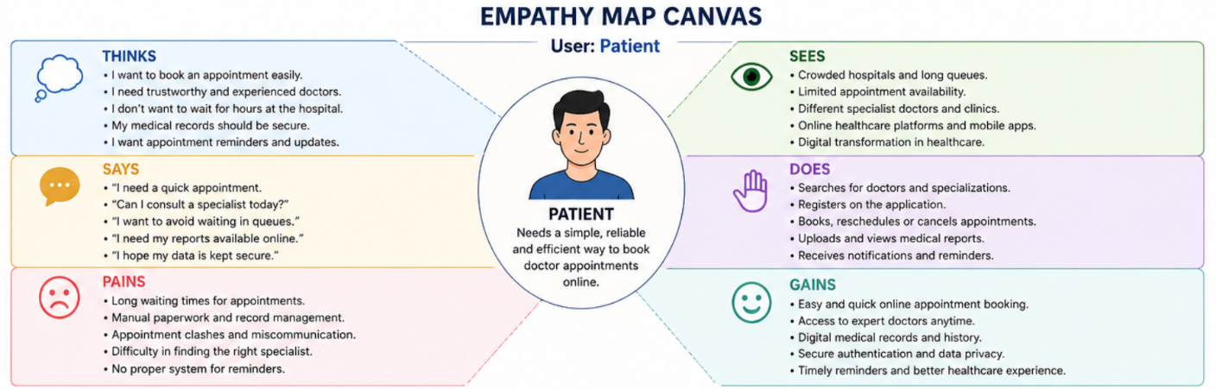

- Requirement Analysis
2.1 Data Flow Diagram & User Stories
Date | 31 January 2025
Team ID
Project Name | Book a Doctor App
Maximum Marks | 4 Marks

A Data Flow Diagram (DFD) is a traditional visual representation of the information flows within a system. A neat and clear DFD can depict the right amount of the system requirement graphically. It shows how data enters and leaves the system, what changes the information, and where data is stored.
Data Flow Diagram (Level-0)
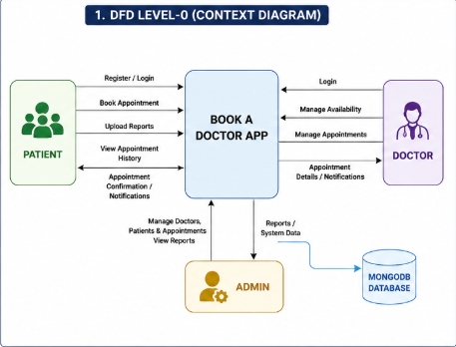
The Level-0 Data Flow Diagram (Context Diagram) provides a high-level overview of the Book a Doctor App. It illustrates the interaction between the primary external entities—Patient, Doctor, and Admin—and the application. Patients can register, log in, book appointments, upload medical reports, and view appointment history. Doctors manage their availability, view appointments, and update appointment statuses. The Admin oversees user management, doctor approvals, appointments, and system reports. All application data is securely stored and retrieved from the MongoDB database, ensuring efficient data management and seamless communication between users and the system.
Data Flow Diagram (Level-1)
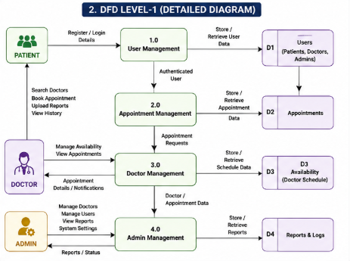
The Level-1 Data Flow Diagram provides a detailed representation of the internal processes of the Book a Doctor App. It decomposes the main system into functional modules such as User Management, Appointment Management, Doctor Management, and Admin Management. User information is processed through the User Management module, while appointment requests are handled by the Appointment Management module. Doctors manage their schedules and appointment details through the Doctor Management module, whereas administrators supervise users, doctors, and reports using the Admin Management module. Each module interacts with the corresponding database collections to store and retrieve information efficiently.
User Stories
User Type | Functional Requirement (Epic) | User Story No. | User Story / Task | Acceptance Criteria | Priority | Release
Patient | Registration | USN-1 | As a patient, I can register by providing my personal details to access the application. | Account created successfully. | High | Sprint-1
Patient | Login | USN-2 | As a patient, I can log in securely using my email and password. | Login successful. | High | Sprint-1
Patient | Book Appointment | USN-3 | As a patient, I can search doctors and book appointments. | Appointment confirmed. | High | Sprint-1
Patient | Appointment History | USN-4 | As a patient, I can view all my previous and upcoming appointments. | Appointment history displayed. | Medium | Sprint-2
Patient | Upload Medical Reports | USN-5 | As a patient, I can upload my medical documents securely. | Reports uploaded successfully. | Medium | Sprint-2
Doctor | Appointment Management | USN-6 | As a doctor, I can approve or reject appointments. | Appointment status updated. | High | Sprint-1
Doctor | Availability | USN-7 | As a doctor, I can update my availability schedule. | Schedule updated successfully. | High | Sprint-2
Admin | Doctor Management | USN-8 | As an admin, I can approve doctor registrations. | Doctor approved successfully. | High | Sprint-1
Admin | User Management | USN-9 | As an admin, I can manage users and appointments. | User details updated. | High | Sprint-2

2.2 Solution Requirements
Date | 31 January 2025
Team ID
Project Name | Book a Doctor App
Maximum Marks | 4 Marks

Functional Requirements
FR No. | Functional Requirement (Epic) | Sub Requirement (Story / Sub-Task)
FR-1 | User Registration | Patient Registration
 |  | Doctor Registration
 |  | Admin Login
FR-2 | User Authentication | Secure Login using JWT
 |  | Password Encryption
FR-3 | Doctor Management | Add Doctor
 |  | Approve Doctor
 |  | Update Doctor Details
FR-4 | Patient Management | Register Patient
 |  | Update Patient Profile
FR-5 | Appointment Management | Book Appointment
 |  | Cancel Appointment
 |  | View Appointment History
FR-6 | Medical Report Management | Upload Reports
 |  | Download Reports
FR-7 | Notifications | Appointment Confirmation
 |  | Appointment Reminder

Non-Functional Requirements
NFR No. | Requirement | Description
NFR-1 | Usability | Simple and user-friendly interface.
NFR-2 | Security | JWT Authentication, Password Encryption, Role-Based Access Control.
NFR-3 | Reliability | Continuous system availability with secure database operations.
NFR-4 | Performance | Fast API response time and optimized database queries.
NFR-5 | Availability | 24×7 application availability.
NFR-6 | Scalability | Supports increasing users and appointments efficiently.
NFR-7 | Maintainability | Modular MERN architecture for easier maintenance.
NFR-8 | Compatibility | Compatible with modern browsers and devices.

2.3 Technology Stack
Date | 31 January 2025
Team ID
Project Name | Book a Doctor App
Maximum Marks | 4 Marks

Technical Architecture
S.No | Component | Description | Technology
1 | User Interface | Patient, Doctor, and Admin dashboards | React.js, HTML5, CSS3, Bootstrap
2 | Application Logic | REST API development | Node.js, Express.js
3 | Authentication | Secure user authentication | JWT, bcrypt.js
4 | Database | Stores users, doctors, appointments, reports | MongoDB
5 | File Storage | Medical report uploads | Local Storage / Cloudinary (if used)
6 | Backend APIs | RESTful API Services | Express.js
7 | State Management | Frontend state handling | React Context API
8 | Version Control | Source Code Management | Git & GitHub
9 | Deployment | Hosting the application | Render / Vercel / Localhost (based on your deployment)

Application Characteristics
S.No | Characteristics | Description | Technology
1 | OpenSource Frameworks | MERN Stack | React.js, Node.js, Express.js, MongoDB
2 | Security Implementations | Authentication & Authorization | JWT, bcrypt.js, Role-Based Access Control
3 | Scalable Architecture | Three-tier architecture | React + Express + MongoDB
4 | Availability | Accessible anytime via web | Web-based Application
5 | Performance | Fast API communication | REST APIs, Optimized MongoDB Queries

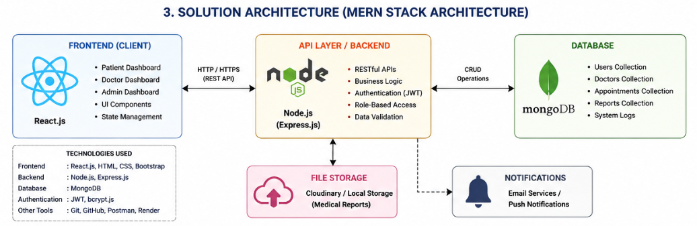

- Project Planning Phase
3.1 Project Planning (Product Backlog, Sprint Planning, Stories, Story points)
Date | 15 February 2025
Team ID
Project Name | Book a Doctor App
Maximum Marks | 5 Marks

Product Backlog, Sprint Schedule and Estimation
Sprint | Functional Requirement (Epic) | User Story Number | User Story / Task | Story Points | Priority | Team Member
Sprint-1 | User Registration | USN-1 | Patient can register using personal details. | 3 | High | Team Member 1
Sprint-1 | User Login | USN-2 | Patient can securely log in using email and password. | 2 | High | Team Member 1
Sprint-1 | Doctor Registration | USN-3 | Doctor can register and submit profile details. | 3 | High | Team Member 2
Sprint-1 | Admin Login | USN-4 | Admin can log in securely. | 2 | High | Team Leader
Sprint-2 | Appointment Booking | USN-5 | Patient can search doctors and book appointments. | 5 | High | Team Member 2
Sprint-2 | Appointment Management | USN-6 | Doctor can approve or reject appointments. | 5 | High | Team Member 3
Sprint-2 | Doctor Availability | USN-7 | Doctor can update available slots. | 3 | Medium | Team Member 3
Sprint-3 | Medical Report Upload | USN-8 | Patient can upload medical reports securely. | 3 | Medium | Team Member 4
Sprint-3 | Appointment History | USN-9 | Patient can view previous appointments. | 2 | Medium | Team Member 1
Sprint-3 | Notifications | USN-10 | User receives appointment confirmation notifications. | 2 | Medium | Team Leader
Sprint-4 | Admin Dashboard | USN-11 | Admin manages doctors, patients and appointments. | 5 | High | Team Leader
Sprint-4 | Final Testing & Deployment | USN-12 | Complete testing, bug fixing and deployment. | 5 | High | Entire Team

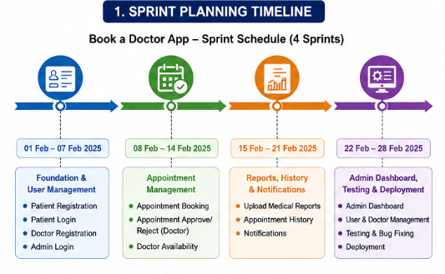
Project Tracker
Sprint | Total Story Points | Duration | Sprint Start Date | Sprint End Date (Planned) | Story Points Completed | Sprint Release Date
Sprint-1 | 20 | 7 Days | 01-Feb-2025 | 07-Feb-2025 | 20 | 07-Feb-2025
Sprint-2 | 20 | 7 Days | 08-Feb-2025 | 14-Feb-2025 | 20 | 14-Feb-2025
Sprint-3 | 20 | 7 Days | 15-Feb-2025 | 21-Feb-2025 | 20 | 21-Feb-2025
Sprint-4 | 20 | 7 Days | 22-Feb-2025 | 28-Feb-2025 | 20 | 28-Feb-2025

Velocity
The development of the Book a Doctor App was planned across 4 sprints, with each sprint consisting of 20 story points over a duration of 7 days.
Average Velocity Calculation
Total Story Points Completed = 80
Total Number of Sprints = 4
Average Velocity = 80 ÷ 4 = 20 Story Points per Sprint
Average Velocity per Day = 20 ÷ 7 ≈ 2.86 Story Points per Day
This indicates that the development team consistently completed approximately 20 story points in each sprint, demonstrating effective sprint planning and steady project progress.

Burndown Chart
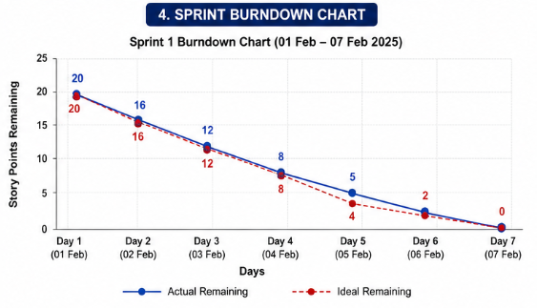
- Project Design Phase
4.1 Problem – Solution Fit
Date | 15 February 2025
Team ID
Project Name | Book a Doctor App
Maximum Marks | 2 Marks

The Problem–Solution Fit Canvas demonstrates how the Book a Doctor App effectively addresses the limitations of manual appointment scheduling by providing a secure, centralized, and user-friendly healthcare platform. The solution connects patients, doctors, and administrators through an integrated web application, improving appointment management, reducing waiting times, and enhancing overall healthcare service delivery.
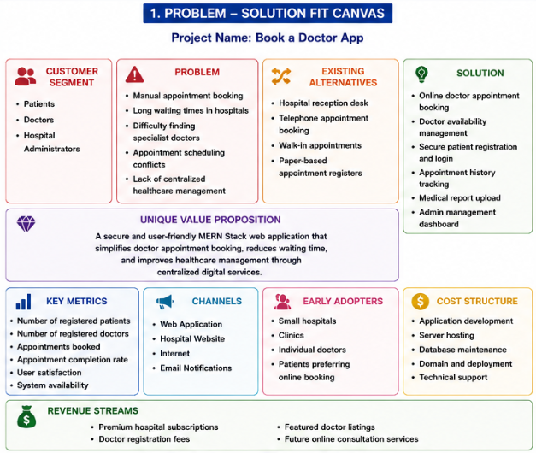

4.2 Proposed Solution
Date | 15 February 2025
Team ID
Project Name | Book a Doctor App
Maximum Marks | 2 Marks

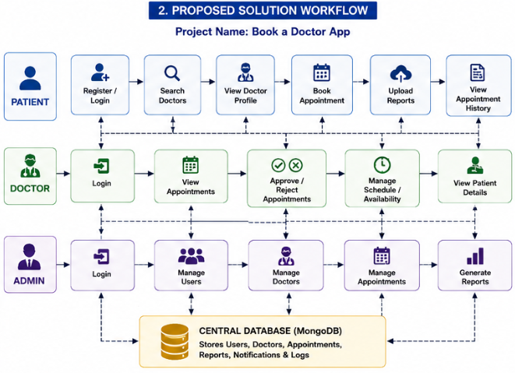

S.No | Parameter | Description
1 | Problem Statement (Problem to be solved) | Patients experience difficulties in booking doctor appointments due to manual scheduling, long waiting times, and lack of centralized healthcare management. Doctors and administrators also face challenges in managing appointments efficiently.
2 | Idea / Solution Description | Develop a web-based Book a Doctor App using the MERN Stack that enables patients to register, search doctors, book appointments, upload medical reports, and manage appointment history. Doctors can manage their schedules, while administrators oversee the complete system.
3 | Novelty / Uniqueness | The application combines role-based access, secure JWT authentication, appointment management, and digital medical record support within a single platform, improving convenience and operational efficiency.
4 | Social Impact / Customer Satisfaction | The solution reduces hospital waiting time, improves healthcare accessibility, enhances patient satisfaction, and enables better communication between patients and doctors.
5 | Business Model (Revenue Model) | Revenue can be generated through hospital subscriptions, premium doctor accounts, featured listings, and future integration of online consultation and payment services.
6 | Scalability of the Solution | The MERN Stack architecture supports scalability, allowing the system to accommodate more users, hospitals, and additional healthcare services in the future.

4.3 Solution Architecture
Date | 15 February 2025
Team ID
Project Name | Book a Doctor App
Maximum Marks | 4 Marks

The Book a Doctor App follows a three-tier MERN architecture consisting of the Presentation Layer, Application Layer, and Database Layer. The frontend is developed using React.js, providing interactive interfaces for Patients, Doctors, and Administrators. The backend is implemented using Node.js and Express.js, exposing RESTful APIs that manage authentication, appointment scheduling, and business logic. MongoDB stores user profiles, doctor information, appointments, and medical reports. JWT-based authentication ensures secure access to the application, while the modular architecture enables scalability, maintainability, and efficient communication between all system components.


- Project Development Phase
5.1 User Acceptance Testing (UAT)
Date
Team ID
Project Name | Book a Doctor App
Maximum Marks

Project Overview
Project Name: Book a Doctor App
Project Description: Book a Doctor App is a web-based healthcare appointment management system developed using the MERN Stack. It enables patients to register, search for doctors, book appointments, upload medical reports, and view appointment history. Doctors can manage appointments and update their availability, while administrators manage users, doctors, and appointments through a centralized dashboard.
Project Version: Version 1.0
Testing Period: 01 March 2025 to 05 March 2025

Testing Scope
Features Tested
- Patient Registration
- User Login
- Doctor Registration
- Doctor Approval
- Appointment Booking
- Appointment Management
- Doctor Availability
- Medical Report Upload
- Appointment History
- Admin Dashboard
- Logout
User Stories Tested
- USN-1 Patient Registration
- USN-2 User Login
- USN-3 Doctor Registration
- USN-4 Admin Approval
- USN-5 Appointment Booking
- USN-6 Appointment Management
- USN-7 Doctor Availability
- USN-8 Medical Report Upload
- USN-9 Appointment History
- USN-10 User Management

Testing Environment
URL / Location:
Localhost (Development Environment)
(If you deployed it, replace with your deployed URL.)
Credentials (if required)
Role | Username | Password
Admin | admin@gmail.com | ********
Doctor | doctor@gmail.com | ********
Patient | patient@gmail.com | ********

Test Cases
Test Case ID | Test Scenario | Test Steps | Expected Result | Actual Result | Pass / Fail
TC-001 | Patient Registration | Open Registration → Enter Details → Submit | Registration successful | Registration successful | Pass
TC-002 | User Login | Enter Email & Password → Login | Dashboard opens | Dashboard opens | Pass
TC-003 | Doctor Registration | Fill Doctor Form → Submit | Registration request submitted | Registration request submitted | Pass
TC-004 | Doctor Approval | Admin approves doctor | Doctor account activated | Doctor account activated | Pass
TC-005 | Appointment Booking | Search Doctor → Select Slot → Book | Appointment booked | Appointment booked | Pass
TC-006 | Appointment Management | Doctor accepts appointment | Status updated | Status updated | Pass
TC-007 | Upload Medical Report | Select File → Upload | Report uploaded | Report uploaded | Pass
TC-008 | Appointment History | Open History | Appointment list displayed | Appointment list displayed | Pass
TC-009 | User Management | Admin updates user | User updated | User updated | Pass
TC-010 | Logout | Click Logout | Login page displayed | Login page displayed | Pass

Bug Tracking
Bug ID | Bug Description | Steps to Reproduce | Severity | Status | Additional Feedback
BG-001 | Login validation message not displayed properly | Enter invalid credentials | Low | Closed | Improved validation message
BG-002 | Mobile UI alignment issue | Open dashboard on mobile | Low | Closed | Responsive layout fixed
BG-003 | Appointment booking without selecting time slot | Try booking directly | Medium | Closed | Validation added
BG-004 | Report upload file size validation | Upload large file | Low | Closed | File size limit implemented

Sign-off:
Tester Name: [Name of Tester]
Date: 05 March 2025
Signature: [Tester's Signature]

