A Mini-Project Report on
GUI BASED SCHEMA GENERATION FOR DIFFERENT DATABASES
Submitted to the Dept. of Information Technology, SNIST
in the partial fulfillment of the academic requirements for the award of
B.Tech (Information Technology)
under JNTUH
by
SAI KOUMUDI(12311A1269)
SAI GEETIKA(12311A1267)
SINDHUJA(12311A1272)
under the guidance of
Mr. N.Chaithanya Kumar
Associate Professor


Department of Information Technology
School of Computer Science and Informatics
SreeNidhi Institute of Science and Technology (An Autonomous Institution)
Yamnampet, Ghatkesar Mandal, R. R. Dist., Hyderabad – 501301
affiliated to
Jawaharlal Nehru Technological University Hyderabad
Hyderabad – 500 085
2015–16
INDEX

CONTENT | PAGE NO.
ABSTRACT | 3
INTRODUCTION TO MODULES | 5
EXISTING SYSTEM | 9
PROPOSED SYSTEM | 9
SOFTWARE REQUIREMENT SPECIFICATION | 10
MODULES DESCRIPTION | 11
UML DIAGRAMS | 13
SCREENSHOTS OF THE APPLICATION | 24
TESTING | 42
CONCLUSION AND RECOMMENDATIONS | 44
FUTURE SCOPE | 45
BIBLIOGRAPHY | 46

ABSTRACT

Name of the project Gui based schema generation for different databases

Objective The Database Schema Builder is a system, which allows the developers to focus on creating the database using the GUI interface. The user needs to fulfill the requirements in the interface and he can perform the database operations which he wants and can create the database.
This project aims at creation of an automatic database schema generation. This project will be accessible to all developers and its facility allows developers to focus on creating the database schema on the basis of JSP while letting the application server define table based on the fields in JSP and relationships between them. This system provides the following facilities. This helps in combining two databases.

Users of the System A. Administrator
B. Client

Functional Requirements i. The Database Schema Builder provides a Common User Interface to interact with all the databases.
ii. Here the user interface is Graphical User Interface.
iii. This application is a Web based Application.
Iv Being a web based application it doesn’t require any client side installation.
v. Any number of users can interact with the system simultaneously.
vi Centralized database connectivity.
vii Using Session management the interaction more flexible and secure.

Non-Functional Requirements i. secures access of confidential data (user’s details).
SSL can be used.
ii.24 Χ 7 availability

Start working on a test-plan for the entire system.
This test-plan can be updated as and when new
Scenarios come to mind.

Technologies to be Used UML, JEE,JEE, XML, e-Forms, Web2.0, Web-
Services, SOA.

Tools to be Used i. Rose/RSA/Web Logic Modeler
ii. Eclipse/RAD Lotus Forms Designer/Port let
Factory
iii. Oracle/MySQL/Microsoft SQL/PostgreSQL
iv. Jboss /Glassfish /Tomcat 6.0 Server
v Windows XP will be the preferred OS.

Final Deliverable must Include
i. Online or offline help to above said users, Application deployment executive and developer
ii. Application archive (.war/.ear) with source code
iii. Database backup and DDL Script
iv. Complete Source code
Introduction to Modules

1) SQL Query Pane Module
Here we can type SQL queries and get the data from Database

2) Import Option Module
We can import .sql files only into the Database

3) Export Option Module
We can export sql Structure, sql Data or both based on some conditions into 3 types of files
.sql files
.html files
.csv files(Excel Files)
4) Operation Module
Here we can create table with constraints
Alter the existing table like
Alter column
Rename column
Drop column
Empty column
5) Search Database Module
Search based on keywords
Search looks for column names only
Search looks for data only
Hardware requirements:
Hard Disk: 500 GB
RAM: 2 GB
Processor: Quad core.

INTRODUCTION

The Automatic Database Schema Generation is a system, which allows the developers to focus on creating the database using the GUI interface .The user needs to fulfill the requirements in the interface and he can perform the database operations which he wants and can create the database.
This project aims at creation of an automatic database schema generation. This project will be accessible to all developers and its facility allows developers to focus on creating the database schema on the basis of JSP while letting the application server define table based on the fields in JSP and relationships between them. This system provides the following facilities.
This facilitates the user to focus much on application aspects leaving behind the database aspects.
This project allows users to generate database schema generation without having much knowledge of database Aspects.

Introduction to Modules

1) SQL Query Pane Module
Here we can type SQL queries and get the data from Database

2) Import Option Module
We can import .sql files only into the Database

3) Export Option Module
We can export sql Structure, sql Data or both based on some conditions into 3 types of files
.sql files
.html files
.csv files(Excel Files)
4) Operation Module
Here we can create table with constraints
Alter the existing table like
Alter column
Rename column
Drop column
Empty column
5) Search Database Module
Search based on keywords
Search looks for column names only
Search looks for data only

Number of Modules:

1) SQL Query Pane Module
This module is used to retrieve data from the database by using SQL Queries. The User interface is designed with a query pane to type the query, where a user can type the sql query. The sql query is taken by the module as input and generates the output of that query. The output is displayed in a tabular manner.

2) Import Option Module
This module is developed to retrieve schema from the external files. The supported files are .sql files. .sql files contains the set of queries that can be executed. This module uses the FTP protocol which will enable the web server to load the files.

3) Export Option Module
The user can export sql Structure, sql Data or both based on some conditions into 3 types of files.
- .sql files
- .html files
- .csv files(Excel Files)

4) Operations Module
The user can create table with constraints, Alter the table, Rename the Table, Drop table.
The user can Alter the existing table like by using following keys.

Alter column
  - Rename column
  - Drop column
  - Empty column
The user can rename the table by giving the old name and new name. The user can drop the table by selecting the table name from the select box.

5) Search Database Module
The user must search based on keywords
  - Search looks for column names only
  - Search looks for data only

EXISTING SYSTEM :

There are many Database Management systems available today. The Database designer is familiar with any one of the database Management Systems. Let us consider a condition when a database designer required to design the schema for an application on different DBMS. He required to learn all the DBMS User Interfaces. Where some of them are GUI (Graphic User Interface) based and others are CUI(Character User Interface).

DRAWBACKS OF EXISTING SYSTEM

Through this approach to alter or to edit a large database schema, It consumes more time for a Database Designer. The operations like altering the table structure, Editing the table, Dropping columns, searching for a column name, searching for a data in the table.. etc.,
To Design and alter the Database schema there exists different user interfaces for different DBMS.

PROPOSED SYSTEM AND ITS FEATURES:
The Automatic Database Schema Generation System provides the following features.
- The Automatic Database Schema Generation System provides a Common User Interface to interact with all the databases.
- Here the user interface is Graphical User Interface.
- This application is a Web based Application.
- Being a web based application it doesn’t require any client side installation.
- Any number of users can interact with the system simultaneously.
- Centralized database connectivity.
- Using Session management the interaction more flexible and secure.

SOFTWARE REQUIREMENT SPECIFICATION
REQUIREMENT SPECIFICATION:
The application Automatic Database Schema Generation , which is design to connect different DBMS using common Interface. All the major activities that are carried are used to Design the database schema transparent to the DBMS by using a GUI.

Required Hardware:

Pentium IV Processor.

256 MB RAM.

40GB Hard Disk space.

Ethernet card with an Internet and Internet zone.

Required Software:
Server Side:

Platform Independent (Based on Operating System).

Internet explorer 5.0 or above or Netscape navigator.

Any Centralized Database.

JDK 1.4 or higher.

Apache Tomcat Web Server 4.0 or above.

TCP/IP Protocol suite.

Client Side:

Any Web Browser on any operating system.

MODULES DESCRIPTION

Number of Modules:

1) SQL Query Pane Module
This module is used to retrieve data from the database by using SQL Queries. The User interface is designed with a query pane to type the query, where a user can type the sql query. The sql query is taken by the module as input and generates the output of that query. The output is displayed in a tabular manner.

2) Import Option Module
This module is developed to retrieve schema from the external files. The supported files are .sql files. .sql files contains the set of queries that can be executed. This module uses the FTP protocol which will enable the web server to load the files.

3) Export Option Module
The user can export sql Structure, sql Data or both based on some conditions into 3 types of files.
- .sql files
- .html files
- .csv files(Excel Files)

4) Operations Module
The user can create table with constraints, Alter the table, Rename the Table, Drop table.
The user can Alter the existing table like by using following keys.

Alter column
  - Rename column
  - Drop column
  - Empty column
The user can rename the table by giving the old name and new name. The user can drop the table by selecting the table name from the select box.
5) Search Database Module
The user must search based on keywords
  - Search looks for column names only
  - Search looks for data only

UNIFIED MODELING LANGUAGE DIAGRAMS
  - The unified modeling language allows the software engineer to express an analysis model using the modeling notation that is governed by a set of syntactic semantic and pragmatic rules.
  - A UML system is represented using five different views that describe the system from distinctly different perspective. Each view is defined by a set of diagram, which is as follows.
  - User Model View
    - This view represents the system from the users perspective.
    - The analysis representation describes a usage scenario from the end-users perspective.

Structural Model view
    - In this model the data and functionality are arrived from inside the system.
    - This model view models the static structures.
Behavioral Model View
- It represents the dynamic of behavioral as parts of the system, depicting the interactions of collection between various structural elements described in the user model and structural model view.
Implementation Model View
- In this the structural and behavioral as parts of the system are represented as they are to be built.
Environmental Model View
In this the structural and behavioral aspects of the environment in which the system is to be implemented are represented.

UML is specifically constructed through two different domains they are:
- UML Analysis modeling, which focuses on the user model and structural model views of the system.
- UML design modeling, which focuses on the behavioral modeling, implementation modeling and environmental model views.

Use case Diagrams represent the functionality of the system from a user’s point of view. Use cases are used during requirements elicitation and analysis to represent the functionality of the system. Use cases focus on the behavior of the system from external point of view.

Actors are external entities that interact with the system. Examples of actors include users like administrator, bank customer …etc., or another system like central database.

USECASE MODEL:

SYSTEM NAME

Use case 1

Use case 2

Use case n

Actor
Actor

Usecases of Automatic Database Schema Generation

SHAPE \* MERGEFORMAT
AUTOMATIC DB SCHEMA GENERATION

DATABASE LOGIN

SCHEMA CREATION

SCHEMA MODIFICATION

DATABASE SEARCH

EXPORT SCHEMA

IMPORT SCHEMA

Database Schema Designer

Use case name | Database Login
Participating actors | Schema Designer
Flow of events | DB Schema Designer gives the database driver name, selects the url, enters user name and password.  On success connection is established to the database.
Entry Condition | The DB Designer Logged into the system automatic database schema generation.
Exit condition | The DB Designer Disconnects from the system automatic database schema generation
Quality Requirements | Must provide respective error messages during connection.

Use case name | Schema Creation
Participating actors | Schema Designer
Flow of events | The DB Designer uses the user interface, to create tables, generate the schema, the database responds on successful schema creation
Entry Condition | The user must enter the table names, column names and their datatypes.
Exit condition | Successful creation
Quality Requirements | User Interface must be user friendly,

Use case name | Schema Modification
Participating actors | Database Designer
Flow of events | The DB Designer uses the user interface to modify the tables, column names, column content, data types.
Entry Condition | The user must select the respective table, column and data for the modification
Exit condition | Successful modification
Quality Requirements | Best Error Handling techniques.

Use case name | Search
Participating actors | Database Designer
Flow of events | The DB Designer enters the search key and must select the criteria to search like column names, data or both. Optional is the search condition too.
Entry Condition | User must have knowledge of what he required
Exit condition | Result set displayed on the User interface.
Quality Requirements | Easy viability in displaying the records.

Use case name | Export schema
Participating actors | Database Schema Designer
Flow of events | The user must select the schema or tables or columns to be exported in the required formats like into sql,html,excel and also what to be exported like structure, data, both.
Entry Condition | User must be ready with what tables to be exported.
Exit condition | Save the file in the specified location.
Quality Requirements | File insertion must be error free.

Use case name | Import schma
Participating actors | Database Schema Designer
Flow of events | The user select the file to be imported here it will support only SQL format.
Entry Condition | The user must search for where the sql file exists
Exit condition | Successful import of the schema from sql file.
Quality Requirements | The file must be read the delimiters carefully for successful import

SEQUENCE DIAGRAMS:
Sequence Diagrams Represent the objects participating the interaction horizontally and time vertically.

Sequence Diagram 1
DB Schema Designer
: Login
: Load All
: Log Out
Use url
Press login button
Press disconnect Button
Time

Sequence Diagram 2
DB Schema Designer
: Login
: Load All
DB Operations
Use url
Press login button
Press Operations Button

Sequence Diagram 3
DB Schema Designer
: Login
: Load All
: Sturcutre
Use url
Press login button
Press Structure Button

Sequence Diagram 4
DB Schema Designer
: Login
: Load All
: Properities
Use url
Press login button
Press Properities Button

Sequence Diagram 5
DB Schema Designer
: Login
: Load All
: SQL
Use url
Press login button
Press SQL Button

Sequence Diagram 6
DB Schema Designer
: Login
: Load All
: Import
Use url
Press login button
Press Import Button

Sequence Diagram 7
DB Schema Designer
: Login
: Load All
: Export
Use url
Press login button
Press Export Button

Sequence Diagram 8
DB Schema Designer
: Login
: Load All
:Operations
Use url
Press login button
Press Operations Button

Sequence Diagram 9
DB Schema Designer
: Login
: Load All
: Search
Use url
Press login button
Press Search Button

SCREENSHOTS OF THE APPLICATION :

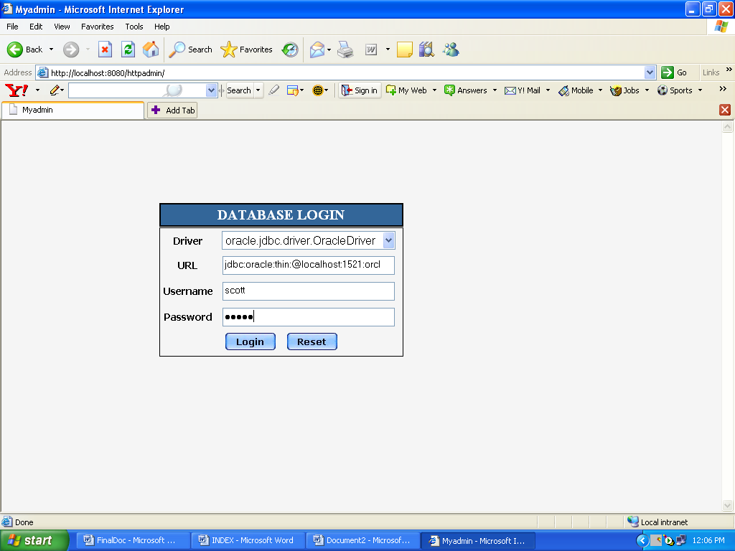

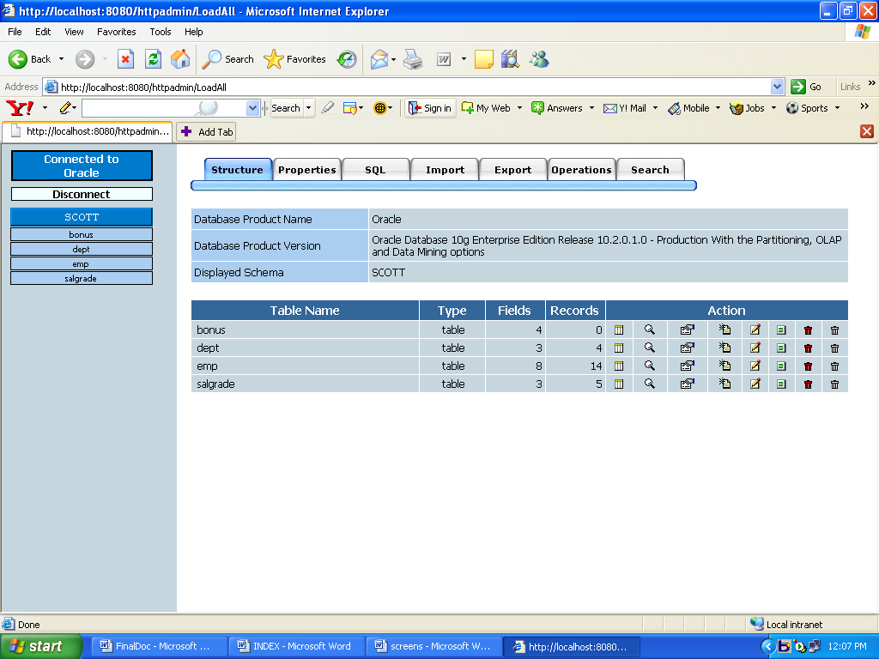

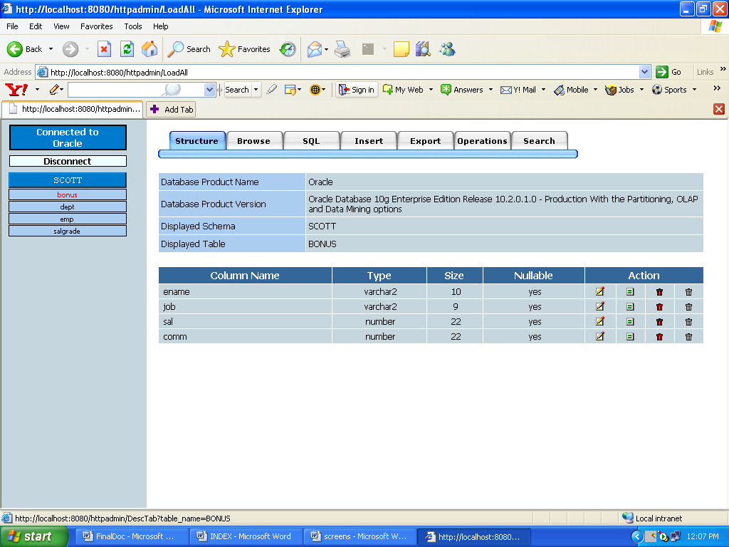

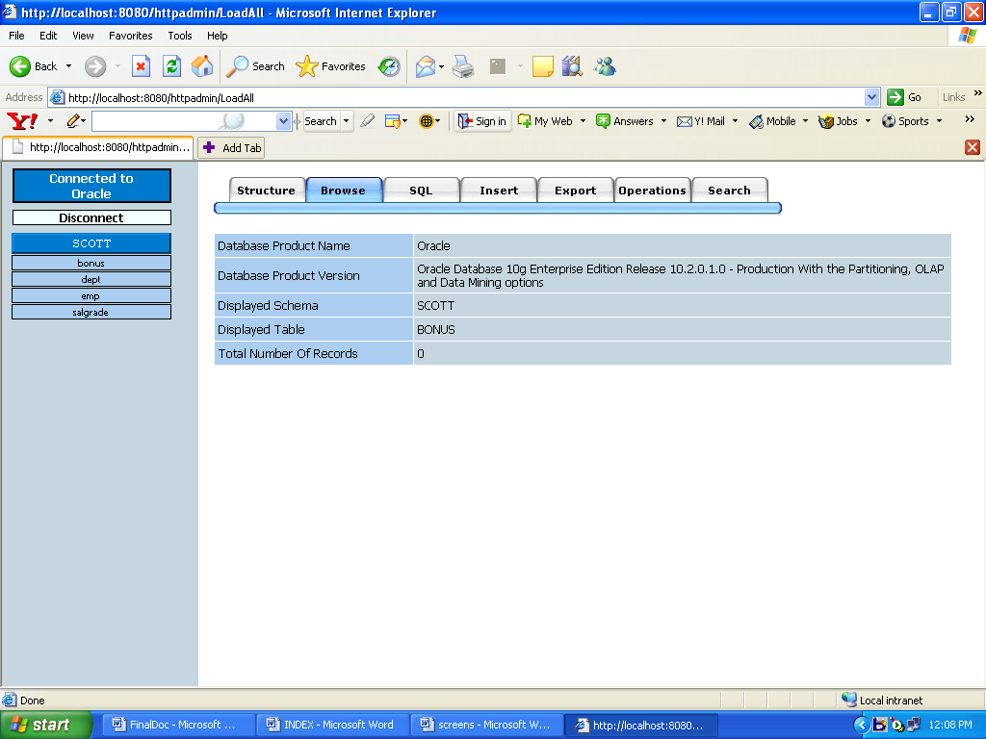

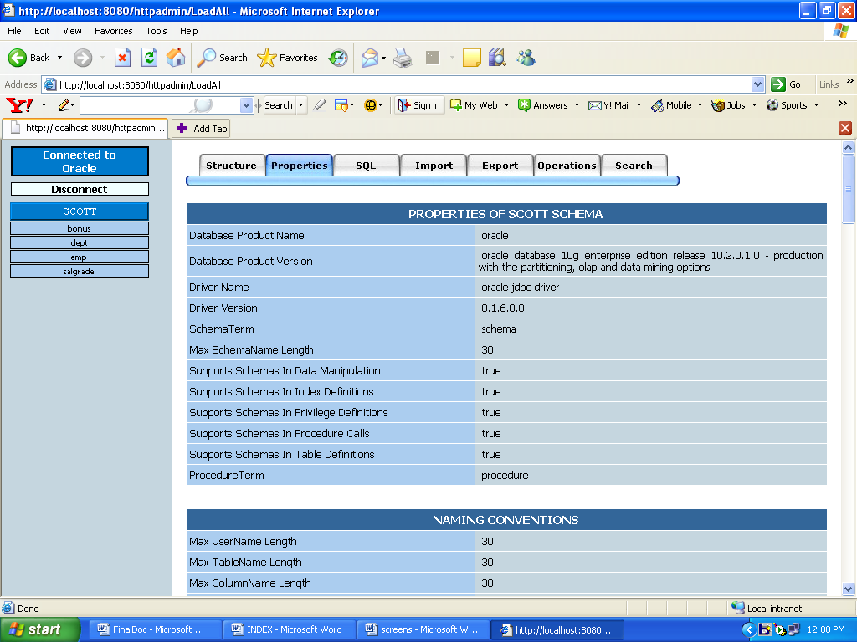

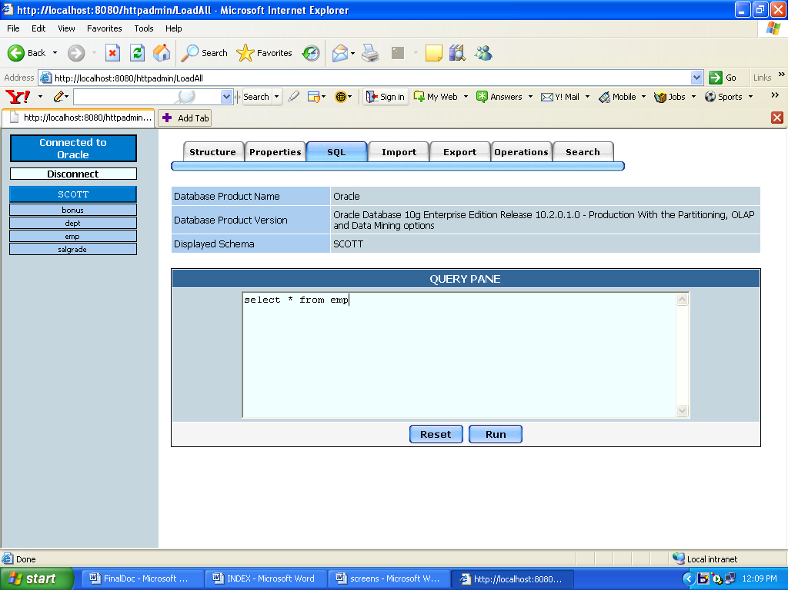

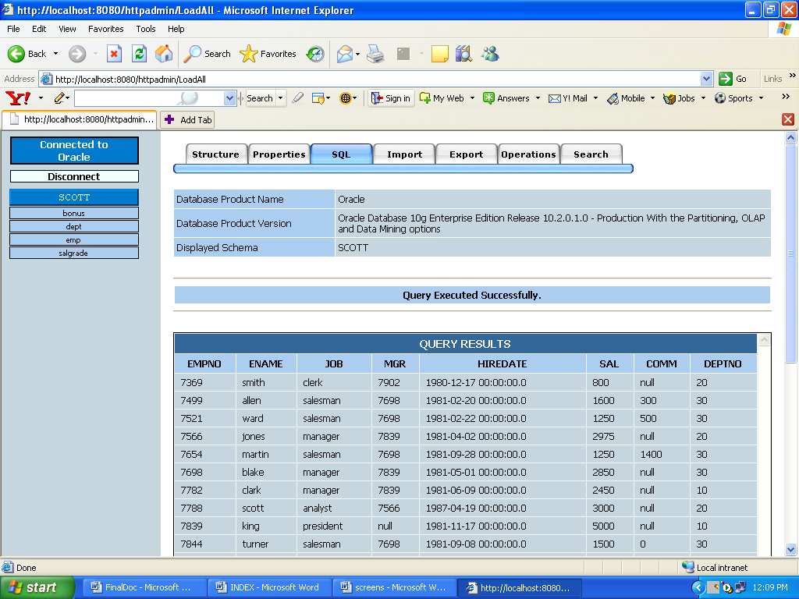

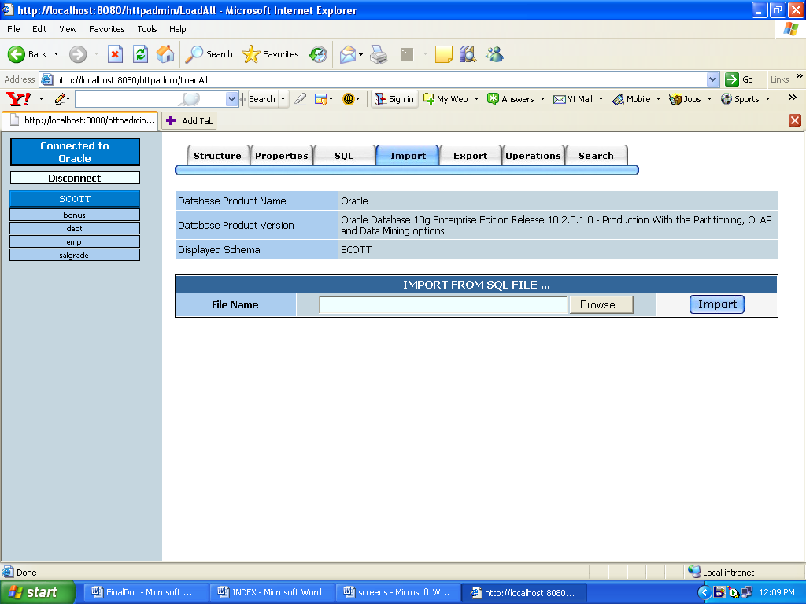

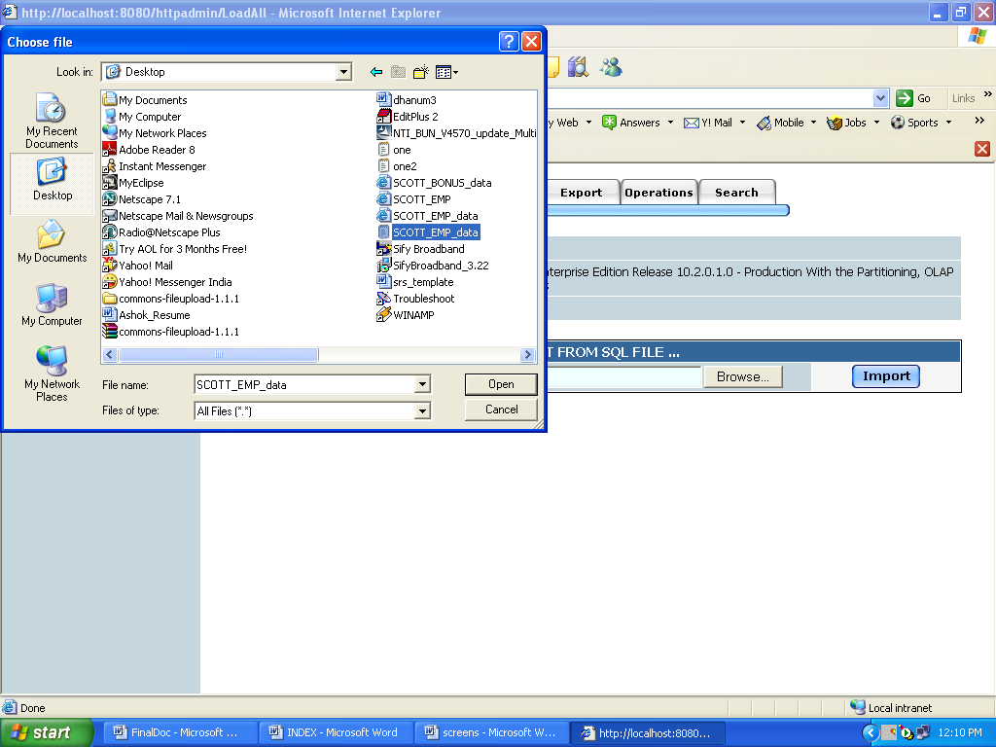

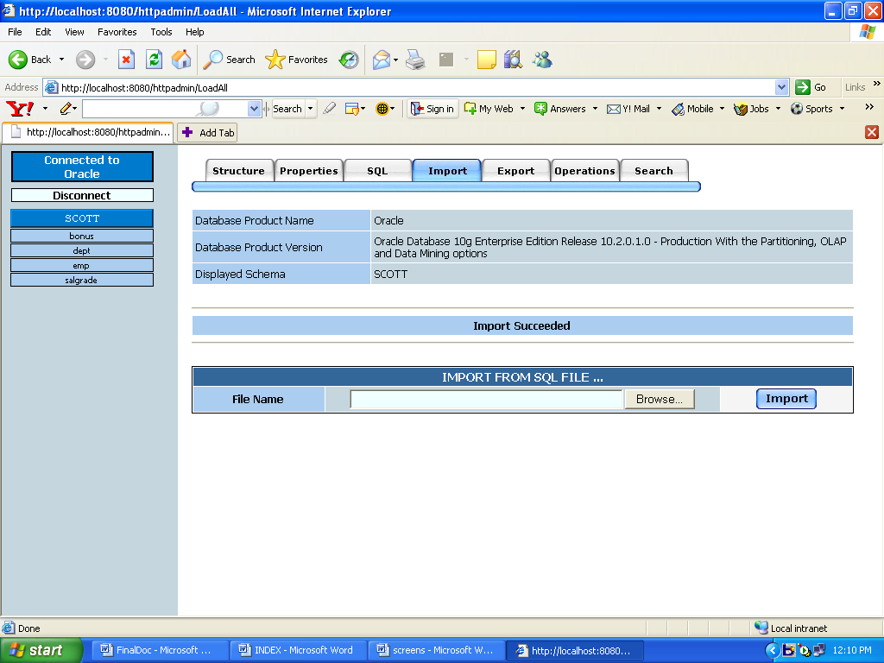

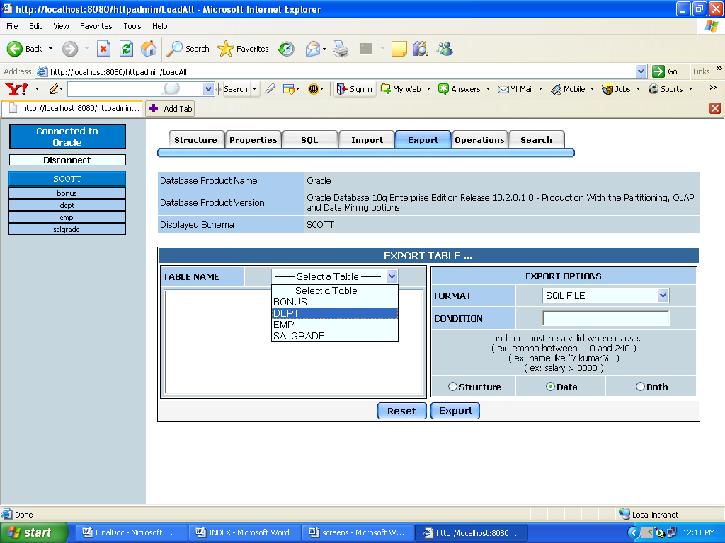

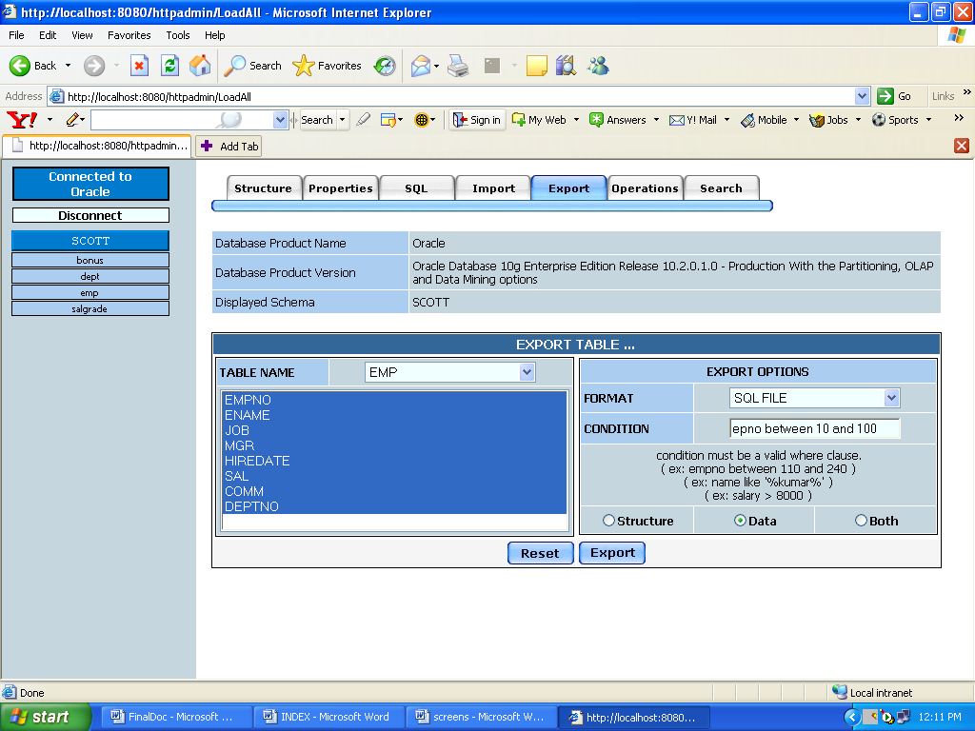

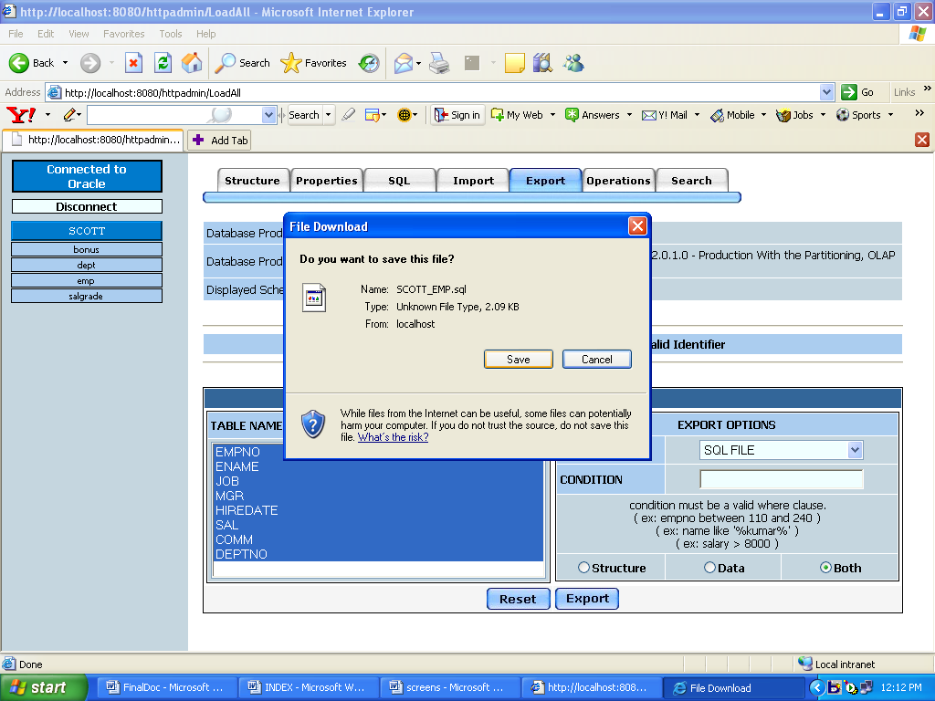

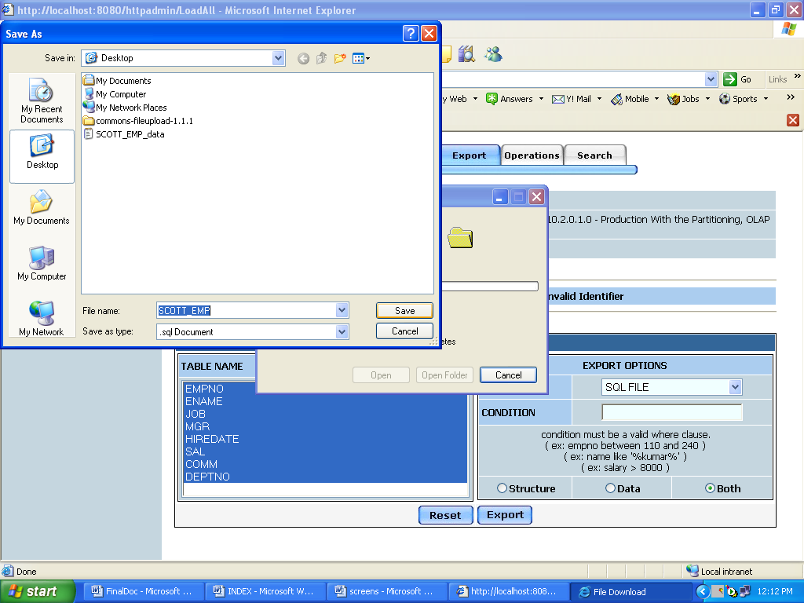

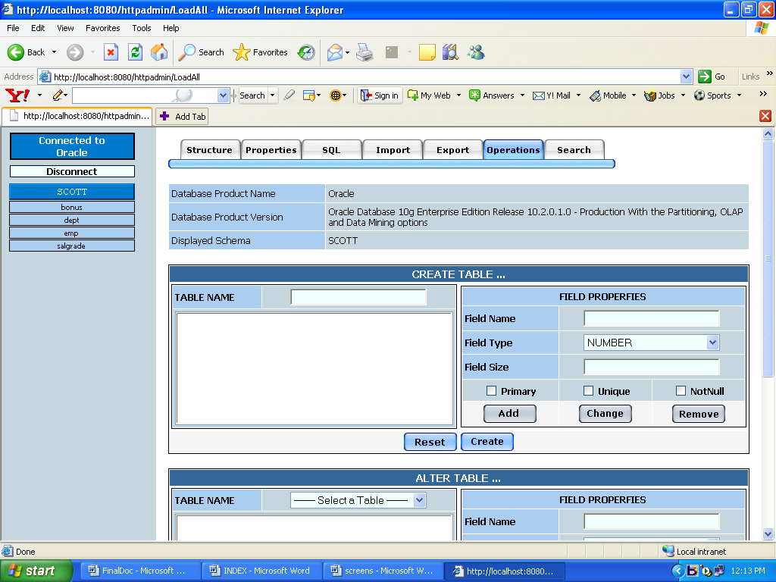

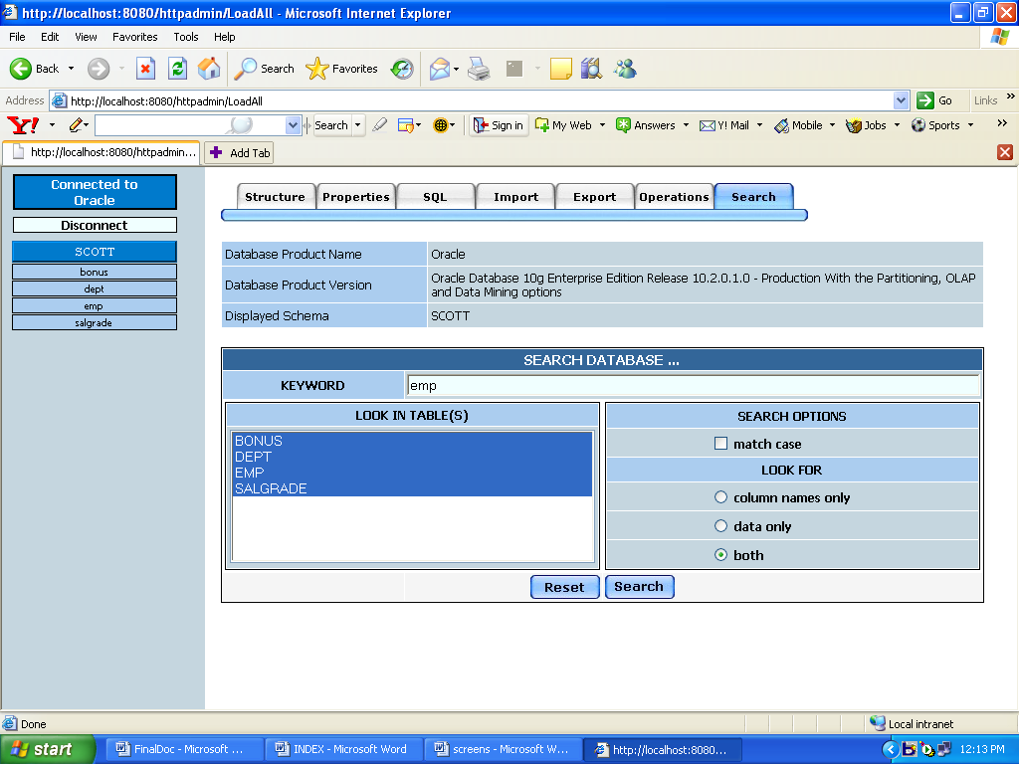

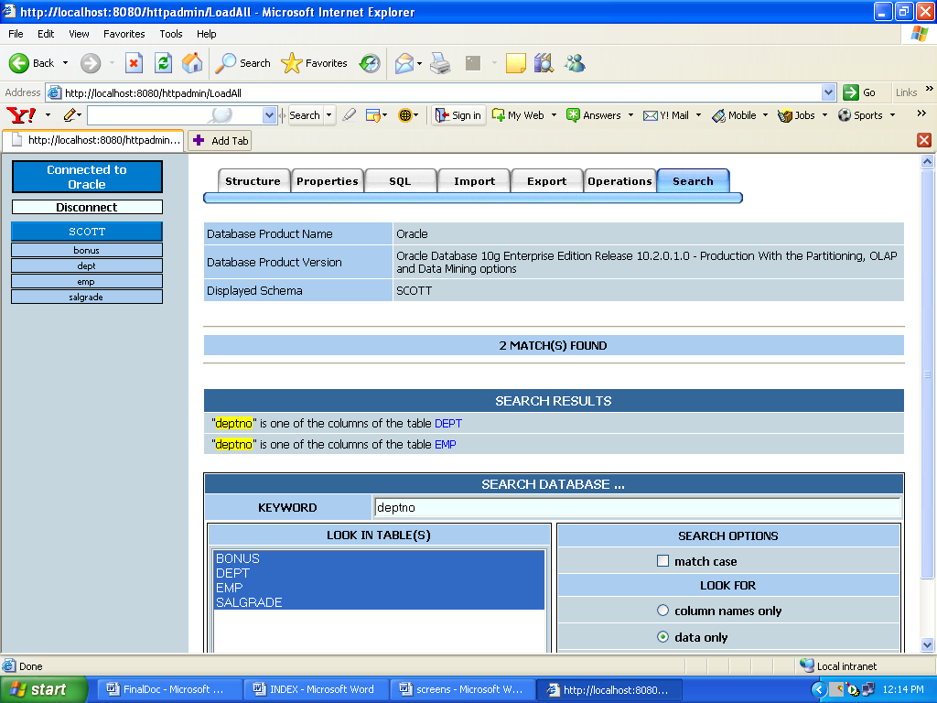

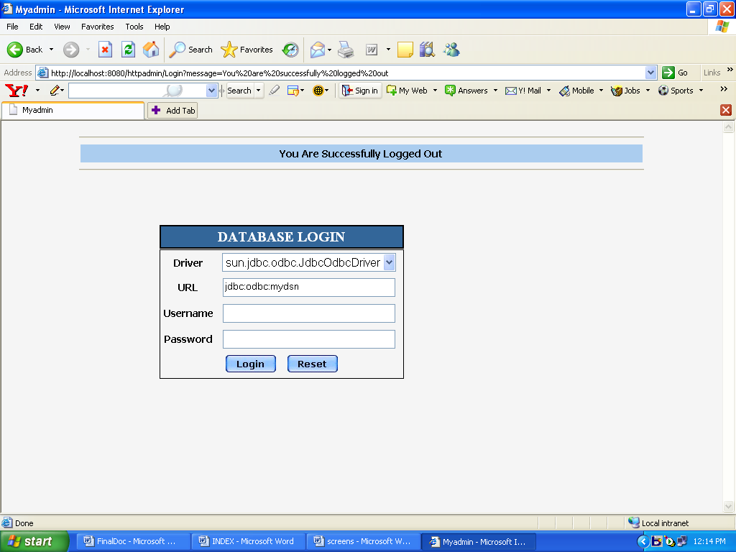

TESTING:

Testing is the process of detecting errors. Testing performs a very critical role for quality assurance and for ensuring the reliability of software. The results of testing are used later on during maintenance also.
Psychology of Testing:
The aim of testing is often to demonstrate that a program works by showing that it has no errors. The basic purpose of testing phase is to detect the errors that may be present in the program. Hence one should not start testing with the intent of showing that a program works, but the intent should be to show that a program doesn’t work. Testing is the process of executing a program with the intent of finding errors.
Testing Objectives:
The main objective of testing is to uncover a host of errors, systematically and with minimum effort and time. Stating formally, we can say,
- Testing is a process of executing a program with the intent of finding an error.
- A successful test is one that uncovers an as yet undiscovered error.
- A good test case is one that has a high probability of finding error, if it exists.
- The tests are inadequate to detect possibly present errors.
- The software more or less confirms to the quality and reliable standards.

Levels of Testing:
In order to uncover the errors present in different phases we have the concept of levels of testing. The basic levels of testing are as shown below…

Client Needs
Acceptance Testing
System Testing
Integration Testing
Unit Testing

Requirements

Design

Code

System Testing:
The philosophy behind testing is to find errors. Test cases are devised with this in mind. A strategy employed for system testing is code testing.
Code Testing:
This strategy examines the logic of the program. To follow this method we developed some test data that resulted in executing every instruction in the program and module i.e. every path is tested. Systems are not designed as entire nor are they tested as single systems. To ensure that the coding is perfect two types of testing is performed or for that matter is performed or that matter is performed or for that matter is performed on all systems.

CONCLUSIONS AND FUTURE SCOPE:

- If two companies using different databases merge then there is a need for this type of application to make their work easier.

- With the advancement of technology, there are many more things an dB administrator must concentrate on than learning all database management system.

SCOPE OF THE DEVELOPMENT PROJECT:

Database Tier: The concentration is applied by adopting wide range of DBMS.

User Tier: The user interface is developed in a browser specific environment to have web based architecture. The components are designed using HTML standards and Java server pages power the dynamic of the page design. Java Script for Loading graphics and Validations.

Data Base Connectivity Tier: The communication architecture is designed by concentrated on the standards of servlets and JSP’s. The database connectivity is established using the JDBC.

Bibliography:
References for the Project Development Were Taken From the following Books and Web Sites.
JAVA Technologies
JAVA Complete Reference by Herbert Sheildt and Patrick Naughton
Java Script Bible Gold Edition
Web Enable Commercial Application Development Using… Java 2.0 by Ivan Bayross
Professional Java Server Programming Subhramanyam Allamaraju.
Inside Servlets.
Java.sun.com tutorials
Software Engineering by Roger Pressman
Object-Oriented Software Engineering Using UML, Pattern and Java Second Edition by Bernd Bruegge, Allen H.Duetoit.

