**­­­­Introduction to Networking:**

* What is a computer network?
* Types of networks (LAN, WAN, MAN, PAN, etc.).
* Network topologies (star, bus, ring, mesh).

**Network Devices and Components:**

* Network interface cards (NICs).
* Switches and routers.
* Hubs and repeaters.
* Modems and gateways.

**Network Protocols:**

* TCP/IP (Transmission Control Protocol/Internet Protocol).
* UDP (User Datagram Protocol).
* HTTP (Hypertext Transfer Protocol).
* DNS (Domain Name System).
* DHCP (Dynamic Host Configuration Protocol).
* ICMP (Internet Control Message Protocol).

**OSI Model:**

* Understanding the OSI (Open Systems Interconnection) model.
* Explanation of each OSI layer and its functions.

**IP Addressing:**

* IPv4 and IPv6 addressing.
* Subnetting and CIDR notation.
* Private vs. public IP addresses.

­­**­­­­Introduction to Networking**

* What is a computer network?

A computer network is a collection of interconnected devices that communicate with each other to share resources and information. These devices can be computers, servers, printers, smartphones, or any other device capable of connecting to the network. By establishing a network, these devices can exchange data and collaborate effectively, enabling seamless communication and resource sharing.

Imagine a computer network as a digital highway, where data travels between devices, reaching its destination efficiently. Networks are essential for businesses, organizations, and individuals alike, as they provide the backbone for modern communication and internet connectivity.

* Types of networks (LAN, WAN, MAN, PAN, etc.).
* **Local Area Network (LAN):**
  + A LAN covers a limited geographical area, such as a home, office building, or campus.
  + It allows devices in close proximity to share resources like files, printers, and internet connections.
  + LANs are commonly used in households and small businesses.
* **Wide Area Network (WAN):**
  + WANs span large geographical distances, often connecting LANs from different cities or countries.
  + They rely on public and private telecommunication networks to facilitate data transmission.
  + The internet is the largest and most well-known example of a WAN.
* **Metropolitan Area Network (MAN):**
  + A MAN falls between LAN and WAN in terms of geographical coverage.
  + It typically spans a city or a metropolitan area, connecting multiple LANs.
  + MANs are commonly used by organizations that require high-speed connections across various locations within a city.
* **Personal Area Network (PAN):**
  + A PAN is the smallest type of network, usually cantered around an individual's devices.
  + It allows devices like smartphones, tablets, and smartwatches to communicate directly with each other.
  + PANs are often established through Bluetooth or infrared connections.
* Network topologies (star, bus, ring, mesh).

Network topology refers to the arrangement of devices and communication links in a network. Different topologies offer various advantages and disadvantages in terms of performance, scalability, and fault tolerance. Here are some common network topologies:

* **Star Topology:**



* + In a star topology, all devices are connected to a central hub (like a switch or router).
  + Devices communicate by sending data to the hub, which then forwards it to the intended recipient.
  + It is easy to add or remove devices in a star network, making it simple to expand.
* **Bus Topology:**



* + A bus topology uses a single communication channel (a "bus") to connect all devices in a linear fashion.
  + Data transmitted by one device travels along the bus and can be received by all devices connected to it.
  + Adding or removing devices in a bus network can be more challenging compared to a star topology.
* **Ring Topology:**



* + In a ring topology, each device is connected to precisely two other devices, forming a circular network.
  + Data travels around the ring from one device to the next until it reaches the intended destination.
  + Ring topologies are less common in modern networks due to their limited scalability and vulnerability to single point failures.
* **Mesh Topology:**
  + A mesh topology provides redundant connections between devices, ensuring multiple paths for data transmission.
  + This redundancy improves fault tolerance and network reliability.
  + However, mesh topologies can be complex and costly to implement, primarily in large networks.

====================================================================================================

**Network Devices and Components**

In the world of computer networking, various devices and components play crucial roles in enabling communication and data exchange between computers and other devices. Understanding these fundamental network devices is essential for anyone starting their journey into the fascinating realm of computer networks. Let's explore the key network devices and components in simple terms:

**1. Network Interface Cards (NICs):**

A Network Interface Card, commonly known as NIC, is a hardware component that allows a computer or any other device to connect to a network. It acts as an interface between the computer and the network medium, enabling the device to send and receive data. Think of NICs as the essential communication link that enables your computer to participate in a network, whether it's a local network within your home or a vast global network like the internet.

**2. Switches and Routers:**

* **Switches:**
  + Imagine a network switch as a smart traffic cop that efficiently directs data traffic within a local network. When computers or devices connected to the same network want to communicate with each other, a switch intelligently forwards the data directly to the intended recipient, improving the network's performance. Unlike hubs (we'll discuss them next), switches create dedicated communication channels between devices, making data transmissions faster and more secure.



* **Routers:**



* + If switches are the traffic cops within a local neighbourhood, routers are the navigation systems that guide data packets between different networks. Routers operate at a higher level of intelligence and are responsible for directing data between networks, such as connecting your home network to the internet. They use IP addresses to determine the best path for data to reach its destination. Routers are essential for interconnecting networks across vast distances, creating a global web of networks we call the internet.



**3. Hubs and Repeaters:**

* **Hubs:**
  + Think of a hub as a simple, old-fashioned signal repeater. When data is sent from one device connected to a hub, it broadcasts the data to all other devices connected to the same hub. In other words, hubs lack the intelligence of switches, and data sent through a hub reaches all devices, even if the data is intended for just one device. This approach leads to more collisions and reduced network efficiency compared to switches. Hubs are now less common in modern networks as switches have largely replaced them.



* **Repeaters:**
  + Repeaters are network devices designed to extend the reach of a network's physical connection. When data travels across long distances, it can lose strength and clarity, leading to signal degradation. Repeaters regenerate and amplify these weakening signals, allowing data to travel further without losing quality. In essence, repeaters help maintain the integrity of the data as it travels over long distances.

**4. Modems and Gateways:**



* **Modems:**
  + A modem, short for modulator-demodulator, is a device that allows digital devices, like your computer, to communicate with analog systems, such as telephone lines or cable networks. Modems convert digital signals from your computer into analog signals that can be transmitted over traditional communication lines. Conversely, they also convert incoming analog signals back into digital signals for your computer to understand.
* **Gateways:**
  + Gateways serve as intermediaries between different networks, acting as translators to ensure seamless communication. When data is sent from one network to another, it may use different protocols or formats. Gateways convert data from one format to another, making sure that information can flow smoothly between networks with distinct characteristics. For example, a gateway might facilitate communication between a local network and a cloud-based service.

====================================================================================================

**Network Protocols**

Network protocols are sets of rules and conventions that enable computers and devices to communicate with each other over a network. They ensure that data is transmitted accurately and efficiently. Here are some important network protocols every beginner should know:

* **TCP/IP (Transmission Control Protocol/Internet Protocol):**
  + TCP/IP is the foundation of the internet and most modern networks. It breaks data into packets and ensures they reach their destination reliably. TCP manages the data delivery, while IP handles the addressing and routing.
* **UDP (User Datagram Protocol):**
  + UDP is another protocol used for data transmission, but it's faster and more lightweight than TCP. It's commonly used for real-time applications like video streaming and online gaming, where a little data loss is acceptable.
* **HTTP (Hypertext Transfer Protocol):**
  + HTTP is the protocol used for web browsing. It allows web browsers to request and receive web pages, images, and other resources from web servers. When you type a web address (URL) into your browser, it uses HTTP to fetch the content and display it on your screen.
* **DNS (Domain Name System):**
  + DNS translates human-readable domain names (like www.example.com) into IP addresses (like 192.168.1.1) that computers understand. It acts as a phonebook for the internet, making it easier for us to access websites without remembering long strings of numbers.
* **DHCP (Dynamic Host Configuration Protocol):**
  + DHCP automatically assigns IP addresses to devices on a network, making it easier for users to connect without manually configuring their network settings. When you connect to a Wi-Fi network, for instance, DHCP gives your device an IP address so it can communicate on the network.
* **ICMP (Internet Control Message Protocol):**
  + ICMP is a supporting protocol that helps manage network errors and diagnostics. It's used to check if a device is reachable on the network (ping) or to report errors when data cannot be delivered.

====================================================================================================

**OSI Model**

The OSI (Open Systems Interconnection) model is like a blueprint for how computer networks should communicate with each other. It divides the complex process into smaller, manageable layers, each with its own specific role. Think of it as building a tall tower one floor at a time.

* Layer 7: Application Layer
  + Finally, we reach the top floor, where all the user applications reside—email, web browsers, file transfers, and more. This is where you interact directly with the network and use the services provided.
* Layer 6: Presentation Layer
  + On the sixth floor, we focus on how data should be presented. It's responsible for translating data into a format that applications can understand. Think of it as translating different languages so everyone can communicate.
* Layer 5: Session Layer
  + Here, we establish, manage, and terminate connections between applications. It's like opening and closing doors for communication, making sure everything is organized and secure.
* Layer 4: Transport Layer
  + This layer ensures data delivery is smooth and reliable. It breaks data into smaller chunks and checks if everything arrives correctly. It's like splitting a big message into smaller envelopes to make sure nothing gets lost in transit.
* Layer 3: Network Layer
  + On the third floor, we find the Network Layer, which focuses on routing. It uses IP addresses (like postal codes) to deliver data across different networks. Think of it as guiding data through traffic to reach its final destination.
* Layer 2: Data Link Layer
  + The second floor takes care of linking devices on the same network. It uses MAC addresses (like a home address for devices) to ensure data reaches the correct recipient. This layer also handles error detection and retransmission if data gets corrupted.
* Layer 1: Physical Layer
  + This is the foundation of our tower, dealing with the physical connections and raw data transmission. It handles electrical signals, cables, and network hardware like switches and routers. It's all about moving bits from one place to another.

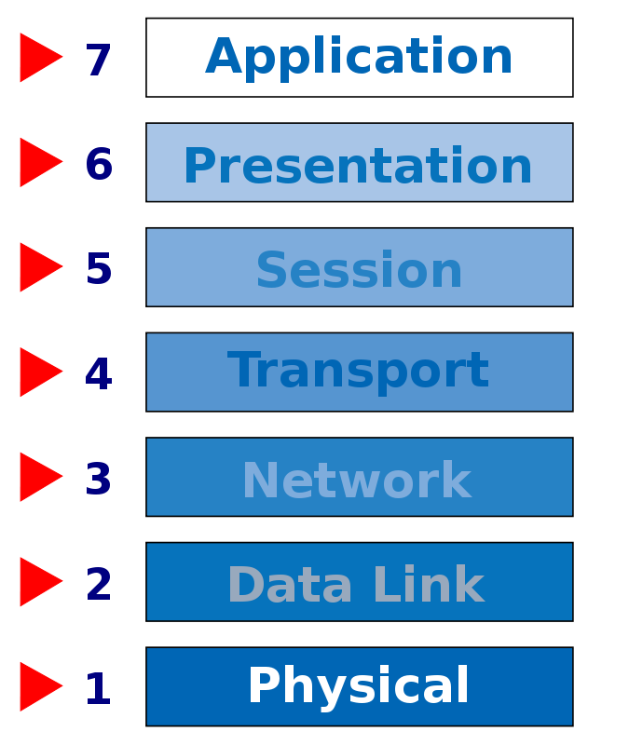

====================================================================================================

**IP Addressing**

IP addressing is a fundamental concept in computer networking that allows devices to communicate with each other over the internet or within a local network. An IP address is a unique numerical label assigned to each device connected to a network. It serves as the device's identity, enabling data to be sent to the correct destination.

**IPv4 and IPv6 addressing:**

IPv4 (Internet Protocol version 4) and IPv6 (Internet Protocol version 6) are two different versions of IP addressing.

* **IPv4 Addressing:**
  + IPv4 addresses consist of four sets of numbers, separated by dots (e.g., 192.168.0.1).
  + Each number in the address can range from 0 to 255, making a total of approximately 4.3 billion possible IPv4 addresses.
  + The rapid growth of the internet and the increasing number of devices connected to it have led to a depletion of available IPv4 addresses.
* **IPv6 Addressing:**
  + IPv6 addresses are much longer, represented as eight groups of four hexadecimal digits, separated by colons (e.g., 2001:0db8:85a3:0000:0000:8a2e:0370:7334).
  + This provides an enormous address space, with approximately 340 undecillion (3.4 x 10^38) unique IPv6 addresses.
  + The adoption of IPv6 is essential to accommodate the ever-expanding number of internet-connected devices.