**Assignment**

**Restaurant Menu Showcase**

**Objective:** Style a restaurant menu page with focus on typography, spacing, and visual hierarchy.

**Requirements:**

Apply sophisticated CSS3 styling to restaurant menu layout

CSS3 Selectors Implementation (Must Use All):

3 class selectors with different styling rules

2 ID selectors for unique elements

2 attribute selectors (e.g., [data-price], [class*="menu"])

3 pseudo-class selectors (:hover, :focus, :nth-child())

2 pseudo-element selectors (::before, ::after)

**Box Model Mastery:**

4 different margin configurations (auto centering, negative margins)

4 different padding implementations (shorthand and individual)

3 border variations (solid, dashed, with border-radius)

Box-sizing property usage with border-box

Required Styling Elements:

Ο Header with restaurant branding and hero image

Menu sections with category headers and item cards

Ο Price display with special formatting

Location and hours section with contact details

2 hover effects with smooth transitions

**Technical Requirements:**

External CSS file (no inline styles) 2

2 CSS custom properties for color scheme (4 colors minimum)

3 different box-shadow implementations

Responsive design with 2 media query breakpoints

Font styling with 2 different font families

**Deliverables:**

* HTML file with complete menu structure

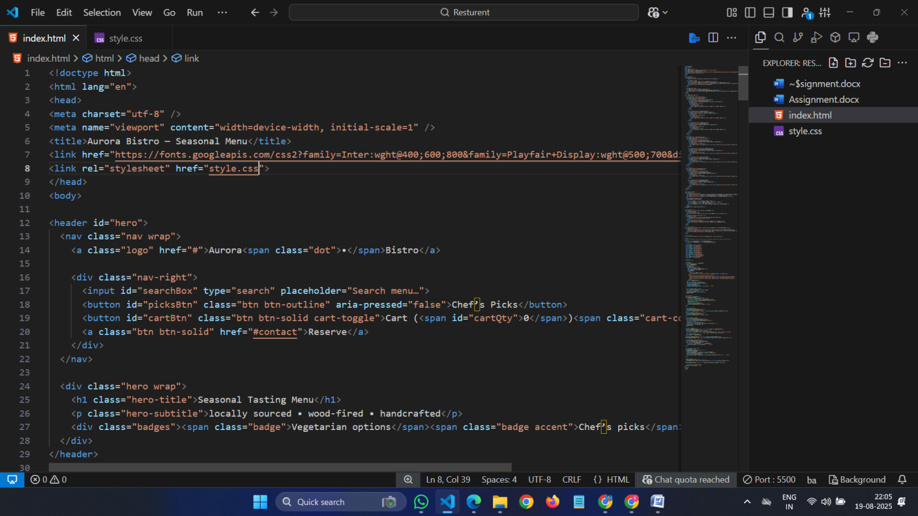

* CSS file with typography and layout styling

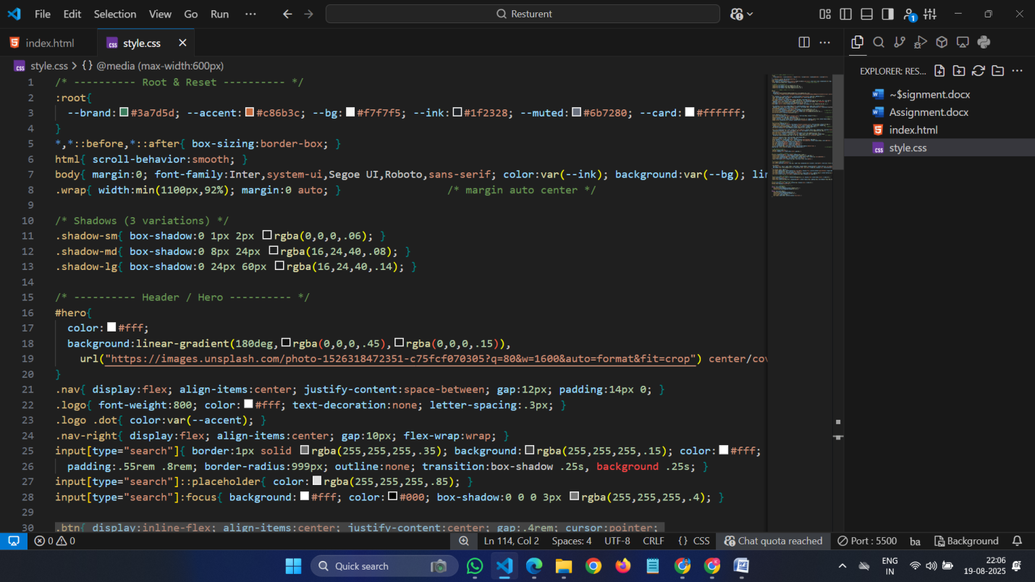

* 2 Typography style guide documentation

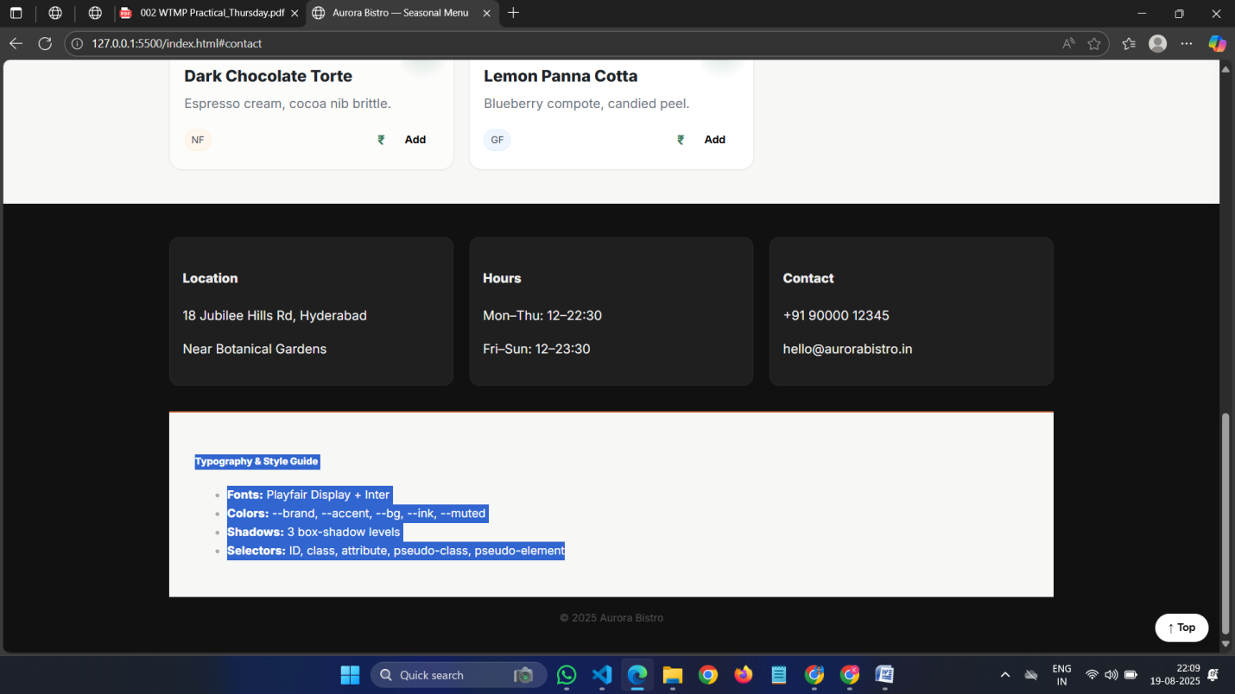

* Mobile responsiveness testing screenshots

