**Infosys Limited**

**Theia Self-Help Document for Invigilators**

***TABLE OF CONTENTS***

1. Theia Instructions………………………………………………………………………………………………………….3
2. Editor Issues………………………………………………………………………………………………………………….5
3. *Menu Items not Visible*
4. *Error in pre-implemented code*
5. *Stuck on VM preparation page*
6. Verification Tool Issues…………………………………………………………………………………………………7
7. *Verification tool shows blank screen*
8. *Verification Tool shows ‘Server error’*
9. *The extension providing Browser-preview is not capable of restoring it error*
10. *Verification Tool shows Incorrect data*
11. All Other Issues…………………………………………………………………………………………………………….9
12. *API URL’s showing Connection Rejected*
13. *Header name must be a valid HTTP token*
14. *Page Unresponsive*

**Theia Instructions:**

1. The duration of this assessment is 2 hours 15 minutes.
2. It consists of 1 Hands-on / Coding Question.
3. Open assessment in **Fullscreen** mode for better user experience.
4. To open the project explorer, click on **Explorer** icon present below the File tab.
5. 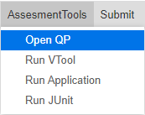To open QP, click on **‘Assessment Tool → Open QP’** once inside the container.
6. Run your code as Java Application using the button **‘Assessment Tool → Run Application’.**
7. Run your code against Junit Test Cases using the button **‘Assessment Tool → Run JUnit’.**
8. Before checking your code against APIs **make sure application is running.**
9. 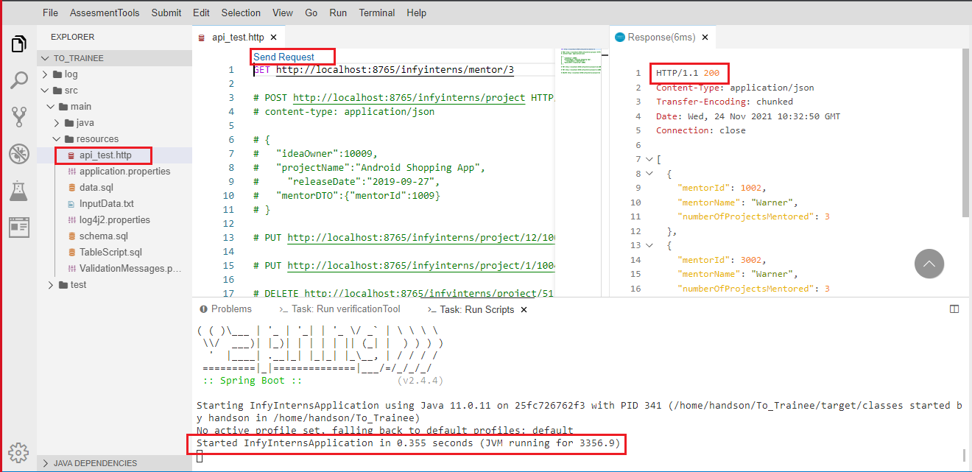Test your code against APIs from **api_test.http** file at **src/main/resources.** Uncomment the API URL that you want to check. Click on Send Request just above the URL and wait for response.
10. For **POST API Request,** uncomment the lines including data from api_test.http file at src/main/resources.
11. 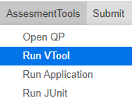Run your code against structural test cases using the button **‘Assessment Tool → Run VTool’.**
12. In case VTool or QP doesn’t get triggered in one go, please close that tab and follow the steps to relaunch it.
13. To submit, you **need to run VTool** before submitting.
14. Then click on **‘Submit → Confirm Submit’** to submit the script for it to be considered for the final evaluation. [It is **compulsory to submit** your code before finishing the test]
15. Once code is submitted successfully, come out from full screen mode and **finish test.**
16. You can **submit** your answer script **multiple times**. In that case, your **last submission** will be considered for evaluation.
17. Click on **"Start"** to proceed.
18. Inside the IDE/exam view, you may get a dialog box at the bottom right corner saying “Do you want to exclude the Hands-on Client Java project settings files (.classpath, .project. .settings, .factorypath) from the file explorer?”. Do not choose any option. Just click on the **cross symbol (X).**

**Editor Issues:**

1. 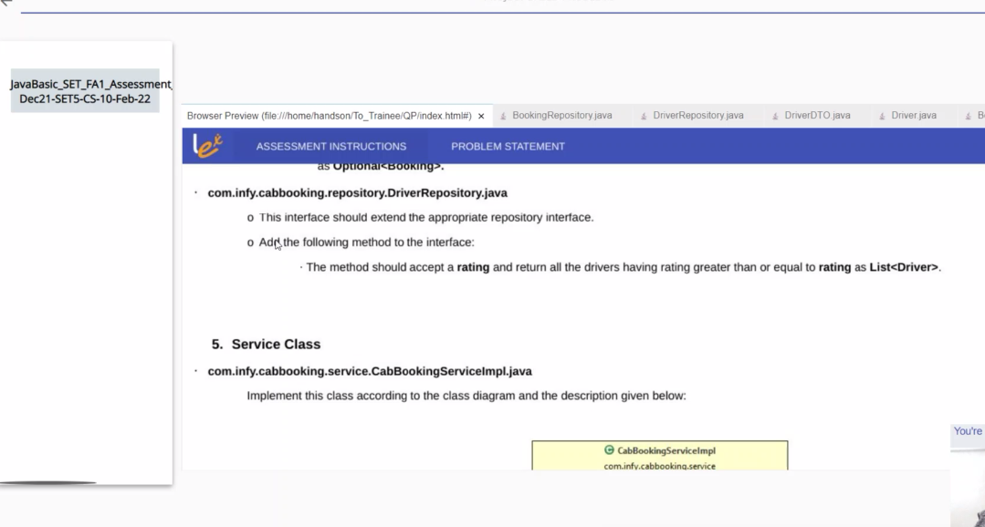**Menu Items not Visible:**  If you get the following container window with no menu items, please reload the page. you can use either “ctrl+shift+R” or press Esc and reload the browser.
2. **Error in pre-implemented code:** If any trainee encounters issues in pre-implemented code,
   1. kindly check for project structure if that is fine ask the trainee to reload the browser.
   2. If the error is still not resolved, kindly check if the submission is failed or success.

**Note:** If both solutions don’t work, kindly check error log file for error trace.

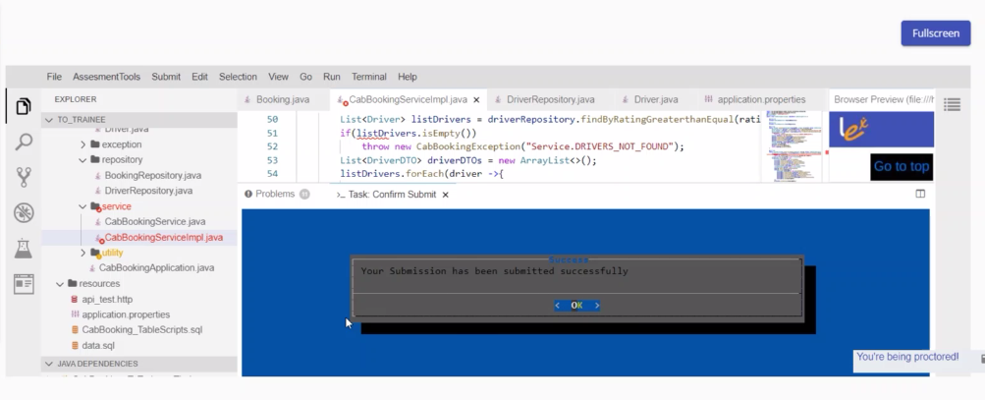

Above screenshot depicts the submission successful even when some red lines were present in the code. Page reload was not able to resolve the above issue.

1. **Stuck on VM preparation page:** Press ‘ESC’ key and reload browser, clear cookies and browsing history and start assessment again. If it is still not loading, switch to different browser or go into incognito mode and try.

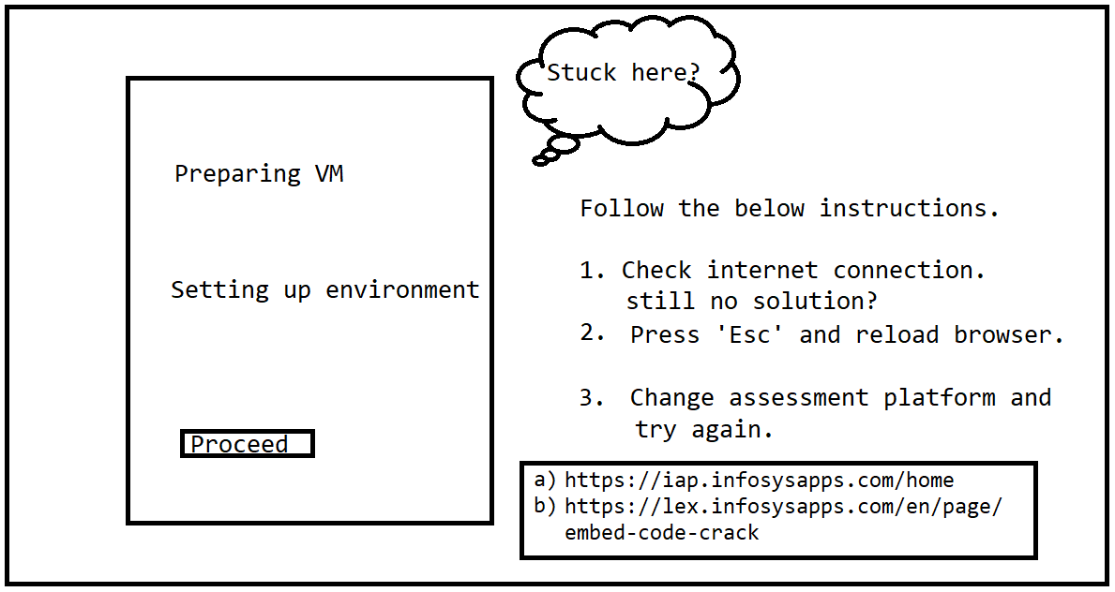  
**Note:**  Please contact [mohammed.bijly@infosys.com](mailto:mohammed.bijly@infosys.com) if issue is not resolved.

**Verification Tool Issues:**

1. **Verification tool shows blank screen:** If verification tool is shows blank screen after getting triggered, kindly follow the below steps:
2. Please close verification tool from terminal and close the VTOOL tab and trigger it again.
3. Please check if the trainee’s internet speed if fine or not.
4. Press ‘Esc’ and reload browser page again. Start with assessment and check if the issue persists.
5. 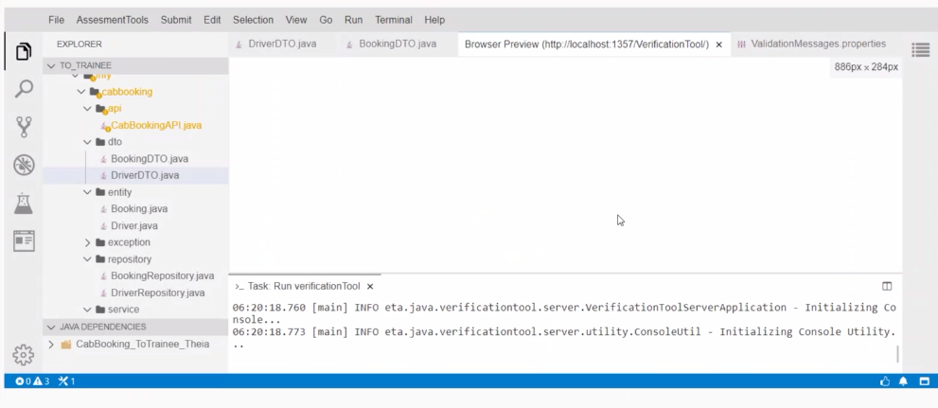If yes, then change assessment platform and try again.
6. **Verification Tool shows ‘Server error’:** Please terminate the VTOOL and run it again. If the issue persists, kindly reload the browser after pressing ‘Esc’ button.
7. 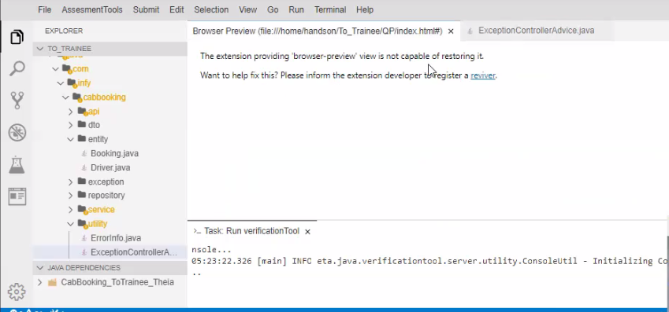**The extension providing Browser**-**preview is not capable of restoring it error:** Please terminate the VTOOL and run it again. If the issue persists, kindly reload the browser after pressing ‘Esc’ button.
8. **Verification Tool shows Incorrect data:**
9. Please terminate the VTOOL and run it again.
10. If issue persists, clear VTOOL logs and run it again. Refer the below image.
11. 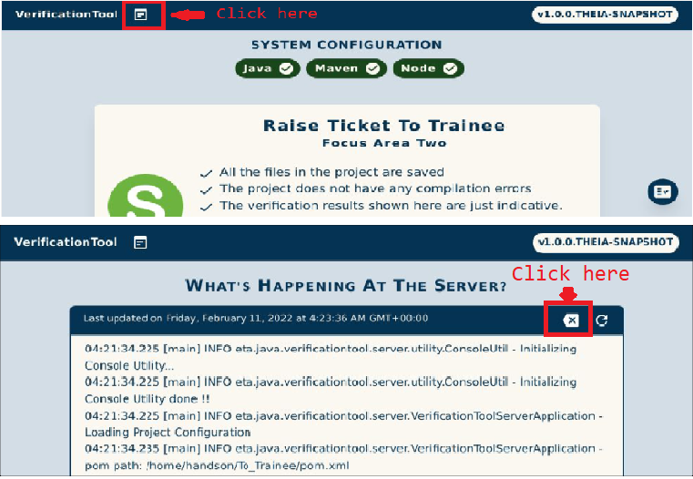 If the issue persists, kindly reload the browser after pressing ‘Esc’ button.

**All Other Issues:**

1. 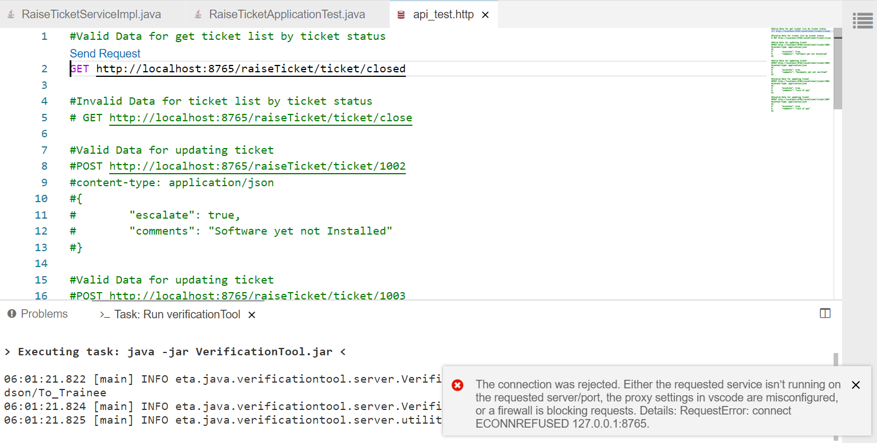**API URL’s showing Connection Rejected:** Please make sure application application is running**.** If not, please run and trigger api-url again.
2. 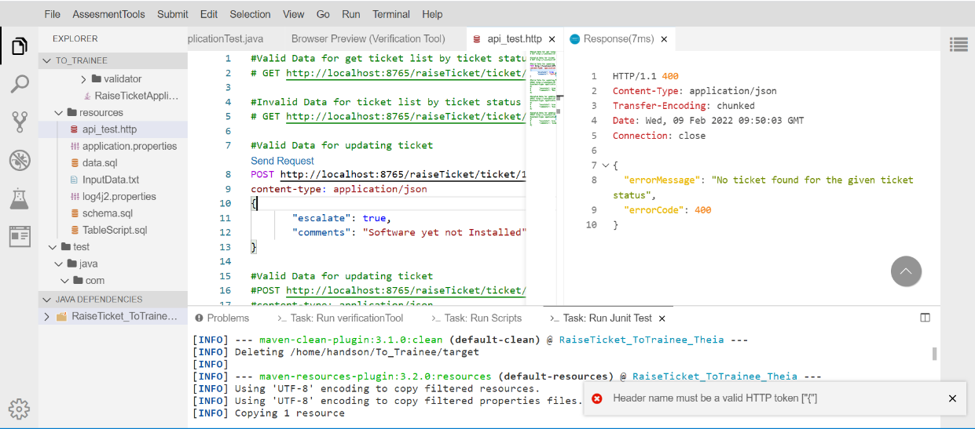**Header name must be a valid HTTP token:** It might come sometimes in Post/Put api requests. Please put a new line between ‘content-type: application/json’ and opening curly braces(‘{‘).
3. **Page Unresponsive:**  It generally happens during last few minutes of exam. Kindly wait for some time and if the page still does not load, kindly try with other browser.

* If this issue appears in the middle of examination and after reloading shows no assessments, Kindly get in touch with assessment team to resolve it.