Name: G.SAIKRISHNA

Reg.no: 9919004095

1. Write a program called CountVowelsDigits, which prompts the user for a String, counts the number of vowels (a, e, i, o, u, A, E, I, O, U) and digits (0-9) contained in the string, and prints the counts and the percentages

Program:

import java.io.\*;

public class Main

{

public static void main(String[] args) throws IOException {

BufferedReader br = new BufferedReader(new InputStreamReader(System.in));

String line = br.readLine();

int vowels = 0, digits = 0;

line = line.toLowerCase();

for(int i = 0; i < line.length(); ++i)

{

char ch = line.charAt(i);

if(ch == 'a' || ch == 'e' || ch == 'i'

|| ch == 'o' || ch == 'u') {

vowels++;

}

else if( ch >= '0' && ch <= '9')

{

++digits;

}

}

System.out.println("Vowels: " + vowels);

System.out.println("the percentage of vowels "+ (((float)vowels/(float)line.length())\*100));

System.out.println("Digits: " + digits);

System.out.println("the percentage of vowels "+ (((float)digits/(float)line.length())\*100));

}

}

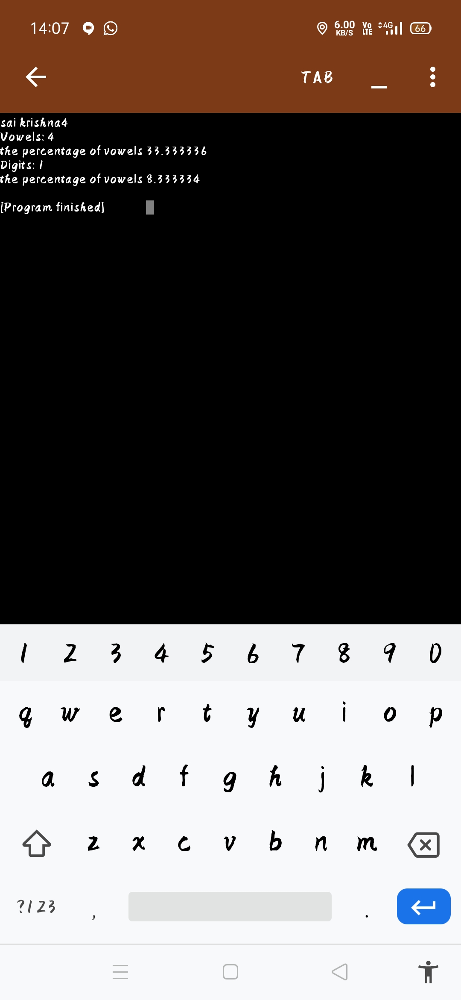

2. Write a program called ReverseString, which prompts user for a String, and prints the reverse of the String by extracting and processing each character.

Program:

import java.io.\*;

public class MyClass {

public static void main(String args[]) throws IOException {

BufferedReader br=new BufferedReader(new InputStreamReader(System.in));

String s=br.readLine();

MyClass mc=new MyClass();

String r=mc.ReverseString(s);

System.out.println("Given String is : "+s);

System.out.println("Reverse String is : "+r);

}

String ReverseString(String s)

{

String rev="";

for(int i=s.length()-1;i>=0;i--)

rev=rev+s.charAt(i);

return rev;

}

}

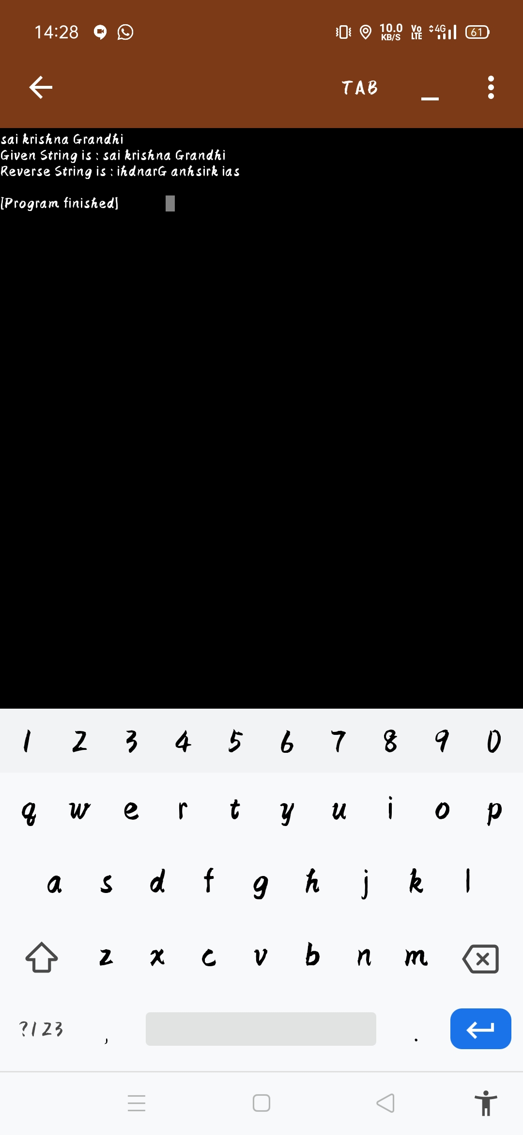

3. Write a Java Program that reads a line of integers, and then displays each integer, and the sum of all the integers

Program:

import java.io.\*;

import java.lang.\*;

import java.util.\*;

public class Main

{

public static void main(String[] args) throws IOException {

BufferedReader br = new BufferedReader(new InputStreamReader(System.in));

String line = br.readLine();

int sum=0;

String even="";

for(int i =0;i<line.length();i++){

if(Character.isDigit(line.charAt(i)))

sum += Integer.parseInt(Character.toString(line.charAt(i)));

}

System.out.println("the sum is "+ sum);

}

}

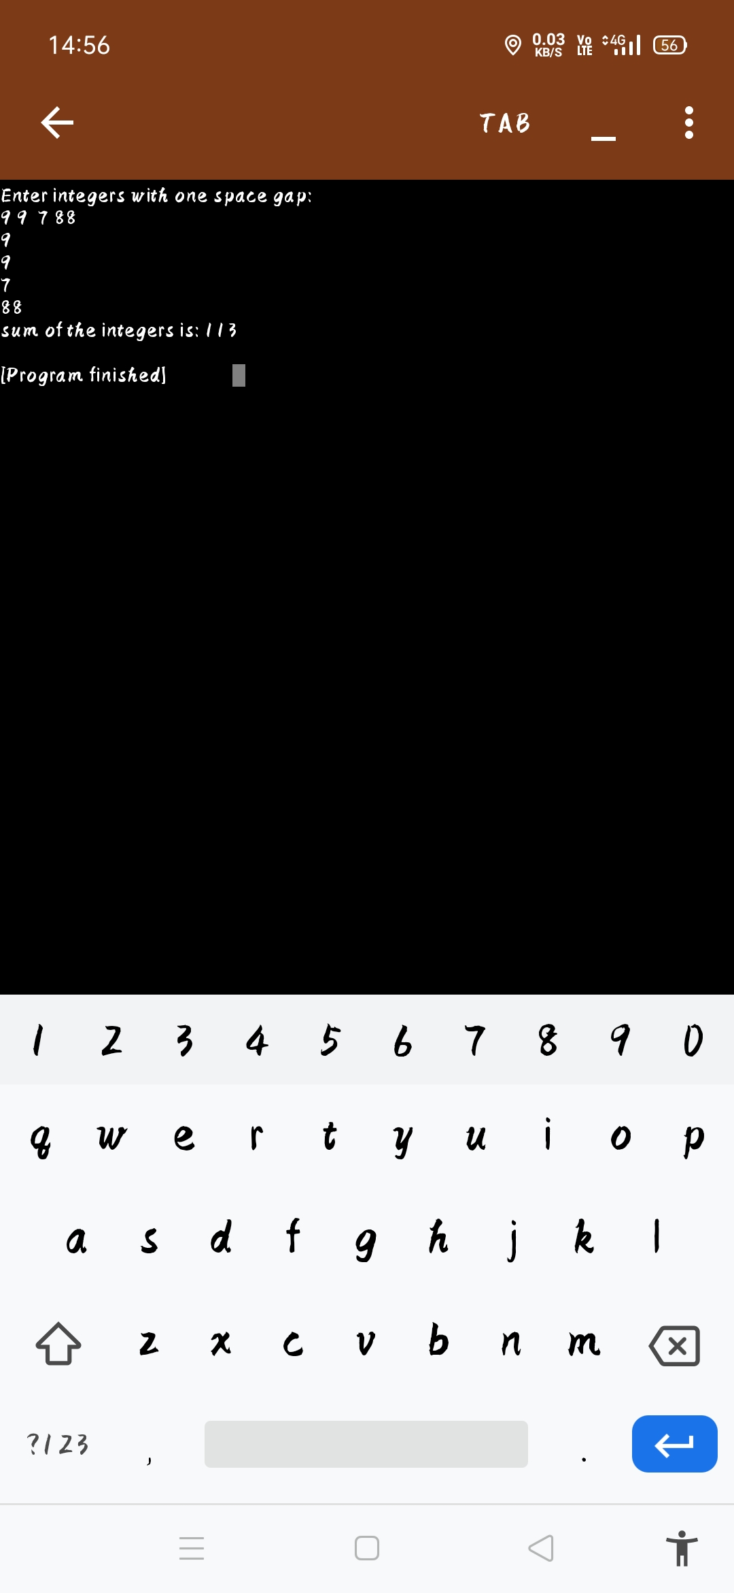

4. Write a Java program to return the sum of the digits present in the given string. If there is no digits the sum return is 0.

Program:

import java.util.\*;

public class Main

{

public int sumOfDigits(String stng)

{

int l = stng.length();

int sum = 0;

for (int i = 0; i < l; i++)

{

if (Character.isDigit(stng.charAt(i)))

{

String tmp = stng.substring(i,i+1);

sum += Integer.parseInt(tmp);

}

}

return sum;

}

public static void main (String[] args)

{

Main m= new Main();

String str1 = "jayachandrapal120";

System.out.println("The given string is: "+str1);

System.out.println("The sum of the digits in the string is: "+m.sumOfDigits(str1));

}

}

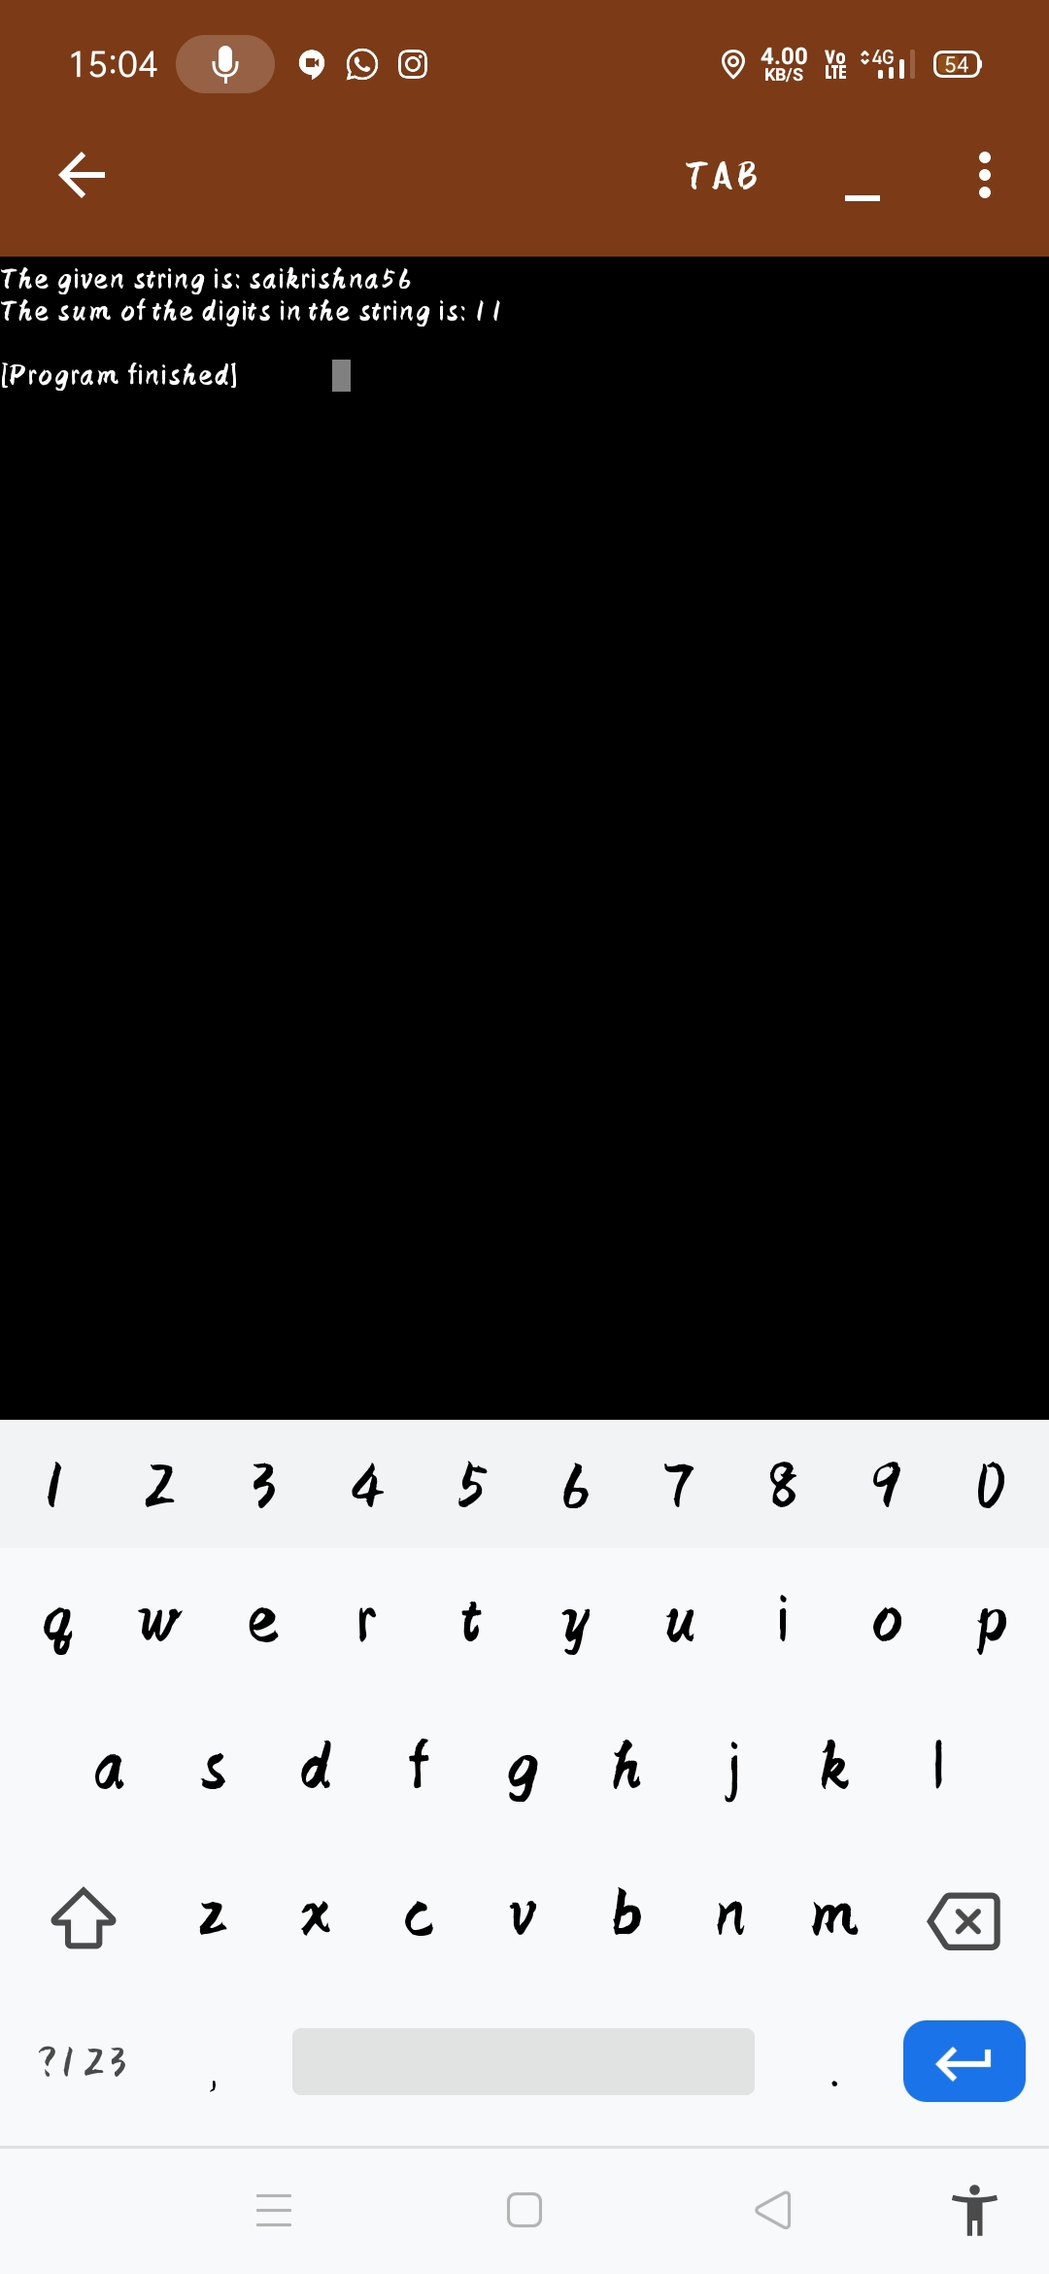

5. Write a Java program to return a new string using every characters of even positions from a given string. (

Program:

import java.io.\*;

import java.lang.\*;

import java.util.\*;

public class Main

{

public static void main(String[] args) throws IOException {

BufferedReader br = new BufferedReader(new InputStreamReader(System.in));

String line = br.readLine();

int sum=0;

String even="";

for(int i =0;i<line.length();i++){

if(Character.isDigit(line.charAt(i)))

sum += Integer.parseInt(Character.toString(line.charAt(i)));

}

System.out.println("the sum is "+ sum);

for(int i =0;i<line.length();i+=2){

even+=line.charAt(i);

}

System.out.println("the even string is "+ even);

}

}

