1. Write a Java program to sort a list of names in ascending order.

Program:

import java.io.\*;

public class Main

{

public static void main(String[] args) throws IOException{

String name[] = new String[5];

String temp="";

int i=0;

BufferedReader br = new BufferedReader(new InputStreamReader(System.in));

for(i=0;i<5;i++){

name[i]=br.readLine();

}

for (i = 0; i < 5; i++)

{

for (int j = i + 1; j < 5; j++)

{

if (name[i].compareTo(name[j])>0)

{

temp = name[i];

name[i] = name[j];

name[j] = temp;

}

}

}

System.out.println("names in alphabetical order");

for(i=0;i<5;i++){

System.out.println(name[i] + " ");

}

}

}

Output:

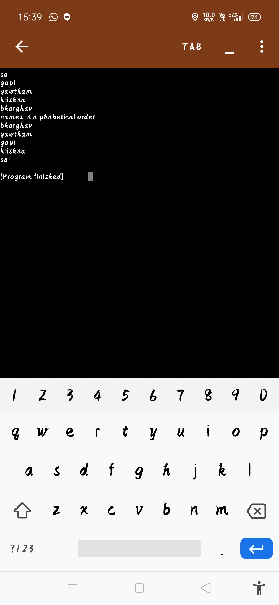

2. Write a Java program to concatenate a given string with itself of a given number of times.

import java.io.\*;

public class Main

{

public static void main(String[] args) throws IOException{

String name;

String temp="";

int n;

int i=0;

BufferedReader br = new BufferedReader(new InputStreamReader(System.in));

name=br.readLine();

n = Integer.parseInt(br.readLine());

for(i=0;i<n;i++){

temp+=name;

}

System.out.println("printing name as given no of times " + temp);

}

}

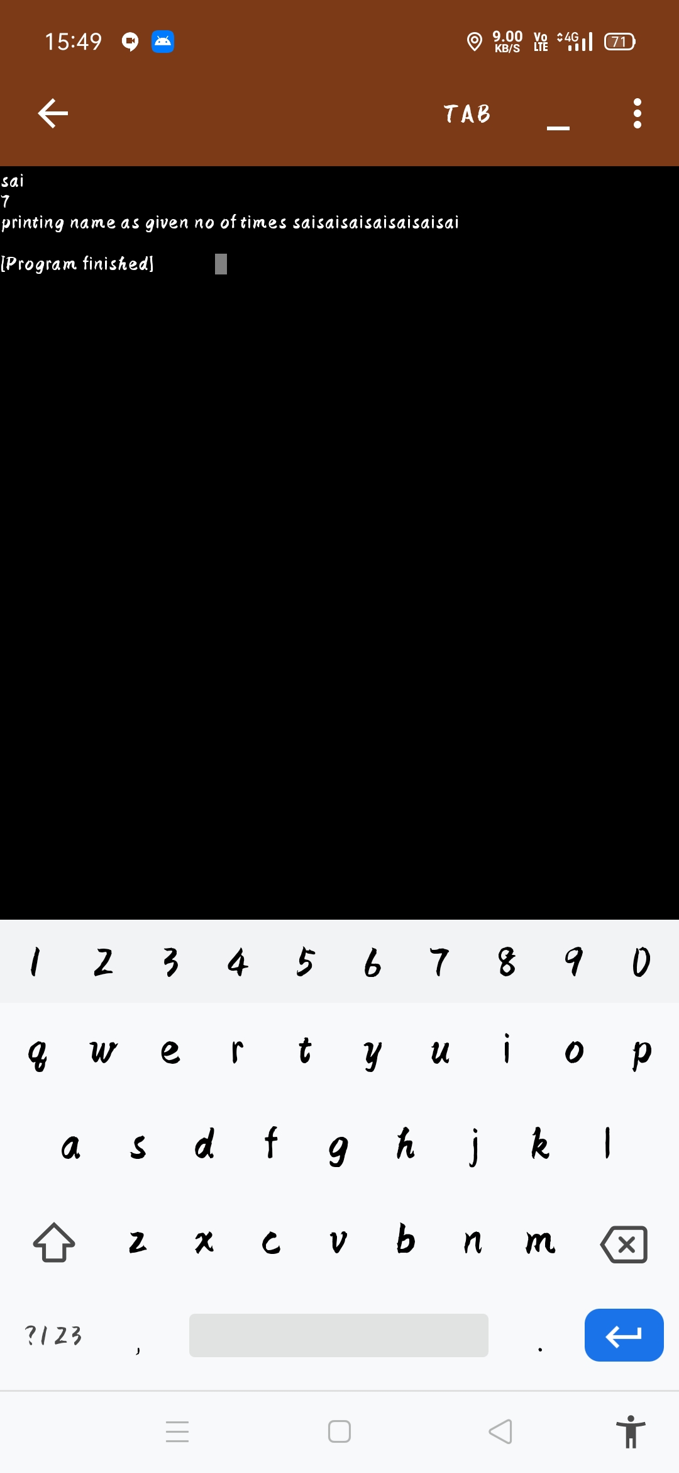

3. Write a Java program to counts occurrences of a certain character in a given string.

Program:

import java.io.\*;

public class Counting{

public static void main(String[] args) throws IOException{

int count = 0, i;

char ch;

BufferedReader br= new BufferedReader(new InputStreamReader(System.in));

String str = br.readLine();

ch = br.readLine().charAt(0);

for(i = 0; i < str.length(); i++){

if(str.charAt(i) == ch){

count++;

}

}

System.out.println("Total occurences of " + ch + " is "+ count);

}

}

