Program 1:-
interface Shape{
double pi =3.14;
public double perimeter();
public double area();
}

class Circle implements Shape{
float radius;
Circle(float r){
radius = r;
}
public double area(){
return pi*radius*radius;
}
public double perimeter(){
return 2*pi*radius;
}
}
class Ecllipse implements Shape{
float a,b;
Ecllipse(float a,float b){
this.a = a;
this.b=b;
}
public double perimeter(){
return (2*pi*Math.sqrt(a*a+b*b));
}
public double area(){
return pi*a*b;
}
}
public class Main
{
public static void main(String[] args) {
Circle c = new Circle(5.0f);
Ecllipse e = new Ecllipse(6.0f,7.0f);
System.out.println("area of circle is "+ c.area());

System.out.println("area of ellipse is "+ e.area());

System.out.println("perimeter of circle is "+ c.perimeter());
System.out.println("perimeter of ecclipse is "+ e.perimeter());
}
}
You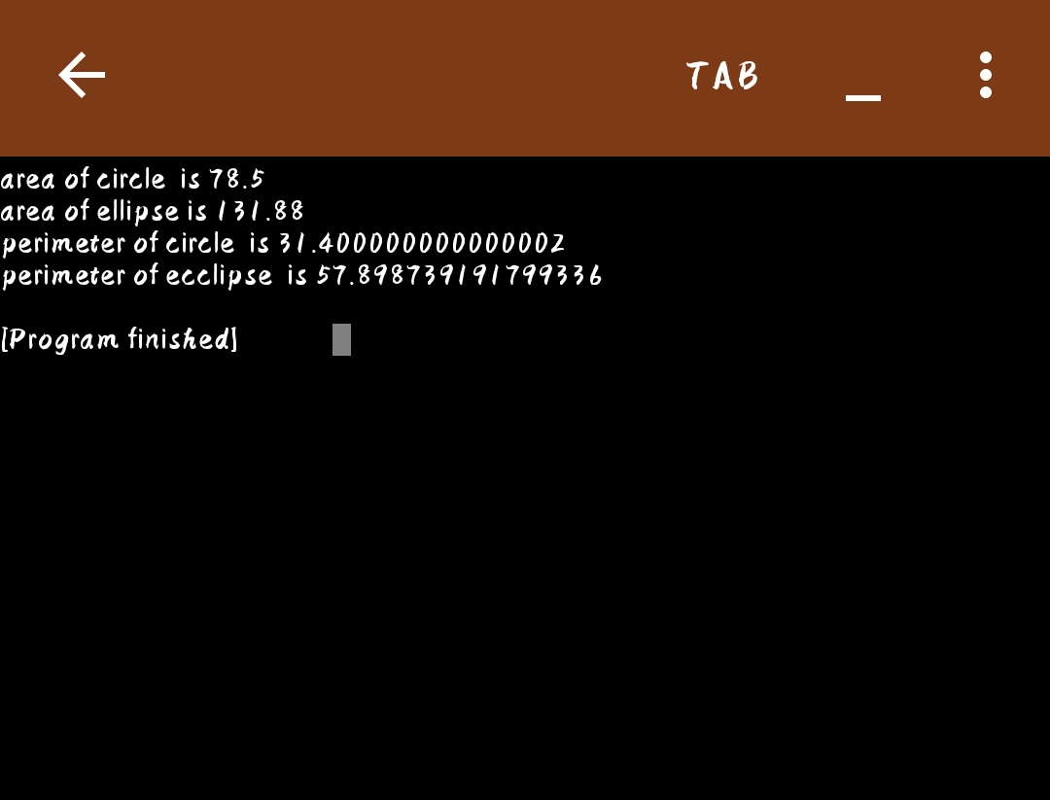
2.Design a vehicle class that contains the following properties of motor vehicles:
Fuel tank capacity, average fuel consumption per 100 km and the distance a
vehicle can travel on a full tank. The vehicle class should be designed as a base
class from which the Car and Truck classes are derived. The derived classes
should have following member functions.
A function that contains data for a vehicle from the user
• A function that computes and returns the distance a vehicle can travel on a
full tank.
• A function that computes and returns how many times a vehicle has to be
refueled to travel a given distance.
Test the class in main method:
class Vehicle{
int capacity;
float consumption, distance;
Vehicle(int a,float b, float c){
capacity=a;
consumption=b;
distance=c;
}
}
class Car extends Vehicle{
Car(int a, float b, float c){
super(a,b,c);
}
float compute_dist(){
float d=capacity*consumption/100;
return d;
}
float compute_fuel(int d){
return (distance*100)/(consumption);
}
}
class Truck extends Vehicle{
Truck(int a, float b, float c){
super(a,b,c);
}
float compute_dist(){
float d=capacity*consumption/100;
return d;
}
float compute_fuel(int d){
return (distance*100)/(consumption);
}
}

public class Vehicle_main
{
public static void main(String[] args) {
Car c = new Car(35,25.0f,20.0f);
System.out.println("Distance covered by Car: "+ c.compute_dist()+" km\n"+"Fuel Consumed by Car: "+c.compute_fuel(5)+" litres");
Truck t= new Truck(55,25.0f,40.0f);
System.out.println("\nDistance covered by Truck: "+ t.compute_dist()+" km\n"+"Fuel Consumed by Truck: "+t.compute_fuel(15)+" litres \n");
}
}
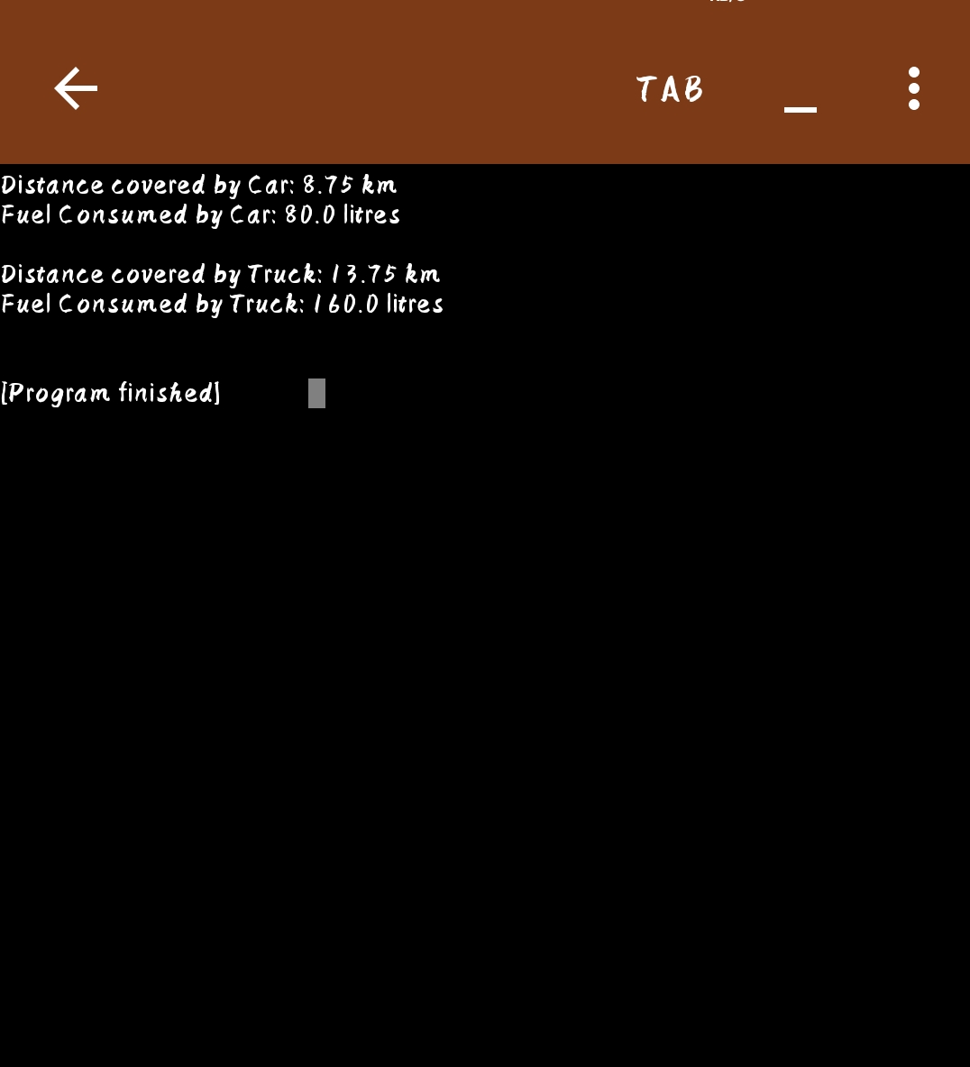.
Program 3:
class Student
{
int regno;
String name, dept;
Student(int rno, String name, String dept)
{
regno = rno; this.name=name; this.dept =dept;
}
void display()
{
System.out.print(regno + " "+ name + " "+ dept);
}
}

class Test extends Student
{
int marks[];
Test(int r, String n, String d, int m[])
{
super(r,n,d);
marks = m;
}
}
class Result extends Test
{
Result(int r, String n, String d, int m[])
{
super(r,n,d,m);
}
void printResult() {
display();
int sum = 0;
for (int i =0; i< marks.length; i++)
sum += marks[i];
System.out.println(" Total Marks: "+ sum + " Average = " + (sum/5.0) );
}
}

public class TestMain
{
public static void main(String arg[])
{
int mark[]= {67,89,98,76,87};
Result r = new Result(4045, "saikrishna", "CSE", mark);
r.printResult();
int mark2[] = {86,98,76,89,77};
Result r2 = new Result(4055," deva kiran", "CSE", mark2);
r2.printResult();
}
}
