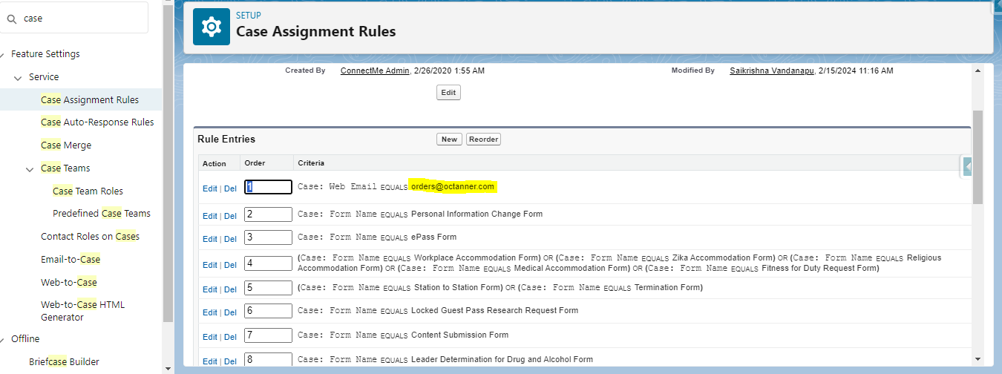

Added Case routing rule address [orders@octanner.com](mailto:orders@octanner.com) – PASS

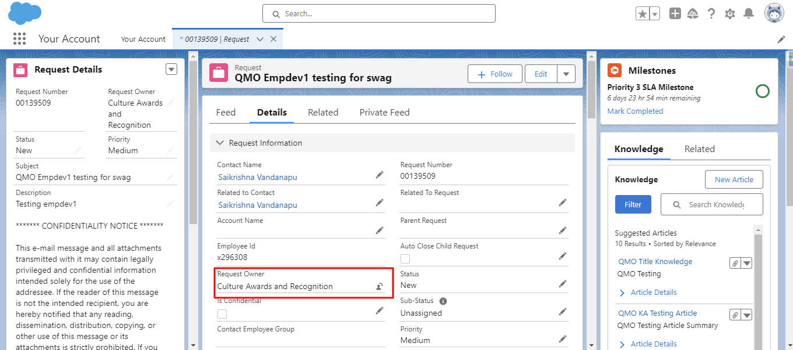

Tested with personal email address, the case is routed to correct queue “Culture Awards and Recognition” – PASS

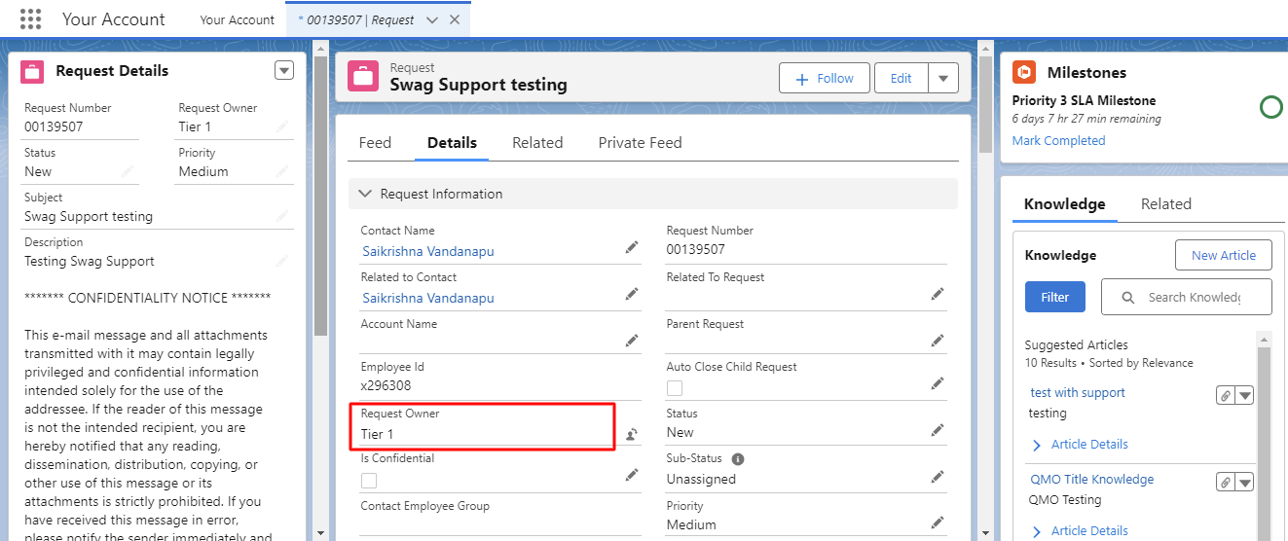

Tested “SWAG Report” Email to case scenario , the case routed to correct queue “Tier 1” - PASS