Software Requirements Specification
for
Project VIBHAV
Version 1.0

Prepared by
DEEPJUN DASGUPTA M190537CS
GAURAV KUMAR NAGAR M190496CS
GUDIPATI SAI KRISHNA M190241CS
GURPREET KAUR M190183CS

organization
Department of Computer Science and Engineering
NIT Calicut
date created
03/09/2019
1. Introduction
1.1 Purpose
This document aims at defining the overall software requirements for the VIBHAV project. The final project will be having only features mentioned in this document and assumption for any additional features should not be made by any of the parties. This site will provide different functions like ordering of vegetables by students and faculties. It has the facility to order in advance using their college id and they can also cancel their order if required.After booking if they didn’t collect the item, they will be automatically added into the black list.
1.2 Project Scope
VIBHAV Project can be used by the students and faculties for ordering the vegetables. Through this site, students and faculties will be benefited. They can order vegetables from their place and collect it later. Vibhav can also make money using this site.

2. Overall Description
2.1 Product Perspective
The site is useful for the students and the faculties. It will provide the flexibility to order vegetables from their place. In order to place the order,new users should have to register on the website by entering their details like Name, Department Name, Course/Duty, College Id, Phone number and Residential address. After registering they can order vegetables if available. They also have the facility to order in advance. They can also cancel their order if they wish to but before 1’O clock.
After booking if they did not collect the item, then they will be added automatically to the black list and they are not allowed to order until they are allowed by administrator(Vibhav).
2.2 Product Functions
2.2.1 User Functions
- User Registration
- Booking Order
- Cancel Order
2.2.2 Admin Functions
- Admin Login
- Admin Controller(Add/Update/Delete)
- Order Status
- Blaclist

2.3 User classes and characteristics
There are two different user for the website:
- Administrator: Admin can add the quantities of the vegetables in the database. He can also add and remove the user from the blacklist.
- Student/ faculties: They are allowed to register by entering their details. They are allowed to book vegetables and can also cancel their order.
2.4 Operating Environment
- Web Browser: Chrome,FireFox,Safari
2.5 Design
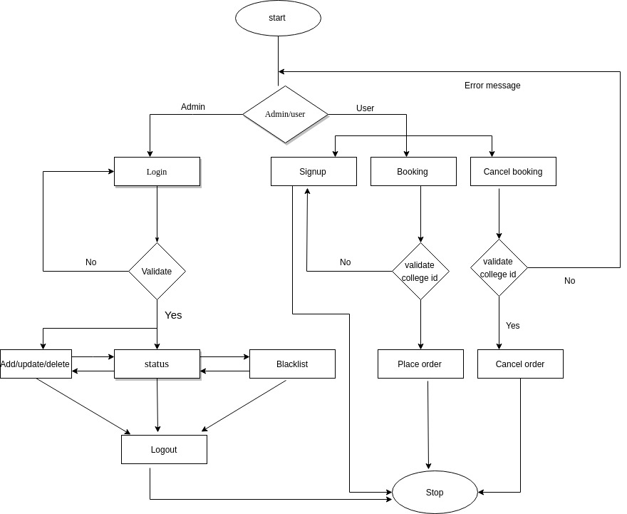
3. External Interface Requirements
3.1 User Interfaces
- Welcome page: There will be option to continue as a admin or as a user (student/faculty).
- Signup page: New users are required to register by entering their details.
- Booking page: Availabe vegetables will be shown with their prices.
- Admin page: Here admin will login using his user id and password. And after logging in he will be able to add, delete or alter the quantities of vegetables and can also delete the user from the blacklist.
3.2 Hardware Interface
- Screen resolution of atleast 800*600 required for proper viewing of pages.
- Support for printers like dot-matrix/ desk jet/ ink jet etc. are required for printing the receipt.
- Standalone system to run the system.
3.3 Software Interface
- Platform: Independent
- Tools: Ruby 2.6.3, Rails 6.0.0, Sublime Text
- Database: Mysql.

4. System Features
4.1 Signup
Users can signup before logging in so that they can order vegetables. Without signup no new user can place order.
4.2 Booking Order
After logging in user can see the vegetables available in the store and can place his order providing valid College id. While placing order without signup the user is redirected automatically to the signup page.
4.3 Cancel Order
The user can cancel his order before 1’O clock providing valid college id after that he can not cancel his order.

4.4 Admin Login
Vibhav can login into the admin page by providing his username and password.
4.5 Admin Controller
Vibhav can add/update/delete the name,quantity and price of the vegetables.
4.6 Order Status
Vibhav can check the current orders that are placed and can acknowledge if its delivered or else by the end of the day the unacknowledged orders placed by the users are added automatically to the blacklist.
4.7 Blacklist
Vibhav can view the blacklisted users and can also delete them from blacklist if required.

5. Other non functional requirements :
5.1 Performance Requirements:
In order to book vegetables in advance, users have to order them before 1’O clock. After advance booking if the user does not collect the item then that user will be added in the black list.
5.2 Safety Requirements:
- Emergency phone number or email id should be provided to solve the queries or doubts of the users of the website.
- Website will be kept updated.
5.3 Security Requirements
- Users are required not to disclose their college id.
- While using the website if users find something wrong they are adviced to contact the administrator.

