**VISVESVARAYA TECHNOLOGICAL UNIVERSITY**

**“Jnana Sangama”, Belgaum -590014, Karnataka.**



**PROJECT WORK-1 REPORT**

**on**

**PROJECT TITLE**

***Submitted by***

**NAME (1BM11CS111)**

**NAME (1BM11CS111)**

**NAME (1BM11CS111)**

**NAME (1BM11CS111)**

***Under the Guidance of***

|  |  |
| --- | --- |
| **Mrs. Lakshmi Neelima**  **Assistant Professor, BMSCE** |  |

***in partial fulfillment for the award of the degree of***

**BACHELOR OF ENGINEERING**

***in***

**COMPUTER SCIENCE AND ENGINEERING**



**B.M.S. COLLEGE OF ENGINEERING**

**(Autonomous Institution under VTU)**

**BENGALURU-560019**

**FEB 2023**

**B. M. S. College of Engineering,**

**Bull Temple Road, Bengaluru 560019**

(Affiliated To Visvesvaraya Technological University, Belgaum)

**Department of Computer Science and Engineering**



**CERTIFICATE**

This is to certify that the project work entitled “**PROJECT TITLE**” carried out by **NAME (1BM11CS111), NAME (1BM11CS111), NAME (1BM11CS111) AND NAME (1BM11CS111)** who are bonafide students of **B. M. S. College of Engineering.** It is in partial fulfillment for the award of **Bachelor of Engineering in Computer Science and Engineering** of the Visveswaraiah Technological University, Belgaum during the year 2022-23. The project report has been approved as it satisfies the academic requirements in respect of **Web Application Development (21CS3AEWAD)** work prescribed for the said degree.

Signature of the Guide                 Signature of the HOD

Dr. Selva Kumar S Dr. Jyothi S Nayak

Assistant Professor Prof & Head of Dept of CSE

BMSCE, Bengaluru BMSCE, Bengaluru

External Viva

Name of the Examiner                                                                                       Signature with date

1._____________________________ ________________________

2. _____________________________ _________________________

**B.M.S. College of EngineerinG**

**DEPARTMENT OF COMPUTER SCIENCE AND ENGINEERING**



***DECLARATION***

We, AAAA (1BM15CS001), BBBB (1BM15CS002), CCCC (1BM15CS003), DDDD (1BM15CS004), students of 3rd Semester, B.E, Department of Computer Science and Engineering, BMS College of Engineering, Bangalore, hereby declare that, this Web Application Development entitled "Project Title" has been carried out by us under the guidance of Dr. Selva kumar S, Assistant Professor, Department of CSE, BMS College of Engineering, Bangalore during the academic semester Oct-Feb 2022-23.

We also declare that to the best of our knowledge and belief, the development reported here is not from part of any other report by any other students.

Signature

AAAA (1BM15CS001)

BBBB (1BM15CS002)

CCCC (1BM15CS003)

DDDD (1BM15CS004)

**TABLE OF CONTENTS**

|  |  |  |
| --- | --- | --- |
| **CHAPTER NO.** | **TITLE** | **PAGE NO.** |
| 1 | **Introduction** | 1 |
| 1.1 | Overview | 1 |
| 1.2 | Motivation | 1 |
| 2 | **Software Requirement Specification** | 2 |
| 2.1 | Hardware Requirements | 2 |
| 2.2 | Software Requirements | 2 |
| 3 | **User Interface Design** | 3 |
| 3.1 | Login screen | 3 |
| 3.2 | Home Page | 4 |
| 3.3 | Configuration Page | 5 |

**Chapter 1**

**INTRODUCTION**

**1.1 Overview**

Face recognition is an important research problem spanning numerous fields and disciplines. This is because face recognition, in additional to having numerous practical applications such as bankcard identification, access control, Mug shots searching, security monitoring, and surveillance system, is a fundamental human behavior that is essential for effective communications and interactions among people. Maintenance of student attendance is the most difficult task in various institutions. Every institution has its own method of taking attendance such as using attendance sheet or by using some biometric methods. But these methods consumes a lot of time. Mostly student attendance is taken with the help of attendance sheet given to the faculty members. This consumes a lot of work and time. We do not know whether the authenticated student is responding or not. Calculation of consolidated attendance is another major task which may cause manual errors. In some other cases the attendance sheet may become lost or stolen by some of the students. To overcome such troubles we are in need of automated attendance management system.

**1.2 Motivation**

Our major advantages can be summarized as follows:

(1) Eliminating Proxy. We are preventing students by giving proxy and also are using blink detection module so that a students face on phone is not detected as face.

(2) Time, Effort and cost Saving Since our system is automated, the lecturer does not need to spend time in manually taking attendance, thereby saving time and effort. As we are not using any extra hardware, cost involved is reduced.

(3) Tighter security Facial biometric time tracking allows you to not only track employees but also add visitors to the system so they can be tracked throughout the worksite. Access can be denied to any person not in the system.

(4) Easy Integration Process Biometric facial recognition technology can be easily programmed into your time and attendance system

(5) Individual tracking: This application detects the employee’s face and compares it with the individual facial database, then reports the identification of the employee. This method demonstrates not only the improvement in the process’s reliability but also the efficiently cheating prevention. Moreover, this application also presents the economical implementation, easy installations as well as real-time detection.

**Chapter 2**

SOFTWARE REQUIREMENTS

**2.1 Hardware Requirements:**

* A PC with the following or greater specifications:
  + Intel Core i7 (6th gen or higher)
  + 8 GB RAM
  + 500 GB Hard Drive
* A stable internet connection (2Mbps or higher).

**2.2 Software Requirements:**

* Operating system : Windows 10
* Technologies : HTML, CSS, Javascript
* IDE : Atom
* Database : MySQL

**Chapter 3**

USER INTERFACE DESIGN

**1. Login Screen**

This online submission system supports following users

a. Student

b. CS Office staff

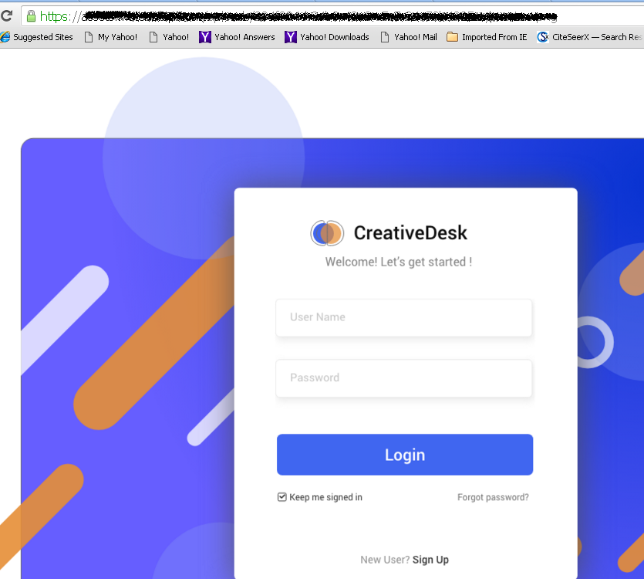

**Fig.1 Login Screen**

**2. Home Page Sceen**

**Functionalities under Student login**

i. Can register for 7th semester subjects through blogs

ii. Display of the list of subjects registered

**Functionalities under CS office staff login**

1. Display of the list of students registered
2. Statistics of Student registration

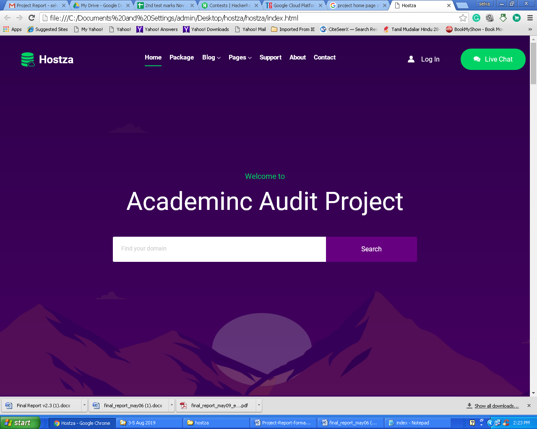

Fig.2 Home Page

**3. Configuration Page .. etc.**