Assignment

2) Navigate to the home directory.
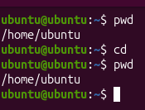

3) Create a new directory.
Mkdir --->help us to create the directory(linux we call it as directory and window we call it as folder)
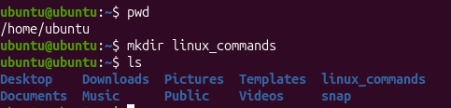
4) Change the current directory.
cd - change directory - (in linux, to c the directory use cd and the thing - cd desktop(use tab- if it is unique)
cd .. - to go back one step (from desktop location to sai location)
cd ../.. - two steps back.
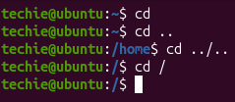
5) Create a new empty file.
create a file with size zero(command with size and zero) - using Touch command
touch newfile
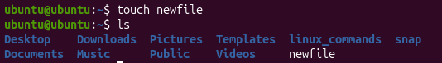
6) Copy a file to another location. 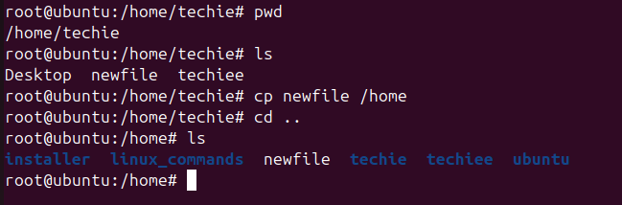
- Rename a file.
mv sai.txt sai_krishna.txt(mv can be used both for moving and renaming)
- Delete a file.
rm -rf sai krishna - it will delete(before deleting , make sure it should be properly checked)
- View the running processes.
Ps -ef (consists of process id
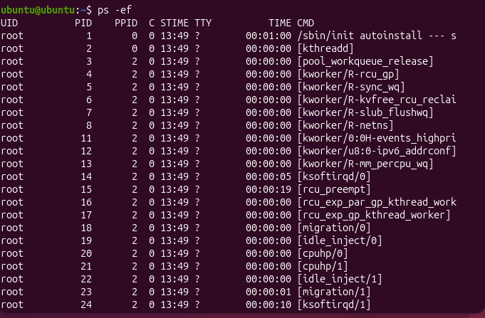
11. Kill a running process.
if u want to stop the service, if it is not working - then we will use
sudo kill -9 process id) --don't use unnecessarily) - bcoz all the sudden it will stop the process, chances that ur files might get corrupted or u might not be able to restart the service.
12. Current date and time

13. Check the system uptime.
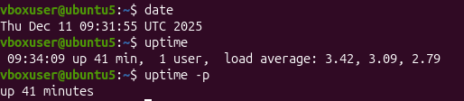
14. Update the system packages.
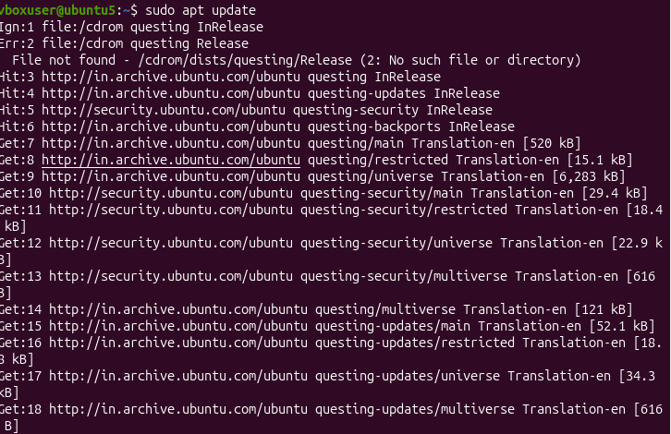
- . Create a symbolic link.
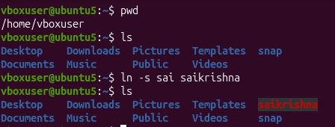
- . Monitor system resources with top or htop.
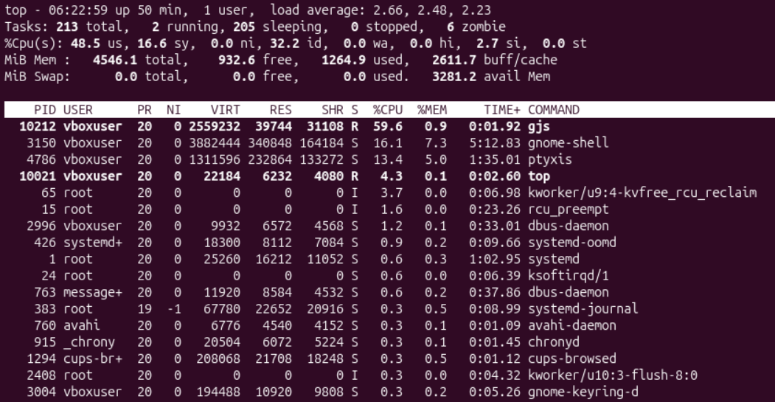
- Create and manage user groups.
- Set up SSH password less authentication.
- Monitor log files using tail or grep.
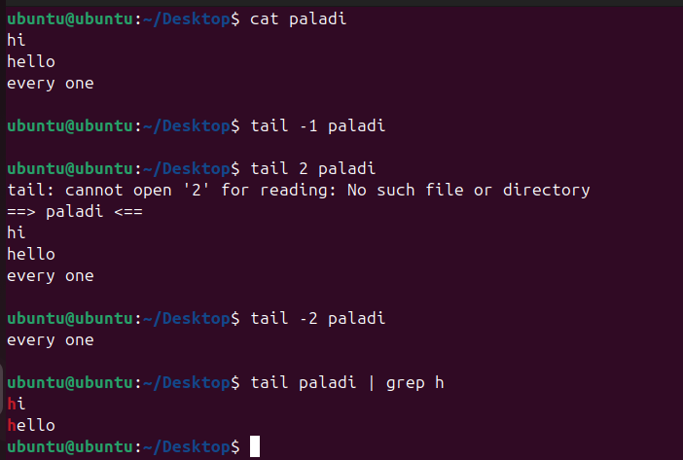
- . Filter and print lines based on a specific pattern or condition.
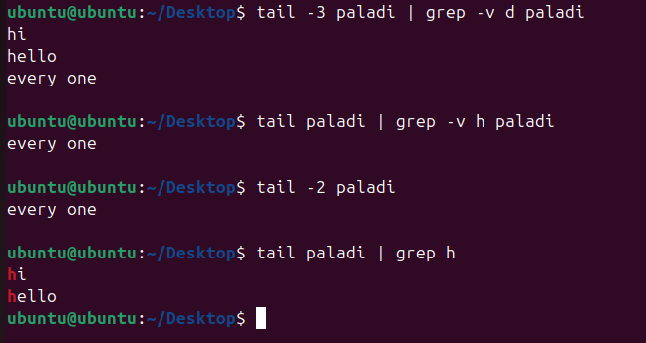
- Count the occurrences of a specific pattern in a file
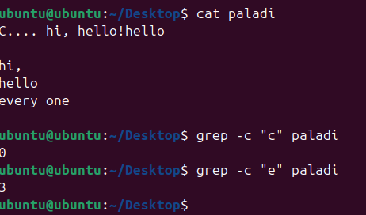
- Create user with name Techie and provide sudo access to user.
Steps to do this task:
Switch to root user using command sudo su
type the command: adduser techiee
Then it asks password so enter password
Then switch to techiee user and try using sudo command ex: sudo apt-get update.
It throws error because techiee user doesn’t have sudo access to give sudo access to techiee user open sudoers file using sudo visudo command then add the details like
techiee ALL=(ALL:ALL) ALL Under this line
sudo ALL=(ALL:ALL) ALL
Then exit editer And check user has sudo access or not
Switch to techiee :su techiee
Sudo apt-get update
Then it works
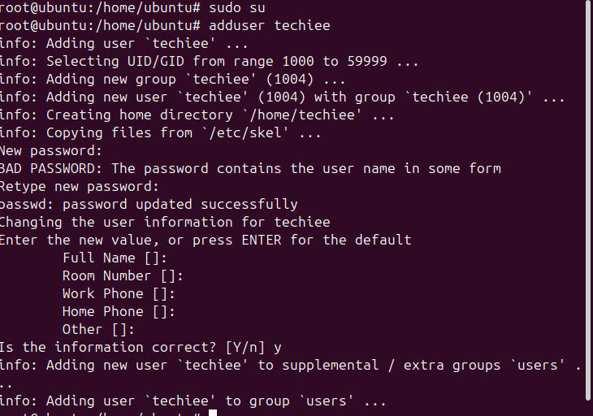
- View the contents of a file.
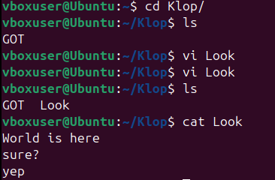
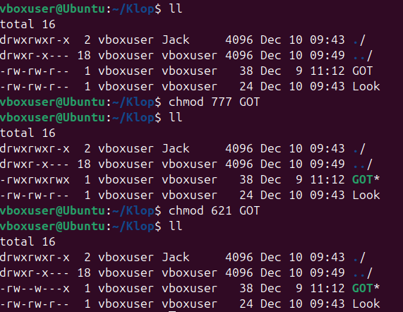
- Grant or revoke permissions on a file or directory.
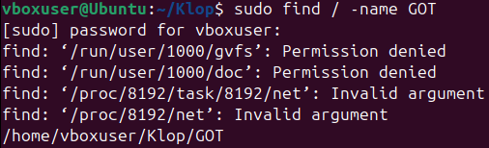
- Search for files using the find command.
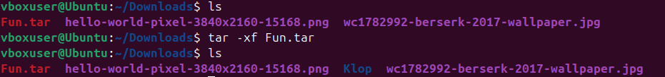
- Sort lines based on a specific field or column.
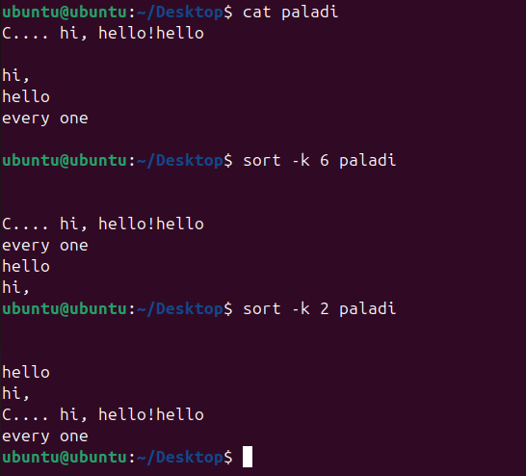.21. Compress and decompress files using tar.

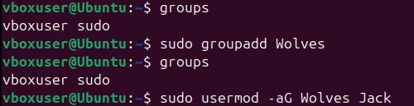
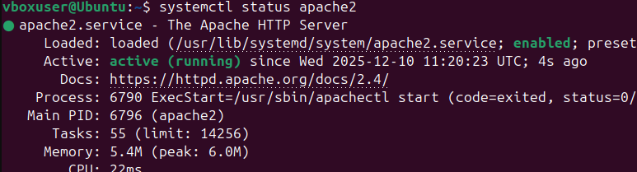
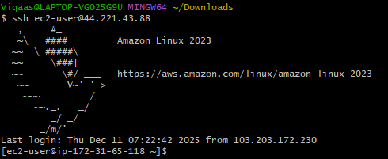
- 24 . Set up SSH password less authentication.
28. Set up a web server (e.g., Apache or Nginx).
27. Configure and secure a MySQL Database.
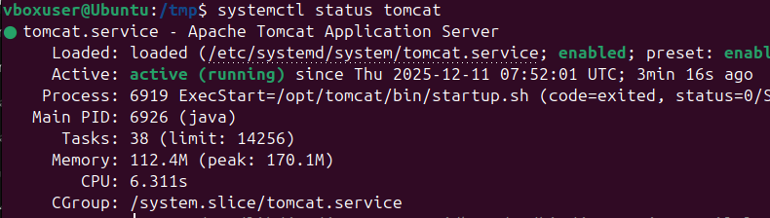
- Create a service file for Apache Tomcat. (Should execute by using systemtctl command)

30 . Print specific columns from a delimited file.
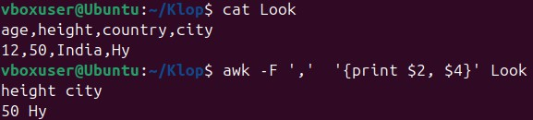
- . Filter and print lines based on a specific pattern or condition.
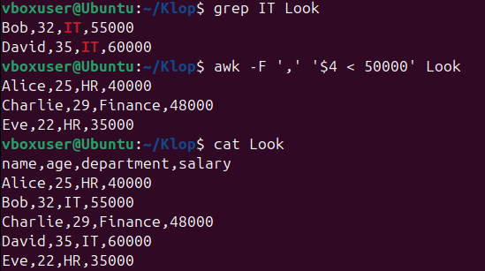
- 32. Calculate and print the average, sum, or other statistics of a column.
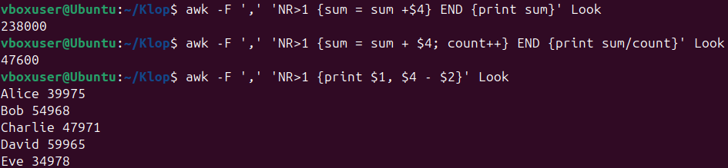
- 33. Perform string manipulation, such as extracting substrings or changing cases.
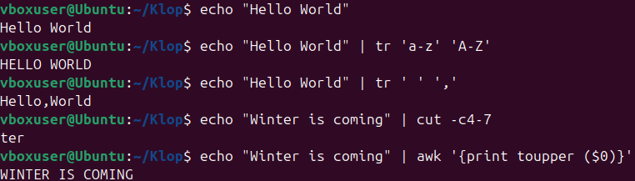
- 34. Count the occurrences of a specific pattern in a file.
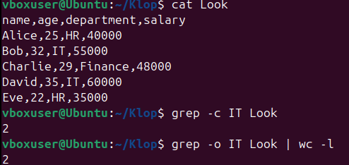
- 35. Sort lines based on a specific field or column.
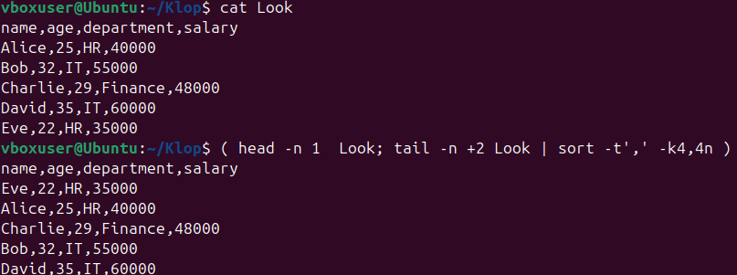
- 36. Merge multiple files based on a common field or column.
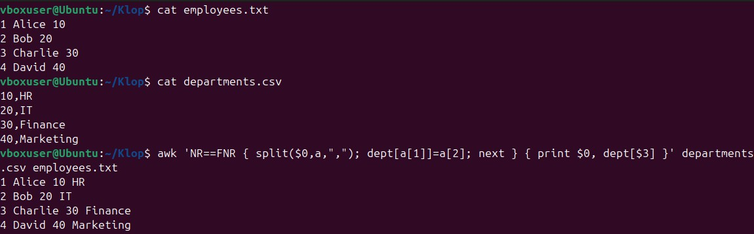
- 37. Substitute text in a file using search and replace.
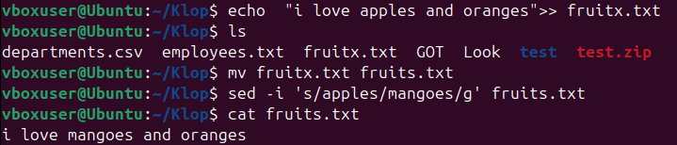

- 38. Delete specific lines based on a pattern or line number.
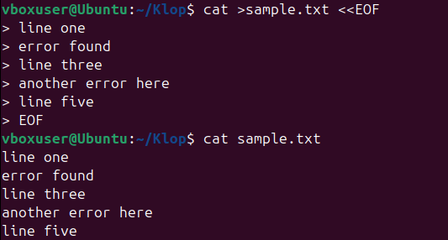
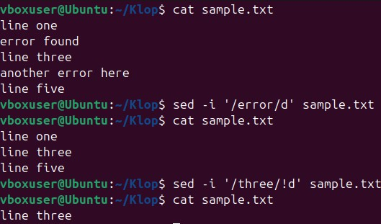
- 39. Append or insert text before or after a specific pattern or line.
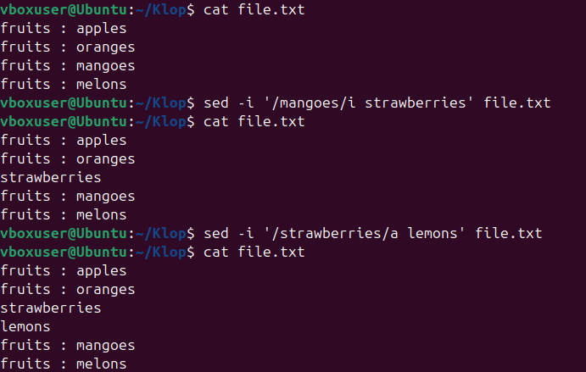

- 40. Print only specific lines from a file.
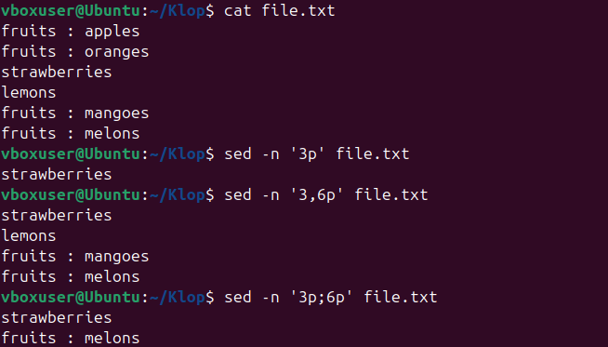
- 41. Copy file from linux to windows machine.
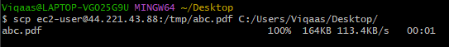
- 42. 5 use cases for AWK and 5 use cases for sed.
- awk -F ',' 'NR>1 {sum = sum + $n} END {print sum}' filename – for adding content in a file
- ps -ef | awk '{print $2}' - gives pid column in processes,
- awk -F ',' 'NR>1 {sum = sum + $4; count++} END {print sum/count}' filename - an example for taking a average in a file.
- awk -F ',' 'NR>1 {print $1, $4 - $2}' filename - an example for subtracting ( NR>1 means to ignore the first line, use it if the file contains header)
- sed -i '/keyword/d' filename - to delete lines with the specific keyword.
- sed -i '/keyword/!d' filename - to delete every line except the ones with the specific keyword.
- sed -n '3p' filename - to print the third line.
- sed -n '2,4p' filename - to print 2-4 line.
- sed -n '/keyword/p' filename - print lines that match a pattern.

